Practical No –
Aim: Implement Windows Function.
Code
CREATE TABLE bhargaviwindows (new_id INT,new_cat VARCHAR(20));
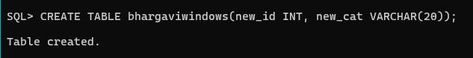
SQL>INSERT ALL INTO bhargaviwindows VALUES(100,’agni’) INTO bhargaviwindows VALUES(200,’agni’) INTO bhargaviwindows VALUES(500,’dharti’) INTO bhargaviwindows VALUES(700,’dharti’) INTO bhargaviwindows VALUES(200,’vayu’) INTO bhargaviwindows VALUES(300,’vayu’) INTO bhargaviwindows VALUES (500,’vayu’)
SELECT * FROM dual;

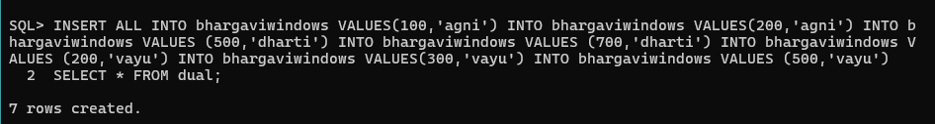
SELECT
new_id,
new_cat,
SUM(new_id) OVER (PARTITION BY new_cat ORDER BY new_id) AS TOTAL,
MIN(new_id) OVER (PARTITION BY new_cat ORDER BY new_id) AS MIN,
MAX(new_id) OVER (PARTITION BY new_cat ORDER BY new_id) AS MAX,
AVG(new_id) OVER (PARTITION BY new_cat ORDER BY new_id) AS AVERAGE,
COUNT(new_id) OVER (PARTITION BY new_cat ORDER BY new_id) AS COUNT
FROM bhargaviwindows;

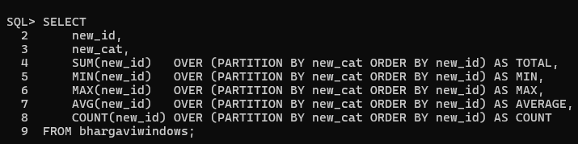
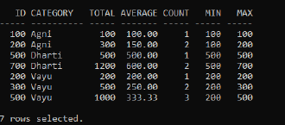

SQL> SELECT new_id,new_cat,
SUM(new_id)OVER(ORDER BY new_id ROWS BETWEEN UNBOUNDED PRECEDING AND UNBOUNDED FOLLOWING) AS "TOTAL",
MIN(new_id)OVER(ORDER BY new_id ROWS BETWEEN UNBOUNDED PRECEDING AND UNBOUNDED FOLLOWING) AS "MINIMUN",
AVG(new_id)OVER(ORDER BY new_id ROWS BETWEEN UNBOUNDED PRECEDING AND UNBOUNDED FOLLOWING) AS "AVERAGE",
MAX(new_id)OVER(ORDER BY new_id ROWS BETWEEN UNBOUNDED PRECEDING AND UNBOUNDED FOLlOWING) AS "MAXIMUM",
COUNT(new_id)OVER(ORDER BY new_id ROWS BETWEEN UNBOUNDED PRECEDING AND UNBOUNDED FOLLOWING) AS "COUNT" FROM bhargaviwindows;
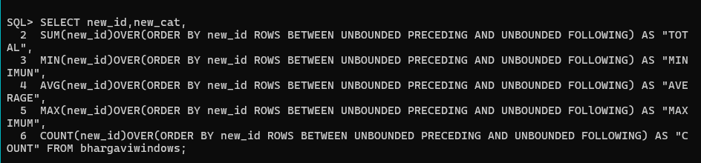

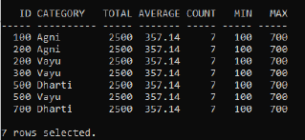
SELECT new_id,
ROW_NUMBER()OVER(ORDER BY new_id) AS "ROW_NUMBER",
RANK()OVER(ORDER BY new_id) AS "RANK",
DENSE_RANK()OVER(ORDER BY new_id) AS "DENSE_RANK",
PERCENT_RANK()OVER(ORDER BY new_id) AS "PERCENT_RANK"
FROM bhargaviwindows;

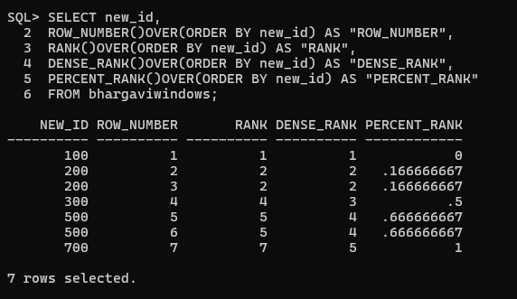

PRACTICAL NO-
AIM:Implement of LIST PARTITION
SQL> SELECT new_id,
FIRST_VALUE(new_id)OVER(ORDER BY new_id) AS "FIRST_VALUE",
LAST_VALUE(new_id)OVER(ORDER BY new_id ROWS BETWEEN UNBOUNDED PRECEDING AND UNBOUNDED FOLLOWING) AS "LAST_VALUE",
LEAD(new_id)OVER(ORDER BY new_id) AS "LEAD",
LAG(new_id)OVER(ORDER BY new_id) AS "LAG" FROM bhargaviwindows;
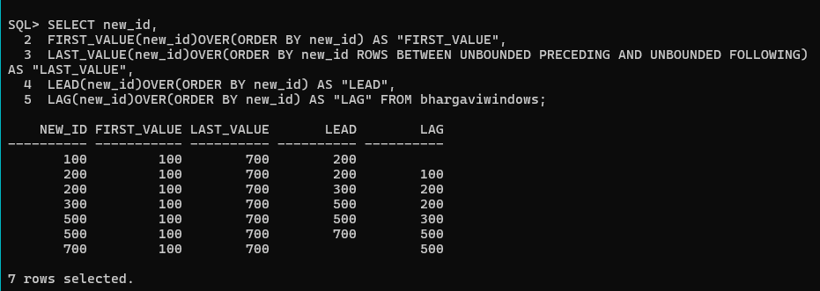
SELECT new_id,
LEAD(new_id,2)OVER(ORDER BY new_id) AS "LEAD_by2",
LAG(new_id,2)OVER(ORDER BY new_id) AS "LAG_by2"
FROM bhargaviwindows;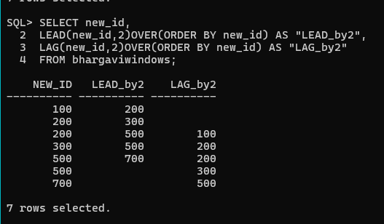

SQL> create table bhargavilist(sales_id INT,sales_name VARCHAR(20),sales_state VARCHAR(20),sales_amount NUMBER(10),sales_date DATE)
PARTITION BY LIST(sales_state)
(PARTITION sales_east VALUES('govandi','chembur'),
PARTITION sales_west VALUES('mankurd','vashi'),
PARTITION sales_central VALUES('Seawoods','nerul'),
PARTITION sales_other VALUES(DEFAULT));
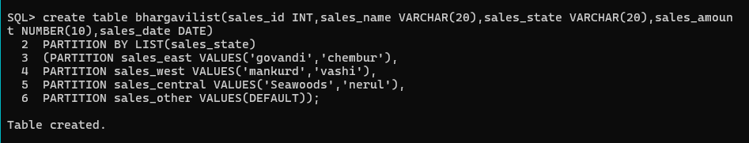

INSERT INTO bhargavilist VALUES (6,'A','govandi',15000, DATE '2025-03-01');
INSERT INTO bhargavilist VALUES (7,'B','chembur',25000, DATE '2025-03-02');
INSERT INTO bhargavilist VALUES (8,'C','mankurd',35000, DATE '2025-03-03');
INSERT INTO bhargavilist VALUES (9,'D','Seawoods',45000, DATE '2025-03-04');
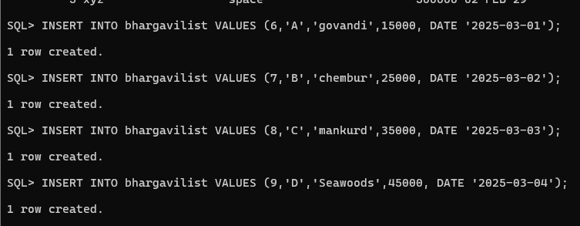

SELECT * FROM bhargavilist PARTITION (sales_east);
SELECT * FROM bhargavilist PARTITION (sales_west);
SELECT * FROM bhargavilist PARTITION (sales_central);

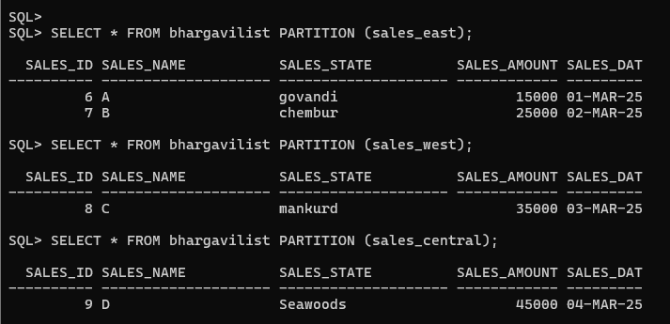

PRACTICAL NO-
AIM:Implementation of Range Partitions.
Code:
CREATE TABLE bhargavirange (
sales_id INT,
sales_name VARCHAR2(20),
sales_state INT,
sales_date DATE
)
PARTITION BY RANGE (sales_date)
(
PARTITION sales_2022 VALUES LESS THAN (DATE '2022-01-01'),
PARTITION sales_2023 VALUES LESS THAN (DATE '2023-01-01'),
PARTITION sales_2024 VALUES LESS THAN (DATE '2024-01-01'),
PARTITION sales_2025 VALUES LESS THAN (DATE '2025-01-01'),
PARTITION sales_future VALUES LESS THAN (DATE '9999-12-31')
);
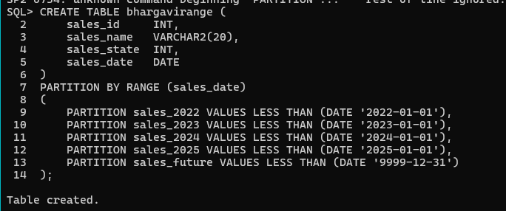

INSERT INTO bhargavirange
VALUES (1, 'A', 101, DATE '2022-01-01');
SQL> INSERT INTO bhargavirange VALUES(2,'B',102,DATE'2023-01-01');
SQL> INSERT INTO bhargavirange VALUES(3,'B',103,DATE'2024-01-01');
SQL> INSERT INTO bhargavirange VALUES(4,'B',104,DATE'2025-01-01');
SQL> INSERT INTO bhargavirange VALUES(5,'B',105,DATE'2026-01-01');

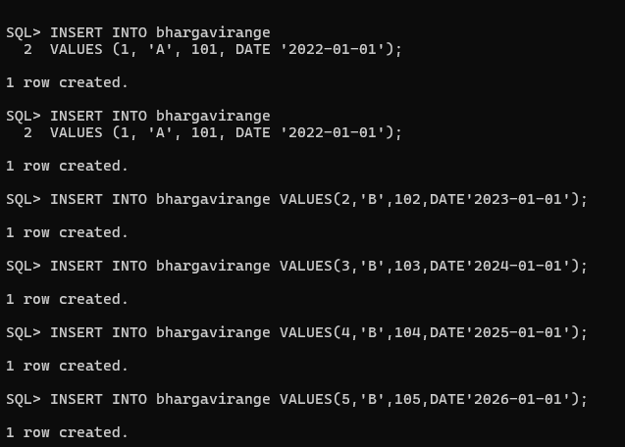

SELECT * FROM bhargavirange PARTITION(sales_2023);
SELECT * FROM bhargavirange PARTITION(sales_2024);
SELECT * FROM bhargavirange PARTITION(sales_2025);
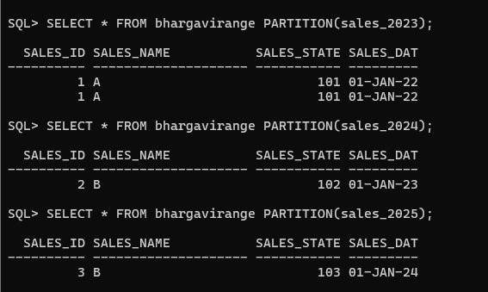
Practical No –
Aim: Implement of Hash Partition.
Code
SQL> create table bhargavihashtable1 (
salesman_id NUMBER(10),
salesman_name VARCHAR(20),
salesman_state VARCHAR(20),
salesman_amount NUMBER(10),
salesman_date DATE)
PARTITION BY HASH (salesman_state)
PARTITIONS 4;
Table created.
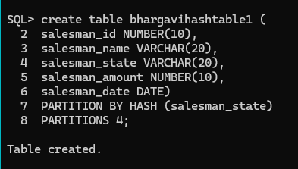
SQL> INSERT INTO bhargavihashtable1 VALUES (
1,'bhargavi','maharashtra',1000,DATE '2004-03-14');
INSERT INTO bhargavihashtable1 VALUES(
2,'shatayu','gujarat',40000,DATE '2002-01-17');
insert into bhargavihashtable1 values (
3,'ram','jalgaon',60000,DATE '2025-12-24');
insert into bhargavihashtable1 values(
4,'sita','kashmir',90000,DATE'2025-12-31');
insert into bhargavihashtable1 values(
5,'lakshman','rampur',1000000,DATE'2016-01-01');
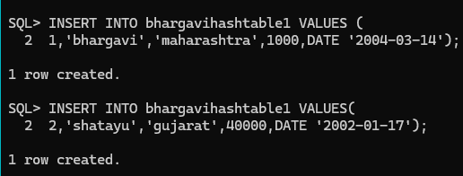
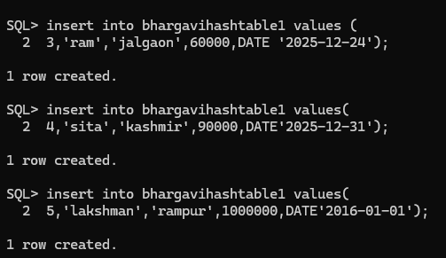
SELECT * FROM bhargavihashtable1:
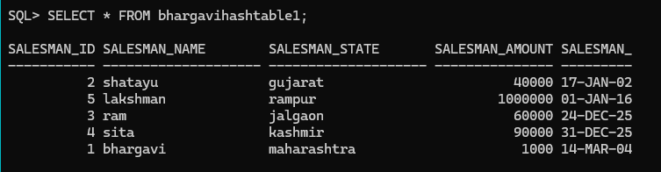
SQL> SELECT table_name,partition_name,high_value
FROM user_tab_partitions
WHERE table_name = ‘BHARGAVIHASHTABLE1’;

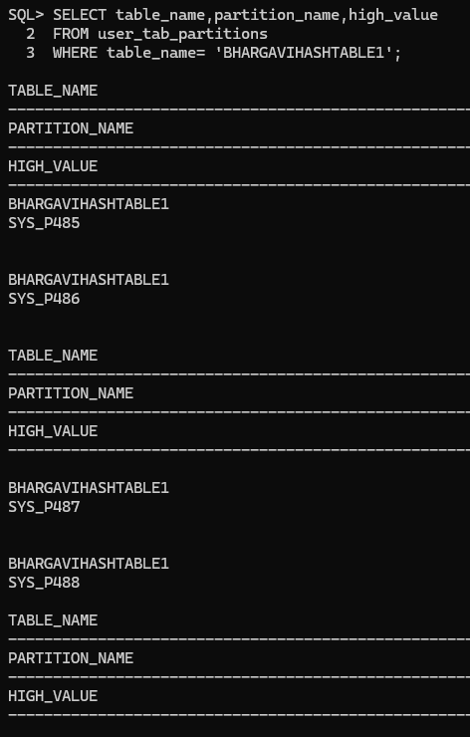
SQL> SELECT * FROM bhargavihashtable1
WHERE SALESMAN_STATE=’ gujarat’;
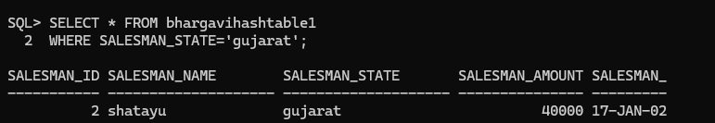

Practical No-
Aim: Implement of Abstract data Type.
Code:
SQL> CREATE TYPE type_name1 AS OBJECT (
fname VARCHAR2(20),
mname VARCHAR2(20),
lname VARCHAR2(20)
);
/
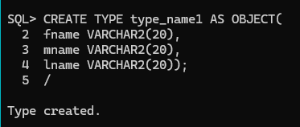
Code.
SQL> CREATE TYPE type_address1 AS OBJECT (
street VARCHAR2(20),
city VARCHAR2(20),
pincode VARCHAR2(20)
);
/
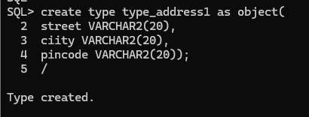

SQL> create table table1(
c_id NUMBER(10) PRIMARY KEY,
c_name type_name1,
c_add type_address1,
c_phone NUMBER(10));

Table created.
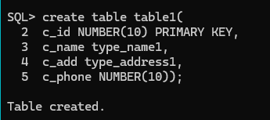

SQL> INSERT INTO TABLE1 VALUES(
1,type_name1('bhargavi','chintamani','keni'),
type_address1('govandi','mumbai','400088'),
8879118119);
1 row created.
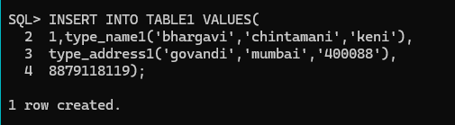
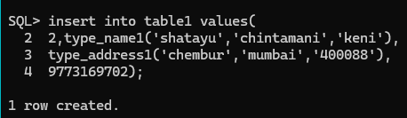

SQL> SELECT * FROM table1;
