Practical No: 1
Aim: Assignments on Java Generics.

1)Write a java Program to demonstrate a Generic class.
Code:
package prince127;
class Main1<T> {
T obj;
void add(T obj) {
this.obj = obj;
}
T get() {
return obj;
}
}
public class Prince_generic {
public static void main(String[] args) {
Main1<Integer> nn = new Main1<Integer>();
nn.add(127);
Main1<String> ss = new Main1<String>();
ss.add("Prince Yadav");
System.out.println("Member of My Generic Class<Integer>: " + nn.get());
System.out.println("Member of My Generic Class<String>: " + ss.get());
}
}

Output
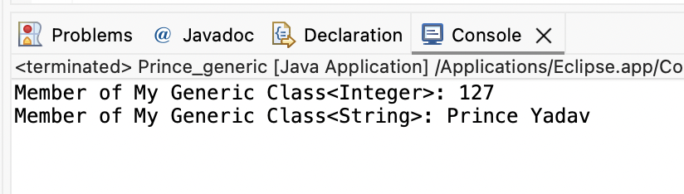

2. Write a Java Program to demonstrate Generic Methods.
Code
package prince127;

public class GenericMethod {
public static<T>void printGenericArray(T[]items){
for(T item:items) {
System.out.print(item+"");
}
System.out.println();
}
public static void main(String[] args) {
Integer[]int_Array= {1,2,4,5,6,11};
Character[]char_Array= {'P','R','I','N','C','E'};
System.out.println("Integer Array contents: ");
printGenericArray(int_Array);
System.out.println("Character Array contents: ");
printGenericArray(char_Array);
}
}

Output
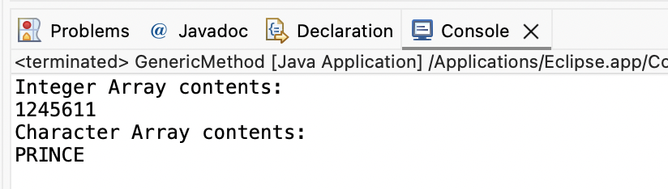

3. Write a Java Program to demonstrate Wildcards in Java Generics.’
1) Unbound:
Code
package prince127;

import java.util.Arrays;
import java.util.List;
public class Unbounded {
public static void main(String[] args) {
List<Integer>list1=Arrays.asList(1,2,3);
List<Double>list2=Arrays.asList(1.1,2.2,3.3);
printlist(list1);
printlist(list2);

}
private static void printlist(List<?>list) {
System.out.println(list);
}
}

Output
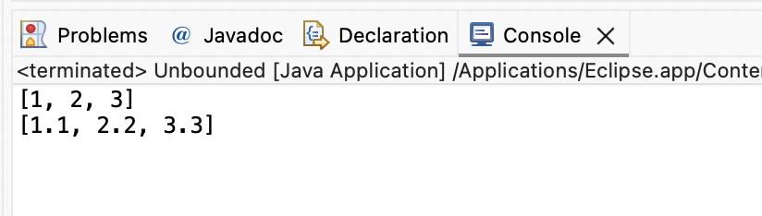

2) Lowerbound:
Code
package prince127;

import java.util.Arrays;
import java.util.List;

public class Lowerbound {

public static void main(String[]args) {
List<Integer>list1=Arrays.asList(5,4,3,2,1);
superClass(list1);

List<Number>list2=Arrays.asList(4,5,12,74,41);
superClass(list2);
}

public static void superClass(List<?super Integer>list) {
System.out.println(list);
}
}

Output:
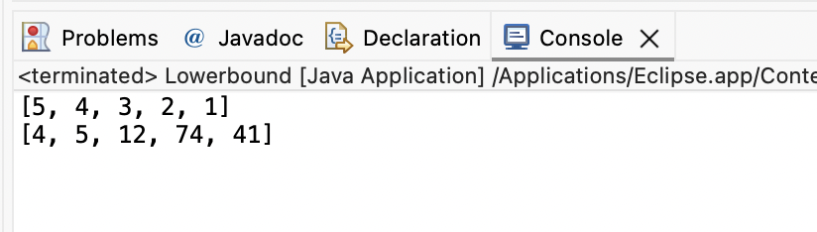

3) UpperBound
Code
package prince127;

import java.util.*;

public class Upperbound<T> {

private static Number sum(List<? extends Number>numbers) {
double a=0.0;

for(Number n:numbers)
a+=n.doubleValue();
return a;
}
public static void main(String[] args) {
List<Integer>list1=Arrays.asList(5,4,3,2,1);
System.out.println(sum(list1));
List<Double>list2=Arrays.asList(4.2,8.5,5.5,77.7,4.1);
System.out.println(sum(list2));

}
}

Output:
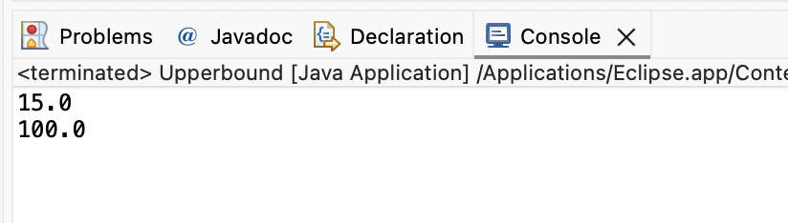

Practical No: 2
Aim: Assignments on List Interface.
1. Write a Java program to create List containing list of items of type String and use for-each loop to print the items of the list.
Code
package prince127;

import java.util.*;
public class ArrayListDemoPrince {

public static void main(String args[]) {

ArrayList<String> list = new ArrayList<String>();

list.add("hello");
list.add("dear");
list.add("root");
list.add("This");
list.add("is");
list.add("Prince");

System.out.println("ArrayList:" + list);

for(String s:list){
System.out.println(s);
}
}
}

Output
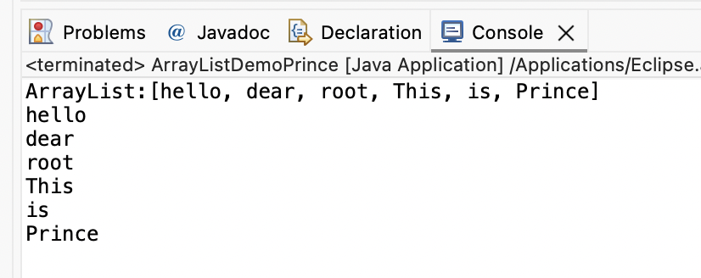
2. Write a Java program to create List containing list of items and use ListIterator interface to print items present in the list. Also print the list in reverse/ backword direction.
Code
package prince127;

import java.util.ArrayList;
import java.util.Iterator;
public class ReverseArrayListPrince {

public static void main(String[] args) {
ArrayList<String>arr = new ArrayList<String>();
arr.add(“hello”);
arr.add(“dear”);
arr.add(“root”);
arr.add(“This”);
arr.add(“is”);
arr.add(“Prince”);
System.out.println(arr);
Iterator<String> it= arr.iterator();
for (int I = arr.size()-1; I >=0; i--) {
System.out.println(arr.get(i));
}
}
}

Output
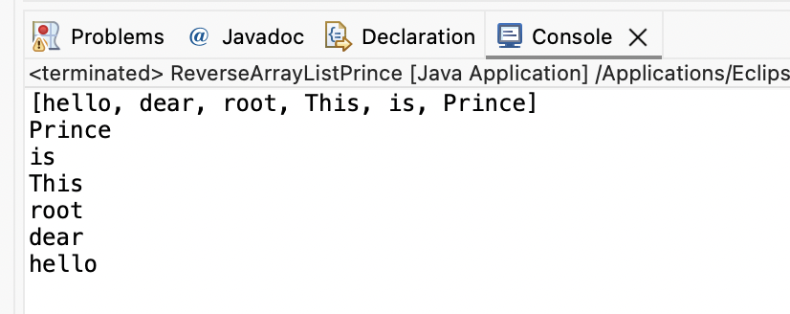

Practical No: 3
Aim: Assignments on Set Interface.
1. Write a Java program using Set interface containing list of items and perform the following operations:
a. Add items in the set.
b. Insert items of one set in to other set.
c. Remove items from the set
d. Search the specified item in the set
Code
package prince127;
import java.util.*;
public class Hash_Set_Prince {
public static void main(String[] args) {
Set<String> hset = new HashSet<String>();
hset.add("Apple");
hset.add("Mango");
hset.add("Banana");
hset.add("Papaya");
hset.add("Grapes");

System.out.println("After Using Add Function: " + hset);

hset.remove("Mango");
System.out.println("After Using Remove Function: " + hset);

String check = "Papaya";

System.out.println(hset);
System.out.println("Contain " + check + " is " + hset.contains(check) + ".");

Set<String> hset1 = new HashSet<String>();
hset1.addAll(Arrays.asList(new String[] { "ABC", "XYZ", "MNO", "EFG" }));

Set<String> hset2 = new HashSet<String>();
hset2.addAll(Arrays.asList(new String[] { "KLM", "HIJ", "PQR", "STY" }));

Set<String> union = new HashSet<String>(hset1);
union.addAll(hset2);

System.out.println("Union of the hset1 and hset2 Set: ");
System.out.println(union);
}
}

Output
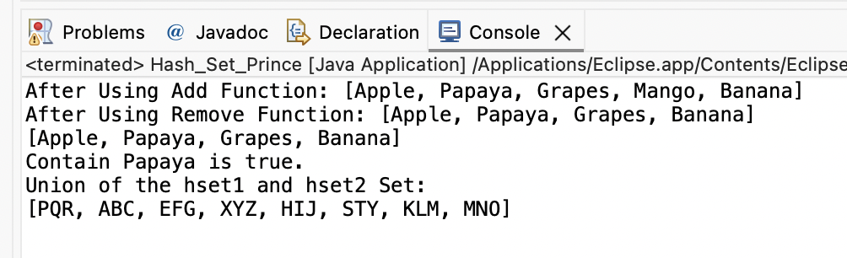

Practical No – 4
Aim: Assignments on Map Interface
Write a Java program using Map interface containing list of items having
keys and associated values and perform the following operations:
a. Add items in the map.
b. Remove items from the map
c. Search specific key from the map
d. Get value of the specified key
e. Insert map elements of one map in to other map.
f. Print all keys and values of the map
Code
package prince127;

import java.util.*;
public class MapInterfacePrince {
public static void main(String[] args) {
Map<Integer, String> map1 = new HashMap<Integer, String>();
map1.put(new Integer(1), "Prince");
map1.put(new Integer(2), "Anurag");
map1.put(new Integer(3), "Abhishek");
map1.put(new Integer(4), "Alok");
map1.put(new Integer(5), "Dheeraj");
map1.put(new Integer(6), "Ganesh");
System.out.println(map1);
map1.remove(new Integer(3));
System.out.println(map1);
System.out.println("Key 3 is present "+map1.containsKey(3));
String val=(String)map1.get(4);
System.out.println("Value of specified key: "+val);
Map<Integer, String> map2 = new HashMap<Integer, String>();
map2.put(6, "Aman");
map2.put(7, "Satyam");
map2.put(8, "shivam");
map2.put(9, "Ujala");
map1.putAll(map2);
System.out.println(map1);
}
}

Output
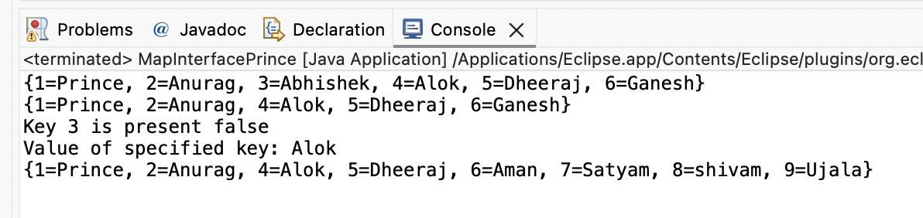

Practical No - 5
Aim: Assignments on Lambda Expression.
1. Write a Java program using Lambda Expression to print “Hello Prince”.
Code
package prince127;
public class P1 {
// Functional interface
interface Hello {
void hello();
}
public static void main(String[] args) {
System.out.println("Name: Prince, Roll No: 127");
Hello obj = () -> System.out.println("Hello Prince, Good Morning");
obj.hello();
}
}

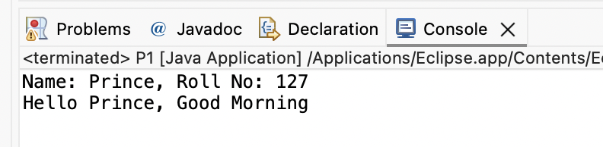

2. Write a Java program using Lambda Expression with single parameters.
Code
package prince127;

interface Sayable {
public String say(String name);
}
public class P2 {
public static void main(String[] args) {
System.out.println("Name: Prince, Roll No: 127");
Sayable S1 = (name) -> {
return "Hello, " + name;
};
System.out.println(S1.say("Prince"));
Sayable S2 = (name) -> {
return "Prince your " + name;
};
System.out.println(S2.say("Roll No is: 127"));
}
}

Output
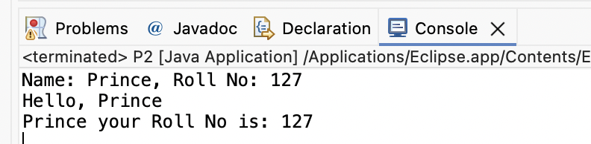

3. Write a Java program using Lambda Expression with multiple parameters to add two numbers.
Code:
package prince127;

interface Addition {
int add(int a, int b);
}
public class P3 {
public static void main(String[] args) {
System.out.println("Name: Prince, Roll No: 127");
Addition ad1 = (a, b) -> (a + b);
System.out.println("Addition is: " + ad1.add(50, 11));
Addition ad2 = (int x, int y) -> (x + y);
System.out.println("Addition is: " + ad2.add(510, 400));
}
}

Output
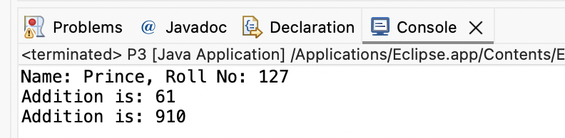

4. Write a Java program using Lambda Expression to calculate the following:

a. Convert Fahrenheit to Celcius.

Code:
package prince127;

import java.util.Scanner;
class FahrenheittoCelsius {
double celsius(double f) {
return (f - 32) * 5 / 9;
}
public static void main(String arg[]) {
// Print name and roll number
System.out.println("Name: Prince, Roll No: 127");
double a, c;
Scanner sc = new Scanner(System.in);
System.out.print("Enter Fahrenheit temperature: ");
a = sc.nextDouble();
FahrenheittoCelsius fah = new FahrenheittoCelsius();
double result = fah.celsius(a);
System.out.println("Celsius temperature is = " + result);
}
}

Output
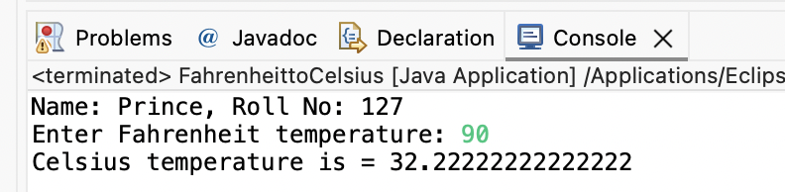

b. Convert Kilometers to Miles.
Code:
package prince127;

import java.util.Scanner;
public class KilometertoMiles {
public static void main(String[] args) {
System.out.println("Name: Prince, Roll No: 127");
double kilometers, miles;
double conversionFactor = 1.609344;
System.out.print("Enter distance value in kilometer: ");
Scanner input = new Scanner(System.in);
kilometers = input.nextDouble();
miles = kilometers / conversionFactor;
System.out.println("The distance in Miles: " + miles);
}
}

Output
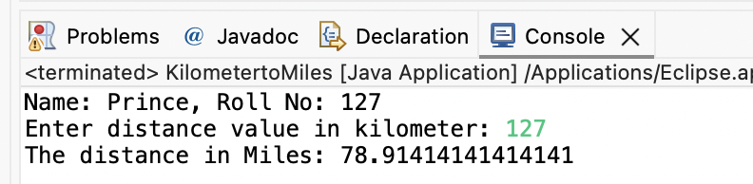

5. Write a Java program using Lambda Expression with or without return keyword.
Code:
package prince127;
import java.util.stream.LongStream;
public class P7 {
public static long factorialStreams(long n) {
return LongStream.rangeClosed(2, n)
.reduce(1, (long x, long y) -> x * y);
}
public static void main(String[] args) {
System.out.println("Name: Prince, Roll No: 127");
long n = 5;
long fact = factorialStreams(n);
System.out.println("The factorial of " + n + " is: " + fact);
}
}

Output
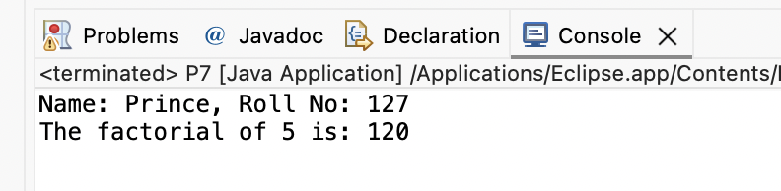

Practical No – 6
Aim: Assignments based on web application development using JSP.
1. Write Programs to demonstrate different Implicit Objects
a. OUT
Code
<%@ page language="java" contentType="text/html; charset=ISO-8859-1"
pageEncoding="ISO-8859-1"%>
<!DOCTYPE html>
<html>
<head>
<meta charset="ISO-8859-1">
<title>Implicit OUT</title>
</head>
<body>
<%
int num1 = 10;
int num2 = 20;
out.println("num1 is " + num1);
out.println("<br>num2 is " + num2);
%>
</body>
</html>

Output
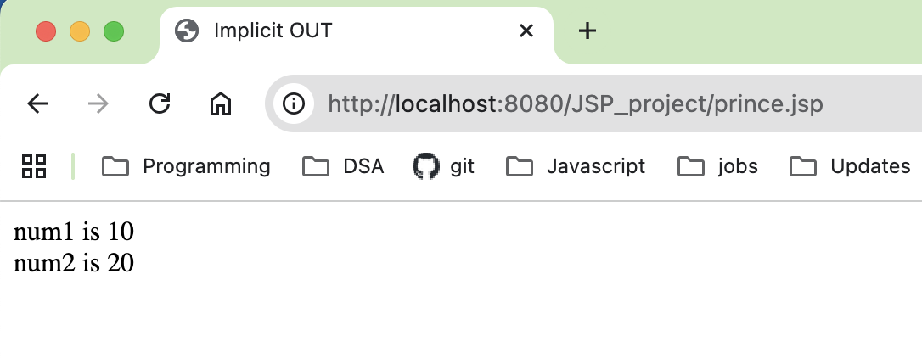

b. Request
RequestObj.jsp
<%@ page language="java" contentType="text/html; charset=ISO-8859-1"
pageEncoding="ISO-8859-1"%>
<!DOCTYPE html>
<html>
<head>
<meta charset="ISO-8859-1">
<title>Request Object</title>
</head>
<body>
<form action="form1.jsp">
<input type="text" name="Username">
<input type="submit" value="submit">
</form>
</body>
</html>

form1.jsp
<%@ page language="java" contentType="text/html; charset=ISO-8859-1"
pageEncoding="ISO-8859-1"%>
<!DOCTYPE html>
<html>
<head>
<meta charset="ISO-8859-1">
<title>Request Result</title>
</head>
<body>
<%
String Username = request.getParameter("Username");
out.println("Welcome " + Username);
%>
</body>
</html>

Output
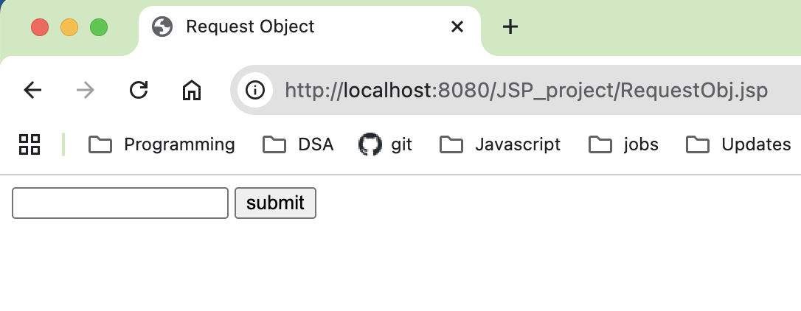
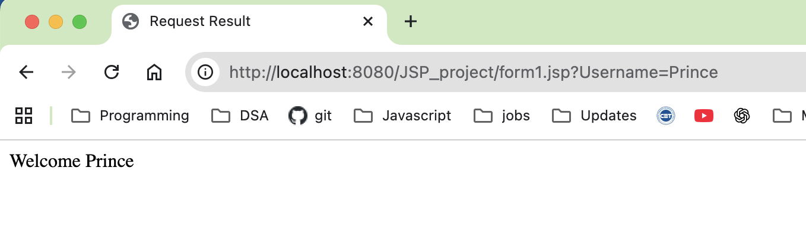

c. Session Code:
Session.jsp
<%@ page language="java" contentType="text/html; charset=ISO-8859-1"
pageEncoding="ISO-8859-1"%>
<!DOCTYPE html>
<html>
<head>
<meta charset="ISO-8859-1">
<title>Insert title here</title>
</head>
<body>
<% session.setAttribute("user", "Prince"); %>
<a href="Implicit_jsp8.jsp">Click here to here User name</a>
</body>
</html>

Implicit_jsp8.jsp
<%@ page language="java" contentType="text/html; charset=ISO-8859-1"
pageEncoding="ISO-8859-1"%>
<!DOCTYPE html>
<html>
<head>
<meta charset="ISO-8859-1">
<title>Insert title here</title>
</head>
<body>
<% String name=(String)session.getAttribute("user");
out.println("User Name is: "+name);
%>
</body>
</html>

Output
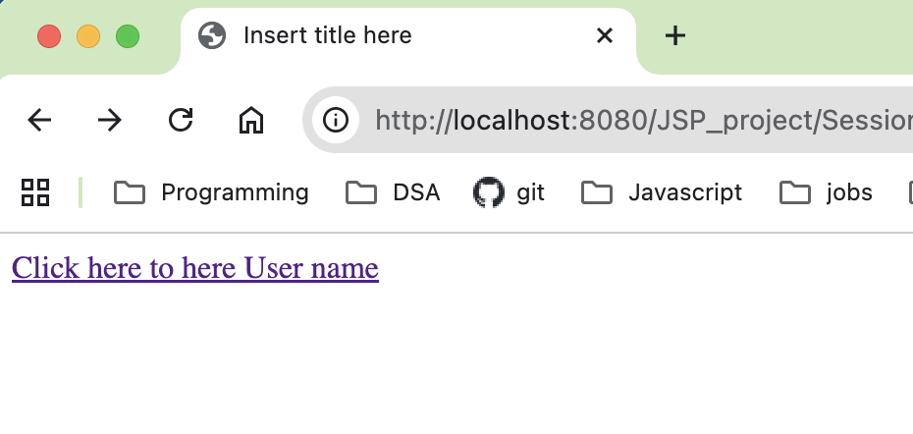
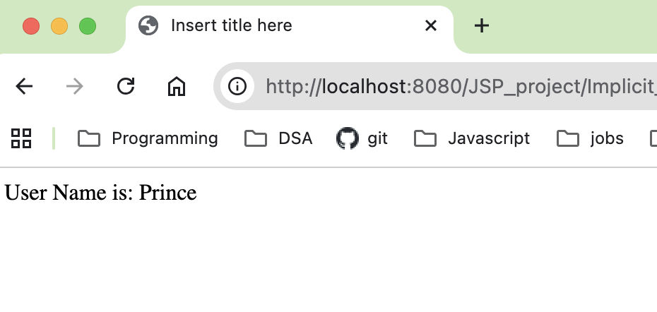

2. Write Programs to demonstrate temporary storage using Bean.
Form.jsp
<%@ page language="java" contentType="text/html; charset=ISO-8859-1"
pageEncoding="ISO-8859-1"%>
<!DOCTYPE html>
<html>
<head>
<meta charset="ISO-8859-1">
<title>Insert title here</title>
</head>
<body>
<form method="post" action="person.jsp">
<h1>Person Form</h1>
First Name: <input type="text" name="firstName">
<br><br>
Last Name: <input type="text" name="lastName">
<br><br>
Email: <input type="text" name="email">
<br><br>
<button type="submit" name="submit">Submit</button>
</form>
</body>
</html>

PersonBean.java

package Person;

public class PersonBean {
private String firstName;
private String lastName;
private String email;

public String getFirstName() {
return firstName;
}
public void setFirstName(String firstName) {
this.firstName = firstName;
}
public String getLastName() {
return lastName;
}
public void setLastName(String lastName) {
this.lastName = lastName;
}
public String getEmail() {
return email;
}
public void setEmail(String email) {
this.email = email;
}
}

person.jsp
<%@ page language="java" contentType="text/html; charset=ISO-8859-1"
pageEncoding="ISO-8859-1"%>
<!DOCTYPE html>
<html>
<head>
<meta charset="ISO-8859-1">
<title>Person Bean Test</title>
</head>
<body>
<%
if("POST".equalsIgnoreCase(request.getMethod()) && request.getParameter("submit")!=null)
{
%>
<jsp:useBean id="PersonBean" class="Person.PersonBean" scope="session" />
<jsp:setProperty name="PersonBean" property="*" />

<%
out.println("First Name: " + PersonBean.getFirstName());
out.println("<br>Last Name: " + PersonBean.getLastName());
out.println("<br>Email: " + PersonBean.getEmail());
}
%>
</body>
</html>

Output
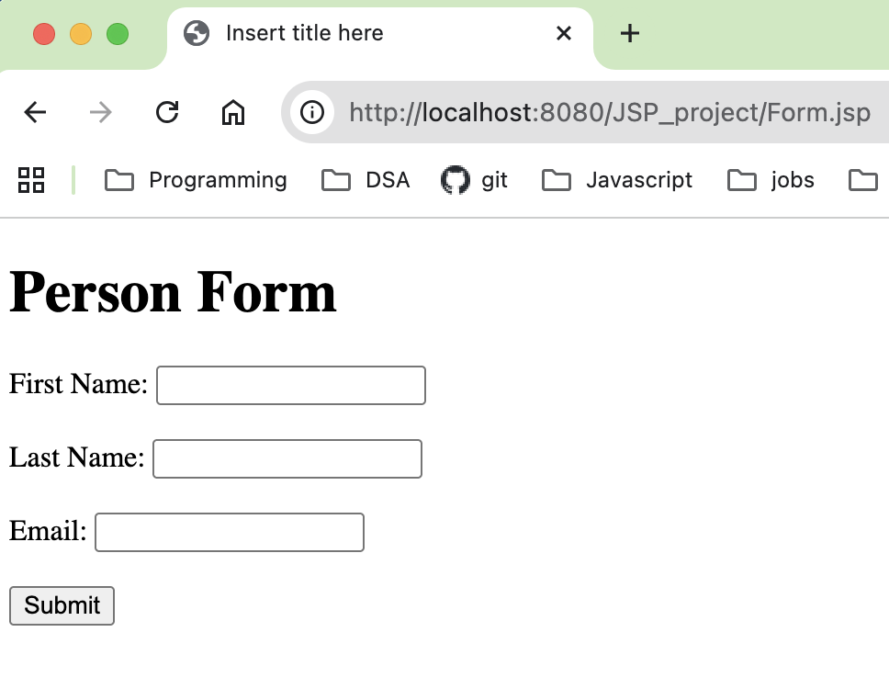
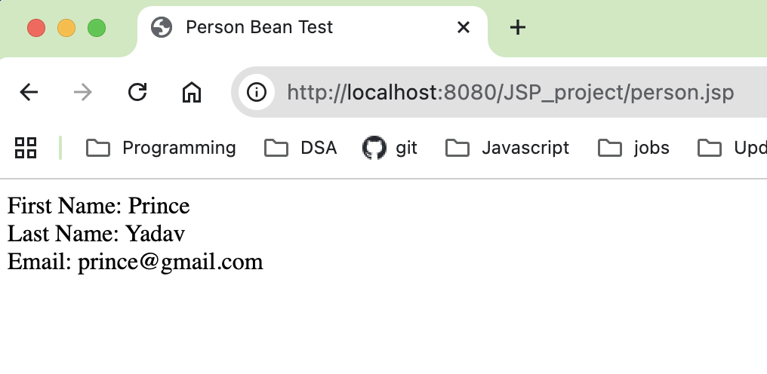

3. Write a program to demonstrate Standard Action tags.
action_cookie.java
<%@ page language="java" contentType="text/html; charset=UTF-8"
pageEncoding="UTF-8"%>
<!DOCTYPE html>
<html>
<head>
<meta charset="UTF-8">
<title>Cookie Input Form</title>
</head>
<body>
<form action="action_cookie_main.jsp" method="get">
Username: <input type="text" name="username">
<br><br>
Email: <input type="text" name="email">
<br><br>
<input type="submit" value="submit">
</form>
</body>
</html>

action_cookie_main.jsp
<%@ page language="java" contentType="text/html; charset=UTF-8"
pageEncoding="UTF-8"%>
<!DOCTYPE html>
<%
// Correcting the syntax 'newCookie' to 'new Cookie'
Cookie username = new Cookie("username", request.getParameter("username"));
Cookie email = new Cookie("email", request.getParameter("email"));

// Setting cookie expiry to 10 hours (60*60*10)
username.setMaxAge(60*60*10);
email.setMaxAge(60*60*10);

// Adding cookies to the response
response.addCookie(username);
response.addCookie(email);
%>
<html>
<head>
<meta charset="UTF-8">
<title>Cookie Result</title>
</head>
<body>
<b>Username:</b>
<%= request.getParameter("username") %>
<br><br>
<b>Email:</b>
<%= request.getParameter("email") %>
</body>
</html>

Output:
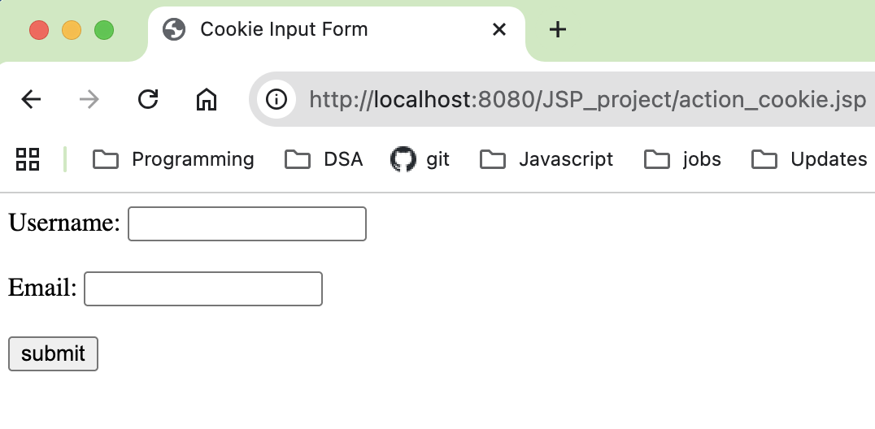
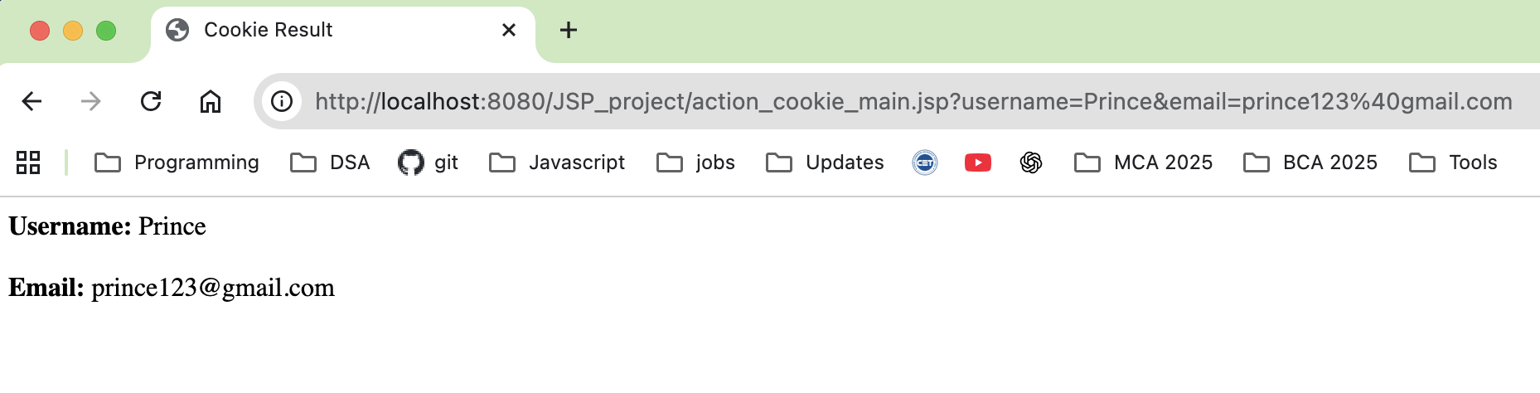

4. Write a program to demonstrate JSTL Tags.
action_tags.jsp
<%@ page language="java" contentType="text/html; charset=ISO8859-1" pageEncoding="ISO-8859-1"%>
<!DOCTYPE html>
<html>
<head>
<meta charset="ISO-8859-1">
<title>action tag</title>
</head>
<body>
<h1>JSP Action Tags Demonstration</h1>
<!--jsp:include action tag -->
<h3>Use of include action tags</h3>
<jsp:include page="header.jsp" />
<!--jsp:useBean action tag -->
<h3>Use of useBean action tags</h3>
<jsp:useBean id="date"
class="java.util.Date" /> Current Date: <%=
date %><br><br>
</body>
</html>

header.jsp
<%@ page language="java" contentType="text/html; charset=ISO-8859-1"
pageEncoding="ISO-8859-1"%>
<!DOCTYPE html>
<html>
<head>
<meta charset="ISO-8859-1">
<title>document</title>
</head>
<body>
<h2>Header Page - Prince 127</h2>
<p>This is a header page that can be included in multiple pages using the jsp:include
action tag.</p>
</body>
</html>

Output
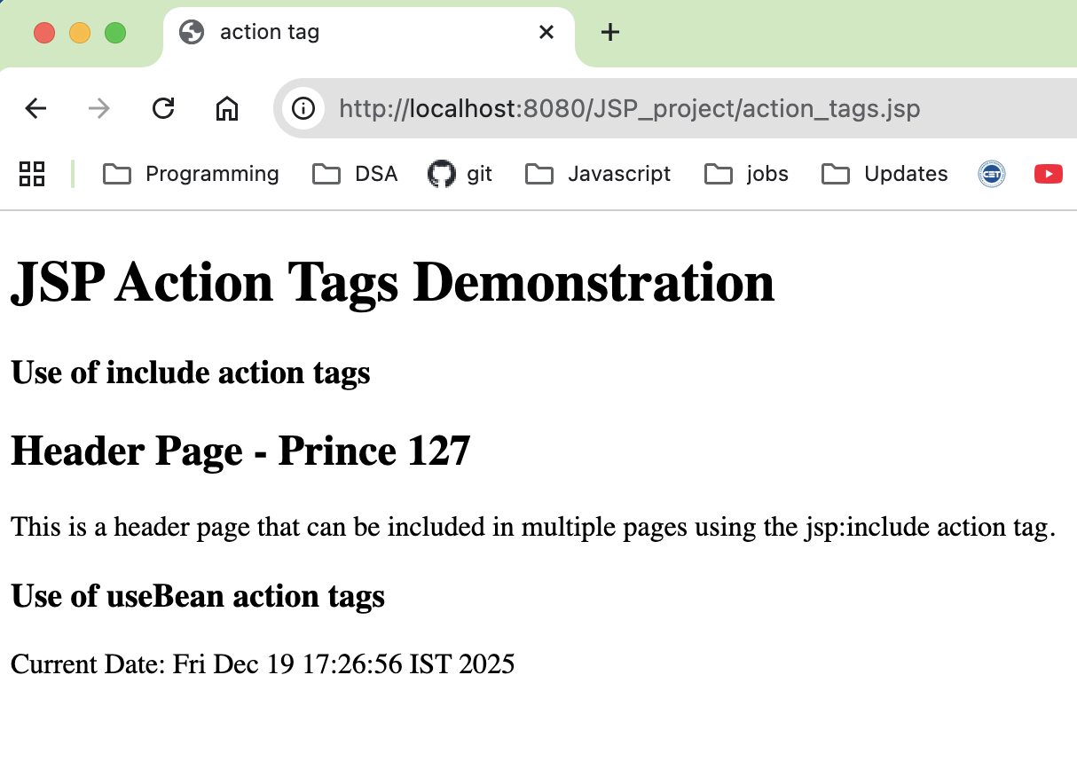

5) Write a program to demonstrate Forward Action Tag
ForwardDemo.jsp
<%@ page language="java" contentType="text/html; charset=ISO-8859-1"
pageEncoding="ISO-8859-1"%>
<!DOCTYPE html>
<html>
<head>
<meta charset="ISO-8859-1">
<title>forward tag</title>
</head>
<body>
<h1>JSP Action Tags Demonstration</h1>
<h3>Use of forward action tags</h3>

<jsp:forward page="forwardPage.jsp" />
</body>
</html>

forwardPage.jsp
<%@ page language="java" contentType="text/html; charset=ISO-8859-1"
pageEncoding="ISO-8859-1"%>
<!DOCTYPE html>
<html>
<head>
<meta charset="ISO-8859-1">
<title>Target Page</title>
</head>
<body>
<h2>Forward Page</h2>
<p>This is a page that can be forwarded to using the jsp:forward action tag.</p>
</body>
</html>

Output
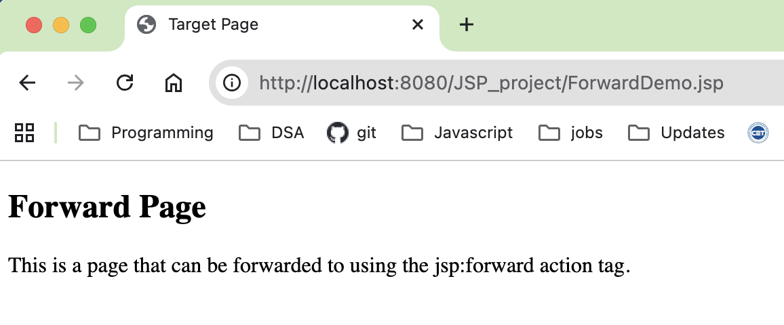
6. Create a Telephone directory using JSP and store all the information within a database, so that later could be retrieved as per the requirement. Make your own assumptions.
Index.html
<!DOCTYPE html>
<html>
<head>
<meta charset="ISO-8859-1">
<title>Telephone Directory</title>
</head>
<body>
<form action="indexaction.jsp" method="post">
<fieldset>
<label>Name:</label>
<input type="text" name="name"><br><br>
<label>Mobile Number:</label>
<input type="number" name="mobileno"><br><br>
<label>City:</label>
<input type="text" name="city"><br><br>
<input type="submit" value="submit">
</fieldset>
</form>
</body>
</html>

Indexacton.jsp
<%@ page import="java.sql.*" %>
<html>
<head>
<meta charset="ISO-8859-1">
<title>Retrieve Data</title>
</head>
<body>
<h1>Retrieve Data</h1>
<table border="1">
<tr>
<th>Name</th>
<th>Mobile Number</th>
<th>City</th>
</tr>
<%
String name = request.getParameter("name");
String mobileno = request.getParameter("mobileno");
String city = request.getParameter("city");
try {
Class.forName("com.mysql.cj.jdbc.Driver");
Connection con = DriverManager.getConnection(
"jdbc:mysql://localhost:3306/DIRECTORY",
"root",
""
);

// Insert only if data is not null
if(name != null && mobileno != null && city != null) {
PreparedStatement ps =
con.prepareStatement("INSERT INTO TELEPHONE VALUES (?, ?, ?)");
ps.setString(1, name);
ps.setString(2, mobileno);
ps.setString(3, city);
ps.executeUpdate();
}
Statement st = con.createStatement();
ResultSet rs = st.executeQuery("SELECT * FROM TELEPHONE");

while(rs.next()) {
%>
<tr>
<td><%= rs.getString(1) %></td>
<td><%= rs.getString(2) %></td>
<td><%= rs.getString(3) %></td>
</tr>
<%
}
con.close();
} catch(Exception e) {
out.println("Error: " + e);
}
%>
</table>
</body>
</html>

Output:
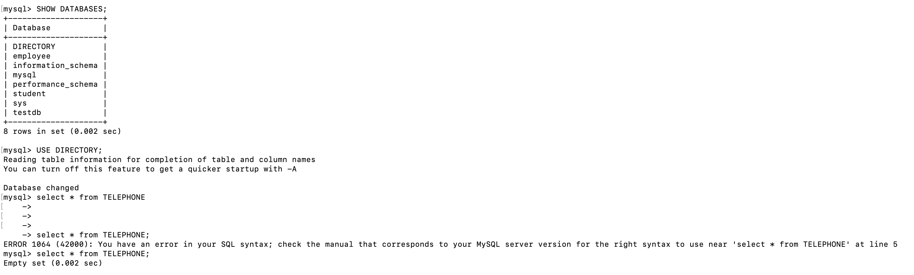
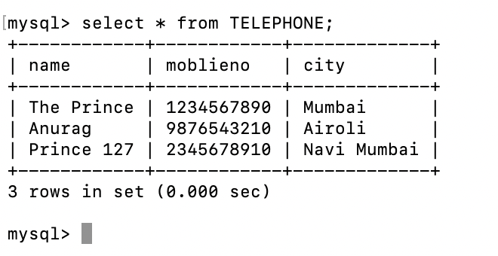

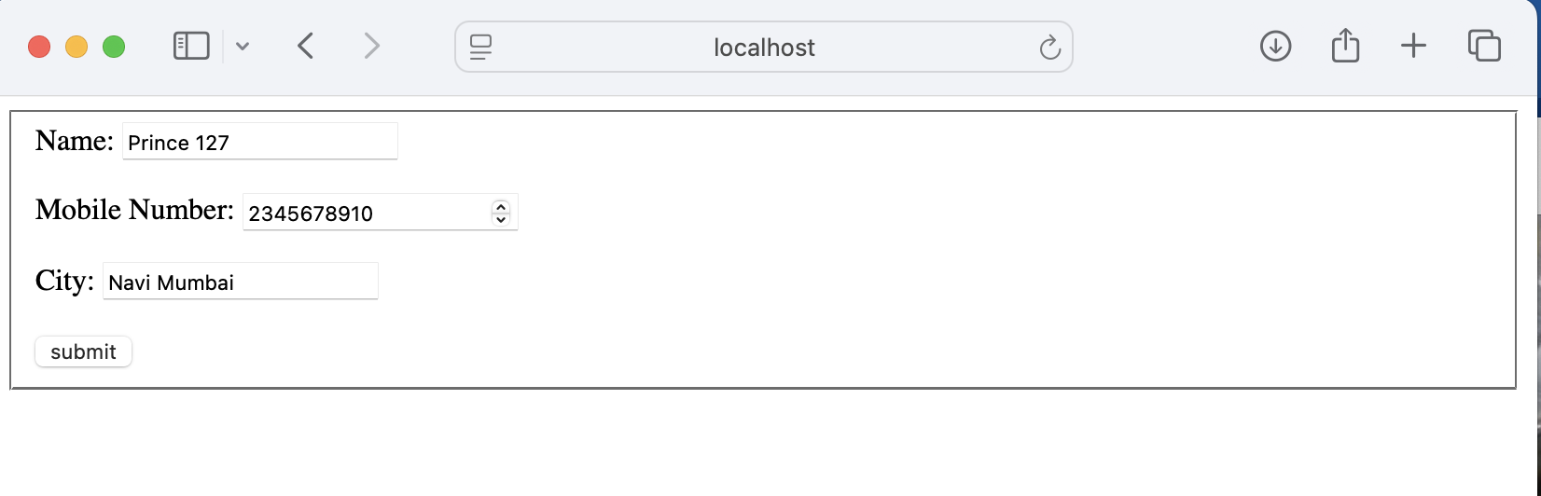
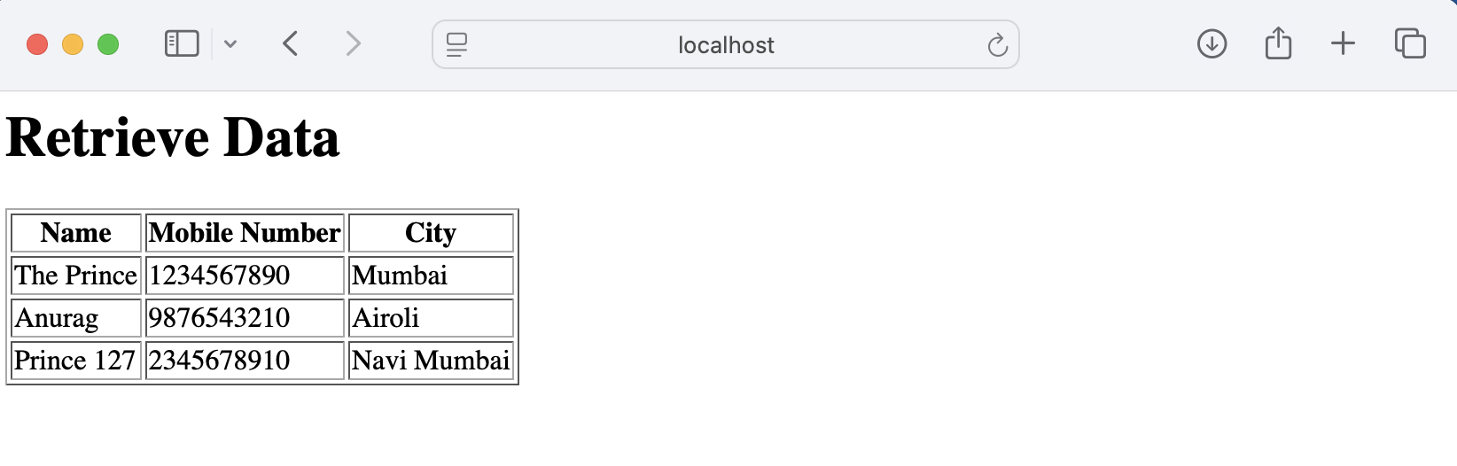

7. Write a program using JSP that displays a webpage consisting Application form for
change of Study Center which can be filled by any student who wants to change his/ her
study center. Make necessary assumptions.
Code:
CREATE DATABASE Formdb;
USE Formdb;
CREATE TABLE Reg (
first_name VARCHAR(25),
last_name VARCHAR(25),
username VARCHAR(30),
password VARCHAR(15),
address VARCHAR(40),
contact BIGINT
);
SELECT * FROM Reg;

Registrationform.html
<!DOCTYPE html>
<html>
<head>
<title>Change of Study Center</title>
</head>
<body>

<h1>Application Form for Change of Study Center</h1>

<form action="regaction.jsp" method="post">
<table border="1">
<tr>
<td>First Name</td>
<td><input type="text" name="first_name" required></td>
</tr>

<tr>
<td>Last Name</td>
<td><input type="text" name="last_name" required></td>
</tr>

<tr>
<td>User Name</td>
<td><input type="text" name="username" required></td>
</tr>

<tr>
<td>Password</td>
<td><input type="password" name="password" required></td>
</tr>

<tr>
<td>Address</td>
<td><input type="text" name="address" required></td>
</tr>

<tr>
<td>Contact No</td>
<td><input type="text" name="contact" required></td>
</tr>
</table>

<br>
<input type="submit" value="Submit Application">
</form>

</body>
</html>

regaction.jsp
<%@ page import="java.sql.*" %>
<!DOCTYPE html>
<html>
<head>
<title>Student Details</title>
</head>
<body>

<h1>Student Details</h1>

<table border="1">
<tr>
<th>First Name</th>
<th>Last Name</th>
<th>User Name</th>
<th>Address</th>
<th>Contact</th>
</tr>

<%
String first_name = request.getParameter("first_name");
String last_name = request.getParameter("last_name");
String username = request.getParameter("username");
String password = request.getParameter("password");
String address = request.getParameter("address");
String contact = request.getParameter("contact");

try {
Class.forName("com.mysql.cj.jdbc.Driver");

Connection con = DriverManager.getConnection(
"jdbc:mysql://localhost:3306/Formdb?useSSL=false&serverTimezone=UTC",
"root",
""
);
PreparedStatement ps = con.prepareStatement(
"INSERT INTO Reg VALUES (?,?,?,?,?,?)"
);

ps.setString(1, first_name);
ps.setString(2, last_name);
ps.setString(3, username);
ps.setString(4, password);
ps.setString(5, address);
ps.setString(6, contact);

ps.executeUpdate();

Statement st = con.createStatement();
ResultSet rs = st.executeQuery("SELECT * FROM Reg");

while(rs.next()) {
%>
<tr>
<td><%= rs.getString(1) %></td>
<td><%= rs.getString(2) %></td>
<td><%= rs.getString(3) %></td>
<td><%= rs.getString(5) %></td>
<td><%= rs.getString(6) %></td>
</tr>
<%
}
con.close();
}
catch(Exception e) {
out.println("Error : " + e);
}
%>

</table>

</body>
</html>

Output
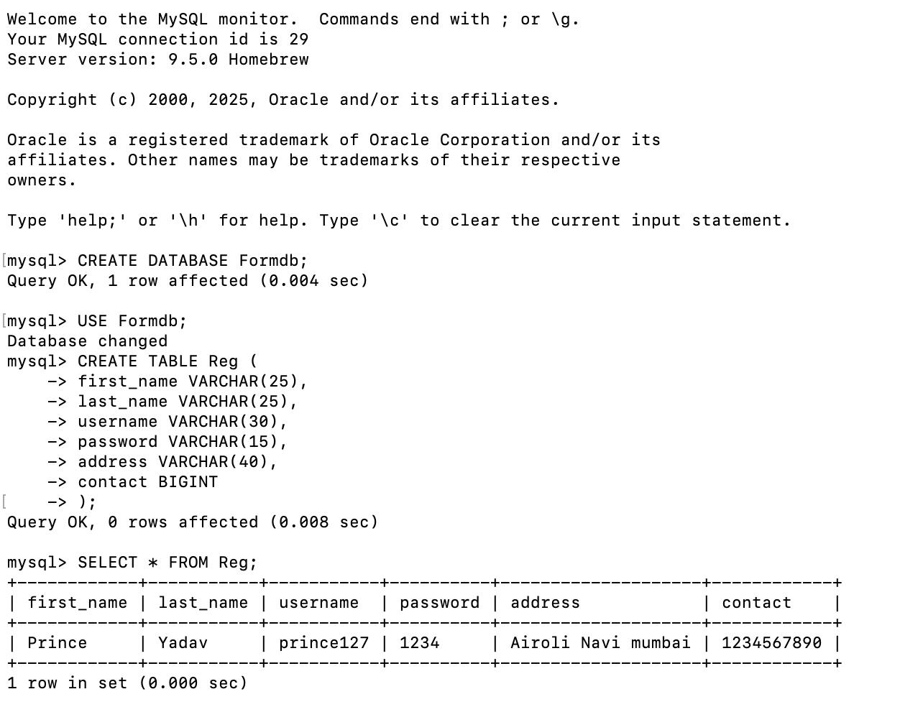
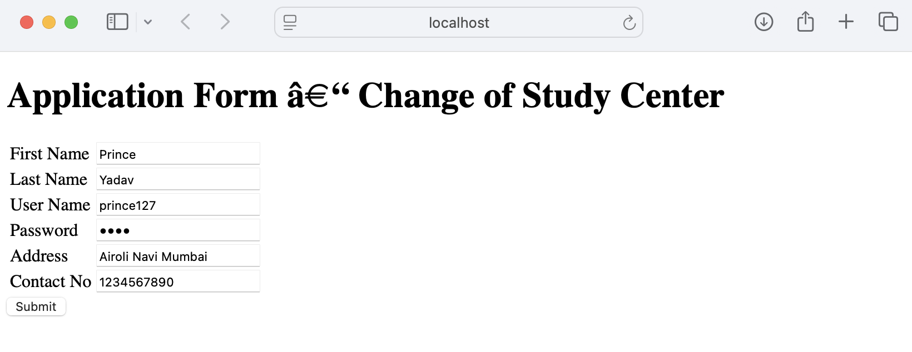
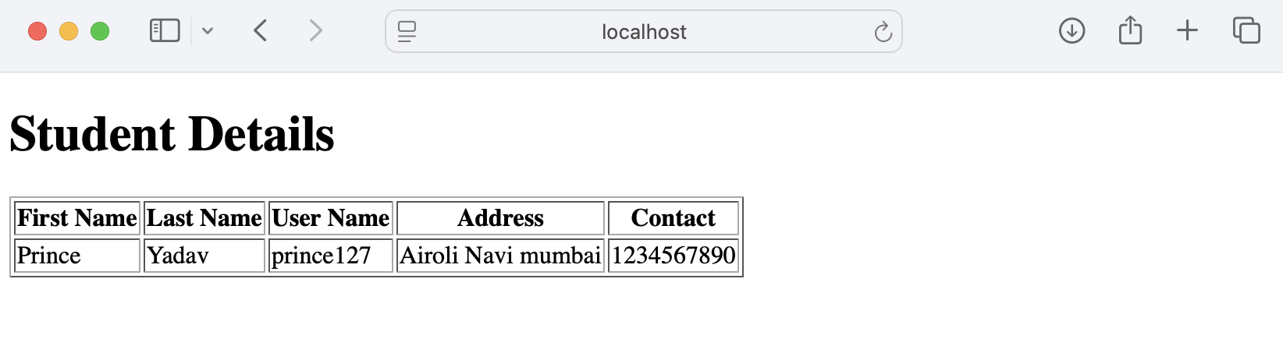

7) Assignment based Spring Framework.
1. Write a program to print Singer Name and Age using spring framework.
Code:
saap.xml
<?xml version="1.0" encoding="UTF-8"?>
<beans xmlns="http://www.springframework.org/schema/beans"
xmlns:xsi="http://www.w3.org/2001/XMLSchema-instance"
xsi:schemaLocation="
http://www.springframework.org/schema/beans
http://www.springframework.org/schema/beans/spring-beans.xsd">

<bean id="Singer" class="com.demo.Singer">
<property name="name" value="Prince Yadav"/>
<property name="age" value="23"/>
</bean>

</beans>

TestSinger.java
package com.demo;

import org.springframework.context.ApplicationContext;
import org.springframework.context.support.ClassPathXmlApplicationContext;

public class TestSinger {
public static void main(String[] args) {

ApplicationContext ctx =
new ClassPathXmlApplicationContext("saap.xml");

Singer s1 = (Singer) ctx.getBean("Singer");
s1.displayInfo();
}
}

Singer.java
package com.demo;

public class Singer {
String name;
int age;

public String getName() {
return name;
}

public void setName(String name) {
this.name = name;
}

public int getAge() {
return age;
}

public void setAge(int age) {
this.age = age;
}

void displayInfo() {
System.out.println("Name: " + name);
System.out.println("Age: " + age);
}
}

Output:
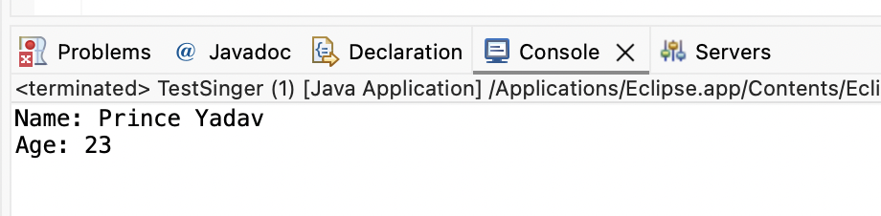

2. Write a program to demonstrate dependency injection via Constructor.(Primitive).
Appctx.xml
Code:
<?xml version="1.0" encoding="UTF-8"?>
<beans xmlns="http://www.springframework.org/schema/beans"
xmlns:xsi="http://www.w3.org/2001/XMLSchema-instance"
xsi:schemaLocation="
http://www.springframework.org/schema/beans
http://www.springframework.org/schema/beans/spring-beans.xsd">

<bean id="account" class="com.demo2.demo2.Account">
<constructor-arg index="0" value="127"/>
<constructor-arg index="1" value="Prince Yadav"/>
<constructor-arg index="2" value="100000"/>
</bean>

</beans>

Account.java
package com.demo2.demo2;

public class Account {
private int acNo;
private String acName;
private double acBalance;

// Constructor Injection
public Account(int acNo, String acName, double acBalance) {
this.acNo = acNo;
this.acName = acName;
this.acBalance = acBalance;
}

public int getAcNo() {
return acNo;
}

public String getAcName() {
return acName;
}

public double getAcBalance() {
return acBalance;
}
}

AccountTest.java
package com.demo2.demo2;

import org.springframework.context.ApplicationContext;
import org.springframework.context.support.ClassPathXmlApplicationContext;

public class AccountTest {

public static void main(String[] args) {

ApplicationContext ctx =
new ClassPathXmlApplicationContext("appctx.xml");

Account a1 = (Account) ctx.getBean("account");

System.out.println("Ac No : " + a1.getAcNo());
System.out.println("Ac Name : " + a1.getAcName());
System.out.println("Ac Balance : " + a1.getAcBalance());
}
}

Output:
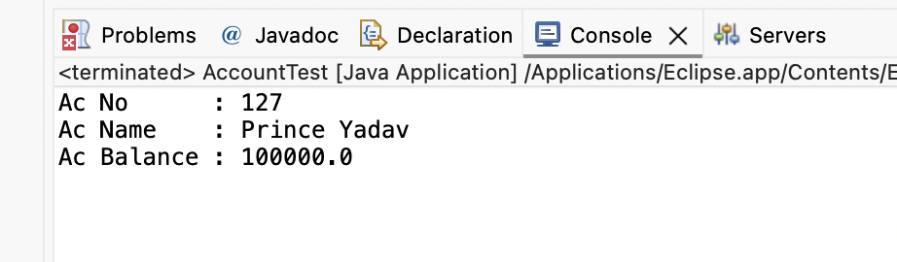

3. Write a program to demonstrate dependency injection via setter method.(Non Primitive)
Code:
Shape.java
package prince;

public interface Shape {
void show();
}

Circle.java
package prince;

public class Circle implements Shape {

@Override
public void show() {
System.out.println("I am Circle");
}
}

ShapeManager.java
package prince;

public class ShapeManager {

private Shape myShape;

public void show() {
this.myShape.show();
}

public Shape getMyShape() {
return myShape;
}

public void setMyShape(Shape myShape) {
this.myShape = myShape;
}
}

ShapeTest.java
package prince;

import org.springframework.context.ApplicationContext;
import org.springframework.context.support.ClassPathXmlApplicationContext;

public class ShapeTest {

public static void main(String[] args) {

ApplicationContext appCon =
new ClassPathXmlApplicationContext("Appctx3.xml");

ShapeManager factory =
(ShapeManager) appCon.getBean("ShapeMan");

factory.show();
}
}

Appctx3.xml
<?xml version="1.0" encoding="UTF-8"?>
<beans xmlns="http://www.springframework.org/schema/beans"
xmlns:xsi="http://www.w3.org/2001/XMLSchema-instance"
xsi:schemaLocation="
http://www.springframework.org/schema/beans
http://www.springframework.org/schema/beans/spring-beans.xsd">

<bean id="Circle" class="prince.Circle"/>

<bean id="ShapeMan" class="prince.ShapeManager">
<property name="myShape" ref="Circle"/>
</bean>

</beans>

Output
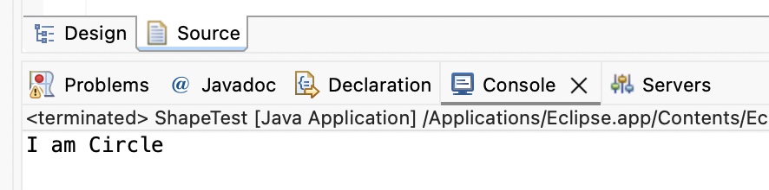
4.Write a program to demonstrate dependency injection via Constructor.(Non Primitive)By Ref.
Employee.java
package spring2;

public class Employee {
int id;
FullName name;

public Employee(int id, FullName name) {
this.id = id;
this.name = name;
}
void show() {
System.out.println("Id: " + id);
System.out.println("Full Name: " + name);
}
}

FullName.java
package spring2;
public class FullName {
private String fname;
private String mname;
private String lname;

public FullName(String fname, String mname, String lname) {
this.fname = fname;
this.mname = mname;
this.lname = lname;
}
@Override
public String toString() {
return fname + " " + mname + " " + lname;
}
}

apptcx1.xml
<?xml version="1.0" encoding="UTF-8"?>
<beans xmlns="http://www.springframework.org/schema/beans"
xmlns:xsi="http://www.w3.org/2001/XMLSchema-instance"
xsi:schemaLocation="
http://www.springframework.org/schema/beans
http://www.springframework.org/schema/beans/spring-beans.xsd">

<bean id="FullName" class="spring2.FullName">
<constructor-arg value="Prince"/>
<constructor-arg value="Harinath"/>
<constructor-arg value="Yadav"/>
</bean>

<bean id="Employee" class="spring2.Employee">
<constructor-arg value="1"/>
<constructor-arg ref="FullName"/>
</bean>

</beans>

EmpTest.java
package spring2;

import org.springframework.context.ApplicationContext;
import org.springframework.context.support.ClassPathXmlApplicationContext;

public class EmpTest {

public static void main(String[] args) {

ApplicationContext appCon =
new ClassPathXmlApplicationContext("appctx1.xml");

Employee factory =
(Employee) appCon.getBean("Employee");

factory.show();
}
}

Output:
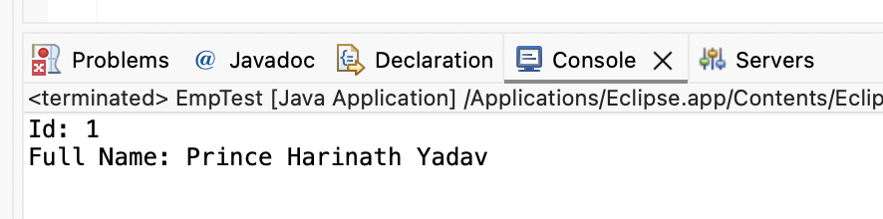

6. Write a program to demonstrate dependency injection via Constructor.(Collection ).
Movie.java
package spring4;

import java.util.List;

public class Movie {

private List<String> movies;

public List<String> getMovies() {
return movies;
}

public void setMovies(List<String> movies) {
this.movies = movies;
}

public void printMovies() {
System.out.println(this.movies);
}
}

Appctx4.xml
<?xml version="1.0" encoding="UTF-8"?>
<beans xmlns="http://www.springframework.org/schema/beans"
xmlns:xsi="http://www.w3.org/2001/XMLSchema-instance"
xsi:schemaLocation="
http://www.springframework.org/schema/beans
http://www.springframework.org/schema/beans/spring-beans.xsd">

<bean id="Movie" class="spring4.Movie">
<property name="movies">
<list>
<value>A Beautiful Mind</value>
<value>Inception</value>
<value>Cast Away</value>
</list>
</property>
</bean>

</beans>

MovieTest.java
package spring4;

import org.springframework.context.ApplicationContext;
import org.springframework.context.support.ClassPathXmlApplicationContext;

public class MovieTest {

public static void main(String[] args) {

ApplicationContext appCon =
new ClassPathXmlApplicationContext("Appctx4.xml");

Movie factory = (Movie) appCon.getBean("Movie");
factory.printMovies();
}
}

Output
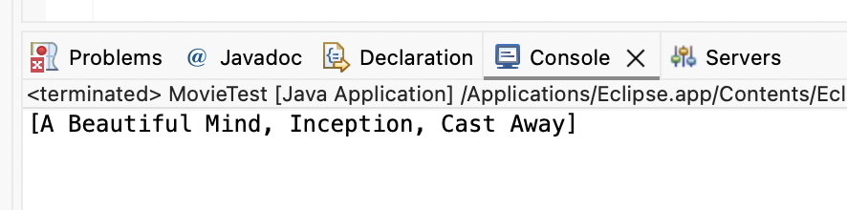

Practical No - 7
1) Write a program to print “Hello World” using spring framework.
Code:
HelloWorld.java
package com.example;
public class HelloWorld {
private String message;
public void setMessage(String message) {
this.message = message;
}
public void printMessage() {
System.out.println(message);
}
}

MainApp.java
package com.example;
import org.springframework.context.ApplicationContext;
import org.springframework.context.support.ClassPathXmlApplicationContext;
public class MainApp {
public static void main(String[] args) {
ApplicationContext context =
new ClassPathXmlApplicationContext("applicationContext.xml");
HelloWorld obj = (HelloWorld) context.getBean("helloBean");
obj.printMessage();
}
}

applicationContext.xml
<?xml version="1.0" encoding="UTF-8"?>
<beans xmlns="http://www.springframework.org/schema/beans"
xmlns:xsi="http://www.w3.org/2001/XMLSchema-instance"
xsi:schemaLocation="
http://www.springframework.org/schema/beans
https://www.springframework.org/schema/beans/spring-beans.xsd">
<bean id="helloBean" class="com.example.HelloWorld">
<property name="message" value="Hello World from Prince Yadav" />
</bean>

</beans>

Output
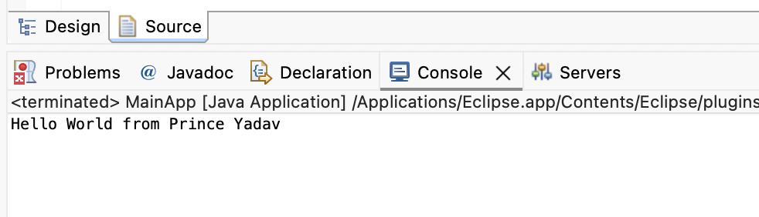

2) Write a program to demonstrate dependency injection via setter method
MessageService.java
package com.example;

public class MessageService {
public String getMessage() {
return "Hello from MessageService! (Prince Yadav 127)";
}
}
MessagePrinter.java
package com.example;

public class MessagePrinter {
private MessageService messageService;

public void setMessageService(MessageService messageService) {
this.messageService = messageService;
}

public void printMessage() {
System.out.println(messageService.getMessage());
}
}

applicationContent.xml
<?xml version="1.0" encoding="UTF-8"?>
<beans xmlns="http://www.springframework.org/schema/beans"
xmlns:xsi="http://www.w3.org/2001/XMLSchema-instance"
xsi:schemaLocation="
http://www.springframework.org/schema/beans
https://www.springframework.org/schema/beans/spring-beans.xsd">

<bean id="messageService" class="com.example.MessageService" />

<bean id="messagePrinter" class="com.example.MessagePrinter">
<property name="messageService" ref="messageService" />
</bean>

</beans>

MainApp.java
package com.example;

import org.springframework.context.ApplicationContext;
import org.springframework.context.support.ClassPathXmlApplicationContext;

public class MainApp {
public static void main(String[] args) {
ApplicationContext context =
new ClassPathXmlApplicationContext("applicationContext.xml");

MessagePrinter printer =
(MessagePrinter) context.getBean("messagePrinter");

printer.printMessage();
}
}

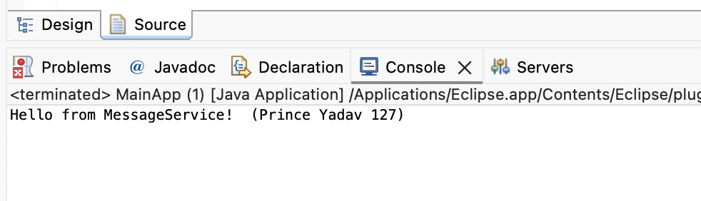

3) Write a program to demonstrate dependency injection via Constructor.
MessageService.java
package com.example;

public class MessageService {
public String getMessage() {
return "Hello from MessageService (Constructor Injection)! (Prince Yadavv 127)";
}
}

MessagePrinter.java
package com.example;

public class MessagePrinter {
private MessageService messageService;

// Constructor Injection
public MessagePrinter(MessageService messageService) {
this.messageService = messageService;
}

public void printMessage() {
System.out.println(messageService.getMessage());
}
}

applicationContent.xml
<?xml version="1.0" encoding="UTF-8"?>
<beans xmlns="http://www.springframework.org/schema/beans"
xmlns:xsi="http://www.w3.org/2001/XMLSchema-instance"
xsi:schemaLocation="
http://www.springframework.org/schema/beans
https://www.springframework.org/schema/beans/spring-beans.xsd">

<bean id="messageService" class="com.example.MessageService" />

<bean id="messagePrinter" class="com.example.MessagePrinter">
<constructor-arg ref="messageService" />
</bean>

</beans>

MainApp.java
package com.example;

import org.springframework.context.ApplicationContext;
import org.springframework.context.support.ClassPathXmlApplicationContext;

public class MainApp {
public static void main(String[] args) {
ApplicationContext context =
new ClassPathXmlApplicationContext("applicationContext.xml");

MessagePrinter printer =
(MessagePrinter) context.getBean("messagePrinter");

printer.printMessage();
}
}

Output:
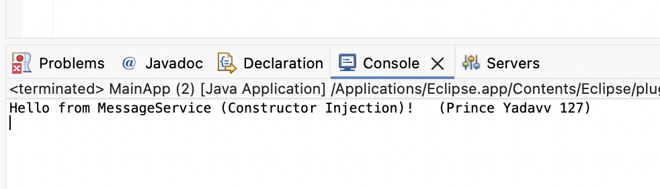

4) Write a program to demonstrate Autowiring.
MessageService.java
package com.example;

import org.springframework.stereotype.Component;

@Component
public class MessageService {
public String getMessage() {
return "Hello from MessageService (Autowiring)! (Prince Yadav 127)";
}
}

MessagePrinter.java
package com.example;
import org.springframework.beans.factory.annotation.Autowired;
import org.springframework.stereotype.Component;

@Component
public class MessagePrinter {

@Autowired
private MessageService messageService;

public void printMessage() {
System.out.println(messageService.getMessage());
}
}

applicationContent.java
<?xml version="1.0" encoding="UTF-8"?>
<beans xmlns="http://www.springframework.org/schema/beans"
xmlns:xsi="http://www.w3.org/2001/XMLSchema-instance"
xmlns:context="http://www.springframework.org/schema/context"
xsi:schemaLocation="
http://www.springframework.org/schema/beans
https://www.springframework.org/schema/beans/spring-beans.xsd
http://www.springframework.org/schema/context
https://www.springframework.org/schema/context/spring-context.xsd">

<context:component-scan base-package="com.example"/>

</beans>

MainApp.java
package com.example;

import org.springframework.context.ApplicationContext;
import org.springframework.context.support.ClassPathXmlApplicationContext;

public class MainApp {
public static void main(String[] args) {

ApplicationContext context =
new ClassPathXmlApplicationContext("applicationContext.xml");

MessagePrinter printer = context.getBean(MessagePrinter.class);
printer.printMessage();
}
}

Output:
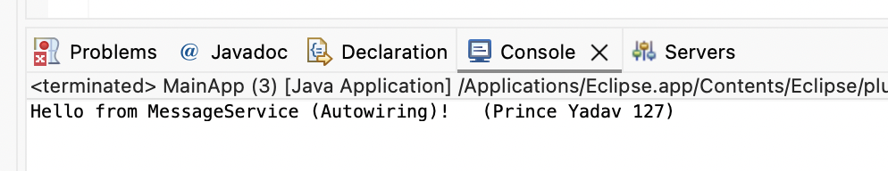

Practical No - 8
[A]Aim: Write a program to demonstrate Spring AOP – before advice.
pom.xml
<project xmlns="http://maven.apache.org/POM/4.0.0" xmlns:xsi="http://www.w3.org/2001/XMLSchema-instance" xsi:schemaLocation="http://maven.apache.org/POM/4.0.0
http://maven.apache.org/xsd/maven-4.0.0.xsd">
<modelVersion>4.0.0</modelVersion>
<groupId>com.springMca</groupId>
<artifactId>springMca</artifactId>
<version>0.0.1-SNAPSHOT</version>
<dependencies>
<dependency>
<groupId>org.springframework</groupId>
<artifactId>spring-core</artifactId>
<version>5.2.3.RELEASE</version>
</dependency>
<dependency>
<groupId>org.springframework</groupId>
<artifactId>spring-context</artifactId>
<version>5.2.3.RELEASE</version>
</dependency>
<dependency>
<groupId>org.springframework</groupId>
<artifactId>spring-aop</artifactId>
<version>5.2.3.RELEASE</version>
</dependency>
<dependency>
<groupId>org.aspectj</groupId>
<artifactId>aspectjrt</artifactId>
<version>1.9.7</version>
</dependency>
<dependency>
<groupId>org.aspectj</groupId>
<artifactId>aspectjweaver</artifactId>
<version>1.9.6</version>
</dependency>
</dependencies>
</project>

Interface - Guitar.java
package aop;
public interface Guitar {
public void makeSong();
}

Target Object - brook.java
package aop;
public class brook implements Guitar {
public void makeSong() {
System.out.println("Song Started");
System.out.println("Song Ended");
}
}

Aspect Class - mcaAspect.java
package aop;
import org.aspectj.lang.annotation.Aspect;
import org.aspectj.lang.annotation.Before;
@Aspect
public class mcaAspect {
@Before("execution(* aop.brook.makeSong())")
public void beforeSong() {
System.out.println("Yahoo Yahoo : I am Prince - before Aspect");
}
}

Configuration Class - aopConfig.xml
<?xml version="1.0" encoding="UTF-8"?>
<beans xmlns="http://www.springframework.org/schema/beans"
xmlns:xsi="http://www.w3.org/2001/XMLSchema-instance"
xmlns:aop="http://www.springframework.org/schema/aop"
xsi:schemaLocation="
http://www.springframework.org/schema/beans
http://www.springframework.org/schema/beans/spring-beans.xsd
http://www.springframework.org/schema/aop
http://www.springframework.org/schema/aop/spring-aop.xsd">
<aop:aspectj-autoproxy />
<bean id="brook" class="aop.brook"/>
<bean id="mcaaspect" class="aop.mcaAspect"/>
</beans>

Main Class - App.java
package aop;
import org.springframework.context.ApplicationContext;
import org.springframework.context.support.ClassPathXmlApplicationContext;
public class App {
public static void main(String[] args) {
ApplicationContext context =
new ClassPathXmlApplicationContext("aopConfig.xml");
Guitar g = (Guitar) context.getBean("brook");
g.makeSong();
}
}

Output:
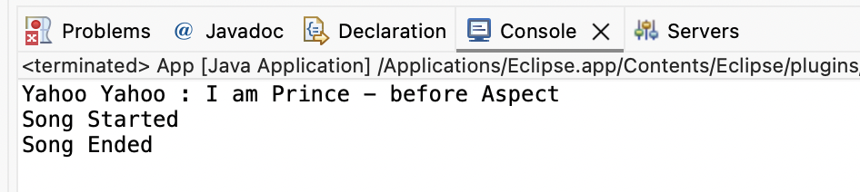

[B]Aim: Write a program to demonstrate Spring AOP – after advice
Aspect Class – mcaAspect.java
package aop;

import org.aspectj.lang.annotation.After;
import org.aspectj.lang.annotation.Aspect;

@Aspect
public class mcaAspect {

@After("execution(* aop.brook.makeSong())")
public void afterSong() {
System.out.println("Yahoo Yahoo : I am Prince - After Aspect");
}
}

Output:
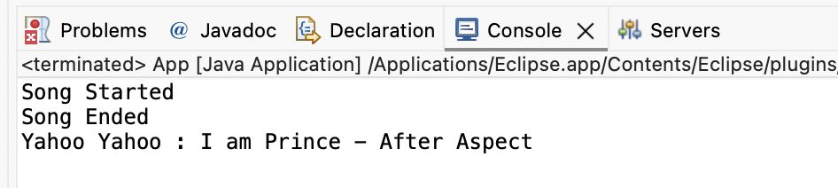

[C]Aim: Write a program to demonstrate Spring AOP– around advice.
Aspect Class – mcaAspect.java
package aop;

import org.aspectj.lang.annotation.Around;
import org.aspectj.lang.annotation.Aspect;

@Aspect
public class mcaAspect {

@Around("execution(* aop.brook.makeSong())")
public void aroundSong() {
System.out.println("Yahoo Yahoo : Around Aspect");

}
}

Output:
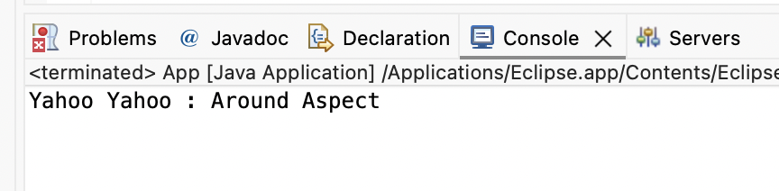

[D]Aim: Write a program to demonstrate Spring AOP – after returning advice.
Aspect Class – mcaAspect.java
package aop;

import org.aspectj.lang.annotation.AfterReturning;
import org.aspectj.lang.annotation.Aspect;

@Aspect
public class mcaAspect {

@AfterReturning("execution(* aop.brook.makeSong())")
public void afterReturnSong() {
System.out.println("Yahoo Yahoo : After Returning Aspect");
}
}

Output:
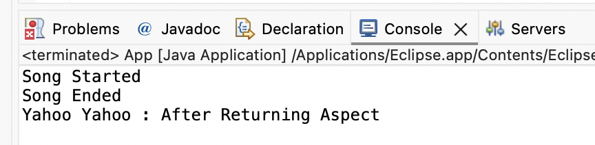

[E]Aim: Write a program to demonstrate Spring AOP – after throwing advice.
Aspect Class – mcaAspect.java
package aop;
import org.aspectj.lang.annotation.AfterThrowing;
import org.aspectj.lang.annotation.Aspect;
import org.aspectj.lang.annotation.Pointcut;

@Aspect
public class mcaAspect {

@Pointcut("execution(* aop.brook.makeSong(..))")
private void selectAll() {}

@AfterThrowing(pointcut = "selectAll()", throwing = "error")
public void afterThrowingAdvice(IllegalArgumentException error) {

System.out.println("Yahoo Yahoo : There has been an exception");
System.out.println("Exception message: " + error.getMessage());
}
}

Target Class – brook.java
package aop;
public class brook implements Guitar {

public void makeSong() {

System.out.println("Song Started");
System.out.println("Song Ended");
// Force an exception
throw new IllegalArgumentException(
"An error occurred while making the song");
}
}

Output:
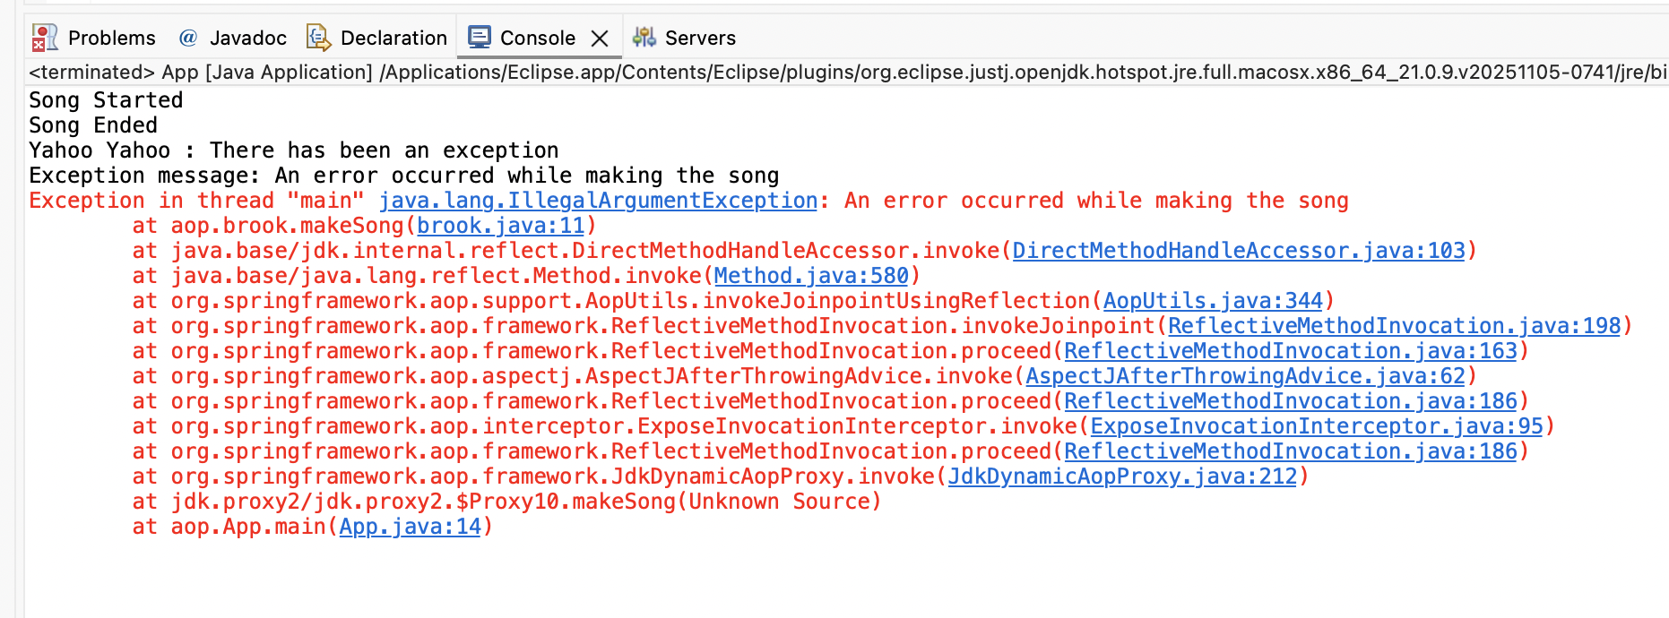

[F]Aim: Write a program to demonstrate Spring AOP – pointcuts.
Aspect Class – mcaAspect.java
package aop;

import org.aspectj.lang.annotation.AfterReturning;
import org.aspectj.lang.annotation.Aspect;
import org.aspectj.lang.annotation.Pointcut;

@Aspect
public class mcaAspect {

// Pointcut definition (NO body)
@Pointcut("execution(* aop.brook.makeSong())")
public void songPointCut() {}

// Advice using pointcut
@AfterReturning("songPointCut()")
public void afterSong() {
System.out.println("Yahoo Yahoo : Used By Pointcut");
}
}

Output:
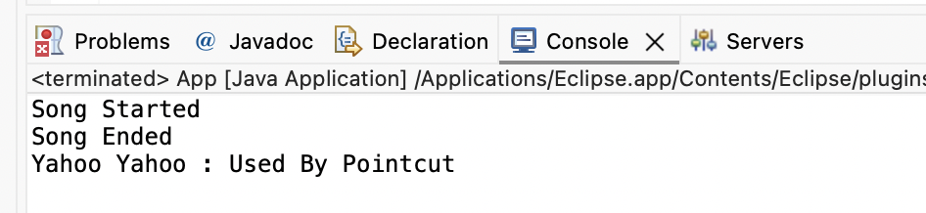

Practical No - 9
Aim: Assignment based Spring JDBC.
Q.1Write a program to insert, update and delete records from the given table.
Student.java
package experiment8;
public class Student {
private int id;
private String name;
private int age;
// Parameterized constructor
public Student(int id, String name, int age) {
this.id = id;
this.name = name;
this.age = age;
}
// Getters and setters
public int getId() {
return id;
}
public void setId(int id) {
this.id = id;
}
public String getName() {
return name;
}
public void setName(String name) {
this.name = name;
}
public int getAge() {
return age;
}
public void setAge(int age) {
this.age = age;
}
// Display method
public void show() {
System.out.println("Id = " + id + ", Name = " + name + ", Age = " + age);
}
}

StudentDao.java
package experiment8;
import experiment8.Student;
public interface StudentDao {
public int save(Student s) throws Exception;
public int update(Student s) throws Exception;
public int delete(int id) throws Exception;
}

Studentdaoimpl.java
package experiment8;
import java.sql.Connection;
import java.sql.PreparedStatement;
import javax.sql.DataSource;
public class Studentdaoimpl implements StudentDao {
private DataSource ds;
private Connection con;
public void setDs(DataSource ds) {
this.ds = ds;
}
@Override
public int save(Student s) throws Exception {
con = ds.getConnection();
String sql = "insert into student values(?,?,?)";
PreparedStatement ps = con.prepareStatement(sql);
ps.setInt(1, s.getId());
ps.setString(2, s.getName());
ps.setInt(3, s.getAge());
return ps.executeUpdate();
}
@Override
public int update(Student s) throws Exception {
con = ds.getConnection();
String sql = "update student set name=?, age=? where id=?";
PreparedStatement ps = con.prepareStatement(sql);
ps.setString(1, s.getName());
ps.setInt(2, s.getAge());
ps.setInt(3, s.getId());
return ps.executeUpdate();
}
@Override
public int delete(int id) throws Exception {
con = ds.getConnection();
String sql = "delete from student where id=?";
PreparedStatement ps = con.prepareStatement(sql);
ps.setInt(1, id);
return ps.executeUpdate();
}
}

Appconfig.xml
<?xml version="1.0" encoding="UTF-8"?>
<beans xmlns="http://www.springframework.org/schema/beans"
xmlns:xsi="http://www.w3.org/2001/XMLSchema-instance"
xsi:schemaLocation="
http://www.springframework.org/schema/beans
http://www.springframework.org/schema/beans/spring-beans.xsd">

<bean id="bds"
class="org.springframework.jdbc.datasource.DriverManagerDataSource">
<property name="driverClassName" value="com.mysql.cj.jdbc.Driver"/>
<property name="url"
value="jdbc:mysql://localhost:3306/student?useSSL=false&amp;serverTimezone=UTC"/>
<property name="username" value="root"/>
<property name="password" value=""/>
</bean>

<bean id="dao" class="experiment8.Studentdaoimpl">
<property name="ds" ref="bds"/>
</bean>

</beans>

Test.java
package experiment8;
import org.springframework.context.ApplicationContext;
import org.springframework.context.support.ClassPathXmlApplicationContext;
public class Test {
public static void main(String[] args) throws Exception {
// Load Spring configuration file
ApplicationContext ac =
new ClassPathXmlApplicationContext("appConfig.xml");
// Get DAO bean (use interface reference)
StudentDao dao = (StudentDao) ac.getBean("dao");
// Create Student objects
Student s1 = new Student(18, "Prince", 21);
Student s2 = new Student(45, "Dheeraj", 22);
Student s3 = new Student(15, "Ganesh", 23);
// Insert records
int check1 = dao.save(s1);
int check2 = dao.save(s2);
int check3 = dao.save(s3);
System.out.println("\nChecking if inserted?");
System.out.println((check1 > 0) ? "1st Record Inserted" : "1st Record Not Inserted");
System.out.println((check2 > 0) ? "2nd Record Inserted" : "2nd Record Not Inserted");
System.out.println((check3 > 0) ? "3rd Record Inserted" : "3rd Record Not Inserted");
// Update records
s1.setName("Dheeraj");
s2.setName("Abhi");
s3.setName("Prince");
int update1 = dao.update(s1);
int update2 = dao.update(s2);
int update3 = dao.update(s3);
System.out.println("\nChecking if updated?");
System.out.println((update1 > 0) ? "1st Record Updated" : "1st Record Not Updated");
System.out.println((update2 > 0) ? "2nd Record Updated" : "2nd Record Not Updated");
System.out.println((update3 > 0) ? "3rd Record Updated" : "3rd Record Not Updated");
// Delete record
int delete1 = dao.delete(45);
int delete2 = dao.delete(45);
System.out.println("\nChecking if deleted?");
System.out.println((delete1 > 0) ? "1st Record Deleted" : "1st Record Not Deleted");
System.out.println((delete2 > 0) ? "2nd Record Deleted" : "2nd Record Not Deleted");
}
}

Output
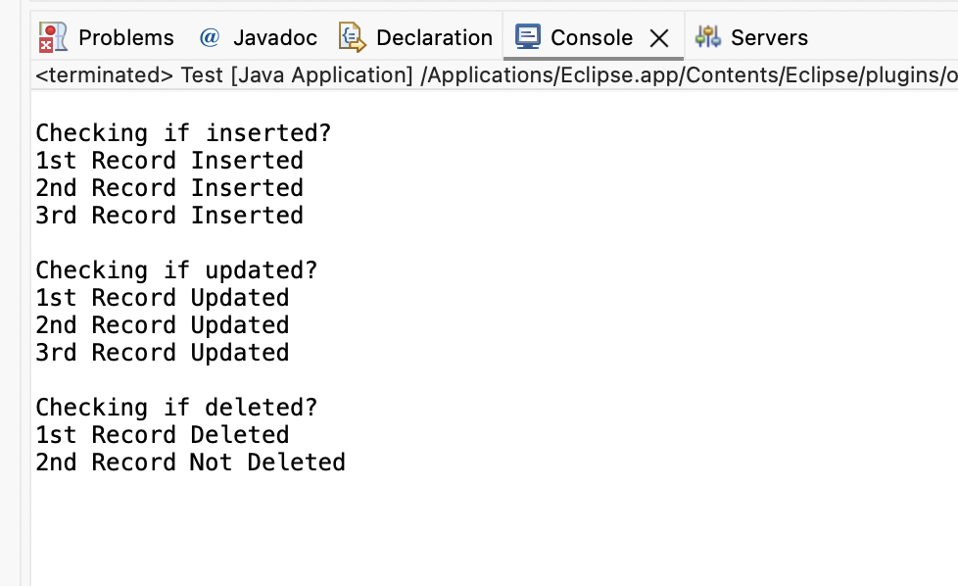
OUTPUT: Before and after insertion of data
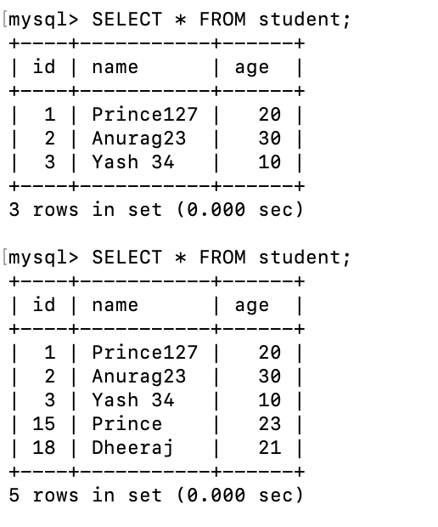

2. Write a program to demonstrate Prepared Statement in Spring Jdbc Template.
Code:
Employee.java
package spring;
public class Employee {
private int id;
private String name;
private float salary;
// Parameterized constructor
public Employee(int id, String name, float salary) {
this.id = id;
this.name = name;
this.salary = salary;
}
// Getters & Setters
public int getId() {
return id;
}
public void setId(int id) {
this.id = id;
}
public String getName() {
return name;
}
public void setName(String name) {
this.name = name;
}
public float getSalary() {
return salary;
}
public void setSalary(float salary) {
this.salary = salary;
}
// Display method
public void show() {
System.out.println("Employee [id=" + id + ", name=" + name + ", salary=" + salary + "]");
}
}

EmployeeDao.java
package spring;

public interface EmployeeDao {

int saveEmployee(Employee e);

int updateEmployee(Employee e);
}

EmployeeDaoImpl.java
package spring;
import java.sql.PreparedStatement;
import java.sql.SQLException;
import org.springframework.dao.DataAccessException;
import org.springframework.jdbc.core.JdbcTemplate;
import org.springframework.jdbc.core.PreparedStatementCallback;

public class EmployeeDaoImpl implements EmployeeDao {
private JdbcTemplate jdbcTemplate;
// Setter Injection (IMPORTANT: name must be jdbcTemplate)
public void setJdbcTemplate(JdbcTemplate jdbcTemplate) {
this.jdbcTemplate = jdbcTemplate;
}

// INSERT using PreparedStatement
@Override
public int saveEmployee(Employee e) {
String query = "insert into employee values(?,?,?)";

return jdbcTemplate.execute(query,
new PreparedStatementCallback<Integer>() {

@Override
public Integer doInPreparedStatement(PreparedStatement ps)
throws SQLException, DataAccessException {

ps.setInt(1, e.getId());
ps.setString(2, e.getName());
ps.setFloat(3, e.getSalary());

return ps.executeUpdate();
}
});
}
// UPDATE using PreparedStatement
@Override
public int updateEmployee(Employee e) {
String query = "update employee set name=?, salary=? where id=?";

return jdbcTemplate.execute(query,
new PreparedStatementCallback<Integer>() {

@Override
public Integer doInPreparedStatement(PreparedStatement ps)
throws SQLException, DataAccessException {

ps.setString(1, e.getName());
ps.setFloat(2, e.getSalary());
ps.setInt(3, e.getId());

return ps.executeUpdate();
}
});
}
}

applicationContext.xml
<?xml version="1.0" encoding="UTF-8"?>
<beans xmlns="http://www.springframework.org/schema/beans"
xmlns:xsi="http://www.w3.org/2001/XMLSchema-instance"
xsi:schemaLocation="
http://www.springframework.org/schema/beans
http://www.springframework.org/schema/beans/spring-beans.xsd">

<!-- DataSource Bean -->
<bean id="ds"
class="org.springframework.jdbc.datasource.DriverManagerDataSource">
<property name="driverClassName" value="com.mysql.cj.jdbc.Driver"/>
<property name="url" value="jdbc:mysql://localhost:3306/employee"/>
<property name="username" value="root"/>
<property name="password" value=""/>
</bean>
<!-- JdbcTemplate Bean -->
<bean id="jdbcTempl"
class="org.springframework.jdbc.core.JdbcTemplate">
<property name="dataSource" ref="ds"/>
</bean>

<!-- DAO Bean -->
<bean id="edao" class="spring.EmployeeDaoImpl">
<property name="jdbcTemplate" ref="jdbcTempl"/>
</bean>
</beans>
<?xml version="1.0" encoding="UTF-8"?>
<beans xmlns="http://www.springframework.org/schema/beans"
xmlns:xsi="http://www.w3.org/2001/XMLSchema-instance"
xsi:schemaLocation="
http://www.springframework.org/schema/beans
http://www.springframework.org/schema/beans/spring-beans.xsd">

<!-- DataSource Bean -->
<bean id="ds"
class="org.springframework.jdbc.datasource.DriverManagerDataSource">
<property name="driverClassName" value="com.mysql.cj.jdbc.Driver"/>
<property name="url" value="jdbc:mysql://localhost:3306/employee"/>
<property name="username" value="root"/>
<property name="password" value=""/>
</bean>
<!-- JdbcTemplate Bean -->
<bean id="jdbcTempl"
class="org.springframework.jdbc.core.JdbcTemplate">
<property name="dataSource" ref="ds"/>
</bean>

<!-- DAO Bean -->
<bean id="edao" class="spring.EmployeeDaoImpl">
<property name="jdbcTemplate" ref="jdbcTempl"/>
</bean>
</beans>

Employee_Test.java
package spring;
import org.springframework.context.ApplicationContext;
import org.springframework.context.support.ClassPathXmlApplicationContext;

public class Employee_Test {
public static void main(String[] args) {
// Load Spring configuration file
ApplicationContext ctx =
new ClassPathXmlApplicationContext("applicationContext.xml");

EmployeeDao dao = (EmployeeDao) ctx.getBean("edao");
// Insert records
int insert1 = dao.saveEmployee(new Employee(101, "Prince", 45000));
int insert2 = dao.saveEmployee(new Employee(102, "Dheeraj", 35000));
System.out.println("\nChecking if record inserted?");
System.out.println(insert1 > 0 ? "1st Record Inserted" : "1st Record Not Inserted");
System.out.println(insert2 > 0 ? "2nd Record Inserted" : "2nd Record Not Inserted");

// Update records
int update1 = dao.updateEmployee(new Employee(101, "Prince 127", 40000));
int update2 = dao.updateEmployee(new Employee(102, "Dheeraj 307", 30000));

System.out.println("\nChecking if record updated?");
System.out.println(update1 > 0 ? "1st Record Updated" : "1st Record Not Updated");
System.out.println(update2 > 0 ? "2nd Record Updated" : "2nd Record Not Updated");
}
}

Output:
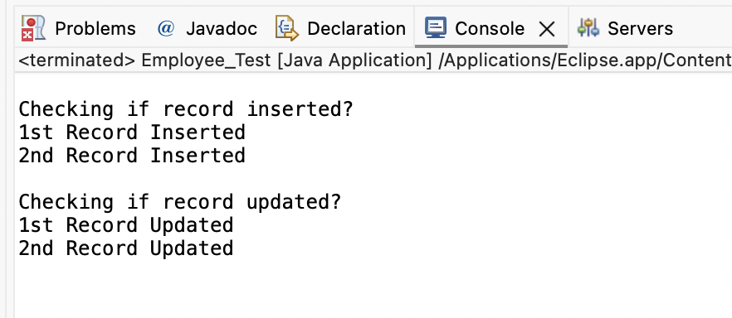
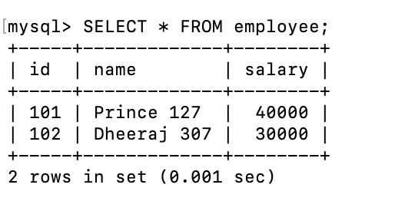

Practical - 10
Aim: Write a program to create a simple Spring Boot application that prints a message.
Step1:
Go to Spring Initializer.
Select the type of project (Maven).
Choose the language (Java).
Select the Spring Boot version.
Fillin the project metadata.
Add the necessary dependencies (at least spring- boot- starter-web).
Click on “Generate” to download the project.
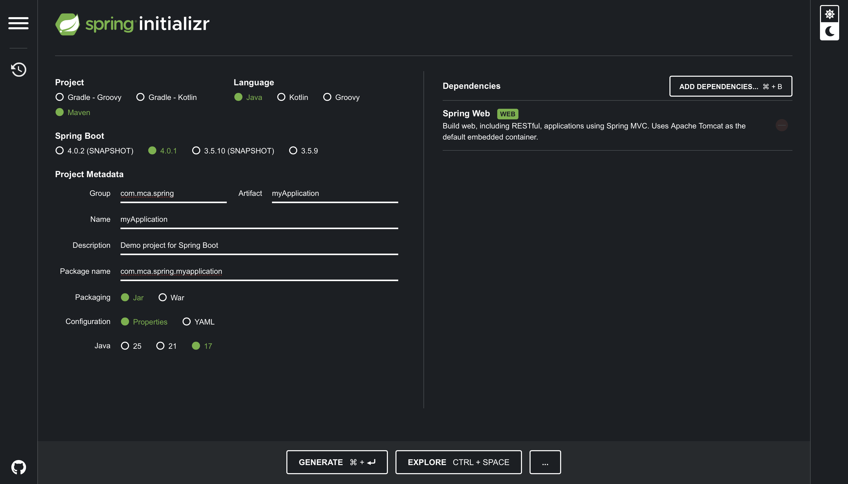
Step2:
Open Eclipse IDE.
Navigate to File;
Import.
Select “Existing Maven Projects”.
Click on “Next”.
Click on “Browse” and navigate to the location where you downloaded the project.
Make sure the pom.xml file is checked. Click on “Finish”.
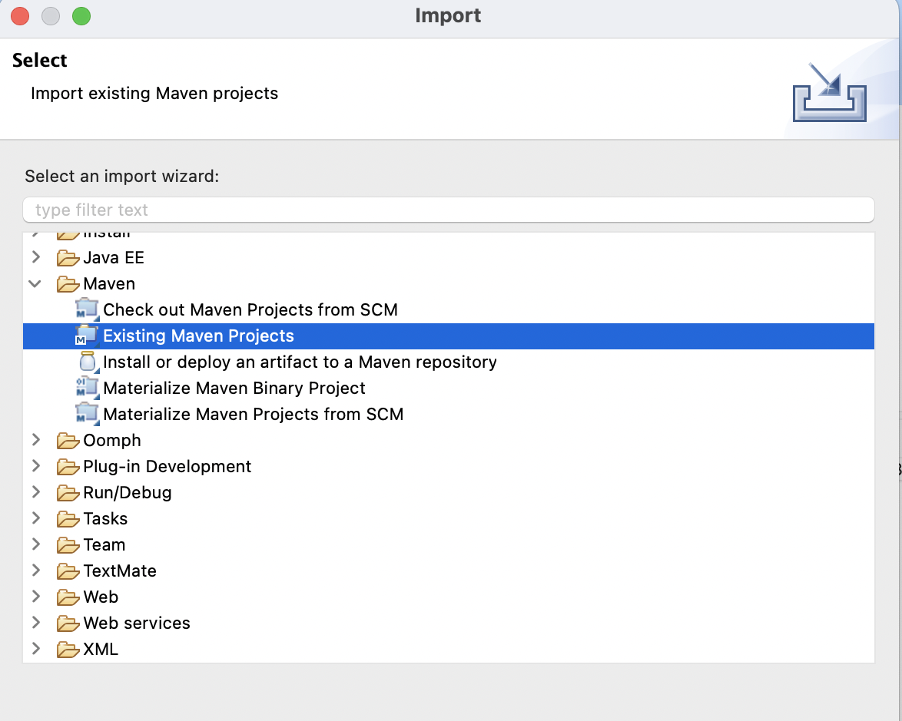
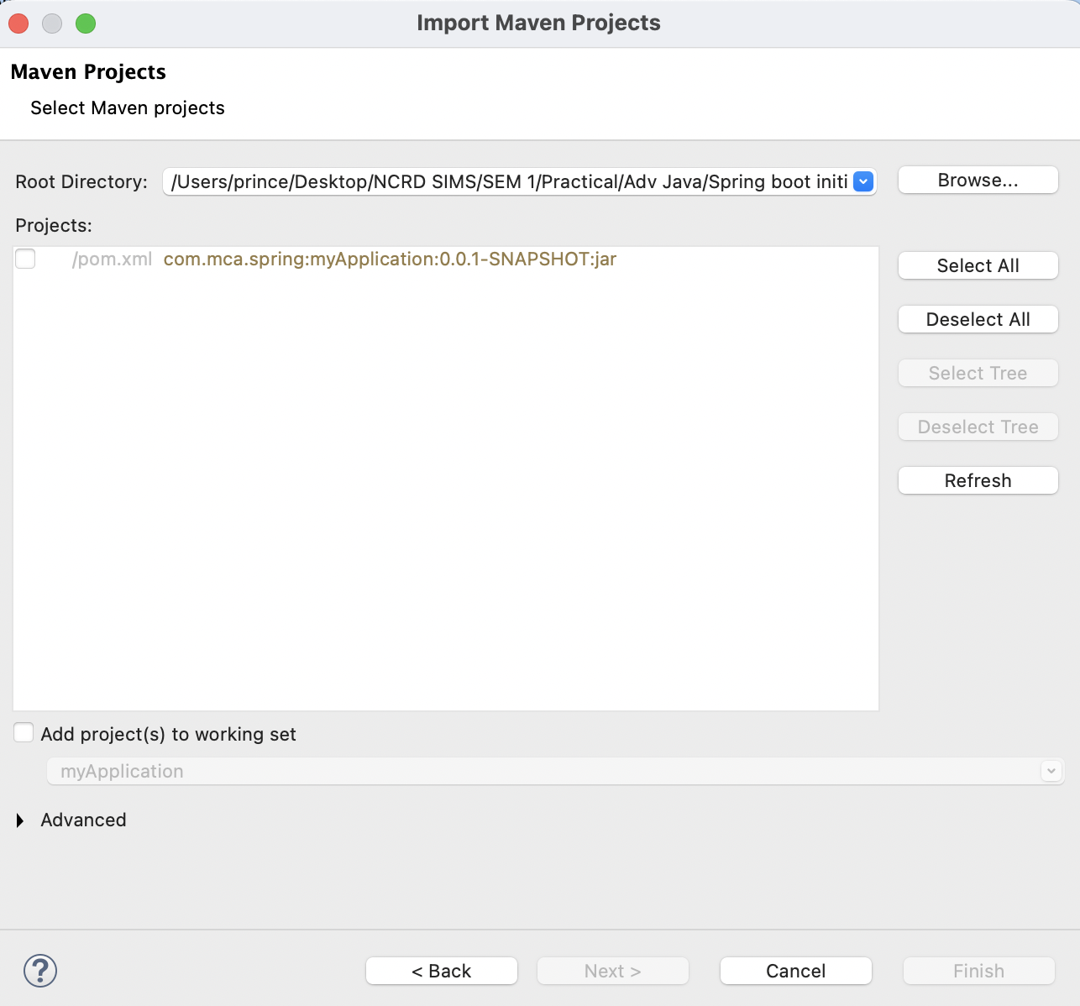
Main Class – MyApplication.java
package com.mca.spring.myapplication;
import org.springframework.boot.SpringApplication;
import org.springframework.boot.autoconfigure.SpringBootApplication;
import org.springframework.web.bind.annotation.GetMapping;
import org.springframework.web.bind.annotation.RestController;

@SpringBootApplication
@RestController
public class MyApplication {

public static void main(String[] args) {
SpringApplication.run(MyApplication.class, args);
}

@GetMapping("/")
public String quote() {
return "Prince Yadav - Hero? No! We’re pirates! I love heroes, but I don’t wanna be one!";
}
}

Output
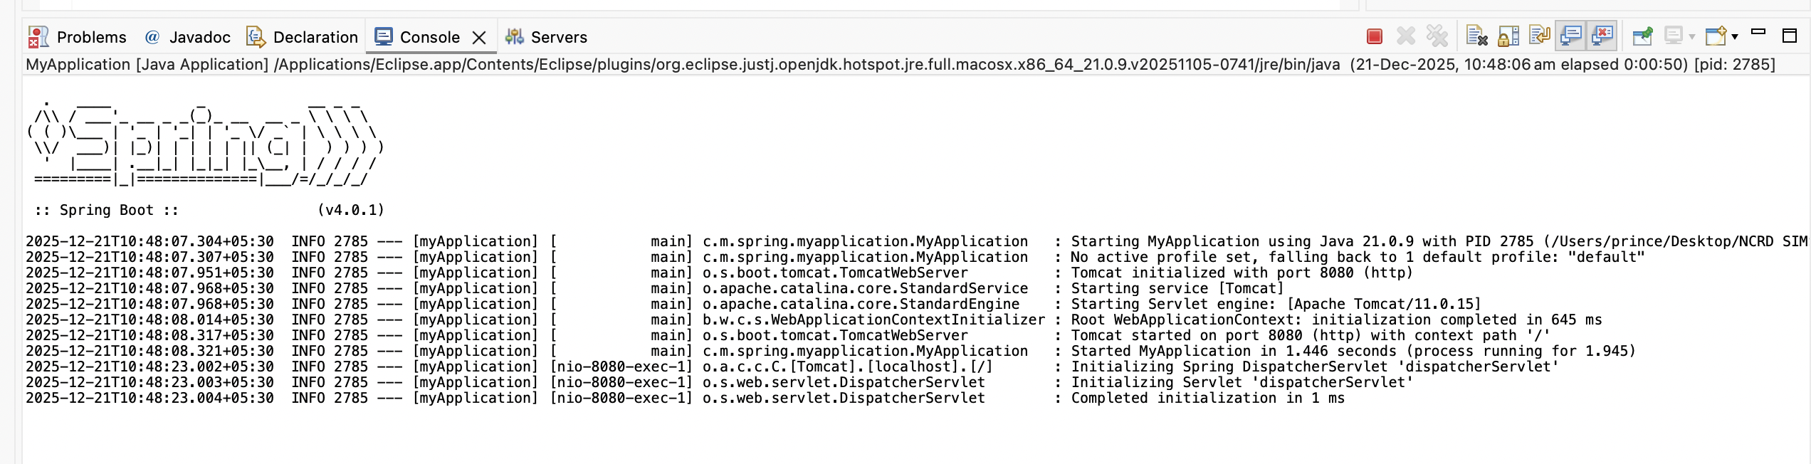
http://localhost:8080
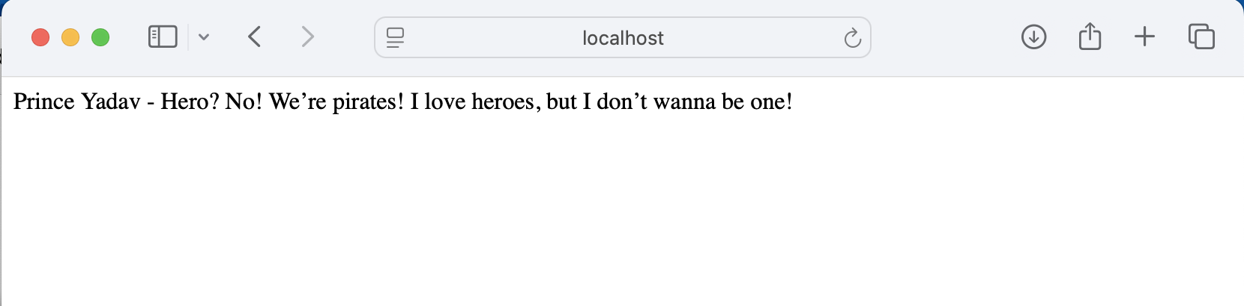

2 - Write a program to demonstrate RESTful Web Services with spring boot.
pom.xml
<?xml version="1.0" encoding="UTF-8"?>
<project xmlns="http://maven.apache.org/POM/4.0.0"
xmlns:xsi="http://www.w3.org/2001/XMLSchema-instance"
xsi:schemaLocation="http://maven.apache.org/POM/4.0.0
https://maven.apache.org/xsd/maven-4.0.0.xsd">

<modelVersion>4.0.0</modelVersion>

<parent>
<groupId>org.springframework.boot</groupId>
<artifactId>spring-boot-starter-parent</artifactId>
<version>3.2.0</version>
<relativePath/>
</parent>

<groupId>com.example</groupId>
<artifactId>demo</artifactId>
<version>0.0.1-SNAPSHOT</version>
<name>demo</name>
<description>Demo project for Spring Boot REST</description>

<properties>
<java.version>17</java.version>
</properties>

<dependencies>
<!-- Spring Boot REST / Web -->
<dependency>
<groupId>org.springframework.boot</groupId>
<artifactId>spring-boot-starter-web</artifactId>
</dependency>
</dependencies>

<build>
<plugins>
<plugin>
<groupId>org.springframework.boot</groupId>
<artifactId>spring-boot-maven-plugin</artifactId>
</plugin>
</plugins>
</build>

</project>

Main Application Class - DemoApplicationTests.java
package com.example.demo;

import org.springframework.boot.SpringApplication;
import org.springframework.boot.autoconfigure.SpringBootApplication;

@SpringBootApplication
public class DemoApplicationTests {

public static void main(String[] args) {
SpringApplication.run(DemoApplicationTests.class, args);
}
}

Model Class - Student.java
package com.example.demo.model;

public class Student {

private int id;
private String name;
private String course;

public Student() {
}

public Student(int id, String name, String course) {
this.id = id;
this.name = name;
this.course = course;
}

public int getId() {
return id;
}

public void setId(int id) {
this.id = id;
}

public String getName() {
return name;
}

public void setName(String name) {
this.name = name;
}

public String getCourse() {
return course;
}

public void setCourse(String course) {
this.course = course;
}
}

REST Controller - StudentController.java
package com.example.demo.controller;

import com.example.demo.model.Student;
import org.springframework.web.bind.annotation.*;

import java.util.ArrayList;
import java.util.List;

@RestController
@RequestMapping("/students")
public class StudentController {

private List<Student> students = new ArrayList<>();

// GET all students
@GetMapping
public List<Student> getAllStudents() {
return students;
}

// GET student by ID
@GetMapping("/{id}")
public Student getStudentById(@PathVariable int id) {
return students.stream()
.filter(student -> student.getId() == id)
.findFirst()
.orElse(null);
}
// POST - add student
@PostMapping
public String addStudent(@RequestBody Student student) {
students.add(student);
return "Student added successfully";
}
// PUT - update student
@PutMapping("/{id}")
public String updateStudent(@PathVariable int id, @RequestBody Student student) {
for (Student s : students) {
if (s.getId() == id) {
s.setName(student.getName());
s.setCourse(student.getCourse());
return "Student updated successfully";
}
}
return "Student not found";
}

// DELETE - remove student
@DeleteMapping("/{id}")
public String deleteStudent(@PathVariable int id) {
students.removeIf(student -> student.getId() == id);
return "Student deleted successfully";
}
}

Output:
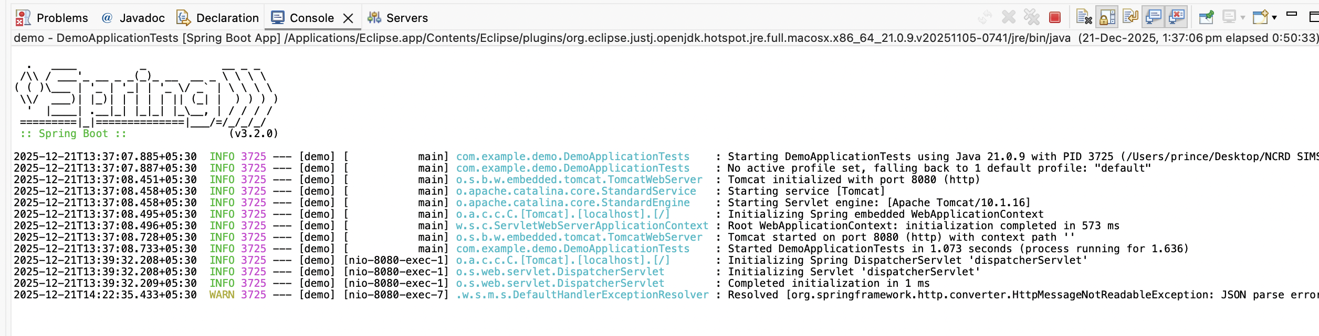
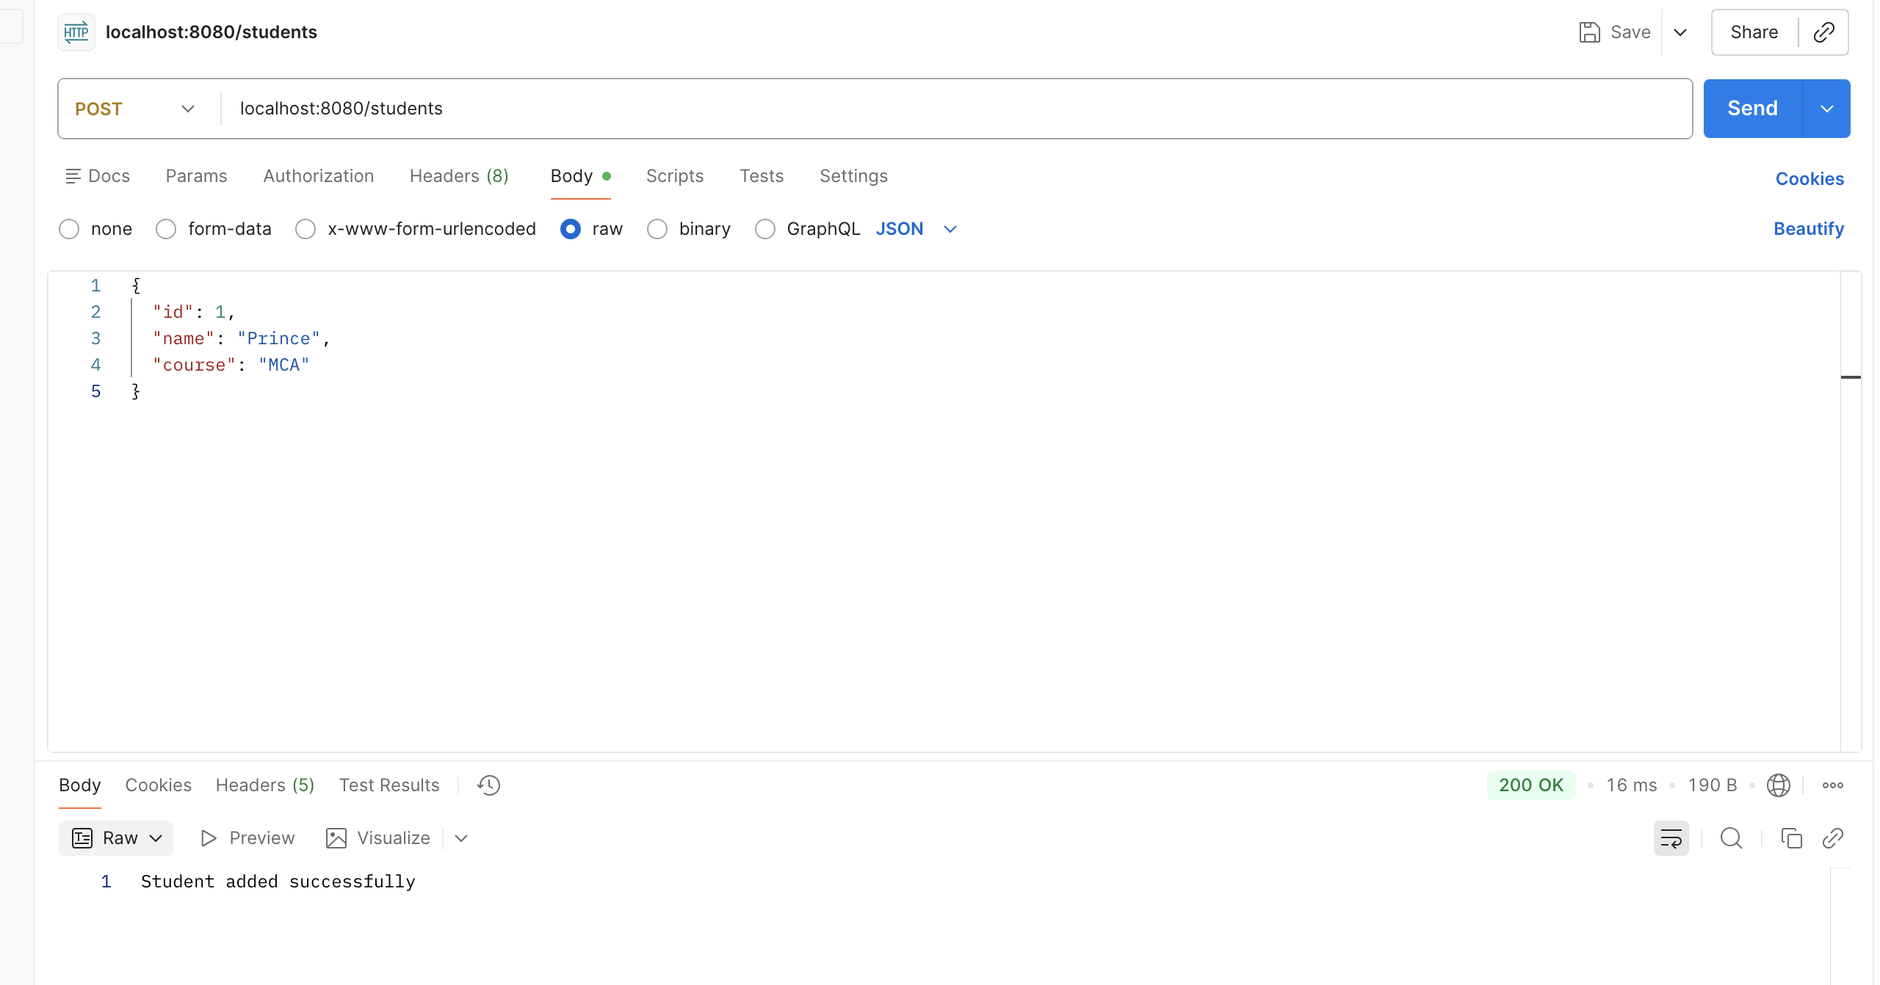

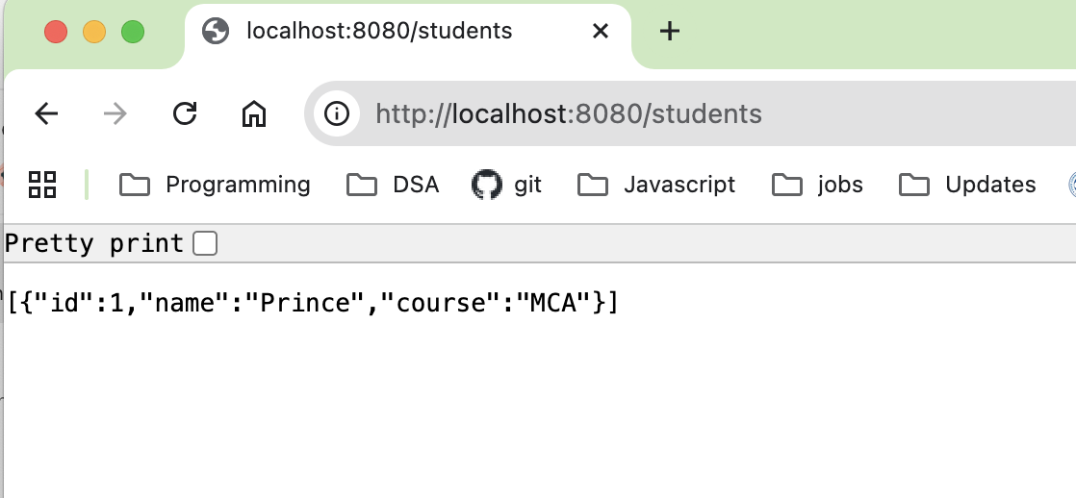

3. Write a program to demonstrate Database Connection with spring.
Database Table:
CREATE DATABASE testdb;
USE testdb;

CREATE TABLE user (
id INT PRIMARY KEY,
name VARCHAR(255),
email VARCHAR(255)
);
pom.xml
<?xml version="1.0" encoding="UTF-8"?>
<project xmlns="http://maven.apache.org/POM/4.0.0" xmlns:xsi="http://www.w3.org/2001/XMLSchema-instance"
xsi:schemaLocation="http://maven.apache.org/POM/4.0.0 https://maven.apache.org/xsd/maven-4.0.0.xsd">
<modelVersion>4.0.0</modelVersion>
<parent>
<groupId>org.springframework.boot</groupId>
<artifactId>spring-boot-starter-parent</artifactId>
<version>4.0.1</version>
<relativePath/> <!-- lookup parent from repository -->
</parent>
<groupId>com.example</groupId>
<artifactId>springbootdemo</artifactId>
<version>0.0.1-SNAPSHOT</version>
<name>springbootdemo</name>
<description>Demo project for Spring Boot</description>
<url/>
<licenses>
<license/>
</licenses>
<developers>
<developer/>
</developers>
<scm>
<connection/>
<developerConnection/>
<tag/>
<url/>
</scm>
<properties>
<java.version>17</java.version>
</properties>
<dependencies>
<dependency>
<groupId>org.springframework.boot</groupId>
<artifactId>spring-boot-starter-data-jpa</artifactId>
</dependency>
<dependency>
<groupId>org.springframework.boot</groupId>
<artifactId>spring-boot-starter-webmvc</artifactId>
</dependency>

<dependency>
<groupId>com.mysql</groupId>
<artifactId>mysql-connector-j</artifactId>
<scope>runtime</scope>
</dependency>
<dependency>
<groupId>org.springframework.boot</groupId>
<artifactId>spring-boot-starter-data-jpa-test</artifactId>
<scope>test</scope>
</dependency>
<dependency>
<groupId>org.springframework.boot</groupId>
<artifactId>spring-boot-starter-webmvc-test</artifactId>
<scope>test</scope>
</dependency>
</dependencies>

<build>
<plugins>
<plugin>
<groupId>org.springframework.boot</groupId>
<artifactId>spring-boot-maven-plugin</artifactId>
</plugin>
</plugins>
</build>

</project>

src/main/resources - > application.properties
spring.application.name=springbootdemo
server.port=8083

spring.datasource.url=jdbc:mysql://localhost:3306/testdb
spring.datasource.username=root
spring.datasource.password=

spring.jpa.hibernate.ddl-auto=update
spring.jpa.show-sql=true

Main Class – DemoApplication1.java
package com.example.rest.db;

import org.springframework.boot.SpringApplication;
import org.springframework.boot.autoconfigure.SpringBootApplication;

@SpringBootApplication
public class DemoApplication1 {

public static void main(String[] args) {
SpringApplication.run(DemoApplication1.class, args);
System.out.println("Database Connected Successfully!");
}
}

Entity Class – User.java
package com.example.rest.db;

import jakarta.persistence.Entity;
import jakarta.persistence.Id;

@Entity
public class User {

@Id
private int id;
private String name;
private String email;

public int getId() {
return id;
}
public void setId(int id) {
this.id = id;
}

public String getName() {
return name;
}
public void setName(String name) {
this.name = name;
}

public String getEmail() {
return email;
}
public void setEmail(String email) {
this.email = email;
}
}

UserController.java
package com.example.rest.db;

import org.springframework.data.jpa.repository.JpaRepository;

public interface UserRepository extends JpaRepository<User, Integer> {
}

Repository Interface – UserRepository.java
package com.example.rest.db;

import org.springframework.web.bind.annotation.*;

@RestController
@RequestMapping("/user")
public class UserController {

private final UserRepository repo;

public UserController(UserRepository repo) {
this.repo = repo;
}

@PostMapping("/save")
public String saveUser(@RequestBody User user) {
repo.save(user);
return "User saved in database";
}
}

Output

