PRACTICAL NO-1

Implementation of Analytical queries(Rank and dense Rank)
>>> CREATE TABLE Bhargavi_89 ( rollno NUMBER,name VARCHAR2(10),subject VARCHAR2(7), marks NUMBER);
>>> INSERT INTO student1 VALUES (106, 'Anandu', 'ADTA', 87);
INSERT INTO student1 VALUES (11, 'Mohan', 'ADS', 57);
INSERT INTO student1 VALUES(12, 'Rishi', 'MFCS', 47);
INSERT INTO student1 VALUES (13, 'Kavya', 'SPM', 38);
INSERT INTO student1 VALUES (14, 'Neha', 'MFCS', 37);
INSERT INTO student1 VALUES (15, 'Mitali', 'AWT', 35);
OUTPUT:



SQL> select rollno,name,marks,subject,rank() over(partition by subject order by marks) as "rank" from student;
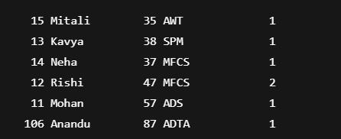

SQL> select rollno,name,subject,marks,subject,rank() over(partition by subject order by marks desc) as "rank" from student;
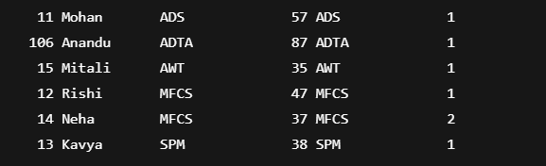

PRACTICAL NO-2
Q)Implementation of Analytical queries(first,last)
SQL> select rollno,name,subject,marks,max(marks) keep(dense_rank first order by marks) over(partition by subject) as "highest" from student order by subject marks;
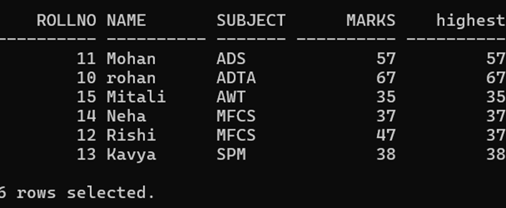

SQL> select rollno,name,subject,marks,min(marks) keep(dense_rank first order by marks) over(partition by subject) as "lowest" from student1 order by subject,marks;
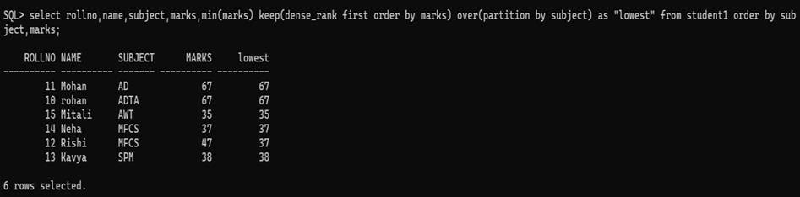

SQL> SELECT rollno, name, marks, subject, MIN(marks) KEEP (DENSE_RANK FIRST ORDER BY marks) OVER (PARTITION BY subject) AS "lowest", MIN(marks) KEEP (DENSE_RANK LAST ORDER BY marks) OVER (PARTITION BY subject) AS
"highest"FROM student1 ORDER BY subject, marks
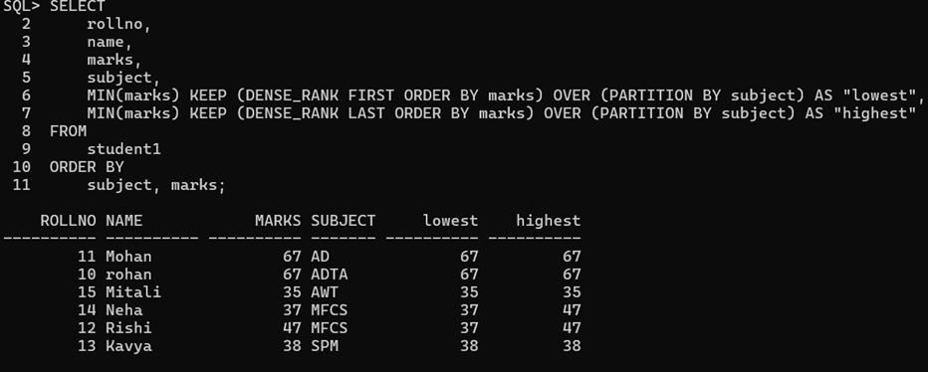

>>>CREATE TABLE emp (empid INT,empname VARCHAR(10), dept VARCHAR(20),salary INT);
>>>INSERT INTO emp VALUES (1, 'Ram', 'marketing', 10000);
INSERT INTO emp VALUES (2, 'Nita', 'marketing', 103000); INSERT INTO emp VALUES (3, 'Raj', 'marketing', 10500);
INSERT INTO emp VALUES (4, 'Shilpa', 'IT', 10500; INSERT INTO emp VALUES (5, 'Prapti', 'IT', 11100); INSERT INT emp VALUES (6, 'Mitali', 'sales', 12100); INSERT INTO emp VALUES (7, 'Moksh',
'sales', 13100);
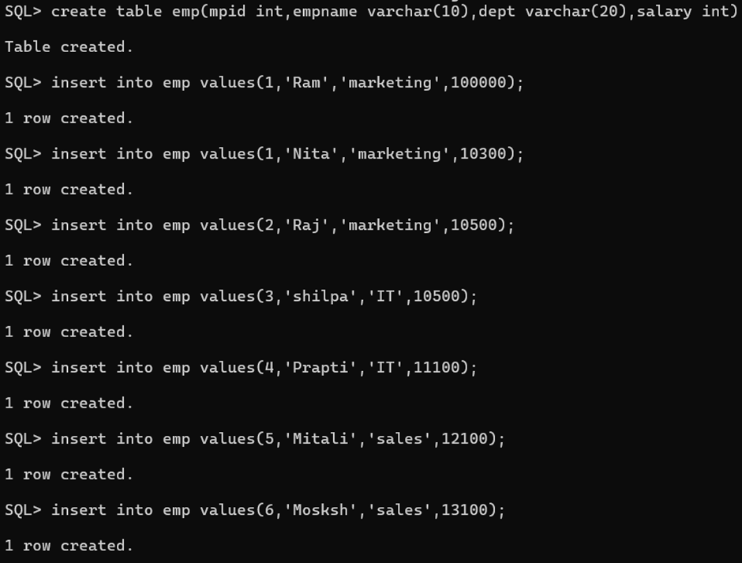

PRACTICALNO-3

Q)Implementation of analytical queries(lead and lag)
SQL> select mpid,empname,dept,salary,lag(salary,1,0)
2 over(partition by dept order by salary) as "previous" from emp;
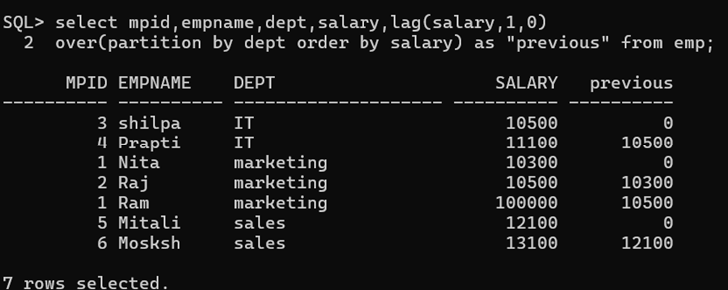
SQL> select mpid,empname,dept,salary,lead(salary,1,0)
2 over(partition by dept order by salary) as "previous" from emp;
