Practical No –20
Aim: Implementation of K-means Classification Algorithm.
Code:
head(iris)
library(ggplot2)
ggplot(iris,aes(Petal.Length,Petal.Width,colour = Species))+geom_point()
set.seed(20)
irisCluster <- kmeans(iris[,3:4],3,nstart = 20)
irisCluster
table(irisCluster$cluster,iris$Species)
irisCluster$cluster <- as.factor(irisCluster$cluster)
ggplot(iris,aes(Petal.Length,Petal.Width,colour = irisCluster$cluster))+geom_point()
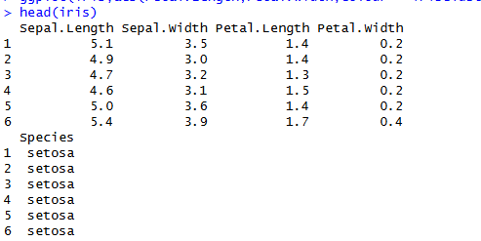
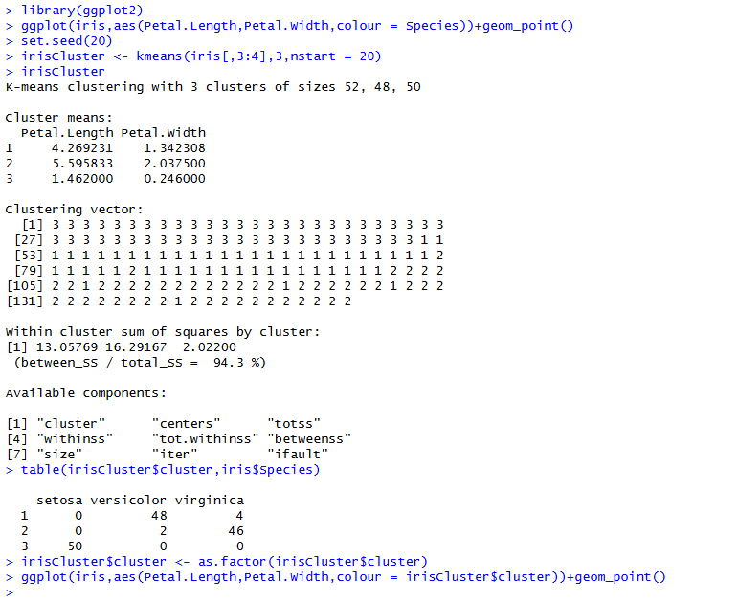
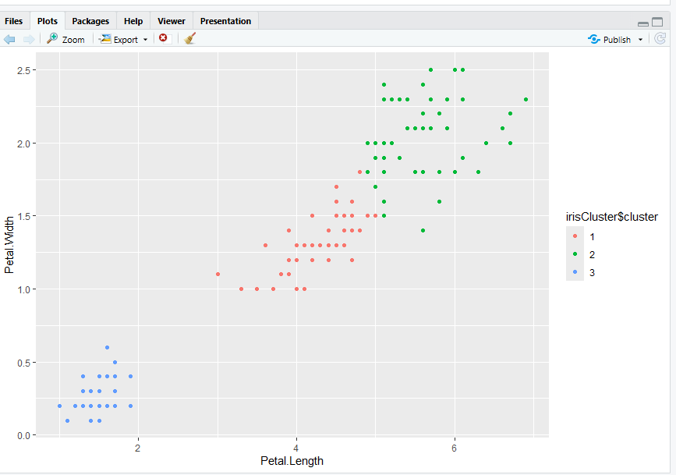
data1 <- read.csv("hello.csv")
data1
head(data1)
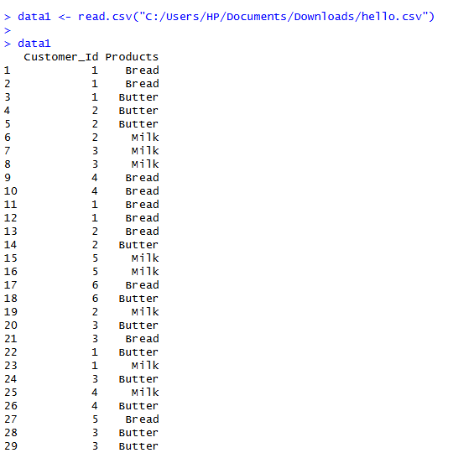
ran <- sample(1:nrow(iris),0.9 * nrow(iris))
ran
nor <- function(x) { (x - min(x)) / (max(x) - min(x))}
nor
iris_norm <- as.data.frame(lapply(iris[,c(1,2,3,4)], nor))
summary(iris_norm)
iris_target_category <- iris[ran, 5]
iris_test_category <- iris[-ran, 5]
library(class)
pr <- knn(iris_norm[ran,],
iris_norm[-ran,],
cl = iris_target_category,
k=13)

# Correct confusion matrix
tab <- table(pr, iris_test_category)
tab
accuracy <- function(x) { (sum(diag(x)) / (sum(rowSums(x)))) * 100}
accuracy(tab)

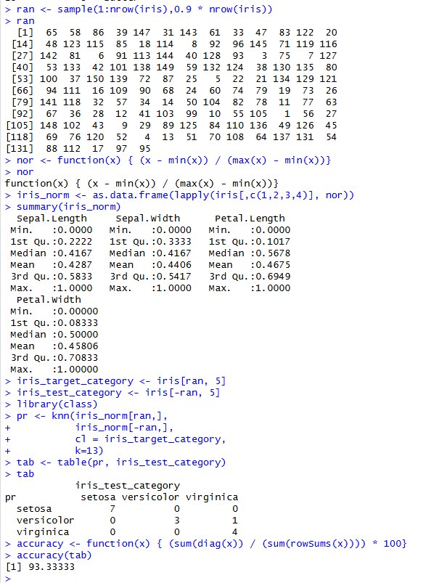

Practical no :18
Implementation of K-nearest neighbor Classification
iris_train <- iris_norm[ran, ]
iris_test <- iris_norm[-ran, ]

iris_target_category <- iris[ran, 5]
iris_test_category <- iris[-ran, 5]
library(class)
pr <- knn(
iris_train,
iris_test,
cl = iris_target_category,
k = 13
)
tab <- table(pr, iris_test_category)

accuracy <- function(x) {
sum(diag(x)) / sum(x) * 100
}

accuracy(tab)
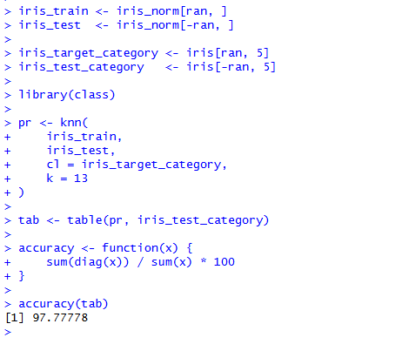

Practical no :19
Implementation of Navie Bayesian Classification
library(caret)
library(e1071)
set.seed(123)
index <- sample(nrow(iris), floor(nrow(iris) * 0.7))
train <- iris[index, ]
test <- iris[-index, ]
xTrain <- train[, -5]
yTrain <- train$Species
xTest <- test[, -5]
yTest <- test$Species
model <- train(
xTrain,
yTrain,
method = "nb",
trControl = trainControl(method = "cv", number = 10)
)
Model

OUTPUT:
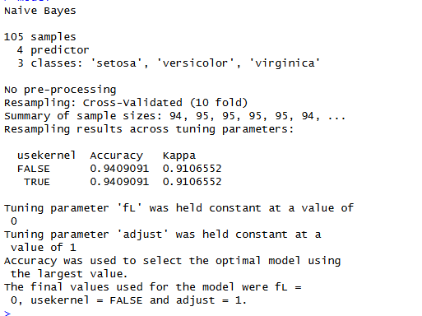

Practical No: 17
Aim: Implementation of Apriori Algorithms using Market Basket.
Code:
mba_data <- read.csv("D:\\SIMS\\AprioriDataset.csv")
mba_data
trans <- split (mba_data$ProductName, mba_data$CustomerID, "transactions")
head(trans)
library(arules)
rules = apriori(trans, parameter= list(support=0.5, confidence = 0.9, maxlen = 3,minlen=2))
inspect(rules)

OUTPUT: