Practical No:
Implementation of Basics R, vector ,data Frame
A) Basics R, vector
1) Write a command to print a string in R.
mystring<-"Hello I am Bhargavi"
mystring
print(mystring)
OUTPUT:
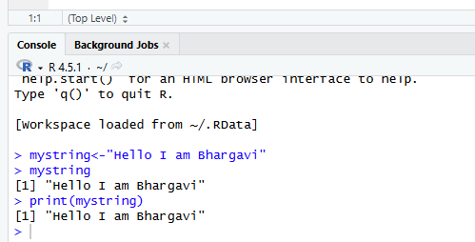
2) Write a command to print working directory.
getwd()
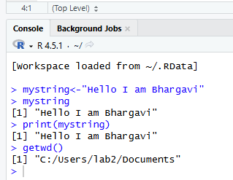
3) Write a command to print all the files from directory.
dir()
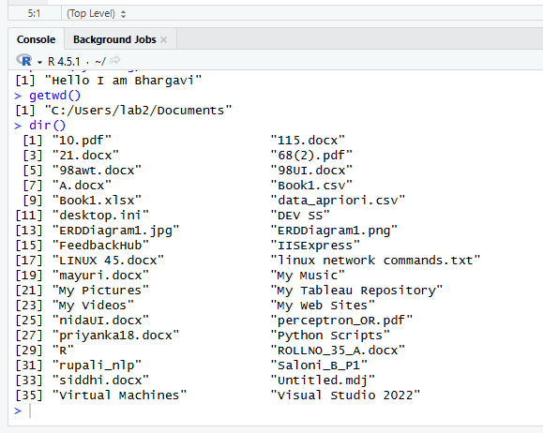
4) Write a command to print variables listed.
ls()
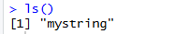

5) Write a command to start a html page
help.start()
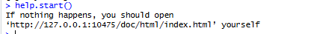
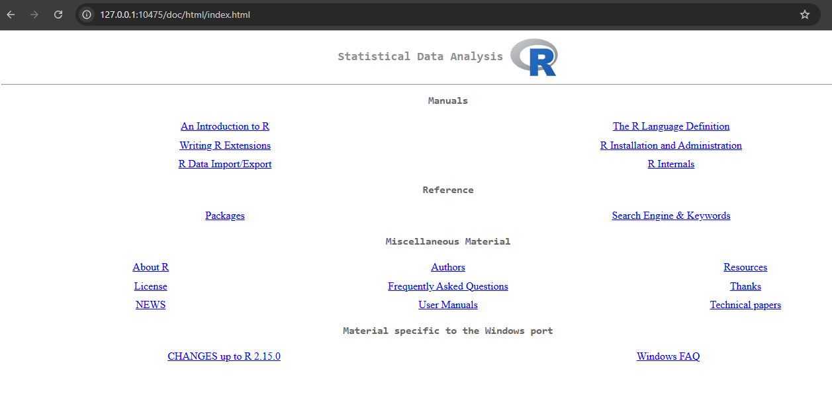

6) Write a command to list all data sets available.
data()
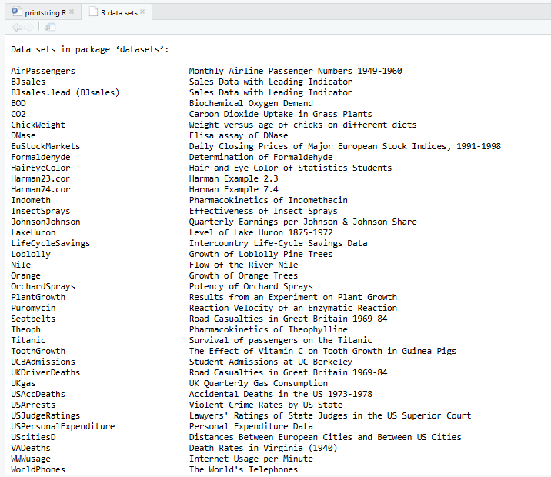

7) Write a command to list all packages available
library()
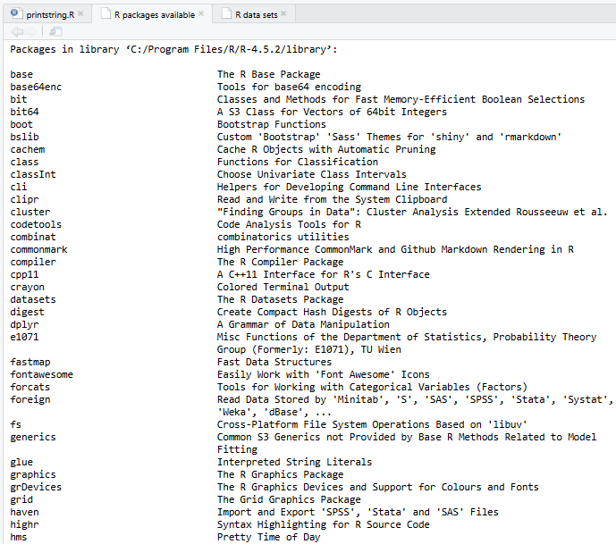

8) Write a command to retrieve the data type of the variable.
num<-107
class(num)
x<-'A'
class(x)
y<-10.7
class(y)
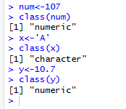
9) Write a command to verify its data type.
is.integer(x)
is.integer(y)
is.character(x)
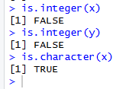
10) Write a command to parse float value to int.
as.integer(y)
print(y)
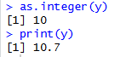

11) Write an expression to create a vector using c function and print it.
### Creating vectors: It contains objects of same class
### creating vectors c function
x1<-c(61.3,107.5,91.9)
x2<-c(3,5,6,7,4,2)
x3<-c('Bargavi','Anurag','Satish','Gayle','Miller')
print(x1)
print(x2)
print(x3)
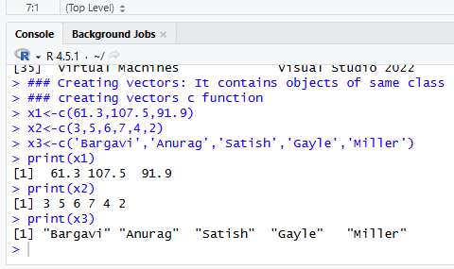

12) Write an expression to create a vector using the vector function and print it.
### using vector function
y1<-vector('logical',length = 10)
y1
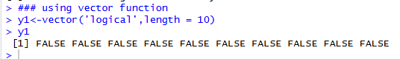
13) Write an expression to print the length of the vector.
length(x1)
length(y1)
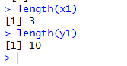
14) Write an expressions to create 2 vectors and perfom arithmetic operations on it.
### Create 2 numeric vectors v1 and v2 with 3 values each and perform the arithmetic
### operations and print it
v1<-c(12,13,14,15,16,17)
v2<-c(21,22,23,24,25,26)
## sum
total<-v1+v2
total
## difference
difference<-v1-v2
difference
## multiply
product<-v1*v2
product
## divide
div<-v1/v2
div
## power
pow<-v1^v2
pow

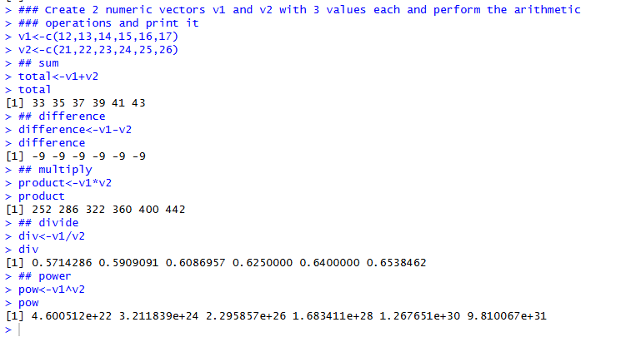
15. Write an expression to concatenate strings.
fullname<-paste('Jai','Hind','Jai','Maharashtra')
fullnameo<-paste0('Jai','Hind','Jai','Maharashtra')
fullname
fullnameo
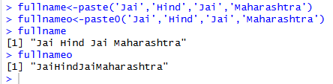

16. Write an expression to create a matrix and print it.
## Creating Matrix: Two dimensional array having elements of same class
## Using matix function
m<-matrix(c(23,12,43,12,35,40,34,54,56),nrow = 3,ncol = 3, byrow = TRUE)
m
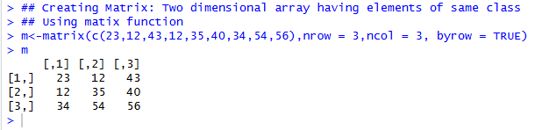

17. Write an expression to find the dimensions of the matrix.
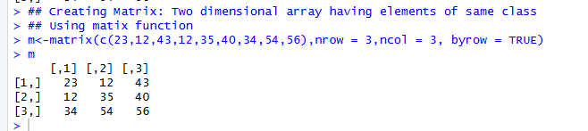

18. Write an expression to find the dimensions of the matrix
dim(m)
attributes(m)
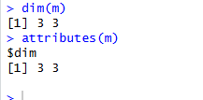

19. Write an expression to bind vectors.
s1<-c(12,23,34,45,56)
s2<-c(09,98,87,76,65)
s3<-c(56,23,34,65,56)
cbind(s1,s2,s3)
rbind(s1,s2,s3)

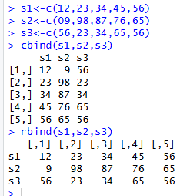

20. Write an expression to create 2 matrix and perform addition, subtraction and multiplications on it.
mat1<-matrix(c(1,2,3,4,5,6),nrow = 3,ncol = 2, byrow = TRUE)
mat2<-matrix(c(7,8,9,10,11,12),nrow = 2,ncol = 3, byrow = TRUE)
## multiplication
matproduct<- mat1 %*% mat2
matproduct
## addition
mat3<-matrix(c(1,2,3,4),nrow = 2,ncol = 2, byrow = TRUE)
mat4<-matrix(c(7,8,9,10),nrow = 2,ncol = 2, byrow = TRUE)
matsum<- mat3 + mat4
matsum
## subtraction
matsub<- mat3 - mat4
matsub
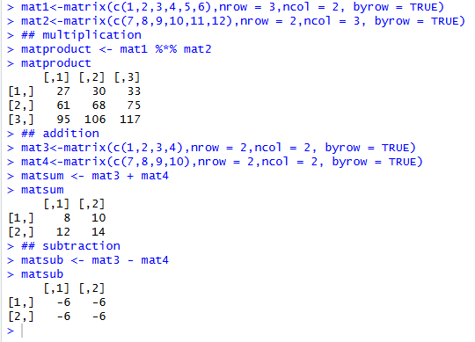
21. Write an expression to create a list in r.
#LIST: Special type of vector containing elements of different classes.
#Elements of a list can be accessed by giving the name of the element index or namein[[]]
#Creating LIST
#using list() function
x<-list(1,"P",TRUE,2+4i)
x[[1]]
x
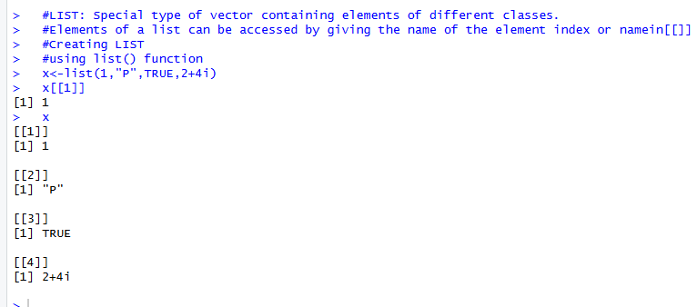

22. Write an expression to execute factor in r.
#FACTOR: Represents categorical data. Can be ordered or unordered.
status<-c("low", "high", "low", "medium", "low")
#using factor() function
fac1<-factor(status, ordered = TRUE, levels = c("low", "medium", "high"))
fac1
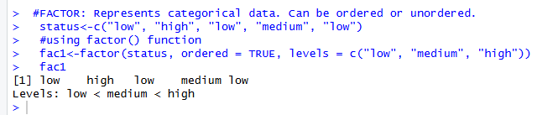

B)Data Frame
i) Write an expression to execute factor in r.
# Factor example
status <- c("low", "high", "low", "medium", "low")
fac1 <- factor(status, ordered = TRUE, levels = c("low", "medium", "high"))
fac1
# Example of data frame with a factor column
student_id<- c(1, 2, 3, 4, 5)
student_name<- c("Bhargavi", "Namrata", "keni", "Divya", "Shyam")
student_div<-c("A","B","C","A","B")
student_age<- c(20, 21, 22, 20, 23)
student_position<- c("FIRST", "FIRST", "SECOND", "SECOND", "THIRD")
student_details<- data.frame(student_id,student_name,student_age,student_position)
print(student_details)
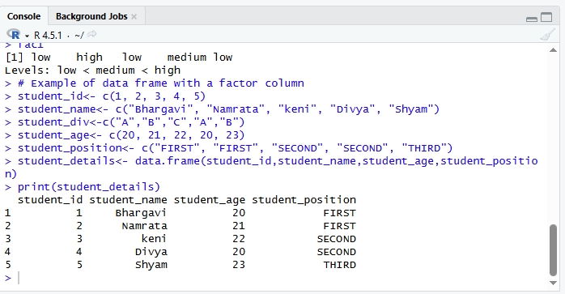

ii) Write an expression for accessing a particular column in Dataframe.
#accessing particular columns in a data frame
a<-student_details$student_name[[4]]
print(a)
b<-student_details$student_id[[4]]
print(b)
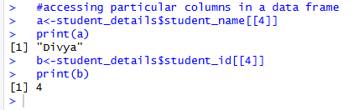

iii) Write an expression to get the number of rows and colums of dataframe.
nrow(student_details)#numberofrowsindataframe
ncol(student_details)#numberofcolumns indata frame
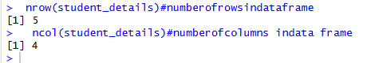

iv)Write an expression to access the name of the rows and columns.
#accessing the names of columns of the table
names(student_details)
colnames(student_details)
rownames(student_details)
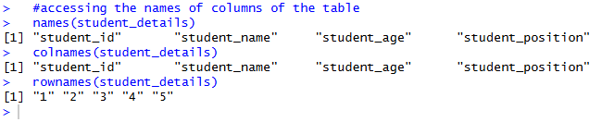

v) Write an expression to create a 2D table in r using TABLE command.
#TABLEcommand:used create 2 dimensional table in R
smoke<-matrix(c(63,81,42,31,32,33,34,52,35), nrow = 3, ncol = 3, byrow = TRUE)
colnames(smoke) <- c("High", "Middle", "Low")
rownames(smoke) <- c("Never", "Current", "Former")
smoke<-as.table(smoke)
print(smoke)
class(smoke)
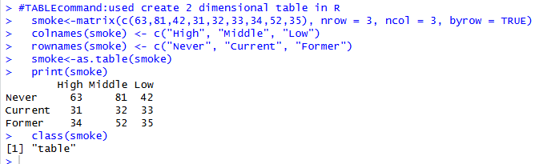

C)excel_read_and_write
i) Write a program for reading and writing data from Excel using readxl.
#Reading and Writing a data from Excel using the readxl
install.packages("readxl")
library("readxl")
my_data<- read_excel("C:/Users/Admin/Documents/Prince 127/ADBMS Practical/data.xlsx",sheet = 1)
print(my_data)
my_data<- read_excel("C:/Users/Admin/Documents/Prince 127/ADBMS Practical/data.xlsx", sheet = 2)
print(my_data)
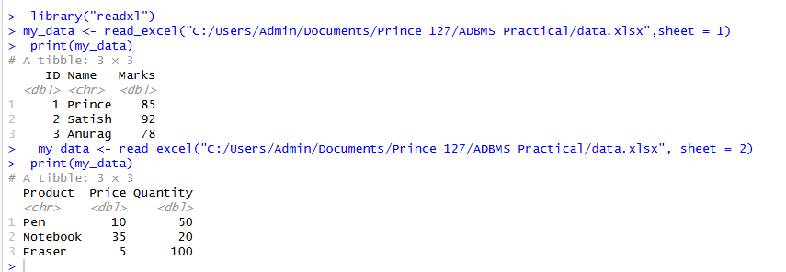

ii) Write a program to write data into an excel file.
install.packages("writexl")
# Create vectors
student_id<- c(3041601, 3041602, 3041603, 3041604, 3041605)
student_name<- c("Devilliers", "Miller", "Steyn", "Smith", "Rabada")
student_class<- c("FYMCA", "SYMCA", "FYMCA", "SYMCA", "FYMCA")
student_age<- c(20, 21, 20, 21, 22)
student_position<- c("FIRST", "FIRST", "SECOND", "SECOND", "THIRD")
# Create a data frame
student_details<- data.frame(
student_id,
student_name,
student_class,
student_age,
student_position
)
# Print the data frame
print(student_details)
# Write to Excel file using writexl package
library(writexl)
write_xlsx(student_details, "data.xlsx", col_names = TRUE)
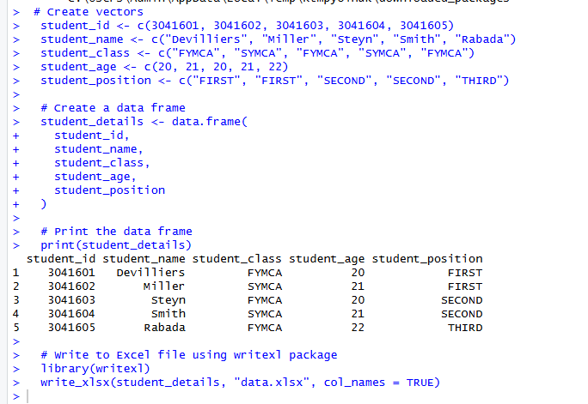

Practical No:
Implementation of data preprocessing using R
## Imputation
## The process of estimating or deriving missing value
install.packages("Hmisc")
library(Hmisc)
x <- c(1,2,3,NA,4,4,NA)
X <- impute(x, fun = mean)
X
Y <- impute(x, fun = median)
Y
Z <- impute(x, fun = mode)
Z
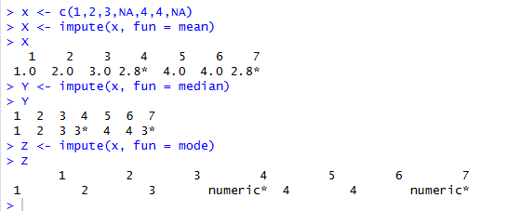
## Categorical data
## Factors are variables in R which take on a class
gender_vector<-c("Male","Female","Female","Male")
class(gender_vector)
factor_gender_vector<- factor(gender_vector)
class(factor_gender_vector)
timing <- c("Morning", "Evening", "Afternoon", "Night", "Evening", "Afternon", "Midnight", "Midnight")
factor_timing<- factor(timing, order=TRUE, levels = c("Morning","Afternoon","Evening","Night","Midnight"))
factor_timing
age <- c(21,32,34,65,32,34,22)
salary <- c(12000, 32000, 20000, 23000, 50000, 35000, 40000)
gender <- c("male", "male", "female", "female", "transgender", "female", "transgender")
education <- c("PostGraduate", "Matric", "Graduate", "Phd", "Matric",
"PostGraduate", "Graduate")
employee <- data.frame(age, salary, gender,education)
employee
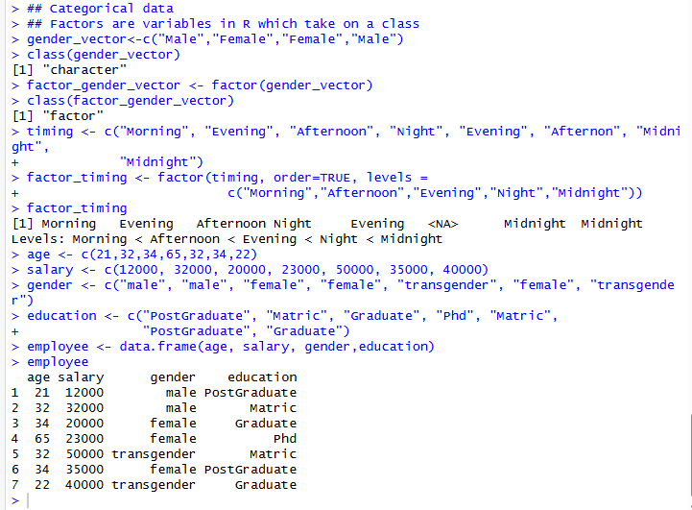

## Creating a factor corresponding to age with table
efact<- cut(employee$age, 3, labels = c("Young", "Medium", "Aged"))
table(efact)
x1 <- c("Prince","Anurag","Ayush","Abhishek",NA,"Phillips",NA,"Joe")
x1
x2 <- impute(x1, fun = mode)
x2
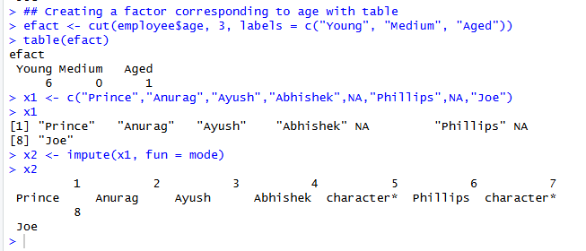
#simple regression
x<-c(151, 174, 138, 186, 128, 179, 163, 152, 131)
y<-c(63, 81, 56, 91, 47, 57, 76, 72, 62)
relation<-lm(y~x)
print(relation)
a <- data.frame(x = 170)
result <- predict(relation, a)
print(result)
plot(y,x,col = "blue", main="height&weight line", abline(lm(x~y)), cex=1.3, pch=18,
xlab="weight in KG", ylab="height in cm")
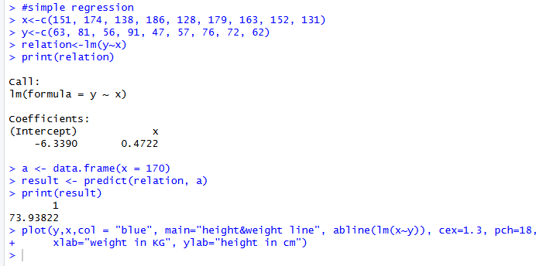
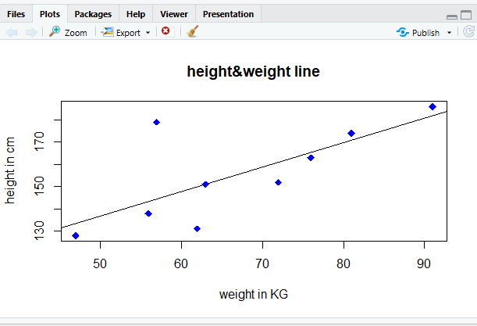

Practical No:
Implementation of Linear regression
library(ggplot2)
my_data<- mtcars
names(my_data)
dim(my_data)
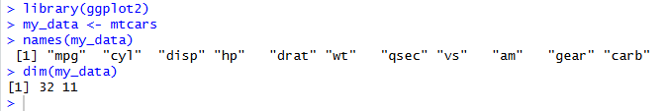
#randomize
my_data<- my_data[sample(nrow(my_data), ), ]
head(my_data)
TrainData<-my_data[1:20, ]
TestData<- my_data[21:32, ]
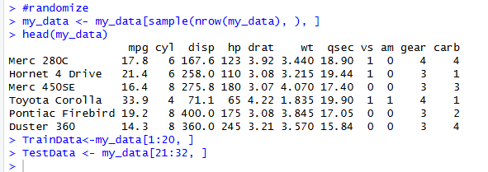

# Linear Model
fit = lm(mpg ~hp, data = mtcars)
summary(fit)
preds <- predict(fit, newdata = TestData)
dfl<- data.frame(preds, TestData$mpg)
head(dfl)
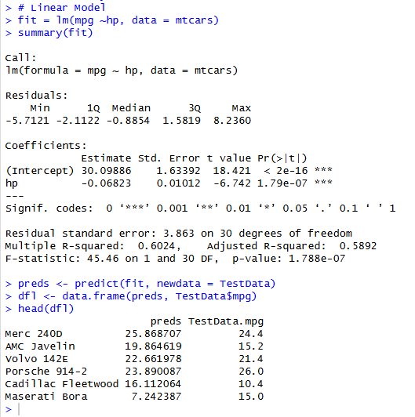

# correlation
cor(preds, TestData$mpg)
plot(mtcars$hp, mtcars$mpg)
ggplot(fit, aes(hp, mpg)) + geom_point() + stat_smooth(method = lm, se = FALSE) +
geom_segment(aes(xend = hp, yend= .fitted), color = "red", size = 0.3)
