Practical No. 4

AIM:Implementation of analytical queries (Rollup and Cube)

ALTER TABLE student1 ADD Year VARCHAR(20);



SELECT* FROM student1;



SELECT year, rollno, SUM(marks)
FROM student1
GROUP BY CUBE (year, rollno)
ORDER BY year, rollno;

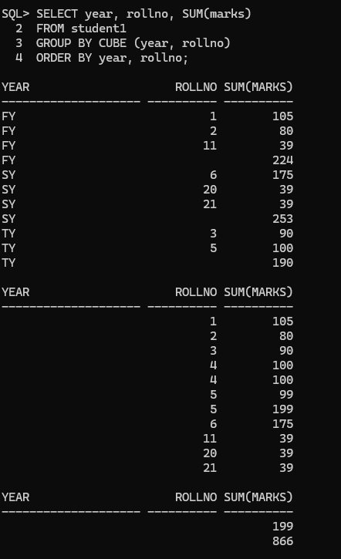

2)ROLLUP

SELECT year, rollno, SUM(marks)
FROM student1
GROUP BY ROLLUP (year, rollno)
ORDER BY year, rollno;
