Practical No - 9
Aim: Assignment based Spring JDBC.
Q.1Write a program to insert, update and delete records from the given table.
Student.java
package experiment8;
public class Student {
private int id;
private String name;
private int age;
// Parameterized constructor
public Student(int id, String name, int age) {
this.id = id;
this.name = name;
this.age = age;
}
// Getters and setters
public int getId() {
return id;
}
public void setId(int id) {
this.id = id;
}
public String getName() {
return name;
}
public void setName(String name) {
this.name = name;
}
public int getAge() {
return age;
}
public void setAge(int age) {
this.age = age;
}
// Display method
public void show() {
System.out.println("Id = " + id + ", Name = " + name + ", Age = " + age);
}
}

StudentDao.java
package experiment8;
import experiment8.Student;
public interface StudentDao {
public int save(Student s) throws Exception;
public int update(Student s) throws Exception;
public int delete(int id) throws Exception;
}

Studentdaoimpl.java
package experiment8;
import java.sql.Connection;
import java.sql.PreparedStatement;
import javax.sql.DataSource;
public class Studentdaoimpl implements StudentDao {
private DataSource ds;
private Connection con;
public void setDs(DataSource ds) {
this.ds = ds;
}
@Override
public int save(Student s) throws Exception {
con = ds.getConnection();
String sql = "insert into student values(?,?,?)";
PreparedStatement ps = con.prepareStatement(sql);
ps.setInt(1, s.getId());
ps.setString(2, s.getName());
ps.setInt(3, s.getAge());
return ps.executeUpdate();
}
@Override
public int update(Student s) throws Exception {
con = ds.getConnection();
String sql = "update student set name=?, age=? where id=?";
PreparedStatement ps = con.prepareStatement(sql);
ps.setString(1, s.getName());
ps.setInt(2, s.getAge());
ps.setInt(3, s.getId());
return ps.executeUpdate();
}
@Override
public int delete(int id) throws Exception {
con = ds.getConnection();
String sql = "delete from student where id=?";
PreparedStatement ps = con.prepareStatement(sql);
ps.setInt(1, id);
return ps.executeUpdate();
}
}

Appconfig.xml
<?xml version="1.0" encoding="UTF-8"?>
<beans xmlns="http://www.springframework.org/schema/beans"
xmlns:xsi="http://www.w3.org/2001/XMLSchema-instance"
xsi:schemaLocation="
http://www.springframework.org/schema/beans
http://www.springframework.org/schema/beans/spring-beans.xsd">

<bean id="bds"
class="org.springframework.jdbc.datasource.DriverManagerDataSource">
<property name="driverClassName" value="com.mysql.cj.jdbc.Driver"/>
<property name="url"
value="jdbc:mysql://localhost:3306/student?useSSL=false&amp;serverTimezone=UTC"/>
<property name="username" value="root"/>
<property name="password" value=""/>
</bean>

<bean id="dao" class="experiment8.Studentdaoimpl">
<property name="ds" ref="bds"/>
</bean>

</beans>

Test.java
package experiment8;
import org.springframework.context.ApplicationContext;
import org.springframework.context.support.ClassPathXmlApplicationContext;
public class Test {
public static void main(String[] args) throws Exception {
// Load Spring configuration file
ApplicationContext ac =
new ClassPathXmlApplicationContext("appConfig.xml");
// Get DAO bean (use interface reference)
StudentDao dao = (StudentDao) ac.getBean("dao");
// Create Student objects
Student s1 = new Student(18, "Prince", 21);
Student s2 = new Student(45, "Dheeraj", 22);
Student s3 = new Student(15, "Ganesh", 23);
// Insert records
int check1 = dao.save(s1);
int check2 = dao.save(s2);
int check3 = dao.save(s3);
System.out.println("\nChecking if inserted?");
System.out.println((check1 > 0) ? "1st Record Inserted" : "1st Record Not Inserted");
System.out.println((check2 > 0) ? "2nd Record Inserted" : "2nd Record Not Inserted");
System.out.println((check3 > 0) ? "3rd Record Inserted" : "3rd Record Not Inserted");
// Update records
s1.setName("Dheeraj");
s2.setName("Abhi");
s3.setName("Prince");
int update1 = dao.update(s1);
int update2 = dao.update(s2);
int update3 = dao.update(s3);
System.out.println("\nChecking if updated?");
System.out.println((update1 > 0) ? "1st Record Updated" : "1st Record Not Updated");
System.out.println((update2 > 0) ? "2nd Record Updated" : "2nd Record Not Updated");
System.out.println((update3 > 0) ? "3rd Record Updated" : "3rd Record Not Updated");
// Delete record
int delete1 = dao.delete(45);
int delete2 = dao.delete(45);
System.out.println("\nChecking if deleted?");
System.out.println((delete1 > 0) ? "1st Record Deleted" : "1st Record Not Deleted");
System.out.println((delete2 > 0) ? "2nd Record Deleted" : "2nd Record Not Deleted");
}
}

Output
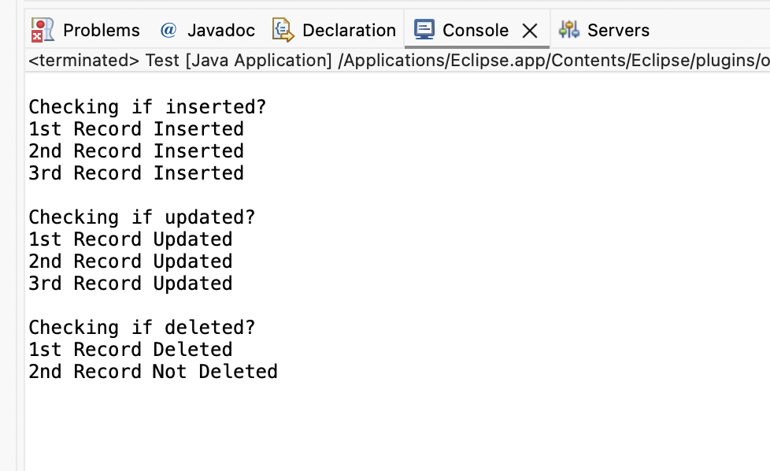
OUTPUT: Before and after insertion of data
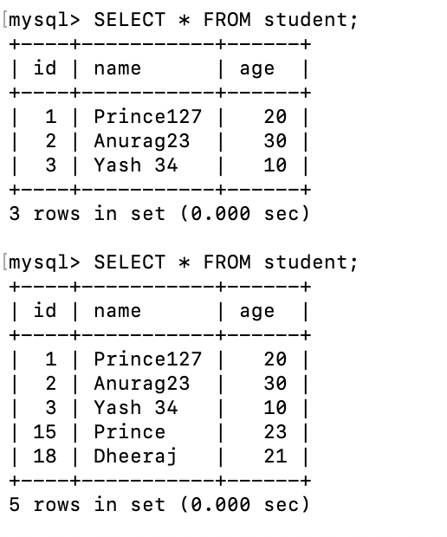

2. Write a program to demonstrate Prepared Statement in Spring Jdbc Template.
Code:
Employee.java
package spring;
public class Employee {
private int id;
private String name;
private float salary;
// Parameterized constructor
public Employee(int id, String name, float salary) {
this.id = id;
this.name = name;
this.salary = salary;
}
// Getters & Setters
public int getId() {
return id;
}
public void setId(int id) {
this.id = id;
}
public String getName() {
return name;
}
public void setName(String name) {
this.name = name;
}
public float getSalary() {
return salary;
}
public void setSalary(float salary) {
this.salary = salary;
}
// Display method
public void show() {
System.out.println("Employee [id=" + id + ", name=" + name + ", salary=" + salary + "]");
}
}

EmployeeDao.java
package spring;

public interface EmployeeDao {

int saveEmployee(Employee e);

int updateEmployee(Employee e);
}

EmployeeDaoImpl.java
package spring;
import java.sql.PreparedStatement;
import java.sql.SQLException;
import org.springframework.dao.DataAccessException;
import org.springframework.jdbc.core.JdbcTemplate;
import org.springframework.jdbc.core.PreparedStatementCallback;

public class EmployeeDaoImpl implements EmployeeDao {
private JdbcTemplate jdbcTemplate;
// Setter Injection (IMPORTANT: name must be jdbcTemplate)
public void setJdbcTemplate(JdbcTemplate jdbcTemplate) {
this.jdbcTemplate = jdbcTemplate;
}

// INSERT using PreparedStatement
@Override
public int saveEmployee(Employee e) {
String query = "insert into employee values(?,?,?)";

return jdbcTemplate.execute(query,
new PreparedStatementCallback<Integer>() {

@Override
public Integer doInPreparedStatement(PreparedStatement ps)
throws SQLException, DataAccessException {

ps.setInt(1, e.getId());
ps.setString(2, e.getName());
ps.setFloat(3, e.getSalary());

return ps.executeUpdate();
}
});
}
// UPDATE using PreparedStatement
@Override
public int updateEmployee(Employee e) {
String query = "update employee set name=?, salary=? where id=?";

return jdbcTemplate.execute(query,
new PreparedStatementCallback<Integer>() {

@Override
public Integer doInPreparedStatement(PreparedStatement ps)
throws SQLException, DataAccessException {

ps.setString(1, e.getName());
ps.setFloat(2, e.getSalary());
ps.setInt(3, e.getId());

return ps.executeUpdate();
}
});
}
}

applicationContext.xml
<?xml version="1.0" encoding="UTF-8"?>
<beans xmlns="http://www.springframework.org/schema/beans"
xmlns:xsi="http://www.w3.org/2001/XMLSchema-instance"
xsi:schemaLocation="
http://www.springframework.org/schema/beans
http://www.springframework.org/schema/beans/spring-beans.xsd">

<!-- DataSource Bean -->
<bean id="ds"
class="org.springframework.jdbc.datasource.DriverManagerDataSource">
<property name="driverClassName" value="com.mysql.cj.jdbc.Driver"/>
<property name="url" value="jdbc:mysql://localhost:3306/employee"/>
<property name="username" value="root"/>
<property name="password" value=""/>
</bean>
<!-- JdbcTemplate Bean -->
<bean id="jdbcTempl"
class="org.springframework.jdbc.core.JdbcTemplate">
<property name="dataSource" ref="ds"/>
</bean>

<!-- DAO Bean -->
<bean id="edao" class="spring.EmployeeDaoImpl">
<property name="jdbcTemplate" ref="jdbcTempl"/>
</bean>
</beans>
<?xml version="1.0" encoding="UTF-8"?>
<beans xmlns="http://www.springframework.org/schema/beans"
xmlns:xsi="http://www.w3.org/2001/XMLSchema-instance"
xsi:schemaLocation="
http://www.springframework.org/schema/beans
http://www.springframework.org/schema/beans/spring-beans.xsd">

<!-- DataSource Bean -->
<bean id="ds"
class="org.springframework.jdbc.datasource.DriverManagerDataSource">
<property name="driverClassName" value="com.mysql.cj.jdbc.Driver"/>
<property name="url" value="jdbc:mysql://localhost:3306/employee"/>
<property name="username" value="root"/>
<property name="password" value=""/>
</bean>
<!-- JdbcTemplate Bean -->
<bean id="jdbcTempl"
class="org.springframework.jdbc.core.JdbcTemplate">
<property name="dataSource" ref="ds"/>
</bean>

<!-- DAO Bean -->
<bean id="edao" class="spring.EmployeeDaoImpl">
<property name="jdbcTemplate" ref="jdbcTempl"/>
</bean>
</beans>

Employee_Test.java
package spring;
import org.springframework.context.ApplicationContext;
import org.springframework.context.support.ClassPathXmlApplicationContext;

public class Employee_Test {
public static void main(String[] args) {
// Load Spring configuration file
ApplicationContext ctx =
new ClassPathXmlApplicationContext("applicationContext.xml");

EmployeeDao dao = (EmployeeDao) ctx.getBean("edao");
// Insert records
int insert1 = dao.saveEmployee(new Employee(101, "Prince", 45000));
int insert2 = dao.saveEmployee(new Employee(102, "Dheeraj", 35000));
System.out.println("\nChecking if record inserted?");
System.out.println(insert1 > 0 ? "1st Record Inserted" : "1st Record Not Inserted");
System.out.println(insert2 > 0 ? "2nd Record Inserted" : "2nd Record Not Inserted");

// Update records
int update1 = dao.updateEmployee(new Employee(101, "Prince 127", 40000));
int update2 = dao.updateEmployee(new Employee(102, "Dheeraj 307", 30000));

System.out.println("\nChecking if record updated?");
System.out.println(update1 > 0 ? "1st Record Updated" : "1st Record Not Updated");
System.out.println(update2 > 0 ? "2nd Record Updated" : "2nd Record Not Updated");
}
}

Output:
