Practical No: 11
AIM: Implementation of Input Function (Excel Input, Table Input) using Pentaho.
1) Excel Input:
Step 1: Set system variable for java updated version java 1.8
Step 2: In C: click on data-integration folder.
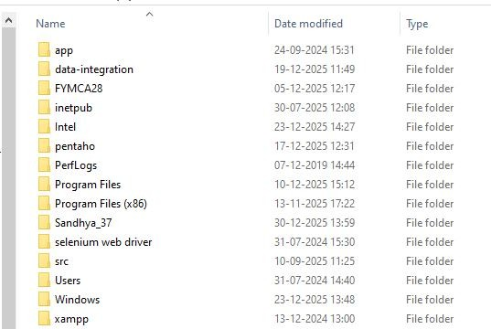
Step 3: click on “spoon.bat” file in data-integration folder.

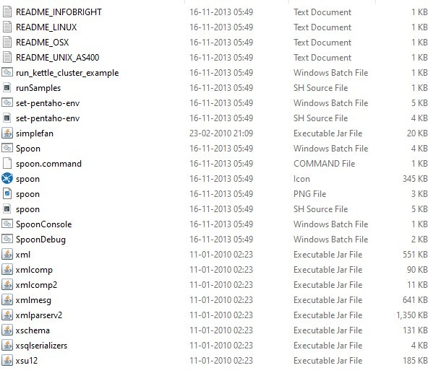

Step 4: This window will appear click on the “cancel”.
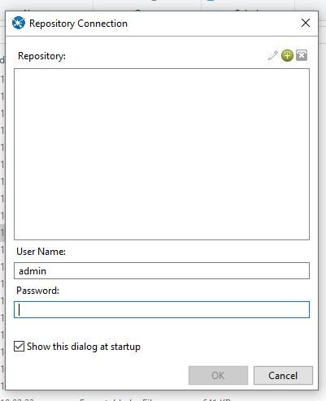
Step 5: “PENTAHO” will start.
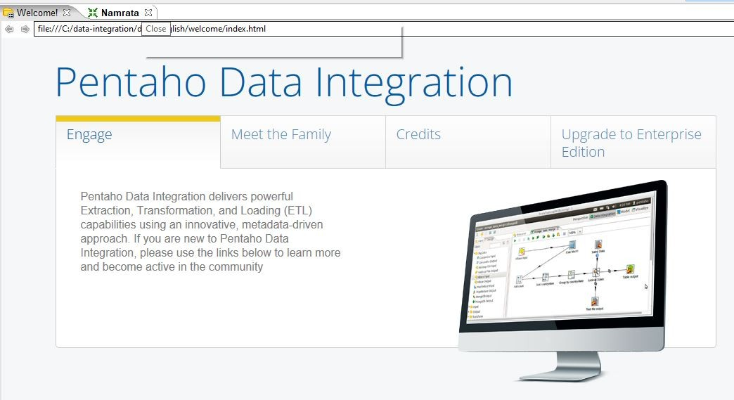

Step 6: Pull down File menu and select the New menu item followed by Transformation.

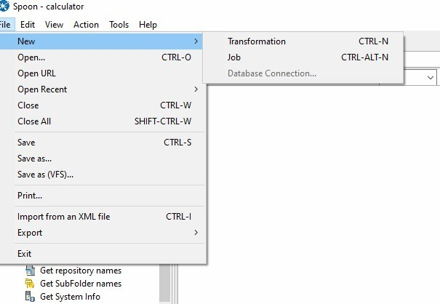
Step 7: Drag “Microsoft Excel Input” form the “Input” folder and drag it on main window of Pentaho.

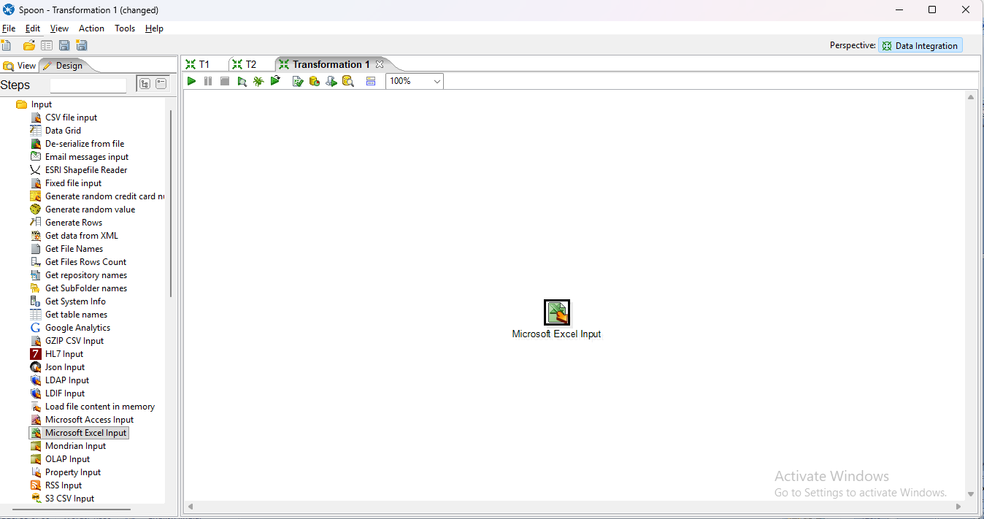

Step 8: Double-click on the Microsoft Excel Input step to view its properties Click on the Browse button next to Filename field and navigate to the folder with the Excel files. Select the Excel file as shown below and then click the Open button.
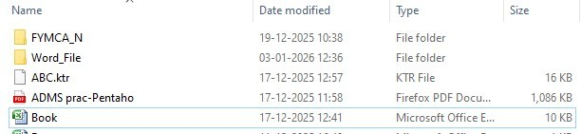

Step 9: Click on ADD button to add excel file.

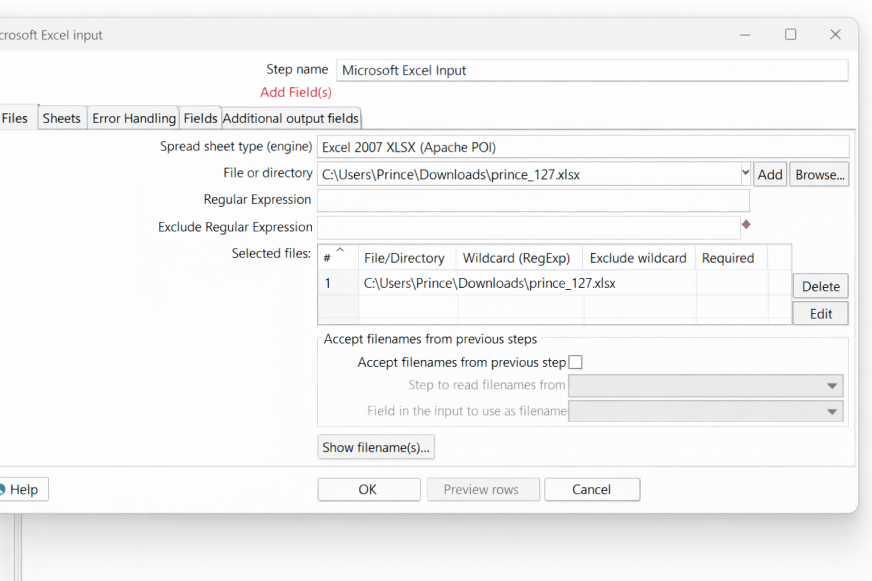

Step 10: Navigate to Sheet tab to select the sheet which you want to select. And select Sheet name(s) Button. Following form will appear then select sheet and select (>) button to add sheet.
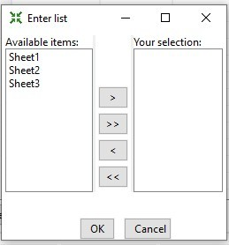

Step 11: Navigate to Fields tab to assert the header name. Click on “Get Fields from Header row” button to get column list.
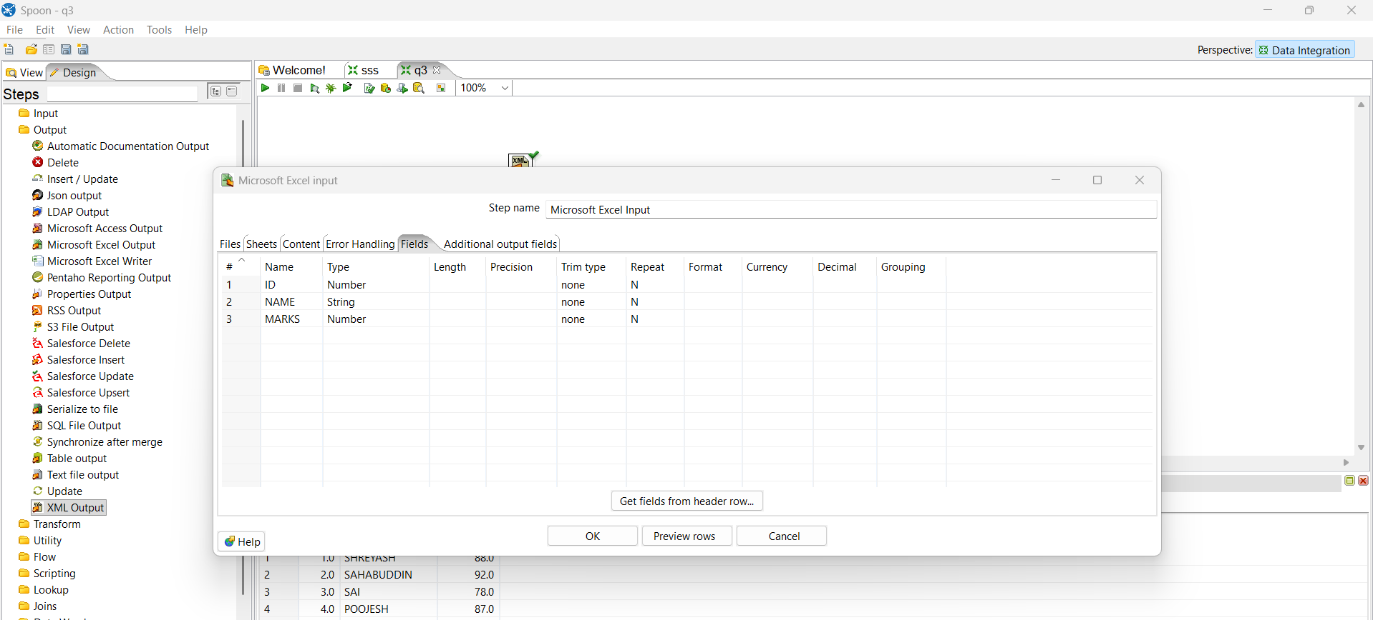

Step 12: Click on “Preview Row” button to select top 1000 row.

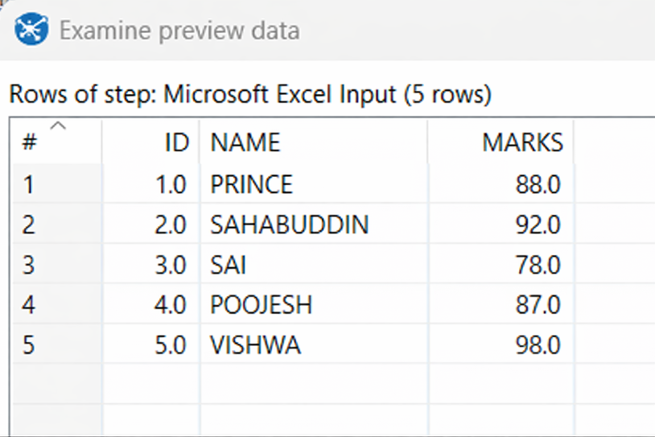

2) Table Input:

Step 1: Double-click on the Table Input step to view its properties. Select “New” button to configure database connection Or “Edit” button to edit previously configured connection.
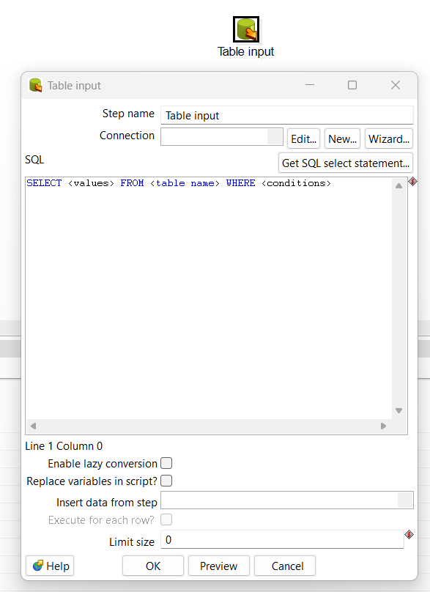

Step 2: Fill the following connection information. And click on “Test” button to verify information.

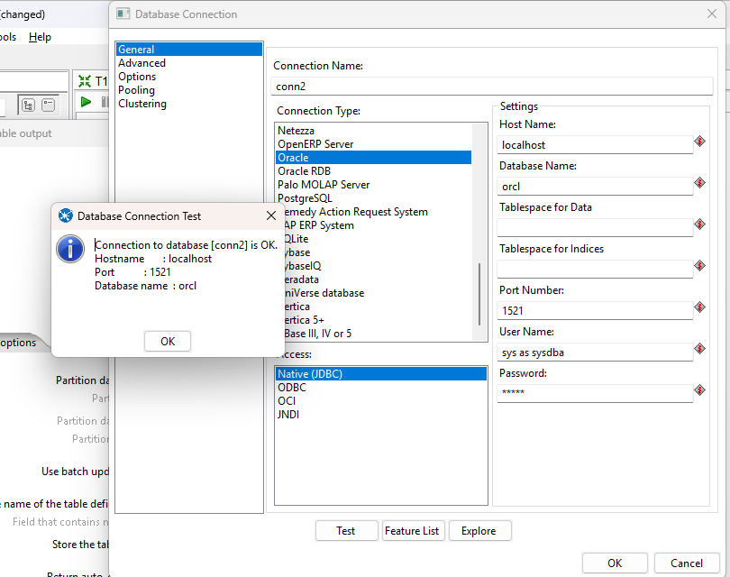

Step 3: Click on “Get SQL select statement” to retrieve table data.

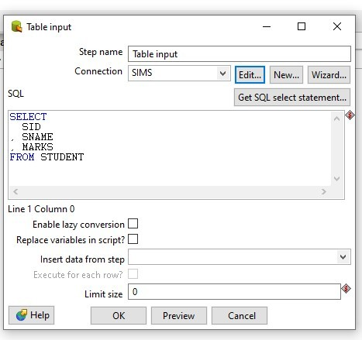

Step 4: Select Table and click on OK. And Click on “Preview” button to preview data of selected table.
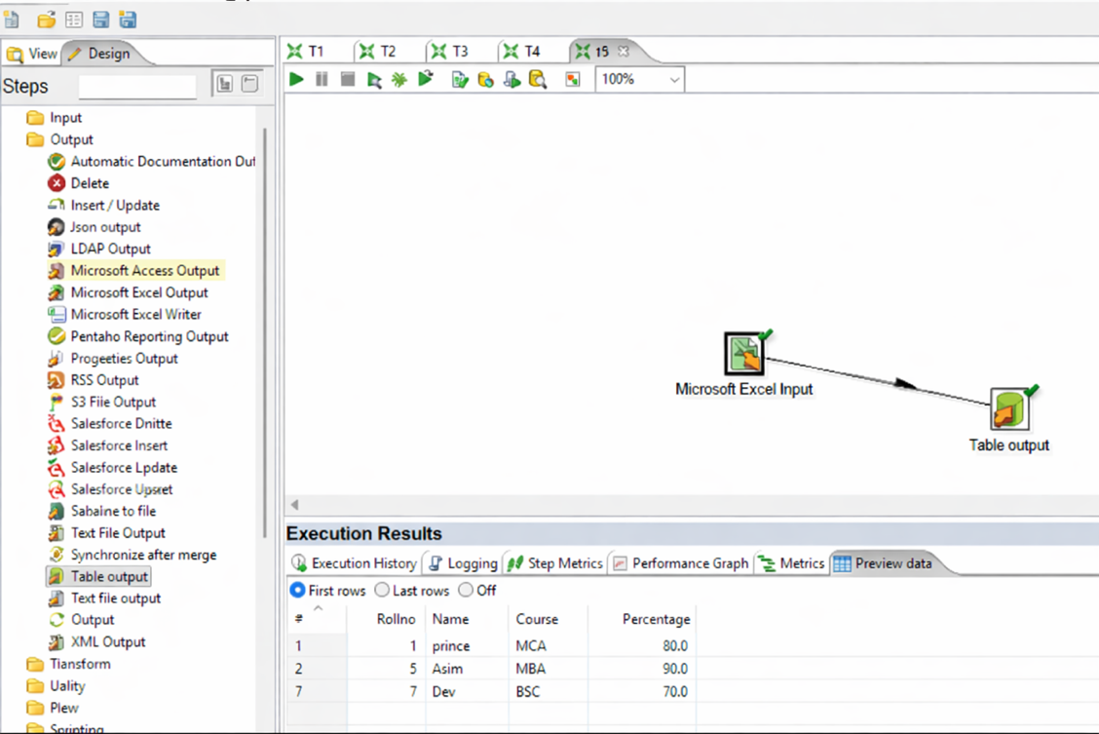

Practical No: 12

AIM: Implementation of Output Function (XL input, XL output and XL input, XML output) using Pentaho.

- XL Input, XL Output:

Step 1: Open up the Output folder and drag and drop the Microsoft excel output step on to the transformation window.
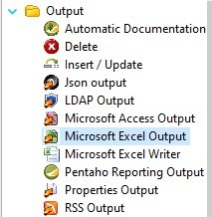

Step 2: Double-click on the Microsoft Excel output step to view its properties. Click on the Browse button next to Filename field and navigate to the folder to store the output.
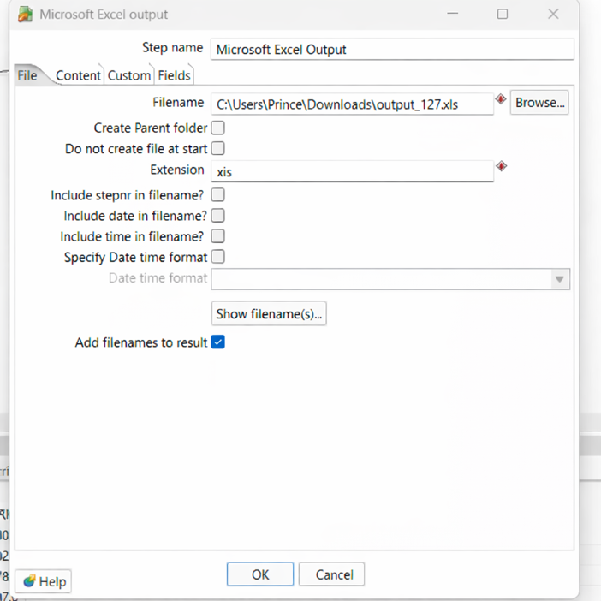

Step 3: Make connection to input and output i.e. Create a hop between the Microsoft Excel Input and Microsoft Excel Output steps. Go to field tab of Excel output step and click on “Get fields” button to retrieve column list of table data.
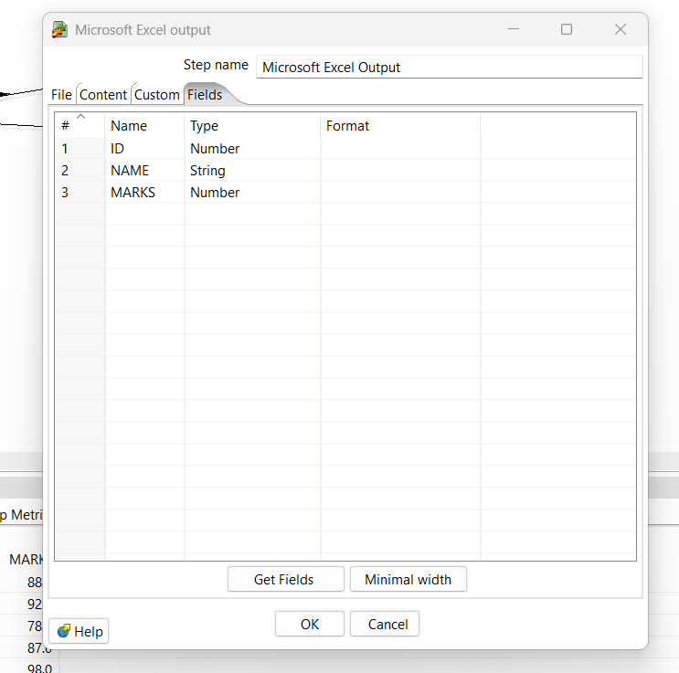

- XL Input, XML Output:

Step 1: Open up the Output folder and drag and drop the XML output step on to the transformation window.
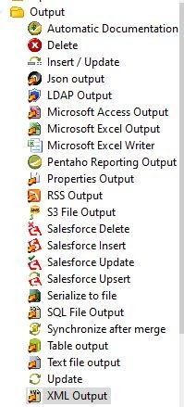

Step 2: Double-click on the XML output step to view its properties. Click on the Browse button next to Filename field and navigate to the folder to store the output.
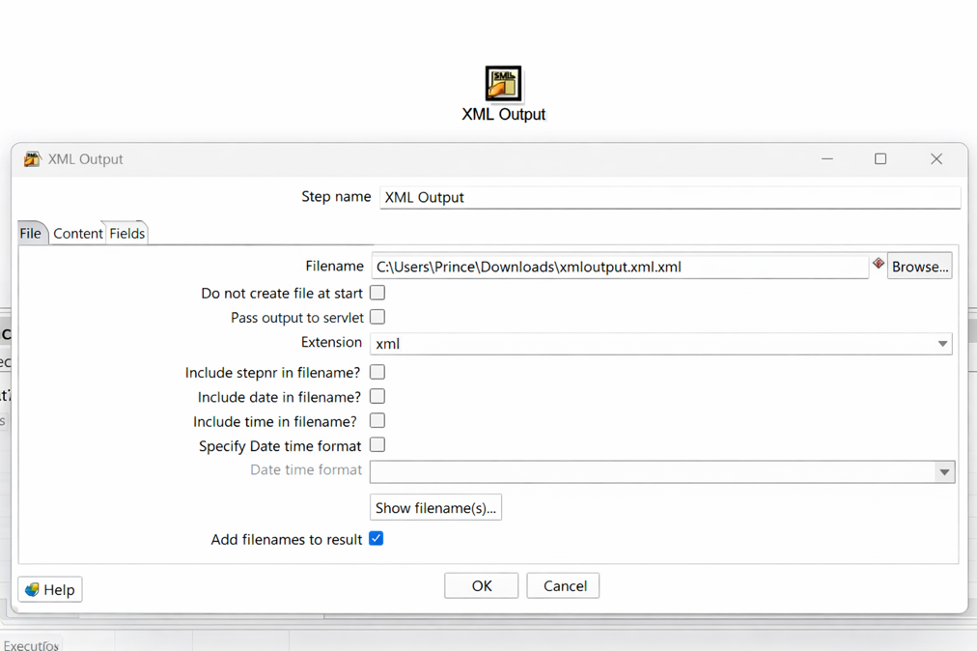
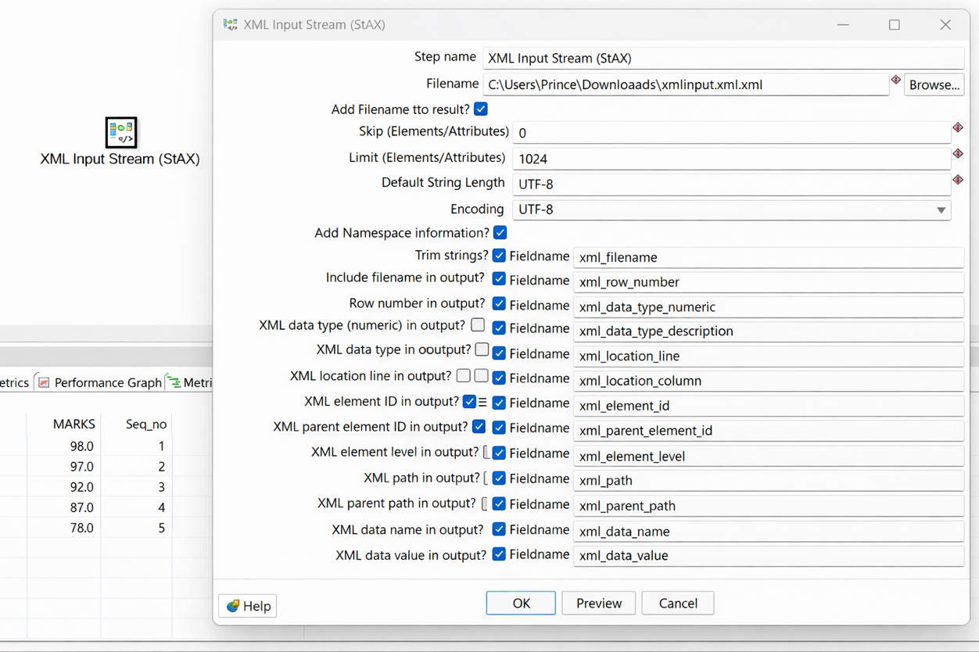

Step 3: Make connection to input and output i.e. Create a hop between the Microsoft Excel Input and XML Output steps. Go to field tab of XML output step and click on “Get fields” button to retrieve column list of table data.
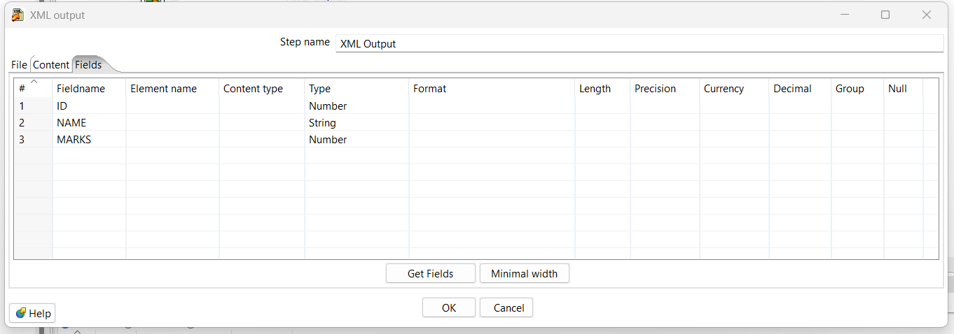

Practical No: 13

AIM: Implementation of Transformation (sorting, add sequence, null if, string Operator, calculator, Upper & Lower Padding).

- Sorting:

Step 1: Open up the Transform folder and drag and drop the Sort Rows step on to the transformation window.
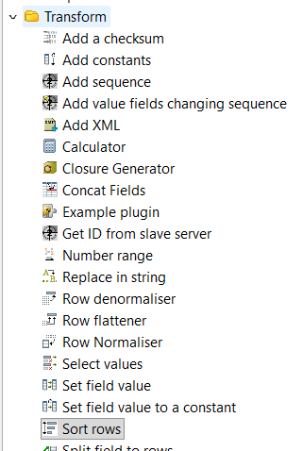
Step 2: Create a hop between Microsoft Excel Input and Sort Rows. Double click on the Sort Rows. In the fields section select the roll_no value as N(No) from the dropdown in the ascending column to transform the data. Click on Ok.
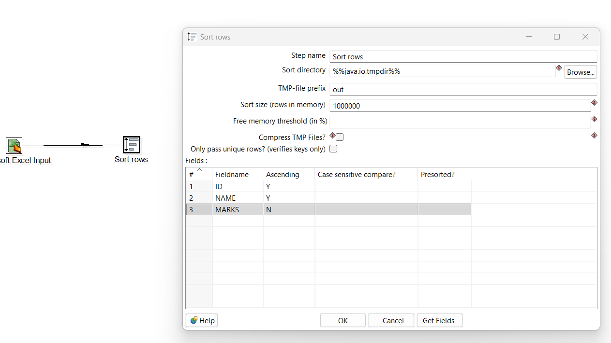
Step 3: Right Click on ‘Step rows’ step & click on Preview. A window will appear, click on Quick Launch button. Data in the Descending order of Roll Number will be transformed.
BEFORE TRANSFORMATION:
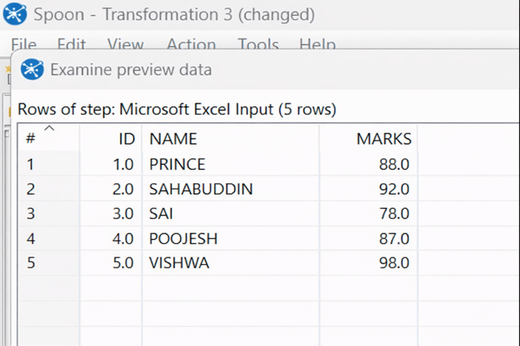

AFTER TRANSFORMATION:
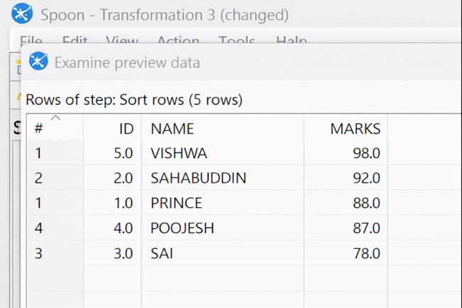

- Add Sequence:

Step 1: Open up the Transform folder and drag and drop the Add Sequence step on to the transformation window next to Step rows.

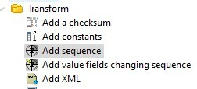
Step 2: Create a hop between Sort Rows and Add Sequence. Double click on the Add Sequence, in the ‘Name of Value’ field give the values as ‘Seq_no’ and click on Ok.
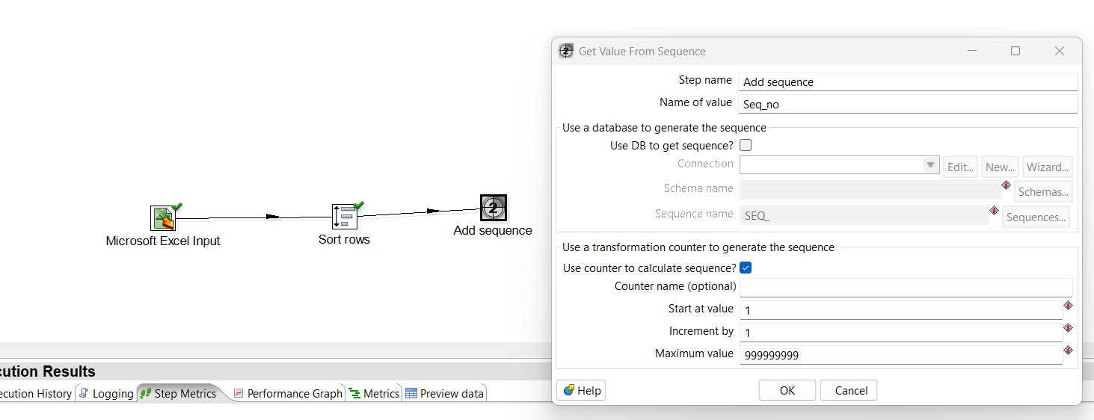

Step 3: Right Click on ‘Add Sequence’ step & click on Preview. A window will appear, click on Quick Launch button. Data with new column as ‘Seq_no’ will be transformed.

BEFORE TRANSFORMATION:

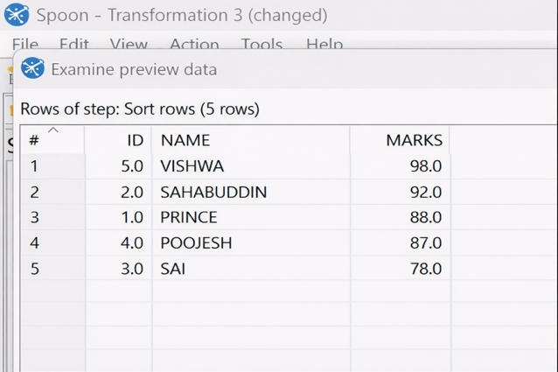

AFTER TRANSFORMATION:

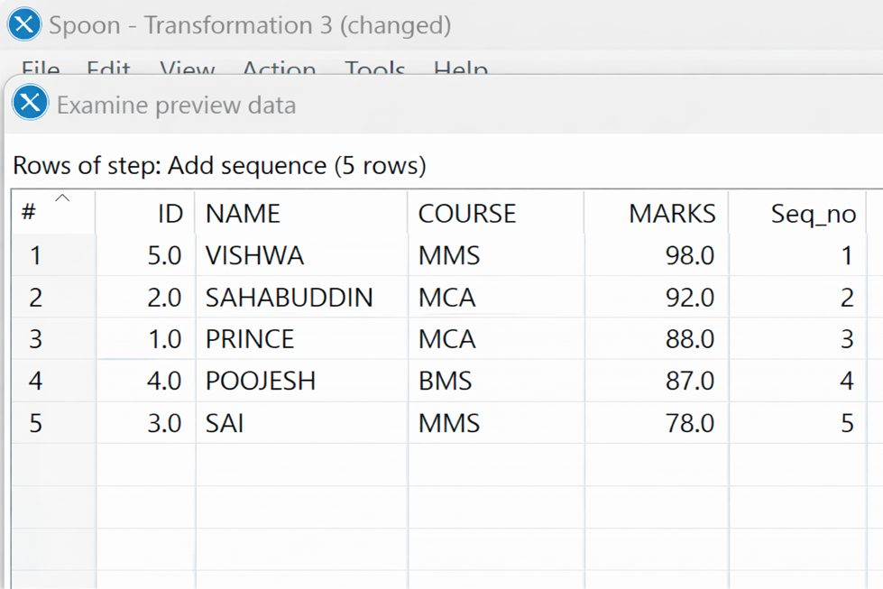

- Null If:

Step 1: Open up the Utility folder, drag and drop the Null if… step on to the transformation window next to Add Sequence.

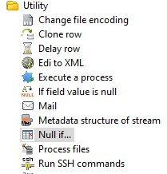

Step 2: Create a hop between Add Sequence and Null if... Double click on the Null if, in the ‘Name’ column select ‘course’ from the dropdown. In the ‘Value to turn to NULL’ column give the value as ‘Maths’ to transform it into NULL value and click on Ok.
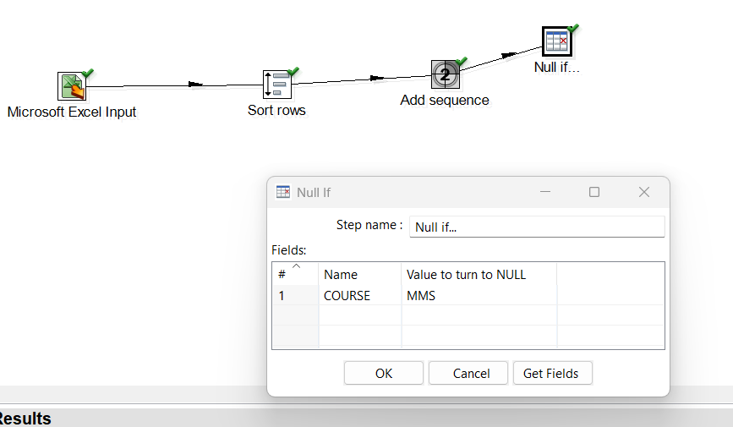

Step 3: Right Click on ‘Null if…’ step & click on Preview. A window will appear, click on Quick Launch button. Data with NULL value will be transformed.

BEFORE TRANSFORMATION:

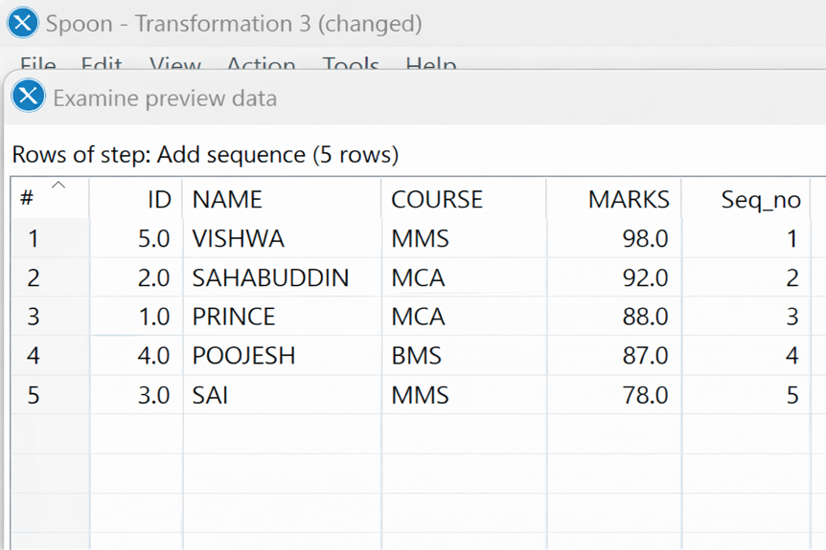

AFTER TRANSFORMATION:

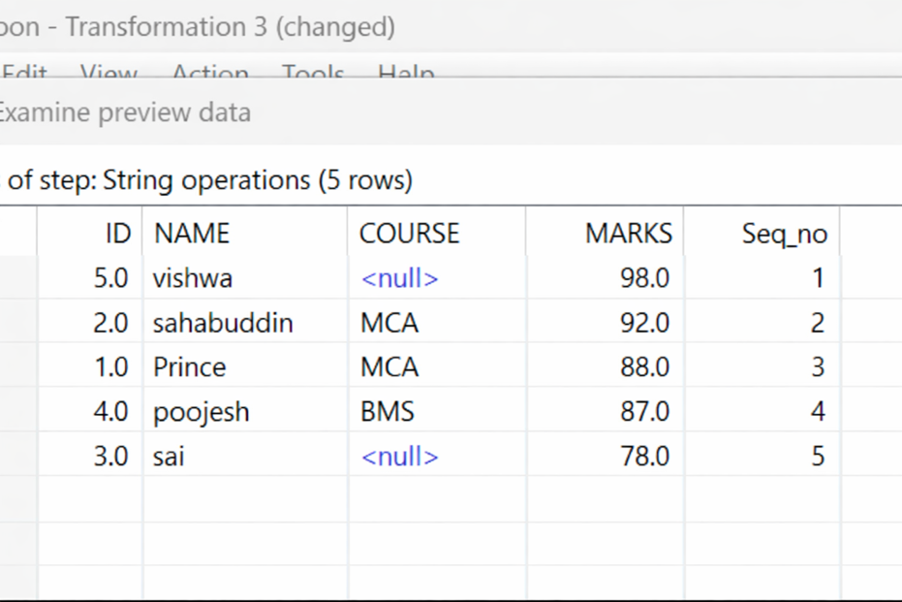

- String Operator - UPPER:

Step 1: Open up the Transform folder, drag and drop the String Operations step on to the transformation window next to Null if...
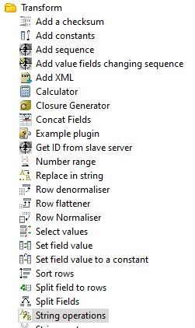
Step 2: Create a hop between Null if... and String Operations. Double click on the String
Operations. Select the values as ‘name’ from the dropdown in the ‘In stream field’ column. Select the values as ‘upper’ from the dropdown in the Lower/Upper column & click on Ok.
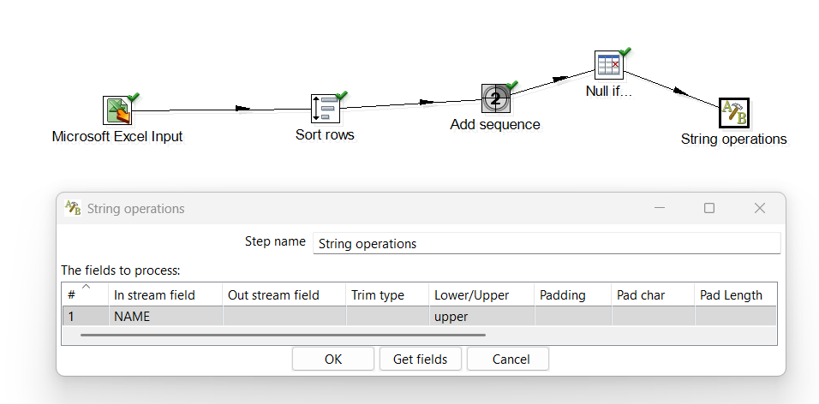

Step 3: Right Click on ‘String Operations’ step & click on Preview. A window will appear, click on Quick Launch button. Names in the column ‘name’ with uppercase values will be transformed.

BEFORE TRANSFORMATION:
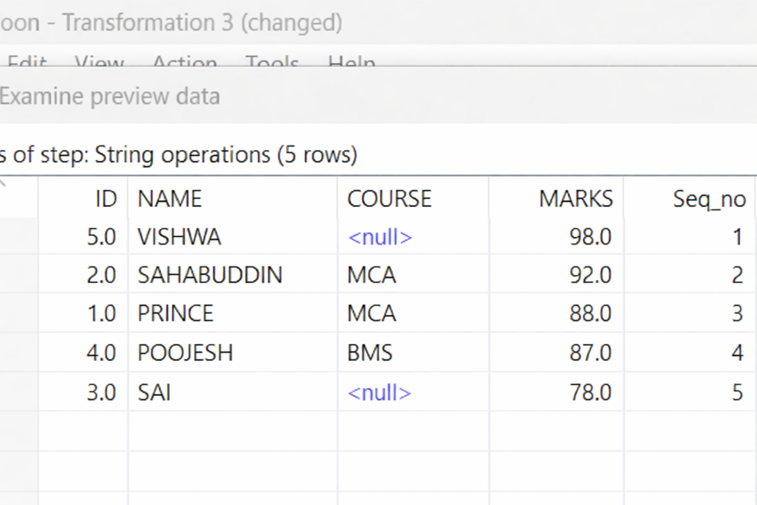

AFTER TRANSFORMATION: (ALREADY IN UPPER CASE)

- String Operator – LOWER:

Step 1: Open up the Transform folder, drag and drop the String Operations step on to the transformation window next to Null if...
Step 2: Create a hop between Null if... and String Operations. Double click on the String Operations. Select the values as ‘name’ from the dropdown in the ‘In stream field’ column. Select the values as ‘lower’ from the dropdown in the Lower/Upper column & click on Ok.
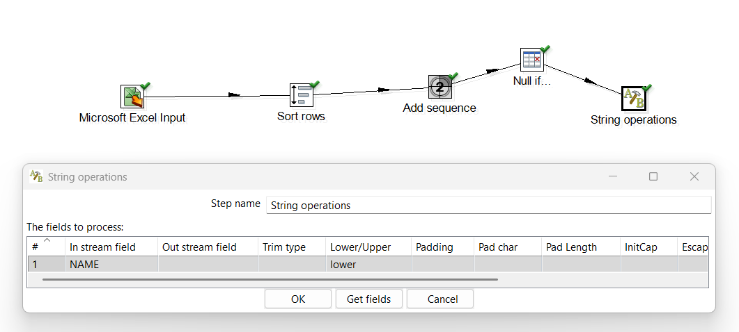
Step 3: Right Click on ‘String Operations’ step & click on Preview. A window will appear, click on Quick Launch button. Names in the column ‘name’ with lowercase values will be transformed.

BEFORE TRANSFORMATION:

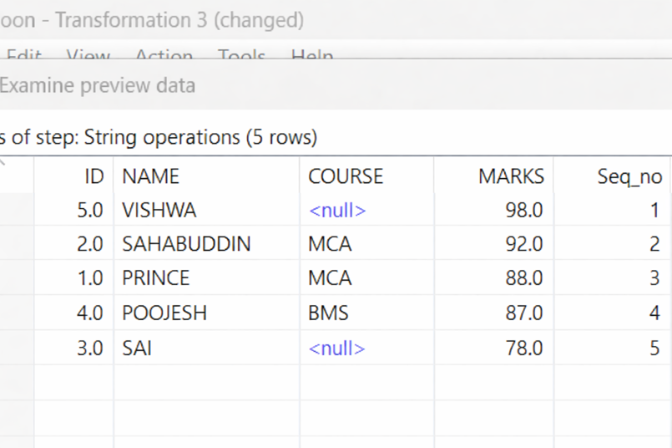

AFTER TRANSFORMATION:

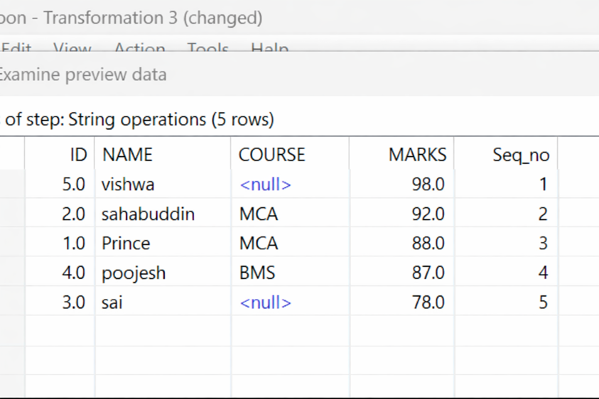

- Calculator:

Step 1: Open up the Transform folder, drag and drop the Calculator step on to the transformation window next to String Operations.

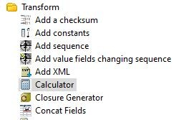
Step 2: Create a hop between String Operations and Calculator.
Double-click on the Calculator step.
In the New Field column, give the value as SQRT_MARKS.
Select SQRT (A) from the Calculation dropdown.
Select MARKS from the Field A dropdown and click on OK.
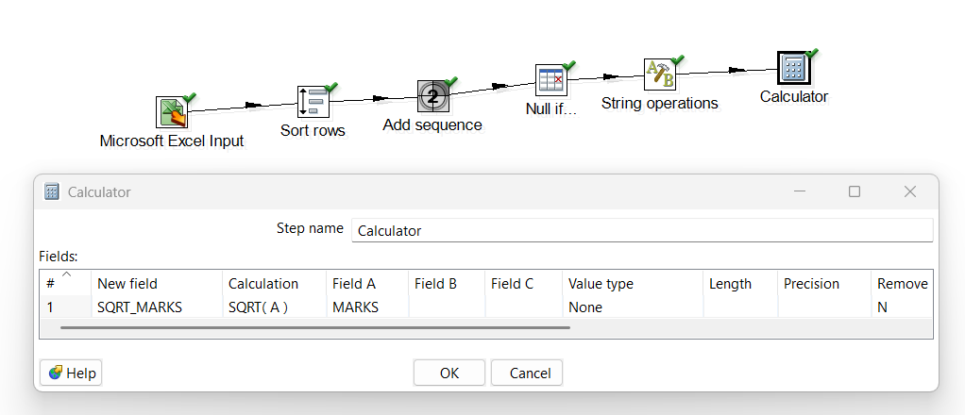

Step 3: Right Click on ‘Calculator’ step & click on Preview. A window will appear, click on Quick Launch button. A new column with integer values will be transformed.

BEFORE TRANSFORMATION:

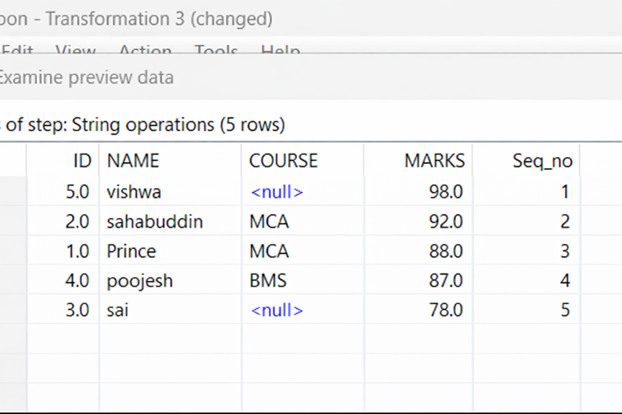

AFTER TRANSFORMATION:

