Practical - 10
Aim: Write a program to create a simple Spring Boot application that prints a message.
Step1:
Go to Spring Initializer.
Select the type of project (Maven).
Choose the language (Java).
Select the Spring Boot version.
Fillin the project metadata.
Add the necessary dependencies (at least spring- boot- starter-web).
Click on “Generate” to download the project.
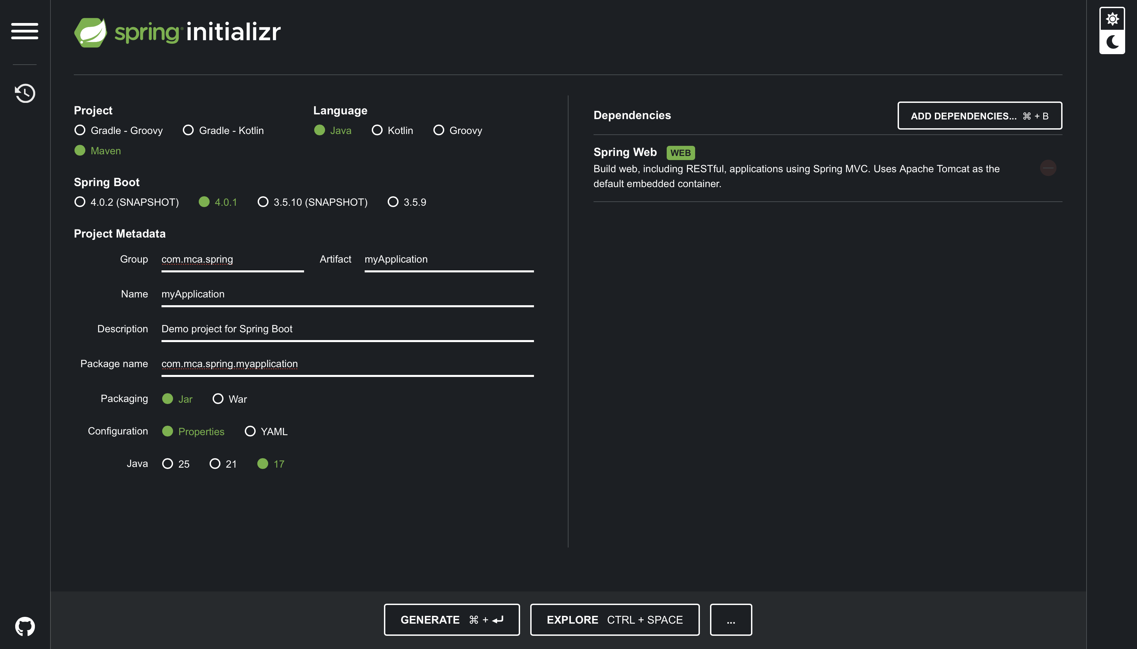
Step2:
Open Eclipse IDE.
Navigate to File;
Import.
Select “Existing Maven Projects”.
Click on “Next”.
Click on “Browse” and navigate to the location where you downloaded the project.
Make sure the pom.xml file is checked. Click on “Finish”.
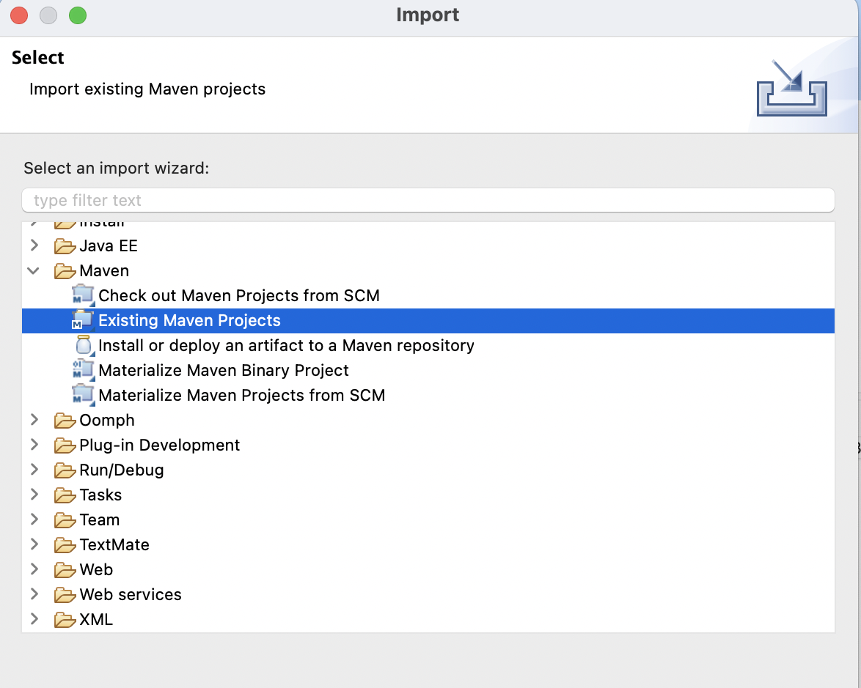
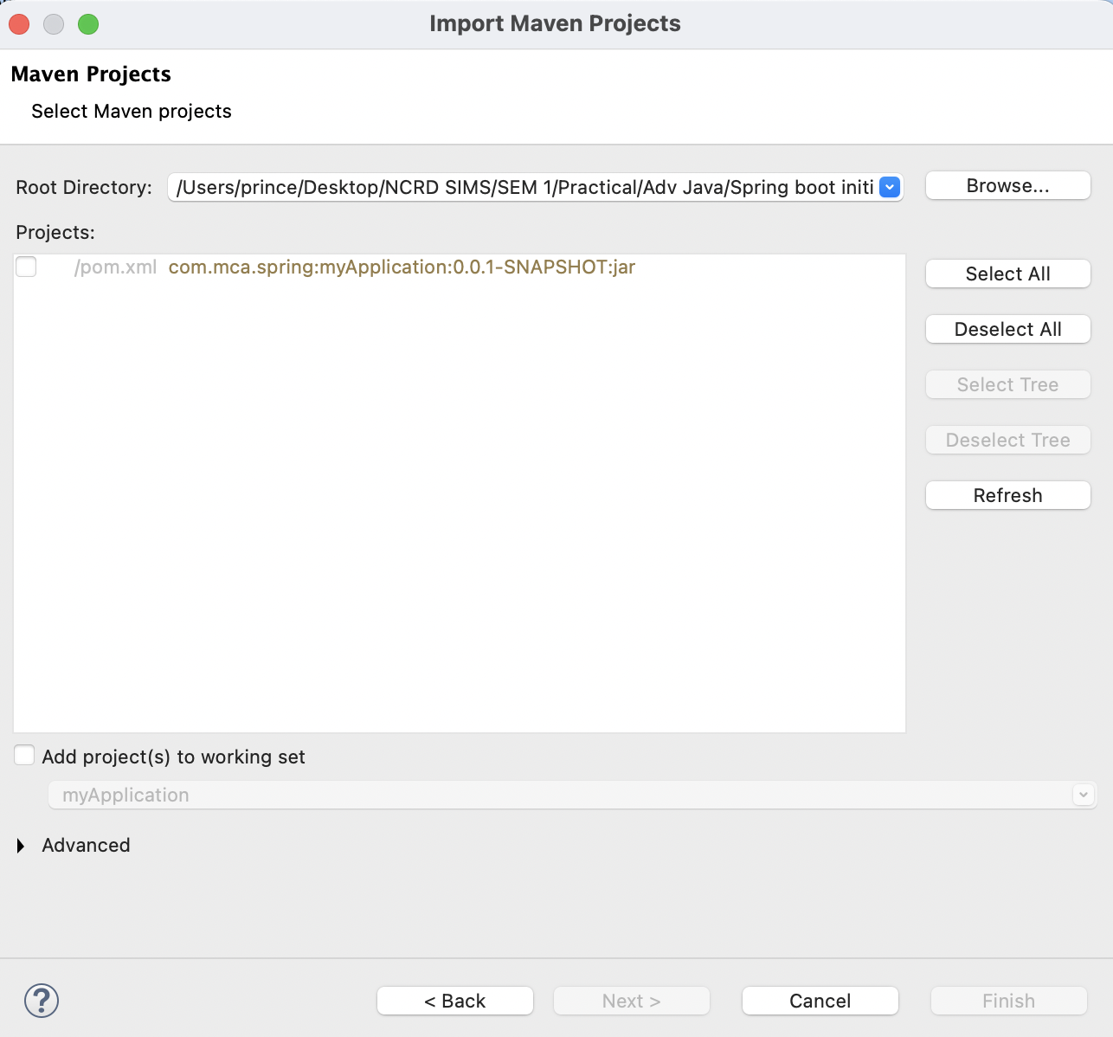
Main Class – MyApplication.java
package com.mca.spring.myapplication;
import org.springframework.boot.SpringApplication;
import org.springframework.boot.autoconfigure.SpringBootApplication;
import org.springframework.web.bind.annotation.GetMapping;
import org.springframework.web.bind.annotation.RestController;

@SpringBootApplication
@RestController
public class MyApplication {

public static void main(String[] args) {
SpringApplication.run(MyApplication.class, args);
}

@GetMapping("/")
public String quote() {
return "Prince Yadav - Hero? No! We’re pirates! I love heroes, but I don’t wanna be one!";
}
}

Output
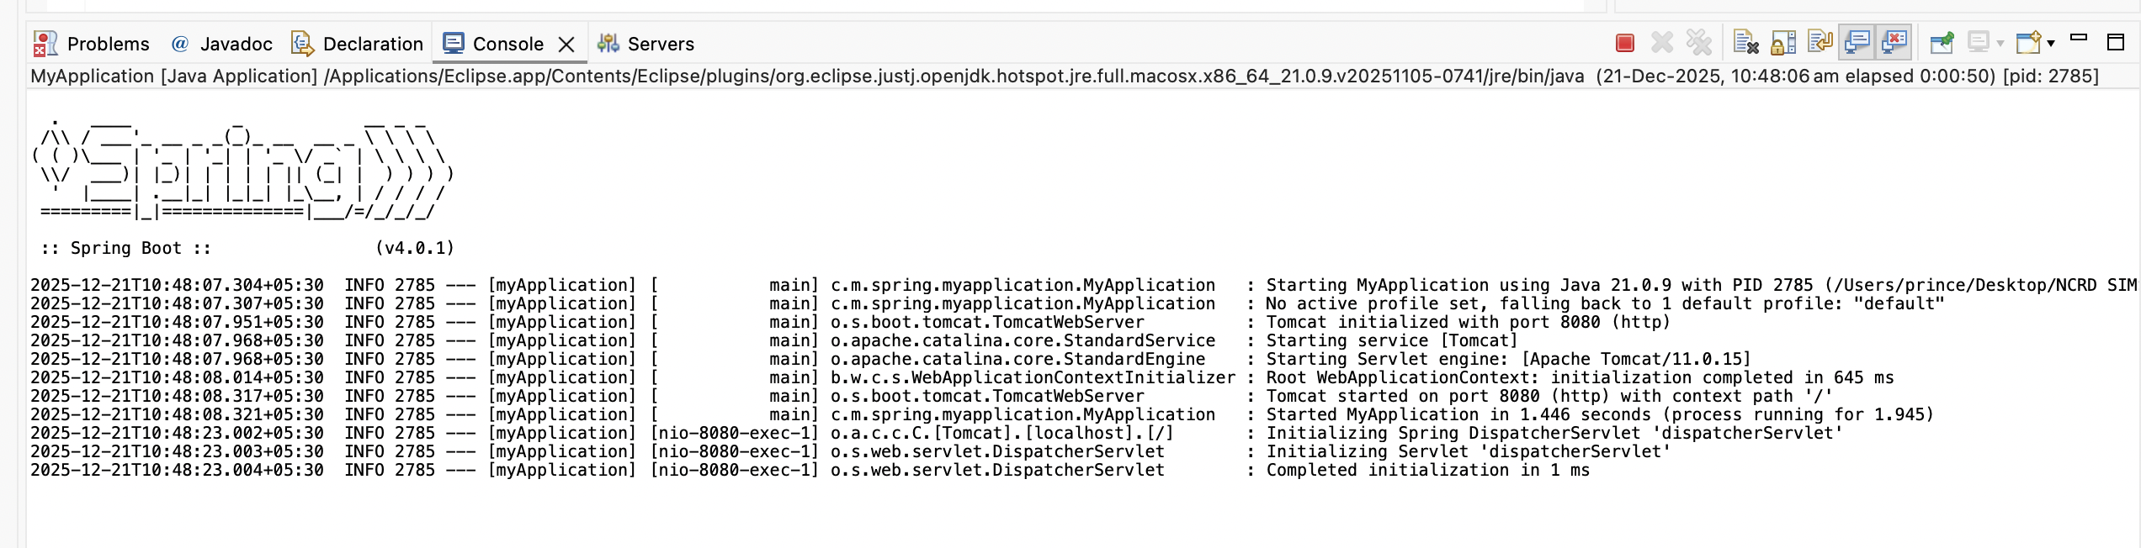
http://localhost:8080
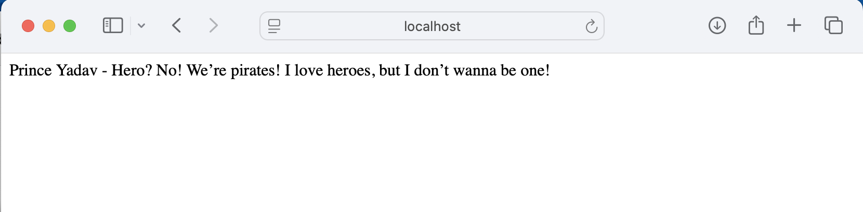

2 - Write a program to demonstrate RESTful Web Services with spring boot.
pom.xml
<?xml version="1.0" encoding="UTF-8"?>
<project xmlns="http://maven.apache.org/POM/4.0.0"
xmlns:xsi="http://www.w3.org/2001/XMLSchema-instance"
xsi:schemaLocation="http://maven.apache.org/POM/4.0.0
https://maven.apache.org/xsd/maven-4.0.0.xsd">

<modelVersion>4.0.0</modelVersion>

<parent>
<groupId>org.springframework.boot</groupId>
<artifactId>spring-boot-starter-parent</artifactId>
<version>3.2.0</version>
<relativePath/>
</parent>

<groupId>com.example</groupId>
<artifactId>demo</artifactId>
<version>0.0.1-SNAPSHOT</version>
<name>demo</name>
<description>Demo project for Spring Boot REST</description>

<properties>
<java.version>17</java.version>
</properties>

<dependencies>
<!-- Spring Boot REST / Web -->
<dependency>
<groupId>org.springframework.boot</groupId>
<artifactId>spring-boot-starter-web</artifactId>
</dependency>
</dependencies>

<build>
<plugins>
<plugin>
<groupId>org.springframework.boot</groupId>
<artifactId>spring-boot-maven-plugin</artifactId>
</plugin>
</plugins>
</build>

</project>

Main Application Class - DemoApplicationTests.java
package com.example.demo;

import org.springframework.boot.SpringApplication;
import org.springframework.boot.autoconfigure.SpringBootApplication;

@SpringBootApplication
public class DemoApplicationTests {

public static void main(String[] args) {
SpringApplication.run(DemoApplicationTests.class, args);
}
}

Model Class - Student.java
package com.example.demo.model;

public class Student {

private int id;
private String name;
private String course;

public Student() {
}

public Student(int id, String name, String course) {
this.id = id;
this.name = name;
this.course = course;
}

public int getId() {
return id;
}

public void setId(int id) {
this.id = id;
}

public String getName() {
return name;
}

public void setName(String name) {
this.name = name;
}

public String getCourse() {
return course;
}

public void setCourse(String course) {
this.course = course;
}
}

REST Controller - StudentController.java
package com.example.demo.controller;

import com.example.demo.model.Student;
import org.springframework.web.bind.annotation.*;

import java.util.ArrayList;
import java.util.List;

@RestController
@RequestMapping("/students")
public class StudentController {

private List<Student> students = new ArrayList<>();

// GET all students
@GetMapping
public List<Student> getAllStudents() {
return students;
}

// GET student by ID
@GetMapping("/{id}")
public Student getStudentById(@PathVariable int id) {
return students.stream()
.filter(student -> student.getId() == id)
.findFirst()
.orElse(null);
}
// POST - add student
@PostMapping
public String addStudent(@RequestBody Student student) {
students.add(student);
return "Student added successfully";
}
// PUT - update student
@PutMapping("/{id}")
public String updateStudent(@PathVariable int id, @RequestBody Student student) {
for (Student s : students) {
if (s.getId() == id) {
s.setName(student.getName());
s.setCourse(student.getCourse());
return "Student updated successfully";
}
}
return "Student not found";
}

// DELETE - remove student
@DeleteMapping("/{id}")
public String deleteStudent(@PathVariable int id) {
students.removeIf(student -> student.getId() == id);
return "Student deleted successfully";
}
}

Output:
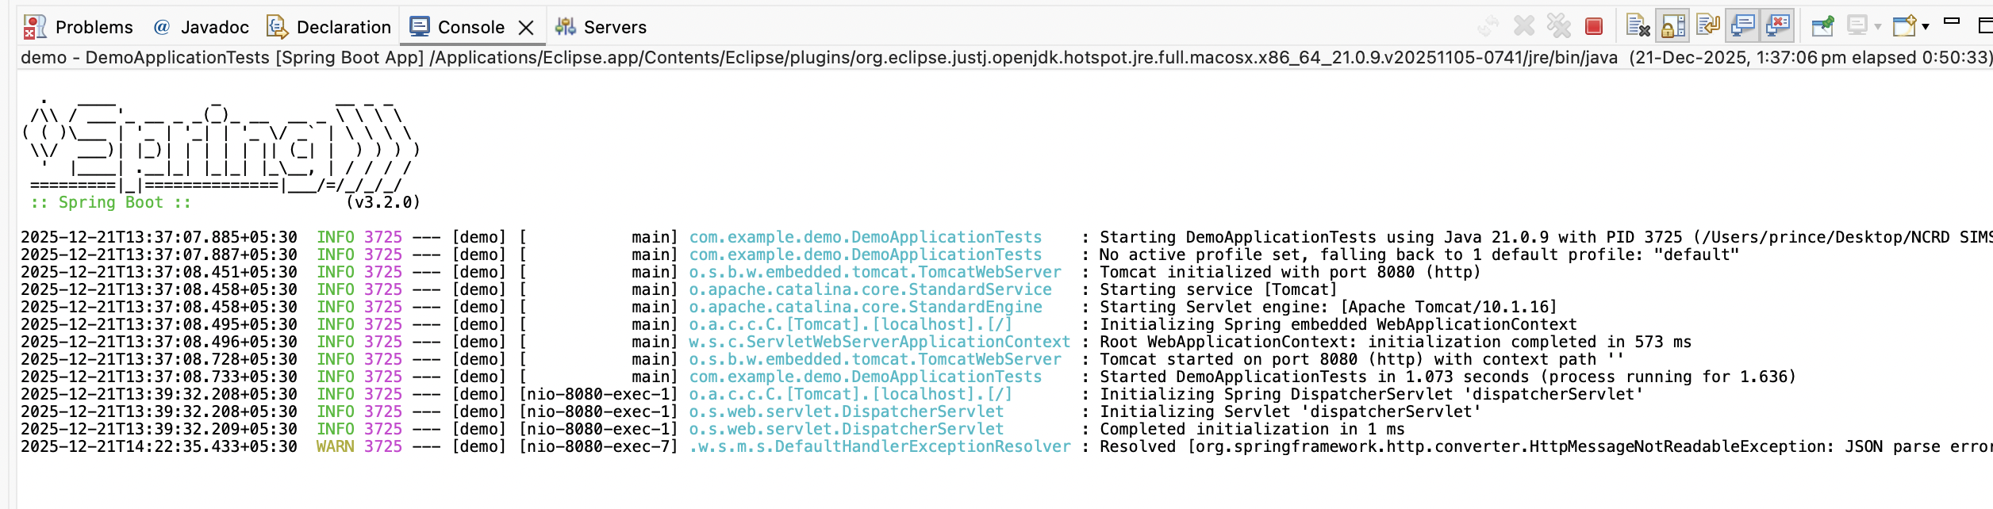
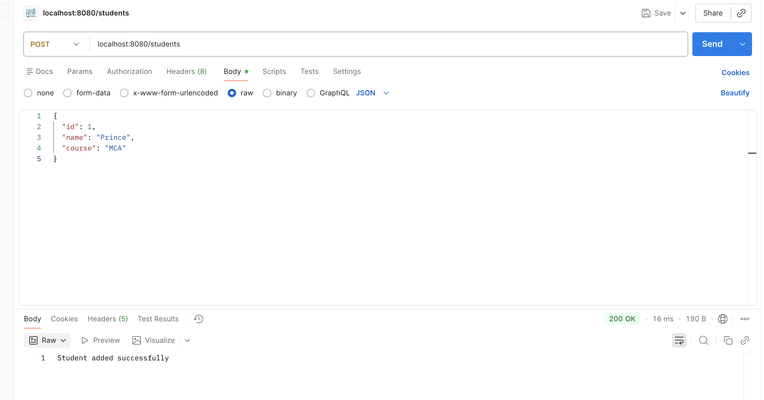

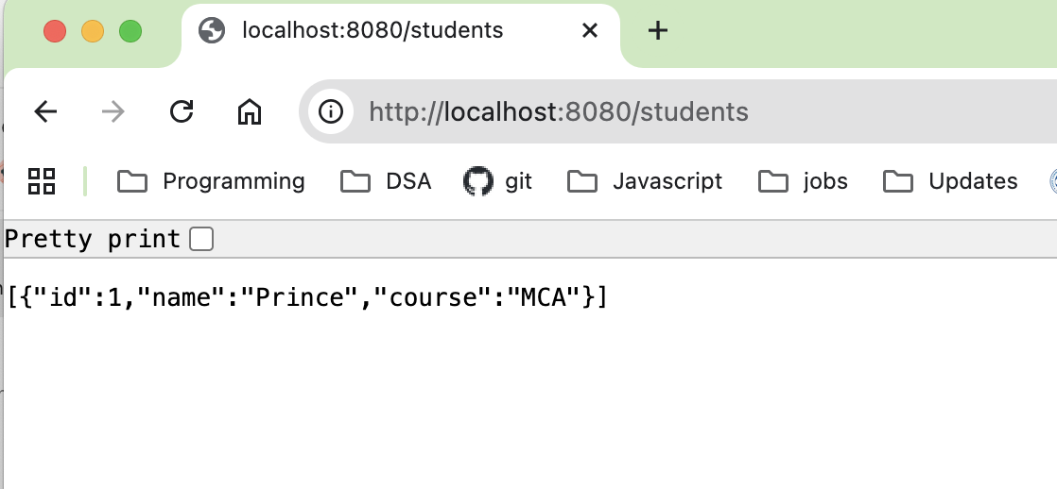

3. Write a program to demonstrate Database Connection with spring.
Database Table:
CREATE DATABASE testdb;
USE testdb;

CREATE TABLE user (
id INT PRIMARY KEY,
name VARCHAR(255),
email VARCHAR(255)
);
pom.xml
<?xml version="1.0" encoding="UTF-8"?>
<project xmlns="http://maven.apache.org/POM/4.0.0" xmlns:xsi="http://www.w3.org/2001/XMLSchema-instance"
xsi:schemaLocation="http://maven.apache.org/POM/4.0.0 https://maven.apache.org/xsd/maven-4.0.0.xsd">
<modelVersion>4.0.0</modelVersion>
<parent>
<groupId>org.springframework.boot</groupId>
<artifactId>spring-boot-starter-parent</artifactId>
<version>4.0.1</version>
<relativePath/> <!-- lookup parent from repository -->
</parent>
<groupId>com.example</groupId>
<artifactId>springbootdemo</artifactId>
<version>0.0.1-SNAPSHOT</version>
<name>springbootdemo</name>
<description>Demo project for Spring Boot</description>
<url/>
<licenses>
<license/>
</licenses>
<developers>
<developer/>
</developers>
<scm>
<connection/>
<developerConnection/>
<tag/>
<url/>
</scm>
<properties>
<java.version>17</java.version>
</properties>
<dependencies>
<dependency>
<groupId>org.springframework.boot</groupId>
<artifactId>spring-boot-starter-data-jpa</artifactId>
</dependency>
<dependency>
<groupId>org.springframework.boot</groupId>
<artifactId>spring-boot-starter-webmvc</artifactId>
</dependency>

<dependency>
<groupId>com.mysql</groupId>
<artifactId>mysql-connector-j</artifactId>
<scope>runtime</scope>
</dependency>
<dependency>
<groupId>org.springframework.boot</groupId>
<artifactId>spring-boot-starter-data-jpa-test</artifactId>
<scope>test</scope>
</dependency>
<dependency>
<groupId>org.springframework.boot</groupId>
<artifactId>spring-boot-starter-webmvc-test</artifactId>
<scope>test</scope>
</dependency>
</dependencies>

<build>
<plugins>
<plugin>
<groupId>org.springframework.boot</groupId>
<artifactId>spring-boot-maven-plugin</artifactId>
</plugin>
</plugins>
</build>

</project>

src/main/resources - > application.properties
spring.application.name=springbootdemo
server.port=8083

spring.datasource.url=jdbc:mysql://localhost:3306/testdb
spring.datasource.username=root
spring.datasource.password=

spring.jpa.hibernate.ddl-auto=update
spring.jpa.show-sql=true

Main Class – DemoApplication1.java
package com.example.rest.db;

import org.springframework.boot.SpringApplication;
import org.springframework.boot.autoconfigure.SpringBootApplication;

@SpringBootApplication
public class DemoApplication1 {

public static void main(String[] args) {
SpringApplication.run(DemoApplication1.class, args);
System.out.println("Database Connected Successfully!");
}
}

Entity Class – User.java
package com.example.rest.db;

import jakarta.persistence.Entity;
import jakarta.persistence.Id;

@Entity
public class User {

@Id
private int id;
private String name;
private String email;

public int getId() {
return id;
}
public void setId(int id) {
this.id = id;
}

public String getName() {
return name;
}
public void setName(String name) {
this.name = name;
}

public String getEmail() {
return email;
}
public void setEmail(String email) {
this.email = email;
}
}

UserController.java
package com.example.rest.db;

import org.springframework.data.jpa.repository.JpaRepository;

public interface UserRepository extends JpaRepository<User, Integer> {
}

Repository Interface – UserRepository.java
package com.example.rest.db;

import org.springframework.web.bind.annotation.*;

@RestController
@RequestMapping("/user")
public class UserController {

private final UserRepository repo;

public UserController(UserRepository repo) {
this.repo = repo;
}

@PostMapping("/save")
public String saveUser(@RequestBody User user) {
repo.save(user);
return "User saved in database";
}
}

Output

