Practical No – 1
A] Aim: To install Node.js on the system and verify its successful installation.
Step 1: Go to www.nodejs.org/en/download & Click on Windows Installer (.msi) (Downloading will start)
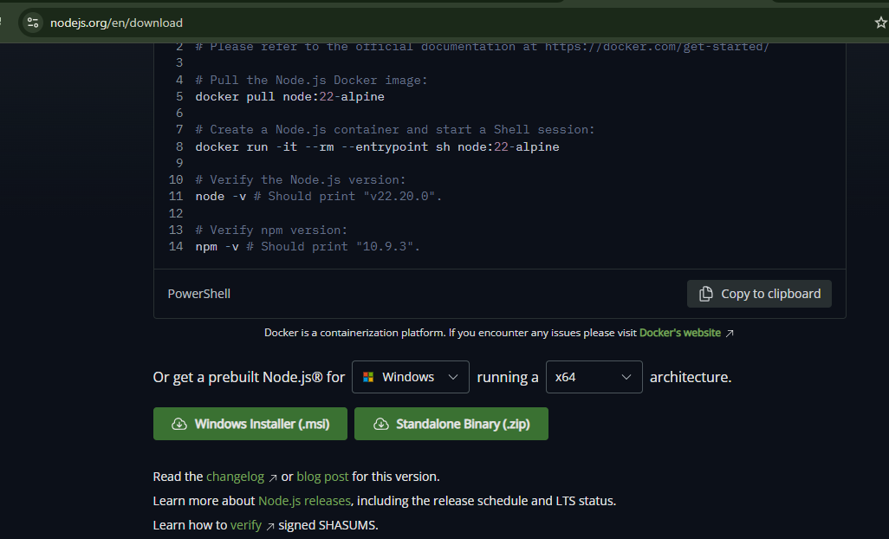
Step 2: Click on Downloaded file & installation window will popup.
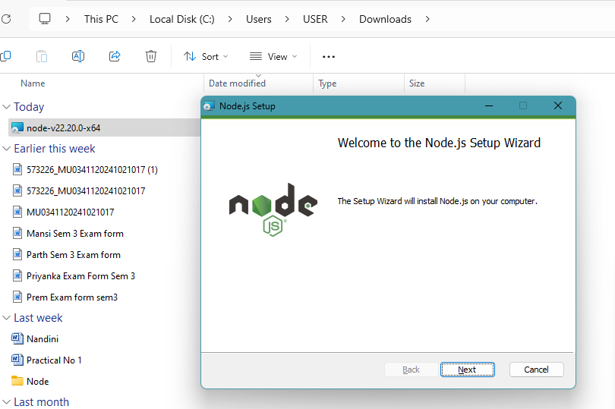

Step 3: Click on Next and Accept the Terms & Click on Next.
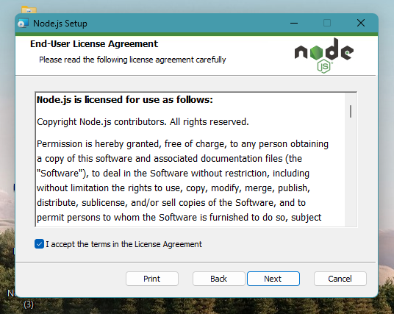
Step 4: Select the path of Installation & Click on Next.
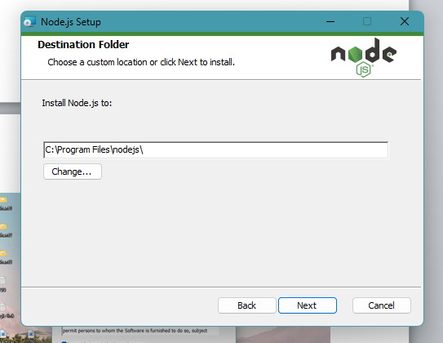
Click on Next.
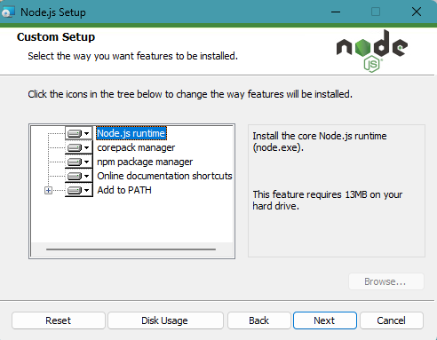

Step 5: Proceed to Install.
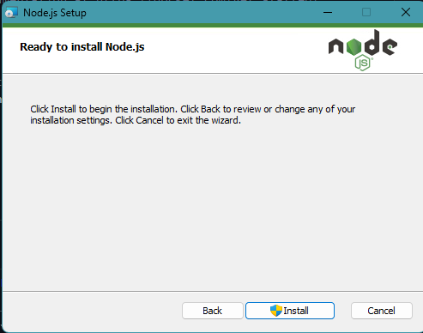
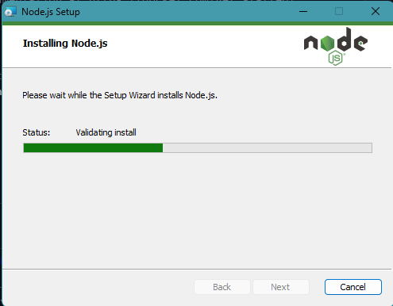
Step 6: Click on Finish.
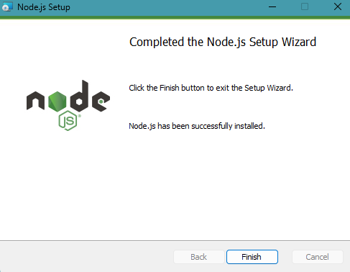

Step 6: Search for Node.js – A window will popup & Press any key to continue.
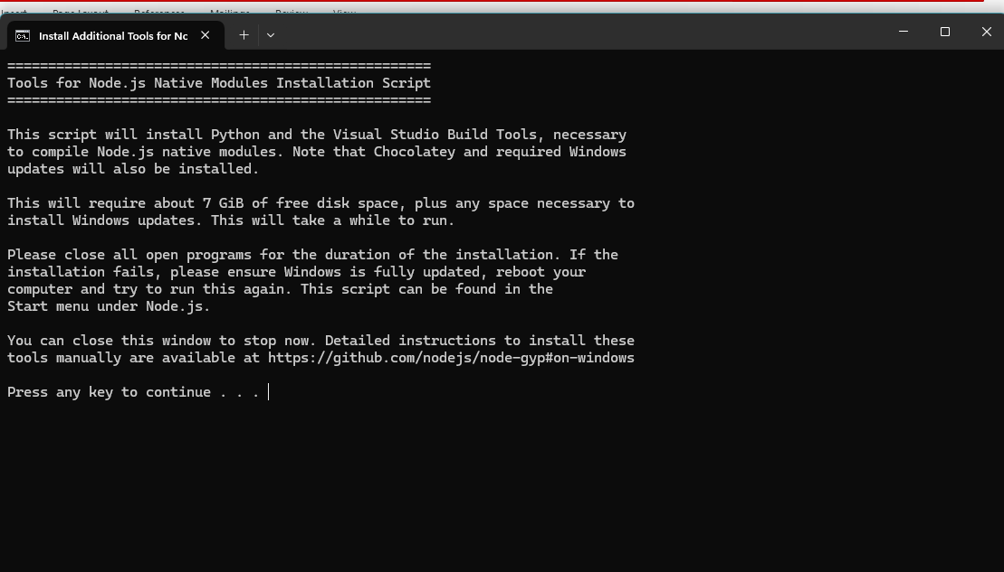
Step 7: Installation is completed - Node.js is ready to access.
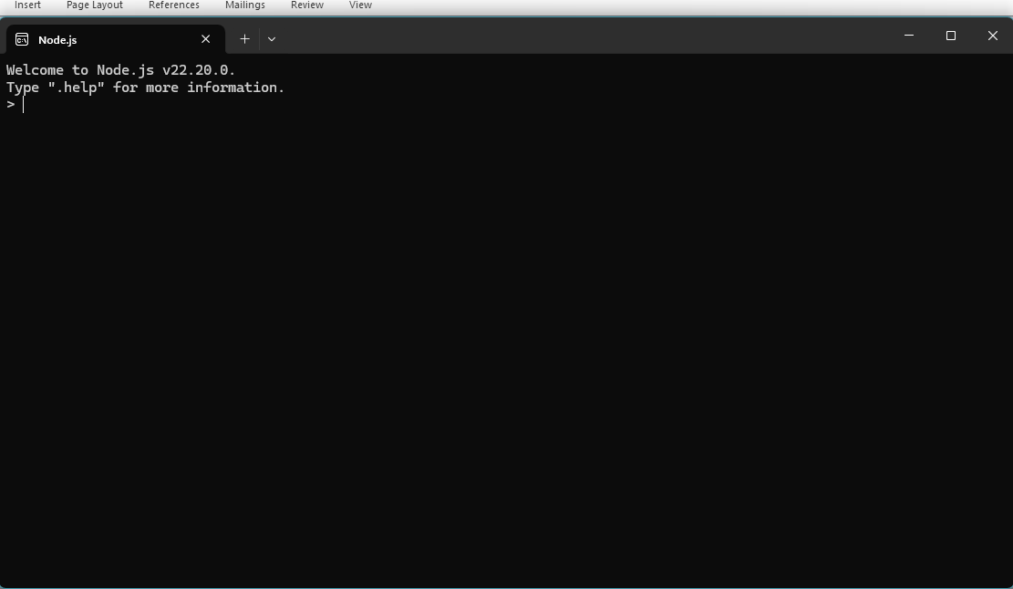

Practical No – 1
Aim: To execute basic Node.js console programs for arithmetic
A] Addition of two numbers
// addition.js
// Declare two numbers
let num1 = 10;
let num2 = 20;
// Perform addition
let sum = num1 + num2;
// Display result
console.log("Addition of two numbers:", sum);
Output
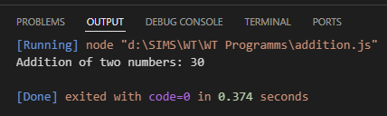

B] Simple calculator
const readline = require("readline");
const rl = readline.createInterface({
input: process.stdin,
output: process.stdout,
});
rl.question("Enter first number: ", (a) => {
rl.question("Enter second number: ", (b) => {
const num1 = Number(a);
const num2 = Number(b);
console.log("Addition:", num1 + num2);
console.log("Subtraction:", num1 - num2);
console.log("Multiplication:", num1 * num2);
console.log("Division:", num1 / num2);
rl.close();
});
});
Output
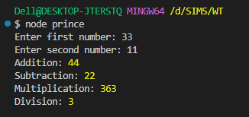

Practical – 2
Aim: To implement iterative logic using Node.js loops.
A) Implementation using do…while loop
let i = 1
do {
console.log(i)
i++
} while (i <= 5)

Output:
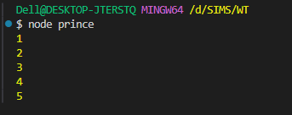

B) Implementation using for loop.
for (let i = 1; i <= 5; i++) {
console.log(i);
}
Output:
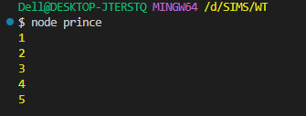

Practical No – 3
Aim: To demonstrate mathematical table generation and conditional logic
A) Generating table of 2
for (let i = 1; i <= 10; i++) {
console.log(`2 x ${i} = ${2 * i}`);
}
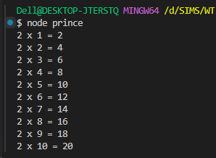

B) Generating table of 3
for (let i = 1; i <= 10; i++) {
console.log(`3 x ${i} = ${3 * i}`)
}
Output:
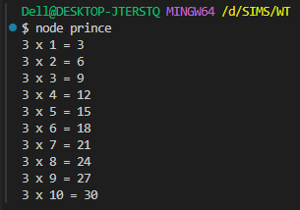

C) Finding the greatest of three numbers using if…else if
const x = 12;
const y = 55;
const z = 55;
if (x >= y && x >= z) {
console.log(x);
} else if (y >= x && y >= z) {
console.log(y);
} else {
console.log(z);
}
Output:
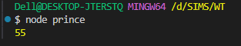

Practical No – 4
AIM: To demonstrate nested loop structures for pattern printing.
Print * patterns using nested loops.
Code 1:
for (let i = 1; i <= 5; i++) {
let row = "";
for (let j = 1; j <= i; j++) {
row += "* ";
}
console.log(row);
}
Output:
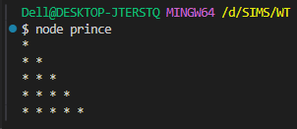

Code 2:
let rows = 5;
for (let i = 1; i <= rows; i++) {
let line = "";
for (let space = 1; space <= rows - i; space++) {
line += " ";
}
for (let star = 1; star <= i; star++) {
line += "* ";
}
console.log(line);
}

Output:
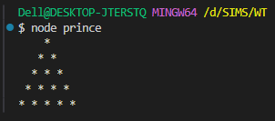
Code 3:
for (let i = 1; i <= 4; i++) {
let row = "";
for (let j = 1; j <= 4; j++) {
row += "*";
}
console.log(row);
}
Output:
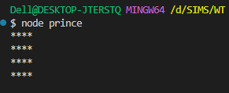

Code 4
let n = 5;
for (let i = n; i >= 1; i--) {
let pattern = "";
for (let s = 0; s < n - i; s++) {
pattern += " ";
}
for (let j = 1; j <= i; j++) {
pattern += "* ";
}
console.log(pattern);
}
Output:
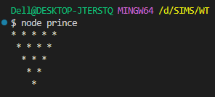

Practical No – 5
Aim: To implement number property checks and ranges.
A] Write a program to find if the number is odd or even.
const readline = require("readline");
const rl = readline.createInterface({
input: process.stdin,
output: process.stdout,
});
rl.question("Enter a number: ", (n) => {
console.log(Number(n) % 2 === 0 ? "Even" : "Odd");
rl.close();
});
Output:
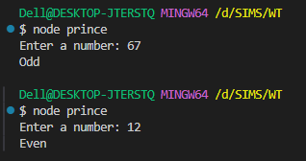
B] Write a program to print the Prime Numbers from 1 to 50.
for (let i = 2; i <= 50; i++) {
let prime = true;
for (let j = 2; j < i; j++) {
if (i % j === 0) {
prime = false;
break;
} }
if (prime) console.log(i);
}
Output:
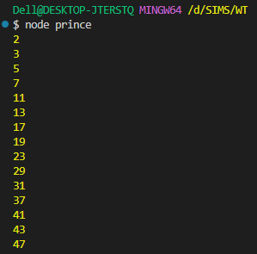
Practical No – 6
Aim: To study digit manipulation and mathematical constants.
A] Write a program to index the reverse of a four-digit number.
Code:
console.log("prince 127");
function reverseNumber(num) {
if (num < 1000 || num > 9999) {
console.log("Please enter valid four digit number");
return;
}
const reverseNum = num.toString().split("").reverse().join("");
return parseInt(reverseNum);
}
const number = 3425;
const reversed = reverseNumber(number);
console.log("Orignal :" + number);
console.log("Reversed :" + reversed);

Output:
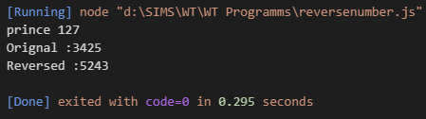

B] Write a program to check if the entered number is Armstrong or not.
Code:
console.log("Prince 127");
function isArmstrong(num) {
const numStr = num.toString();
const numDigits = numStr.length;
let sum = 0;
let temp = num;
while (temp > 0) {
const digit = temp % 10;
sum += Math.pow(digit, numDigits);
temp = Math.floor(temp / 10);
}
if (sum === num) {
console.log(num + " is an Armstrong number!");
} else {
console.log(num + " is not an Armstrong number.");
}}
isArmstrong(153); // 153 is an Armstrong number!
isArmstrong(123); // 123 is not an Armstrong number.

Output:
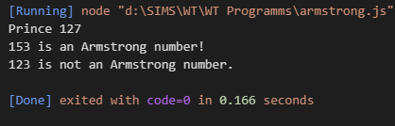

Practical No – 7
AIM: To implement series generation and unit conversion.
A) Write a program to print the Fibonacci series
Code:
Code:
console.log("Prince 127");
function printFibonacci(n) {
let a = 0,
b = 1,
next;
console.log("Fibonacci Series up to " + n + " terms:");
for (let i = 1; i <= n; i++) {
console.log(a);
next = a + b;
a = b;
b = next;
}}
const prompt = require("prompt-sync")();
const numTerms = parseInt(
prompt("Enter the number of terms for Fibonacci series: ")
);
printFibonacci(numTerms);
Output:
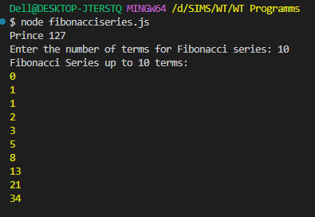

B) Write a program to convert the temperature entered by the user.
Code:
console.log("Prince 127");
const prompt = require("prompt-sync")();
function celsiusToFahrenheit(celsius) {
return (celsius * 9) / 5 + 32;
}
function fahrenheitToCelsius(fahrenheit) {
return ((fahrenheit - 32) * 5) / 9;
}
console.log("Choose the conversion type:");
console.log("1. Celsius to Fahrenheit");
console.log("2. Fahrenheit to Celsius");
const choice = prompt("Enter 1 or 2 to choose conversion: ");
if (choice === "1") {
const celsius = parseFloat(prompt("Enter temperature in Celsius: "));
const fahrenheit = celsiusToFahrenheit(celsius);
console.log(`${celsius}°C is equal to ${fahrenheit}°F`);
} else if (choice === "2") {
const fahrenheit = parseFloat(prompt("Enter temperature in Fahrenheit: "));
const celsius = fahrenheitToCelsius(fahrenheit);
console.log(`${fahrenheit}°F is equal to ${celsius}°C`);
} else {
console.log("Invalid choice. Please enter 1 or 2.");
}
Output
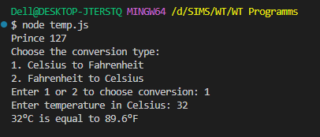

Practical No – 8
AIM: To demonstrate the use of Anonymous Functions in Node.js.
A] Write a program to demonstrate the factorial of a number using Anonymous Functions
Code:
console.log("Prince 127");
const prompt = require("prompt");
prompt.start();
prompt.get(["number"], function (err, result) {
if (err) {
console.error("Error occurred:", err);
return;
}
const number = parseInt(result.number);
if (isNaN(number) || number < 0) {
console.log("Please enter a valid non-negative integer.");
return;
}
const factorial = function (num) {
return num === 0 ? 1 : num * factorial(num - 1);
};
console.log(`The factorial of ${number} is: ${factorial(number)}`);
});
Output:
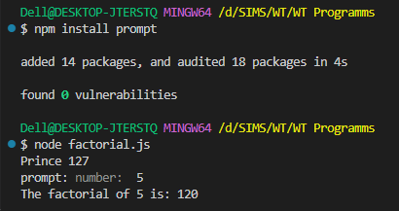

B) Write a program to demonstrate the Pattern using Anonymous Functions.
Code:
console.log("prince 127");
const generatePattern = (rows) => {
const patternLine = (i) =>
Array.from({ length: i }, (_, idx) => idx + 1).join(" ");
for (let i = 1; i <= rows; i++) {
console.log(patternLine(i));
}};
const rows = 5;
generatePattern(rows);

Output:
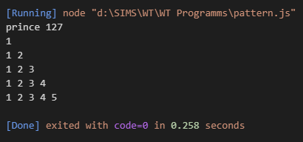

Practical No – 9
AIM: To study asynchronous behavior and Callback functions.
A) Write a program to demonstrate the arithmetic operations using Callback Functions.
Code:
console.log("prince 127");
function add(a, b, callback) {
const result = a + b;
callback(null, result);
}
function subtract(a, b, callback) {
const result = a - b;
callback(null, result);
}
function multiply(a, b, callback) {
const result = a * b;
callback(null, result);
}
function divide(a, b, callback) {
if (b === 0) {
callback("Error: Division by zero is not allowed", null);
} else {
const result = a / b;
callback(null, result);
}}
function main() {
const a = 10,
b = 5;
console.log("Performing Arithmetic Operations Using Callbacks:");
add(a, b, (err, result) => {
if (err) {
console.error(err);
} else {
console.log(`Addition: ${a} + ${b} = ${result}`);
} });
subtract(a, b, (err, result) => {
if (err) {
console.error(err);
} else {
console.log(`Subtraction: ${a} - ${b} = ${result}`);
} });
multiply(a, b, (err, result) => {
if (err) {
console.error(err);
} else {
console.log(`Multiplication: ${a} * ${b} = ${result}`);
} });
divide(a, b, (err, result) => {
if (err) {
console.error(err);
} else {
console.log(`Division: ${a} / ${b} = ${result}`);
}});
}
main();
Output:
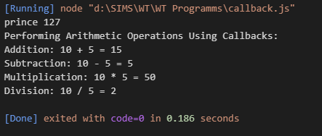

B) Write a program to demonstrate the setTimeout function
Code:
const delayedTask = () => {
console.log("This message is displayed after a 3-second delay.");
};
console.log("Program started. Waiting for 3 seconds...");
console.log("You will see this message immediately after the program starts.");
Output:
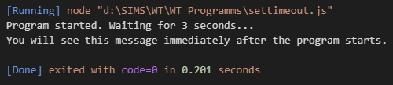

Practical No – 10
AIM: To implement modularity in Node.js using require and exports.
A) Aim: Using modules, perform the Arithmetic Operations.
Arithmetic.js
function add(a, b) {
return a + b;
}
function subtract(a, b) {
return a - b;
}
function multiply(a, b) {
return a * b;
}
function divide(a, b) {
if (b === 0) {
return "Error: Division by zero is not allowed.";
}
return a / b;
}
module.exports = { add, subtract, multiply, divide };

Index.js
const arithmetic = require("./arithmetic");
const num1 = 10;
const num2 = 5;
console.log(`Addition of ${num1} and ${num2}: ${arithmetic.add(num1, num2)}`);
console.log(`Subtraction of ${num1} and ${num2}: ${arithmetic.subtract(num1, num2)}`);
console.log( `Multiplication of ${num1} and ${num2}: ${arithmetic.multiply(num1, num2)}`);
console.log(`Division of ${num1} by ${num2}: ${arithmetic.divide(num1, num2)}`);

Output
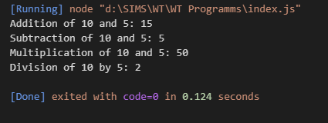
B) Using modules, index the Area of a Circle, Rectangle, Square
area.js
function circle(radius) {
if (radius < 0) return "Invalid radius";
return Math.PI * radius * radius;
}
function rectangle(length, width) {
if (length < 0 || width < 0) return "Invalid dimensions";
return length * width;
}
function square(side) {
if (side < 0) return "Invalid side length";
return side * side;
}
module.exports = { circle, rectangle, square };
console.log("Exported object:", module.exports);

index1.js
const area = require("./area");
console.log("Imported area module:", area);
const radius = 5;
const length = 10;
const width = 6;
const side = 4;
console.log(`Area of Circle with radius ${radius}:`, area.circle(radius));
console.log( `Area of Rectangle with length ${length} and width ${width}:`,
area.rectangle(length, width));
console.log(`Area of Square with side ${side}:`, area.square(side));

Output:
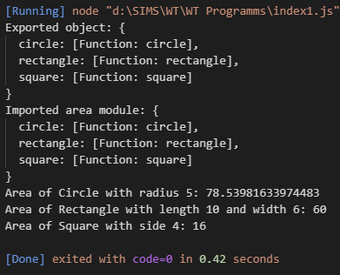

Practical No – 11
AIM: To implement user input processing and complex grading logic.
A) Write a program to take the marks of four subjects from user and check if the student has passed the examination or not, calculate percentage and grade.
Code:
console.log("Prince 127");
const prompt = require("prompt-sync")();
const subject1 = parseFloat(prompt("Enter marks for subject 1: "));
const subject2 = parseFloat(prompt("Enter marks for subject 2: "));
const subject3 = parseFloat(prompt("Enter marks for subject 3: "));
const subject4 = parseFloat(prompt("Enter marks for subject 4: "));
let passStatus;
// Check pass/fail for all subjects
if (subject1 >= 40 && subject2 >= 40 && subject3 >= 40 && subject4 >= 40) {
passStatus = "Passed";
} else {
passStatus = "Failed";
}
const totalMarks = subject1 + subject2 + subject3 + subject4;
const percentage = (totalMarks / 400) * 100;
function calculateGrade(percentage) {
if (percentage >= 90) {
return "A+";
} else if (percentage >= 80) {
return "A";
} else if (percentage >= 70) {
return "B+";
} else if (percentage >= 60) {
return "B";
} else if (percentage >= 50) {
return "C+";
} else if (percentage >= 40) {
return "C";
} else {
return "F";
}
}
const grade = calculateGrade(percentage);
console.log(`\n--- Result ---`);
console.log(`Total Marks: ${totalMarks}/400`);
console.log(`Percentage: ${percentage.toFixed(2)}%`);
console.log(`Status: ${passStatus}`);
console.log(`Grade: ${grade}`);

Output:
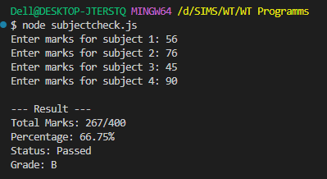
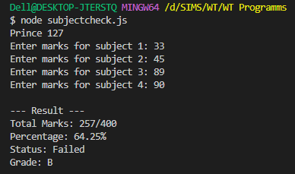

Practical No – 12
Aim: To manage event listeners within the EventEmiter class.
Write an application on to demonstrate function on (removeListner, listnerCount).
console.log("Name: Prince Yadav 127");
const events = require("events");
const eventEmitter = new events.EventEmitter();
function listner1() {
console.log("Event received by Listner 1");
}
function listner2() {
console.log("Event received by Listner 2");
}
eventEmitter.addListener("write", listner1);
eventEmitter.on("write", listner2);
eventEmitter.emit("write");
console.log(eventEmitter.listenerCount("write"));
eventEmitter.removeListener("write", listner1);
console.log("Listner 1 is removed");
eventEmitter.emit("write");
console.log(eventEmitter.listenerCount("write"));
console.log("Program Ended ....");
Output:
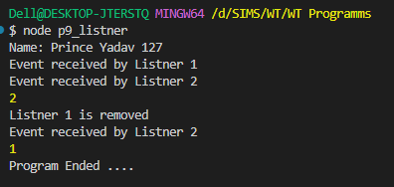

Practical No – 13
Aim: To implement advanced EventEmitter patterns.
A) Create an application in node.js to create Return Event Emitter.
Code:
console.log("Name: Prince Yadav 127");
var emitter = require("events").EventEmitter;

function LoopProcessor(num) {
var e = new emitter();
setTimeout(function () {
for (var i = 1; i <= num; i++) {
e.emit("BeforeProcess", i);
console.log("processing number:" + i);
e.emit("AfterProcess", i);
}
}, 2000);
return e;
}
var lp = LoopProcessor(3);
lp.on("BeforeProcess", function (data) {
console.log("About to start the process for " + data);
});
lp.on("AfterProcess", function (data) {
console.log("completed processing " + data);
});
Output:
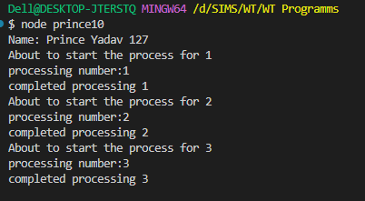

B) Create an application on in node.js to create Extent Event Emitter.
Code:
console.log("Name: Prince Yadav 127");
var emitter = require("events").EventEmitter;
var util = require("util");
function LoopProcessor(num) {
var me = this;
setTimeout(function () {
for (var i = 1; i <= num; i++) {
me.emit("BeforeProcess", i);
console.log("processing number:" + i);
me.emit("AfterProcess", i);
}
}, 2000);
return this;
}
util.inherits(LoopProcessor, emitter);
var lp = new LoopProcessor(3);
lp.on("BeforeProcess", function (data) {
console.log("About to start the process for " + data);
});
lp.on("AfterProcess", function (data) {
console.log("completed processing " + data);
});
Output:
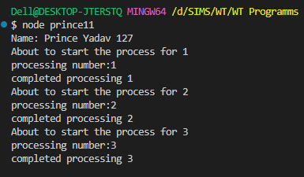

Practical No – 14
Aim: To apply event-driven programming to business workflow.
1) Write a program to place the order for a pizza using Events.
Code:
console.log("Name: Prince Yadav 127");
const EventEmitter = require("events");
class PizzaOrder extends EventEmitter {}
const pizzaShop = new PizzaOrder();
pizzaShop.on("orderPlaced", (customerName, pizzaType) => {
console.log(`Order placed by ${customerName} for a ${pizzaType} pizza.`);
setTimeout(() => {
pizzaShop.emit("preparing", customerName, pizzaType);
}, 2000);
});
pizzaShop.on("preparing", (customerName, pizzaType) => {
console.log(`Preparing the ${pizzaType} pizza for ${customerName}.`);
setTimeout(() => {
pizzaShop.emit("delivering", customerName, pizzaType);
}, 3000);
});
pizzaShop.on("delivering", (customerName, pizzaType) => {
console.log(`Delivering the ${pizzaType} pizza to ${customerName}.`);
setTimeout(() => {
pizzaShop.emit("delivered", customerName, pizzaType);
}, 2000);
});
pizzaShop.on("delivered", (customerName, pizzaType) => {
console.log(
`The ${pizzaType} pizza has been delivered to ${customerName}. Enjoy your meal!`
);
});
console.log("Welcome to Pizza Shop!");
setTimeout(() => {
pizzaShop.emit("orderPlaced", "Suraj Sanap", "Margherita");
}, 1000);
Output:
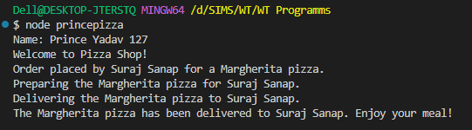
Practical No – 15
Aim: To apply event-driven programming to financial calculation.
1)Write a program to calculate the salary using Event.
Code:
console.log("Name: Prince Yadav 127");
const EventEmitter = require("events");
class SalaryCalculator extends EventEmitter {}
const salaryEmitter = new SalaryCalculator();
const TAX_RATE = 0.2;
const BONUS = 5000;
const DEDUCTIONS = 2000;
salaryEmitter.on("calculate", (baseSalary) => {
console.log(`Base Salary: $${baseSalary}`);
const tax = baseSalary * TAX_RATE;
salaryEmitter.emit("applyTax", baseSalary, tax);
});
salaryEmitter.on("applyTax", (baseSalary, tax) => {
console.log(`Tax Deducted: $${tax}`);
const afterTaxSalary = baseSalary - tax;
salaryEmitter.emit("applyBonus", afterTaxSalary);
});
salaryEmitter.on("applyBonus", (afterTaxSalary) => {
console.log(`Bonus Added: $${BONUS}`);
const afterBonusSalary = afterTaxSalary + BONUS;
salaryEmitter.emit("applyDeductions", afterBonusSalary);
});
salaryEmitter.on("applyDeductions", (afterBonusSalary) => {
console.log(`Other Deductions: $${DEDUCTIONS}`);
const finalSalary = afterBonusSalary - DEDUCTIONS;
salaryEmitter.emit("finalSalary", finalSalary);
});
salaryEmitter.on("finalSalary", (finalSalary) => {
console.log(`Final Salary: $${finalSalary}`);
});
const baseSalary = 50000;
console.log("Starting salary calculation...");
salaryEmitter.emit("calculate", baseSalary);

Output:
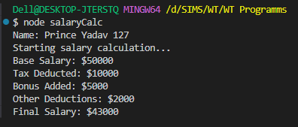

Practical No – 16
Aim: To handle arrays and duplicate events.
A) Write a program to create Event Emitters to print the sum of odd and even numbers
from an array.
console.log("Name: Prince Yadav 127");
const EventEmitter = require("events");
class SumEmitter extends EventEmitter {
constructor(arr) {
super();
this.arr = arr;
}
sumEven() {
let evenSum = this.arr
.filter((num) => num % 2 == 0)
.reduce((acc, curr) => acc + curr, 0);
this.emit("evenSum", evenSum);
}
sumOdd() {
let oddSum = this.arr
.filter((num) => num % 2 !== 0)
.reduce((acc, curr) => acc + curr, 0);
this.emit("oddSum", oddSum);
}
}
const numbers = [1, 2, 3, 4, 5, 6, 7, 8, 9, 10];
const sumEmitter = new SumEmitter(numbers);
sumEmitter.on("evenSum", (sum) => {
console.log(`The sum of even numbers is: ${sum}`);
});
sumEmitter.on("oddSum", (sum) => {
console.log(`The sum of odd numbers is: ${sum}`);
});
sumEmitter.sumEven();
sumEmitter.sumOdd();

Output:
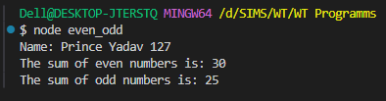

B) Write a program to demonstrate Events by the same name.
console.log("Name: Prince Yadav 127");
const EventEmitter = require("events");
const eventEmitter = new EventEmitter();
eventEmitter.on("greet", (name) => {
console.log(`Hello, ${name}! Welcome to our Node.js event demo.`);
});
eventEmitter.on("greet", (name) => {
console.log(`${name}, hope you have a fantastic day!`);
});
eventEmitter.on("greet", (name) => {
console.log(`Goodbye, ${name}. See you next time!`);
});
console.log("Emitting the 'greet' event...");
eventEmitter.emit("greet", "Prince");

Output:
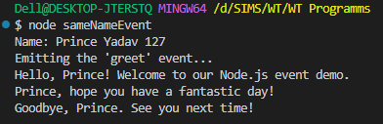

Practical No – 17
Aim: To study and display local system file paths.
1) Write an Applica on to Display Details of the Current File Path.
Code:
console.log("Name: Prince Yadav 127");
console.log("Current File Path:", __filename);
console.log("Current Directory Path:", __dirname);

Output:
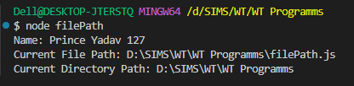

Practical No – 18
Aim: To implement basic file I/O operation using the fs module.
A) Write an Applica on to Read File.
Readfile.js
console.log("Name: Prince Yadav 127");
const fs = require("fs");
fs.readFile("sample.txt", "utf8", (err, data) => {
if (err) {
console.error("Error reading file:", err);
return;
}
console.log("File Content:");
console.log(data);
});
sample.txt
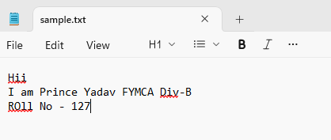
Output:
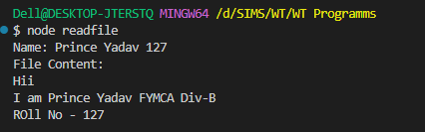

B) Write an application to Write in File.
Code:
console.log("Name: Prince Yadav 127");
const fs = require("fs");
fs.writeFile("sample.txt", "This is written using Node.js", (err) => {
if (err) {
console.error("Error writing file:", err);
return;
}
console.log("File written successfully.");
});
Output:
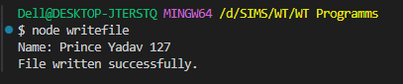
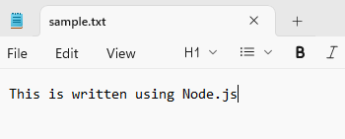

Practical No: 19
Aim: To perform advanced file system operations.
A] Write an application to Add Data in File.
console.log("Name: Prince Yadav 127");
const fs = require("fs");
fs.appendFile("sample.txt", "\nPrince is appended.", (err) => {
if (err) {
console.error("Error appending file:", err);
return;
}
console.log("Data appended successfully.");
});
Output:
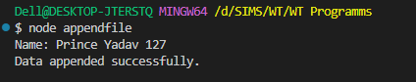
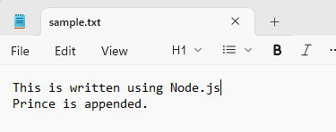

B) Write an application on to Delete a File.
console.log("Name: Prince Yadav 127");
const fs = require("fs");
fs.unlink("sample.txt", (err) => {
if (err) {
console.error("Error dele ng file:", err);
return;
}
console.log("File deleted successfully.");
});
Output:
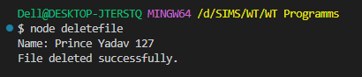
C) File Handling Programs Using Arrow Function.
1) Read File (Arrow Function)
console.log("Name: Prince Yadav 127");
const fs = require("fs");
fs.readFile("data.txt", "utf8", (err, data) => {
if (err) return console.error(err);
console.log(data);
});
Output:
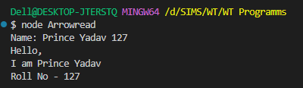

2) Write File (Arrow Function)
console.log("Name: Prince Yadav 127");
const fs = require("fs");
fs.writeFile("data.txt", "Write arrow function with Prince", (err) => {
if (err) return console.error(err);
console.log("Write arrow function with Prince.");
});
Output:
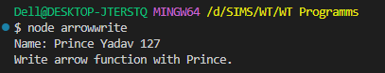
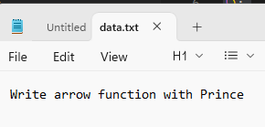
3) Append File (Arrow Function)
Code:
console.log("Name: Prince Yadav 127");
const fs = require("fs");
fs.appendFile("data.txt", "\nAppended using arrow func on", (err) => {
if (err) return console.error(err);
console.log("File appended using arrow func on.");
});
Output:
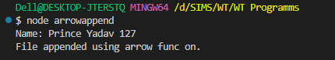
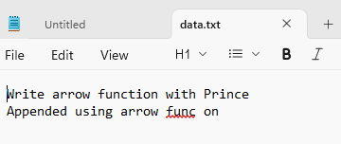

Practical No – 20
Aim: To create a web server and handle data streams.
A) To create a simple Node.js HTTP Server
console.log("Name: Prince Yadav 127");
const http = require("http");
const server = http.createServer((req, res) => {
console.log("Server Running");
res.setHeader("Content-Type", "text/html");
res.write("<html>");
res.write("<h1>Hello from Node js server</h1>");
res.write("<h1>This is Prince Yadav FYMCA 127</h1>");
res.write("<h2>Welcome to My Youtube Channel</h2>");
res.write("</html>");
res.end();
});
server.listen(3000, () => {
console.log("Server is listening on port 3000");
});
Output:
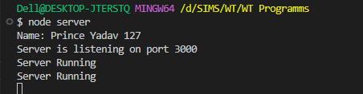
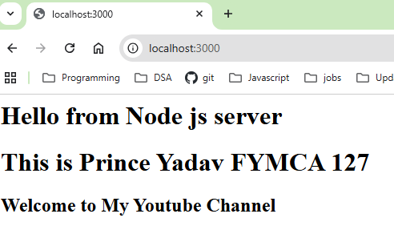
B) Demonstrate Piping in Node.js
console.log("Name: Prince Yadav 127");
var fs = require("fs");
var readStream = fs.createReadStream("input.txt");
var writeStream = fs.createWriteStream("output.txt");
// Pipe read stream into write stream
readStream.pipe(writeStream);
console.log("Piping completed successfully");
Output:
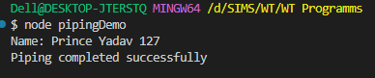
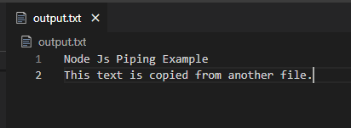

Practical No – 21
AIM: To implement server-side routing and business logic.
A) Write an application on to create Home Page, Admin Page, and Student Page using HTTP Server.
Form.js
var http = require("http");
var server = http.createServer(function (req, res) {
if (req.url == "/") {
res.writeHead(200, { "content-type": "text/html" });
res.write("<html><head></head><body>");
res.write(
"<style>ul li{display:inline-block; float:right; height:40px;} ul li a{padding:20px; background:orange; color:white;}</style>"
);
res.write("<div><h1>My First Website</h1></div>");
res.write("<ul>");
res.write('<li><a href="/admin">Contact Admin</a></li>');
res.write('<li><a href="/student">Student</a></li>');
res.write('<li><a href="/home">Home</a></li>');
res.write("</ul></div>");
res.write('<div style="background:white; padding:20px;">');
res.write("<h2>Start Page</h2>");
res.write("<p>This is my first webpage hehe!</p>");
res.write("<p>Hi everyone</p>");
res.write("</div></body></html>");
res.end();
} else if (req.url == "/home") {
res.writeHead(200, { "content-type": "text/html" });
res.write("<html><head>");
res.write(
"<style>body{padding-left:43px; padding-right:43px; background-color:lightyellow;}</style>"
);
res.write("</head><body>");
res.write("<h1>This is home page</h1>");
res.write("<h3>Prince Yadav</h3>");
res.write("<h3>This page is a brief insight to who I am.</h3>");
res.write('<nav style="background-color:black; text-align:center;">');
res.write('<li><a href="/">Start Page</a></li>');
res.write('<li><a href="/student">Student</a></li>');
res.write('<li><a href="/admin">Admin</a></li>');
res.write("</ul></nav>");
res.write("</body></html>");
res.end();
} else if (req.url == "/student") {
res.writeHead(200, { "content-type": "text/html" });
res.write("<html><head>");
res.write("<style>body{background-color:pink;}</style>");
res.write("<title>Student Form</title>");
res.write("</head><body>");
res.write('<h1 align="center">Student Page Form</h1>');
res.write("<form>");
res.write("<fieldset><legend>Personal Information</legend>");
res.write(
'Student Name:<br><input type="text" placeholder="Enter Your Name"><br>'
);
res.write(
'Email:<br><input type="email" placeholder="Enter Your Email"><br>'
);
res.write(
'Password:<br><input type="password" placeholder="Enter Password"><br>'
);
res.write("Gender:<br>");
res.write('<input type="radio" name="g">Male ');
res.write('<input type="radio" name="g">Female<br>');
res.write("Hobbies:<br>");
res.write('<input type="checkbox">Playing Sports<br>');
res.write('<input type="checkbox">Listening Music<br>');
res.write('<input type="checkbox">Traveling<br>');
res.write('<input type="checkbox">Reading Books<br>');
res.write("City:<br><select>");
res.write("<option>Mumbai</option>");
res.write("<option>Pune</option>");
res.write("<option>Ahilyanagar</option>");
res.write("</select><br><br>");
res.write(
'<input type="submit" value="Submit" onclick="alert(\'Thanks\')">'
);
res.write("</fieldset></form>");
res.write("</body></html>");
res.end();
} else if (req.url == "/admin") {
res.writeHead(200, { "content-type": "text/html" });
res.write("<html><head>");
res.write(
"<style>body{background-color:#faf89a;} button{padding:15px;}</style>"
);
res.write("</head><body>");
res.write("<h1><u>Admin Login</u></h1>");
res.write("<form>");
res.write('Username:<br><input type="text"><br>');
res.write('Password:<br><input type="password"><br><br>');
res.write("<button onclick=\"alert('SUCCESS')\">LOGIN NOW</button>");
res.write("</form>");
res.write("</body></html>");
res.end();
} else {
res.end("Invalid request");
}
});
server.listen(9000);
console.log("Node.js web server at port 9000 is running");
console.log("Prince Yadav 127");

Output
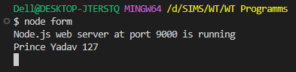

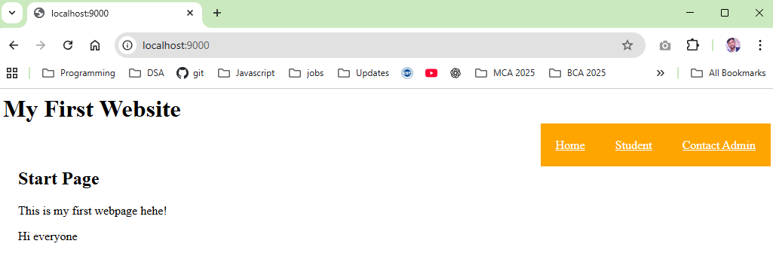

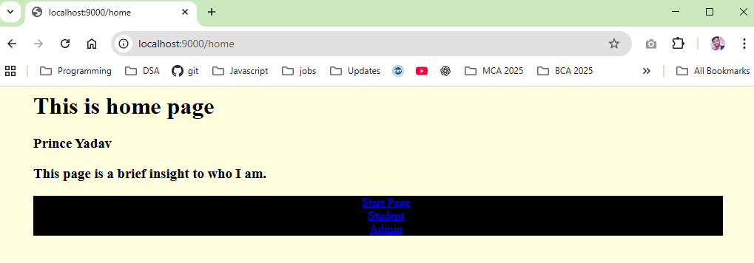
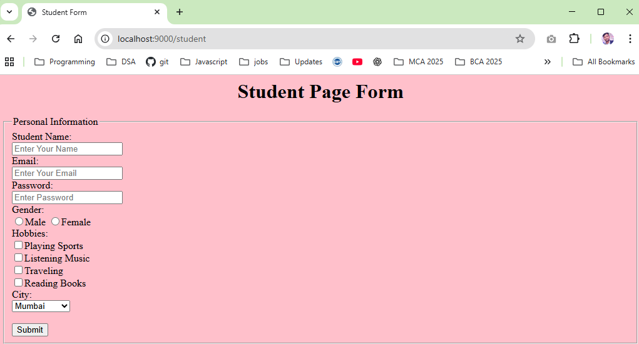

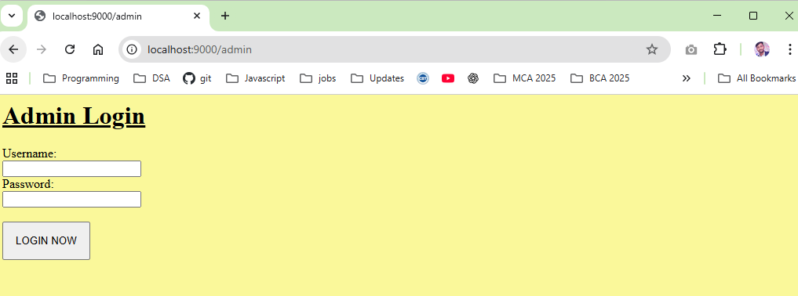

B) ERP Program
console.log("Name: Prince Yadav 127");
var http = require("http");
var server = http.createServer(function (req, res) {
// DASHBOARD
if (req.url == "/") {
res.writeHead(200, { "content-type": "text/html" });
res.write("<html><head>");
res.write("<style>");
res.write(
"body{font-family:Arial;} ul li{display:inline-block; margin:10px;}"
);
res.write(
"a{padding:15px; background:teal; color:white; text-decoration:none;}"
);
res.write("</style>");
res.write("</head><body>");
res.write('<h1 align="center">ERP DASHBOARD</h1>');
res.write("<ul>");
res.write('<li><a href="/student">Student Module</a></li>');
res.write('<li><a href="/faculty">Faculty Module</a></li>');
res.write('<li><a href="/admin">Admin Module</a></li>');
res.write("</ul>");

res.write("</body></html>");
res.end();
}

// STUDENT MODULE
else if (req.url == "/student") {
res.writeHead(200, { "content-type": "text/html" });

res.write('<html><body bgcolor="lightpink">');
res.write("<h1>Student ERP Module</h1>");
res.write("<p>Name : _________</p>");
res.write("<p>Roll No : _________</p>");
res.write("<p>Course : MCA</p>");
res.write("<p>Attendance : 85%</p>");
res.write('<a href="/">Back to Dashboard</a>');
res.write("</body></html>");
res.end();
}
// FACULTY MODULE
else if (req.url == "/faculty") {
res.writeHead(200, { "content-type": "text/html" });

res.write('<html><body bgcolor="lightyellow">');
res.write("<h1>Faculty ERP Module</h1>");
res.write("<p>Faculty Name : _________</p>");
res.write("<p>Subject : Web Technology</p>");
res.write("<p>Department : MCA</p>");
res.write("<p>Lecture Hours : 4 hrs/day</p>");
res.write('<a href="/">Back to Dashboard</a>');
res.write("</body></html>");
res.end();
}

// ADMIN MODULE
else if (req.url == "/admin") {
res.writeHead(200, { "content-type": "text/html" });
res.write('<html><body bgcolor="lightblue">');
res.write("<h1>Admin ERP Module</h1>");
res.write("<form>");
res.write('Username:<br><input type="text"><br>');
res.write('Password:<br><input type="password"><br><br>');
res.write("<button onclick=\"alert('Login Successful')\">LOGIN</button>");
res.write("</form>");
res.write('<br><a href="/">Back to Dashboard</a>');
res.write("</body></html>");
res.end();
} else {
res.end("Invalid Request");
}
});

server.listen(8000);
console.log("ERP Server running on port 8000");

Output:
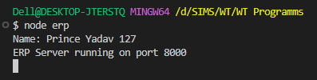

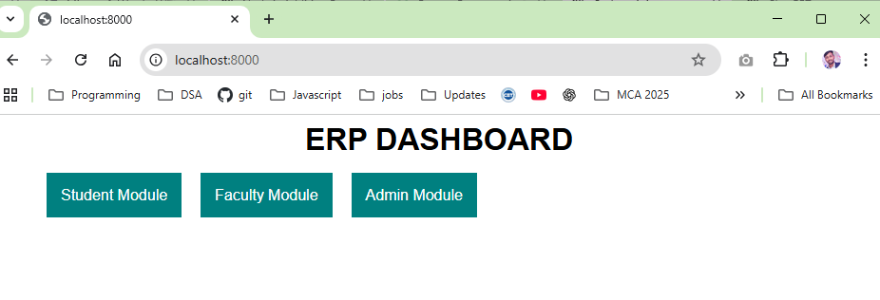

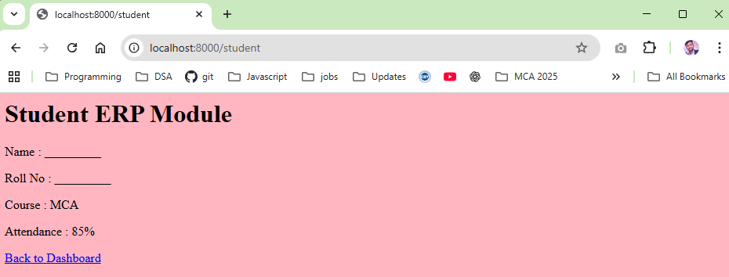

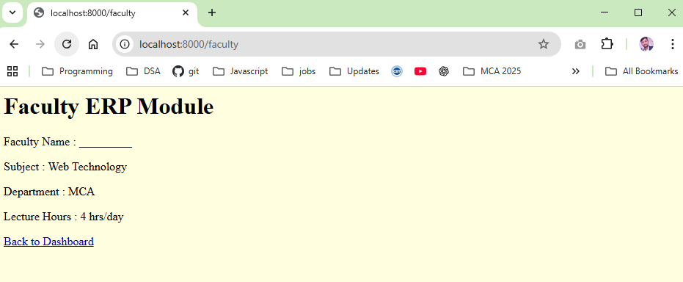

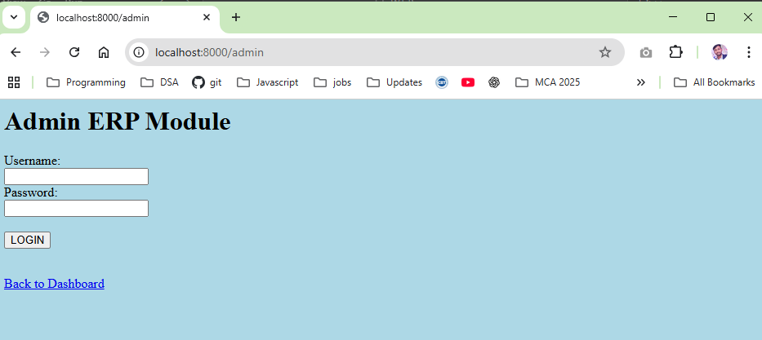

Practical No – 22
Aim: To introduce ReactJS basics and component structure.
Implement Functional Component (React Programs):

A) Implementing JSX in Actions
1) Write a program to display Hello World using ReactJS.
Code:
import logo from "./logo.svg";
import "./App.css";
function App() {
return (
<div className="App">
<header className="App-header">
<img src={logo} className="App-logo" alt="logo" />
<p>Hello World</p>
</header>
</div>
);
}
export default App;

Output:
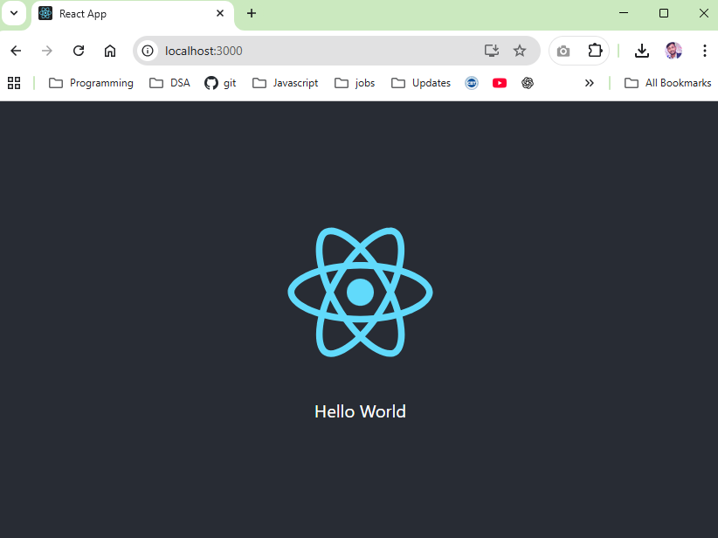

B) Create an application on in ReactJS to Import and Export Files (Components).
App.js
import React from "react";
import FileUploader from "./components/FileUploader";
import FileDownloader from "./components/FileDownloader";
import "./App.css";
function App() {
return (
<div className="App">
<h2>ReactJS File Import & Export</h2>
<FileUploader />
<hr />
<FileDownloader />
</div>
);
}
export default App;

FileUploader.js
import React, { useState } from "react";
const FileUploader = () => {
const [fileContent, setFileContent] = useState("");
const handleFileUpload = (e) => {
const file = e.target.files[0];
const reader = new FileReader();
reader.onload = (event) => {
setFileContent(event.target.result);
};
if (file) {
reader.readAsText(file);
}
};
return (
<div>
<h3>Upload a File</h3>
<input type="file" onChange={handleFileUpload} />
{fileContent && (
<div>
<h4>File Content:</h4>
<textarea
value={fileContent}
readOnly
rows="10"
cols="50"
/>
</div>
)}
</div>
);
};
export default FileUploader;

FileDownloader.js
import React from "react";
const FileDownloader = () => {
const handleDownload = () => {
const content = "This is some sample text for the file.";
const blob = new Blob([content], { type: "text/plain" });
const url = URL.createObjectURL(blob);
const link = document.createElement("a");
link.href = url;
link.download = "sample.txt";
link.click();
URL.revokeObjectURL(url);
};
return (
<div>
<h3>Download a File</h3>
<button onClick={handleDownload}>Download</button>
</div>
);
};
export default FileDownloader;

Output:
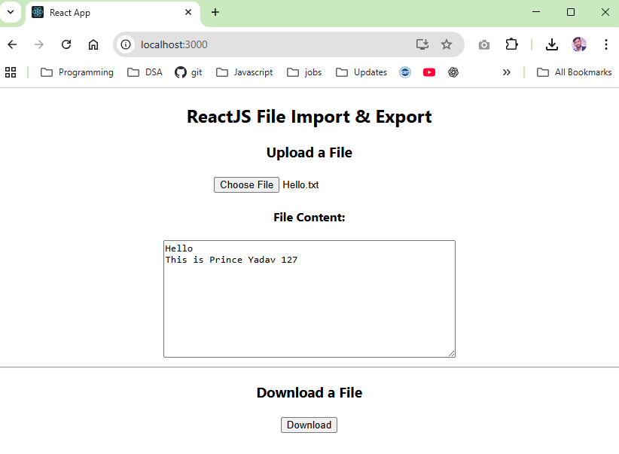

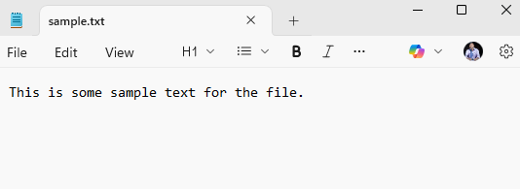

Practical No – 23
Aim: To study React component lifecycles and state management.
Create an application on in ReactJS to implement Component Life Cycle.
Code:
import React, { useState, useEffect } from "react";
import "./App.css";
const LifecycleComponent = () => {
const [count, setCount] = useState(0);
const [message, setMessage] = useState("Hello, World!");
// MOUNTING & UNMOUNTING
useEffect(() => {
console.log("Component mounted!");
return () => {
console.log("Component will unmount!");
};
}, []);
// UPDATING
useEffect(() => {
console.log(`Count updated to: ${count}`);
}, [count]);
const handleClick = () => {
setCount(count + 1);
};
const handleMessageChange = () => {
setMessage("Message has been changed!");
};
return (
<div>
<h1>React Component Lifecycle Example</h1>
<p>Message: {message}</p>
<p>Count: {count}</p>
<button onClick={handleClick}>Increment Count</button>
<button onClick={handleMessageChange}>Change Message</button>
</div>
);};
function App() {
return (
<div className="App">
<h2>React Component Lifecycle Demo</h2>
<LifecycleComponent />
</div>
);
}
export default App;
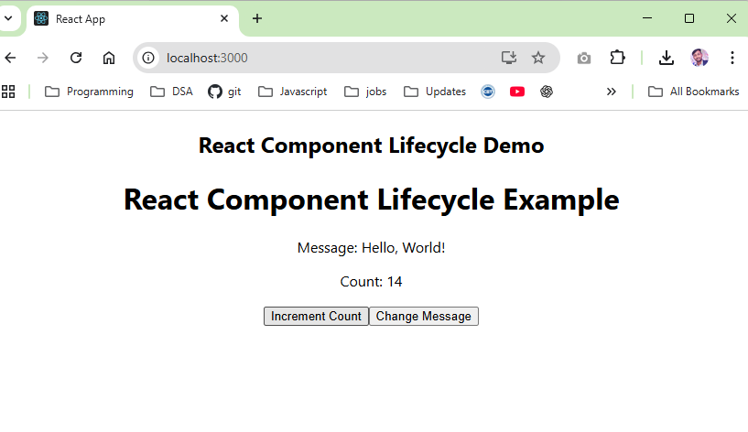

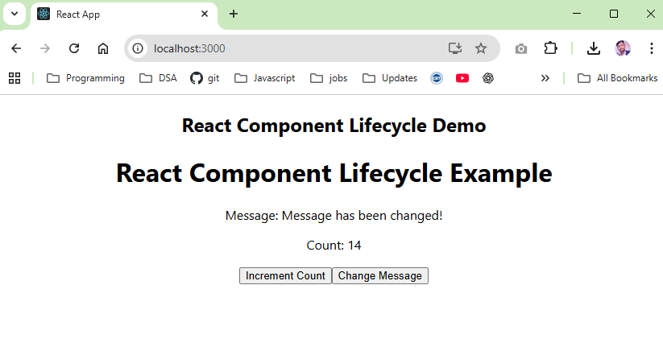

Practical No – 24
Aim: To handle user interaction on via DOM events and Props.
A) Create an application on to Display Your Name Using Prop.
App.js
import React from "react";
import NameDisplay from "./NameDisplay";
function App() {
return (
<div>
<NameDisplay name="Prince" />
</div>
);
}
export default App;
NameDisplay.js
import React from "react";
const NameDisplay = (props) => {
return (
<div style={{ textAlign: "center", marginTop: "50px" }}>
<h1>Hello, {props.name}!</h1>
</div>
);
};
export default NameDisplay;

Output:
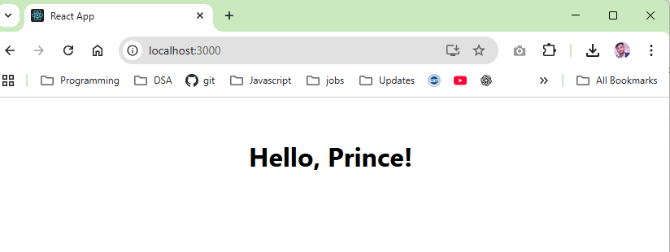

B) Write a Program that Tracks the Changes in an Input Field and Displays the Entered Text in Real-Time Using onChange DOM Event.
App.js
import { useState } from "react";
function App() {
const [text, setText] = useState("");
const handleChange = (event) => {
setText(event.target.value);
};
return (
<div>
<h2>Real-me Input Tracking</h2>
<input
type="text"
placeholder="Type something..."
onChange={handleChange}
/>
<p>You typed: {text}</p>
</div>
);
}
export default App;

Output:
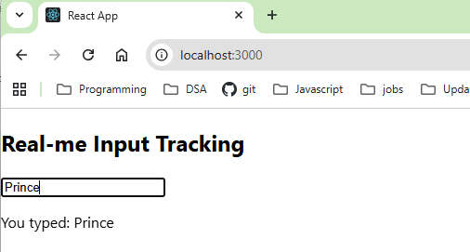

C) Write a Program to Count Words as They Are Typed Using onKeyUp Event.
App.js
Code:
import React, { useState } from "react";
function WordCount() {
const [wordCount, setWordCount] = useState(0);
const handleKeyUp = (e) => {
const words = e.target.value.trim().split(/\s+/);
setWordCount(words[0] === "" ? 0 : words.length);
};
return (
<div>
<textarea
onKeyUp={handleKeyUp}
placeholder="Type your text here..."
></textarea>
<p>Word Count: {wordCount}</p>
</div>
);
}
export default WordCount;

Output

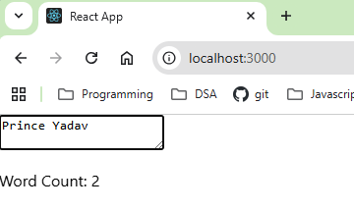

Practical No – 25
Aim: To perform database operation and create function React apps.
A) Create an application on to implement To-Do Task
App.js
import React from "react";
import ToDo from "./ToDo";

function App() {
return (
<div>
<ToDo />
</div>
);
}

export default App;

ToDo.js
import React, { useState } from "react";
const ToDo = () => {
const [tasks, setTasks] = useState([]);
const [task, setTask] = useState("");
const addTask = () => {
if (task.trim()) {
setTasks([...tasks, task]);
setTask("");
}
};
const removeTask = (index) => {
const updatedTasks = tasks.filter((_, i) => i !== index);
setTasks(updatedTasks);
};
return (
<div style={{ textAlign: "center", marginTop: "50px" }}>
<h1>To-Do List</h1>
<div>
<input
type="text"
value={task}
onChange={(e) => setTask(e.target.value)}
placeholder="Enter a task"
style={{ padding: "8px", width: "200px" }}
/>

<button
onClick={addTask}
style={{ padding: "8px 16px", marginLeft: "10px" }}
>
Add Task
</button>
</div>
<ul style={{ listStyle: "none", padding: "0", marginTop: "20px" }}>
{tasks.map((t, index) => (
<li
key={index}
style={{
margin: "10px 0",
display: "flex",
justifyContent: "center",
alignItems: "center",
}}
>
<span style={{ marginRight: "20px" }}>{t}</span>
<button
onClick={() => removeTask(index)}
style={{
backgroundColor: "red",
color: "white",
border: "none",
padding: "5px 10px",
cursor: "pointer",
}}
>
Remove
</button>
</li>
))}
</ul>
</div>
);
};
export default ToDo;

Output:
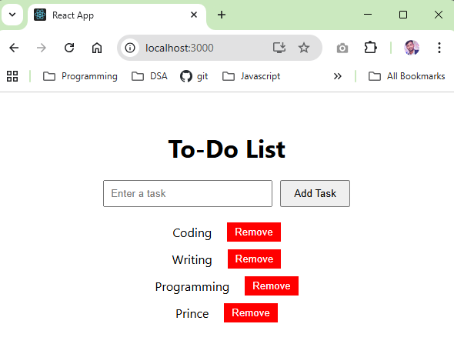

B) Create an application on to implement Function Component in ReactJS (File Downloader and Uploader)
App.js
import React, { useState } from "react";
const FileUploaderDownloader = () => {
const [file, setFile] = useState(null);
const handleFileChange = (event) => {
setFile(event.target.files[0]);
};
const handleUpload = () => {
if (file) {
alert("File uploaded successfully: " + file.name);
} else {
alert("Please select a file first");
}
};
const handleDownload = () => {
alert("File download started");
};
return (
<div>
<h1>File Uploader and Downloader</h1>
<input type="file" onChange={handleFileChange} />
<br /><br />
<button onClick={handleUpload}>Upload File</button>
<br /><br />
<button onClick={handleDownload}>Download File</button>
</div>
);
};
function App() {
return (
<div style={{ textAlign: "center", marginTop: "50px" }}>
<FileUploaderDownloader />
</div>
);
}
export default App;

Output:
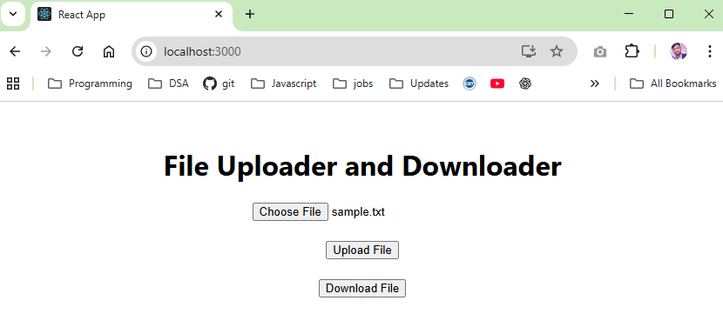
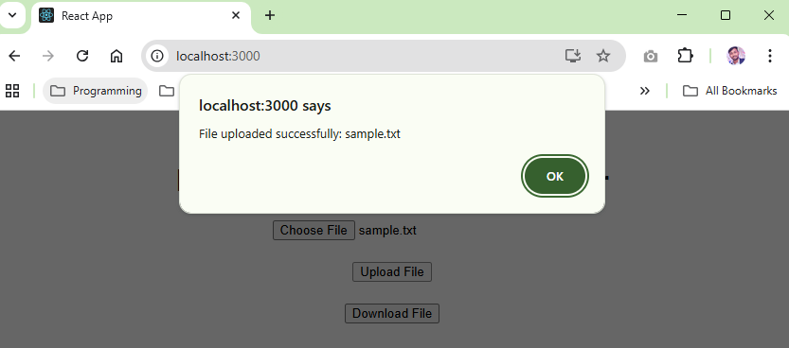

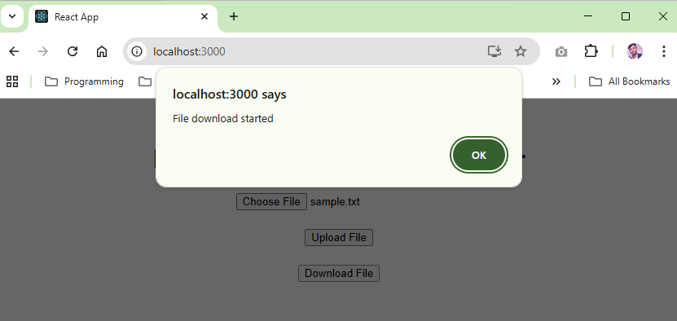

C) Database Connection and Creation (Node.js & XAMMP)
const mysql = require("mysql2");
const connection = mysql.createConnection({
host: "localhost",
user: "root",
password: "", // NO password
});
connection.connect((err) => {
if (err) {
console.error("Error connecting to MySQL:", err);
return;
}
console.log("Connected to MySQL Server!");
const createDBQuery = "CREATE DATABASE IF NOT EXISTS prince_127";
connection.query(createDBQuery, (err, result) => {
if (err) {
console.error("Error creating database:", err);
return;
}
console.log("Database 'prince_127' created successfully!");
connection.end();
});
});

Output:
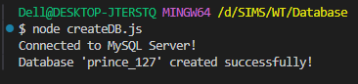

1) Write an Application to create Student table with columns as id, name, address, course, contact in Node.js
const mysql = require('mysql2');
const connection = mysql.createConnection({
host: "localhost",
user: "root",
password: "" // XAMPP default
});
connection.connect((err) => {
if (err) throw err;
console.log("Connected to MySQL (XAMPP)");
// Select database
connection.changeUser({ database: "prince_127" }, (err) => {
if (err) throw err;
console.log("Using database prince_127");
const createTableQuery = `
CREATE TABLE IF NOT EXISTS students (
id INT AUTO_INCREMENT PRIMARY KEY,
name VARCHAR(100),
address VARCHAR(200),
course VARCHAR(100),
contact VARCHAR(15)
)
`;
connection.query(createTableQuery, (err) => {
if (err) throw err;
console.log("Table 'students' created successfully!");
connection.end();
});
});
});
Output:
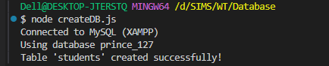
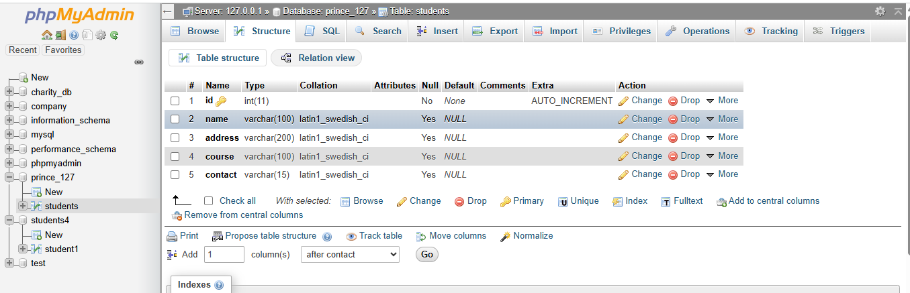

2) Write an application to insert into Student table in Node.js – Minimum 8 rows.
Code:
const mysql = require("mysql2");
const connection = mysql.createConnection({
host: "localhost",
user: "root",
password: "", // XAMPP default (no password)
});
connection.connect((err) => {
if (err) throw err;
console.log("Connected to MySQL Server");
// Select database
connection.changeUser({ database: "prince_127" }, (err) => {
if (err) throw err;
console.log("Using database prince_127");
const insertQuery = `
INSERT INTO students (name, address, course, contact) VALUES
('Prince Yadav', 'Mumbai', 'MCA', '9876543210'),
('Anurag Shukla', 'Pune', 'BBA', '9876543211'),
('Rohit Verma', 'Nagpur', 'MCA', '9876543212'),
('Sneha Kulkarni', 'Nashik', 'MBA', '9876543213'),
('Rahul Mehta', 'Thane', 'BSc IT', '9876543214'),
('Neha Joshi', 'Kolhapur', 'BCA', '9876543215'),
('Karan Singh', 'Delhi', 'BTech', '9876543216'),
('Pooja Deshmukh', 'Aurangabad', 'BMS', '9876543217')
`;
connection.query(insertQuery, (err, result) => {
if (err) throw err;
console.log("✅ 8 Student records inserted successfully!");
connection.end();
});
});
});
Output:
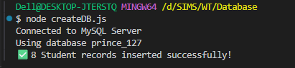

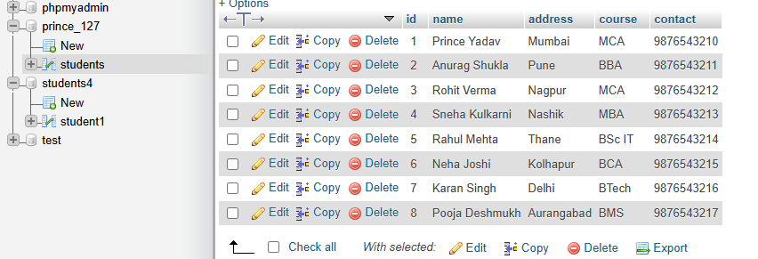
3) Write an application to update a row into Student table in Node.js
Code:
const mysql = require("mysql2");
const connection = mysql.createConnection({
host: "localhost",
user: "root",
password: "", // XAMPP default
});
connection.connect((err) => {
if (err) throw err;
console.log("Connected to MySQL Server");
// Select database
connection.changeUser({ database: "prince_127" }, (err) => {
if (err) throw err;
console.log("Using database prince_127");
const updateQuery = `
UPDATE students
SET
name = 'Abhishek',
course = 'MCA',
address = 'Mumbai'
WHERE id = 2
`;
connection.query(updateQuery, (err, result) => {
if (err) throw err;
console.log("✅ 2nd student record updated successfully!");
console.log("Rows affected:", result.affectedRows);
connection.end();
});
});
});
Output:
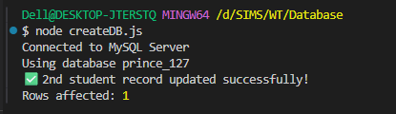
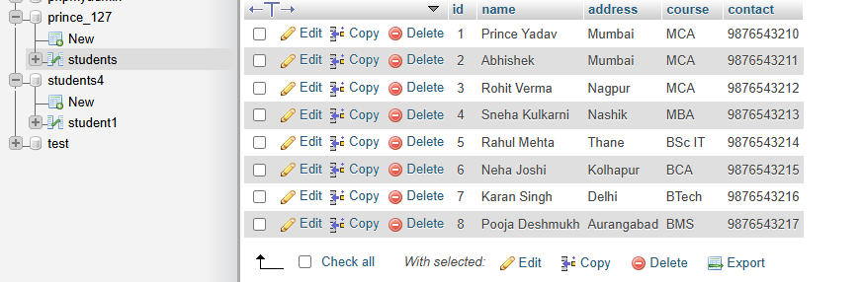

4) Write an application to alter Student table in Node.js
Code:
const mysql = require('mysql2');
const connection = mysql.createConnection({
host: 'localhost',
user: 'root',
password: '', // XAMPP default
database: 'prince_127' // Correct database
});
connection.connect((err) => {
if (err) throw err;
console.log("Connected to database prince_127");
const alterQuery = `
ALTER TABLE students
ADD COLUMN IF NOT EXISTS grade VARCHAR(5)
`;
connection.query(alterQuery, (err, result) => {
if (err) throw err;
console.log("Table altered successfully! Column 'grade' added.");
connection.end();
});
});

Output:
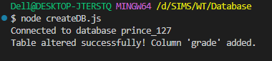
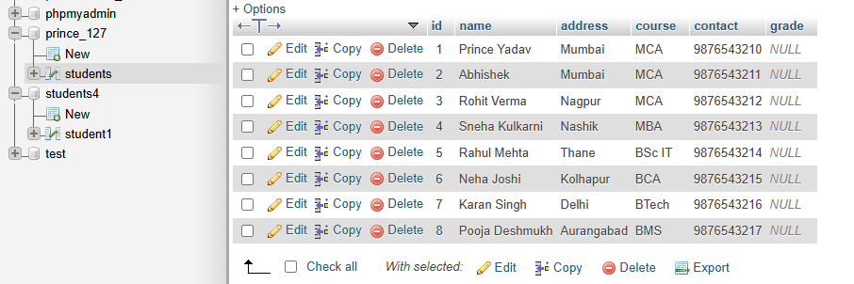

5) Write an application to Delete a record from Student table in Node.js
Code:
const mysql = require("mysql2");
const connection = mysql.createConnection({
host: "localhost",
user: "root",
password: "", // XAMPP default
database: "prince_127",
});
connection.connect((err) => {
if (err) throw err;
console.log("Connected to database prince_127");
const deleteQuery = `
DELETE FROM students
WHERE id = 2
`;
connection.query(deleteQuery, (err, result) => {
if (err) throw err;
console.log("✅ Student record deleted successfully!");
console.log("Rows affected:", result.affectedRows);
connection.end();
});
});

Output:
