PRACTICAL NO : 1
Aim: Implementation of Logic programming using PROLOG DFS for water jug problem
water_jug(X,Y):- X>4,Y<3,write('4L jug overflow'),nl.
water_jug(X,Y):- X<4,Y>3,write('3L jug overflow'),nl.
water_jug(X,Y):- X>4,Y>3,write('Both jug overflow'),nl.

water_jug(X,Y):-
(X=:=0, Y=:=0,nl,write('4L:0 & 3L:3 (Action : Fill 3L jug.)'),YY is 3, water_jug(X,YY));

(X=:=0, Y=:=0,nl,write('4L:4 & 3L:0 (Action : Fill 4L jug.)'),XX is 4, water_jug(XX,Y));

(X=:=2, Y=:=0,nl,write('4L:2 & 3L:0 (Action : Goal Stage reached...)'));

(X=:=4, Y=:=0,nl,write('4L:1 & 3L:3 (Action : Pour water from 4L to 3L jug.)'),
XX is X-3, YY is 3, water_jug(XX,YY));

(X=:=0, Y=:=3,nl,write('4L:3 & 3L:0 (Action : Pour water from 3L to 4L jug.)'),
XX is 3, YY is 0, water_jug(XX,YY));

(X=:=1, Y=:=3,nl,write('4L:1 & 3L:0 (Action : Empty 3L jug.)'),
YY is 0, water_jug(X,YY));

(X=:=3, Y=:=0,nl,write('4L:3 & 3L:3 (Action : Fill 3L jug.)'),
YY is 3, water_jug(X,YY));

(X=:=3, Y=:=3,nl,write('4L:4 & 3L:2 (Action : Pour water from 3L jug to 4L jug untill 4L jug is full.)'),
XX is X+1, YY is Y-1, water_jug(XX,YY));

(X=:=1, Y=:=0,nl,write('4L:0 & 3L:1 (Action : Pour water from 4L jug to 3L jug .)'),
XX is Y, YY is X, water_jug(XX,YY));

(X=:=0, Y=:=1,nl,write('4L:4 & 3L:1 (Action : Pour water from 4L .)'),
XX is 4, water_jug(XX,Y));

(X=:=4, Y=:=1,nl,write('4L:2 & 3L:3 (Action : Pour water from 4L jug to 3L jug untill 3L jug is full.)'),
XX is X-2, YY is Y+2, water_jug(XX,YY));

(X=:=2, Y=:=3,nl,write('4L:2 & 3L:0 (Action : Empty 3L jug .)'),
YY is 0, water_jug(X,YY));

(X=:=4, Y=:=2,nl,write('4L:0 & 3L:2 (Action : Empty 4L jug .)'),
XX is 0, water_jug(XX,Y));

(X=:=0, Y=:=2,nl,write('4L:2 & 3L:0 (Action : Pour water from 3L jug to 4L jug.)'),
XX is Y, YY is X, water_jug(XX,YY)).

OUTPUT:
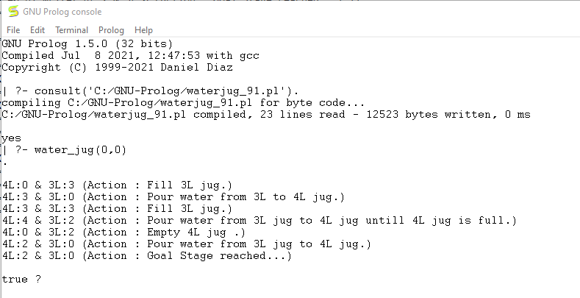
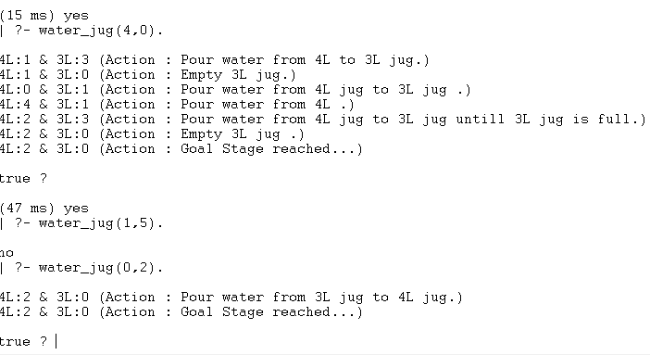

PRACTICAL NO : 2
Aim: Implementation of Logic programming using PROLOG BFS for tic tac toe problems

ordered_line(1, 2, 3). ordered_line(4, 5, 6). ordered_line(7, 8, 9).
ordered_line(1, 4, 7). ordered_line(2, 5, 8). ordered_line(3, 6, 9).
ordered_line(1, 5, 9). ordered_line(3, 5, 7).

line(A, B, C) :- ordered_line(A, B, C).
line(A, B, C) :- ordered_line(A, C, B).
line(A, B, C) :- ordered_line(B, A, C).
line(A, B, C) :- ordered_line(B, C, A).
line(A, B, C) :- ordered_line(C, A, B).
line(A, B, C) :- ordered_line(C, B, A).

full(A) :- x(A).
full(A) :- o(A).
empty(A) :- \+(full(A)).

same(A, A).
different(A, B) :- \+(same(A, B)).

move(C) :- rule1(C).

move(A) :- good(A), empty(A), !.
good(1).
good(3).
good(7).
good(9).
good(5).
good(2).
good(4).
good(6).
good(8).

all_full :- full(1), full(2), full(3), full(4), full(5),
full(6), full(7), full(8), full(9).

% this rule is to block if there is going to be two consecutive moves, then it should prevent the third move
rule1(C) :- line(A,B,C), o(A), o(B), empty(C), !.
rule1(C) :- line(A,B,C), x(A), x(B), empty(C), !.
rule1(5) :- empty(5).
rule1(C) :- o(A), A \= 2, A \= 4, A \= 6, A \= 8, rule2(C).

rule2(C) :- empty(C), C \= 1, C \= 3, C \= 7, C \= 9.

done :- ordered_line(A, B, C), x(A), x(B), x(C), write('I won.'), nl.
done :- all_full, write('Draw.'), nl.

getmove :- repeat, write('Please enter a move: '), read(X), empty(X), assert(o(X)).

makemove :- move(X), !, assert(x(X)).
makemove :- all_full.
printsquare(N) :- o(N), write(' o ').
printsquare(N) :- x(N), write(' x ').
printsquare(N) :- empty(N), write(' ').

printboard :- printsquare(1), printsquare(2), printsquare(3), nl,
printsquare(4), printsquare(5), printsquare(6), nl,
printsquare(7), printsquare(8), printsquare(9), nl.

clear :- retractall(x(_)), retractall(o(_)).

% main
play :- random(1,11,P), (P >= 5), !, start.
play :- elsepart.

random_position(N) :- random(1,10,N).

elsepart :- clear, random_position(N), assert(x(N)), printboard, repeat, getmove, respond.

%-----
start :- clear, repeat, getmove, respond.

respond :- ordered_line(A, B, C), o(A), o(B), o(C), printboard, write('You won.'), nl.
respond :- makemove, printboard, done.

OUTPUT:

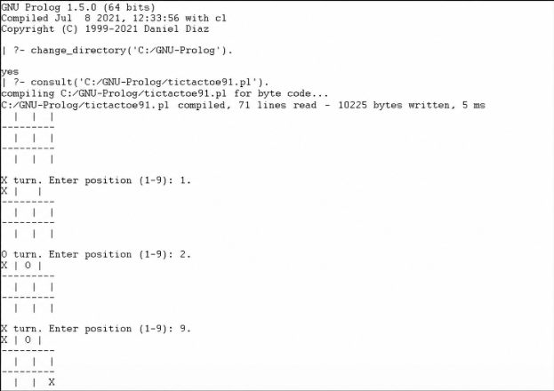

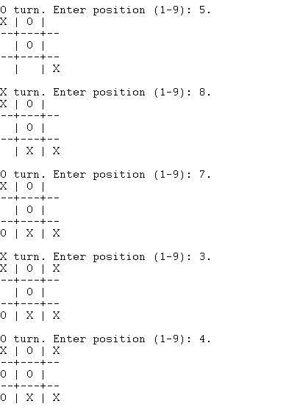
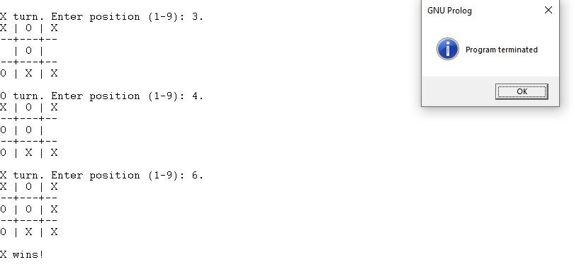

PRACTICAL NO : 3
Aim: Implementation of Logic programming using PROLOG Hill-Climbing to solve 8-puzzle Problem.

% Simple Prolog Planner for the 8 Puzzle Problem

test(Plan):-
write('Initial state:'), nl,

Init = [at(tile1,1), at(tile2,2), at(tile3,3),
at(tile4,4), at(tile5,5), at(empty,6),
at(tile6,7), at(tile7,8), at(tile8,9)],

write_sol(Init),

Goal = [at(tile1,1), at(tile2,2), at(tile3,3),
at(tile4,4), at(empty,5), at(tile5,6),
at(tile6,7), at(tile7,8), at(tile8,9)],

nl, write('Goal state:'), nl,
write(Goal), nl, nl,

solve(Init, Goal, Plan).

solve(State, Goal, Plan):-
solve(State, Goal, [], Plan).

is_movable(X1,Y1) :-
1 is abs(X1 - Y1);
3 is abs(X1 - Y1).

solve(State, Goal, Plan, Plan):-
is_subset(Goal, State),
nl,
write_sol(Plan).

solve(State, Goal, Sofar, Plan):-
act(Action, Preconditions, Delete, Add),
is_subset(Preconditions, State),
Action = move(_,Y,Z),
is_movable(Y,Z),
\+ member(Action, Sofar),
delete_list(Delete, State, Remainder),
append(Add, Remainder, NewState),
solve(NewState, Goal, [Action|Sofar], Plan).

act(move(X,Y,Z),
[at(X,Y), at(empty,Z)],
[at(X,Y), at(empty,Z)],
[at(X,Z), at(empty,Y)]).

is_subset([H|T], Set):-
member(H, Set),
is_subset(T, Set).
is_subset([], _).

delete_list([H|T], Curstate, Newstate):-
remove(H, Curstate, Remainder),
delete_list(T, Remainder, Newstate).
delete_list([], Curstate, Curstate).

remove(X, [X|T], T).
remove(X, [H|T], [H|R]):-
remove(X, T, R).

write_sol([]).
write_sol([H|T]):-
write_sol(T),
write(H), nl.

append([H|T], L1, [H|L2]):-
append(T, L1, L2).
append([], L, L).

member(X, [X|_]).
member(X, [_|T]):-
member(X, T).

OUTPUT:

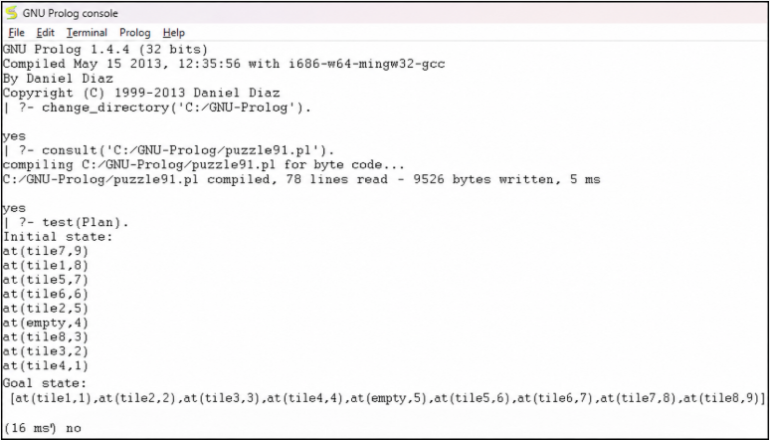

PRACTICAL NO : 4
Aim: Introduction to Python Programming: Learn the different libraries - NumPy, Pandas, SciPy, Matplotlib, Scikit Learn.

Introduction to Python Programming

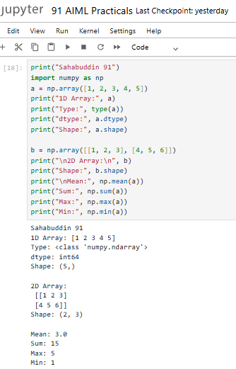

1. NUMPY
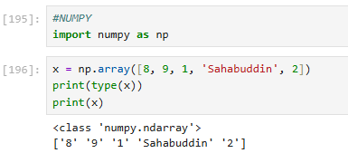

- Using linespace()
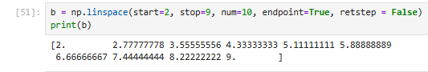

- Using arange()
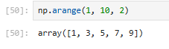

- Using ones()
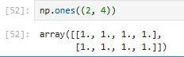

- Using zeros()
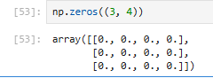

- Using random.rand()
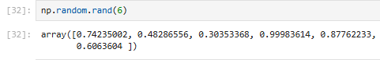

- Using logspace()
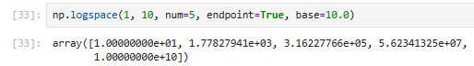

- Using reshape()
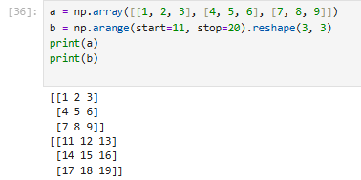

- Using shape()
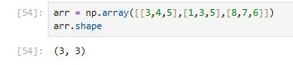

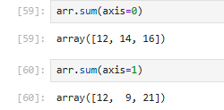
- Using sum()
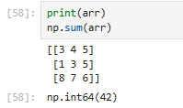

- Using add()
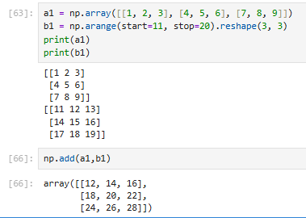

- Using multiply()
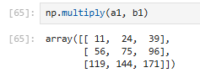

- Accessing the elements of an array : Row wise
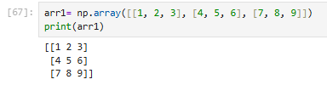

- Accessing the elements of an array : Column wise
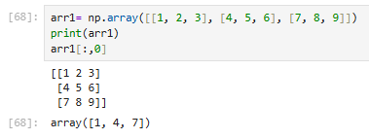

- Subset of an array
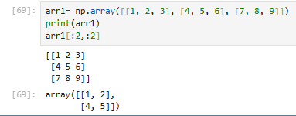

- Update the array
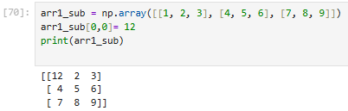

- Modifying array Using transpose()
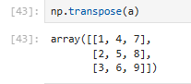

- Modifying array Using append() for row
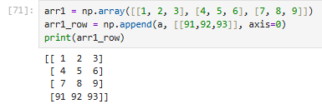
- For column
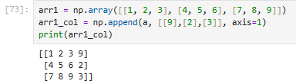

- Using insert() along row and at the 1st index position
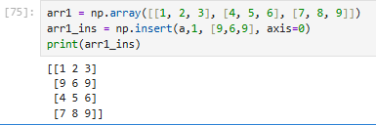

- Using insert() along column and at the 2nd index position
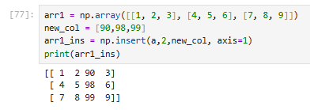

- Using delete() along row
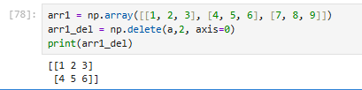

- Using col
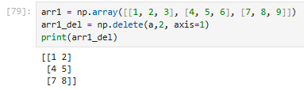

2. Pandas

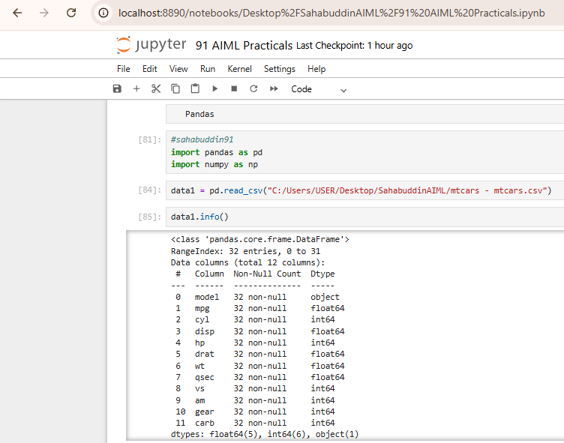
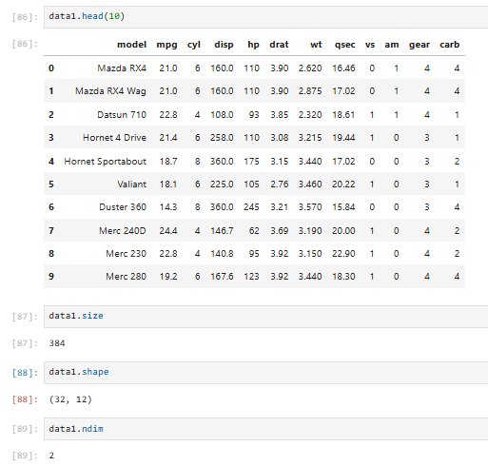
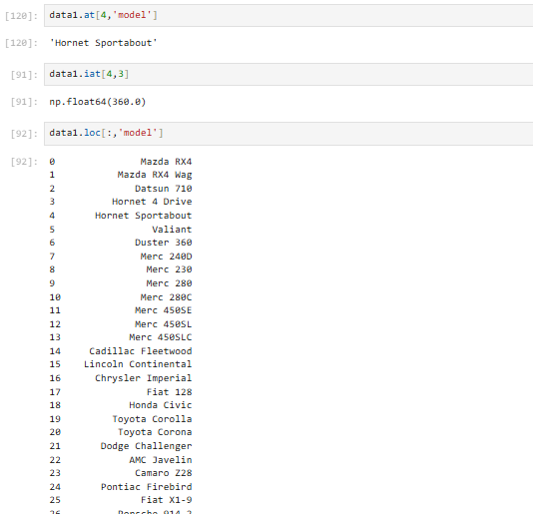
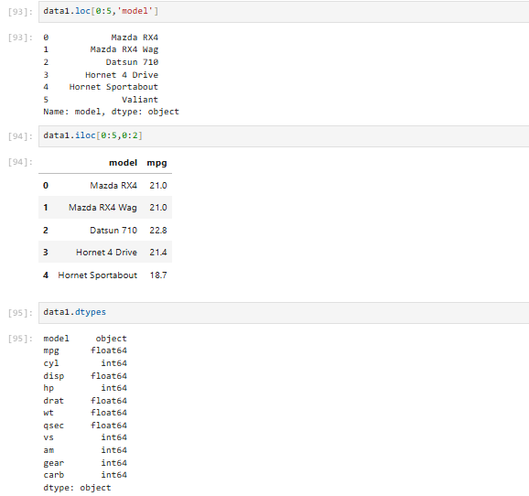
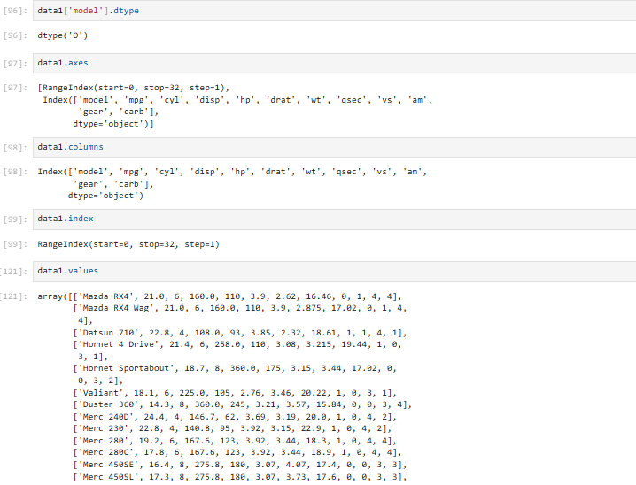
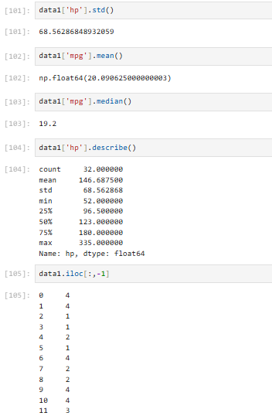

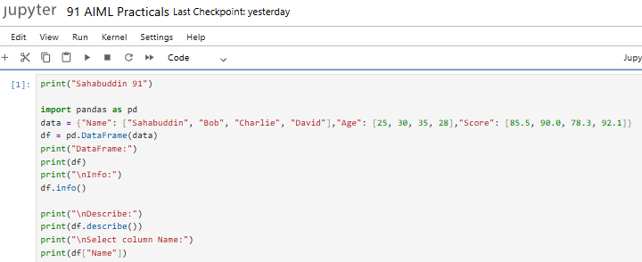
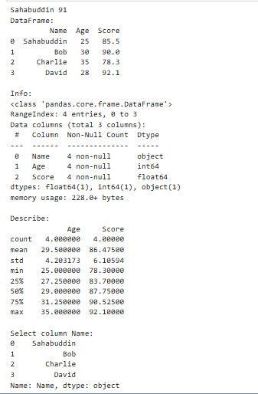

3. SciPy

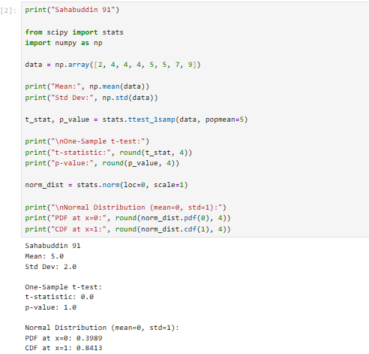

4. Matplotlib
- Line chart
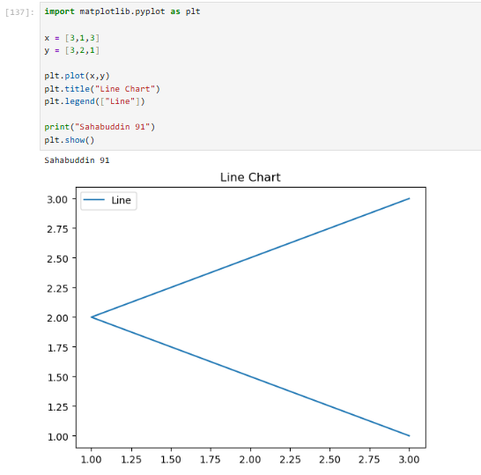

- Bar Chart
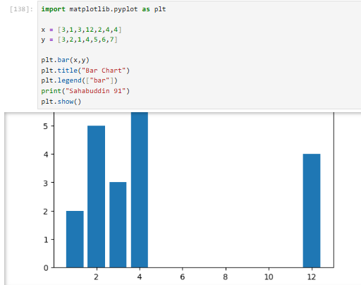

- Histogram
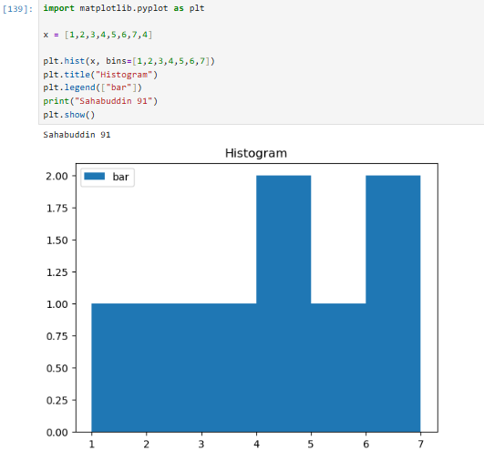
- Scatter Chart
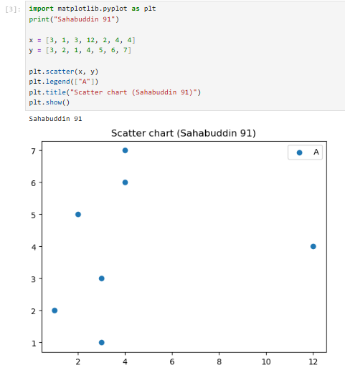

- Pie Chart
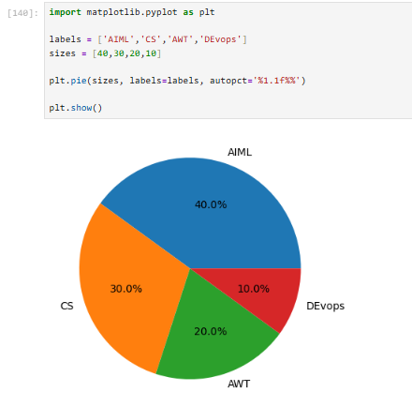

5. Scikit-Learn

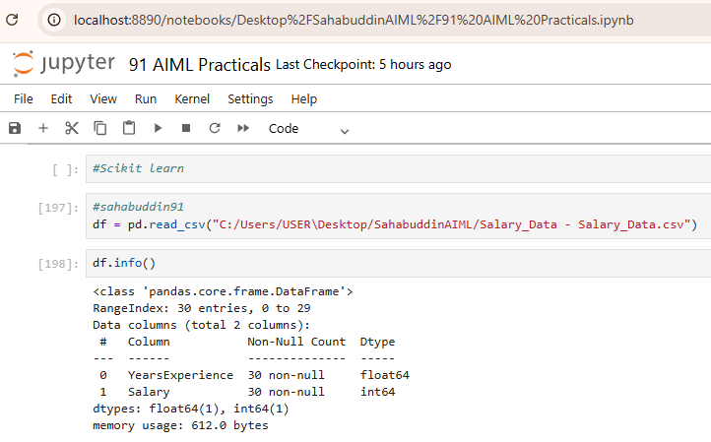
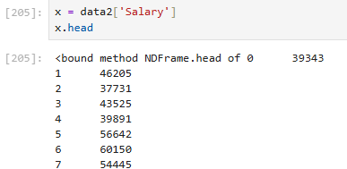
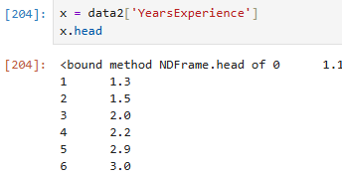
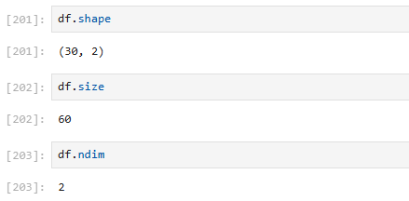
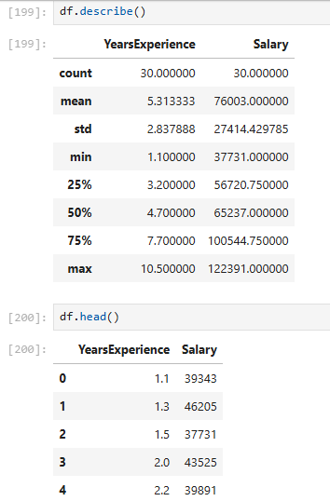

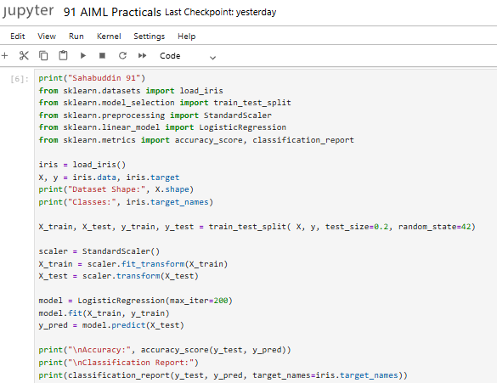

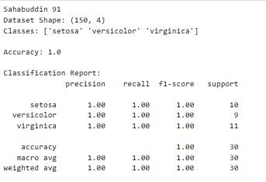

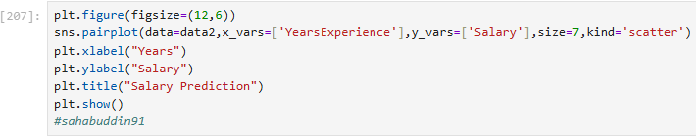

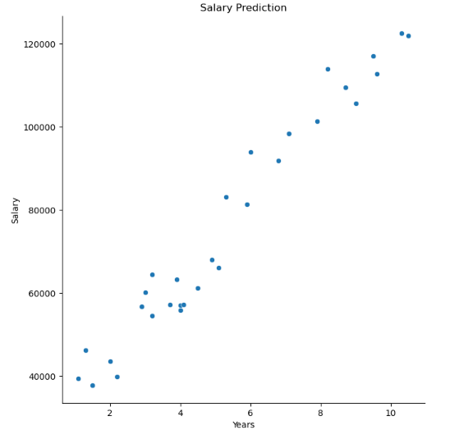

PRACTICAL NO: 5

Aim: Implement Perceptron algorithm for OR operation
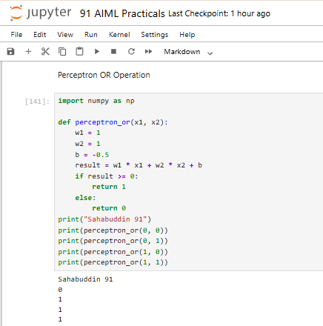

PRACTICAL NO : 6

Aim : Implement of stochastic gradient descent algorithm .

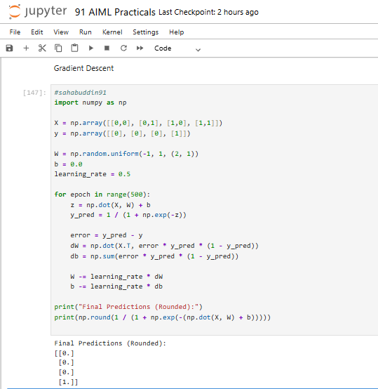

PRACTICAL NO: 7

Aim :Implement Adaline algorithm for AND operation.

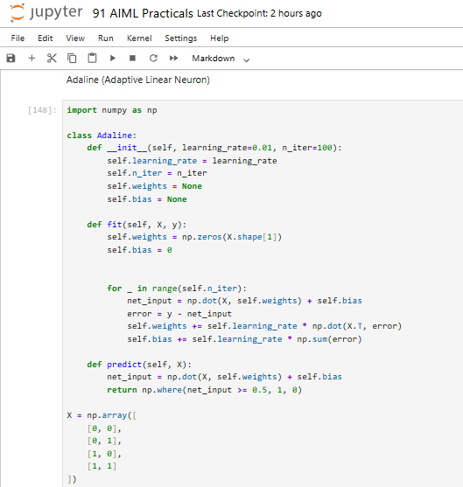
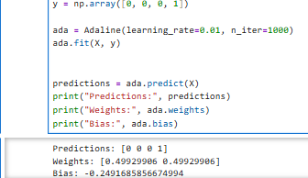

PRACTICAL NO :8
Aim : Implementation of Features Extraction and Selection, Normalization, Transformation, Principal Component Analysis.

Normalization
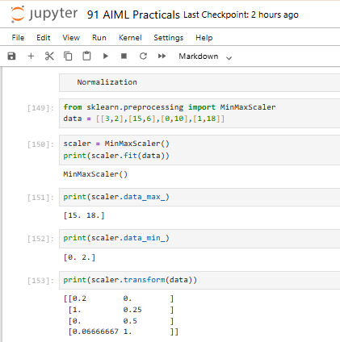

Z-Score Normalization

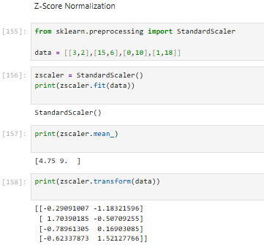

Transformation

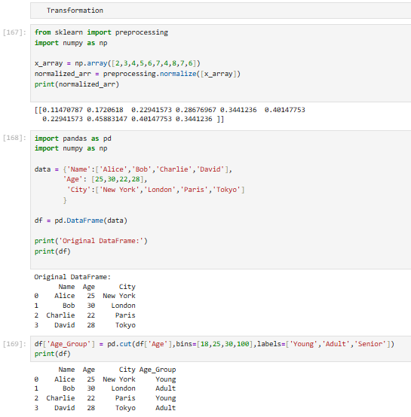

- Creating dummy variable for categorical features

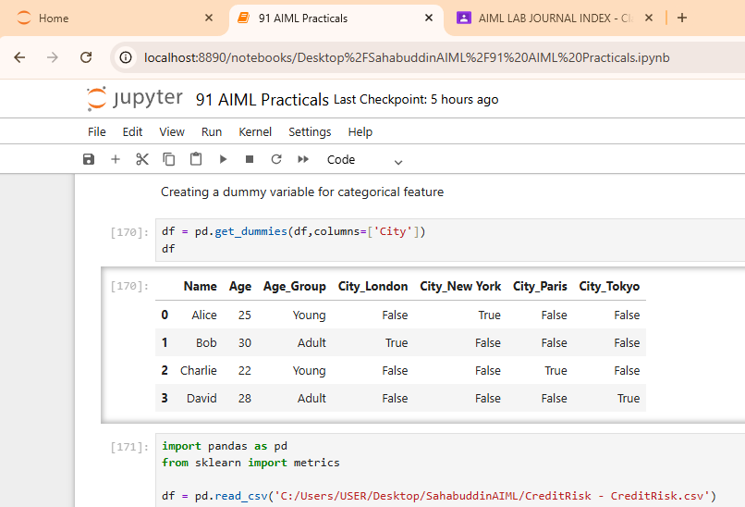

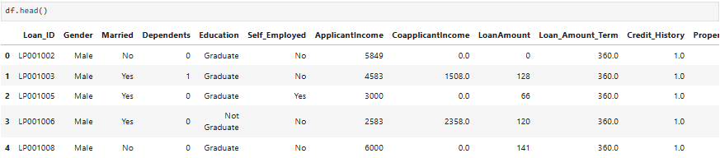
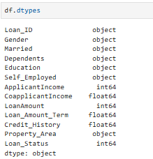
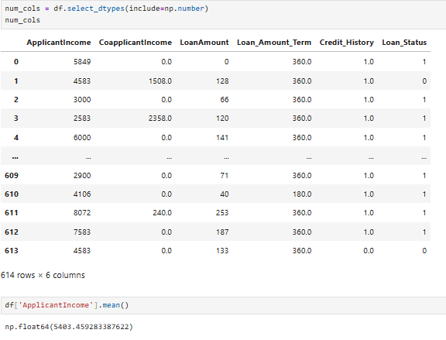
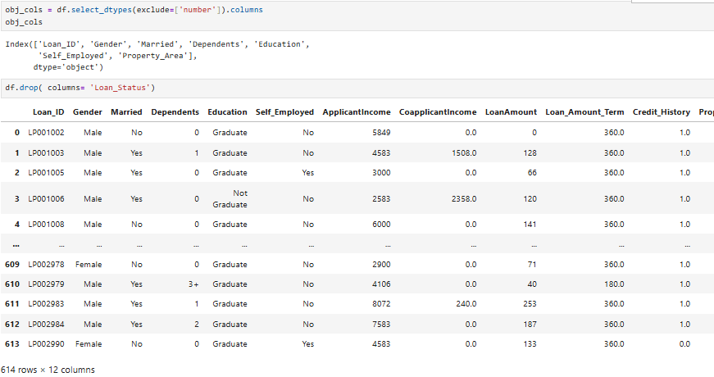
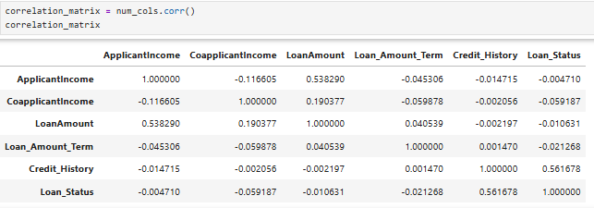

3) Principal Component Analysis(PCA)

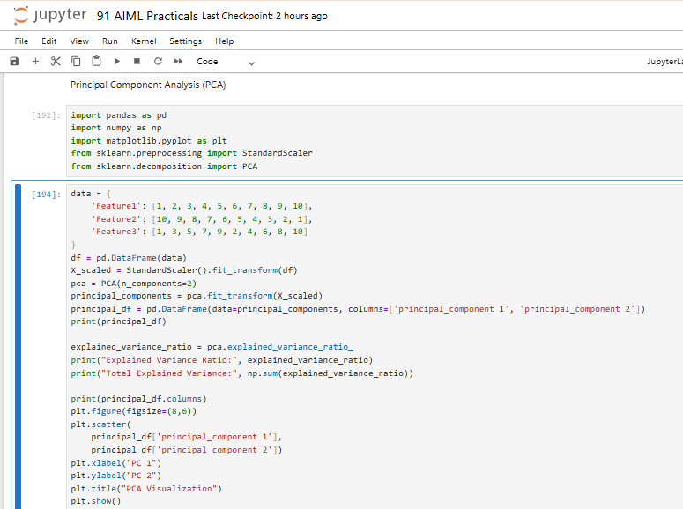

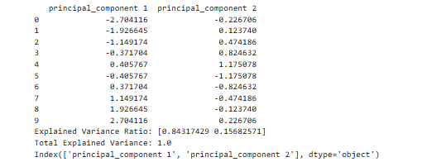

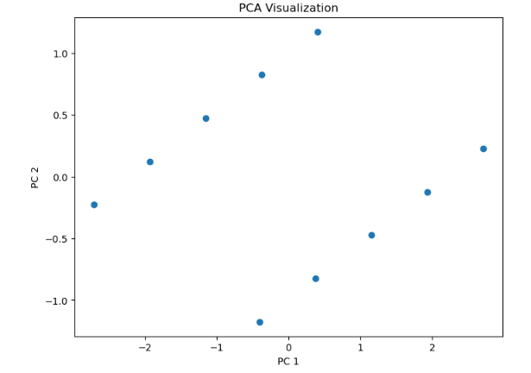

PRACTICAL NO: 9
Aim : Implementation of Logistic regression

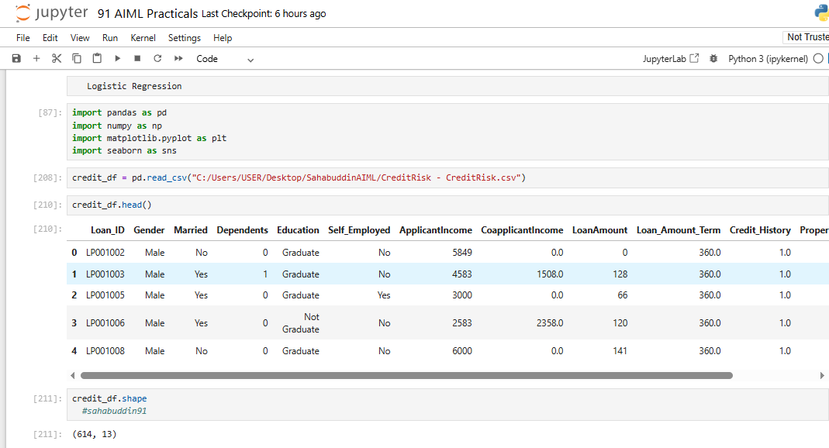

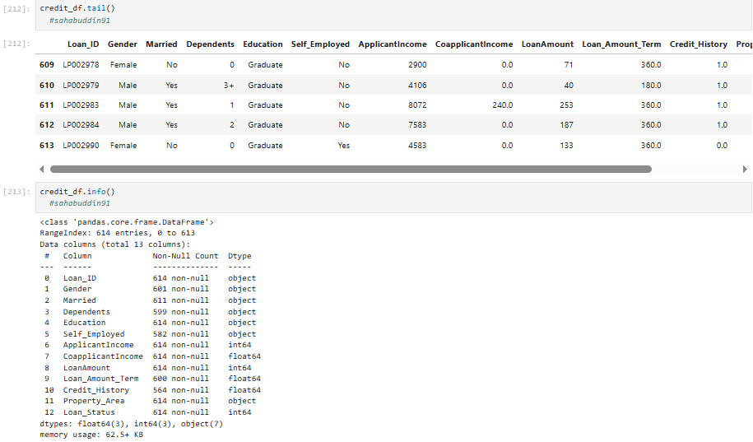
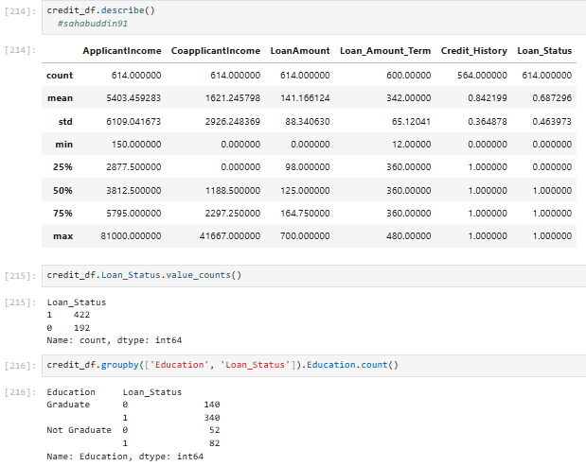

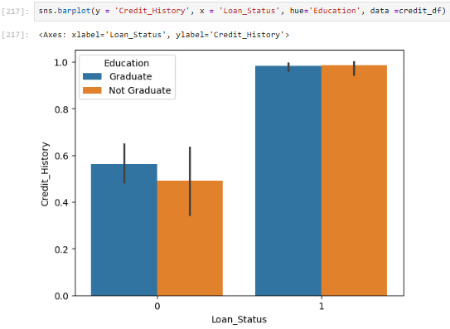
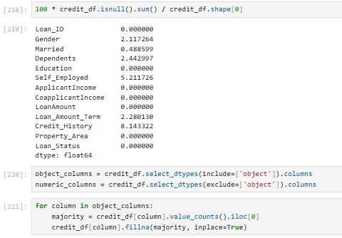
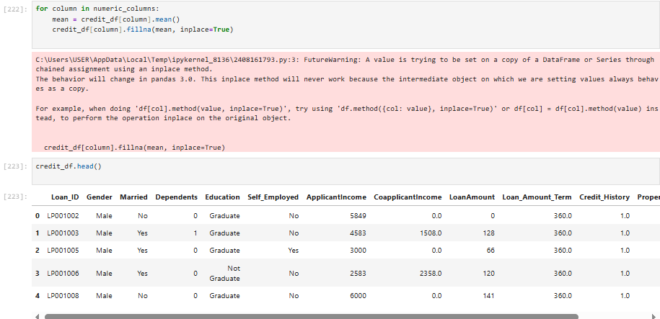
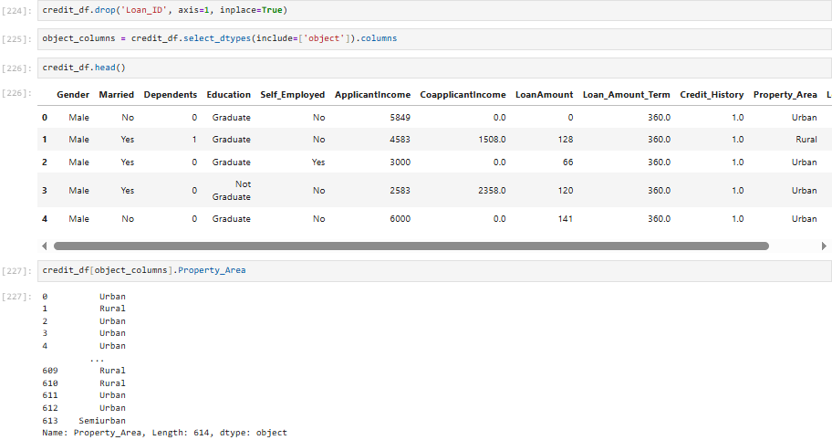
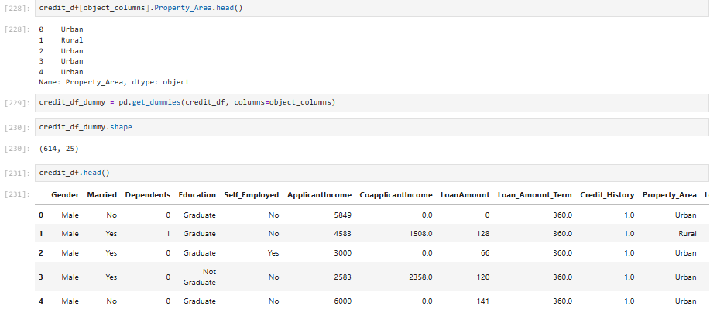

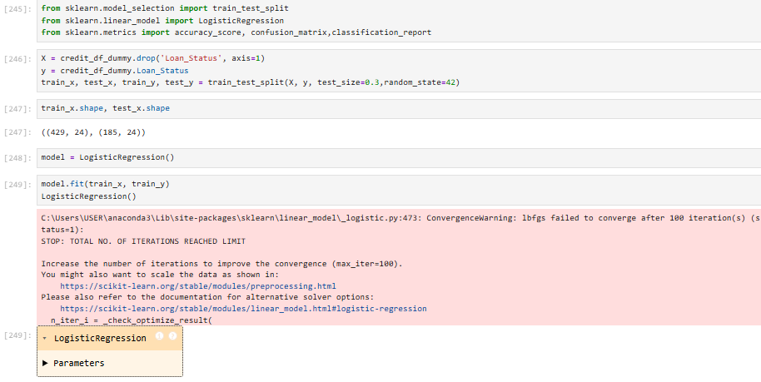
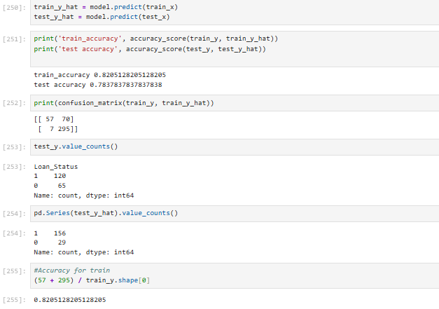
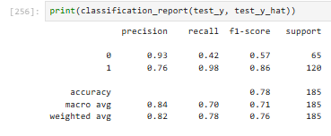
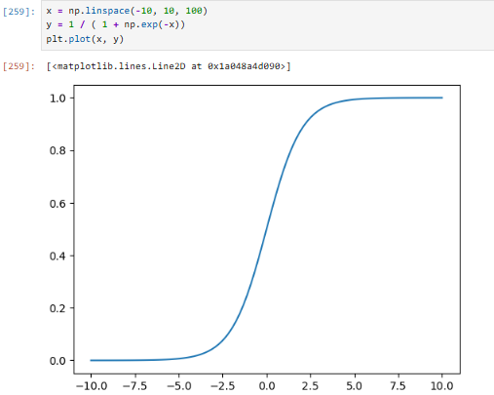
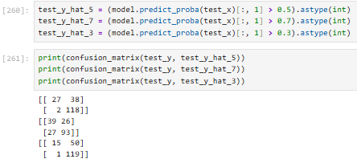
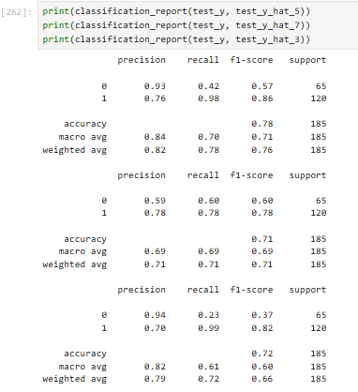

PRACTICAL NO : 10
Aim : Implementation of Classifying data using Support Vector Machine (SVM).

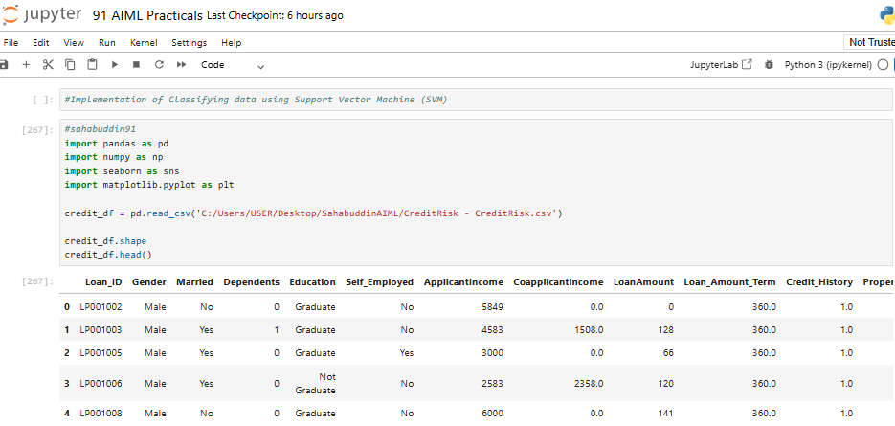
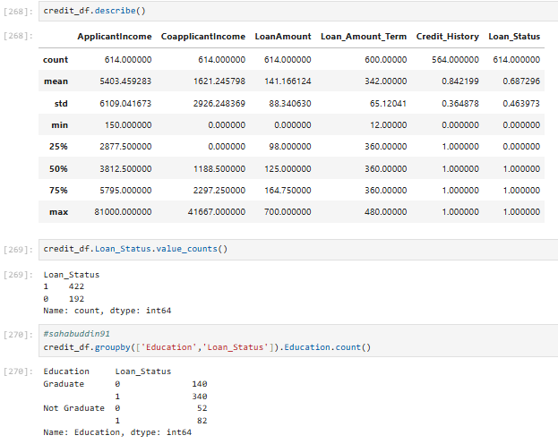
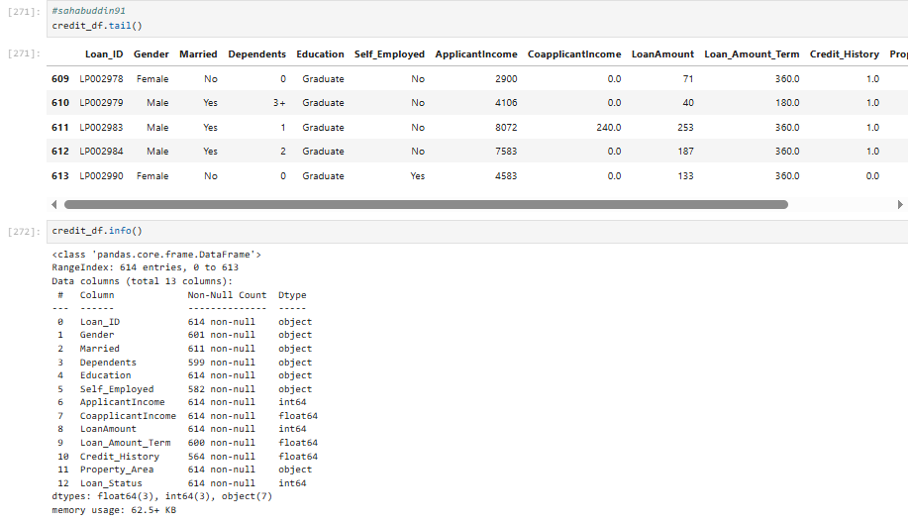

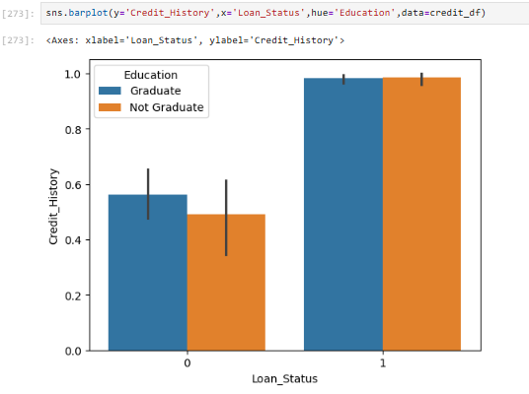
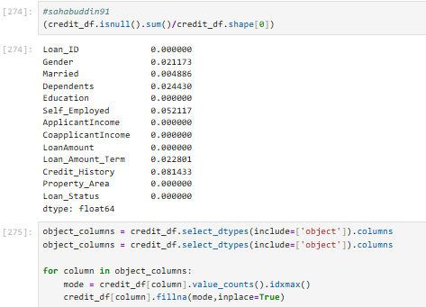
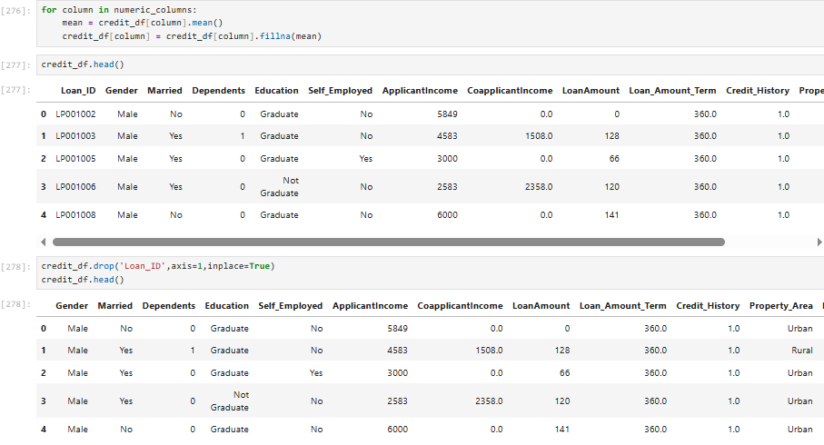
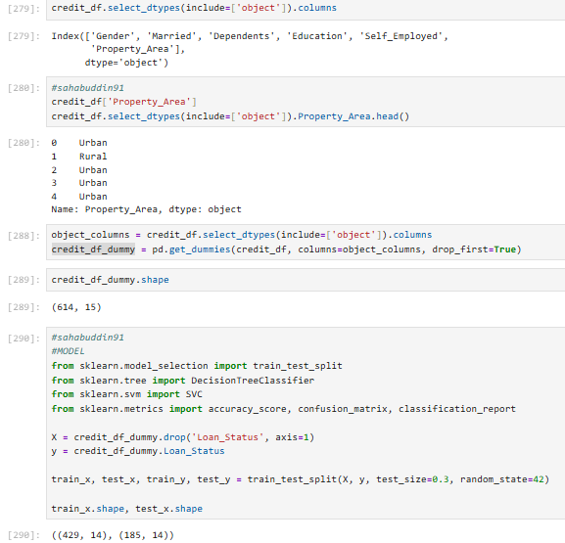
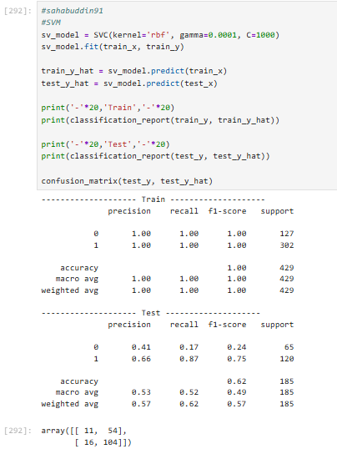
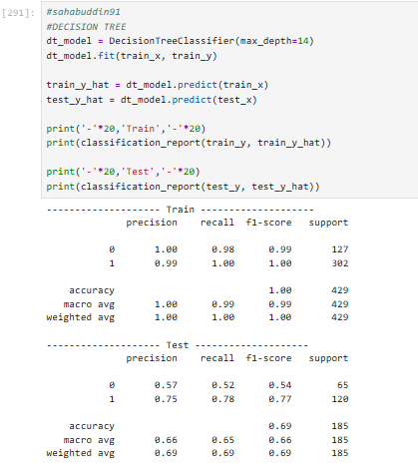

PRACTICAL NO : 11
Aim : Implement Elbow method for K means Clustering

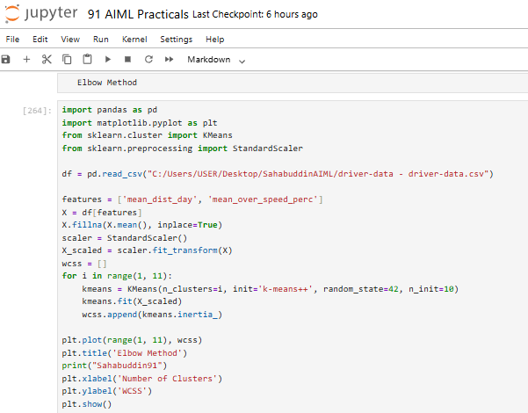
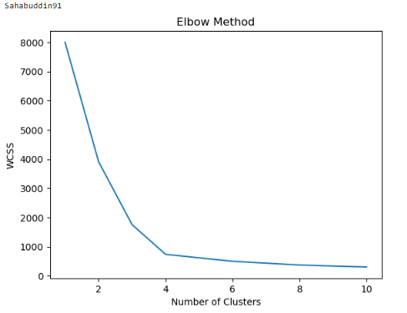
PRACTICAL NO: 12
Aim : Implementation of Bagging Algorithm: Random Forest

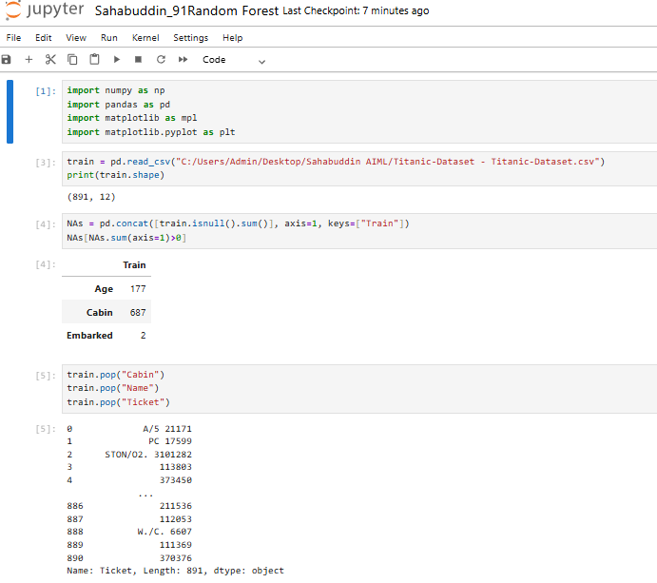
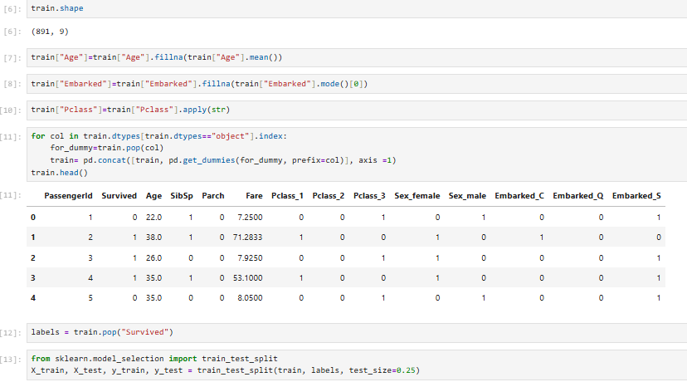
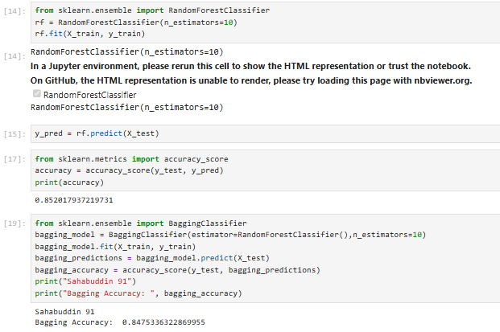

PRACTICAL NO : 13
Aim : Implementation of Boosting Algorithms: AdaBoost, Stochastic Gradient Boosting, Voting Ensemble.

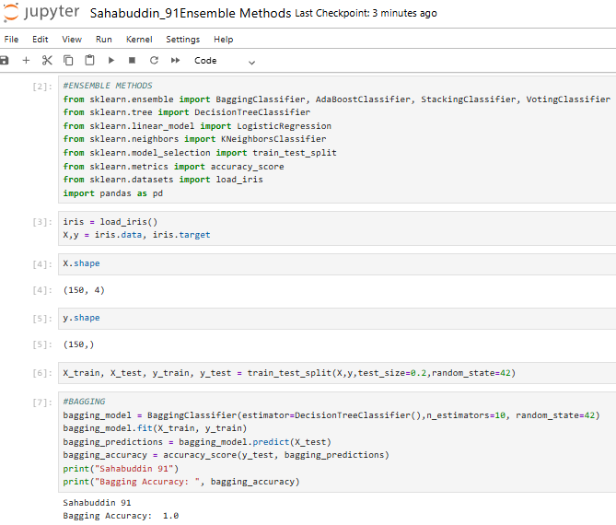
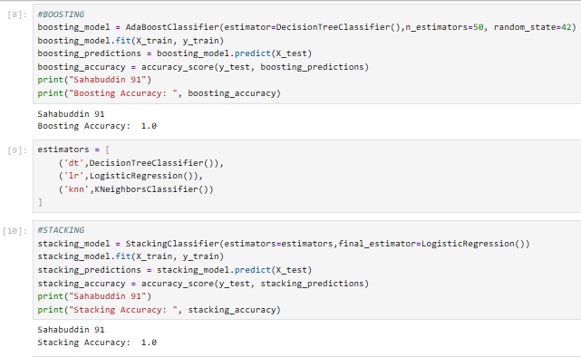
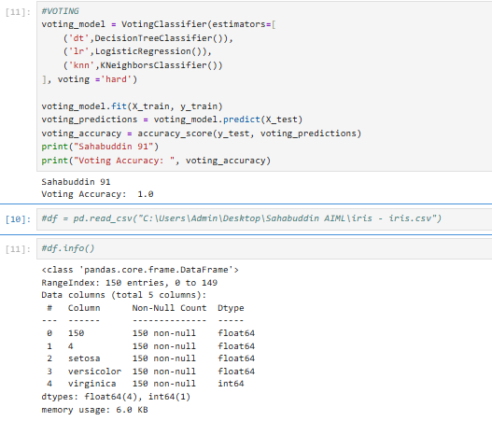

Stochastic Gradient Boosting

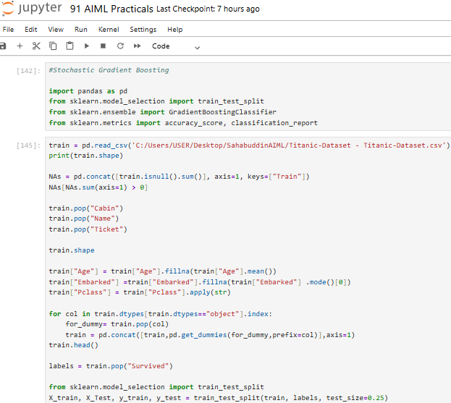
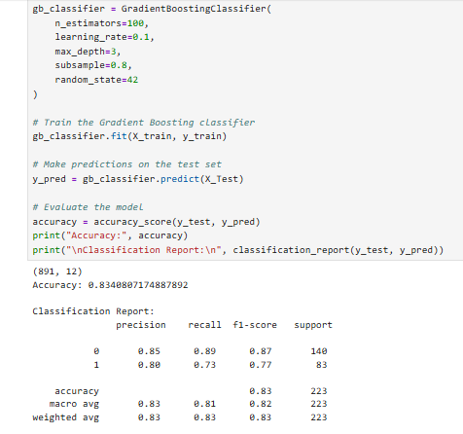

Voting Ensemble
