Module - 3
1. Create a web application to connect to a database using ADO.NET and display data in a GridView.(connected and disconnected)

Prince127.aspx
<%@ Page Language="C#" AutoEventWireup="true" CodeBehind="Prince127.aspx.cs" Inherits="Prince127.Prince127" %>
<!DOCTYPE html>
<html xmlns="http://www.w3.org/1999/xhtml">
<head runat="server">
<title>ADO.NET Practical</title>
</head>
<body>
<form id="form1" runat="server">
<h2>Prince Yadav - 127</h2>
<asp:GridView ID="GridView1" runat="server" AutoGenerateColumns="False" DataKeyNames="Id">
<Columns>
<asp:BoundField DataField="Id" HeaderText="ID" />
<asp:BoundField DataField="name" HeaderText="Name" />
<asp:BoundField DataField="midname" HeaderText="Middle Name" />
<asp:BoundField DataField="salary" HeaderText="Salary" />
</Columns>
</asp:GridView>
<br />
<asp:Button ID="Connected" runat="server"
Text="Connected"
OnClick="Connected_Click" />
<asp:Button ID="Disconnected" runat="server"
Text="Disconnected"
OnClick="Disconnected_Click" />
</form>
</body>
</html>

Prince127.aspx.cs
using System;
using System.Data;
using System.Data.SqlClient;
namespace Prince127
{
public partial class Prince127 : System.Web.UI.Page
{
String StrSQL = "";
String StrConnection = "";
protected void Page_Load(object sender, EventArgs e)
{
StrSQL = "SELECT * FROM data";

StrConnection = @"Data Source=(localdb)\MSSQLLocalDB;Initial Catalog=PrinceDB;Integrated Security=True";
}
protected void Connected_Click(object sender, EventArgs e)
{
SqlConnection objConn = new SqlConnection(StrConnection);
SqlCommand objCmd = new SqlCommand(StrSQL, objConn);
objConn.Open();
SqlDataReader objDr = objCmd.ExecuteReader();
GridView1.DataSource = objDr;
GridView1.DataBind();
objConn.Close();
}
protected void Disconnected_Click(object sender, EventArgs e)
{
SqlDataAdapter objDa = new SqlDataAdapter();
DataSet objDs = new DataSet();
SqlConnection objConn = new SqlConnection(StrConnection);
SqlCommand objCmd = new SqlCommand(StrSQL, objConn);
objDa.SelectCommand = objCmd;
objDa.Fill(objDs, "data");
GridView1.DataSource = objDs.Tables[0];
GridView1.DataBind();
}
}
}

Output:
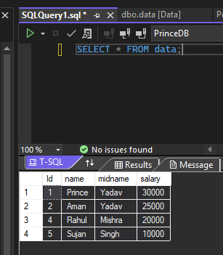
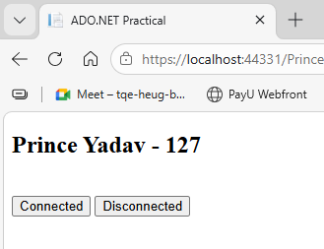

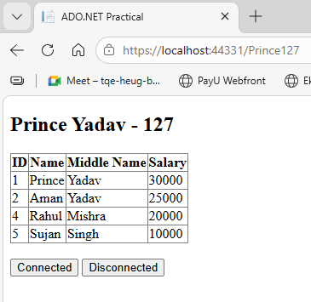

2. Implement a form to insert, update, delete, and display student records using connected architecture.
CREATE TABLE student(
Id INT PRIMARY KEY,
name VARCHAR(50),
course VARCHAR(50),
marks INT
);

Student.aspx
<%@ Page Language="C#" AutoEventWireup="true" CodeBehind="Student.aspx.cs" Inherits="Prince127.Student" %>
<!DOCTYPE html>
<html xmlns="http://www.w3.org/1999/xhtml">
<head runat="server">
<title>Student Record Management</title>
<style>
body{
font-family: Arial;
margin:40px;
}
table{
border-collapse:collapse;
}
td{
padding:8px;
}
</style>
</head>
<body>
<form id="form1" runat="server">
<h3>Prince 127</h3>
<h2>Student Record Management</h2>
<table>
<tr>
<td>Student ID</td>
<td>
<asp:TextBox ID="txtId" runat="server"></asp:TextBox>
</td>
</tr>
<tr>
<td>Name</td>
<td>
<asp:TextBox ID="txtName" runat="server"></asp:TextBox>
</td>
</tr>
<tr>
<td>Course</td>
<td>
<asp:TextBox ID="txtCourse" runat="server"></asp:TextBox>
</td>
</tr>
<tr>
<td>Marks</td>
<td>
<asp:TextBox ID="txtMarks" runat="server"></asp:TextBox>
</td>
</tr>
<tr>
<td colspan="2">
<asp:Button ID="btnInsert" runat="server" Text="Insert"
OnClick="btnInsert_Click" />
<asp:Button ID="btnUpdate" runat="server" Text="Update"
OnClick="btnUpdate_Click" />
<asp:Button ID="btnDelete" runat="server" Text="Delete"
OnClick="btnDelete_Click" />
<asp:Button ID="btnDisplay" runat="server" Text="Display"
OnClick="btnDisplay_Click" />
<asp:Button ID="btnClear" runat="server" Text="Clear"
OnClick="btnClear_Click" />
</td>
</tr>
</table>
<br /><br />
<asp:GridView ID="GridView1" runat="server"
AutoGenerateColumns="True"
BorderWidth="1"
BorderColor="Black">
</asp:GridView>
</form>
</body>
</html>

Student.aspx.cs
using System;
using System.Data;
using System.Data.SqlClient;
namespace Prince127
{
public partial class Student : System.Web.UI.Page
{
SqlConnection con = new SqlConnection(
@"Data Source=(localdb)\MSSQLLocalDB;Initial Catalog=PrinceDB;Integrated Security=True");

protected void Page_Load(object sender, EventArgs e)
{
if (!IsPostBack)
{
LoadData();
}
}
void LoadData()
{
con.Open();
SqlCommand cmd = new SqlCommand("select * from student", con);
SqlDataReader dr = cmd.ExecuteReader();
GridView1.DataSource = dr;
GridView1.DataBind();
con.Close();
}
void ClearData()
{
txtId.Text = "";
txtName.Text = "";
txtCourse.Text = "";
txtMarks.Text = "";
}
protected void btnInsert_Click(object sender, EventArgs e)
{
con.Open();
SqlCommand cmd = new SqlCommand(
"insert into student values(@id,@name,@course,@marks)", con);
cmd.Parameters.AddWithValue("@id", txtId.Text);
cmd.Parameters.AddWithValue("@name", txtName.Text);
cmd.Parameters.AddWithValue("@course", txtCourse.Text);
cmd.Parameters.AddWithValue("@marks", txtMarks.Text);
cmd.ExecuteNonQuery();
con.Close();
LoadData();
ClearData();
}
protected void btnUpdate_Click(object sender, EventArgs e)
{
con.Open();
SqlCommand cmd = new SqlCommand(
"update student set name=@name,course=@course,marks=@marks where id=@id", con);
cmd.Parameters.AddWithValue("@id", txtId.Text);
cmd.Parameters.AddWithValue("@name", txtName.Text);
cmd.Parameters.AddWithValue("@course", txtCourse.Text);
cmd.Parameters.AddWithValue("@marks", txtMarks.Text);
cmd.ExecuteNonQuery();
con.Close();
LoadData();
ClearData();
}
protected void btnDelete_Click(object sender, EventArgs e)
{
con.Open();
SqlCommand cmd = new SqlCommand(
"delete from student where id=@id", con);
cmd.Parameters.AddWithValue("@id", txtId.Text);
cmd.ExecuteNonQuery();
con.Close();
LoadData();
ClearData();
}
protected void btnDisplay_Click(object sender, EventArgs e)
{
LoadData();
}
protected void btnClear_Click(object sender, EventArgs e)
{
ClearData();
}

}
}

Output:
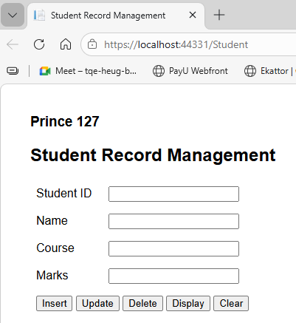

Insert Records:
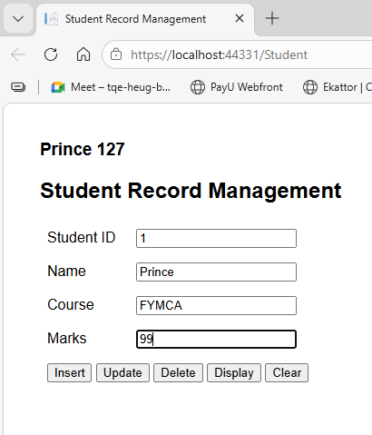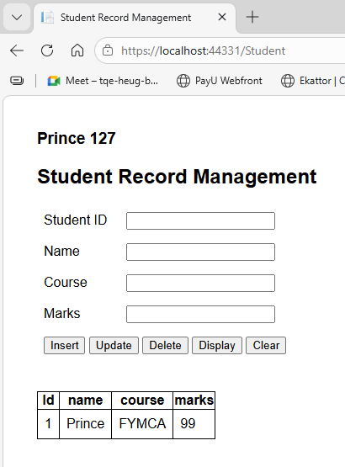

Display
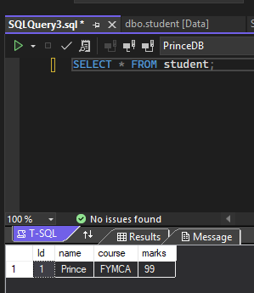

Update Record

Update the course FYMCA to SYMCA
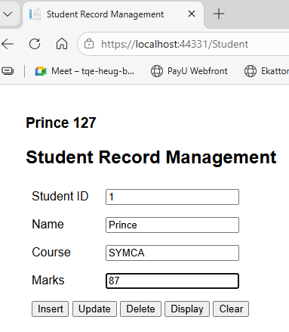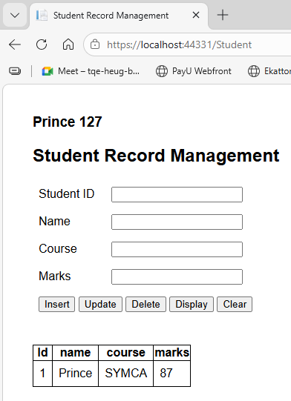

Delete Records
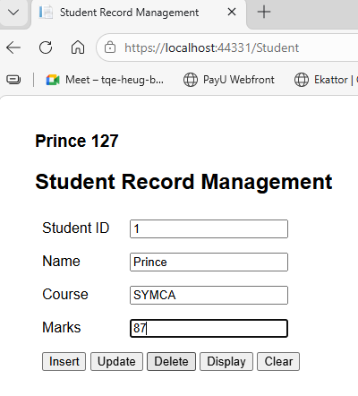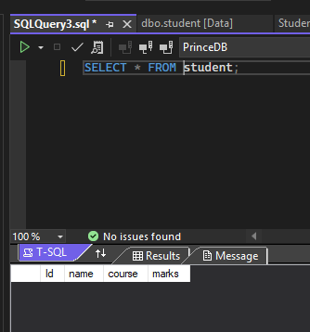

3. Design a web application using disconnected architecture (DataSet and DataAdapter) for managing data.

CREATE TABLE student
(
Id INT PRIMARY KEY,
name VARCHAR(50),
course VARCHAR(50),
marks INT
);

StudentDS.aspx
<%@ Page Language="C#" AutoEventWireup="true" CodeBehind="StudentDS.aspx.cs" Inherits="Prince127.StudentDS" %>
<!DOCTYPE html>
<html xmlns="http://www.w3.org/1999/xhtml">
<head runat="server">
<title>Student Data Management (Disconnected)</title>
</head>
<body>
<form id="form1" runat="server">
<h2>Student Management - Disconnected Architecture</h2>
Student ID :
<asp:TextBox ID="txtId" runat="server"></asp:TextBox>
<br /><br />
Name :
<asp:TextBox ID="txtName" runat="server"></asp:TextBox>
<br /><br />
Course :
<asp:TextBox ID="txtCourse" runat="server"></asp:TextBox>
<br /><br />
Marks :
<asp:TextBox ID="txtMarks" runat="server"></asp:TextBox>
<br /><br />
<asp:Button ID="btnInsert" runat="server" Text="Insert" OnClick="btnInsert_Click" />
<asp:Button ID="btnUpdate" runat="server" Text="Update" OnClick="btnUpdate_Click" />
<asp:Button ID="btnDelete" runat="server" Text="Delete" OnClick="btnDelete_Click" />
<asp:Button ID="btnDisplay" runat="server" Text="Display" OnClick="btnDisplay_Click" />
<br /><br />
<asp:GridView ID="GridView1" runat="server"></asp:GridView>
</form>
</body>
</html>

StudentDS.aspx.cs
using System;
using System.Data;
using System.Data.SqlClient;
namespace Prince127
{
public partial class StudentDS : System.Web.UI.Page
{
SqlConnection con = new SqlConnection(
@"Data Source=(localdb)\MSSQLLocalDB;Initial Catalog=PrinceDB;Integrated Security=True");
SqlDataAdapter da;
DataSet ds;
protected void btnDisplay_Click(object sender, EventArgs e)
{
da = new SqlDataAdapter("select * from student", con);
ds = new DataSet();
da.Fill(ds, "student");
GridView1.DataSource = ds.Tables["student"];
GridView1.DataBind();
}
protected void btnInsert_Click(object sender, EventArgs e)
{
da = new SqlDataAdapter("select * from student", con);
SqlCommandBuilder cb = new SqlCommandBuilder(da);
ds = new DataSet();
da.Fill(ds, "student");
DataRow dr = ds.Tables["student"].NewRow();
dr["Id"] = txtId.Text;
dr["name"] = txtName.Text;
dr["course"] = txtCourse.Text;
dr["marks"] = txtMarks.Text;
ds.Tables["student"].Rows.Add(dr);
da.Update(ds, "student");
GridView1.DataSource = ds.Tables["student"];
GridView1.DataBind();
}
protected void btnUpdate_Click(object sender, EventArgs e)
{
da = new SqlDataAdapter("select * from student", con);
SqlCommandBuilder cb = new SqlCommandBuilder(da);
ds = new DataSet();
da.Fill(ds, "student");
foreach (DataRow dr in ds.Tables["student"].Rows)
{
if (dr["Id"].ToString() == txtId.Text)
{
dr["name"] = txtName.Text;
dr["course"] = txtCourse.Text;
dr["marks"] = txtMarks.Text;
}
}
da.Update(ds, "student");
GridView1.DataSource = ds.Tables["student"];
GridView1.DataBind();
}
protected void btnDelete_Click(object sender, EventArgs e)
{
da = new SqlDataAdapter("select * from student", con);
SqlCommandBuilder cb = new SqlCommandBuilder(da);
ds = new DataSet();
da.Fill(ds, "student");
foreach (DataRow dr in ds.Tables["student"].Rows)
{
if (dr["Id"].ToString() == txtId.Text)
{
dr.Delete();
}
}
da.Update(ds, "student");
GridView1.DataSource = ds.Tables["student"];
GridView1.DataBind();
}

}
}

Output
Insert data
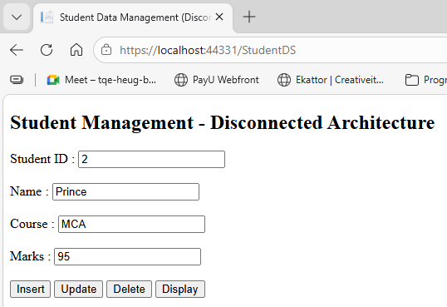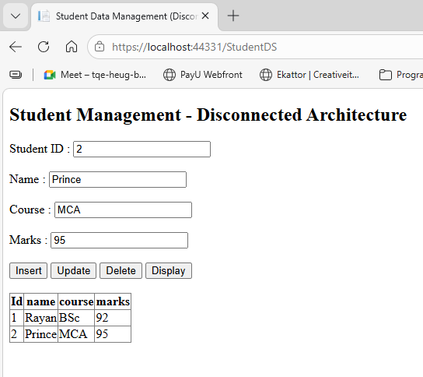

Display Inserted Data
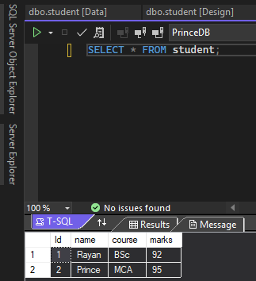

Update id = 1
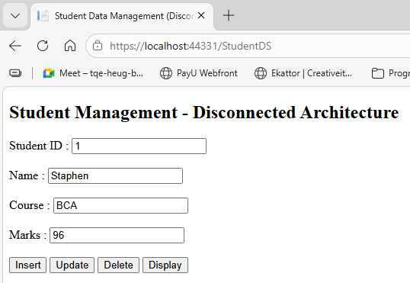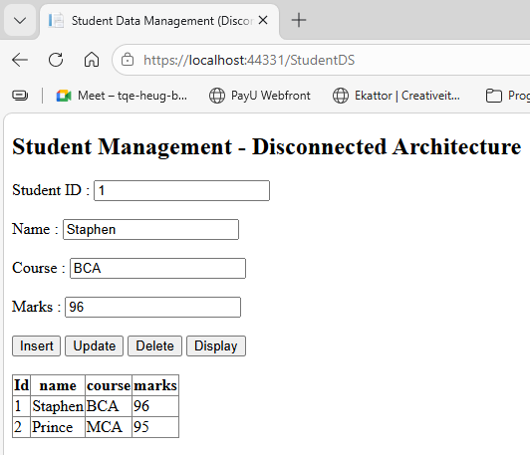

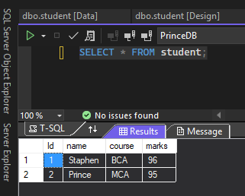

Deleted Data:
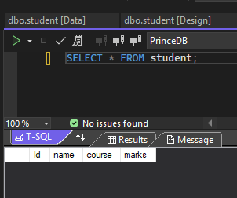

4. Develop a stored procedure to fetch employee details and display them using a DetailsView control.

Create Employee Table
CREATE TABLE employee
(
Id INT PRIMARY KEY,
name VARCHAR(50),
department VARCHAR(50),
salary INT
);

Insert sample data:
INSERT INTO employee VALUES (1,'Prince','IT',50000);
INSERT INTO employee VALUES (2,'Aman','HR',45000);
INSERT INTO employee VALUES (3,'Rahul','Finance',60000);

Create Stored Procedure
CREATE PROCEDURE GetEmployee
@EmpId INT
AS
BEGIN
SELECT * FROM employee WHERE Id = @EmpId
END

Employee.aspx
<%@ Page Language="C#" AutoEventWireup="true" CodeBehind="Employee.aspx.cs" Inherits="Prince127.Employee" %>
<!DOCTYPE html>
<html xmlns="http://www.w3.org/1999/xhtml">
<head runat="server">
<title>Employee Details</title>
</head>
<body>
<form id="form1" runat="server">
<h2>Employee Details</h2>
Enter Employee Id :
<asp:TextBox ID="txtId" runat="server"></asp:TextBox>
<asp:Button ID="btnSearch" runat="server"
Text="Search"
OnClick="btnSearch_Click" />
<br /><br />
<asp:DetailsView ID="DetailsView1"
runat="server"
AutoGenerateRows="True"
Width="300px">
</asp:DetailsView>
</form>
</body>
</html>

Employee.aspx.cs
using System;
using System.Data;
using System.Data.SqlClient;
namespace Prince127
{
public partial class Employee : System.Web.UI.Page
{
string conStr = @"Data Source=(localdb)\MSSQLLocalDB;Initial Catalog=PrinceDB;Integrated Security=True";
protected void btnSearch_Click(object sender, EventArgs e)
{
SqlConnection con = new SqlConnection(conStr);
SqlCommand cmd = new SqlCommand("GetEmployee", con);
cmd.CommandType = CommandType.StoredProcedure;
cmd.Parameters.AddWithValue("@EmpId", txtId.Text);
SqlDataAdapter da = new SqlDataAdapter(cmd);
DataTable dt = new DataTable();
da.Fill(dt);
DetailsView1.DataSource = dt;
DetailsView1.DataBind();
}
}
}
Output
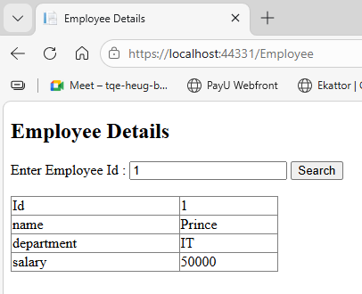

5. Web Application to demonstrate LINQ with object data source.
Student.cs
using System;
using System.Collections.Generic;
using System.Linq;
namespace Prince127
{
public class StudentModel
{
public int Id { get; set; }
public string Name { get; set; }
public int Marks { get; set; }
}
public class StudentData
{
public List<StudentModel> GetStudents()
{
List<StudentModel> students = new List<StudentModel>()
{
new StudentModel { Id = 1, Name = "Prince", Marks = 85 },
new StudentModel { Id = 2, Name = "Aman", Marks = 78 },
new StudentModel { Id = 3, Name = "Rahul", Marks = 92 },
new StudentModel { Id = 4, Name = "Neha", Marks = 88 }
};
var result = from s in students
where s.Marks > 80
select s;
return result.ToList();
}
}
}

LINQDemo.aspx
<%@ Page Language="C#" AutoEventWireup="true" CodeBehind="LINQDemo.aspx.cs" Inherits="Prince127.LINQDemo" %>
<!DOCTYPE html>
<html xmlns="http://www.w3.org/1999/xhtml">
<head runat="server">
<title>LINQ with ObjectDataSource</title>
</head>
<body>
<form id="form1" runat="server">
<h2>LINQ with ObjectDataSource Example</h2>
<asp:GridView ID="GridView1"
runat="server"
AutoGenerateColumns="True"
DataSourceID="ObjectDataSource1">
</asp:GridView>
<asp:ObjectDataSource ID="ObjectDataSource1"
runat="server"
TypeName="Prince127.StudentData" SelectMethod="GetStudents">
</asp:ObjectDataSource>
</form>
</body>
</html>

LINQDemo.aspx.cs
using System;
namespace Prince127
{
public partial class LINQDemo : System.Web.UI.Page
{
protected void Page_Load(object sender, EventArgs e)
{
}
}
}

Output:
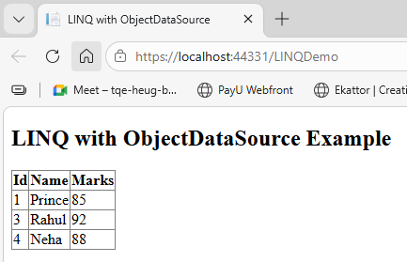

6. Web Application to demonstrate LINQ with data set.

CREATE TABLE student
(
Id INT PRIMARY KEY,
name VARCHAR(50),
course VARCHAR(50),
marks INT
);

Insert sample data:
INSERT INTO student VALUES (1,'Prince','MCA',87);
INSERT INTO student VALUES (2,'Aman','MCA',75);
INSERT INTO student VALUES (3,'Rahul','MBA',90);
INSERT INTO student VALUES (4,'Neha','MCA',82);

LINQDataSet.aspx
<%@ Page Language="C#" AutoEventWireup="true" CodeBehind="LINQDataSet.aspx.cs" Inherits="Prince127.LINQDataSet" %>
<!DOCTYPE html>
<html xmlns="http://www.w3.org/1999/xhtml">
<head runat="server">
<title>LINQ with DataSet</title>
</head>
<body>
<form id="form1" runat="server">
<h2>LINQ with DataSet Example</h2>
<asp:Button ID="btnShow" runat="server" Text="Show Students" OnClick="btnShow_Click" />
<br /><br />
<asp:GridView ID="GridView1" runat="server"></asp:GridView>
</form>
</body>
</html>

LINQDataSet.aspx.cs
using System;
using System.Data;
using System.Data.SqlClient;
using System.Linq;
namespace Prince127
{
public partial class LINQDataSet : System.Web.UI.Page
{
SqlConnection con = new SqlConnection(
@"Data Source=(localdb)\MSSQLLocalDB;Initial Catalog=PrinceDB;Integrated Security=True");
protected void btnShow_Click(object sender, EventArgs e)
{
SqlDataAdapter da = new SqlDataAdapter("select * from student", con);
DataSet ds = new DataSet();
da.Fill(ds, "student");
var result = from s in ds.Tables["student"].AsEnumerable()
where s.Field<int>("marks") > 80
select s;
GridView1.DataSource = result.CopyToDataTable();
GridView1.DataBind();
}
}
}

Output
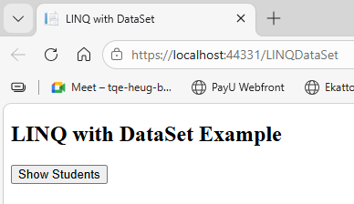

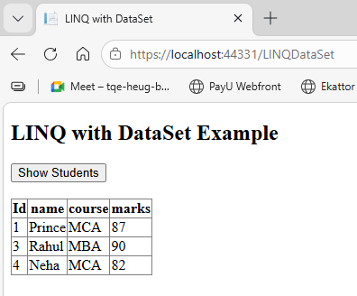

7. Create a webpage that demonstrates the use of data bound controls.
CREATE TABLE student
(
Id INT PRIMARY KEY,
name VARCHAR(50),
course VARCHAR(50),
marks INT
);

Insert sample data:
INSERT INTO student VALUES (1,'Prince','MCA',87);
INSERT INTO student VALUES (2,'Aman','MCA',75);
INSERT INTO student VALUES (3,'Rahul','MBA',90);
INSERT INTO student VALUES (4,'Neha','MCA',82);

DataBound.aspx
<%@ Page Language="C#" AutoEventWireup="true" CodeBehind="DataBound.aspx.cs" Inherits="Prince127.DataBound" %>
<!DOCTYPE html>
<html xmlns="http://www.w3.org/1999/xhtml">
<head runat="server">
<title>Data Bound</title>
</head>
<body>
<form id="form1" runat="server">
<p>Prince 127</p>
<h2>Student Details using Data Bound</h2>
<asp:Button ID="btnLoad" runat="server"
Text="Load Data"
OnClick="btnLoad_Click" />
<br /><br />
<h3>GridView</h3>
<asp:GridView ID="GridView1" runat="server"></asp:GridView>
<br />
<h3>DetailsView</h3>
<asp:DetailsView ID="DetailsView1"
runat="server"
AutoGenerateRows="True">
</asp:DetailsView>
<br />
<h3>DropDownList</h3>
<asp:DropDownList ID="DropDownList1" runat="server"></asp:DropDownList>
</form>
</body>
</html>

DataBound.aspx.cs
using System;
using System.Data;
using System.Data.SqlClient;
namespace Prince127
{
public partial class DataBound : System.Web.UI.Page
{
SqlConnection con = new SqlConnection(
@"Data Source=(localdb)\MSSQLLocalDB;Initial Catalog=PrinceDB;Integrated Security=True");
protected void btnLoad_Click(object sender, EventArgs e)
{
SqlDataAdapter da = new SqlDataAdapter("select * from student", con);
DataSet ds = new DataSet();
da.Fill(ds, "student");
GridView1.DataSource = ds.Tables["student"];
GridView1.DataBind();
DetailsView1.DataSource = ds.Tables["student"];
DetailsView1.DataBind();
DropDownList1.DataSource = ds.Tables["student"];
DropDownList1.DataTextField = "name";
DropDownList1.DataValueField = "Id";
DropDownList1.DataBind();
}
}
}
Output
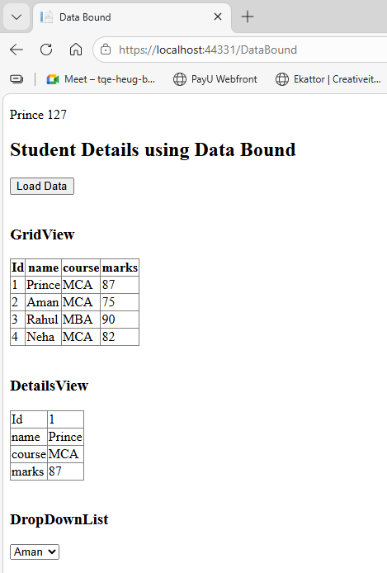

8. Build websites to demonstrate the working of entity framework
CREATE TABLE StudentEF
(
Id INT PRIMARY KEY,
Name VARCHAR(50),
Course VARCHAR(50),
Marks INT
)
EFStudent.aspx
<%@ Page Language="C#" AutoEventWireup="true" CodeBehind="EFStudent.aspx.cs" Inherits="Prince127.EFStudent" %>
<!DOCTYPE html>
<html xmlns="http://www.w3.org/1999/xhtml">
<head runat="server">
<title>Student Management using Entity Framework</title>
</head>
<body>
<form id="form1" runat="server">
<h2>Student Management using Entity Framework</h2>
Id :
<asp:TextBox ID="txtId" runat="server"></asp:TextBox>
<br /><br />
Name :
<asp:TextBox ID="txtName" runat="server"></asp:TextBox>
<br /><br />
Course :
<asp:TextBox ID="txtCourse" runat="server"></asp:TextBox>
<br /><br />
Marks :
<asp:TextBox ID="txtMarks" runat="server"></asp:TextBox>
<br /><br />
<asp:Button ID="btnInsert" runat="server"
Text="Insert"
OnClick="btnInsert_Click" />
<asp:Button ID="btnUpdate" runat="server"
Text="Update"
OnClick="btnUpdate_Click" />
<asp:Button ID="btnDelete" runat="server"
Text="Delete"
OnClick="btnDelete_Click" />
<asp:Button ID="btnDisplay" runat="server"
Text="Display"
OnClick="btnDisplay_Click" />
<br /><br />
<asp:GridView ID="GridView1" runat="server"></asp:GridView>
</form>
</body>
</html>

EFStudent.aspx.cs
using System;
using System.Linq;
namespace Prince127
{
public partial class EFStudent : System.Web.UI.Page
{
PrinceDBEntities1 db = new PrinceDBEntities1();
protected void btnInsert_Click(object sender, EventArgs e)
{
StudentEF s = new StudentEF();
s.Id = Convert.ToInt32(txtId.Text);
s.Name = txtName.Text;
s.Course = txtCourse.Text;
s.Marks = Convert.ToInt32(txtMarks.Text);
db.StudentEFs.Add(s);
db.SaveChanges();
DisplayData();
}
protected void btnUpdate_Click(object sender, EventArgs e)
{
int id = Convert.ToInt32(txtId.Text);
var s = db.StudentEFs.First(x => x.Id == id);
s.Name = txtName.Text;
s.Course = txtCourse.Text;
s.Marks = Convert.ToInt32(txtMarks.Text);
db.SaveChanges();
DisplayData();
}
protected void btnDelete_Click(object sender, EventArgs e)
{
int id = Convert.ToInt32(txtId.Text);
var s = db.StudentEFs.First(x => x.Id == id);
db.StudentEFs.Remove(s);
db.SaveChanges();
DisplayData();
}
protected void btnDisplay_Click(object sender, EventArgs e)
{
DisplayData();
}
void DisplayData()
{
GridView1.DataSource = db.StudentEFs.ToList();
GridView1.DataBind();
}

}
}

Output
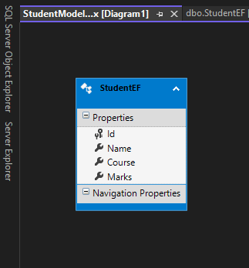

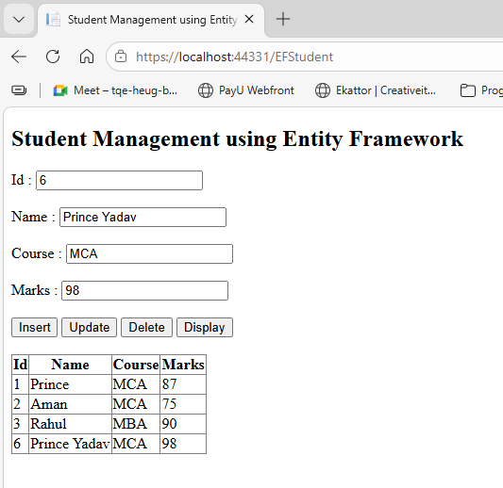

9. Design a web page to perform CRUD operation using SqlDataSource.
CREATE TABLE studentCRUD
(
Id INT IDENTITY(1,1) PRIMARY KEY,
Name NVARCHAR(50),
Course NVARCHAR(50),
Marks INT
)

CRUD.aspx
<%@ Page Language="C#" AutoEventWireup="true" CodeBehind="CRUD.aspx.cs" Inherits="Prince127.CRUD" %>
<!DOCTYPE html>
<html>
<head runat="server">
<title>Student CRUD using SqlDataSource</title>
<style>
body{
font-family: Arial;
margin:40px;
}
h2{
color:#2c3e50;
}
.grid{
margin-top:20px;
}
.insertbox{
margin-top:30px;
padding:10px;
border:1px solid #ccc;
width:300px;
}
</style>
</head>
<body>
<form id="form1" runat="server">
<h2>Student CRUD using SqlDataSource</h2>
<!-- GRIDVIEW FOR DISPLAY / EDIT / DELETE -->
<asp:GridView
ID="GridView1"
runat="server"
CssClass="grid"
DataSourceID="SqlDataSource1"
AutoGenerateColumns="False"
AutoGenerateEditButton="True"
AutoGenerateDeleteButton="True"
DataKeyNames="Id">
<Columns>
<asp:BoundField DataField="Id" HeaderText="Id" ReadOnly="True"/>
<asp:BoundField DataField="Name" HeaderText="Name"/>
<asp:BoundField DataField="Course" HeaderText="Course"/>
<asp:BoundField DataField="Marks" HeaderText="Marks"/>
</Columns>
</asp:GridView>
<br /><br />
<!-- DETAILS VIEW FOR INSERT -->
<asp:DetailsView
ID="DetailsView1"
runat="server"
CssClass="insertbox"
DataSourceID="SqlDataSource1"
AutoGenerateRows="True"
DefaultMode="Insert"
AutoGenerateInsertButton="True">
</asp:DetailsView>
<!-- SQLDATASOURCE -->
<asp:SqlDataSource
ID="SqlDataSource1"
runat="server"
ConnectionString="<%$ ConnectionStrings:PrinceDBConnectionString %>"
SelectCommand="SELECT * FROM studentCRUD"
InsertCommand="INSERT INTO studentCRUD(Name,Course,Marks) VALUES(@Name,@Course,@Marks)"
UpdateCommand="UPDATE studentCRUD SET Name=@Name,Course=@Course,Marks=@Marks WHERE Id=@Id"
DeleteCommand="DELETE FROM studentCRUD WHERE Id=@Id">
</asp:SqlDataSource>
</form>
</body>
</html>

CRUD.aspx.cs
using System;
using System.Collections.Generic;
using System.Linq;
using System.Web;
using System.Web.UI;
namespace Prince127
{
public partial class CRUD : System.Web.UI.Page
{
protected void Page_Load(object sender, EventArgs e)
{
}
}
}

Web.config
<connectionStrings>
<add name="PrinceDBConnectionString"
connectionString="Data Source=(localdb)\MSSQLLocalDB;Initial Catalog=PrinceDB;Integrated Security=True"
providerName="System.Data.SqlClient"/>
</connectionStrings>

Output:
a. Insert
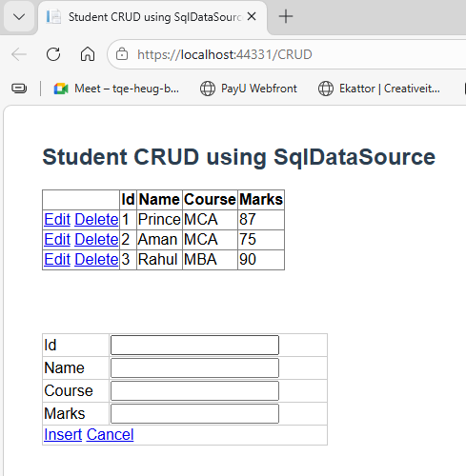

b. Update
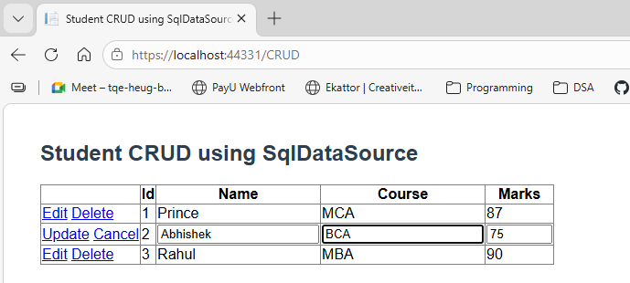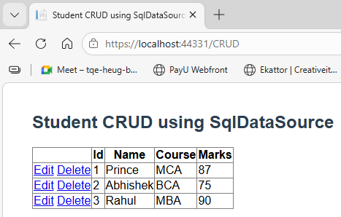

c. Delete
