Practical – 1
Aim: Installation: ns3 in Linux, NetAnim, Wireshark, PyViz, tcpdump

Steps:
sudo apt upgrade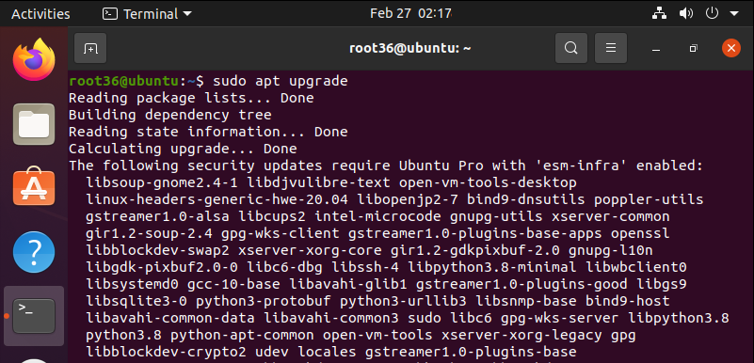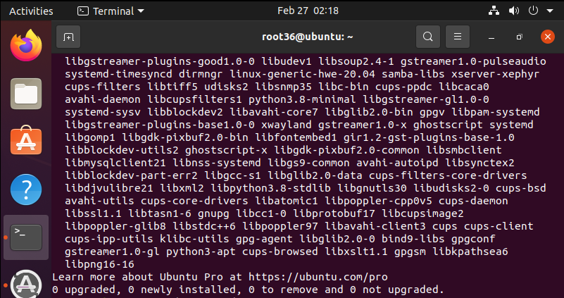sudo apt update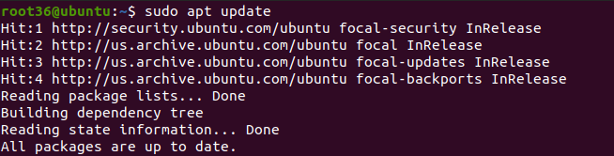
sudo apt-get install g++ python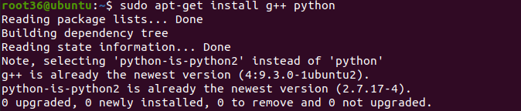sudo apt-get install g++ python3 python3-dev pkg-config sqlite3
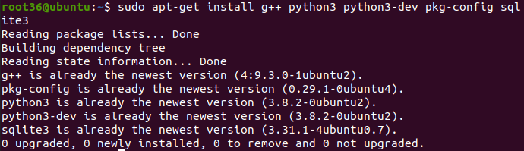sudo apt install -y qtcreator qtbase5-dev qt5-qmake cmake
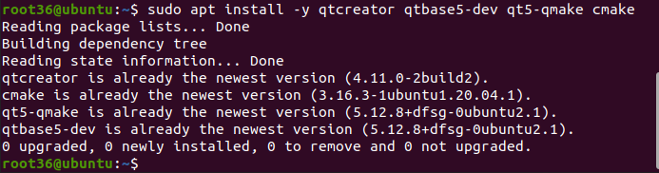

sudo apt-get install gir1.2-goocanvas-2.0 python3-pygraphviz python3-gi python3-gi-cairo gir1.2-gtk-3.0
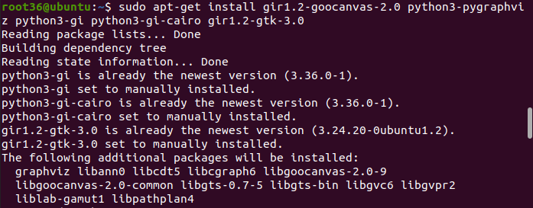sudo apt-get install gdb valgrind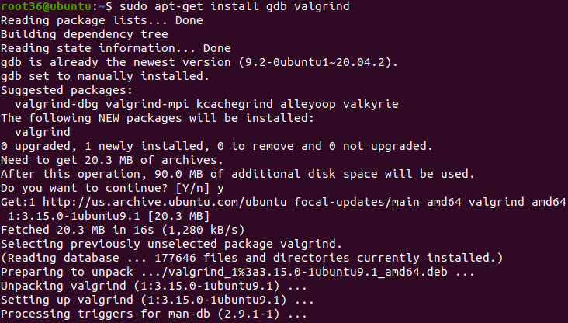sudo apt-get install doxygen graphviz imagemagick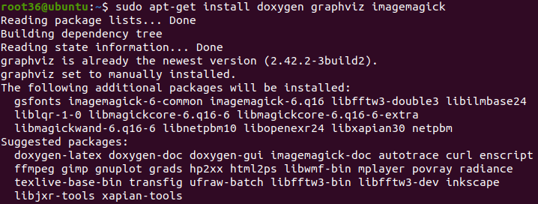
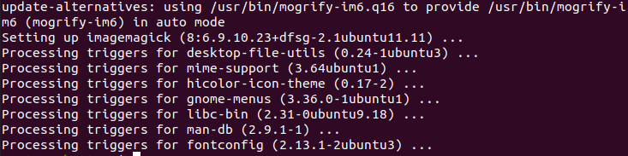sudo apt install python3-pip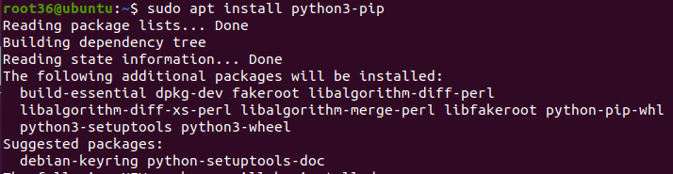sudo apt-get install python3-sphinx dia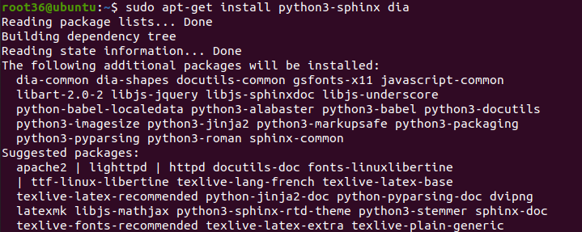
sudo apt-get install tcpdump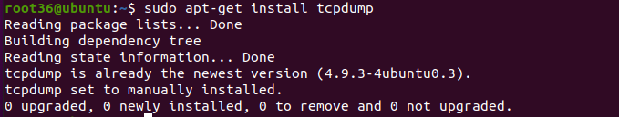sudo apt-get install -y llvm-11 llvm-11-dev clang-11 llvm-11-tools
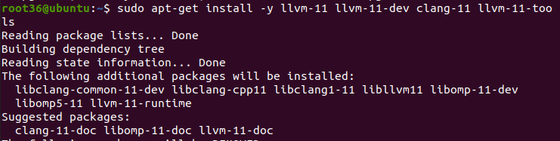
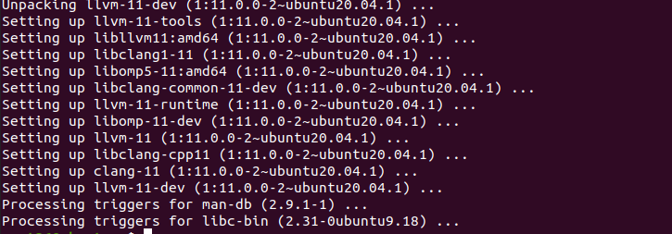pip install cxxfilt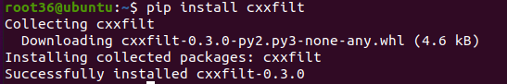wget https://www.nsnam.org/releases/ns-allinone-3.32.tar.bz2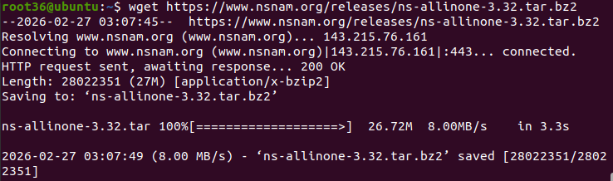
tar -xjf ns-allinone-3.32.tar.bz2
cd ns-allinone-3.39/ns-3.39
./waf configure --enable-examples --enable-tests
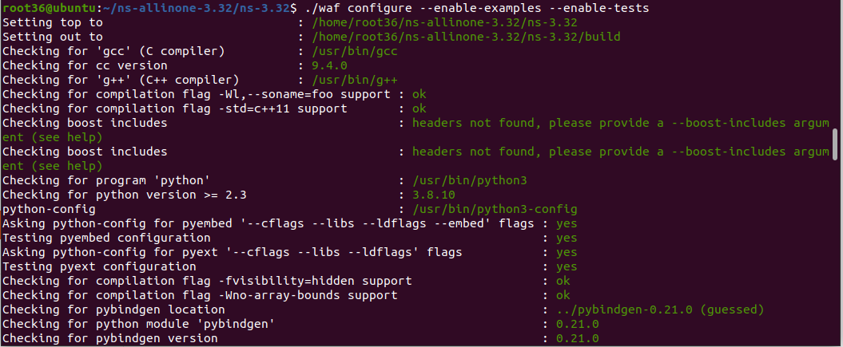./waf build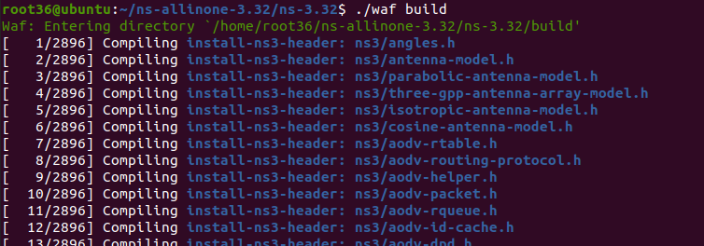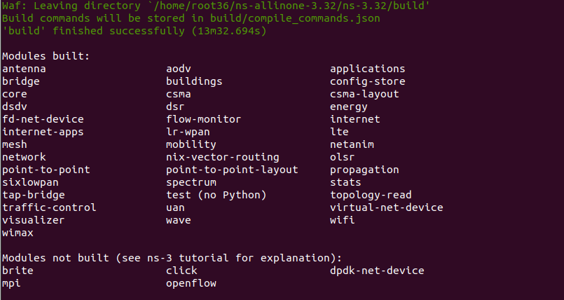
./waf --run "scratch/scratch-simulator"
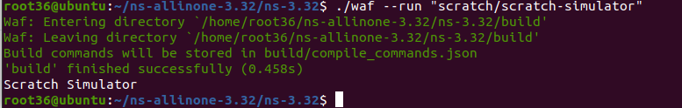
cd ~/ns-allinone-3.32/netanim-3.108
sudo apt install -y qt5-default qttools5-dev qttools5-dev-tools
./waf build
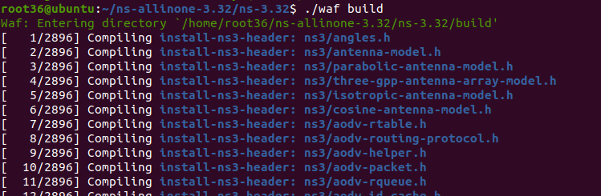sudo apt-get update
sudo apt-get install qtbase5-dev qtchooser qt5-qmake qtbase5-dev-tools build-essential
qmake NetAnim.pro
make
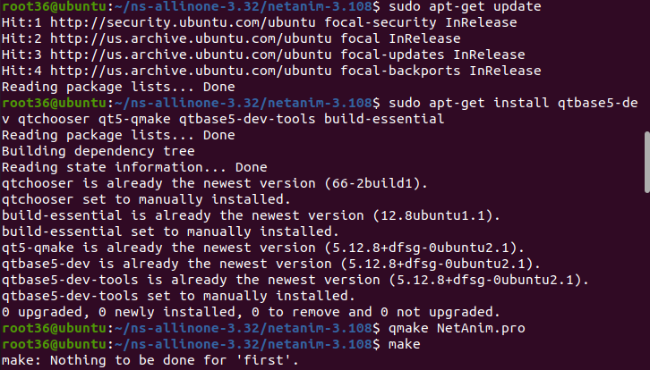

./NetAnim
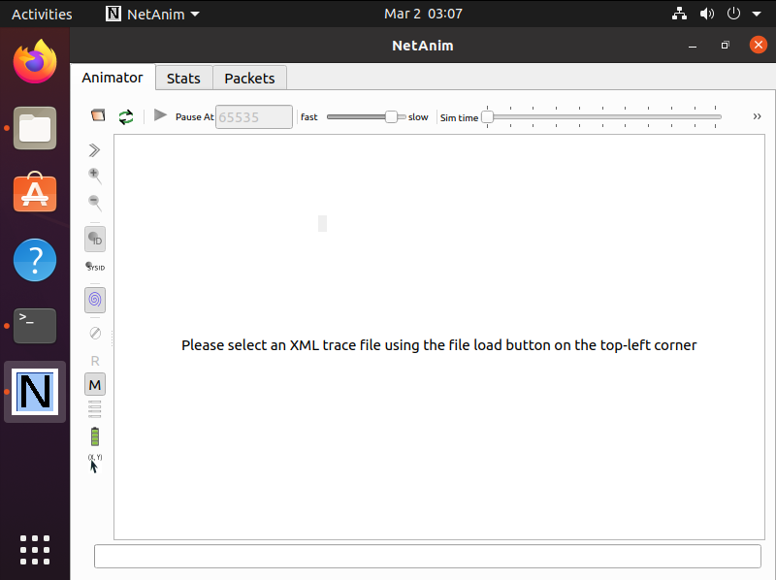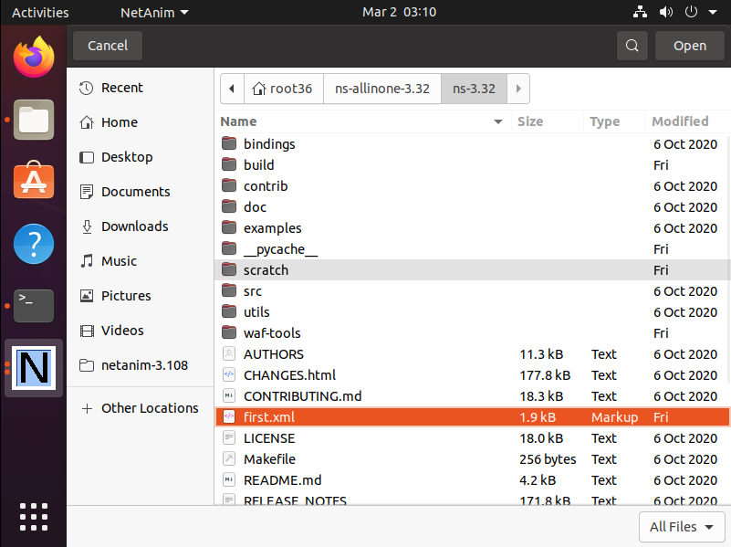
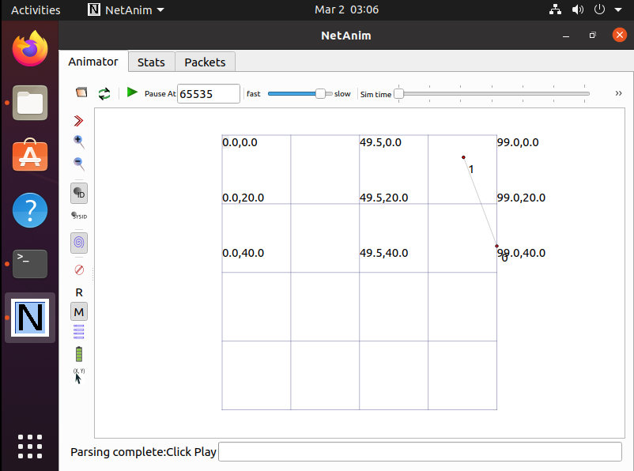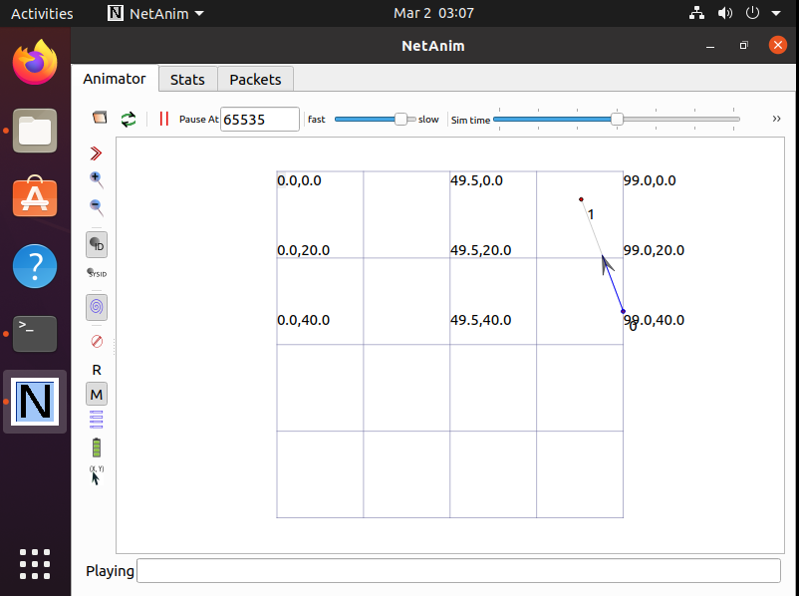
sudo apt install wireshark
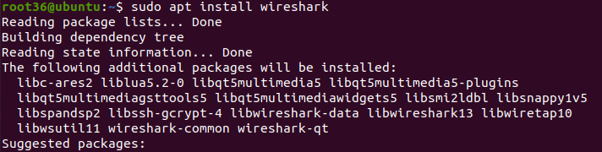
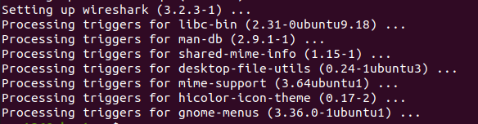
sudo usermod -aG wireshark $(whoami)
sudo reboot
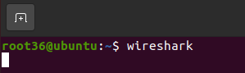
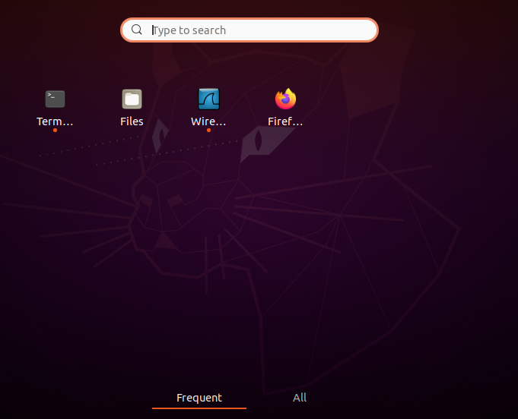
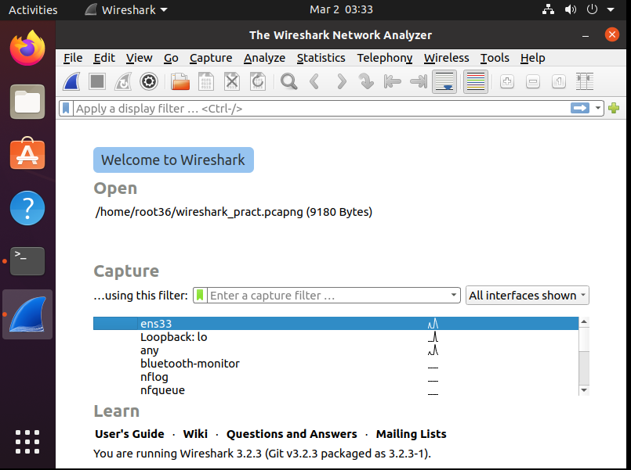
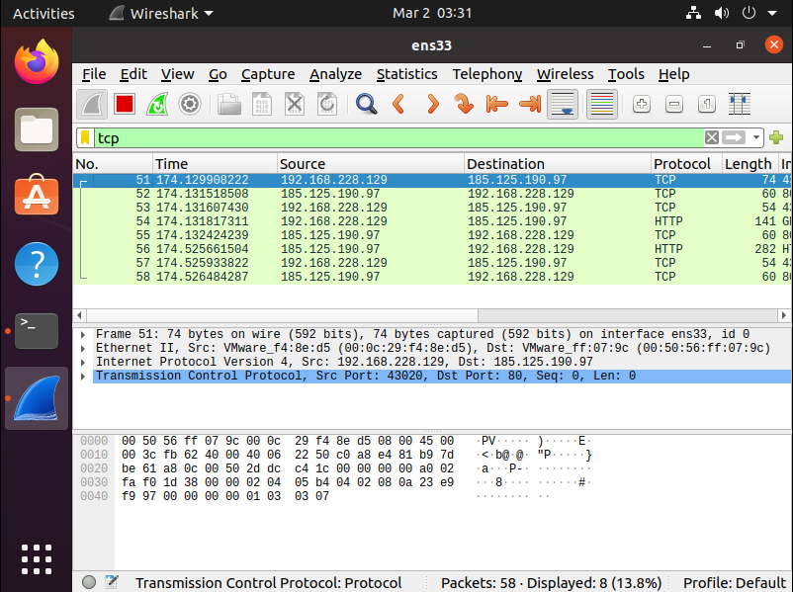
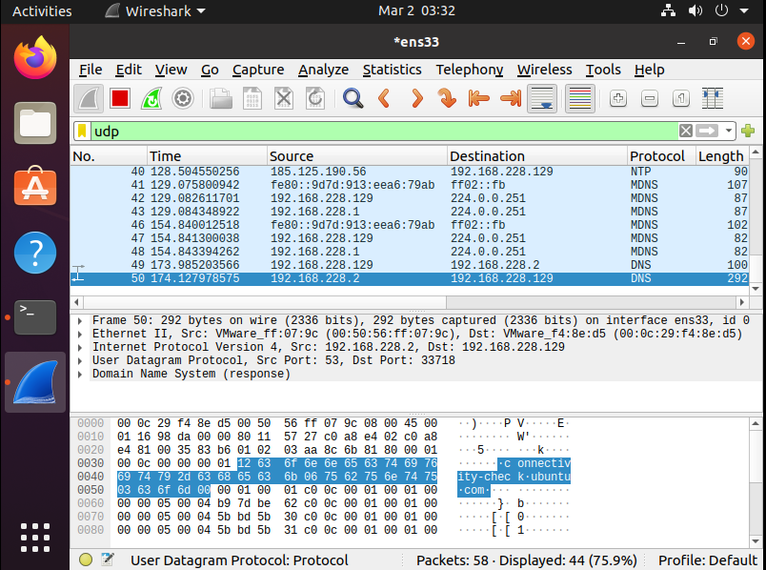
sudo apt update
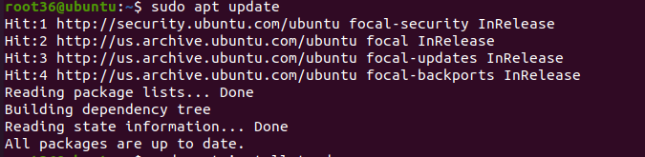
sudo apt install tcpdump -y
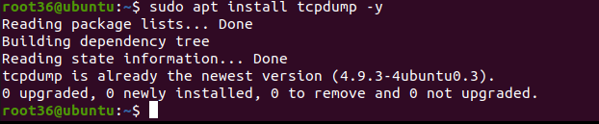
tcpdump –version
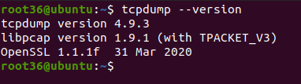
sudo tcpdump -i any -w capture.pcap
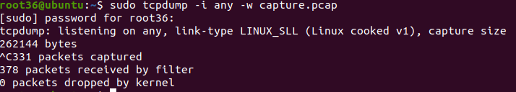
wireshark capture.pcap
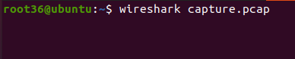
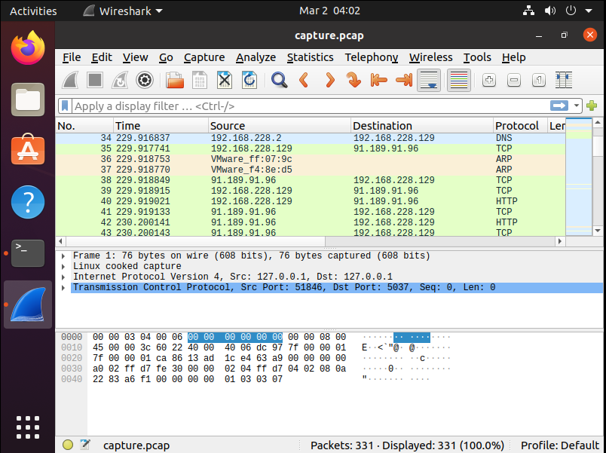
Installation of pyviz visualizeer
➢ Install python3-venv
• sudo apt update
• sudo apt install python3-venv
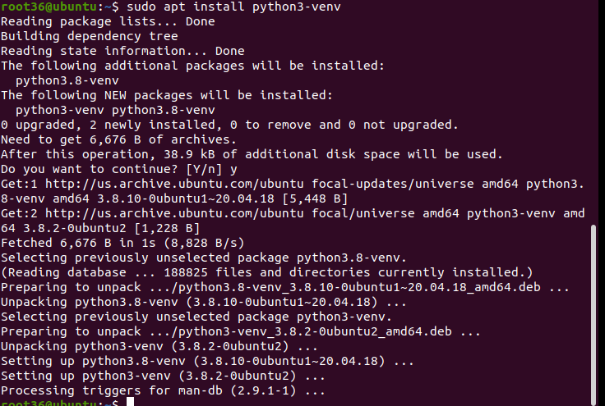
python3 -m venv pyviz-env
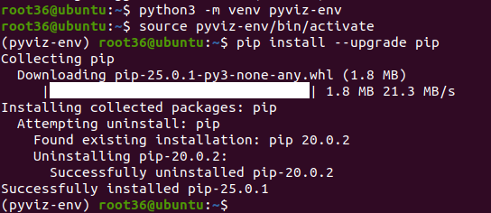

pip install holoviews panel datashader bokeh hvplot
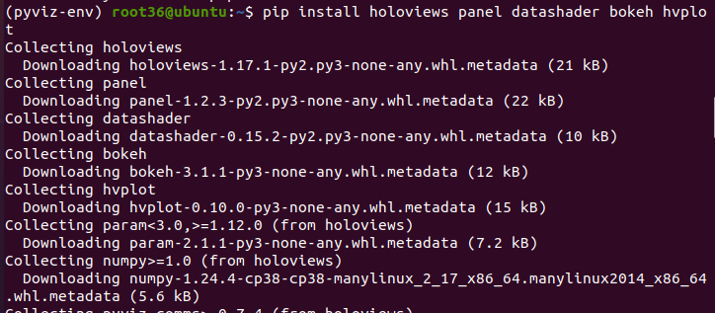
pip install jupyterlab notebook ipywidgets
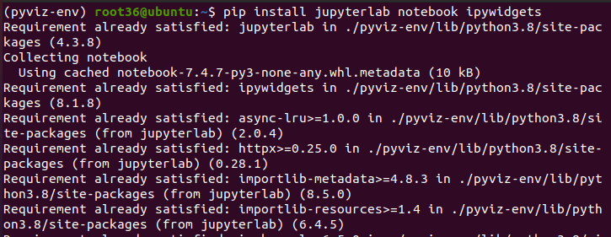
>>> import holoviews as hv
>>> hv.extension('bokeh')
>>> hv.Curve([1, 2, 3])

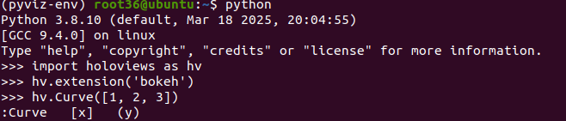
Practical - 2
Aim: Program to simulate Point to Point topology.

point77.cc
#include "ns3/core-module.h"
#include "ns3/network-module.h"
#include "ns3/internet-module.h"
#include "ns3/point-to-point-module.h"
#include "ns3/applications-module.h"
#include "ns3/netanim-module.h"
#include "ns3/mobility-module.h"

using namespace ns3;

NS_LOG_COMPONENT_DEFINE("FirstScriptExample");
int main(int argc, char *argv[])
{
// Parse command line arguments
CommandLine cmd;
cmd.Parse(argc, argv);

// Set the resolution of time (nanoseconds)
Time::SetResolution(Time::NS);

// Enable logging for the UDP Echo client and server applications
LogComponentEnable("UdpEchoClientApplication", LOG_LEVEL_INFO);
LogComponentEnable("UdpEchoServerApplication", LOG_LEVEL_INFO);

// Create two nodes (n0 and n1)
NodeContainer nodes;
nodes.Create(2);

// Set up the Point-to-Point link between the two nodes
PointToPointHelper pointToPoint;
pointToPoint.SetDeviceAttribute("DataRate", StringValue("5Mbps"));
pointToPoint.SetChannelAttribute("Delay", StringValue("2ms"));

// Install the Point-to-Point devices on the nodes
NetDeviceContainer devices;
devices = pointToPoint.Install(nodes);

// Install the Internet stack (IP, UDP, etc.) on the nodes
InternetStackHelper stack;
stack.Install(nodes);

// Set IP addresses for the devices
Ipv4AddressHelper address;
address.SetBase("10.1.1.0", "255.255.255.0");
Ipv4InterfaceContainer interfaces = address.Assign(devices);

// Set up the UDP Echo server on node 1, listening on port 9
UdpEchoServerHelper echoServer(15);
ApplicationContainer serverApps = echoServer.Install(nodes.Get(1));
serverApps.Start(Seconds(1.0));
serverApps.Stop(Seconds(10.0));

// Set up the UDP Echo client on node 0, sending to node 1 at port 9
UdpEchoClientHelper echoClient(interfaces.GetAddress(1), 15);
echoClient.SetAttribute("MaxPackets", UintegerValue(1));
echoClient.SetAttribute("Interval", TimeValue(Seconds(1.0)));
echoClient.SetAttribute("PacketSize", UintegerValue(1024));

// Install the UDP Echo client application on node 0
ApplicationContainer clientApps = echoClient.Install(nodes.Get(0));
clientApps.Start(Seconds(2.0));
clientApps.Stop(Seconds(10.0));

// Set the mobility model for both nodes (Constant Position)
MobilityHelper mobility;
mobility.SetMobilityModel("ns3::ConstantPositionMobilityModel");
mobility.Install(nodes);

// Set specific positions for the nodes (n0 at (10,25), n1 at (40,25))
AnimationInterface anim("first.xml");
AnimationInterface::SetConstantPosition(nodes.Get(0), 10, 25);
AnimationInterface::SetConstantPosition(nodes.Get(1), 40, 25);

// Enable packet metadata in NetAnim (optional but useful for debugging)
anim.EnablePacketMetadata(true);

// Enable Pcap trace for packet capture
pointToPoint.EnablePcapAll("point");

// Run the simulation
Simulator::Run();
Simulator::Destroy();

return 0;
}

OUTPUT:
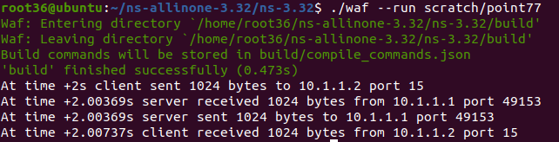

Change the Port Number (15 to 16):
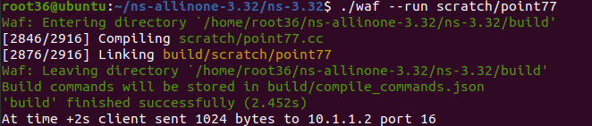
Python Visualization:

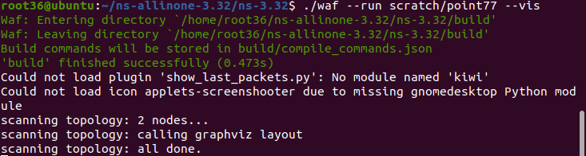

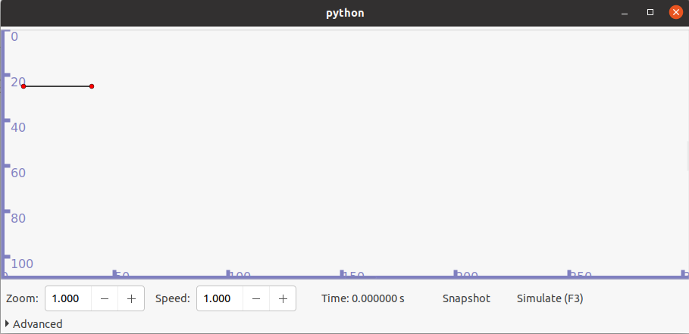

2. Point to point Topology using NetAnim

first77.cc
#include "ns3/core-module.h"
#include "ns3/network-module.h"
#include "ns3/internet-module.h"
#include "ns3/point-to-point-module.h"
#include "ns3/applications-module.h"
#include "ns3/netanim-module.h"
#include "ns3/mobility-module.h"

// Default Network Topology
// 10.1.1.0
// n0 --- n1
// Point-to-Point link

using namespace ns3;

NS_LOG_COMPONENT_DEFINE("FirstScriptExample");

int main(int argc, char *argv[])
{
CommandLine cmd;
cmd.Parse(argc, argv);

// Set time resolution to nanoseconds
Time::SetResolution(Time::NS);

// Enable logging for UDP Echo Client and Server
LogComponentEnable("UdpEchoClientApplication", LOG_LEVEL_INFO);
LogComponentEnable("UdpEchoServerApplication", LOG_LEVEL_INFO);

// Create 2 nodes
NodeContainer nodes;
nodes.Create(2);

// Configure point-to-point connection
PointToPointHelper pointToPoint;
pointToPoint.SetDeviceAttribute("DataRate", StringValue("5Mbps"));
pointToPoint.SetChannelAttribute("Delay", StringValue("2ms"));

// Install devices
NetDeviceContainer devices;
devices = pointToPoint.Install(nodes);
InternetStackHelper stack;
stack.Install(nodes);
Ipv4AddressHelper address;
address.SetBase("10.1.1.0", "255.255.255.0");
Ipv4InterfaceContainer interfaces = address.Assign(devices);

// Create and configure UDP Echo Server on node 1 (n1)
UdpEchoServerHelper echoServer(9);
ApplicationContainer serverApps = echoServer.Install(nodes.Get(1));
serverApps.Start(Seconds(1.0));
serverApps.Stop(Seconds(10.0));

// Create and configure UDP Echo Client on node 0 (n0)
UdpEchoClientHelper echoClient(interfaces.GetAddress(1), 9);
echoClient.SetAttribute("MaxPackets", UintegerValue(1));
echoClient.SetAttribute("Interval", TimeValue(Seconds(1.0)));
echoClient.SetAttribute("PacketSize", UintegerValue(1024));

ApplicationContainer clientApps = echoClient.Install(nodes.Get(0));
clientApps.Start(Seconds(2.0));
clientApps.Stop(Seconds(10.0));

// Set constant mobility for animation
MobilityHelper mobility;
mobility.SetMobilityModel("ns3::ConstantPositionMobilityModel");
mobility.Install(nodes);

// Configure NetAnim
AnimationInterface anim("first.xml");
AnimationInterface::SetConstantPosition(nodes.Get(0), 10, 25);
AnimationInterface::SetConstantPosition(nodes.Get(1), 40, 25);
anim.EnablePacketMetadata(true);

// Enable PCAP tracing
pointToPoint.EnablePcapAll("pract2Mana");

// Run the simulation
Simulator::Run();
Simulator::Destroy();
return 0;
}
OUTPUT:
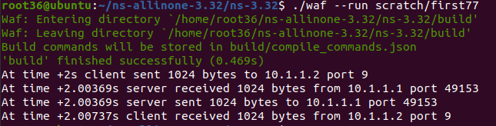
• Open NetAnim to see the animation:

• Run the first.xml file for visualization:
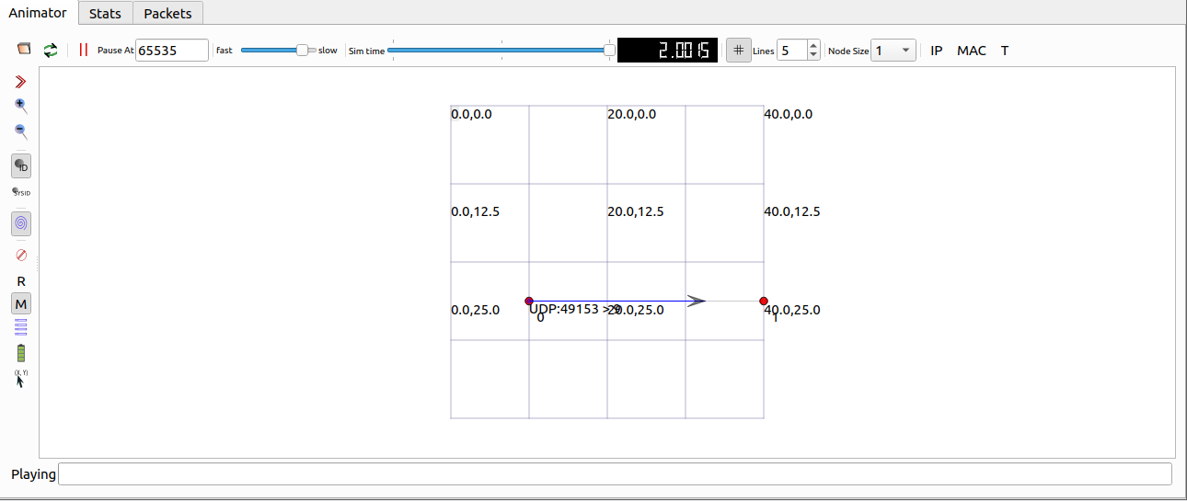

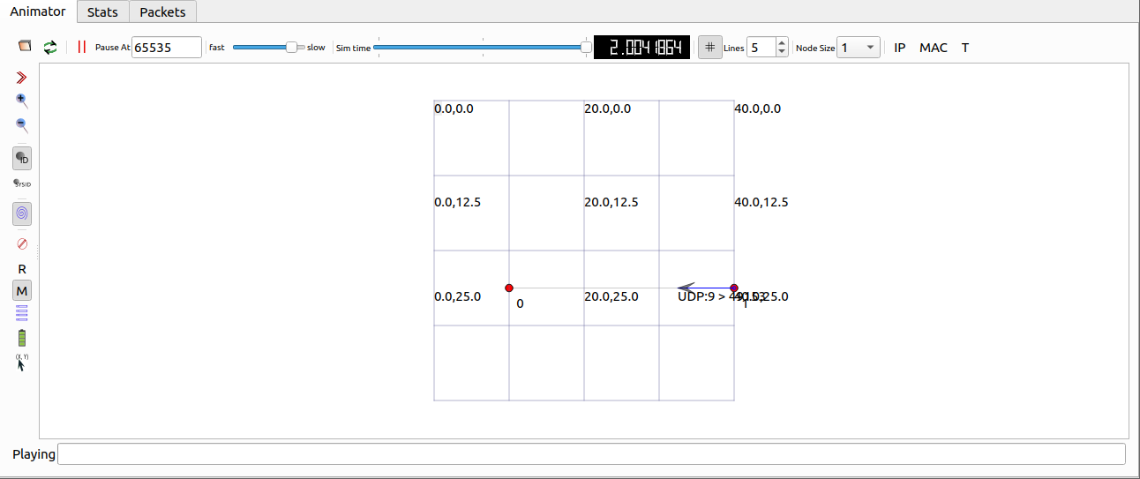

Practical – 3
Aim: Program to simulate Bus topology

bus77.cc
#include "ns3/core-module.h"
#include "ns3/network-module.h"
#include "ns3/csma-module.h"
#include "ns3/internet-module.h"
#include "ns3/point-to-point-module.h"
#include "ns3/applications-module.h"
#include "ns3/ipv4-global-routing-helper.h"

using namespace ns3;
NS_LOG_COMPONENT_DEFINE("SecondScriptExample");
int main(int argc, char *argv[])
{
bool verbose = true;
uint32_t nCsma = 5;

// Command line argument parsing
CommandLine cmd;
cmd.AddValue("nCsma", "Number of CSMA nodes/devices", nCsma);
cmd.AddValue("verbose", "Enable logging if true", verbose);
cmd.Parse(argc, argv);
// Enable logging
if (verbose)
{
LogComponentEnable("UdpEchoClientApplication", LOG_LEVEL_INFO);
LogComponentEnable("UdpEchoServerApplication", LOG_LEVEL_INFO);
}
// Ensure at least 1 CSMA node
if (nCsma == 0)
{
nCsma = 1;
}
// Create point-to-point nodes
NodeContainer p2pNodes;
p2pNodes.Create(2);
// Create CSMA nodes and connect one P2P node
NodeContainer csmaNodes;
csmaNodes.Add(p2pNodes.Get(1));
csmaNodes.Create(nCsma);

// Configure point-to-point link
PointToPointHelper pointToPoint;
pointToPoint.SetDeviceAttribute("DataRate", StringValue("10Mbps"));
pointToPoint.SetChannelAttribute("Delay", StringValue("5ms"));

NetDeviceContainer p2pDevices;
p2pDevices = pointToPoint.Install(p2pNodes);

// Configure CSMA network
CsmaHelper csma;
csma.SetChannelAttribute("DataRate", StringValue("100Mbps"));
csma.SetChannelAttribute("Delay", TimeValue(NanoSeconds(6560)));

NetDeviceContainer csmaDevices;
csmaDevices = csma.Install(csmaNodes);
// Install Internet stack
InternetStackHelper stack;
stack.Install(p2pNodes.Get(0));
stack.Install(csmaNodes);

// Assign IP addresses (P2P)
Ipv4AddressHelper address;
address.SetBase("10.1.1.0", "255.255.255.0");
Ipv4InterfaceContainer p2pInterfaces;
p2pInterfaces = address.Assign(p2pDevices);

// Assign IP addresses (CSMA)
address.SetBase("10.1.2.0", "255.255.255.0");
Ipv4InterfaceContainer csmaInterfaces;
csmaInterfaces = address.Assign(csmaDevices);

// Create UDP Echo Server (last CSMA node)
UdpEchoServerHelper echoServer(9);
ApplicationContainer serverApps;
serverApps = echoServer.Install(csmaNodes.Get(nCsma));
serverApps.Start(Seconds(1.0));
serverApps.Stop(Seconds(10.0));

// Create UDP Echo Client (P2P node)
UdpEchoClientHelper echoClient(csmaInterfaces.GetAddress(nCsma), 9);
echoClient.SetAttribute("MaxPackets", UintegerValue(1));
echoClient.SetAttribute("Interval", TimeValue(Seconds(1.0)));
echoClient.SetAttribute("PacketSize", UintegerValue(1024));
ApplicationContainer clientApps;
clientApps = echoClient.Install(p2pNodes.Get(0));
clientApps.Start(Seconds(2.0));
clientApps.Stop(Seconds(10.0));
// Populate routing tables
Ipv4GlobalRoutingHelper::PopulateRoutingTables();

// Enable PCAP tracing
pointToPoint.EnablePcapAll("pract2Mana");
csma.EnablePcap("pract2Mana", csmaDevices.Get(1), true);
// Run simulation
Simulator::Run();
Simulator::Destroy();
return 0;
}
OUTPUT:
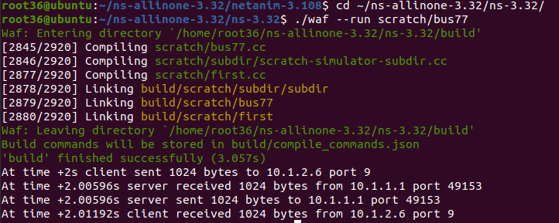
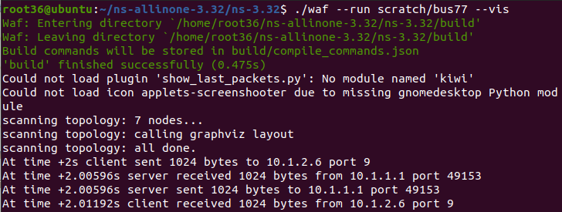
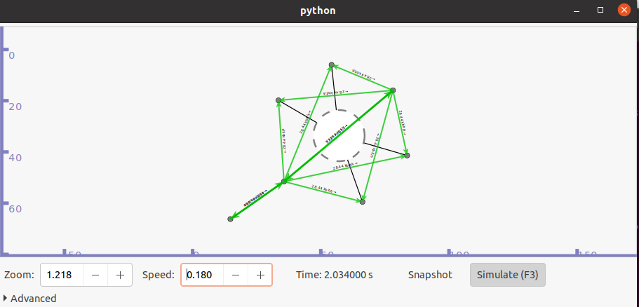
Practical – 4
Aim: Program to simulate Start topology

#include "ns3/core-module.h"
#include "ns3/network-module.h"
#include "ns3/internet-module.h"
#include "ns3/point-to-point-star.h"
#include "ns3/applications-module.h"
#include "ns3/netanim-module.h"
#include "ns3/mobility-module.h"
#include "ns3/onoff-application.h"

using namespace ns3;

NS_LOG_COMPONENT_DEFINE("StarExample");

int main(int argc, char *argv[])
{
// Set default packet size and data rate
Config::SetDefault("ns3::OnOffApplication::PacketSize", UintegerValue(137));
Config::SetDefault("ns3::OnOffApplication::DataRate", StringValue("14kb/s"));

// Default number of spokes
uint32_t nSpokes = 8;

// Command line argument
CommandLine cmd;
cmd.AddValue("nSpokes", "Number of nodes in the star", nSpokes);
cmd.Parse(argc, argv);

// Enable logging
LogComponentEnable("UdpEchoClientApplication", LOG_LEVEL_INFO);
LogComponentEnable("UdpEchoServerApplication", LOG_LEVEL_INFO);

NS_LOG_INFO("Build star topology");

// Configure point-to-point links
PointToPointHelper pointToPoint;
pointToPoint.SetDeviceAttribute("DataRate", StringValue("5Mbps"));
pointToPoint.SetChannelAttribute("Delay", StringValue("2ms"));

// Create star topology
PointToPointStarHelper star(nSpokes, pointToPoint);
NS_LOG_INFO("Install Internet Stack");
InternetStackHelper internet;
star.InstallStack(internet);
NS_LOG_INFO("Assign IP Addresses");
star.AssignIpv4Addresses(Ipv4AddressHelper("10.1.1.0", "255.255.255.0"));
NS_LOG_INFO("Create Applications");
// Create Packet Sink (Server) on Hub
uint16_t port = 50000;
Address hubLocalAddress(InetSocketAddress(Ipv4Address::GetAny(), port));
PacketSinkHelper packetSinkHelper("ns3::TcpSocketFactory", hubLocalAddress);
ApplicationContainer hubApp = packetSinkHelper.Install(star.GetHub());
hubApp.Start(Seconds(1.0));
hubApp.Stop(Seconds(10.0));
// Create OnOff Applications on each spoke
OnOffHelper onOffHelper("ns3::TcpSocketFactory", Address());
onOffHelper.SetAttribute("OnTime",
StringValue("ns3::ConstantRandomVariable[Constant=1]"));
onOffHelper.SetAttribute("OffTime",
StringValue("ns3::ConstantRandomVariable[Constant=0]"));
ApplicationContainer spokeApps;

for (uint32_t i = 0; i < star.SpokeCount(); ++i)
{
AddressValue remoteAddress(
InetSocketAddress(star.GetHubIpv4Address(i), port));

onOffHelper.SetAttribute("Remote", remoteAddress);
spokeApps.Add(onOffHelper.Install(star.GetSpokeNode(i)));
}

spokeApps.Start(Seconds(1.0));
spokeApps.Stop(Seconds(10.0));

NS_LOG_INFO("Enable Routing");
Ipv4GlobalRoutingHelper::PopulateRoutingTables();

NS_LOG_INFO("Enable PCAP tracing");
pointToPoint.EnablePcapAll("star");

// Set layout for NetAnim
star.BoundingBox(1, 1, 100, 100);

// NetAnim output file
AnimationInterface anim("star.xml");

NS_LOG_INFO("Run Simulation");
Simulator::Run();
Simulator::Destroy();
NS_LOG_INFO("Done");
return 0;
}

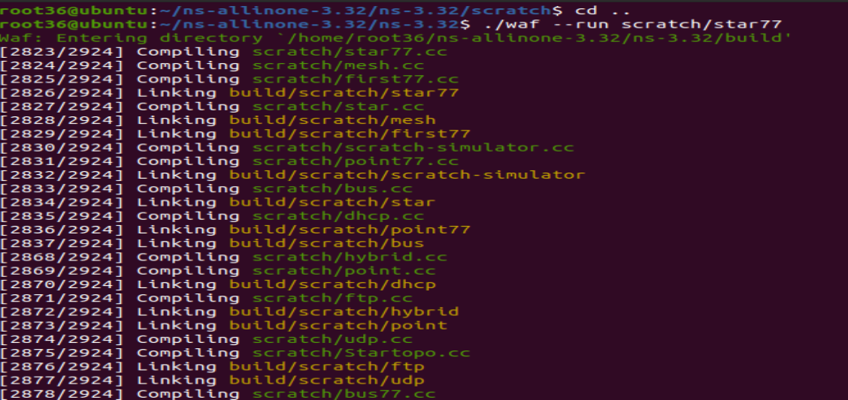
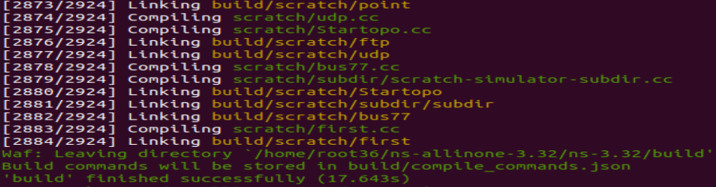
Using Python Visualizer :
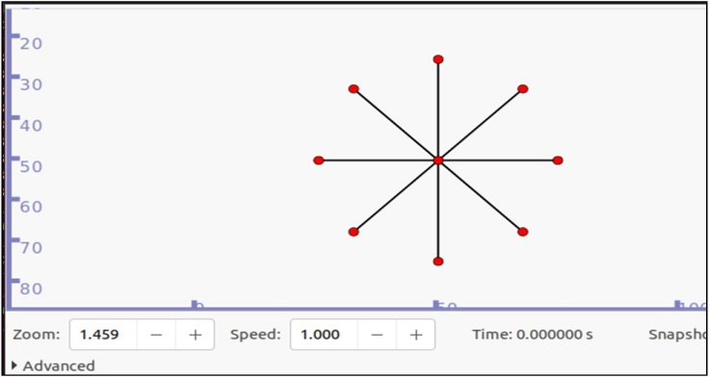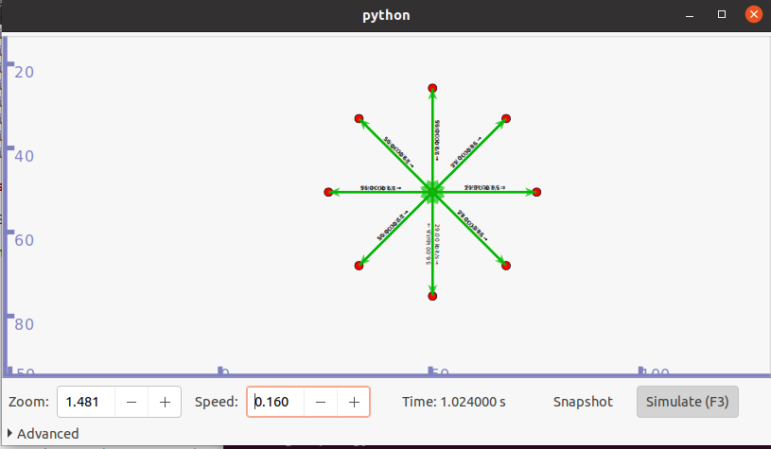
Using NetAnim:
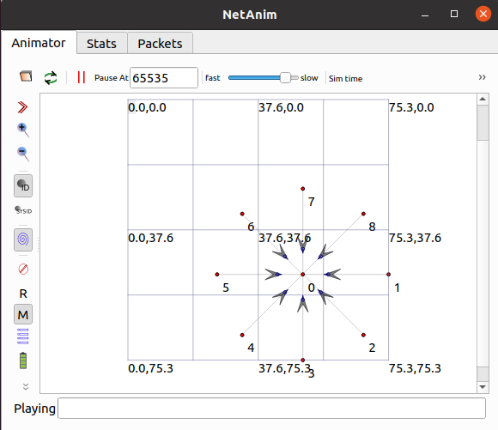
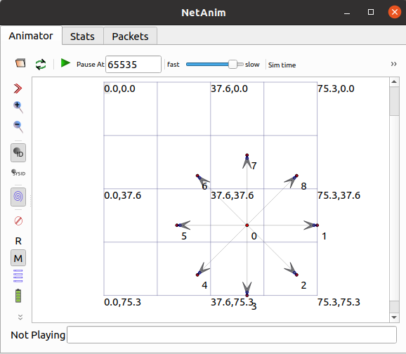

Practical – 5
Aim: Program to simulate Mesh topology

#include "ns3/applications-module.h"
#include "ns3/core-module.h"
#include "ns3/internet-module.h"
#include "ns3/mesh-helper.h"
#include "ns3/mesh-module.h"
#include "ns3/mobility-module.h"
#include "ns3/network-module.h"
#include "ns3/yans-wifi-helper.h"
#include "ns3/netanim-module.h"

#include <fstream>
#include <iostream>
#include <sstream>

using namespace ns3;

NS_LOG_COMPONENT_DEFINE("MeshExample");
// Global counters
uint32_t g_udpTxCount = 0;
uint32_t g_udpRxCount = 0;
// TX Trace
void TxTrace(Ptr<const Packet> p)
{
NS_LOG_DEBUG("Sent " << p->GetSize() << " bytes");
g_udpTxCount++;
}
// RX Trace
void RxTrace(Ptr<const Packet> p)
{
NS_LOG_DEBUG("Received " << p->GetSize() << " bytes");
g_udpRxCount++;
}
class MeshTest
{
public:
MeshTest();
void Configure(int argc, char **argv);
int Run();

private:
// Parameters
int m_xSize;
int m_ySize;
double m_step;
double m_randomStart;
double m_totalTime;
double m_packetInterval;
uint16_t m_packetSize;
uint32_t m_nIfaces;
bool m_chan;
bool m_pcap;
bool m_ascii;
std::string m_stack;
std::string m_root;
// Containers
NodeContainer nodes;
NetDeviceContainer meshDevices;
Ipv4InterfaceContainer interfaces;
MeshHelper mesh;
// Functions
void CreateNodes();
void InstallInternetStack();
void InstallApplication();
void Report();
};
// ================= CONSTRUCTOR =================
MeshTest::MeshTest()
: m_xSize(3),
m_ySize(3),
m_step(50.0),
m_randomStart(0.1),
m_totalTime(100.0),
m_packetInterval(1.0),
m_packetSize(1024),
m_nIfaces(1),
m_chan(true),
m_pcap(false),
m_ascii(false),
m_stack("ns3::Dot11sStack"),
m_root("ff:ff:ff:ff:ff:ff")
{
}
void MeshTest::Configure(int argc, char *argv[])
{
CommandLine cmd;
cmd.AddValue("x-size", "Grid width", m_xSize);
cmd.AddValue("y-size", "Grid height", m_ySize);
cmd.AddValue("step", "Distance between nodes", m_step);
cmd.AddValue("start", "Random start delay", m_randomStart);
cmd.AddValue("time", "Simulation time", m_totalTime);
cmd.AddValue("packet-interval", "Packet interval", m_packetInterval);
cmd.AddValue("packet-size", "Packet size", m_packetSize);
cmd.AddValue("interfaces", "Number of interfaces", m_nIfaces);
cmd.AddValue("channels", "Use multiple channels", m_chan);
cmd.AddValue("pcap", "Enable PCAP", m_pcap);
cmd.AddValue("ascii", "Enable ASCII", m_ascii);
cmd.AddValue("stack", "Protocol stack", m_stack);
cmd.AddValue("root", "Root MAC", m_root);
cmd.Parse(argc, argv);

if (m_ascii)
{
PacketMetadata::Enable();
}
}
// ================= CREATE NODES =================
void MeshTest::CreateNodes()
{
nodes.Create(m_xSize * m_ySize);
YansWifiPhyHelper wifiPhy = YansWifiPhyHelper::Default();
YansWifiChannelHelper wifiChannel = YansWifiChannelHelper::Default();
wifiPhy.SetChannel(wifiChannel.Create());
mesh = MeshHelper::Default();
if (!Mac48Address(m_root.c_str()).IsBroadcast())
{
mesh.SetStackInstaller(m_stack, "Root",
Mac48AddressValue(Mac48Address(m_root.c_str())));
}
else
{
mesh.SetStackInstaller(m_stack);
}
mesh.SetSpreadInterfaceChannels(
m_chan ? MeshHelper::SPREAD_CHANNELS : MeshHelper::ZERO_CHANNEL);

mesh.SetMacType("RandomStart", TimeValue(Seconds(m_randomStart)));
mesh.SetNumberOfInterfaces(m_nIfaces);

meshDevices = mesh.Install(wifiPhy, nodes);
// Mobility
MobilityHelper mobility;
mobility.SetPositionAllocator("ns3::GridPositionAllocator",
"MinX", DoubleValue(0.0),
"MinY", DoubleValue(0.0),
"DeltaX", DoubleValue(m_step),
"DeltaY", DoubleValue(m_step),
"GridWidth", UintegerValue(m_xSize),
"LayoutType", StringValue("RowFirst"));
mobility.SetMobilityModel("ns3::ConstantPositionMobilityModel");
mobility.Install(nodes);
if (m_pcap)
{
wifiPhy.EnablePcapAll("mesh");
}
}
void MeshTest::InstallInternetStack()
{
InternetStackHelper internet;
internet.Install(nodes);

Ipv4AddressHelper address;
address.SetBase("10.1.1.0", "255.255.255.0");
interfaces = address.Assign(meshDevices);
}
// ================= APPLICATION =================
void MeshTest::InstallApplication()
{
uint16_t port = 9;
uint32_t sinkNode = m_xSize * m_ySize - 1;
UdpEchoServerHelper server(port);
ApplicationContainer serverApp = server.Install(nodes.Get(sinkNode));
serverApp.Start(Seconds(1.0));
serverApp.Stop(Seconds(m_totalTime + 1));

UdpEchoClientHelper client(interfaces.GetAddress(sinkNode), port);
client.SetAttribute("MaxPackets",
UintegerValue((uint32_t)(m_totalTime / m_packetInterval)));
client.SetAttribute("Interval",
TimeValue(Seconds(m_packetInterval)));
client.SetAttribute("PacketSize",
UintegerValue(m_packetSize));
ApplicationContainer clientApp = client.Install(nodes.Get(0));
Ptr<UdpEchoClient> app = clientApp.Get(0)->GetObject<UdpEchoClient>();
app->TraceConnectWithoutContext("Tx", MakeCallback(&TxTrace));
app->TraceConnectWithoutContext("Rx", MakeCallback(&RxTrace));
clientApp.Start(Seconds(1.0));
clientApp.Stop(Seconds(m_totalTime + 1.5));
}
int MeshTest::Run()
{
CreateNodes();
InstallInternetStack();
InstallApplication();
AnimationInterface anim("mesh-topology.xml");
Simulator::Schedule(Seconds(m_totalTime), &MeshTest::Report, this);
Simulator::Stop(Seconds(m_totalTime + 2));
Simulator::Run();
Simulator::Destroy();
std::cout << "Packets Sent: " << g_udpTxCount
<< " Received: " << g_udpRxCount << std::endl;
return 0;
}
void MeshTest::Report()
{
unsigned n = 0;

for (auto i = meshDevices.Begin(); i != meshDevices.End(); ++i, ++n)
{
std::ostringstream os;
os << "mp-report-" << n << ".xml";

std::ofstream of(os.str());
mesh.Report(*i, of);
of.close();
}
}
int main(int argc, char *argv[])
{
MeshTest t;
t.Configure(argc, argv);
return t.Run();
}

Output:
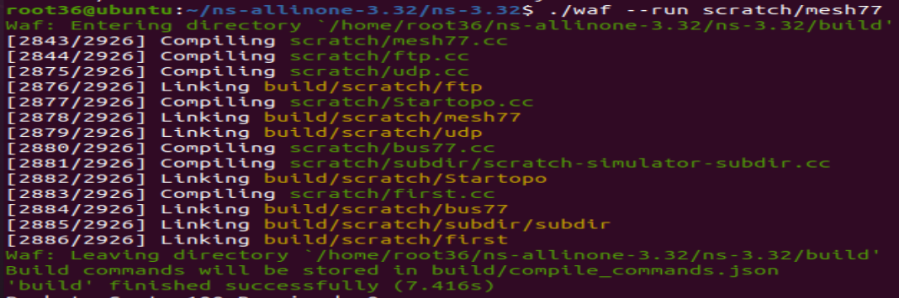
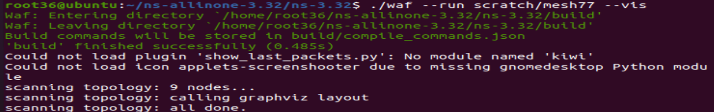

Using python Visualizer:
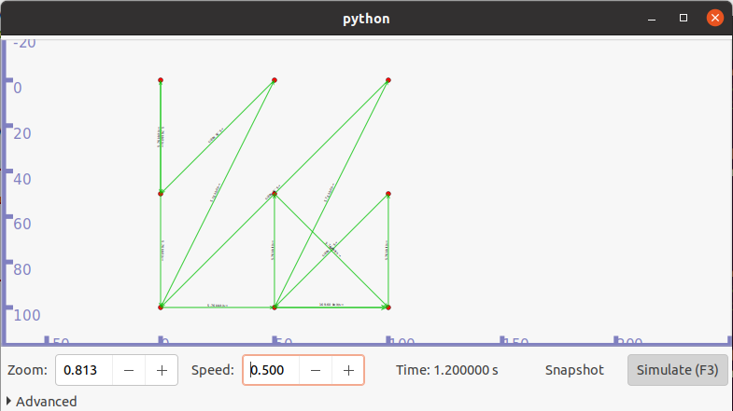

Practical - 6
Aim: Program to simulate Hybrid topology

#include "ns3/core-module.h"
#include "ns3/point-to-point-module.h"
#include "ns3/network-module.h"
#include "ns3/applications-module.h"
#include "ns3/mobility-module.h"
#include "ns3/csma-module.h"
#include "ns3/internet-module.h"
#include "ns3/yans-wifi-helper.h"
#include "ns3/ssid.h"
#include "ns3/netanim-module.h"
#include "ns3/flow-monitor-helper.h"

using namespace ns3;
NS_LOG_COMPONENT_DEFINE("ThirdScriptExample");
int main(int argc, char *argv[])
{
bool verbose = true;
uint32_t nCsma = 3;
uint32_t nWifi = 3;
bool tracing = false;
CommandLine cmd(__FILE__);
cmd.AddValue("nCsma", "Number of CSMA nodes", nCsma);
cmd.AddValue("nWifi", "Number of WiFi STA nodes", nWifi);
cmd.AddValue("verbose", "Enable logging", verbose);
cmd.AddValue("tracing", "Enable PCAP tracing", tracing);
cmd.Parse(argc, argv);

if (nWifi > 18)
{
std::cout << "nWifi should be <= 18 (layout limit)" << std::endl;
return 1;
}

if (verbose)
{
LogComponentEnable("UdpEchoClientApplication", LOG_LEVEL_INFO);
LogComponentEnable("UdpEchoServerApplication", LOG_LEVEL_INFO);
}
// ================= P2P SETUP =================
NodeContainer p2pNodes;
p2pNodes.Create(2);

PointToPointHelper pointToPoint;
pointToPoint.SetDeviceAttribute("DataRate", StringValue("5Mbps"));
pointToPoint.SetChannelAttribute("Delay", StringValue("2ms"));
NetDeviceContainer p2pDevices = pointToPoint.Install(p2pNodes);
// ================= CSMA SETUP =================
NodeContainer csmaNodes;
csmaNodes.Add(p2pNodes.Get(1));
csmaNodes.Create(nCsma);
CsmaHelper csma;
csma.SetChannelAttribute("DataRate", StringValue("100Mbps"));
csma.SetChannelAttribute("Delay", TimeValue(NanoSeconds(6560)));
NetDeviceContainer csmaDevices = csma.Install(csmaNodes);
// ================= WIFI SETUP =================
NodeContainer wifiStaNodes;
wifiStaNodes.Create(nWifi);
NodeContainer wifiApNode = p2pNodes.Get(0);
YansWifiChannelHelper channel = YansWifiChannelHelper::Default();
YansWifiPhyHelper phy = YansWifiPhyHelper::Default();
phy.SetChannel(channel.Create());
WifiHelper wifi;
wifi.SetRemoteStationManager("ns3::AarfWifiManager");

WifiMacHelper mac;
Ssid ssid = Ssid("ns-3-ssid");
// STA
mac.SetType("ns3::StaWifiMac",
"Ssid", SsidValue(ssid),
"ActiveProbing", BooleanValue(false));
NetDeviceContainer staDevices = wifi.Install(phy, mac, wifiStaNodes);
// AP
mac.SetType("ns3::ApWifiMac",
"Ssid", SsidValue(ssid));
NetDeviceContainer apDevices = wifi.Install(phy, mac, wifiApNode);
// ================= MOBILITY =================
MobilityHelper mobility;
mobility.SetPositionAllocator("ns3::GridPositionAllocator",
"MinX", DoubleValue(0.0),
"MinY", DoubleValue(0.0),
"DeltaX", DoubleValue(5.0),
"DeltaY", DoubleValue(10.0),
"GridWidth", UintegerValue(3),
"LayoutType", StringValue("RowFirst"));
mobility.SetMobilityModel("ns3::RandomWalk2dMobilityModel",
"Bounds", RectangleValue(Rectangle(-50, 50, -50, 50)));
mobility.Install(wifiStaNodes);

mobility.SetMobilityModel("ns3::ConstantPositionMobilityModel");
mobility.Install(wifiApNode);
// ================= INTERNET =================
InternetStackHelper stack;
stack.Install(csmaNodes);
stack.Install(wifiApNode);
stack.Install(wifiStaNodes);
Ipv4AddressHelper address;
address.SetBase("10.1.1.0", "255.255.255.0");
Ipv4InterfaceContainer p2pInterfaces = address.Assign(p2pDevices);
address.SetBase("10.1.2.0", "255.255.255.0");
Ipv4InterfaceContainer csmaInterfaces = address.Assign(csmaDevices);
address.SetBase("10.1.3.0", "255.255.255.0");
address.Assign(staDevices);
address.Assign(apDevices);
// ================= APPLICATION =================
UdpEchoServerHelper server(9);
ApplicationContainer serverApps = server.Install(csmaNodes.Get(nCsma));
serverApps.Start(Seconds(1.0));
serverApps.Stop(Seconds(10.0));
UdpEchoClientHelper client(csmaInterfaces.GetAddress(nCsma), 9);
client.SetAttribute("MaxPackets", UintegerValue(1));
client.SetAttribute("Interval", TimeValue(Seconds(1.0)));
client.SetAttribute("PacketSize", UintegerValue(1024));
ApplicationContainer clientApps =
client.Install(wifiStaNodes.Get(nWifi - 1));
clientApps.Start(Seconds(2.0));
clientApps.Stop(Seconds(10.0));
Ipv4GlobalRoutingHelper::PopulateRoutingTables();
// ================= NETANIM =================
AnimationInterface anim("third-animation.xml");
anim.SetConstantPosition(p2pNodes.Get(0), 1.0, 2.0);
anim.SetConstantPosition(p2pNodes.Get(1), 2.0, 2.0);
// ================= FLOW MONITOR =================
FlowMonitorHelper flowmon;
Ptr<FlowMonitor> monitor = flowmon.InstallAll();
// ================= TRACING =================
if (tracing)
{
pointToPoint.EnablePcapAll("third");
phy.EnablePcap("third", apDevices.Get(0));
csma.EnablePcap("third", csmaDevices.Get(0), true);
}
// ================= RUN =================
Simulator::Stop(Seconds(10.0));
Simulator::Run();
monitor->SerializeToXmlFile("third-flowmon.xml", true, true);
Simulator::Destroy();
return 0;
}
OUTPUT:
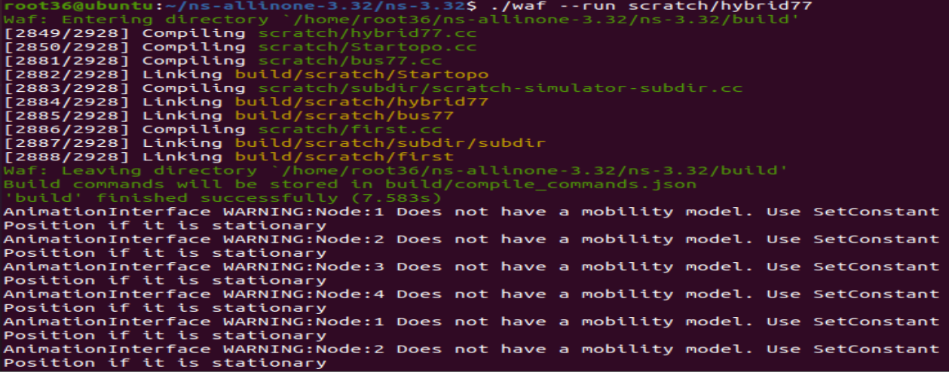
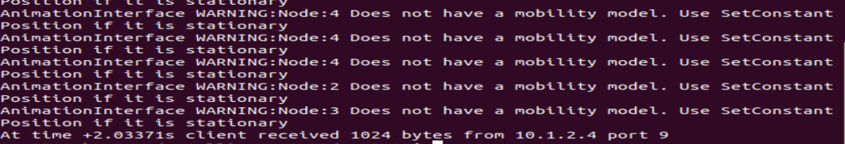

Using Python Visualizer
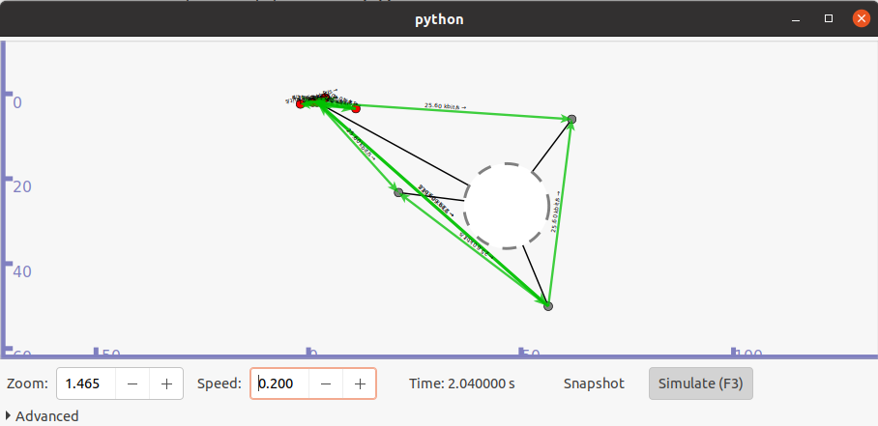

Open NetAnim to see the animation:
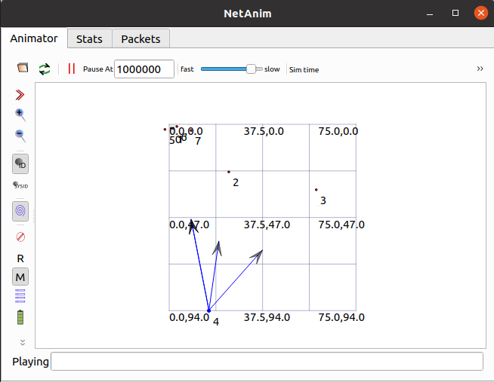
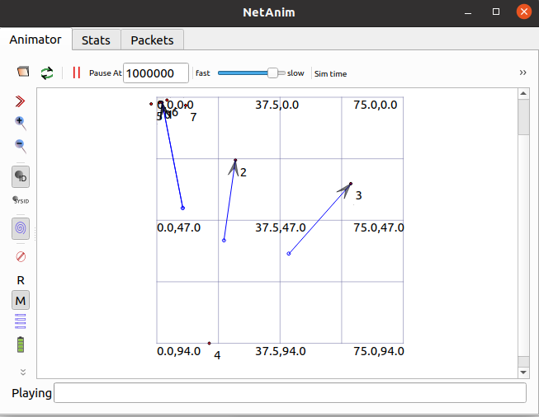
Practical – 7
Aim: Program to simulate UDP Client Server
udp77.cc
#include <fstream>
#include "ns3/core-module.h"
#include "ns3/csma-module.h"
#include "ns3/applications-module.h"
#include "ns3/internet-module.h"

using namespace ns3;

NS_LOG_COMPONENT_DEFINE("UdpClientServerExample");

int main(int argc, char *argv[])
{
// Enable logging for UdpClient and UdpServer
LogComponentEnable("UdpClient", LOG_LEVEL_INFO);
LogComponentEnable("UdpServer", LOG_LEVEL_INFO);

bool useV6 = false;
Address serverAddress;

CommandLine cmd;
cmd.AddValue("useIpv6", "Use Ipv6", useV6);
cmd.Parse(argc, argv);

// Create the nodes required by the topology
NS_LOG_INFO("Create nodes.");
NodeContainer n;
n.Create(2);

InternetStackHelper internet;
internet.Install(n);

// Create the channels required by the topology
NS_LOG_INFO("Create channels.");
CsmaHelper csma;
csma.SetChannelAttribute("DataRate", DataRateValue(DataRate(5000000)));
csma.SetChannelAttribute("Delay", TimeValue(MilliSeconds(2)));
csma.SetDeviceAttribute("Mtu", UintegerValue(1400));

NetDeviceContainer d = csma.Install(n);

// Assign IP Addresses
NS_LOG_INFO("Assign IP Addresses.");
if (useV6 == false)
{
Ipv4AddressHelper ipv4;
ipv4.SetBase("10.1.1.0", "255.255.255.0");
Ipv4InterfaceContainer i = ipv4.Assign(d);
serverAddress = Address(i.GetAddress(1));
}
else
{
Ipv6AddressHelper ipv6;
ipv6.SetBase("2001:0000:f00d:cafe::", Ipv6Prefix(64));
Ipv6InterfaceContainer i6 = ipv6.Assign(d);
serverAddress = Address(i6.GetAddress(1, 1));
}
// Create Applications
NS_LOG_INFO("Create Applications.");

// UDP Server on node 1
uint16_t port = 4000;
UdpServerHelper server(port);
ApplicationContainer apps = server.Install(n.Get(1));
apps.Start(Seconds(1.0));
apps.Stop(Seconds(10.0));

// UDP Client on node 0
uint32_t MaxPacketSize = 1024;
Time interPacketInterval = Seconds(0.05);
uint32_t maxPacketCount = 320;

UdpClientHelper client(serverAddress, port);
client.SetAttribute("MaxPackets", UintegerValue(maxPacketCount));
client.SetAttribute("Interval", TimeValue(interPacketInterval));
client.SetAttribute("PacketSize", UintegerValue(MaxPacketSize));
apps = client.Install(n.Get(0));
apps.Start(Seconds(2.0));
apps.Stop(Seconds(10.0));
// Run the simulation
NS_LOG_INFO("Run Simulation.");
Simulator::Run();
Simulator::Destroy();
NS_LOG_INFO("Done.");
return 0;
}

OUTPUT:
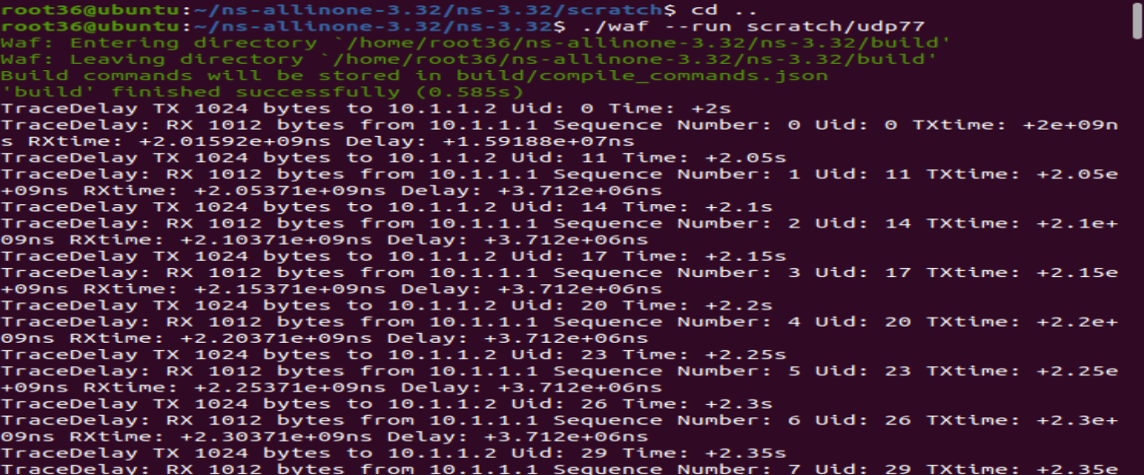
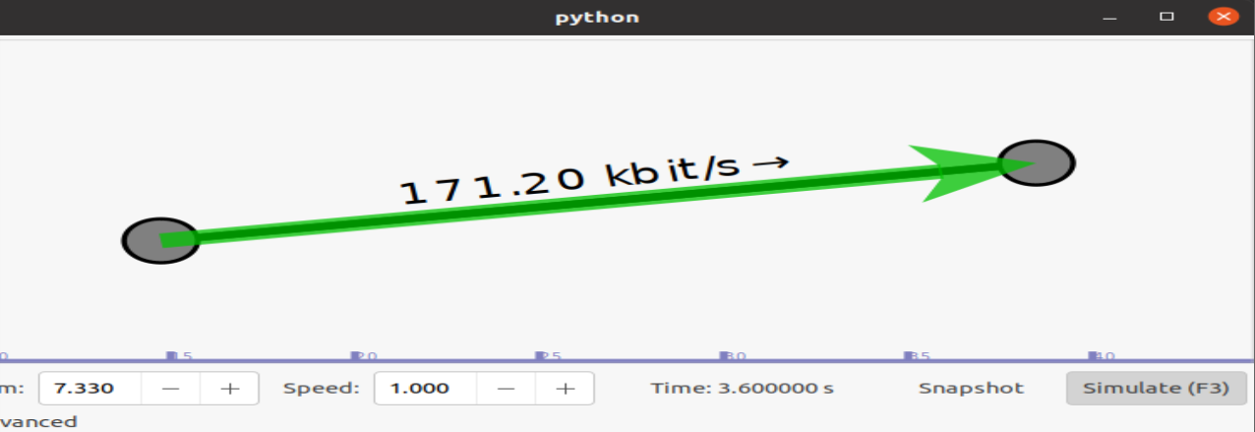

Practical - 8
Aim: Program to simulate DHCP server and Clients.

dhcp77.cc
#include "ns3/core-module.h"
#include "ns3/internet-apps-module.h"
#include "ns3/csma-module.h"
#include "ns3/internet-module.h"
#include "ns3/point-to-point-module.h"
#include "ns3/applications-module.h"

using namespace ns3;
NS_LOG_COMPONENT_DEFINE("DhcpExample");
int main(int argc, char *argv[])
{
CommandLine cmd;
bool verbose = true;
bool tracing = false;

cmd.AddValue("verbose", "Turn on the logs", verbose);
cmd.AddValue("tracing", "Turn on the tracing", tracing);
cmd.Parse(argc, argv);

// Enable log components
if (verbose)
{
LogComponentEnable("DhcpServer", LOG_LEVEL_ALL);
LogComponentEnable("DhcpClient", LOG_LEVEL_ALL);
LogComponentEnable("UdpEchoServerApplication", LOG_LEVEL_INFO);
LogComponentEnable("UdpEchoClientApplication", LOG_LEVEL_INFO);
}

Time stopTime = Seconds(20);

// Create nodes
NS_LOG_INFO("Create nodes.");
NodeContainer nodes;
NodeContainer router;

nodes.Create(3);
router.Create(2);

NodeContainer net(nodes, router);

// Create CSMA channel
NS_LOG_INFO("Create channels.");
CsmaHelper csma;
csma.SetChannelAttribute("DataRate", StringValue("5Mbps"));
csma.SetChannelAttribute("Delay", StringValue("2ms"));
csma.SetDeviceAttribute("Mtu", UintegerValue(1500));
NetDeviceContainer devNet = csma.Install(net);
// Create Point-to-Point connection
NodeContainer p2pNodes;
p2pNodes.Add(net.Get(4)); // router node
p2pNodes.Create(1);
PointToPointHelper pointToPoint;
pointToPoint.SetDeviceAttribute("DataRate", StringValue("5Mbps"));
pointToPoint.SetChannelAttribute("Delay", StringValue("2ms"));
NetDeviceContainer p2pDevices = pointToPoint.Install(p2pNodes);
// Install internet stack
InternetStackHelper tcpip;
tcpip.Install(nodes);
tcpip.Install(router);
tcpip.Install(p2pNodes.Get(1));
// Assign IP addresses for P2P link
Ipv4AddressHelper address;
address.SetBase("172.30.1.0", "255.255.255.0");
Ipv4InterfaceContainer p2pInterfaces;
p2pInterfaces = address.Assign(p2pDevices);

// Static routing
Ipv4StaticRoutingHelper ipv4RoutingHelper;
Ptr<Ipv4> ipv4Ptr = p2pNodes.Get(1)->GetObject<Ipv4>();
Ptr<Ipv4StaticRouting> staticRoutingA =
ipv4RoutingHelper.GetStaticRouting(ipv4Ptr);

staticRoutingA->AddNetworkRouteTo(
Ipv4Address("172.30.0.0"),
Ipv4Mask("/24"),
Ipv4Address("172.30.1.1"),
1
);
// DHCP setup
NS_LOG_INFO("Setup DHCP applications.");
DhcpHelper dhcpHelper;
// Fixed IP for router
Ipv4InterfaceContainer fixedNodes =
dhcpHelper.InstallFixedAddress(
devNet.Get(4),
Ipv4Address("172.30.0.17"),
Ipv4Mask("/24")
);
// DHCP Server
ApplicationContainer dhcpServerApp =
dhcpHelper.InstallDhcpServer(
devNet.Get(3),
Ipv4Address("172.30.0.12"),
Ipv4Address("172.30.0.0"),
Ipv4Mask("/24"),
Ipv4Address("172.30.0.10"),
Ipv4Address("172.30.0.15"),
Ipv4Address("172.30.0.17")
);

DynamicCast<DhcpServer>(dhcpServerApp.Get(0))->AddStaticDhcpEntry(
devNet.Get(2)->GetAddress(),
Ipv4Address("172.30.0.14")
);

dhcpServerApp.Start(Seconds(0.0));
dhcpServerApp.Stop(stopTime);

// DHCP Clients
NetDeviceContainer dhcpClientNetDevs;
dhcpClientNetDevs.Add(devNet.Get(0));
dhcpClientNetDevs.Add(devNet.Get(1));
dhcpClientNetDevs.Add(devNet.Get(2));
ApplicationContainer dhcpClients =
dhcpHelper.InstallDhcpClient(dhcpClientNetDevs);
dhcpClients.Start(Seconds(1.0));
dhcpClients.Stop(stopTime);
// UDP Echo Server
UdpEchoServerHelper echoServer(9);
ApplicationContainer serverApps =
echoServer.Install(p2pNodes.Get(1));
serverApps.Start(Seconds(0.0));
serverApps.Stop(stopTime);
// UDP Echo Client
UdpEchoClientHelper echoClient(
p2pInterfaces.GetAddress(1), 9
);

echoClient.SetAttribute("MaxPackets", UintegerValue(100));
echoClient.SetAttribute("Interval", TimeValue(Seconds(1.0)));
echoClient.SetAttribute("PacketSize", UintegerValue(1024));

ApplicationContainer clientApps =
echoClient.Install(nodes.Get(1));

clientApps.Start(Seconds(10.0));
clientApps.Stop(stopTime);

// Enable tracing
if (tracing)
{
csma.EnablePcapAll("dhcp-csma");
pointToPoint.EnablePcapAll("dhcp-p2p");
}

// Run simulation
Simulator::Stop(stopTime + Seconds(10.0));

NS_LOG_INFO("Run Simulation.");
Simulator::Run();
Simulator::Destroy();

NS_LOG_INFO("Done.");

return 0;
}

OUTPUT:
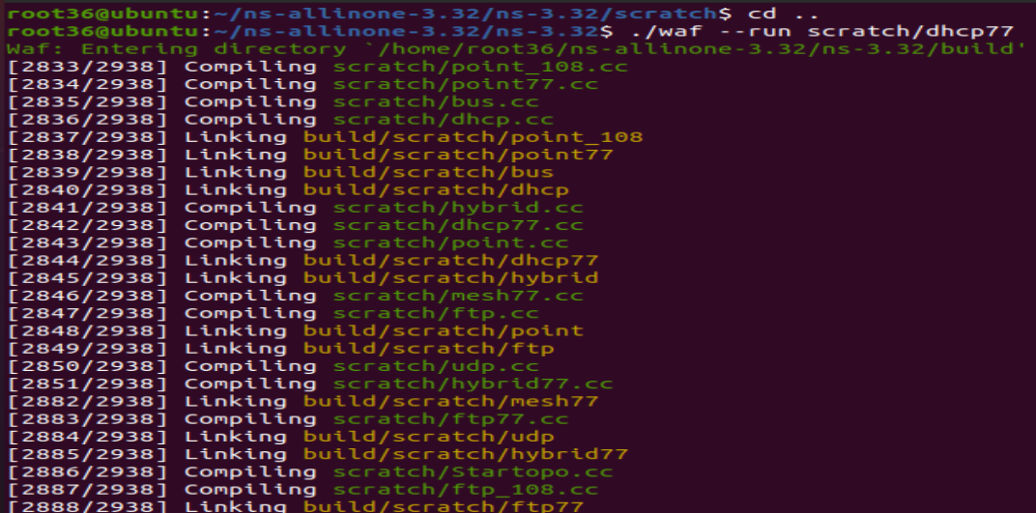
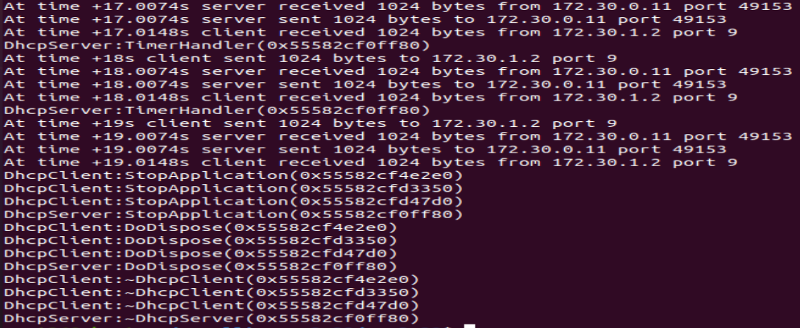

Using Python Visualizer
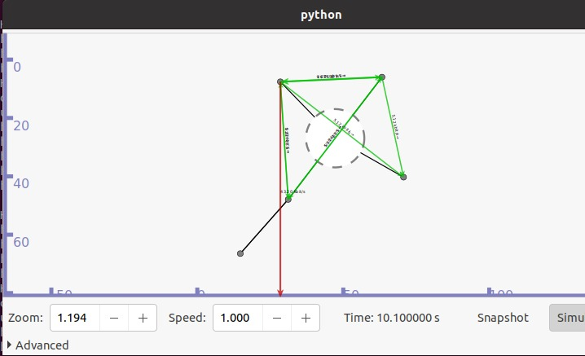

Practical - 9
Aim: Program to simulate FTP using TCP
ftp77.cc

#include <string>
#include <fstream>
#include "ns3/core-module.h"
#include "ns3/point-to-point-module.h"
#include "ns3/internet-module.h"
#include "ns3/applications-module.h"
#include "ns3/network-module.h"
#include "ns3/packet-sink.h"

using namespace ns3;
NS_LOG_COMPONENT_DEFINE("TcpBulkSendExample");
int main(int argc, char *argv[])
{
bool tracing = false;
uint32_t maxBytes = 0;

// Command-line arguments
CommandLine cmd;
cmd.AddValue("tracing", "Flag to enable/disable tracing", tracing);
cmd.AddValue("maxBytes", "Total number of bytes for application to send", maxBytes);
cmd.Parse(argc, argv);
// Create nodes
NS_LOG_INFO("Create nodes.");
NodeContainer nodes;
nodes.Create(2);
// Create point-to-point channel
NS_LOG_INFO("Create channels.");
PointToPointHelper pointToPoint;
pointToPoint.SetDeviceAttribute("DataRate", StringValue("500Kbps"));
pointToPoint.SetChannelAttribute("Delay", StringValue("5ms"));
NetDeviceContainer devices;
devices = pointToPoint.Install(nodes);
// Install internet stack
InternetStackHelper internet;
internet.Install(nodes);
// Assign IP addresses
NS_LOG_INFO("Assign IP Addresses.");
Ipv4AddressHelper ipv4;
ipv4.SetBase("10.1.1.0", "255.255.255.0");
Ipv4InterfaceContainer i = ipv4.Assign(devices);
// Create Applications
NS_LOG_INFO("Create Applications.");

// TCP Bulk Send on node 0
uint16_t port = 9; // well-known port
BulkSendHelper source(
"ns3::TcpSocketFactory",
InetSocketAddress(i.GetAddress(1), port)
);

// Set total bytes to send (0 = unlimited)
source.SetAttribute("MaxBytes", UintegerValue(maxBytes));

ApplicationContainer sourceApps = source.Install(nodes.Get(0));
sourceApps.Start(Seconds(0.0));
sourceApps.Stop(Seconds(10.0));

// Packet Sink on node 1
PacketSinkHelper sink(
"ns3::TcpSocketFactory",
InetSocketAddress(Ipv4Address::GetAny(), port)
);
ApplicationContainer sinkApps = sink.Install(nodes.Get(1));
sinkApps.Start(Seconds(0.0));
sinkApps.Stop(Seconds(10.0));

// Enable tracing if required
if (tracing)
{
AsciiTraceHelper ascii;
pointToPoint.EnableAsciiAll(ascii.CreateFileStream("tcp-bulk-send.tr"));
pointToPoint.EnablePcapAll("tcp-bulk-send", false);
}
// Run simulation
NS_LOG_INFO("Run Simulation.");
Simulator::Stop(Seconds(10.0));
Simulator::Run();
Simulator::Destroy();
NS_LOG_INFO("Done.");

// Output total bytes received
Ptr<PacketSink> sink1 = DynamicCast<PacketSink>(sinkApps.Get(0));
std::cout << "Total Bytes Received: " << sink1->GetTotalRx() << std::endl;

return 0;
}

Output:

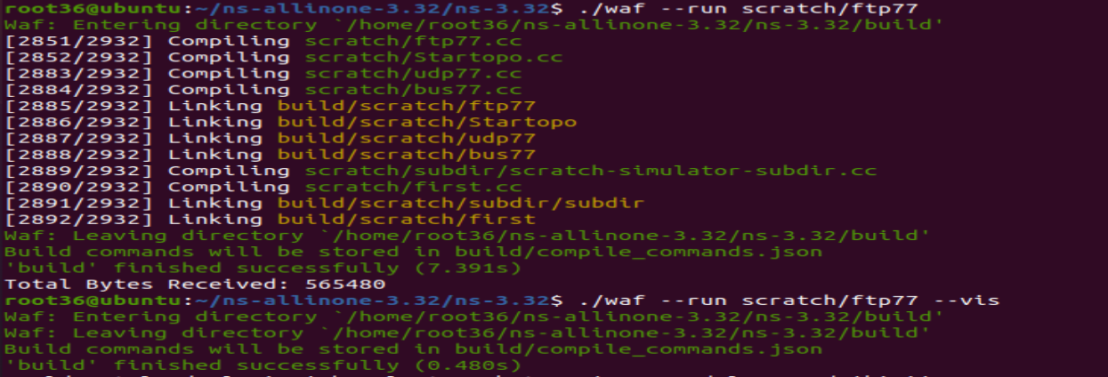
Using Python Visualizer
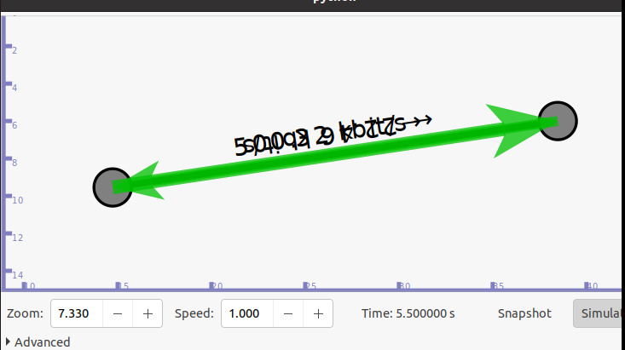
Practical – 10
Aim: Exercises for analyzing the network protocols using Wireshark
• Capture the packets while browsing the any web site
• Analyze the header fields of various protocols
- WINDOWS
- ip.len le 1500
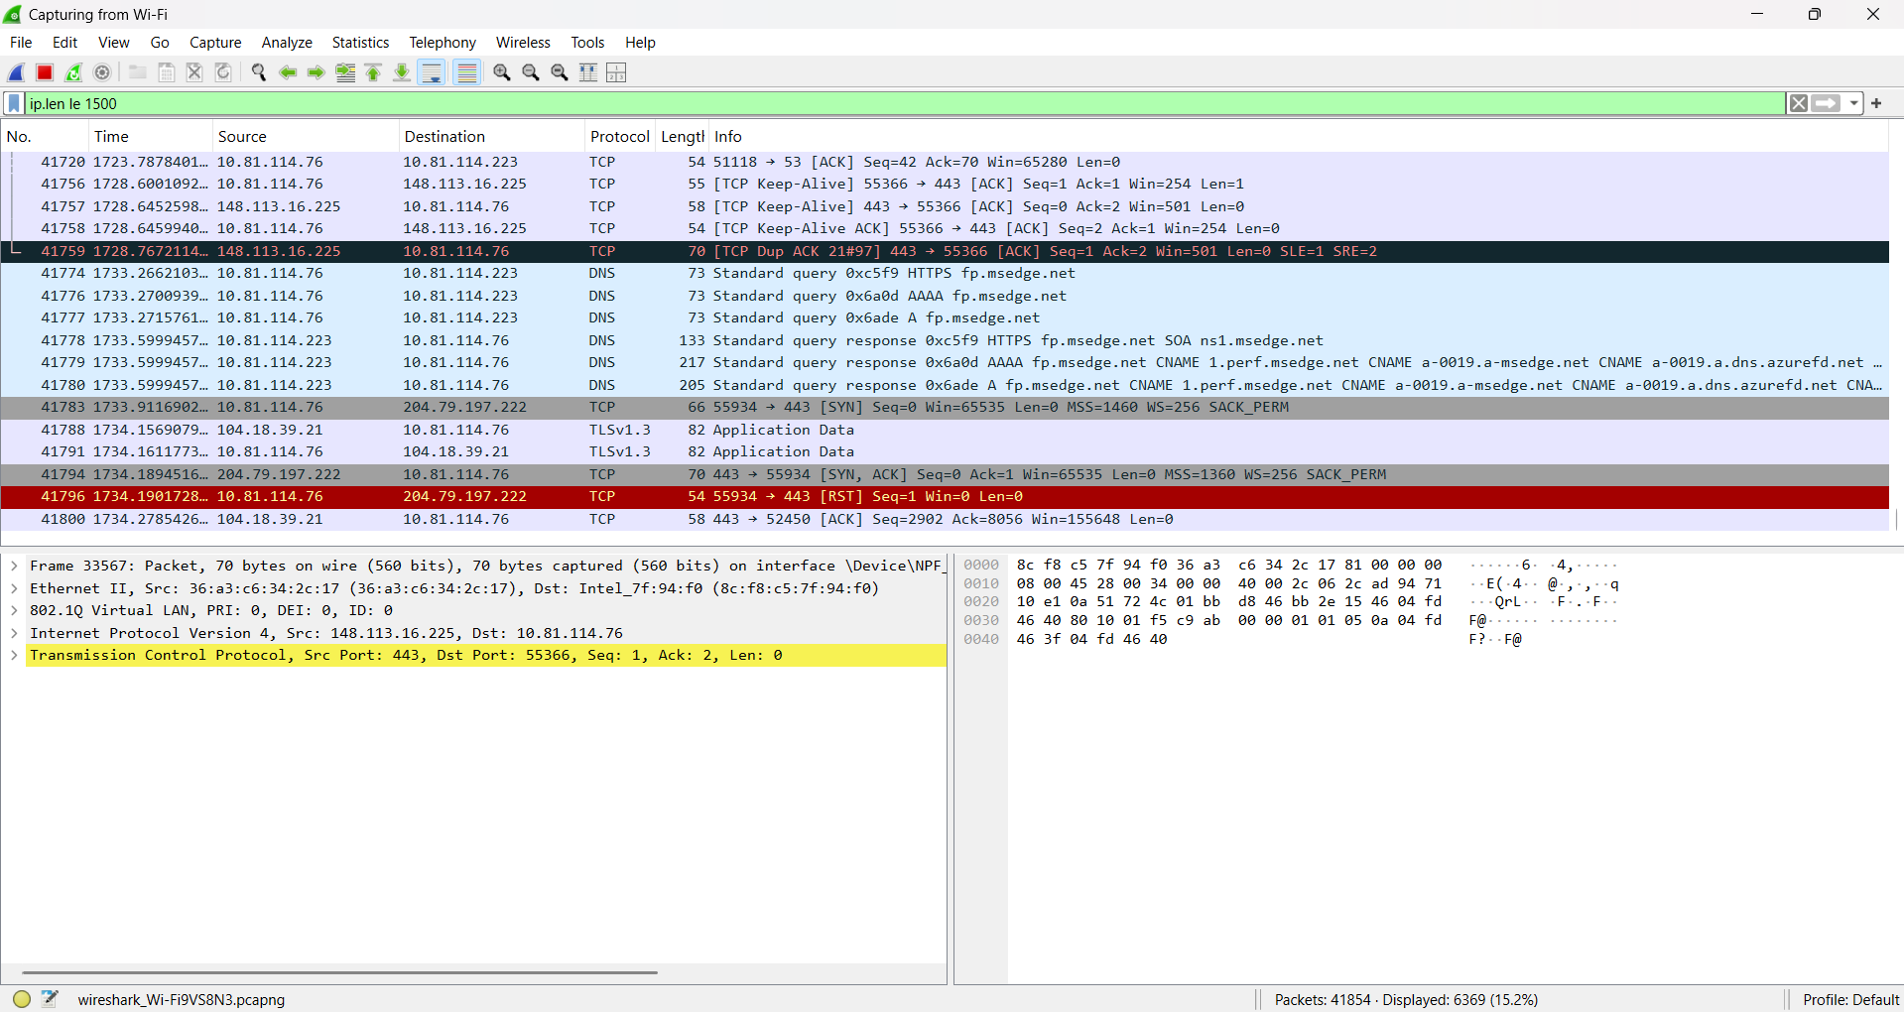

- tcp.window_size != 0 && tcp.flags.reset != 1
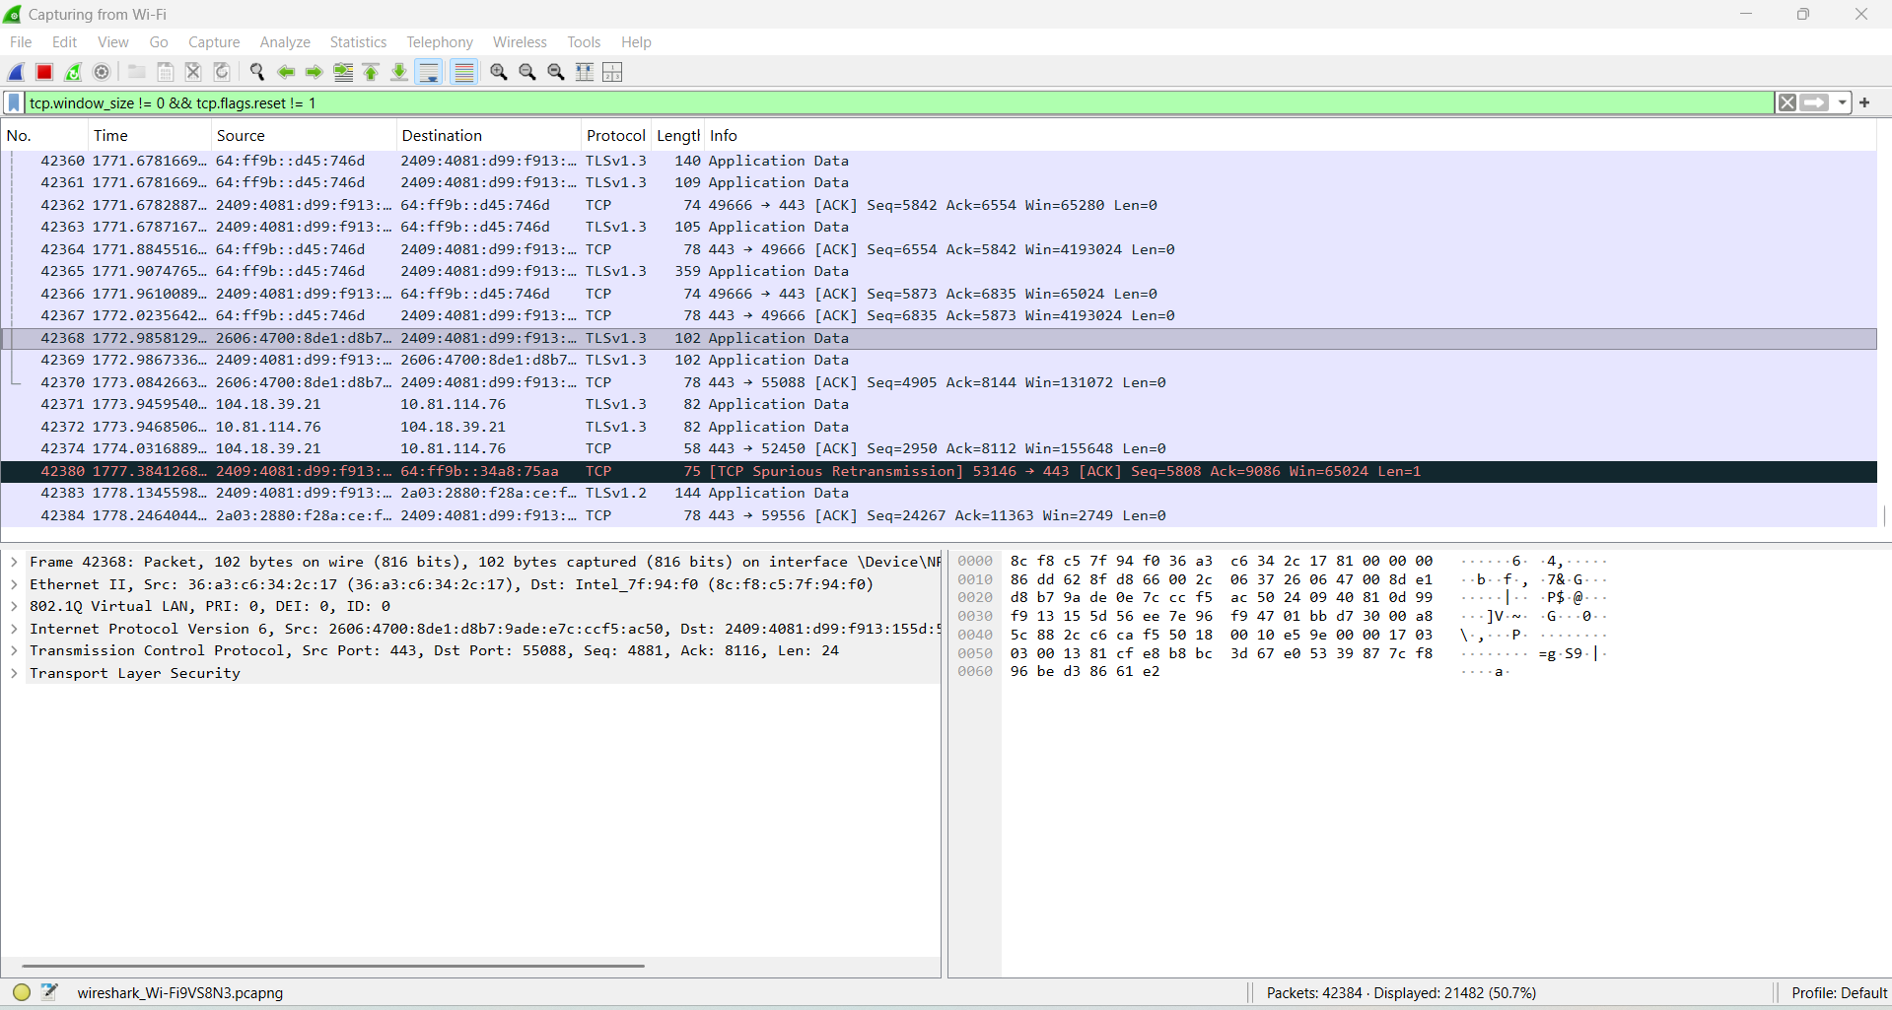
- tcp
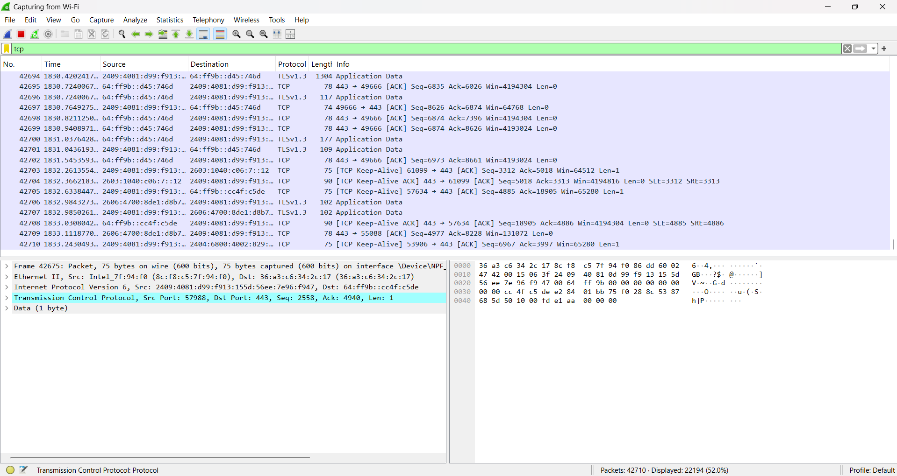
- udp
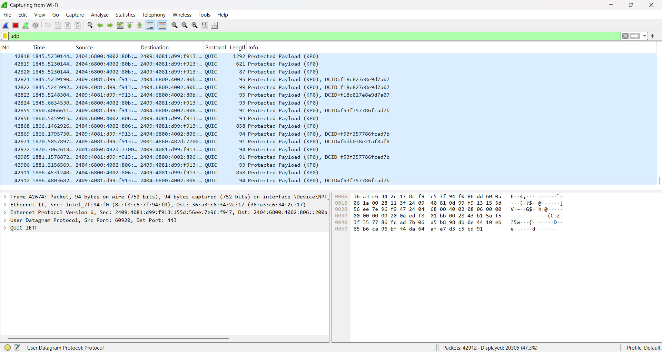

- ipv6
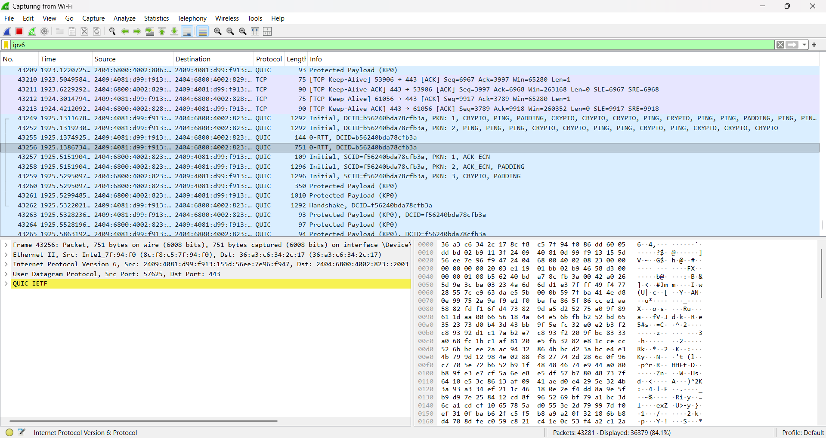

- frame.time != "Sep 26, 2026 23:18:04.954975"
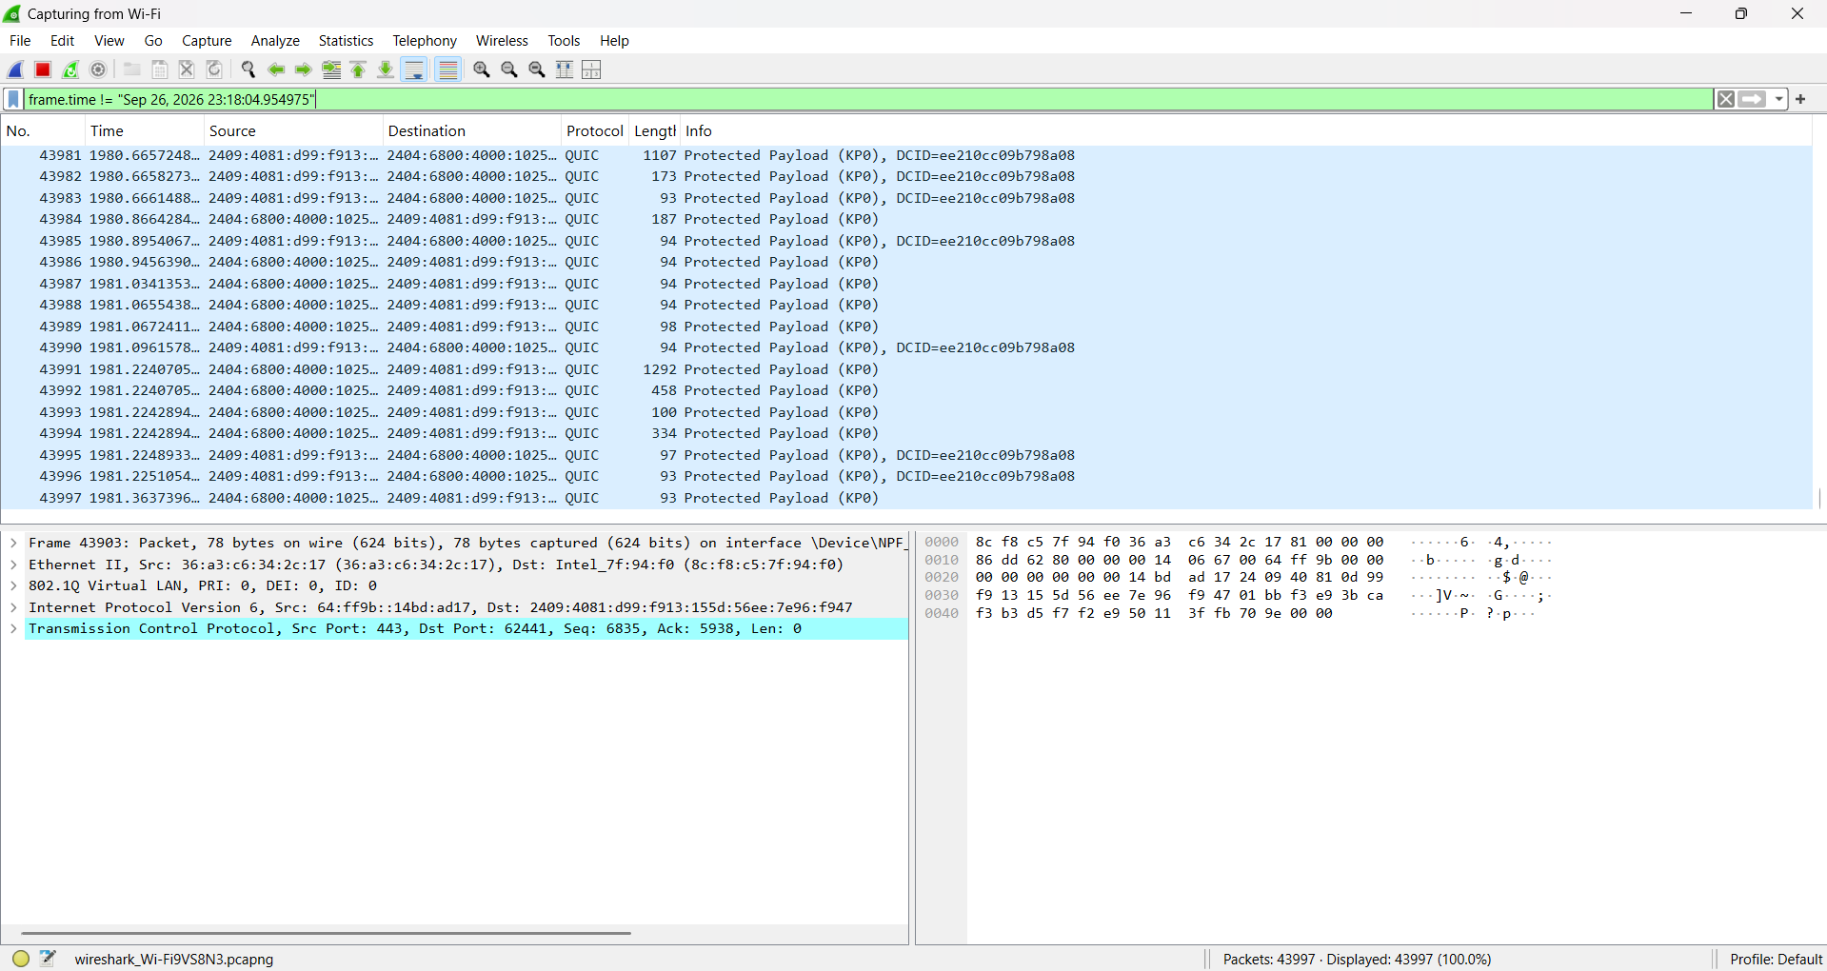

- IP
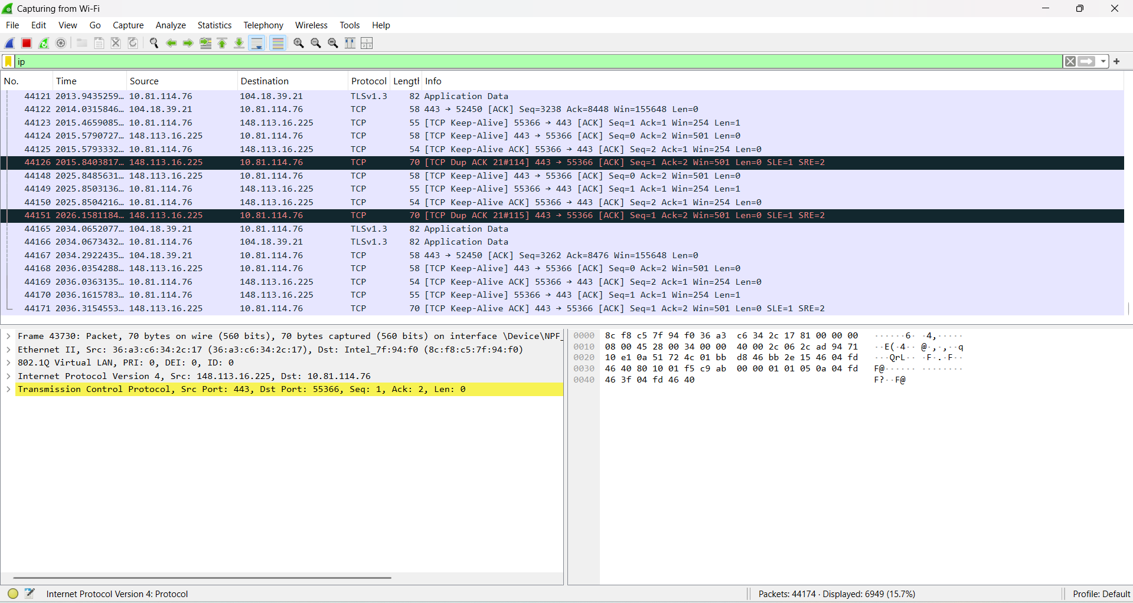
- ARP
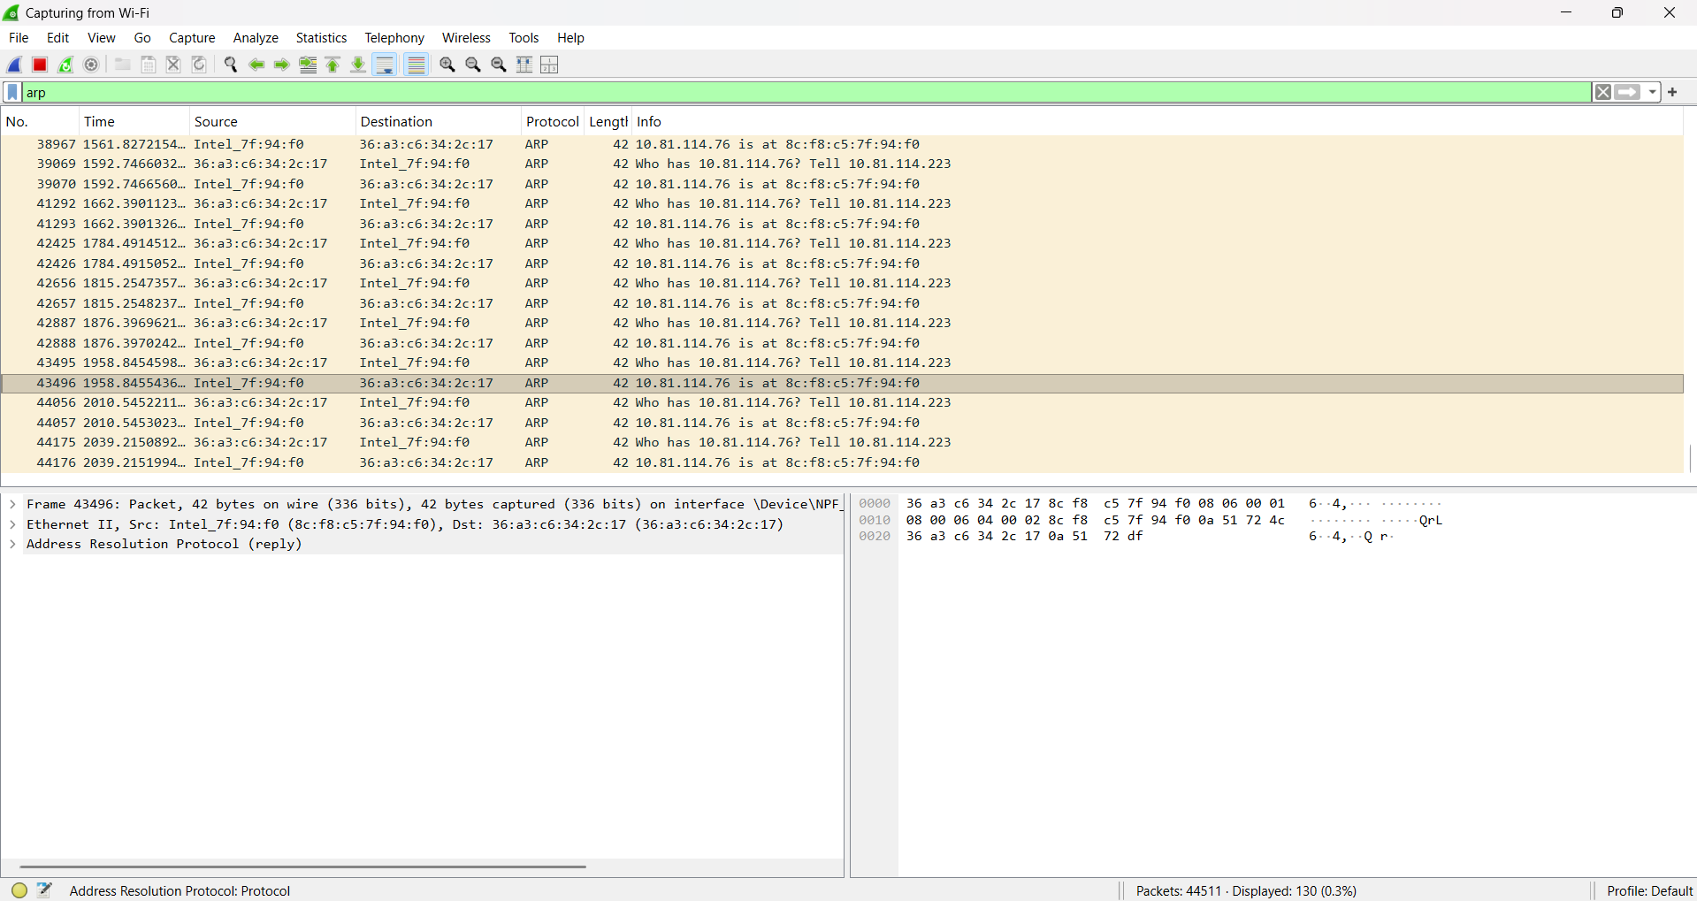

- ip.addr != 10.43.54.65
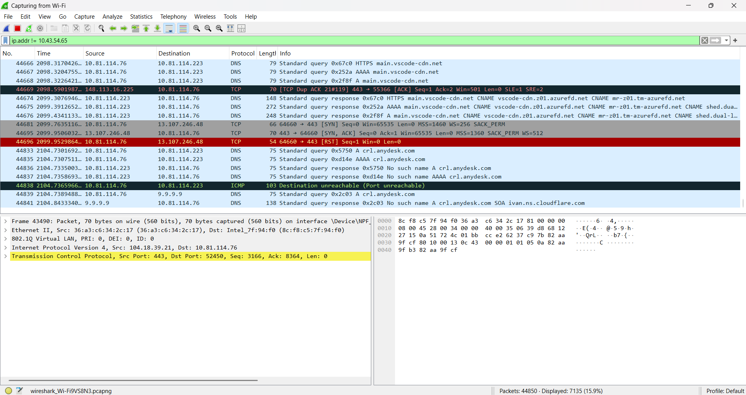

- ip.src != 10.43.54.65 or ip.dst != 10.43.54.65
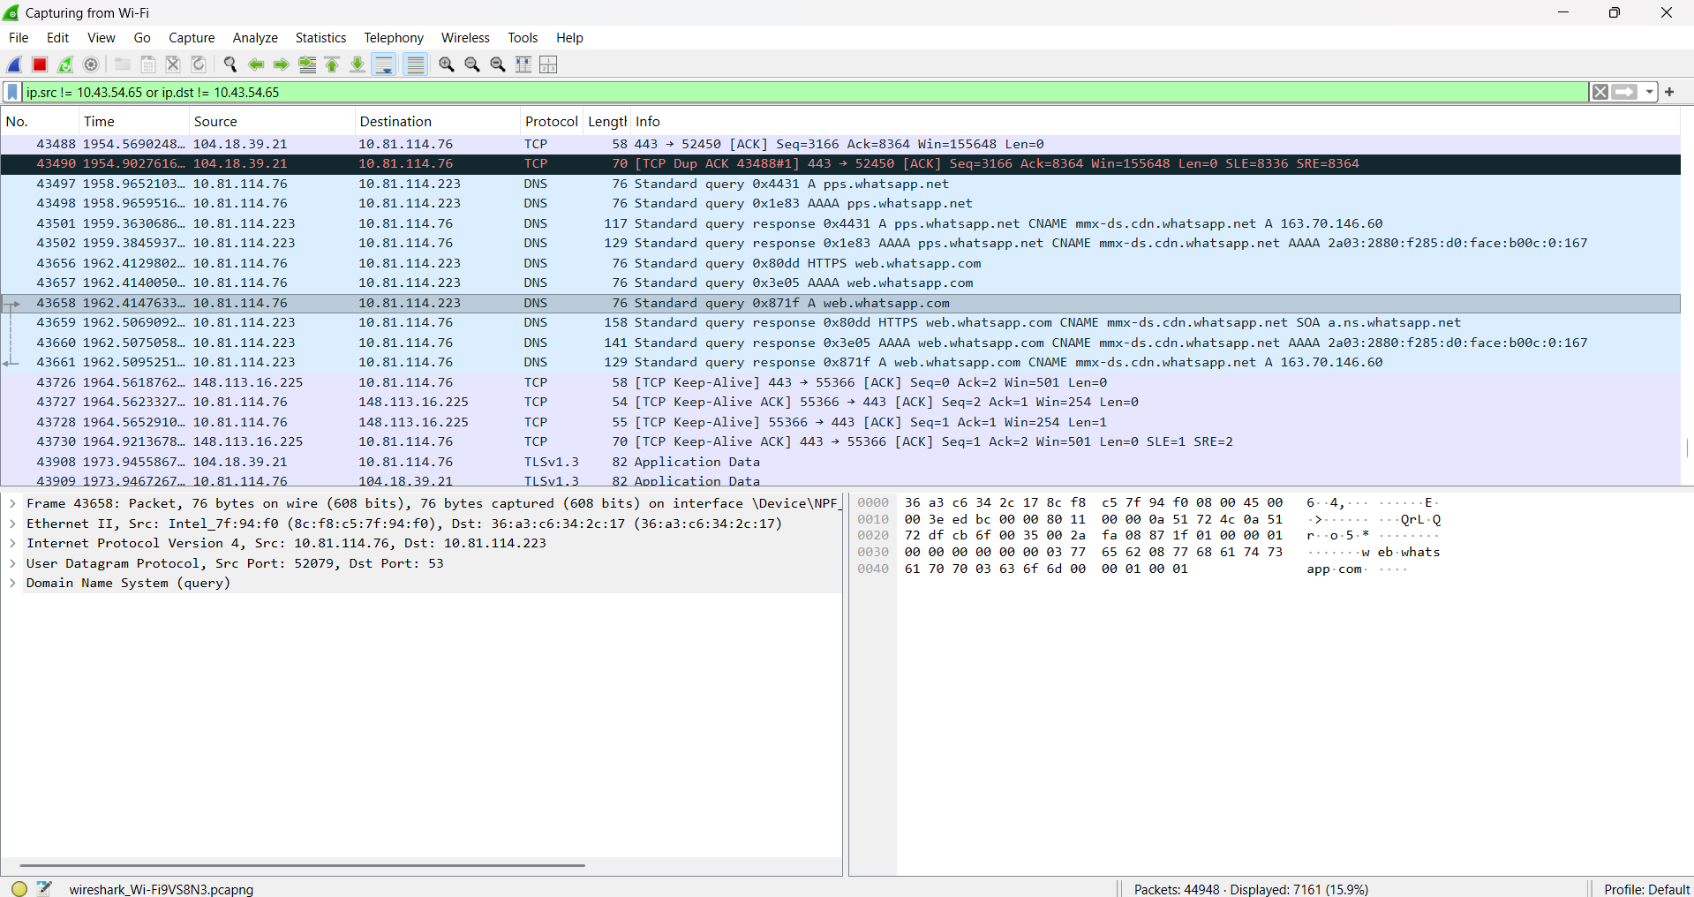

- LINUX
Analyzing Pcap files in point to point network using Wireshark
