Module – 5
1. Create an XML-based web service to fetch product details and consume it in a web application.
ProductService.asmx(Web Service)
using System;
using System.Web.Services;
using System.Xml;
namespace SOAP_127
{
[WebService(Namespace = "http://example.com/ProductService")]
[WebServiceBinding(ConformsTo = WsiProfiles.BasicProfile1_1)]
public class ProductService : WebService
{
[WebMethod]
public XmlDocument GetProductDetails(int productId)
{
XmlDocument xmlDoc = new XmlDocument();
XmlNode root = xmlDoc.CreateElement("ProductDetails");
xmlDoc.AppendChild(root);
XmlNode product = xmlDoc.CreateElement("Product");
root.AppendChild(product);
XmlNode id = xmlDoc.CreateElement("ProductId");
id.InnerText = productId.ToString();
product.AppendChild(id);
XmlNode name = xmlDoc.CreateElement("ProductName");
name.InnerText = "Product " + productId;
product.AppendChild(name);
XmlNode price = xmlDoc.CreateElement("Price");
price.InnerText = (productId * 10).ToString();
product.AppendChild(price);
return xmlDoc;
}
}
}
ProductDetails.aspx
<%@ Page Language="C#" AutoEventWireup="true" CodeBehind="ProductDetails.aspx.cs" Inherits="Soap_client_127.ProductDetails" %>
<!DOCTYPE html>
<html xmlns="http://www.w3.org/1999/xhtml">
<head runat="server">
<title>Product Details</title>
</head>
<body>
<form id="form1" runat="server">
<div>
<h2>Product Details</h2>

<asp:Label ID="lblProductDetails" runat="server"
Text="Enter Product ID:" />
<asp:TextBox ID="txtProductId" runat="server"></asp:TextBox>

<asp:Button ID="btnFetchProduct" runat="server"
Text="Fetch Product"
OnClick="btnFetchProduct_Click" /><br /><br />

<asp:GridView ID="gvProductDetails" runat="server"></asp:GridView>
</div>
</form>
</body>
</html>

ProductDetails.aspx.cs
using System;
using System.Web.UI;
using System.IO;
using System.Data;
using Soap_client_127.ProductServiceRef;
namespace Soap_client_127
{
public partial class ProductDetails : Page
{
protected void btnFetchProduct_Click(object sender, EventArgs e)
{
int productId = Convert.ToInt32(txtProductId.Text);
ProductServiceSoapClient service = new ProductServiceSoapClient();
var productXml = service.GetProductDetails(productId);
DataSet ds = new DataSet();
StringReader sr = new StringReader(productXml.ToString());
ds.ReadXml(sr);
gvProductDetails.DataSource = ds.Tables[0];
gvProductDetails.DataBind();
}
}
}

Output:
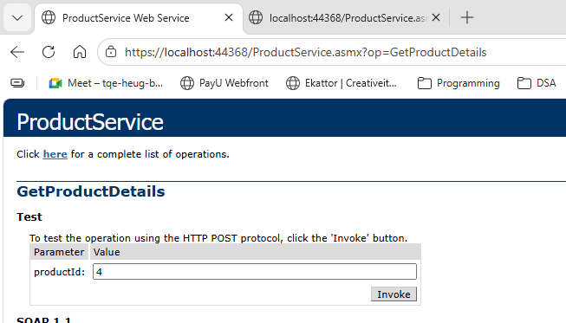

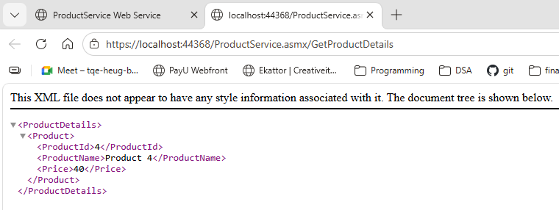

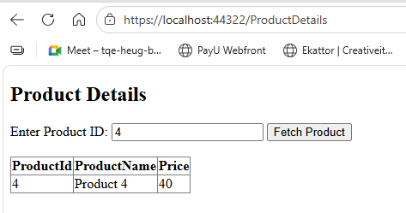

2. Develop a database-driven WCF service to fetch and update user details.
User.cs
namespace UserWCFService
{
using System;
using System.Collections.Generic;
public partial class User
{
public int UserId { get; set; }
public string FirstName { get; set; }
public string LastName { get; set; }
public string Email { get; set; }
public Nullable<int> Age { get; set; }
}
}

IService1.cs
using System.ServiceModel;
namespace UserWCFService
{
[ServiceContract]
public interface IService1
{
[OperationContract]
User GetUserDetails(int userId);
[OperationContract]
bool UpdateUserDetails(User user);
}
}

Service1.svc
<%@ ServiceHost Language="C#" Debug="true" Service="UserWCFService.Service1" CodeBehind="Service1.svc.cs" %>

Services1.svc.cs
using System;
using System.Linq;
namespace UserWCFService
{
public class Service1 : IService1
{
UserDBEntities db = new UserDBEntities();
public User GetUserDetails(int userId)
{
var user = db.Users.FirstOrDefault(u => u.UserId == userId);
if (user != null)
{
return new User
{
UserId = user.UserId,
FirstName = user.FirstName,
LastName = user.LastName,
Email = user.Email,
Age = user.Age
};
}
return null;
}
public bool UpdateUserDetails(User user)
{
var existingUser = db.Users.FirstOrDefault(u => u.UserId == user.UserId);
if (existingUser != null)
{
existingUser.FirstName = user.FirstName;
existingUser.LastName = user.LastName;
existingUser.Email = user.Email;
existingUser.Age = user.Age;
db.SaveChanges();
return true;
}
return false;
}
}
}

Default.aspx
<%@ Page Language="C#" AutoEventWireup="true" CodeBehind="Default.aspx.cs" Inherits="UserWebApp._Default" %>
<!DOCTYPE html>
<html>
<head runat="server">
<title>WCF User Details</title>
</head>
<body>
<form id="form1" runat="server">

<h2>WCF User Details Service</h2>
Enter User ID:
<asp:TextBox ID="txtUserId" runat="server"></asp:TextBox>
<asp:Button ID="btnFetch" runat="server" Text="Fetch User" OnClick="btnFetch_Click" />
<br /><br />
<asp:GridView ID="GridView1" runat="server"></asp:GridView>
<h3>Update User Details</h3>
First Name:
<asp:TextBox ID="txtFirstName" runat="server"></asp:TextBox><br />
Last Name:
<asp:TextBox ID="txtLastName" runat="server"></asp:TextBox><br />
Email:
<asp:TextBox ID="txtEmail" runat="server"></asp:TextBox><br />
Age:
<asp:TextBox ID="txtAge" runat="server"></asp:TextBox><br />
<asp:Button ID="btnUpdate" runat="server" Text="Update User" OnClick="btnUpdate_Click" />
<br /><br />
<asp:Label ID="lblMessage" runat="server" ForeColor="Green"></asp:Label>
</form>
</body>
</html>

Default.aspx.cs

using System;
using System.Collections.Generic;
using UserWebApp.ServiceReference1;
namespace UserWebApp
{
public partial class _Default : System.Web.UI.Page
{
Service1Client client = new Service1Client();
protected void btnFetch_Click(object sender, EventArgs e)
{
int id = Convert.ToInt32(txtUserId.Text);
var user = client.GetUserDetails(id);
if (user != null)
{
List<User> list = new List<User>();
list.Add(user);
GridView1.DataSource = list;
GridView1.DataBind();
txtFirstName.Text = user.FirstName;
txtLastName.Text = user.LastName;
txtEmail.Text = user.Email;
txtAge.Text = user.Age.ToString();
}
}
protected void btnUpdate_Click(object sender, EventArgs e)
{
User user = new User();
user.UserId = Convert.ToInt32(txtUserId.Text);
user.FirstName = txtFirstName.Text;
user.LastName = txtLastName.Text;
user.Email = txtEmail.Text;
user.Age = Convert.ToInt32(txtAge.Text);
bool result = client.UpdateUserDetails(user);
if (result)
{
lblMessage.Text = "User Updated Successfully!";
}
else
{
lblMessage.Text = "Update Failed!";
}
}
}
}

Database (UserDB)
CREATE DATABASE UserDB;
USE UserDB;

CREATE TABLE Users (
UserId INT PRIMARY KEY AUTO_INCREMENT,
FirstName VARCHAR(50),
LastName VARCHAR(50),
Email VARCHAR(100),
Age INT
);

INSERT INTO Users VALUES (NULL, 'Prince', 'Yadav', 'prince@gmail.com', 20);
INSERT INTO Users VALUES (NULL, 'Dheeraj', 'Giri', 'dheeraj@gmail.com', 21);
INSERT INTO Users VALUES (NULL, 'Rohit', 'Verma', 'rohit@gmail.com', 22);
INSERT INTO Users VALUES (NULL, 'Anurag', 'Shukla', 'anurag@gmail.com', 20);
INSERT INTO Users VALUES (NULL, 'Abhishek', 'Shukla', 'abhi@gmail.com', 23);

Output:
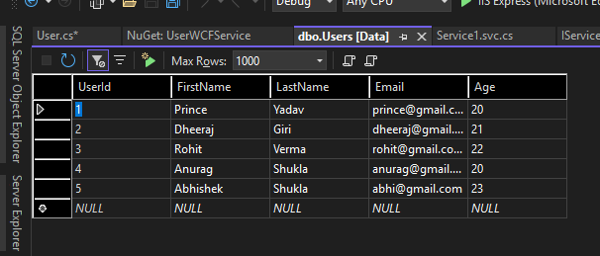

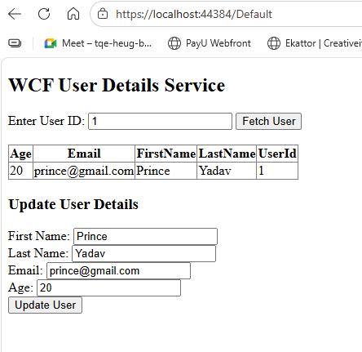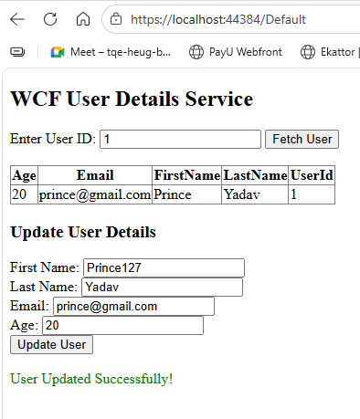

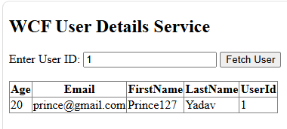

3.Create an XML-based web service to fetch product details and consume it in a web application.
Api:
CalculatorController.cs
using System.Net;
using System.Net.Http;
using System.Web.Http;
using System.Xml.Linq;
namespace CalculatorWebService.Controllers
{
[RoutePrefix("api/calculator")]
public class CalculatorController : ApiController
{
private HttpResponseMessage CreateXmlResponse(int result)
{
var xml = new XElement("Result", result);
return new HttpResponseMessage()
{
Content = new StringContent(xml.ToString(), System.Text.Encoding.UTF8, "application/xml")
};
}
[HttpGet]
[Route("add")]
public HttpResponseMessage Add(int a, int b)
{
return CreateXmlResponse(a + b);
}
[HttpGet]
[Route("subtract")]
public HttpResponseMessage Subtract(int a, int b)
{
return CreateXmlResponse(a - b);
}
[HttpGet]
[Route("multiply")]
public HttpResponseMessage Multiply(int a, int b)
{
return CreateXmlResponse(a * b);
}
[HttpGet]
[Route("divide")]
public HttpResponseMessage Divide(int a, int b)
{
if (b == 0)
return Request.CreateErrorResponse(HttpStatusCode.BadRequest, "Cannot divide by zero");

return CreateXmlResponse(a / b);
}
}
}

Client:
Default.aspx
<%@ Page Language="C#" AutoEventWireup="true" CodeBehind="Default.aspx.cs" Inherits="Module4_client_127.Default" Async="true" %>
<!DOCTYPE html>
<html xmlns="http://www.w3.org/1999/xhtml">
<head runat="server">
<title>Calculator</title>
</head>
<body>
<form id="form1" runat="server">
<div>
<h2>Calculator Web Service</h2>
<h3>Prince 127</h3>
<br />
A:
<asp:TextBox ID="txtA" runat="server"></asp:TextBox>
<br /><br />
B:
<asp:TextBox ID="txtB" runat="server"></asp:TextBox>
<br /><br />
<asp:Button ID="btnAdd" runat="server" Text="Add" OnClick="btnAdd_Click" />
<br /><br />
Result:
<asp:TextBox ID="txtResult" runat="server" ReadOnly="true"></asp:TextBox>
</div>
</form>
</body>
</html>

Default.aspx.cs
using System;
using System.Net.Http;
using System.Xml.Linq;
namespace Module4_client_127
{
public partial class Default : System.Web.UI.Page
{
protected async void btnAdd_Click(object sender, EventArgs e)
{
int a = int.Parse(txtA.Text);
int b = int.Parse(txtB.Text);
using (HttpClient client = new HttpClient())
{
client.BaseAddress = new Uri("https://localhost:44397/api/calculator/"); // change port
HttpResponseMessage response = await client.GetAsync($"add?a={a}&b={b}");
if (response.IsSuccessStatusCode)
{
var xml = await response.Content.ReadAsStringAsync();
XElement data = XElement.Parse(xml);
txtResult.Text = data.Value;
}
else
{
txtResult.Text = "Error";
}
}
}
}
}

Output:

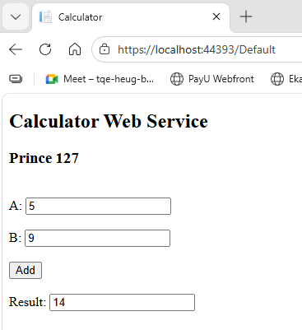

4. Create and consume the WCF service to calculate simple interest.
Service1.svc.cs
namespace SimpleInterestWCF_127
{
public class Service1 : IService1
{
public double CalculateSimpleInterest(double principal, double rate, double time)
{
return (principal * rate * time) / 100;
}
}
}

IService1.cs
using System.ServiceModel;
namespace SimpleInterestWCF_127
{
[ServiceContract]
public interface IService1
{
[OperationContract]
double CalculateSimpleInterest(double principal, double rate, double time);
}
}

Web.config
<?xml version="1.0" encoding="utf-8"?>
<configuration>
<system.web>
<compilation debug="true" targetFramework="4.7.2" />
<httpRuntime targetFramework="4.7.2" />
</system.web>
<system.serviceModel>
<bindings>
<basicHttpBinding>
<binding name="BasicHttpBinding_IService1" />
</basicHttpBinding>
</bindings>
<client>
<endpoint address="http://localhost:57653/Service1.svc" binding="basicHttpBinding"
bindingConfiguration="BasicHttpBinding_IService1" contract="ServiceReference1.IService1"
name="BasicHttpBinding_IService1" />
</client>
<services>
<service name="SimpleInterestWCF_127.Service1">
<endpoint address=""
binding="basicHttpBinding"
contract="SimpleInterestWCF_127.IService1" />
<endpoint address="mex"
binding="mexHttpBinding"
contract="IMetadataExchange" />
</service>
</services>
<behaviors>
<serviceBehaviors>
<behavior>
<serviceMetadata httpGetEnabled="true"/>
<serviceDebug includeExceptionDetailInFaults="true"/>
</behavior>
</serviceBehaviors>
</behaviors>
</system.serviceModel>

</configuration>

Program.cs
using System;
using System.Threading.Tasks;
using ServiceReference1;
namespace SimpleInterestClient127
{
class Program
{
static async Task Main(string[] args)
{
Console.WriteLine("Prince 127");
Service1Client client = new Service1Client();
Console.Write("Enter Principal: ");
double principal = Convert.ToDouble(Console.ReadLine());
Console.Write("Enter Rate: ");
double rate = Convert.ToDouble(Console.ReadLine());

Console.Write("Enter Time: ");
double time = Convert.ToDouble(Console.ReadLine());
double result = await client.CalculateSimpleInterestAsync(principal, rate, time);
Console.WriteLine("\nSimple Interest = " + result);
Console.ReadLine();
}
}
}

Output:
