Module – 2: Creating User Interface
1. Design a registration form with validation controls for mandatory fields, email format, and passwords.
Module2Experiment1.aspx
<%@ Page Language="C#" AutoEventWireup="true" CodeBehind="Module2Experiment1.aspx.cs" Inherits="Prince127.Module2Experiment1" %>
<!DOCTYPE html>
<html xmlns="http://www.w3.org/1999/xhtml">
<head runat="server">
<title>Registration Form</title>
<style>
.error{
color:red;
}
</style>
</head>
<body>
<form id="form1" runat="server">
<div>
<h2>Registration Form</h2>
<label>Enter Full Name:</label>
<asp:TextBox ID="txtName" runat="server"></asp:TextBox>
<asp:RequiredFieldValidator ID="rfvName" runat="server"
ControlToValidate="txtName"
ErrorMessage="Full Name is required."
CssClass="error" Display="Dynamic" />
<br /><br />
<label>Enter Address:</label>
<asp:TextBox ID="txtAddress" runat="server" TextMode="MultiLine"></asp:TextBox>
<asp:RequiredFieldValidator ID="rfvAddress" runat="server"
ControlToValidate="txtAddress"
ErrorMessage="Address is required."
CssClass="error" Display="Dynamic" />
<br /><br />
<label>Enter Email:</label>
<asp:TextBox ID="txtEmail" runat="server"></asp:TextBox>
<asp:RequiredFieldValidator ID="rfvEmail" runat="server"
ControlToValidate="txtEmail"
ErrorMessage="Email is required."
CssClass="error" Display="Dynamic" />
<asp:RegularExpressionValidator ID="revEmail" runat="server"
ControlToValidate="txtEmail"
ValidationExpression="\w+([-+.']\w+)*@\w+([-.]\w+)*\.\w+([-.]\w+)*"
ErrorMessage="Enter valid email."
CssClass="error" Display="Dynamic" />
<br /><br />
<label>Enter Contact Number:</label>
<asp:TextBox ID="txtContact" runat="server"></asp:TextBox>
<asp:RequiredFieldValidator ID="rfvContact" runat="server"
ControlToValidate="txtContact"
ErrorMessage="Contact Number is required."CssClass="error" Display="Dynamic" />
<asp:RegularExpressionValidator ID="revContact" runat="server"
ControlToValidate="txtContact"
ValidationExpression="^\d{10}$"
ErrorMessage="Enter a valid 10-digit number."
CssClass="error" Display="Dynamic" />
<br /><br />
<label>Enter Password:</label>
<asp:TextBox ID="txtPassword" runat="server" TextMode="Password"></asp:TextBox>
<asp:RequiredFieldValidator ID="rfvPassword" runat="server"
ControlToValidate="txtPassword"
ErrorMessage="Password is required."
CssClass="error" Display="Dynamic" />
<br /><br />
<label>Confirm Password:</label>
<asp:TextBox ID="txtConfirmPassword" runat="server" TextMode="Password"></asp:TextBox>
<asp:RequiredFieldValidator ID="rfvConfirmPassword" runat="server"
ControlToValidate="txtConfirmPassword"
ErrorMessage="Confirm Password is required."
CssClass="error" Display="Dynamic" />
<asp:CompareValidator ID="cvPassword" runat="server"
ControlToValidate="txtConfirmPassword"
ControlToCompare="txtPassword"
ErrorMessage="Passwords do not match."
CssClass="error" Display="Dynamic" />
<br /><br />
<asp:Button ID="btnRegister" runat="server"
Text="Register"
OnClick="btnRegister_Click" />
<br /><br />
<asp:Label ID="lblMessage" runat="server" ForeColor="Green"></asp:Label>
</div>
</form>
</body>
</html>

Module2Experiment1.aspx.cs
using System;
using System.Web.UI;
namespace Prince127
{
public partial class Module2Experiment1 : Page
{
protected void Page_Load(object sender, EventArgs e)
{
UnobtrusiveValidationMode = UnobtrusiveValidationMode.None;
}

protected void btnRegister_Click(object sender, EventArgs e)
{
if (Page.IsValid)
{
lblMessage.Text = "Registration Successful!";
}
}
}
}
Output:
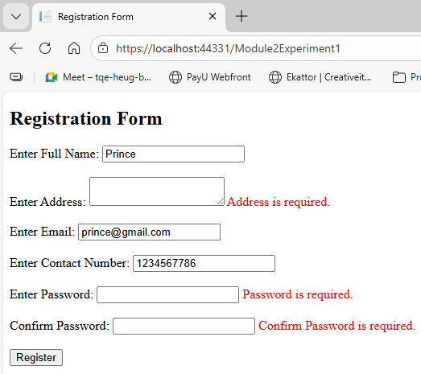
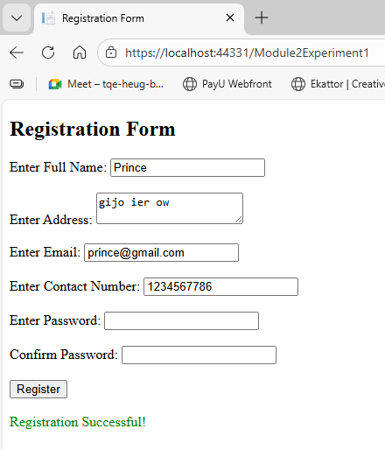

2. Design an ASP.NET Application to Display Random Advertisements using ADRotator Control.
AdRotatorpractical.aspx
<%@ Page Language="C#" AutoEventWireup="true" CodeBehind="AdRotatorpractical.aspx.cs" Inherits="Prince127.AdRotatorpractical" %>
<!DOCTYPE html>
<html xmlns="http://www.w3.org/1999/xhtml">
<head runat="server">
<title>AdRotator Practical</title>
</head>
<body>
<form id="form1" runat="server">
<div style="display:flex; gap:20px;">
<asp:AdRotator
ID="AdRotator1"
runat="server"
AdvertisementFile="~/XMLFile1.xml"
Width="300px"
Height="200px">
</asp:AdRotator>
<asp:AdRotator
ID="AdRotator2"
runat="server"
AdvertisementFile="~/XMLFile1.xml"
Width="300px"
Height="200px">
</asp:AdRotator>
<asp:AdRotator
ID="AdRotator3"
runat="server"
AdvertisementFile="~/XMLFile1.xml"
Width="300px"
Height="200px">
</asp:AdRotator>
</div>
</form>
</body>
</html>

Xml file - XMLFile1.xml
<?xml version="1.0" encoding="utf-8" ?>
<Advertisements>
<Ad>
<ImageUrl>img/1.jpg</ImageUrl>
<NavigateUrl>https://google.com</NavigateUrl>
<AlternateText>Meera Academy</AlternateText>
<Impressions>50</Impressions>
<Keyword>Meera</Keyword>
</Ad>
<Ad>
<ImageUrl>img/2.jpg</ImageUrl>
<NavigateUrl>https://zomato.com</NavigateUrl>
<AlternateText>Meera Academy</AlternateText>
<Impressions>100</Impressions>
<Keyword>Academy</Keyword>
</Ad>
<Ad>
<ImageUrl>img/3.jpg</ImageUrl>
<NavigateUrl>https://swiggy.com</NavigateUrl>
<AlternateText>Meera Academy</AlternateText>
<Impressions>50</Impressions>
<Keyword>Academy</Keyword>
</Ad>
</Advertisements>

Output:
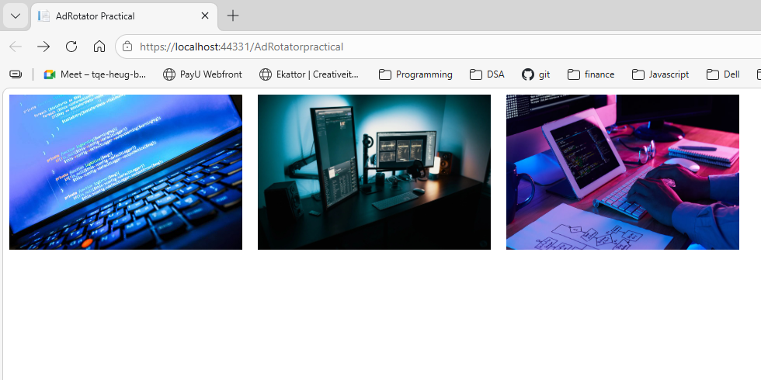
After clicking on image
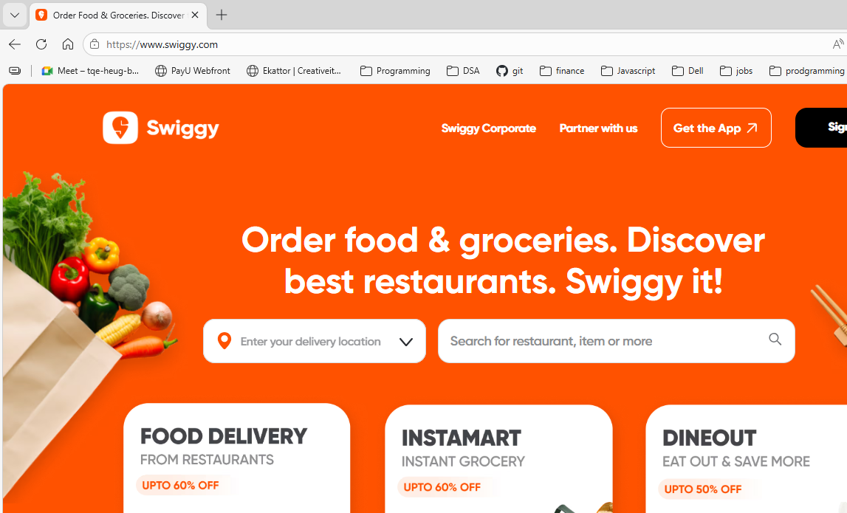

3. Create a web page with an interactive calendar control to select a date and display it in a label. Display Current Month’s Calendar. Show Some image in the cell along message.
CalendarDisplay.aspx
<%@ Page Language="C#" AutoEventWireup="true" CodeBehind="CalendarDisplay.aspx.cs" Inherits="Prince127.CalendarDisplay" %>
<!DOCTYPE html>
<html xmlns="http://www.w3.org/1999/xhtml">
<head runat="server">
<title>Calendar Practical</title>
</head>
<body>
<form id="form1" runat="server">
<div>
<p style="text-align:center">
<asp:Label ID="Label1" runat="server"
Font-Bold="True"
Font-Names="Arial Black"
Font-Size="Medium"
ForeColor="#0066FF">
Prince Yadav
</asp:Label>
</p>
<p style="text-align:center">
<asp:Label ID="Label2" runat="server"
Font-Bold="True"
Font-Names="Arial Black"
Font-Size="Medium"
ForeColor="#0066FF">
Indian List of Holidays 2025
</asp:Label>
</p>
<asp:Calendar
ID="Calendar1"
runat="server"
BackColor="#FFFFCC"
BorderColor="#FFCC66"
BorderWidth="1px"
DayNameFormat="Shortest"
Font-Names="Verdana"
Font-Size="8pt"
ForeColor="#663399"
ShowGridLines="True"
OnDayRender="Calendar1_DayRender"
OnSelectionChanged="Calendar1_SelectionChanged"
OnVisibleMonthChanged="Calendar1_VisibleMonthChanged">
<SelectedDayStyle BackColor="#CCCCFF" Font-Bold="True" />
<SelectorStyle BackColor="#FFCC66" />
<TodayDayStyle BackColor="#FFCC66" ForeColor="White" />
<OtherMonthDayStyle ForeColor="#CC9966" />
<NextPrevStyle Font-Size="9pt" ForeColor="#FFFFCC" />
<DayHeaderStyle BackColor="#FFCC66" Font-Bold="True" Height="1px" />
<TitleStyle BackColor="#990000" Font-Bold="True" Font-Size="9pt" ForeColor="#FFFFCC" />
</asp:Calendar>
<br />
<asp:Label ID="LabelAction" runat="server"></asp:Label>
</div>
</form>
</body>
</html>

CalendarDisplay.aspx.cs
using System;
using System.Collections;
using System.Web.UI;
using System.Web.UI.WebControls;
namespace Prince127
{
public partial class CalendarDisplay : System.Web.UI.Page
{
Hashtable HolidayList;
protected void Page_Load(object sender, EventArgs e)
{
HolidayList = Getholiday();
Calendar1.Caption = "Calendar - Author: Prince";
Calendar1.FirstDayOfWeek = FirstDayOfWeek.Sunday;
Calendar1.NextPrevFormat = NextPrevFormat.ShortMonth;
Calendar1.TitleFormat = TitleFormat.Month;
Calendar1.ShowGridLines = true;
Calendar1.DayStyle.Height = new Unit(50);
Calendar1.DayStyle.Width = new Unit(120);
Calendar1.DayStyle.HorizontalAlign = HorizontalAlign.Center;
Calendar1.DayStyle.VerticalAlign = VerticalAlign.Middle;
Calendar1.OtherMonthDayStyle.BackColor = System.Drawing.Color.AliceBlue;
}
private Hashtable Getholiday()
{
Hashtable holiday = new Hashtable();
holiday["1/1/2025"] = "New Year";
holiday["1/26/2025"] = "Republic Day";
holiday["3/21/2025"] = "Holi";
holiday["8/15/2025"] = "Independence Day";
holiday["10/2/2025"] = "Gandhi Jayanti";
holiday["10/17/2025"] = "Diwali";
holiday["12/25/2025"] = "Christmas";
return holiday;
}
protected void Calendar1_SelectionChanged(object sender, EventArgs e)
{
LabelAction.Text = "Date changed to: " +
Calendar1.SelectedDate.ToShortDateString();
}
protected void Calendar1_VisibleMonthChanged(object sender, MonthChangedEventArgs e)
{
LabelAction.Text = "Month changed to: " +
e.NewDate.ToShortDateString();
}
protected void Calendar1_DayRender(object sender, DayRenderEventArgs e)
{
if (HolidayList[e.Day.Date.ToShortDateString()] != null)
{
Literal literal1 = new Literal();
literal1.Text = "<br/>";
e.Cell.Controls.Add(literal1);
Label label1 = new Label();
label1.Text = (string)HolidayList[e.Day.Date.ToShortDateString()];
label1.Font.Size = new FontUnit(FontSize.Small);
e.Cell.Controls.Add(label1);
}
}
}
}

Output:
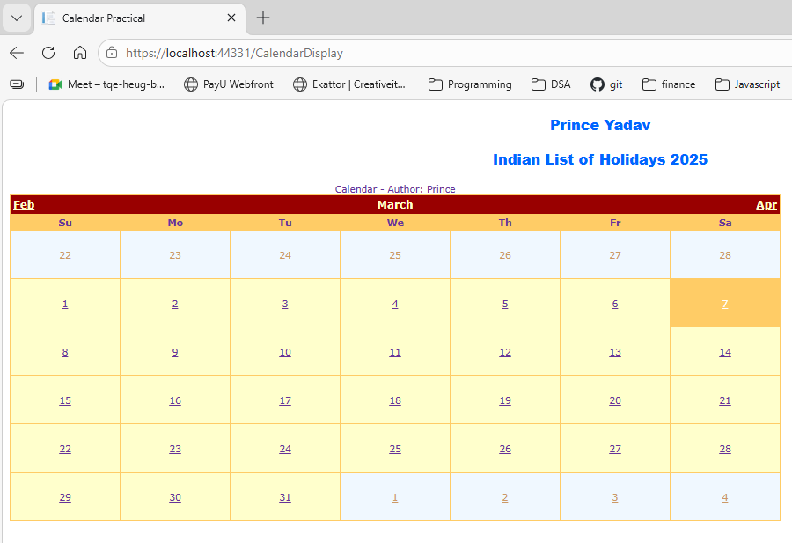

4. Implement a navigation menu to link multiple pages of your web application.
NavigationTree.aspx
<%@ Page Language="C#" AutoEventWireup="true" CodeBehind="MenuExample.aspx.cs" Inherits="Prince127.MenuExample" %>
<!DOCTYPE html>
<html xmlns="http://www.w3.org/1999/xhtml">
<head runat="server">
<title>Menu Navigation</title>
<style>
body{
background-color:mediumaquamarine;
font-family:Arial;
}
.ParentMenu{
width:100px;
background-color:white;
text-align:center;
height:30px;
line-height:30px;
margin-right:5px;
}
.ChildMenu{
width:110px;
background-color:white;
text-align:center;
height:30px;
line-height:30px;
margin-top:5px;
}
.selected{
background-color:#A6A6A6;
color:white;
}
</style>
</head>
<body>
<form id="form1" runat="server">
<asp:Menu ID="Menu1" runat="server" Orientation="Horizontal">
<LevelMenuItemStyles>
<asp:MenuItemStyle CssClass="ParentMenu"/>
<asp:MenuItemStyle CssClass="ChildMenu"/>
<asp:MenuItemStyle CssClass="ChildMenu"/>
</LevelMenuItemStyles>
<StaticSelectedStyle CssClass="selected"/>
</asp:Menu>
</form>
</body>
</html>

NavigationTree.aspx.cs
using System;
using System.Web.UI;
namespace Prince127
{
public partial class NavigationTree : System.Web.UI.Page
{
protected void Page_Load(object sender, EventArgs e)
{
}
}
}

MenuExample.aspx
<%@ Page Language="C#" AutoEventWireup="true" CodeBehind="MenuExample.aspx.cs" Inherits="Prince127.MenuExample" %>
<!DOCTYPE html>
<html xmlns="http://www.w3.org/1999/xhtml">
<head runat="server">
<title>Menu Navigation</title>
<style>
body{
background-color:mediumaquamarine;
font-family:Arial;
}
.ParentMenu{
width:100px;
background-color:white;
text-align:center;
height:30px;
line-height:30px;
margin-right:5px;
}
.ChildMenu{
width:110px;
background-color:white;
text-align:center;
height:30px;
line-height:30px;
margin-top:5px;
}
.selected{
background-color:#A6A6A6;
color:white;
}
</style>
</head>
<body>
<form id="form1" runat="server">
<asp:Menu ID="Menu1" runat="server" Orientation="Horizontal">
<LevelMenuItemStyles>
<asp:MenuItemStyle CssClass="ParentMenu"/>
<asp:MenuItemStyle CssClass="ChildMenu"/>
<asp:MenuItemStyle CssClass="ChildMenu"/>
</LevelMenuItemStyles>
<StaticSelectedStyle CssClass="selected"/>
</asp:Menu>
</form>
</body>
</html>

MenuExample.aspx.cs

using System;
using System.Data;
using System.IO;
using System.Web.UI;
using System.Web.UI.WebControls;
namespace Prince127
{
public partial class MenuExample : System.Web.UI.Page
{
protected void Page_Load(object sender, EventArgs e)
{
if (!IsPostBack)
{
DataTable dt = BindMenuData(0);
DynamicMenuControlPopulation(dt, 0, null);
}
}
protected DataTable BindMenuData(int parentmenuId)
{
DataTable dt = new DataTable();
dt.Columns.Add("MenuId", typeof(int));
dt.Columns.Add("ParentId", typeof(int));
dt.Columns.Add("Title", typeof(string));
dt.Columns.Add("Description", typeof(string));
dt.Columns.Add("URL", typeof(string));
dt.Rows.Add(1, 0, "Home", "", "~/Home.aspx");
dt.Rows.Add(2, 0, "Customer Service", "", "~/Customer.aspx");
dt.Rows.Add(3, 0, "About", "", "~/AboutUs.aspx");
dt.Rows.Add(4, 0, "Contact Us", "", "~/Contact.aspx");
dt.Rows.Add(5, 0, "Testimonial", "", "~/Testimonial.aspx");
dt.Rows.Add(6, 2, "Consulting", "", "~/Consult.aspx");
dt.Rows.Add(7, 2, "Outsourcing", "", "~/Outsource.aspx");
dt.Rows.Add(8, 7, "Domestic", "", "~/Domestic.aspx");
dt.Rows.Add(9, 7, "International", "", "~/International.aspx");
DataView dv = dt.DefaultView;
dv.RowFilter = "ParentId=" + parentmenuId;
return dv.ToTable();
}
protected void DynamicMenuControlPopulation(DataTable dt, int parentMenuId, MenuItem parentMenuItem)
{
string currentPage = Path.GetFileName(Request.Url.AbsolutePath);
foreach (DataRow row in dt.Rows)
{
MenuItem menuItem = new MenuItem
{
Value = row["MenuId"].ToString(),
Text = row["Title"].ToString(),
NavigateUrl = row["URL"].ToString(),
Selected = row["URL"].ToString().EndsWith(currentPage)
};
if (parentMenuId == 0)
{
Menu1.Items.Add(menuItem);
}
else
{
parentMenuItem.ChildItems.Add(menuItem);
}
DataTable dtChild = BindMenuData(Convert.ToInt32(menuItem.Value));
DynamicMenuControlPopulation(dtChild, Convert.ToInt32(menuItem.Value), menuItem);
}
}
}
}

TreeViewHover.aspx
<%@ Page Language="C#" AutoEventWireup="true" CodeBehind="TreeViewHover.aspx.cs" Inherits="Prince127.TreeViewHover" %>
<!DOCTYPE html>
<html xmlns="http://www.w3.org/1999/xhtml">
<head runat="server">
<title>TreeView Hover</title>
</head>
<body>
<form id="form1" runat="server">
<asp:TreeView runat="server" ID="TreeView1">
<Nodes>
<asp:TreeNode Text="Home" NavigateUrl="~/Default.aspx" />
<asp:TreeNode Text="Employee">
<asp:TreeNode Text="Upload Resume" />
<asp:TreeNode Text="Edit Resume" />
<asp:TreeNode Text="View Resume" />
</asp:TreeNode>
<asp:TreeNode Text="Employer">
<asp:TreeNode Text="Upload Job" />
<asp:TreeNode Text="Edit Job" />
<asp:TreeNode Text="View Job" />
</asp:TreeNode>
</Nodes>
</asp:TreeView>
</form>
</body>
</html>

TreeViewHover.aspx.cs
using System;
using System.Web.UI;
namespace Prince127
{
public partial class TreeViewHover : System.Web.UI.Page
{
protected void Page_Load(object sender, EventArgs e)
{
}
}
}

Web.sitemap
<?xml version="1.0" encoding="utf-8" ?>
<siteMap xmlns="http://schemas.microsoft.com/AspNet/SiteMap-File-1.0">
<siteMapNode url="" title="Home">
<siteMapNode url="NavigationTree.aspx" title="Home Page" />
<siteMapNode url="#" title="Services">
<siteMapNode url="TreeViewHover.aspx" title="Consulting" />
<siteMapNode url="MenuExample.aspx" title="Outsourcing" />
</siteMapNode>
<siteMapNode url="About.aspx" title="About Us" />
<siteMapNode url="Contact.aspx" title="Contact" />
</siteMapNode>
</siteMap>

Output:
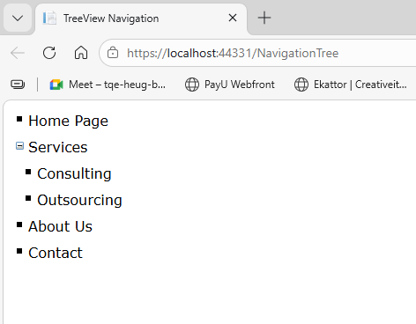
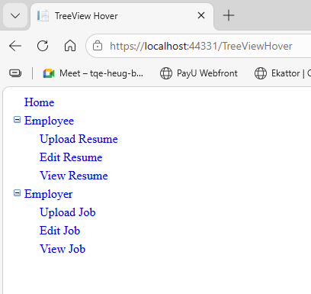

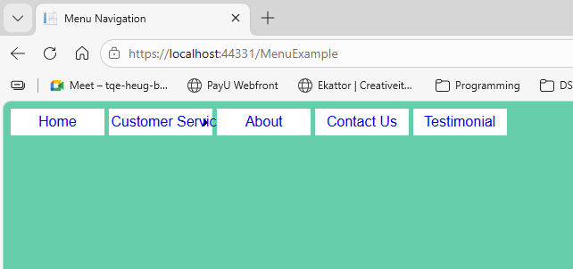

5. Develop a file upload application that saves the uploaded file and displays its name and size.
FileUploadDemo.aspx

<%@ Page Language="C#" AutoEventWireup="true" CodeBehind="FileUploadDemo.aspx.cs" Inherits="Prince127.FileUploadDemo" %>
<!DOCTYPE html>
<html xmlns="http://www.w3.org/1999/xhtml">
<head runat="server">
<title>File Upload Example</title>
</head>
<body>
<form id="upload" runat="server">
<div>
<p>Browse to Upload File</p>
<asp:FileUpload ID="FileUpload1" runat="server" />
</div>
<p>
<asp:Button ID="Button1" runat="server" Text="Upload File" OnClick="Button_Click" />
</p>
<p>
<asp:Label runat="server" ID="UploadStatus"></asp:Label>
</p>
Click on the button to download a file
<br /><br />
<asp:Label ID="lblFilename" runat="server"></asp:Label>
&nbsp;&nbsp;
<asp:Button ID="downloadButton" runat="server" Text="Download" OnClick="downloadButton_Click" />
<br /><br />
<asp:Label ID="downloadLabel" runat="server"></asp:Label>
</form>
</body>
</html>

FileUploadDemo.aspx.cs

using System;
using System.Web;
using System.Web.UI;
namespace Prince127
{
public partial class FileUploadDemo : System.Web.UI.Page
{
protected void Page_Load(object sender, EventArgs e)
{
}
string filename = string.Empty;
protected void Button_Click(object sender, EventArgs e)
{
if ((FileUpload1.PostedFile != null) && (FileUpload1.PostedFile.ContentLength > 0))
{
filename = System.IO.Path.GetFileName(FileUpload1.PostedFile.FileName);
string SaveLocation = Server.MapPath("upload") + "\\" + filename;
try
{
FileUpload1.PostedFile.SaveAs(SaveLocation);

UploadStatus.Text = "The file has been uploaded.";

lblFilename.Text = "upload/" + FileUpload1.FileName;
}
catch (Exception ex)
{
UploadStatus.Text = "Error: " + ex.Message;
}
}
else
{
UploadStatus.Text = "Please select a file to upload.";
}
}
protected void downloadButton_Click(object sender, EventArgs e)
{
if (!string.IsNullOrEmpty(lblFilename.Text))
{
string filePath = lblFilename.Text;
string fileExtension = System.IO.Path.GetExtension(filePath).ToLower();
switch (fileExtension)
{
case ".txt":
Response.ContentType = "application/txt";
break;

case ".pdf":
Response.ContentType = "application/pdf";
break;
case ".docx":
Response.ContentType = "application/vnd.openxmlformats-officedocument.wordprocessingml.document";
break;
default:
Response.ContentType = "image/jpeg";
break;
}
Response.AddHeader("Content-Disposition", "attachment;filename=\"" + System.IO.Path.GetFileName(filePath) + "\"");
Response.TransmitFile(Server.MapPath(filePath));
Response.End();
}
}
}
}

Output
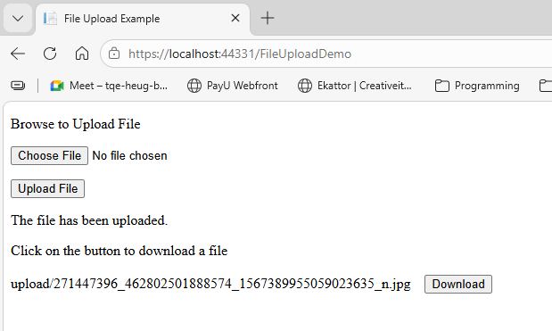

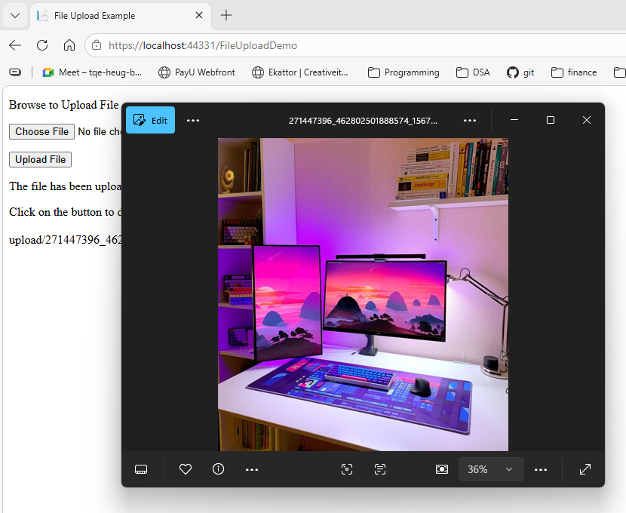

6. Create a Master Page for a website and add different content pages for Home, About, and Contact Us.
Master_Page.master

<%@ Master Language="C#" AutoEventWireup="true" CodeBehind="Master_Page.master.cs" Inherits="Prince127.Master_Page" %>
<!DOCTYPE html>
<html>
<head runat="server">
<title>Prince</title>
<asp:ContentPlaceHolder ID="head" runat="server"></asp:ContentPlaceHolder>
</head>
<body>
<form id="form1" runat="server">
<table border="1" width="100%">
<tr>
<td width="200">
<asp:Image ID="Image1" runat="server" Height="120px" Width="140px" ImageUrl="~/images/logo.png"/>
</td>
<td style="font-size:50px">
The Prince
</td>
</tr>
<tr>
<td>
<br/>
<asp:HyperLink ID="HyperLink1" runat="server" NavigateUrl="~/Home.aspx">Home</asp:HyperLink>
<br/><br/>
<asp:HyperLink ID="HyperLink2" runat="server" NavigateUrl="~/About_Us.aspx">About Us</asp:HyperLink>
<br/><br/>
<asp:HyperLink ID="HyperLink3" runat="server" NavigateUrl="~/Contact_Us.aspx">Contact Us</asp:HyperLink>
</td>
<td>
<asp:ContentPlaceHolder ID="ContentPlaceHolder1" runat="server"></asp:ContentPlaceHolder>
</td>
</tr>
<tr>
<td colspan="2">
<center>
© Prince @ Prince Solution Pvt Ltd
</center>
</td>
</tr>
</table>
</form>
</body>
</html>

Master_Page.master.cs
using System;
using System.Web.UI;
namespace Prince127
{
public partial class Master_Page : System.Web.UI.MasterPage
{
protected void Page_Load(object sender, EventArgs e)
{
}
}
}

Home.aspx
<%@ Page Title="" Language="C#" MasterPageFile="~/Master_Page.master" AutoEventWireup="true" CodeBehind="Home.aspx.cs" Inherits="Prince127.Home" %>
<asp:Content ID="Content1" ContentPlaceHolderID="head" runat="server">
</asp:Content>
<asp:Content ID="Content2" ContentPlaceHolderID="ContentPlaceHolder1" runat="server">
<h2>Welcome to Programmign World !</h2>
<p>This is the HOME page.</p>
</asp:Content>

About_Us.aspx
<%@ Page Title="" Language="C#" MasterPageFile="~/Master_Page.master" AutoEventWireup="true" CodeBehind="About_Us.aspx.cs" Inherits="Prince127.About_Us" %>
<asp:Content ID="Content1" ContentPlaceHolderID="head" runat="server">
</asp:Content>
<asp:Content ID="Content2" ContentPlaceHolderID="ContentPlaceHolder1" runat="server">
<h2>About Us</h2>
<p>Welcome to the CollectiGrade.</p>
<p>This is the ABOUT US Page.</p>
<p><b>MOTTO:</b> “Solution of Every Problem”</p>
</asp:Content>

Contact_Us.aspx
<%@ Page Title="" Language="C#" MasterPageFile="~/Master_Page.master" AutoEventWireup="true" CodeBehind="Contact_Us.aspx.cs" Inherits="Prince127.Contact_Us" %>
<asp:Content ID="Content1" ContentPlaceHolderID="head" runat="server">
</asp:Content>
<asp:Content ID="Content2" ContentPlaceHolderID="ContentPlaceHolder1" runat="server">
<h2>Contact Us</h2>
<p>Email: support@prince.com</p>
<p>Phone: +91 8845341230</p>
<p>Address: Navi Mumbai, India</p>
</asp:Content>

Output
Home Page:
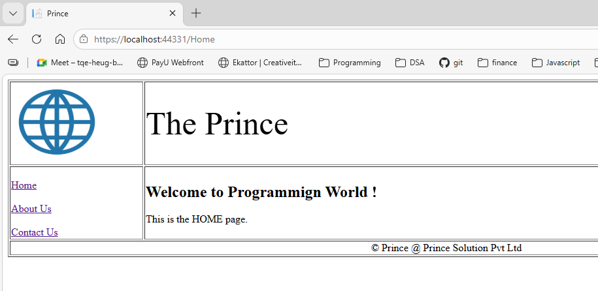
About Page
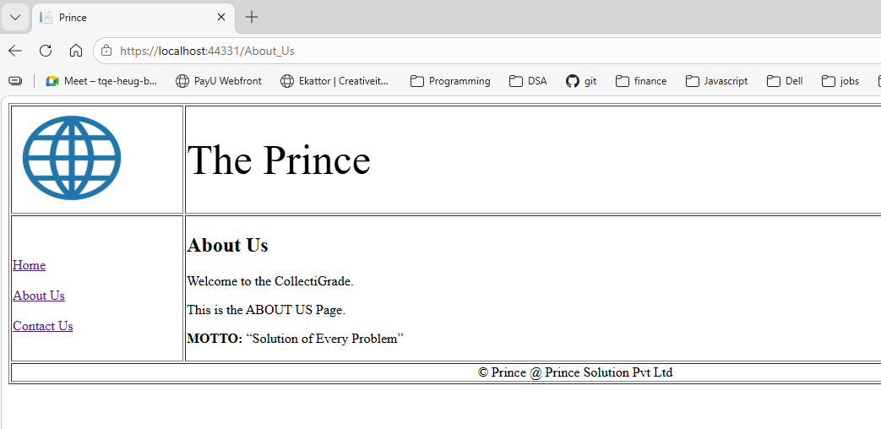
Contact Page
