Practical No - 1

Aim: Write a program to implement Tokenization of text
print("Prince 127")
import nltk
from nltk.tokenize import sent_tokenize, word_tokenize
nltk.download('punkt')
nltk.download('punkt_tab')
paragraph = """Technology is rapidly transforming the way people live and work."""
sentences = sent_tokenize(paragraph)
print("\nSentence Tokenization:")
print(sentences)
words = word_tokenize(paragraph)
print("\nWord Tokenization:")
print(words)
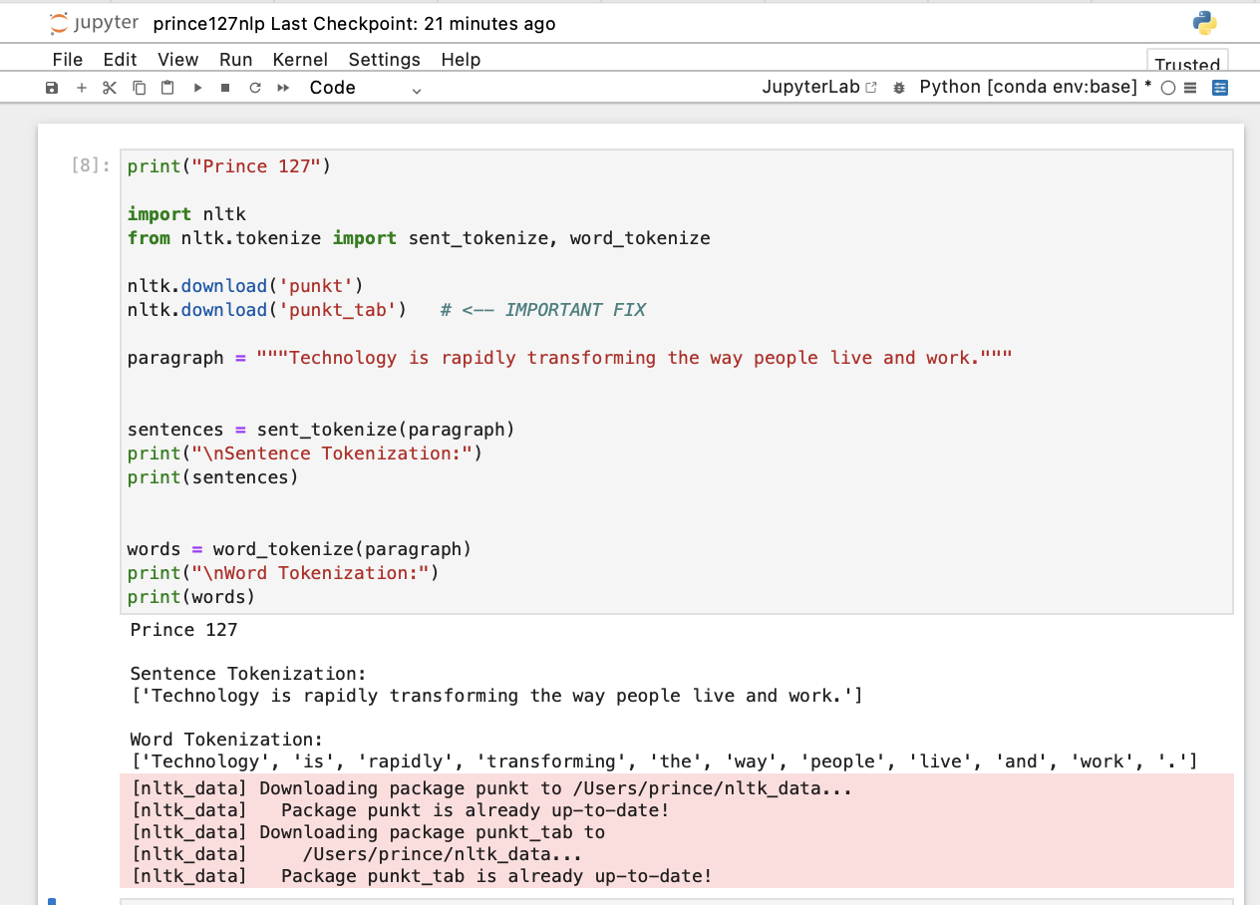

Practical No. 2

Aim: Write a program to implement Tokenization of paragraph.
import nltk
from nltk.tokenize import sent_tokenize, word_tokenize
nltk.download('punkt')
nltk.download('punkt_tab')
print("127 PRINCE YADAV")
data = """Success is not achieved overnight; it is the result of consistent effort and dedication.
Every small step you take brings you closer to your goals.
Challenges are a part of the journey, and they help build strength and confidence.
Learning from mistakes is important for personal growth.
With patience, hard work, and a positive mindset, anyone can achieve their dreams."""
# Sentence Tokenization
tokens = sent_tokenize(data)
print("\nSentence Tokenization:")
print(tokens)
# Word Tokenization
tokens = word_tokenize(data)
print("\nWord Tokenization:")
print(tokens)
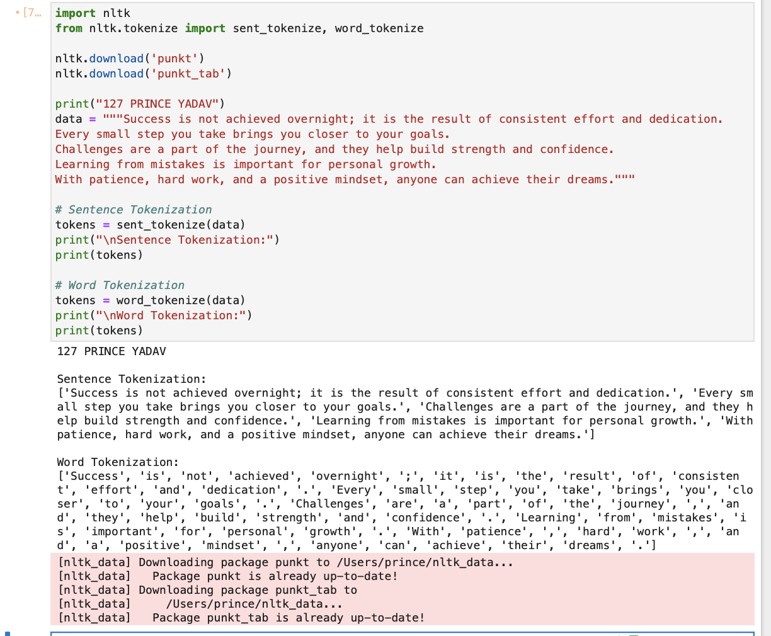

Practical No. 3

Aim: Write a program to implement Stop word removal.
print("Prince 127")
import nltk
from nltk.corpus import stopwords
from nltk.tokenize import word_tokenize
nltk.download('stopwords')
nltk.download('punkt')
nltk.download('punkt_tab')

text = "Technology is improving human life by making tasks easier and faster."
# Tokenization
words = word_tokenize(text)
# Stopwords removal
stop_words = set(stopwords.words('english'))
filtered_words = []
for word in words:
if word.lower() not in stop_words:
filtered_words.append(word)
print("\nOriginal Words:", words)
print("After Removing Stopwords:", filtered_words)

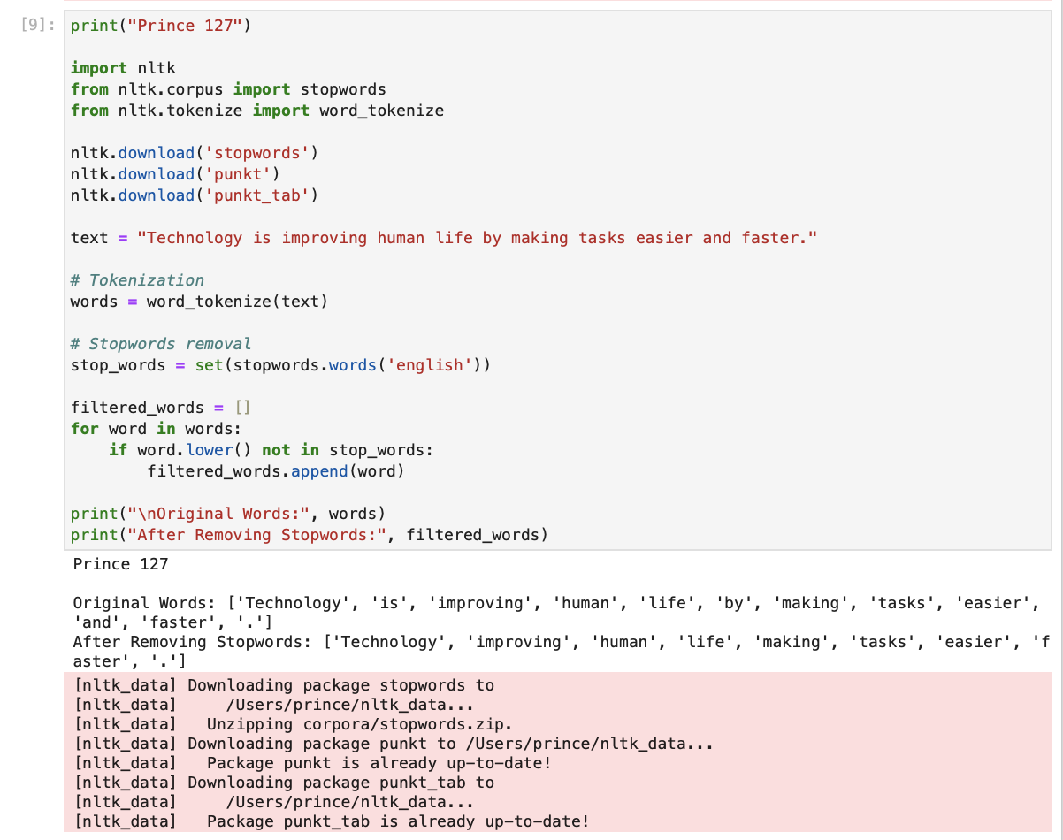

print("Prince 127")
from nltk.corpus import stopwords
nltk.download('stopwords')
stopwords=set(stopwords.words('english'))
print(stopwords)
from nltk.tokenize import sent_tokenize,word_tokenize
from nltk.corpus import stopwords
stopwords=set(stopwords.words("english"))
data="NLP helps computers understand human language."
# Tokenization
tokens = word_tokenize(data)
# Remove stopwords
filtered_data = []
for w in tokens:
if w.lower() not in stop_words:
filtered_data.append(w)
print(filtered_data)
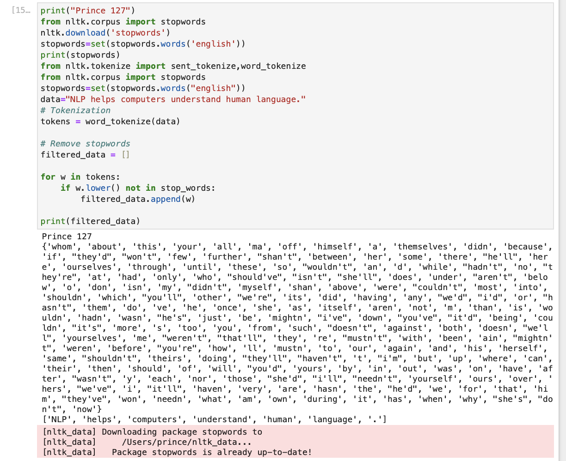

Practical No. 4

Aim: Write a program to implement Stemming of text

print("Prince 127")
import nltk
from nltk.stem import PorterStemmer
port_stemmer = PorterStemmer()
# Sample data
data = ["running", "played", "writing", "studies", "driving", "happiness", "reading"]
# Apply stemming
for word in data:
print(word, ":", port_stemmer.stem(word))

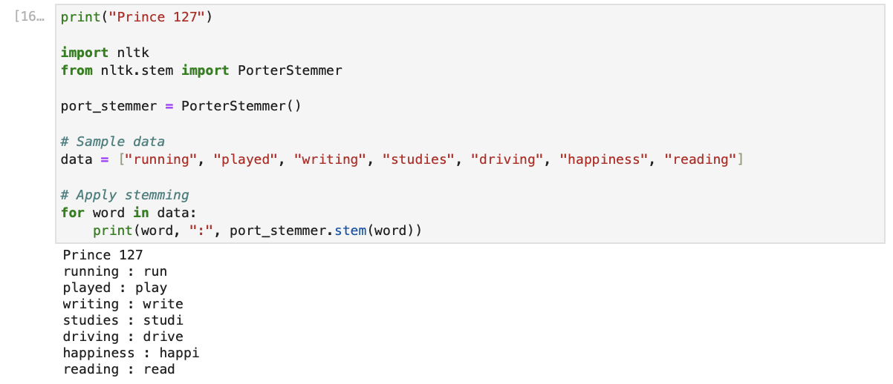

Practical No – 5

Aim: Write a program to implement Lemmatization.

print("Prince 127")
import nltk
from nltk.stem import WordNetLemmatizer

nltk.download('wordnet')
nltk.download('omw-1.4')

# Create lemmatizer object
lemmati = WordNetLemmatizer()

# Lemmatization examples
print("studies :", lemmati.lemmatize("studies"))
print("feet :", lemmati.lemmatize("feet"))
print("children :", lemmati.lemmatize("children"))
print("worse :", lemmati.lemmatize("worse"))
print("socks (adj) :", lemmati.lemmatize("socks", pos="a"))
print("studying (verb) :", lemmati.lemmatize("studying", pos="v"))
print("studies (noun) :", lemmati.lemmatize("studies", pos="n"))
print("better (adj) :", lemmati.lemmatize("better", pos="a"))
print("ran (verb) :", lemmati.lemmatize("ran", pos="v"))
print("driving (verb) :", lemmati.lemmatize("driving", pos="v"))
print("stripes (verb) :", lemmati.lemmatize("stripes", pos="v"))
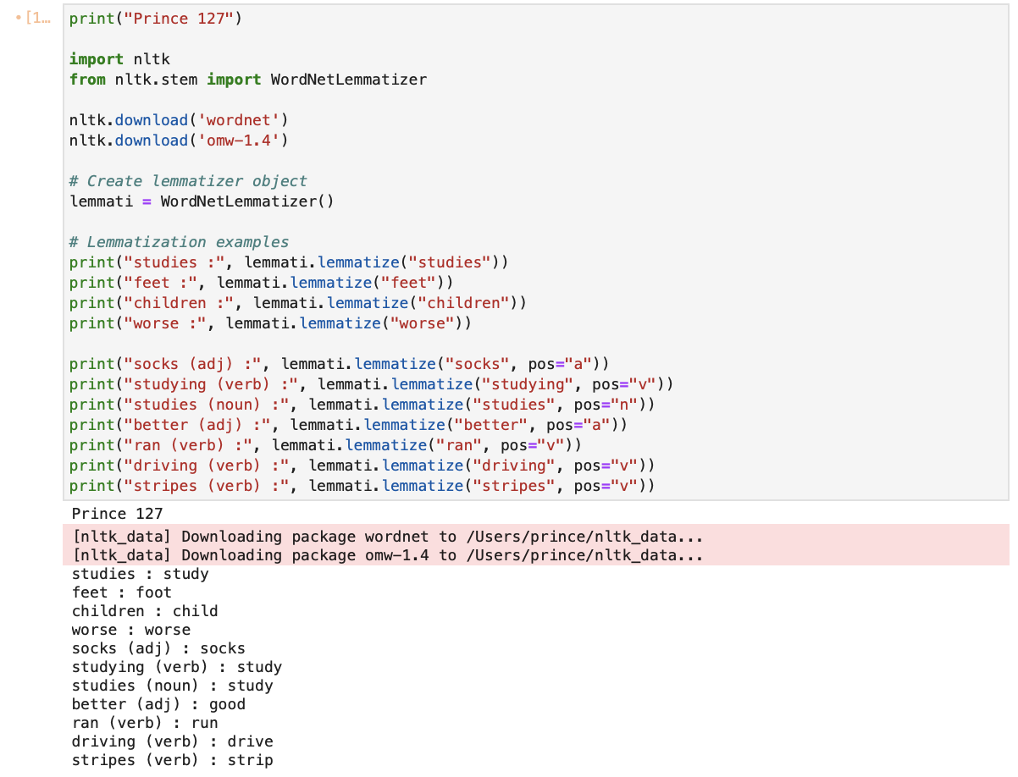
Practical No. 6

Aim: Write a program to implement POS Tagging
print("Prince Yadav 127")
import nltk
from nltk import pos_tag
from nltk.tokenize import word_tokenize
nltk.download('punkt')
nltk.download('punkt_tab')
nltk.download('averaged_perceptron_tagger_eng') # FIX
# Text
text = "Students are learning new technologies to build innovative and creative solutions."
# Tokenization
tokens = word_tokenize(text)
print("Tokenized words:\n", tokens)
# POS Tagging
tagged_words = pos_tag(tokens)
print("\nPOS Tagged words:\n", tagged_words)
# Display POS tags
for word, tag in tagged_words:
print(f"{word} : {tag}")
# Tree display
tree_obj = nltk.Tree("Sentence", [(word, tag) for word, tag in tagged_words])
tree_obj.pretty_print()

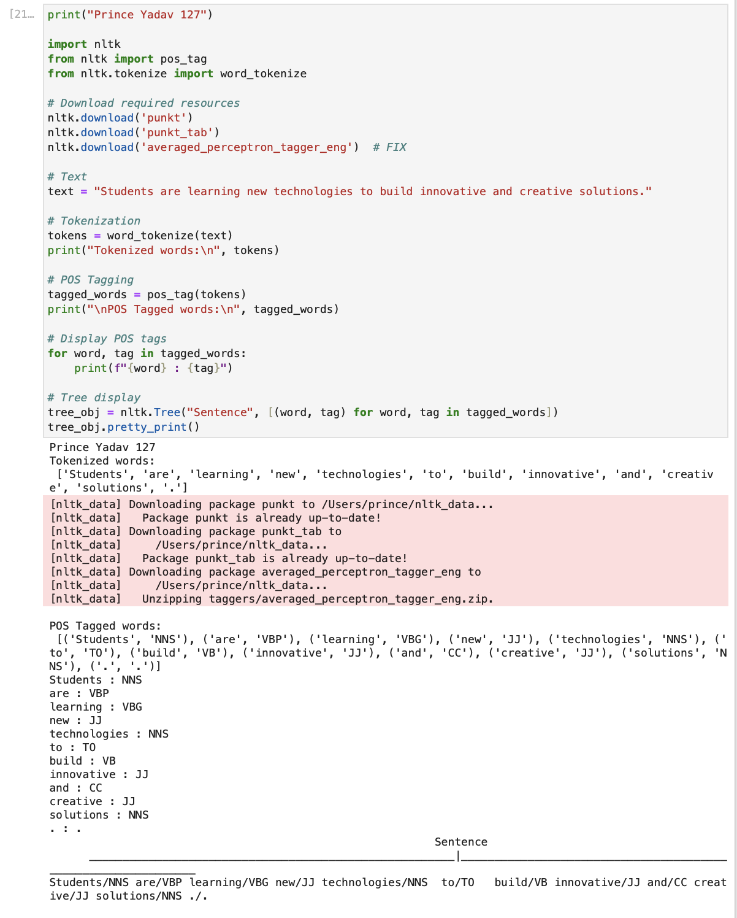

Practical No: 7

Aim: Write a program to perform Natural Language Processing(NLP) on a given paragraph by removing stopwords, tokenizing the text, and identifying the Part-of-Speech (POS) tags (such as noun, verb, adjective) for each word using the NLTK library in python.
import nltk
from nltk.tokenize import word_tokenize
from nltk.corpus import stopwords
from nltk import pos_tag
print("Prince Yadav 127")
nltk.download('punkt')
nltk.download('punkt_tab')
nltk.download('stopwords')
nltk.download('averaged_perceptron_tagger_eng')
text = """Technology is rapidly changing the world by improving communication,
education, and business processes. Artificial intelligence and data science
help organizations make better decisions and automate complex tasks.
These advancements are creating new opportunities and transforming everyday life."""
# Tokenization
tokens = word_tokenize(text)
print("\nTokens:")
print(tokens)
# Remove Stop Words
stop_words = set(stopwords.words('english'))
filtered_tokens = [word for word in tokens if word.lower() not in stop_words]
print("\nFiltered Tokens (Stop words removed):")
print(filtered_tokens)
# POS Tagging
pos_tags = pos_tag(filtered_tokens)
print("\nPOS Tags:")
print(pos_tags)

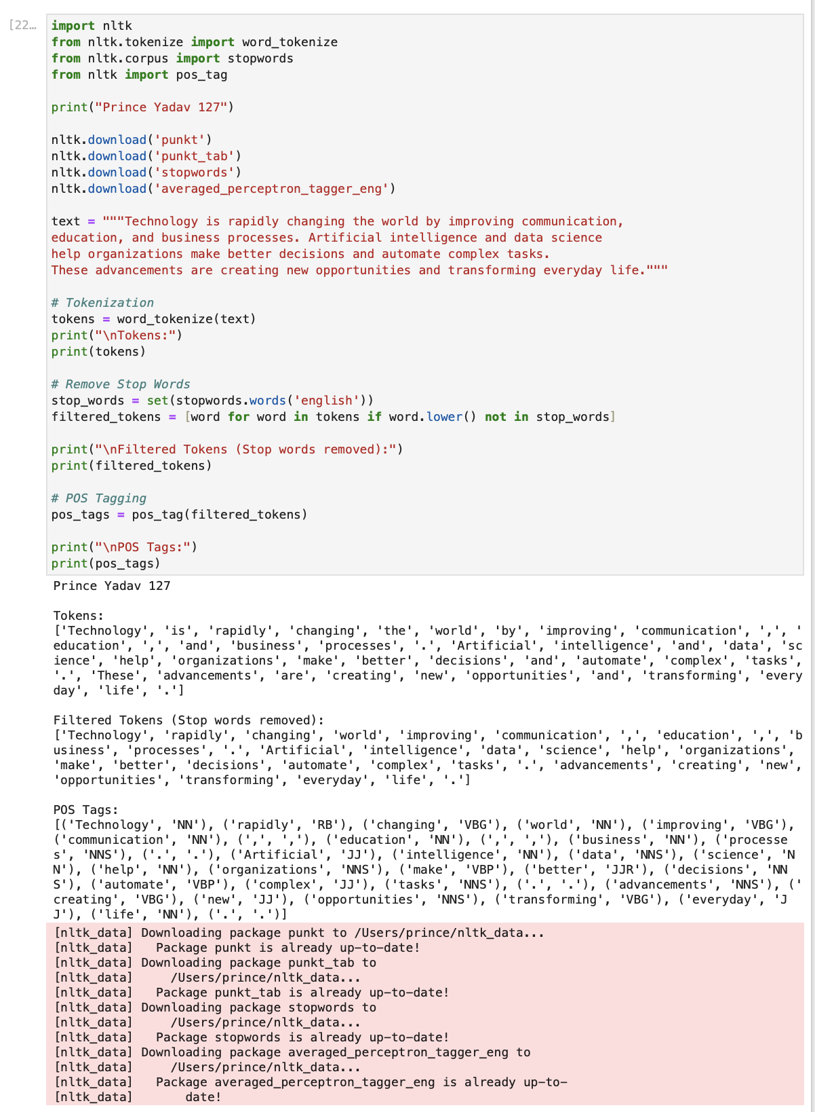

Practical No. 8

Aim: Write a program to implement N-gram Model
print("Prince Yadav 127")
import nltk
from nltk.util import ngrams
from nltk.tokenize import word_tokenize
nltk.download('punkt')
nltk.download('punkt_tab')
data = "Data science and machine learning are transforming modern technology."
# Tokenize the text
tokens = word_tokenize(data)
# Trigram
trigrams = ngrams(tokens, 3)
print("Trigrams:")
for gram in trigrams:
print(gram)
# Bigram
bigrams = ngrams(tokens, 2)
print("\nBigrams:")
for gram in bigrams:
print(gram)

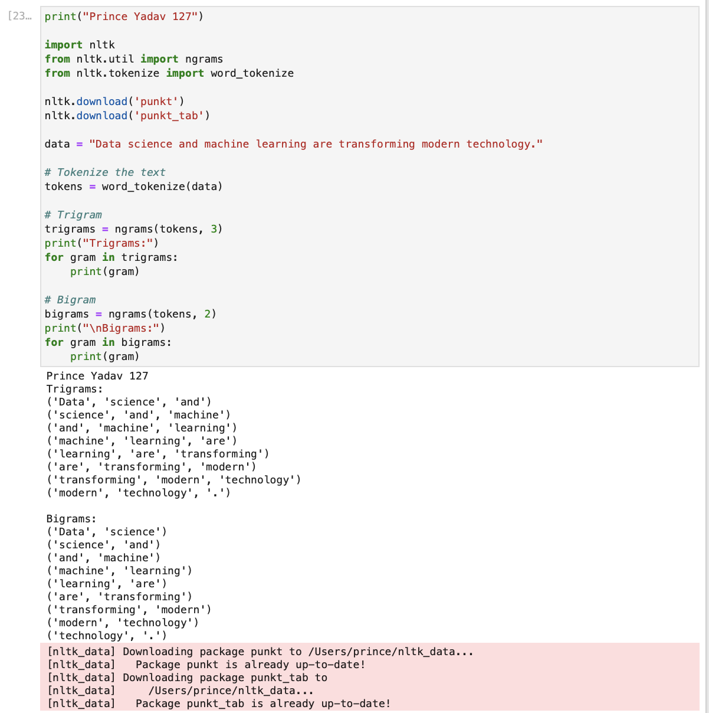

Practical No – 9

Aim: Write a program to Build a custom NER system
print("Prince Yadav 127")
import nltk
from nltk.tokenize import word_tokenize
from nltk.tag import pos_tag
from nltk.chunk import ne_chunk
# Input dataset
dataset = "Mahatma Gandhi led India to independence in 1947"
# Tokenization + POS tagging
dataset_tag = pos_tag(word_tokenize(dataset))
print("\nPOS Tagged Data:")
print(dataset_tag)
# Named Entity Recognition
data_ner = ne_chunk(dataset_tag)
print("\nNamed Entity Tree:")
print(data_ner)
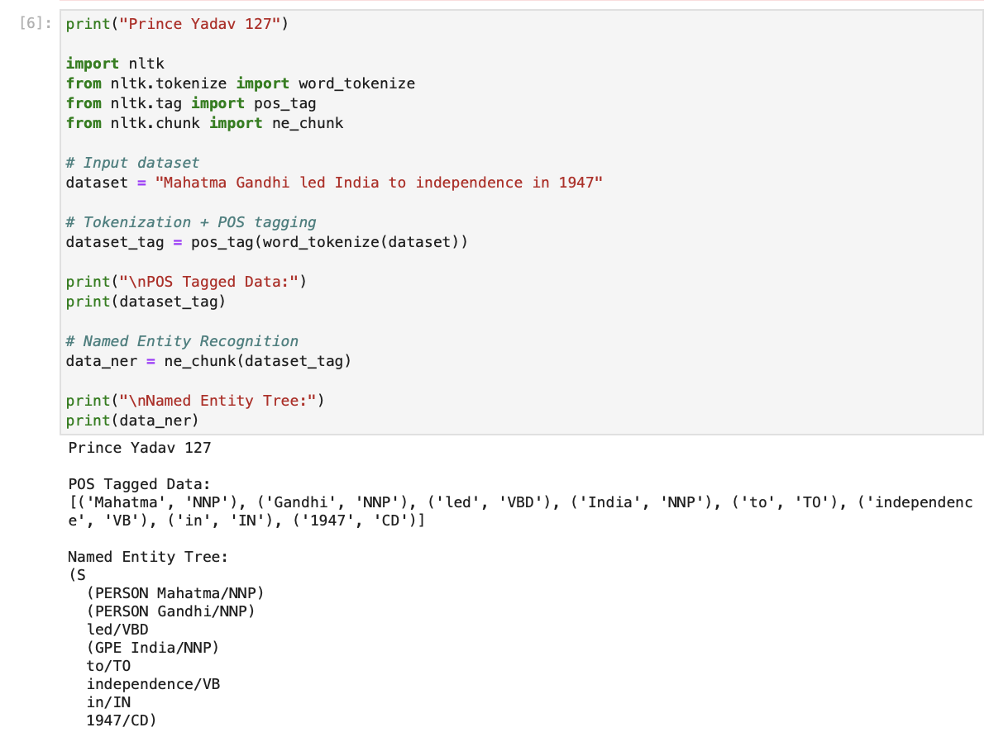
data_ner.draw()
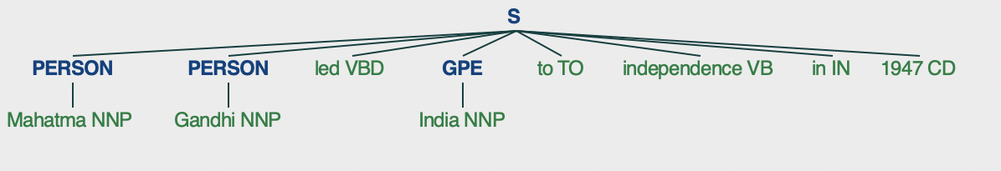

A. Using nltk library.
print("Prince Yadav 127")
import nltk
from nltk.tokenize import word_tokenize
from nltk.tag import pos_tag
from nltk.chunk import ne_chunk
nltk.download('punkt')
nltk.download('punkt_tab')
nltk.download('averaged_perceptron_tagger_eng')
nltk.download('maxent_ne_chunker')
nltk.download('maxent_ne_chunker_tab')
nltk.download('words')
# Sample text
text = "I was born in Mumbai and went to Pune University for pursuing further studies"
# Tokenizing the text
tokens = word_tokenize(text)
# Part of Speech tagging
tagged_tokens = pos_tag(tokens)
# Named Entity Recognition (NE Chunking)
named_entities = ne_chunk(tagged_tokens)
print("\nNamed Entity Tree:")
print(named_entities)
named_entities.draw()

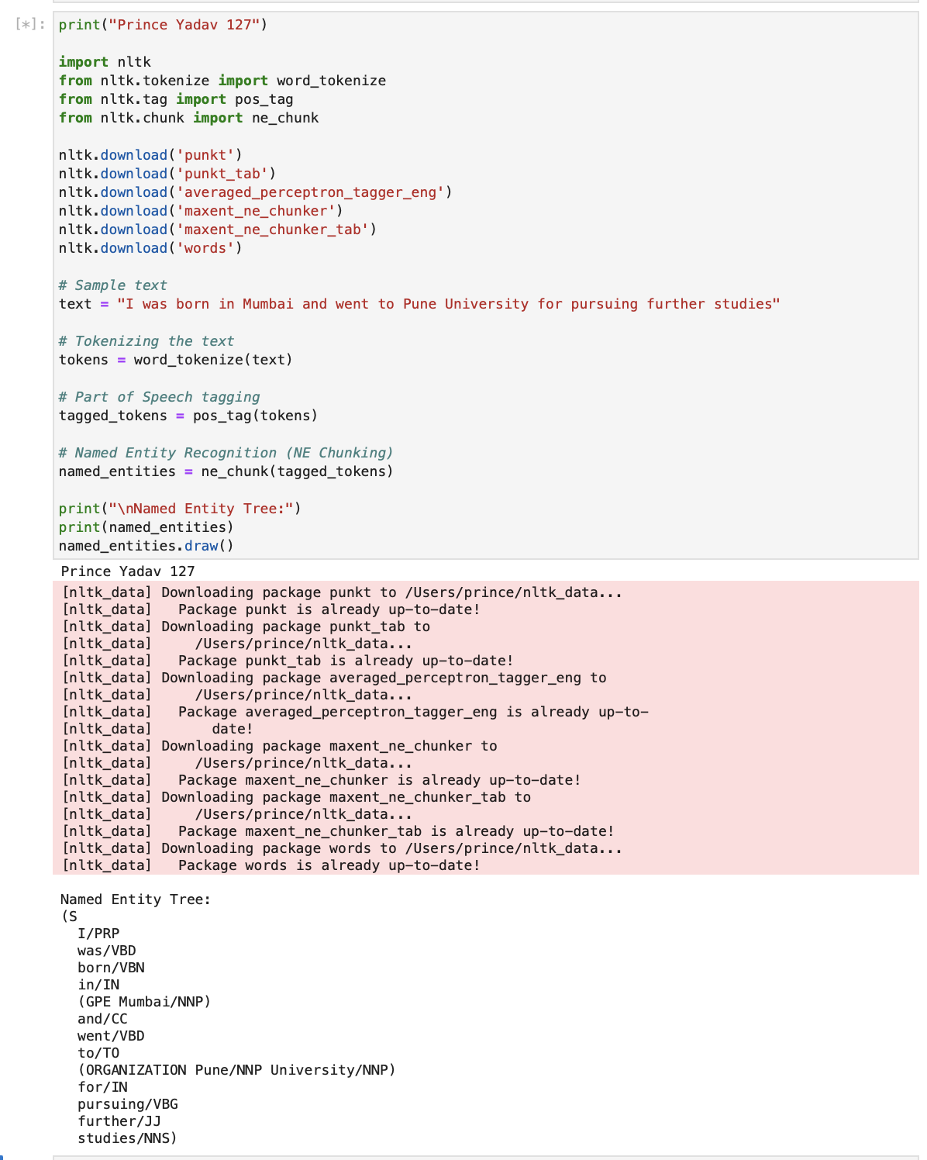

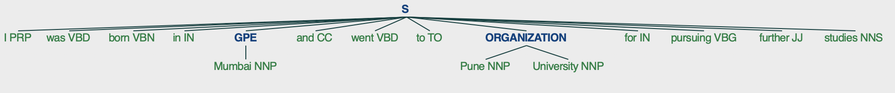

B. Using Spacy.
pip install spacy
!python -m spacy download en_core_web_sm
print("Prince Yadav 127")
import spacy
nlp = spacy.load("en_core_web_sm")
text = "Elon Musk founded SpaceX in the United States."
doc = nlp(text)
print("\nNamed Entities:")
for ent in doc.ents:
print(ent.text, "->", ent.label_)
from spacy import displacy
displacy.render(doc, style="ent", jupyter=True)

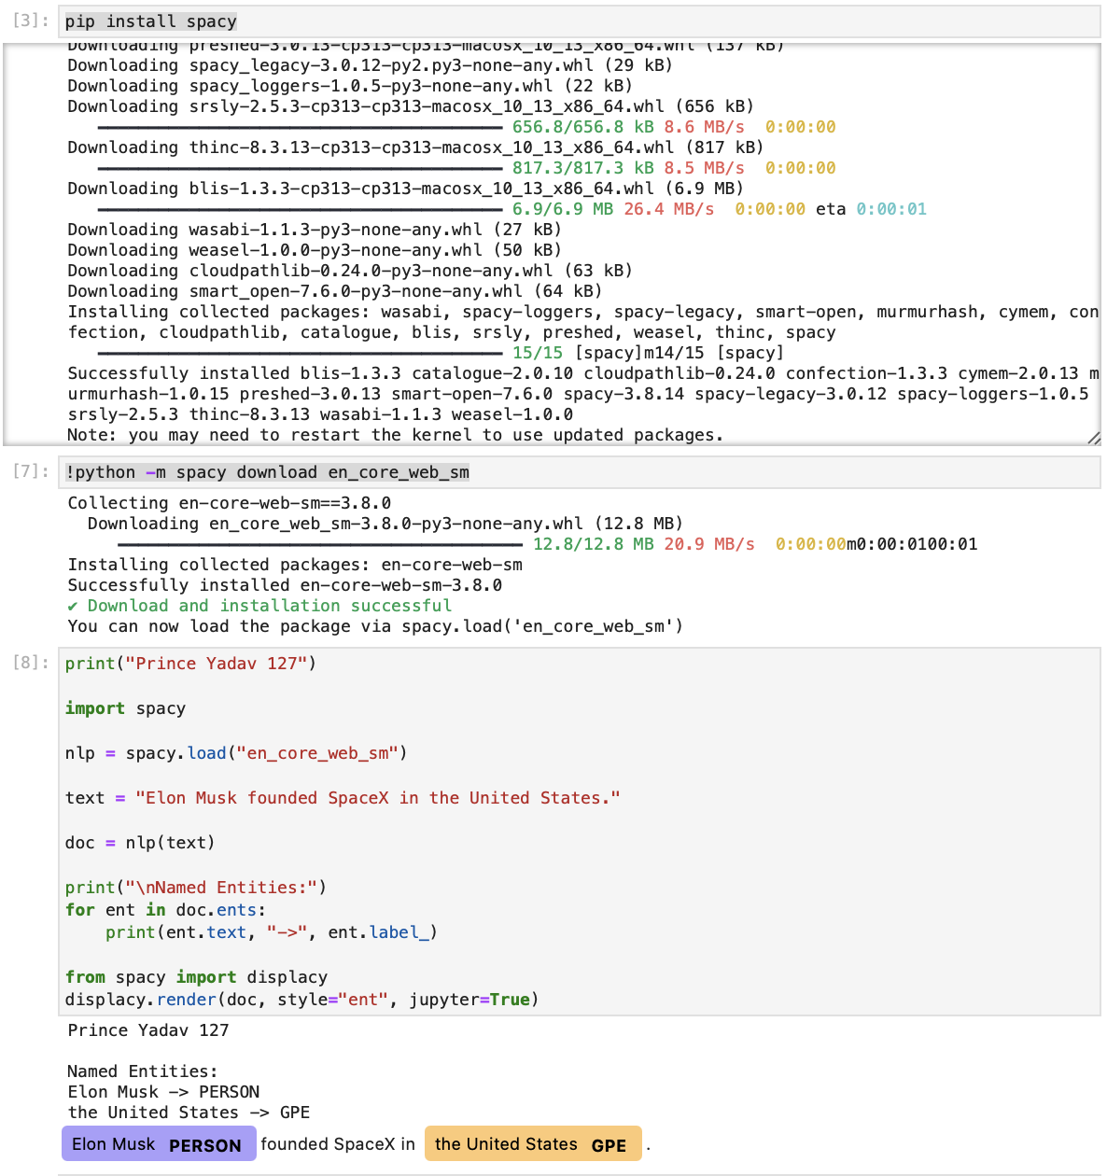

Practical No. 10

Aim: Write a program to create different text representations

- Write a program to create a bag of words (BoW) representations.

print("Prince 127")
import nltk
import numpy as np
nltk.download('punkt')
# Single sentence
text = "Prince is learning natural language processing"
# Tokenize
tokens = nltk.word_tokenize(text.lower())
# Vocabulary
vocabulary = sorted(set(tokens))
print("\nVocabulary:", vocabulary)
# BoW representation
bow_vector = [tokens.count(word) for word in vocabulary]
print("\nBoW vector:")
print(np.array(bow_vector))

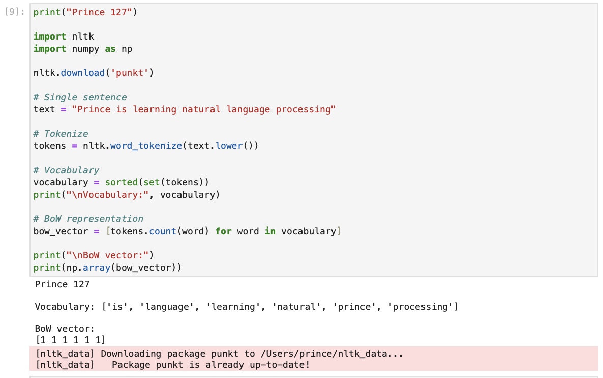

- Write a program to create tf_idf text representations
print("Prince 127")
import nltk
import numpy as np
from math import log
# Download tokenizer (run once)
nltk.download('punkt')
# Sample texts
texts = [
"The frog hopped quickly away from the bog",
"The goat stood proudly on the wooden boat"
]
# Tokenization
tokenized_texts = [nltk.word_tokenize(text.lower()) for text in texts]
# Vocabulary (sorted for consistent order)
vocabulary = sorted(set(word for text in tokenized_texts for word in text))
print("\nVocabulary:", vocabulary)
# Term Frequency (TF)
def get_tf(tokens, vocabulary):
return [tokens.count(word) for word in vocabulary]
# Inverse Document Frequency (IDF)
def get_idf(vocabulary, docs):
num_docs = len(docs)
idf_vector = []
for word in vocabulary:
num_docs_with_word = sum(1 for doc in docs if word in doc)
idf_value = log(num_docs / (1 + num_docs_with_word)) + 1
idf_vector.append(idf_value)
return idf_vector
# TF-IDF
def get_tfidf(tokens, vocabulary, idf_vector):
tf_vector = get_tf(tokens, vocabulary)
return [tf * idf for tf, idf in zip(tf_vector, idf_vector)]
# Calculate IDF
idf_vector = get_idf(vocabulary, tokenized_texts)
print("\nIDF vector:")
print(idf_vector)
# Calculate TF-IDF
tfidf_vectors = [get_tfidf(text, vocabulary, idf_vector) for text in tokenized_texts]
print("\nTF-IDF vectors:")
print(np.array(tfidf_vectors))

Output
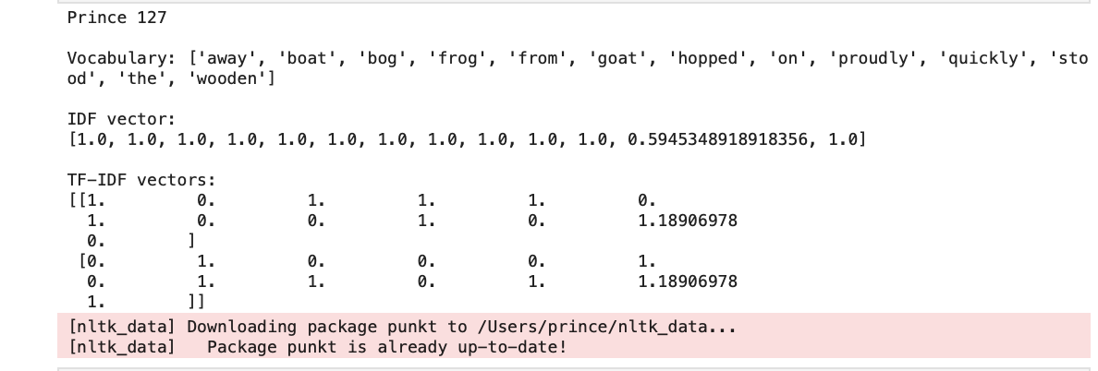

Practical - 11

Aim: Write a program to Compare Bow vector with TF-IDF vector using Cosine similarity

print("Prince 127")

import nltk
import numpy as np
from math import log
from sklearn.metrics.pairwise import cosine_similarity

# Download tokenizer
nltk.download('punkt')

# Use LIST (not set)
texts = [
"The cat sat on the mat",
"The dog sat on the log"
]

# Tokenization
tokenized_texts = [nltk.word_tokenize(text.lower()) for text in texts]

# Sorted vocabulary (important for correct vector alignment)
vocabulary = sorted(set(word for text in tokenized_texts for word in text))
print("\nVocabulary:", vocabulary)

# BoW
def get_bow(tokens, vocabulary):
return [tokens.count(word) for word in vocabulary]

bow_vectors = [get_bow(text, vocabulary) for text in tokenized_texts]

# TF
def get_tf(tokens, vocabulary):
return [tokens.count(word) for word in vocabulary]

# IDF
def get_idf(vocabulary, docs):
num_docs = len(docs)
idf_vector = []
for word in vocabulary:
num_docs_with_word = sum(1 for doc in docs if word in doc)
idf_value = log(num_docs / (1 + num_docs_with_word)) + 1
idf_vector.append(idf_value)
return idf_vector

idf_vector = get_idf(vocabulary, tokenized_texts)

# TF-IDF
def get_tfidf(tokens, vocabulary, idf_vector):
tf_vector = get_tf(tokens, vocabulary)
return [tf * idf for tf, idf in zip(tf_vector, idf_vector)]

tfidf_vectors = [get_tfidf(text, vocabulary, idf_vector) for text in tokenized_texts]

# Convert to arrays
bow_vectors = np.array(bow_vectors)
tfidf_vectors = np.array(tfidf_vectors)

# Correct similarity comparisons
sim_bow = cosine_similarity([bow_vectors[0]], [bow_vectors[1]])[0][0]
sim_tfidf = cosine_similarity([tfidf_vectors[0]], [tfidf_vectors[1]])[0][0]

print("\nCosine Similarity (BoW doc1 vs doc2):", sim_bow)
print("Cosine Similarity (TF-IDF doc1 vs doc2):", sim_tfidf)

Output:

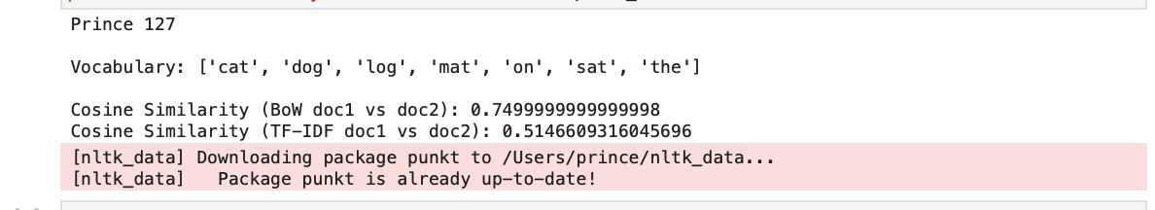

Practical – 12

Aim: Write a program for Training and using word embeddings
a. Word2Vec
!pip install gensim
from gensim.models import Word2Vec
from nltk.tokenize import word_tokenize
import nltk

# Download tokenizer
nltk.download('punkt')

# Train Word2Vec model
def train_word_embeddings(sentences):
tokenized_sentences = [word_tokenize(sentence.lower()) for sentence in sentences]
model = Word2Vec(
sentences=tokenized_sentences,
vector_size=100,
window=5,
min_count=1,
workers=4
)
return model

# Use model to find similar words
def use_word_embeddings(model, word, top_n=5):
print("Prince 127")
try:
similar_words = model.wv.most_similar(word, topn=top_n)
print(f"\nWords most similar to '{word}':")
for w, score in similar_words:
print(f"{w} : {score:.4f}")
except KeyError:
print(f"'{word}' not in vocabulary")

# Sample sentences
sentences = [
"The sun shines brightly in the morning sky",
"A cat is a graceful and curious fox",
"The birds sing loudly at dawn",
"Cats and birds have very different behaviors"
]
# Train model
model = train_word_embeddings(sentences)

# Test word similarity
use_word_embeddings(model, "fox")

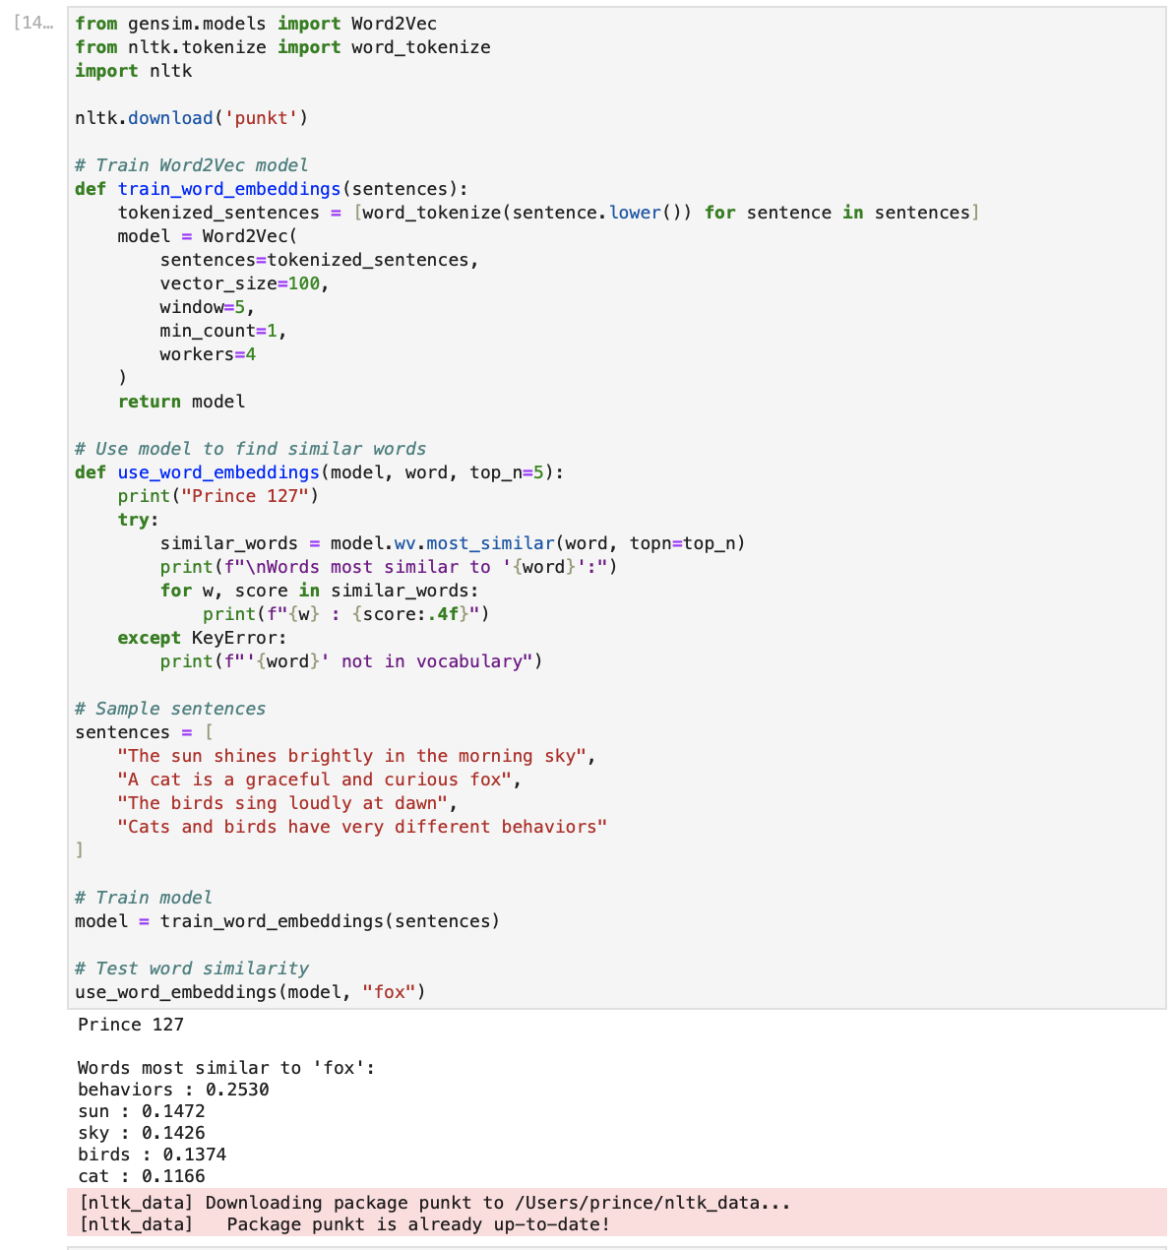

b. GloVe

import re
import nltk
import numpy as np
from collections import Counter
from scipy.sparse import coo_matrix
from sklearn.metrics.pairwise import cosine_similarity
nltk.download('punkt')
text_corpus = [
"Machine learning helps computers learn from data.",
"Natural language processing enables computers to understand text.",
"Deep learning models perform well on complex tasks."
]
def preprocess(text):
text = text.lower()
text = re.sub(r'[^a-z\s]', '', text)
return nltk.word_tokenize(text)
# Tokenization
tokenized = [preprocess(sentence) for sentence in text_corpus]
# Vocabulary creation
word_counts = Counter(word for sent in tokenized for word in sent)
vocab = list(word_counts.keys())
word_to_id = {w: i for i, w in enumerate(vocab)}
id_to_word = {i: w for w, i in word_to_id.items()}
WINDOW_SIZE = 2
co_occurrence = Counter()
# Co-occurrence matrix creation
for sentence in tokenized:
for i, word in enumerate(sentence):
for j in range(max(0, i - WINDOW_SIZE), min(len(sentence), i + WINDOW_SIZE + 1)):
if i != j:
co_occurrence[(word_to_id[word], word_to_id[sentence[j]])] += 1
rows, cols, data = zip(*[(i, j, v) for (i, j), v in co_occurrence.items()])
X = coo_matrix((data, (rows, cols)), shape=(len(vocab), len(vocab)))
X_dense = X.toarray()
vocab_size = len(vocab)
print("Prince127")
print("Vocabulary:", vocab)
print("Co-occurrence matrix:\n", X_dense)

# GloVe Parameters
EMBEDDING_DIM = 10
EPOCHS = 50
LR = 0.05
X_MAX = 100
ALPHA = 0.75
# Initialize weights
W = np.random.randn(vocab_size, EMBEDDING_DIM) * 0.01
W_tilde = np.random.randn(vocab_size, EMBEDDING_DIM) * 0.01
b = np.zeros(vocab_size)
b_tilde = np.zeros(vocab_size)
def weight(x):
return (x / X_MAX) ** ALPHA if x < X_MAX else 1
# Training loop
for epoch in range(EPOCHS):
loss = 0
for i in range(vocab_size):
for j in range(vocab_size):
X_ij = X_dense[i, j]
if X_ij == 0:
continue
w_ij = weight(X_ij)
log_x = np.log(X_ij)

pred = np.dot(W[i], W_tilde[j]) + b[i] + b_tilde[j]
diff = pred - log_x

loss += w_ij * diff**2
grad = w_ij * diff

W[i] -= LR * grad * W_tilde[j]
W_tilde[j] -= LR * grad * W[i]
b[i] -= LR * grad
b_tilde[j] -= LR * grad

if epoch % 20 == 0:
print(f"Epoch {epoch}, Loss: {loss:.4f}")

# Final embeddings
word_vectors = W + W_tilde
word_embeddings = {id_to_word[i]: word_vectors[i] for i in range(vocab_size)}

# Similarity function
def find_similar(word, top_n=5):
if word not in word_embeddings:
return "Word not found"

vec = word_embeddings[word].reshape(1, -1)

sims = {
w: cosine_similarity(vec, word_embeddings[w].reshape(1, -1))[0][0]
for w in word_embeddings if w != word
}

return sorted(sims.items(), key=lambda x: x[1], reverse=True)[:top_n]

# Results
print("\nSimilar words to 'learning':")
print(find_similar("learning"))

print("\nSimilar words to 'models':")
print(find_similar("models"))

Output:
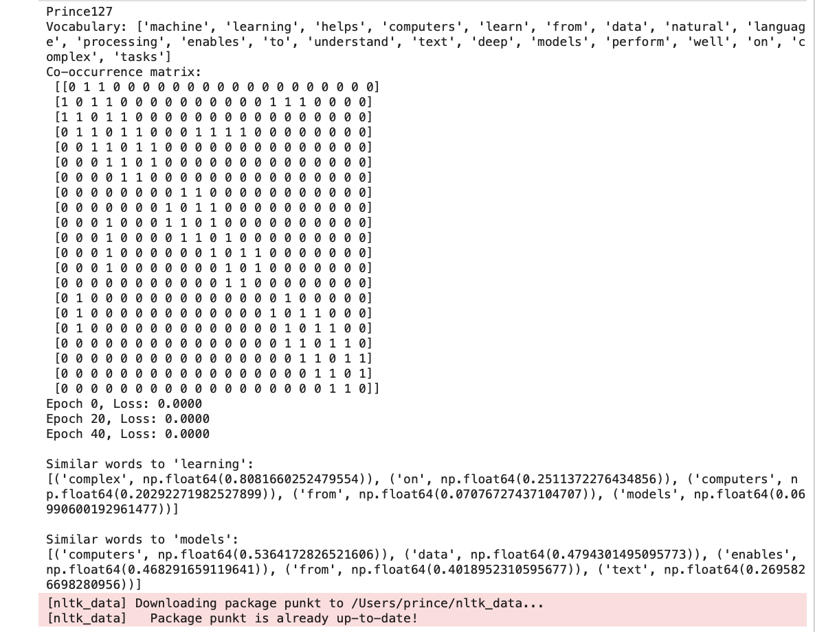

Practical – 13

Aim: Write a program to implement a text classifier using NaiveBayes with Scikit-learn

from sklearn.feature_extraction.text import CountVectorizer
from sklearn.naive_bayes import MultinomialNB
from sklearn.model_selection import train_test_split
from sklearn.metrics import classification_report

def train_text_classifier(X, y):
# Split the data
X_train, X_test, y_train, y_test = train_test_split(
X, y, test_size=0.2, random_state=42
)

# Create CountVectorizer
vectorizer = CountVectorizer()
X_train_vectorized = vectorizer.fit_transform(X_train)
X_test_vectorized = vectorizer.transform(X_test)

# Train Naive Bayes model
classifier = MultinomialNB()
classifier.fit(X_train_vectorized, y_train)

# Predictions
y_pred = classifier.predict(X_test_vectorized)

# Evaluation
print("\nClassification Report:\n")
print(classification_report(y_test, y_pred))

return vectorizer, classifier

def classify_text(text, vectorizer, classifier):
text_vectorized = vectorizer.transform([text])
prediction = classifier.predict(text_vectorized)
return prediction[0]

print("Prince127")

X = [
"The movie was amazing with brilliant acting.",
"I did not like the film, it was boring.",
"What a fantastic storyline and great direction!",
"Terrible movie, waste of time.",
"Absolutely loved the cinematography and music.",
"The plot was weak and very predictable.",
"An outstanding performance by the lead actor.",
"I wouldn't recommend this movie to anyone."
]

y = [
"positive", "negative", "positive", "negative",
"positive", "negative", "positive", "negative"
]

# Train model
vectorizer, classifier = train_text_classifier(X, y)

# Test with new input
new_text = "The movie had a wonderful story and great acting."
prediction = classify_text(new_text, vectorizer, classifier)

print(f"\nPrediction for '{new_text}': {prediction}")

Output

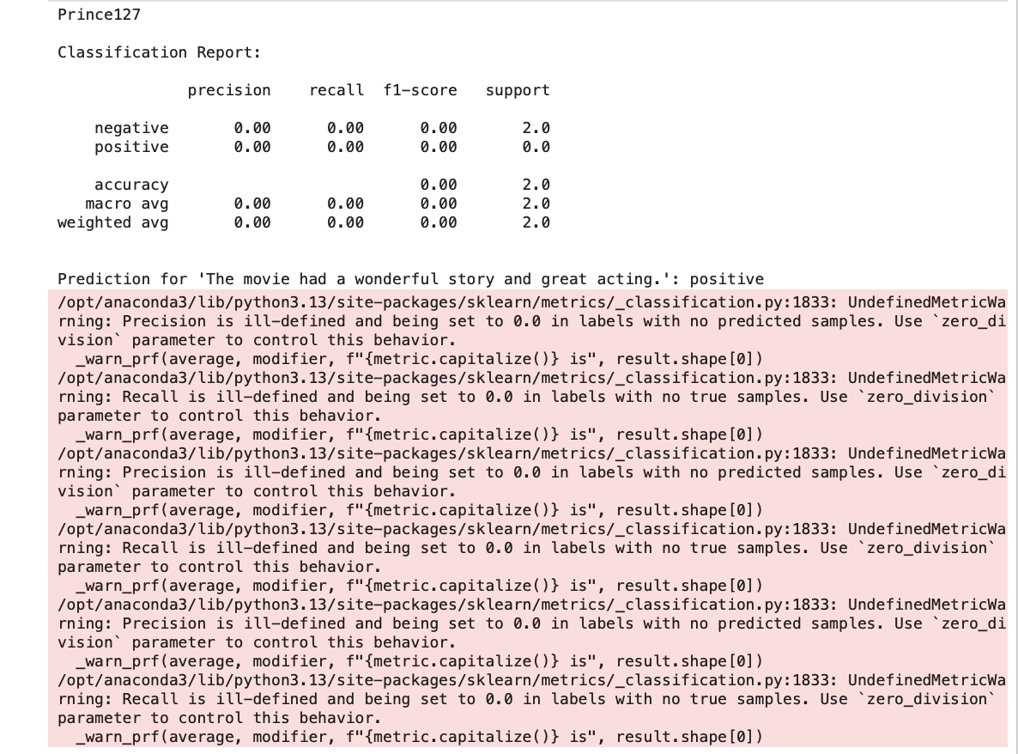

Practical – 14

Aim: Write a program to build a Sentiment Analysis System.
import nltk
from nltk.sentiment import SentimentIntensityAnalyzer
import pandas as pd
nltk.download('vader_lexicon')
def analyze_sentiment(text):
sia = SentimentIntensityAnalyzer()
sentiment_scores = sia.polarity_scores(text)
if sentiment_scores['compound'] >= 0.1:
sentiment = "Positive"
elif sentiment_scores['compound'] <= -0.1:
sentiment = "Negative"
else:
sentiment = "Neutral"
return sentiment, sentiment_scores

def analyze_sentiments(texts):
results = []
for text in texts:
sentiment, scores = analyze_sentiment(text)
results.append({
'text': text,
'sentiment': sentiment,
'pos_score': scores['pos'],
'neg_score': scores['neg'],
'neu_score': scores['neu'],
'compound_score': scores['compound']
})
return pd.DataFrame(results)

print("Prince127")

texts = [
"I love attending college lectures, they are really inspiring.",
"Today's class was so boring, I almost fell asleep.",
"The exam was okay, not too easy but manageable.",
"I'm really excited about the upcoming college fest!",
"The assignment deadline is stressing me out.",
"Group study sessions are helpful and fun.",
"I didn't understand today's lecture at all.",
"The campus environment is beautiful.",
"Nothing special happened today, just a normal day.",
"I am very happy with my results this semester!"
]

# Analyze sentiments
results_df = analyze_sentiments(texts)

# Display results
print("\nSentiment Analysis Results:\n")
print(results_df)

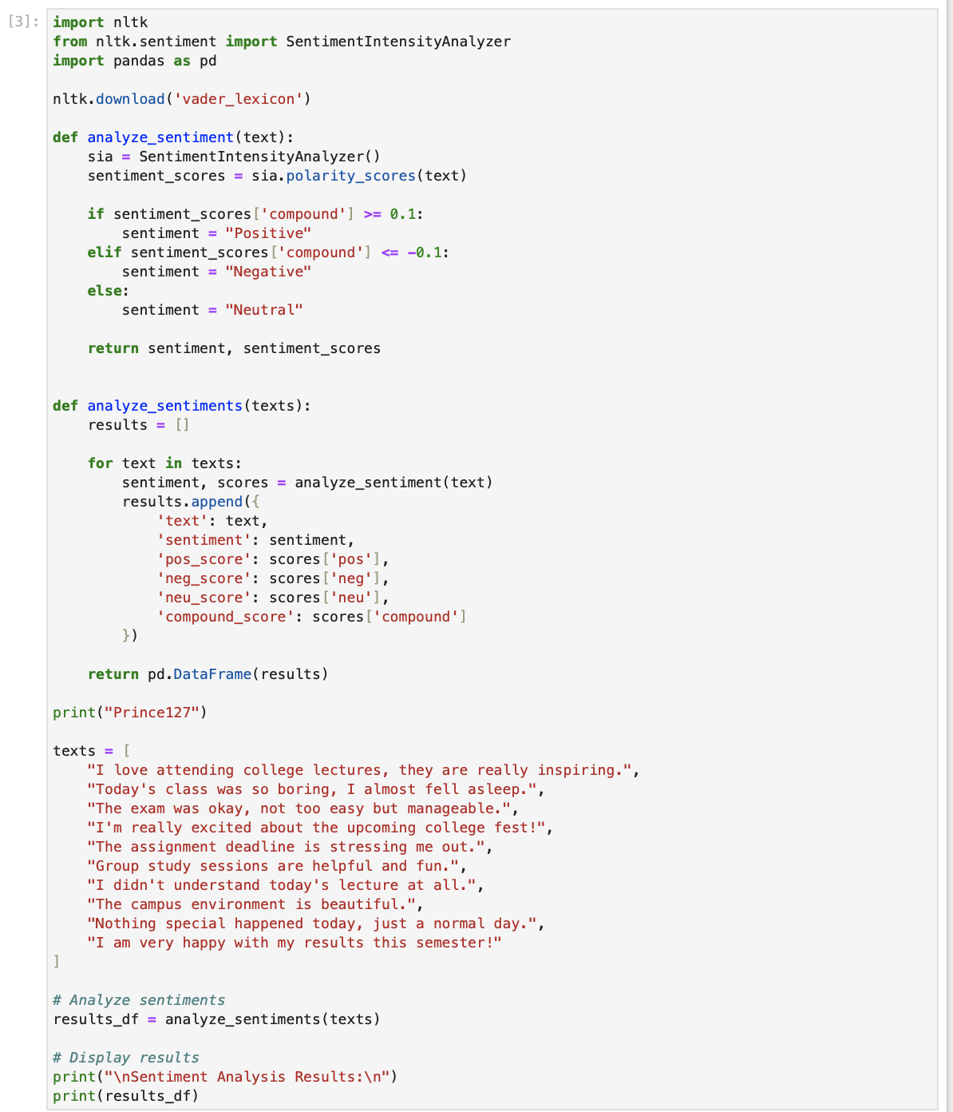
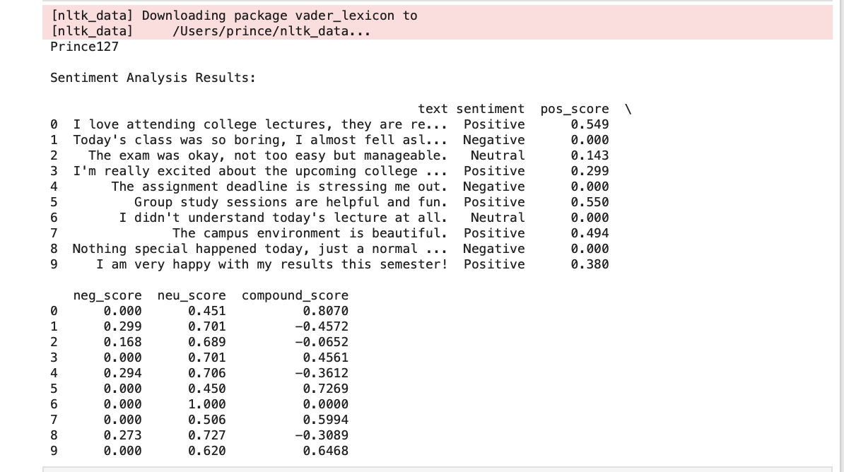

Practical - 15

Aim: Write a program to create a text summarization tool
Abstractive Summarization:
print("PRINCE YADAV 127")
from transformers import pipeline
# Load summarization model
summarizer = pipeline("summarization", model="sshleifer/distilbart-cnn-12-6")
# Sample text
text = """
Artificial Intelligence is transforming the modern world by enabling machines to learn and make decisions.
It is widely used in healthcare, education, finance, and transportation.
AI helps in automation, improves efficiency, and supports innovation.
However, it also raises concerns about job displacement and ethical issues.
"""
# Generate summary
summary = summarizer(text, max_length=80, min_length=30, do_sample=False)
# Print output
print("Summary:")
print(summary[0]['summary_text'])

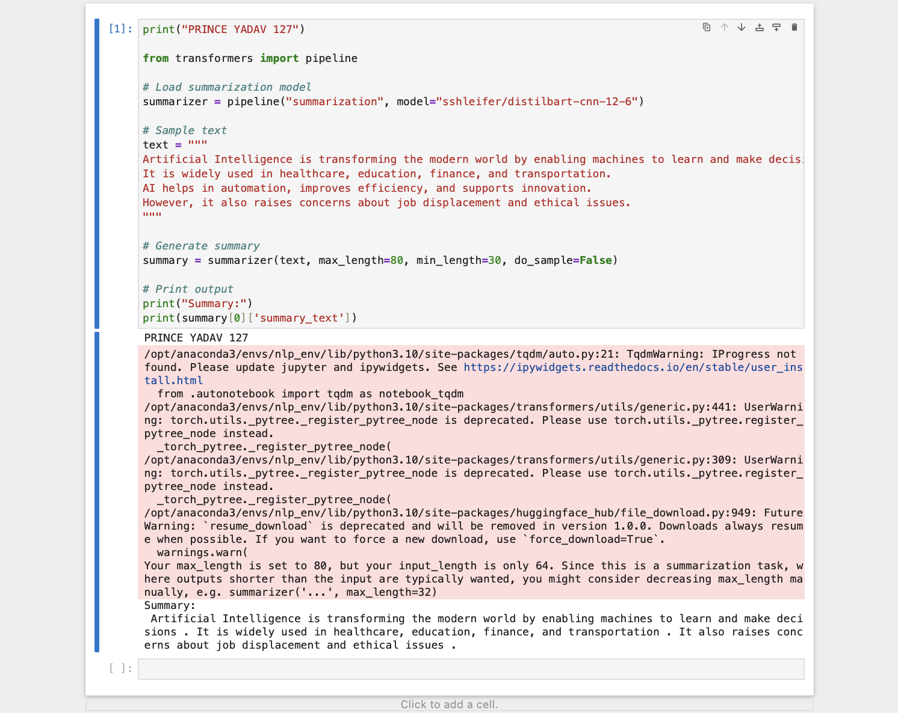

Extractive Summarization
print("PRINCE127")
from sumy.parsers.plaintext import PlaintextParser
from sumy.nlp.tokenizers import Tokenizer
from sumy.summarizers.lex_rank import LexRankSummarizer
text = """
Artificial Intelligence is transforming the modern world through automation and smart systems.
It is widely used in healthcare, education, finance, and transportation.
Machine learning and deep learning are key components of AI.
These technologies help in data analysis, prediction, and decision-making.
AI is expected to grow rapidly and impact future innovations significantly.
"""
parser = PlaintextParser.from_string(text, Tokenizer("english"))
summarizer = LexRankSummarizer()

summary = summarizer(parser.document, sentences_count=2)
summary_text = " ".join([str(sentence) for sentence in summary])

print("Extractive Text Summarization")
print("\nOriginal text length:", len(text.split()), "words")
print("Summary length:", len(summary_text.split()), "words")
print("\nSummary:")
print(summary_text)

