Module 1: Introduction to ASP.NET
1. Create a simple web page to show ASP.NET page Life cycle.
WebForm1.aspx
<%@ Page Language="C#" AutoEventWireup="true" CodeBehind="WebForm1.aspx.cs"
Inherits="Prince127.WebForm1" %>
<!DOCTYPE html>
<html>
<body>
<form runat="server">
<asp:Button ID="btnSubmit" runat="server" Text="Submit"
OnClick="btnSubmit_Click" /> <br /><br />
<asp:Label ID="lblOutput" runat="server"></asp:Label>
</form>
</body>
</html>

WebForm1.aspx.cs
using System;
using System.Web.UI;
namespace Prince127
{
public partial class WebForm1 : Page
{
protected void Page_PreInit(object sender, EventArgs e)
{
lblOutput.Text += "<br/>PreInit";
}
protected void Page_Init(object sender, EventArgs e)
{
lblOutput.Text += "<br/>Init";
}
protected void Page_InitComplete(object sender, EventArgs e)
{
lblOutput.Text += "<br/>InitComplete";
}
protected override void OnPreLoad(EventArgs e)
{
base.OnPreLoad(e);
lblOutput.Text += "<br/>PreLoad";
}
protected void Page_Load(object sender, EventArgs e)
{
lblOutput.Text += "<br/>Load";
}

protected void btnSubmit_Click(object sender, EventArgs e)
{
lblOutput.Text += "<br/>Button Click";
}
protected void Page_LoadComplete(object sender, EventArgs e)
{
lblOutput.Text += "<br/>LoadComplete";
}
protected override void OnPreRender(EventArgs e)
{
base.OnPreRender(e);
lblOutput.Text += "<br/>PreRender";
}
protected override void OnSaveStateComplete(EventArgs e)
{
base.OnSaveStateComplete(e);
lblOutput.Text += "<br/>SaveStateComplete";
}
}
}

Output:
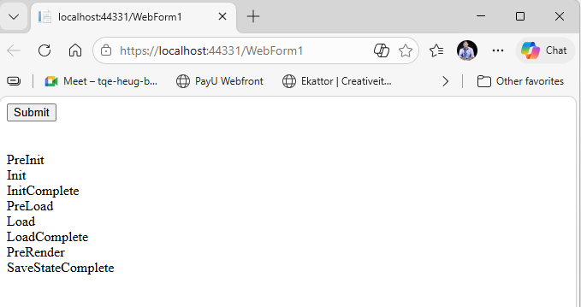

2. Design a web form to accept user input (e.g., name, email, and feedback) and display it after submission.
WebForm2.aspx
<%@ Page Language="C#" AutoEventWireup="true" CodeBehind="WebForm2.aspx.cs"
Inherits="Prince127.WebForm2" %>
<!DOCTYPE html>
<html>
<body>
<form id="form1" runat="server">
<h2>User Registration Form</h2>
Name: <asp:TextBox ID="txtName" runat="server"></asp:TextBox><br /><br />
Email: <asp:TextBox ID="txtEmail" runat="server"></asp:TextBox><br /><br />
Password: <asp:TextBox ID="txtPassword" runat="server"
TextMode="Password"></asp:TextBox><br /><br />
Confirm Password: <asp:TextBox ID="txtConfirmPassword" runat="server"
TextMode="Password"></asp:TextBox><br /><br />
Gender:
<asp:RadioButton ID="rbMale" runat="server" GroupName="gender" Text="Male" />
<asp:RadioButton ID="rbFemale" runat="server" GroupName="gender" Text="Female" />
<br /><br />
Select Course:
<asp:CheckBox ID="chkJava" runat="server" Text="Java" />
<asp:CheckBox ID="chkDotNet" runat="server" Text=".NET" />
<asp:CheckBox ID="chkAndroid" runat="server" Text="Android" />
<br /><br />
Feedback:
<asp:TextBox ID="txtFeedback" runat="server" TextMode="MultiLine"></asp:TextBox>
<br /><br />
<asp:Button ID="btnRegister" runat="server" Text="Register"
OnClick="btnRegister_Click" />
<br /><br />
<asp:Label ID="lblResult" runat="server"></asp:Label>
</form>
</body>
</html>

WebForm2.aspx.cs
using System;
using System.Xml.Linq;
namespace Prince127
{
public partial class WebForm2 : System.Web.UI.Page
{
protected void btnRegister_Click(object sender, EventArgs e)
{
string gender = "";
if (rbMale.Checked)
gender = "Male";
else if (rbFemale.Checked)
gender = "Female";
string courses = "";
if (chkJava.Checked)
courses += "Java ";
if (chkDotNet.Checked)
courses += ".NET ";
if (chkAndroid.Checked)
courses += "Android ";
lblResult.Text =
"<b>Name:</b> " + txtName.Text +
"<br/><b>Email:</b> " + txtEmail.Text +
"<br/><b>Gender:</b> " + gender +
"<br/><b>Courses:</b> " + courses +
"<br/><b>Feedback:</b> " + txtFeedback.Text;
}
}
}
Output:
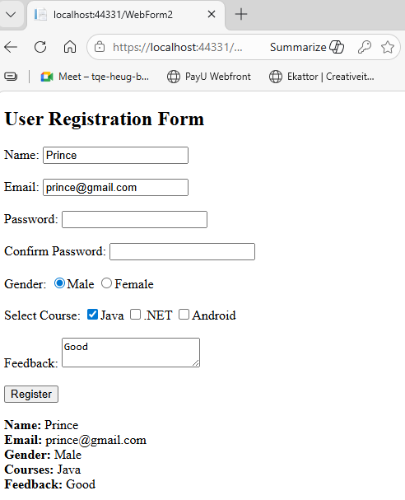
3. Implement a Cross Page Postback feature to pass data between two web pages.
WebForm3A.aspx
<%@ Page Language="C#" AutoEventWireup="true"CodeBehind="WebForm3A.aspx.cs" Inherits ="Prince127.WebForm3A" %>

<form runat="server">
Enter Name: <asp:TextBox ID="txtName" runat="server"></asp:TextBox>
<br /><br />
<asp:Button ID="btnSend"runat="server" Text="Send" PostBackUrl="~/WebForm3B.aspx"/>

</form>

WebForm3A.aspx.cs
using System;
namespace Prince127
{
public partial class WebForm3A : System.Web.UI.Page
{
}}

WebForm3B.aspx
<%@ Page Language="C#" AutoEventWireup="true" CodeBehind="WebForm3B.aspx.cs" Inherits="Prince127.WebForm3B" %>

<form runat="server">

<asp:Label ID="lblResult" runat="server"></asp:Label>
</form>

WebForm3B.aspx.cs
using System;
using System.Web.UI.WebControls;

namespace Prince127
{
public partial class WebForm3B : System.Web.UI.Page
{
protected void Page_Load(object sender, EventArgs e)
{
if (PreviousPage != null)
{
TextBox txt =
(TextBox)PreviousPage.FindControl("txtName");

lblResult.Text =
"Welcome " + txt.Text;
}
}
}
}

Output:
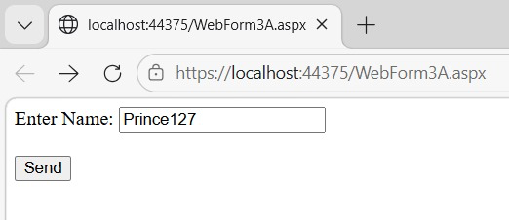

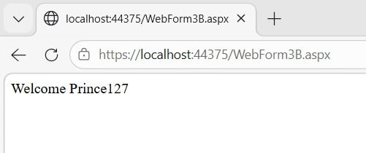

4. Develop a web application demonstrating AutoPostback using a dropdown list to select and display items.
WebForm4.aspx
<%@ Page Language="C#" AutoEventWireup="true" CodeBehind="WebForm4.aspx.cs" Inherits="Prince127.WebForm4" %>
<!DOCTYPE html>
<html>
<head runat="server">
<title>AutoPostBack Demo</title>
</head>
<body>
<form id="form1" runat="server">
<asp:Label runat="server" Text="Prince127"></asp:Label><br /><br />
Select Course:
<asp:DropDownList ID="ddlCourse" runat="server" AutoPostBack="true"
OnSelectedIndexChanged="ddlCourse_SelectedIndexChanged">
<asp:ListItem>Select</asp:ListItem>
<asp:ListItem>MCA</asp:ListItem>
<asp:ListItem>BCA</asp:ListItem>
<asp:ListItem>BScIT</asp:ListItem>
</asp:DropDownList><br /><br />
<asp:Label ID="lblResult" runat="server"></asp:Label>
</form>
</body>
</html>

WebForm4.aspx.cs
using System;
namespace Prince127
{
public partial class WebForm4 : System.Web.UI.Page
{
protected void ddlCourse_SelectedIndexChanged(object sender, EventArgs e)
{
lblResult.Text = "Selected Course: " + ddlCourse.SelectedItem.Text;
}
}
}

Output:
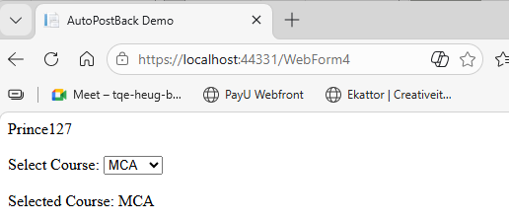

5. Create a simple calculator using server-side controls and operators in ASP.NET.
WebForm5.aspx
<%@ Page Language="C#" AutoEventWireup="true" CodeBehind="WebForm5.aspx.cs" Inherits="Prince127.WebForm5" %>
<!DOCTYPE html>
<html>
<head runat="server">
<title>Simple Calculator</title>
</head>
<body>
<form id="form1" runat="server">
Number 1:
<asp:TextBox ID="txtNum1" runat="server"></asp:TextBox><br /><br />
Number 2:
<asp:TextBox ID="txtNum2" runat="server"></asp:TextBox><br /><br />
<asp:Button ID="btnAdd" runat="server" Text="Add" OnClick="btnAdd_Click" />
<asp:Button ID="btnSub" runat="server" Text="Subtract" OnClick="btnSub_Click" />
<asp:Button ID="btnMul" runat="server" Text="Multiply" OnClick="btnMul_Click" />
<asp:Button ID="btnDiv" runat="server" Text="Divide" OnClick="btnDiv_Click" />
<br /><br />
<asp:Label ID="lblResult" runat="server" Font-Bold="true"></asp:Label>
</form>
</body>
</html>

WebForm5.aspx.cs
using System;
namespace Prince127
{
public partial class WebForm5 : System.Web.UI.Page
{
double a, b;
protected void btnAdd_Click(object sender, EventArgs e)
{
a = Convert.ToDouble(txtNum1.Text);
b = Convert.ToDouble(txtNum2.Text);
lblResult.Text = "Addition: " + (a + b).ToString();
}
protected void btnSub_Click(object sender, EventArgs e)
{
a = Convert.ToDouble(txtNum1.Text);
b = Convert.ToDouble(txtNum2.Text);
lblResult.Text = "Subtraction: " + (a - b).ToString();
}

protected void btnMul_Click(object sender, EventArgs e)
{
a = Convert.ToDouble(txtNum1.Text);
b = Convert.ToDouble(txtNum2.Text);

lblResult.Text = "Multiplication: " + (a * b).ToString();
}
protected void btnDiv_Click(object sender, EventArgs e)
{
a = Convert.ToDouble(txtNum1.Text);
b = Convert.ToDouble(txtNum2.Text);
lblResult.Text = "Division: " + (a / b).ToString();
}
}
}

Output:
