Module - 6

1. Create an simple asp.net core mvc application with models, views, and controllers to display book info.
Book.cs
namespace BookStoreApp.Models
{
public class Book
{
public int Id { get; set; } public string Title { get; set; }
public string Author { get; set; } public string Genre { get; set; } public int Year { get; set; }
}
}

BookController.cs:
using Microsoft.AspNetCore.Mvc; using BookStoreApp.Models; using System.Collections.Generic;
namespace BookStoreApp.Controllers
{
public class BooksController : Controller
{
public static List<Book> Books = new List<Book>
{
new Book
{
Id = 1,
Title = "The Alchemist",
Author = "Paulo Coelho",
Genre = "Fiction",
Year = 1988
},
new Book
{
Id = 2,
Title = "Pride and Prejudice",
Author = "Jane Austen",
Genre = "Romance",
Year = 1813
},
new Book
{
Id = 3,
Title = "The Great Gatsby",
Author = "F. Scott Fitzgerald",
Genre = "Classic",
Year = 1925
},
new Book
{
Id = 4,
Title = "The Hobbit",
Author = "J.R.R. Tolkien",
Genre = "Fantasy",
Year = 1937
}};

public IActionResult Index()
{
return View(Books);
}
public IActionResult Details(int id)
{
var book = Books.Find(b => b.Id == id);

if (book == null)
{
return NotFound();
}
return View(book);
}}}

index.cshtml:
@model List<BookStoreApp.Models.Book>
@{
ViewData["Title"] = "Books List";
}
<h1>@ViewData["Title"]</h1>
<table class="table">
<thead><tr>
<th>Title</th>
<th>Author</th>
<th>Genre</th>
<th>Year</th>
<th>Actions</th>
</tr></thead>
<tbody>
@foreach (var book in Model)
{
<tr>
<td>@book.Title</td>
<td>@book.Author</td>
<td>@book.Genre</td>
<td>@book.Year</td>
<td>
<a href="@Url.Action("Details", "Books", new { id = book.Id })" class="btn btn-info">
Details
</a>
</td>
</tr>
}
</tbody>
</table>
details.cshtml:
@model BookStoreApp.Models.Book
@{
ViewData["Title"] = "Book Details";
}
<h1>@ViewData["Title"]</h1>
<div>
<h3>@Model.Title</h3>
<p>
<strong>Author:</strong> @Model.Author</p>
<p>
<strong>Genre:</strong> @Model.Genre
</p>
<p>
<strong>Year:</strong> @Model.Year
</p>
<a href="@Url.Action("Index", "Books")" class="btn btn-primary"> Back to List</a>
</div>
OUTPUT:
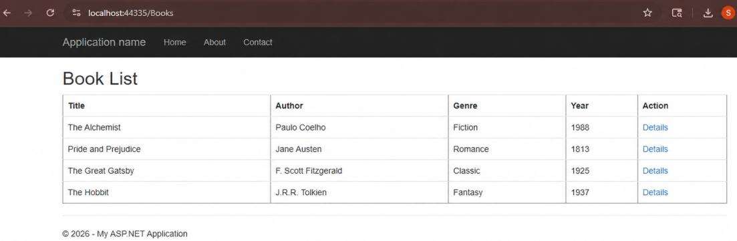

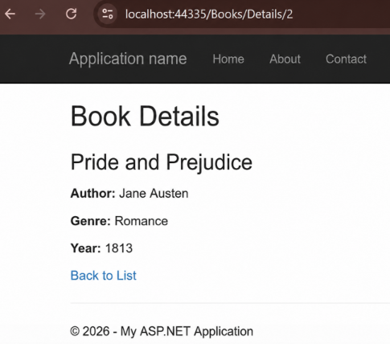
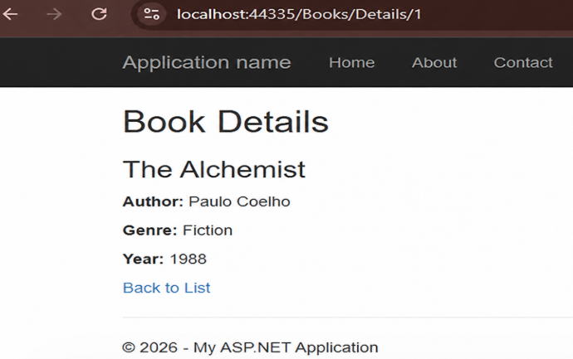

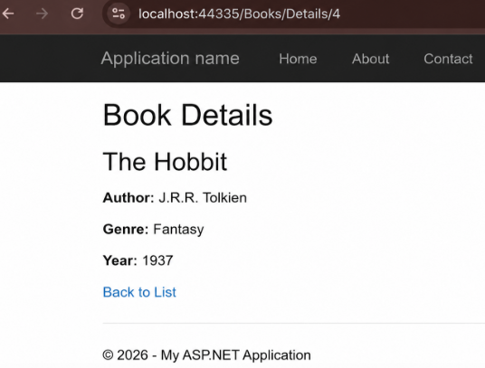
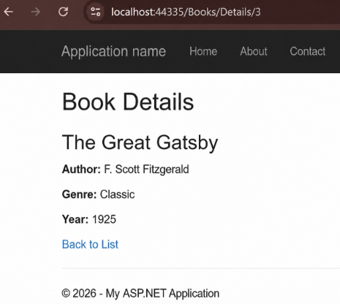

2. Design a form with data annotations for validation and display appropriate error messages.
UserViewModel.cs
using System.ComponentModel.DataAnnotations;
namespace MVC_BOOK_APP.Models
{
public class UserViewModel
{
[Required(ErrorMessage = "Name is required")]
[StringLength(50, ErrorMessage = "Name cannot be longer than 50 characters")]
public string Name { get; set; }

[Required(ErrorMessage = "Email is required")]
[EmailAddress(ErrorMessage = "Invalid email address")]
public string Email { get; set; }

[Range(18, 100, ErrorMessage = "Age must be between 18 and 100")]
public int? Age { get; set; }
}
}

UserController.cs
using System.Web.Mvc;
using MVC_BOOK_APP.Models;
namespace MVC_BOOK_APP.Controllers
{
public class UserController : Controller
{
// GET: User/Register
[HttpGet]
public ActionResult Register()
{
return View();
}
[HttpPost]
public ActionResult Register(UserViewModel model)
{
if (ModelState.IsValid)
{
return RedirectToAction("Success");
}
return View(model);
}
public ActionResult Success()
{
return View();
}
}
}

Register.cshtml
@model MVC_BOOK_APP.Models.UserViewModel
@{
ViewBag.Title = "User Registration";
}
<h2>User Registration</h2>
@using (Html.BeginForm("Register", "User", FormMethod.Post))
{
<div class="form-group">
@Html.LabelFor(m => m.Name)
@Html.TextBoxFor(m => m.Name,
new { @class = "form-control" })
@Html.ValidationMessageFor(m => m.Name,
"",
new { @class = "text-danger" })
</div>
<br />
<div class="form-group">
@Html.LabelFor(m => m.Email)
@Html.TextBoxFor(m => m.Email,
new { @class = "form-control" })
@Html.ValidationMessageFor(m => m.Email,
"",
new { @class = "text-danger" })
</div>
<br />
<div class="form-group">
@Html.LabelFor(m => m.Age)
@Html.TextBoxFor(m => m.Age,
new { @class = "form-control" })
@Html.ValidationMessageFor(m => m.Age,
"",
new { @class = "text-danger" })
</div>
<br />
<button type="submit" class="btn btn-primary">
Register
</button>
}
@section Scripts{
@Scripts.Render("~/bundles/jqueryval")
}

Success.cshtml
@{
ViewBag.Title = "Success";
}

<h2>Registration Successful!</h2>

Output:

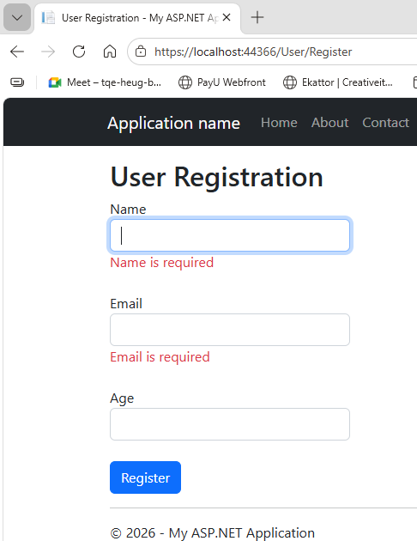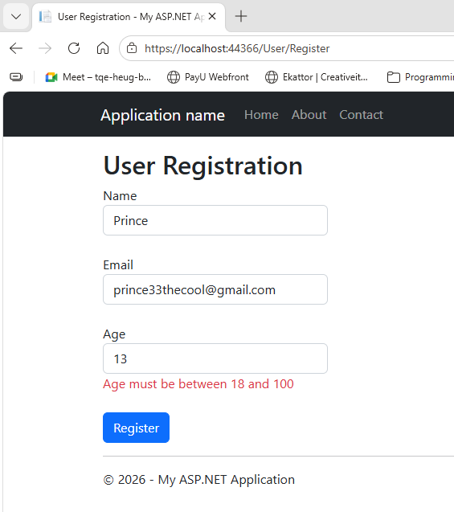

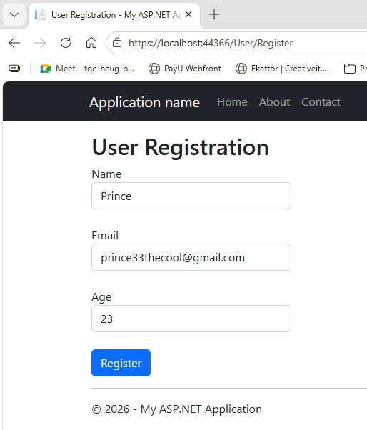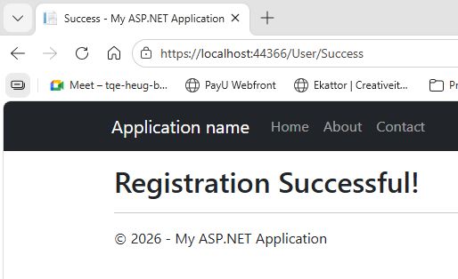

3. Implement CRUD operations using entity framework code- first approach for emp data.

Model Class - Employee.cs

using System.ComponentModel.DataAnnotations;
namespace EmployeeCRUD.Models
{
public class Employee
{
public int Id { get; set; }

[Required]
public string Name { get; set; }

[Required]
public string Department { get; set; }

public decimal Salary { get; set; }
}
}

AppDbContext.cs
using Microsoft.EntityFrameworkCore;
namespace EmployeeCRUD.Models
{
public class AppDbContext : DbContext
{
public AppDbContext(DbContextOptions<AppDbContext> options)
: base(options)
{
}
public DbSet<Employee> Employees { get; set; }
}
}

appsettings.json

{
"ConnectionStrings": {
"DefaultConnection": "server=localhost;port=3306;database=employeedb;user=root;password=;"
},

"Logging": {
"LogLevel": {
"Default": "Information",
"Microsoft.AspNetCore": "Warning"
}
},

"AllowedHosts": "*"
}

Program.cs
using EmployeeCRUD.Models;
using Microsoft.EntityFrameworkCore;
var builder = WebApplication.CreateBuilder(args);
builder.Services.AddControllersWithViews();

builder.Services.AddDbContext<AppDbContext>(options =>
options.UseMySql(
builder.Configuration.GetConnectionString("DefaultConnection"),
ServerVersion.AutoDetect(
builder.Configuration.GetConnectionString("DefaultConnection")
)
)
);
var app = builder.Build();
app.UseStaticFiles();
app.UseRouting();
app.MapControllerRoute(
name: "default",
pattern: "{controller=Employees}/{action=Index}/{id?}"
);
app.Run();

EmployeesController.cs

using Microsoft.AspNetCore.Mvc;
using Microsoft.EntityFrameworkCore;
using EmployeeCRUD.Models;
namespace EmployeeCRUD.Controllers
{
public class EmployeesController : Controller
{
private readonly AppDbContext _context;

public EmployeesController(AppDbContext context)
{
_context = context;
}
public async Task<IActionResult> Index()
{
return View(await _context.Employees.ToListAsync());
}
public async Task<IActionResult> Details(int? id)
{
if (id == null)
{
return NotFound();
}
var employee = await _context.Employees
.FirstOrDefaultAsync(m => m.Id == id);

if (employee == null)
{
return NotFound();
}
return View(employee);
}
public IActionResult Create()
{
return View();
}
[HttpPost]
[ValidateAntiForgeryToken]
public async Task<IActionResult> Create(Employee employee)
{
if (ModelState.IsValid)
{
_context.Add(employee);
await _context.SaveChangesAsync();
return RedirectToAction(nameof(Index));
}
return View(employee);
}
public async Task<IActionResult> Edit(int? id)
{
if (id == null)
{
return NotFound();
}
var employee = await _context.Employees.FindAsync(id);
if (employee == null)
{
return NotFound();
}
return View(employee);
}
[HttpPost]
[ValidateAntiForgeryToken]
public async Task<IActionResult> Edit(int id, Employee employee)
{
if (id != employee.Id)
{
return NotFound();
}
if (ModelState.IsValid)
{
_context.Update(employee);
await _context.SaveChangesAsync();

return RedirectToAction(nameof(Index));
}
return View(employee);
}
public async Task<IActionResult> Delete(int? id)
{
if (id == null)
{
return NotFound();
}
var employee = await _context.Employees
.FirstOrDefaultAsync(m => m.Id == id);
if (employee == null)
{
return NotFound();
}
return View(employee);
}
[HttpPost, ActionName("Delete")]
[ValidateAntiForgeryToken]
public async Task<IActionResult> DeleteConfirmed(int id)
{
var employee = await _context.Employees.FindAsync(id);
_context.Employees.Remove(employee);
await _context.SaveChangesAsync();
return RedirectToAction(nameof(Index));
}
}
}

Create Migration
Package Manager Console:
Install-Package Microsoft.EntityFrameworkCore -Version 8.0.23
Install-Package Microsoft.EntityFrameworkCore.Tools -Version 8.0.23
Install-Package Pomelo.EntityFrameworkCore.MySql -Version 8.0.3
Add-Migration InitialCreate
Update-Database

Create.cshtml

@model EmployeeCRUD.Models.Employee
@{
ViewData["Title"] = "Create";
}
<h1>Create</h1>
<h4>Employee</h4>
<hr />
<div class="row">
<div class="col-md-4">
<form asp-action="Create">
<div asp-validation-summary="ModelOnly" class="text-danger"></div>
<div class="form-group">
<label asp-for="Name" class="control-label"></label>
<input asp-for="Name" class="form-control" />
<span asp-validation-for="Name" class="text-danger"></span>
</div>
<div class="form-group">
<label asp-for="Department" class="control-label"></label>
<input asp-for="Department" class="form-control" />
<span asp-validation-for="Department" class="text-danger"></span>
</div>
<div class="form-group">
<label asp-for="Salary" class="control-label"></label>
<input asp-for="Salary" class="form-control" />
<span asp-validation-for="Salary" class="text-danger"></span>
</div>
<div class="form-group">
<input type="submit" value="Create" class="btn btn-primary" />
</div>
</form>
</div>
</div>
<div>
<a asp-action="Index">Back to List</a>
</div>

@section Scripts {
@{await Html.RenderPartialAsync("_ValidationScriptsPartial");}
}

Delete.cshtml

@model EmployeeCRUD.Models.Employee
@{
ViewData["Title"] = "Delete";
}
<h1>Delete</h1>
<h3>Are you sure you want to delete this?</h3>
<div>
<h4>Employee</h4>
<hr />
<dl class="row">
<dt class = "col-sm-2">
@Html.DisplayNameFor(model => model.Name)
</dt>
<dd class = "col-sm-10">
@Html.DisplayFor(model => model.Name)
</dd>
<dt class = "col-sm-2">
@Html.DisplayNameFor(model => model.Department)
</dt>
<dd class = "col-sm-10">
@Html.DisplayFor(model => model.Department)
</dd>
<dt class = "col-sm-2">
@Html.DisplayNameFor(model => model.Salary)
</dt>
<dd class = "col-sm-10">
@Html.DisplayFor(model => model.Salary)
</dd>
</dl>
<form asp-action="Delete">
<input type="hidden" asp-for="Id" />
<input type="submit" value="Delete" class="btn btn-danger" /> |
<a asp-action="Index">Back to List</a>
</form>
</div>
Details.cshtml
@model EmployeeCRUD.Models.Employee
@{
ViewData["Title"] = "Details";
}
<h1>Details</h1>
<div>
<h4>Employee</h4>
<hr />
<dl class="row">
<dt class = "col-sm-2">
@Html.DisplayNameFor(model => model.Name)
</dt>
<dd class = "col-sm-10">
@Html.DisplayFor(model => model.Name)
</dd>
<dt class = "col-sm-2">
@Html.DisplayNameFor(model => model.Department)
</dt>
<dd class = "col-sm-10">
@Html.DisplayFor(model => model.Department)
</dd>
<dt class = "col-sm-2">
@Html.DisplayNameFor(model => model.Salary)
</dt>
<dd class = "col-sm-10">
@Html.DisplayFor(model => model.Salary)
</dd>
</dl>
</div>
<div>
<a asp-action="Edit" asp-route-id="@Model?.Id">Edit</a> |
<a asp-action="Index">Back to List</a>
</div>

Edit.cshtml

@model EmployeeCRUD.Models.Employee
@{
ViewData["Title"] = "Edit";
}
<h1>Edit</h1>
<h4>Employee</h4>
<hr />
<div class="row">
<div class="col-md-4">
<form asp-action="Edit">
<div asp-validation-summary="ModelOnly" class="text-danger"></div>
<input type="hidden" asp-for="Id" />
<div class="form-group">
<label asp-for="Name" class="control-label"></label>
<input asp-for="Name" class="form-control" />
<span asp-validation-for="Name" class="text-danger"></span>
</div>
<div class="form-group">
<label asp-for="Department" class="control-label"></label>
<input asp-for="Department" class="form-control" />
<span asp-validation-for="Department" class="text-danger"></span>
</div>
<div class="form-group">
<label asp-for="Salary" class="control-label"></label>
<input asp-for="Salary" class="form-control" />
<span asp-validation-for="Salary" class="text-danger"></span>
</div>
<div class="form-group">
<input type="submit" value="Save" class="btn btn-primary" />
</div>
</form>
</div>
</div>
<div>
<a asp-action="Index">Back to List</a>
</div>
@section Scripts {
@{await Html.RenderPartialAsync("_ValidationScriptsPartial");}
}

Index.cshtml
@model IEnumerable<EmployeeCRUD.Models.Employee>
@{
ViewData["Title"] = "Index";
}
<h1>Index</h1>
<p>
<a asp-action="Create">Create New</a>
</p>
<table class="table">
<thead>
<tr>
<th>
@Html.DisplayNameFor(model => model.Name)
</th>
<th>
@Html.DisplayNameFor(model => model.Department)
</th>
<th>
@Html.DisplayNameFor(model => model.Salary)
</th>
<th></th>
</tr>
</thead>
<tbody>
@foreach (var item in Model) {
<tr>
<td>
@Html.DisplayFor(modelItem => item.Name)
</td>
<td>
@Html.DisplayFor(modelItem => item.Department)
</td>
<td>
@Html.DisplayFor(modelItem => item.Salary)
</td>
<td>
<a asp-action="Edit" asp-route-id="@item.Id">Edit</a> |
<a asp-action="Details" asp-route-id="@item.Id">Details</a> |
<a asp-action="Delete" asp-route-id="@item.Id">Delete</a>
</td>
</tr>
}
</tbody>
</table>

Output:
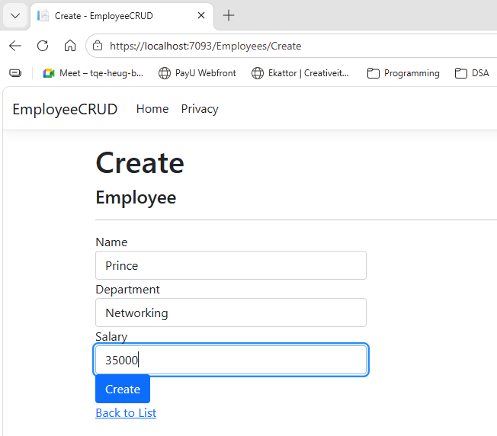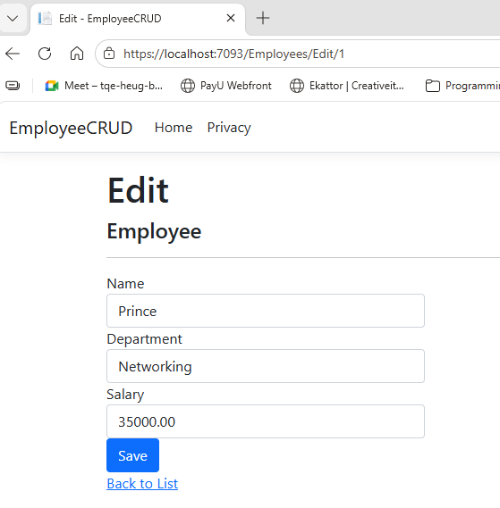

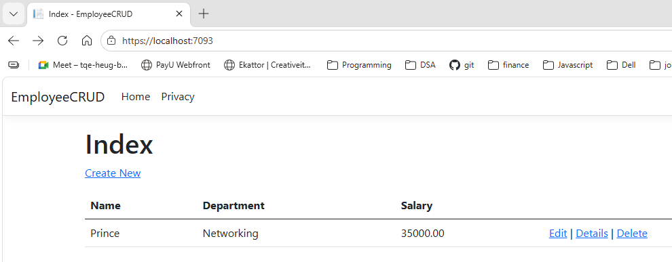

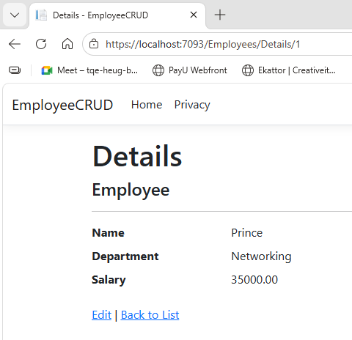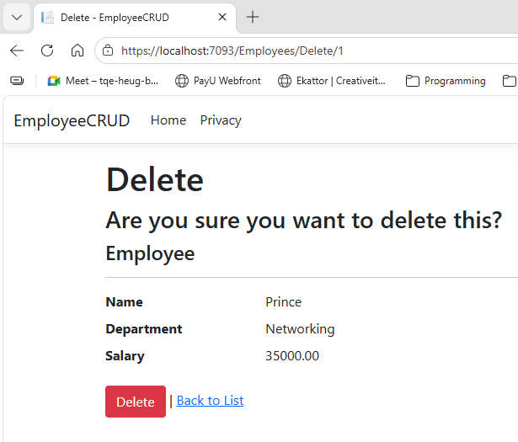

4. ASP.NET CORE MVC with Ef Core Db first approach

Create Database
CREATE DATABASE EF_Core;
GO
USE EF_Core;
GO
CREATE TABLE EmpEFCore
(
Id INT PRIMARY KEY IDENTITY(1,1),
FirstName VARCHAR(50) NOT NULL,
LastName VARCHAR(50),
Salary NUMERIC(18,0),
Department VARCHAR(50)
);

INSERT INTO EmpEFCore
VALUES
('Prince','Yadav',50000,'IT'),
('Dheeraj','Giri',45000,'HR');

SELECT * FROM EmpEFCore;

Package Manager Console
Tools → NuGet Package Manager → Package Manager Console
Install-Package Microsoft.EntityFrameworkCore.SqlServer -Version 8.0.23
Install-Package Microsoft.EntityFrameworkCore.Tools -Version 8.0.23
Install-Package Microsoft.VisualStudio.Web.CodeGeneration.Design -Version 8.0.7

Scaffold Database
Scaffold-DbContext "Server=localhost\SQLEXPRESS02;Database=EF_Core;Trusted_Connection=True;TrustServerCertificate=True;" Microsoft.EntityFrameworkCore.SqlServer -OutputDir Models

EmpEfcoresController.cs
using System;
using System.Collections.Generic;
using System.Linq;
using System.Threading.Tasks;
using Microsoft.AspNetCore.Mvc;
using Microsoft.AspNetCore.Mvc.Rendering;
using Microsoft.EntityFrameworkCore;
using MVC_EF_CORE.Models;
namespace MVC_EF_CORE.Controllers
{
public class EmpEfcoresController : Controller
{
private readonly EfCoreContext _context;

public EmpEfcoresController(EfCoreContext context)
{
_context = context;
}
// GET: EmpEfcores
public async Task<IActionResult> Index()
{
return View(await _context.EmpEfcores.ToListAsync());
}
// GET: EmpEfcores/Details/5
public async Task<IActionResult> Details(int? id)
{
if (id == null)
{
return NotFound();
}
var empEfcore = await _context.EmpEfcores
.FirstOrDefaultAsync(m => m.Id == id);
if (empEfcore == null)
{
return NotFound();
}

return View(empEfcore);
}
// GET: EmpEfcores/Create
public IActionResult Create()
{
return View();
}
// POST: EmpEfcores/Create
// To protect from overposting attacks, enable the specific properties you want to bind to.
// For more details, see http://go.microsoft.com/fwlink/?LinkId=317598.
[HttpPost]
[ValidateAntiForgeryToken]
public async Task<IActionResult> Create([Bind("Id,FirstName,LastName,Salary,Department")] EmpEfcore empEfcore)
{
if (ModelState.IsValid)
{
_context.Add(empEfcore);
await _context.SaveChangesAsync();
return RedirectToAction(nameof(Index));
}
return View(empEfcore);
}
// GET: EmpEfcores/Edit/5
public async Task<IActionResult> Edit(int? id)
{
if (id == null)
{
return NotFound();
}
var empEfcore = await _context.EmpEfcores.FindAsync(id);
if (empEfcore == null)
{
return NotFound();
}
return View(empEfcore);
}
// POST: EmpEfcores/Edit/5
// To protect from overposting attacks, enable the specific properties you want to bind to.
// For more details, see http://go.microsoft.com/fwlink/?LinkId=317598.
[HttpPost]
[ValidateAntiForgeryToken]
public async Task<IActionResult> Edit(int id, [Bind("Id,FirstName,LastName,Salary,Department")] EmpEfcore empEfcore)
{
if (id != empEfcore.Id)
{
return NotFound();
}

if (ModelState.IsValid)
{
try
{
_context.Update(empEfcore);
await _context.SaveChangesAsync();
}
catch (DbUpdateConcurrencyException)
{
if (!EmpEfcoreExists(empEfcore.Id))
{
return NotFound();
}
else
{
throw;
}
}
return RedirectToAction(nameof(Index));
}
return View(empEfcore);
}
// GET: EmpEfcores/Delete/5
public async Task<IActionResult> Delete(int? id)
{
if (id == null)
{
return NotFound();
}
var empEfcore = await _context.EmpEfcores
.FirstOrDefaultAsync(m => m.Id == id);
if (empEfcore == null)
{
return NotFound();
}
return View(empEfcore);
}
// POST: EmpEfcores/Delete/5
[HttpPost, ActionName("Delete")]
[ValidateAntiForgeryToken]
public async Task<IActionResult> DeleteConfirmed(int id)
{
var empEfcore = await _context.EmpEfcores.FindAsync(id);
if (empEfcore != null)
{
_context.EmpEfcores.Remove(empEfcore);
}
await _context.SaveChangesAsync();
return RedirectToAction(nameof(Index));
}

private bool EmpEfcoreExists(int id)
{
return _context.EmpEfcores.Any(e => e.Id == id);
}
}
}

EfCoreContext.cs
using System;
using System.Collections.Generic;
using Microsoft.EntityFrameworkCore;
namespace MVC_EF_CORE.Models;
public partial class EfCoreContext : DbContext
{
public EfCoreContext()
{
}
public EfCoreContext(DbContextOptions<EfCoreContext> options)
: base(options)
{
}
public virtual DbSet<EmpEfcore> EmpEfcores { get; set; }
protected override void OnConfiguring(DbContextOptionsBuilder optionsBuilder)
#warning To protect potentially sensitive information in your connection string, you should move it out of source code. You can avoid scaffolding the connection string by using the Name= syntax to read it from configuration - see https://go.microsoft.com/fwlink/?linkid=2131148. For more guidance on storing connection strings, see https://go.microsoft.com/fwlink/?LinkId=723263.
=> optionsBuilder.UseSqlServer("Server=localhost\\SQLEXPRESS02;Database=EF_Core;Trusted_Connection=True;TrustServerCertificate=True;");
protected override void OnModelCreating(ModelBuilder modelBuilder)
{
modelBuilder.Entity<EmpEfcore>(entity =>
{
entity.HasKey(e => e.Id).HasName("PK__EmpEFCor__3214EC07E2B7EDB1");
entity.ToTable("EmpEFCore");
entity.Property(e => e.Department)
.HasMaxLength(50)
.IsUnicode(false);
entity.Property(e => e.FirstName)
.HasMaxLength(50)
.IsUnicode(false);
entity.Property(e => e.LastName)
.HasMaxLength(50)
.IsUnicode(false);
entity.Property(e => e.Salary).HasColumnType("numeric(18, 0)");
});
OnModelCreatingPartial(modelBuilder);
}
partial void OnModelCreatingPartial(ModelBuilder modelBuilder);
}

Create.cshtml
@model MVC_EF_CORE.Models.EmpEfcore
@{
ViewData["Title"] = "Create";
}
<h1>Create</h1>
<h4>EmpEfcore</h4>
<hr />
<div class="row">
<div class="col-md-4">
<form asp-action="Create">
<div asp-validation-summary="ModelOnly" class="text-danger"></div>
<div class="form-group">
<label asp-for="FirstName" class="control-label"></label>
<input asp-for="FirstName" class="form-control" />
<span asp-validation-for="FirstName" class="text-danger"></span>
</div>
<div class="form-group">
<label asp-for="LastName" class="control-label"></label>
<input asp-for="LastName" class="form-control" />
<span asp-validation-for="LastName" class="text-danger"></span>
</div>
<div class="form-group">
<label asp-for="Salary" class="control-label"></label>
<input asp-for="Salary" class="form-control" />
<span asp-validation-for="Salary" class="text-danger"></span>
</div>
<div class="form-group">
<label asp-for="Department" class="control-label"></label>
<input asp-for="Department" class="form-control" />
<span asp-validation-for="Department" class="text-danger"></span>
</div>
<div class="form-group">
<input type="submit" value="Create" class="btn btn-primary" />
</div>
</form>
</div>
</div>

<div>
<a asp-action="Index">Back to List</a>
</div>
@section Scripts {
@{await Html.RenderPartialAsync("_ValidationScriptsPartial");}
}

Delete.cshtml
@model MVC_EF_CORE.Models.EmpEfcore
@{
ViewData["Title"] = "Delete";
}
<h1>Delete</h1>
<h3>Are you sure you want to delete this?</h3>
<div>
<h4>EmpEfcore</h4>
<hr />
<dl class="row">
<dt class = "col-sm-2">
@Html.DisplayNameFor(model => model.FirstName)
</dt>
<dd class = "col-sm-10">
@Html.DisplayFor(model => model.FirstName)
</dd>
<dt class = "col-sm-2">
@Html.DisplayNameFor(model => model.LastName)
</dt>
<dd class = "col-sm-10">
@Html.DisplayFor(model => model.LastName)
</dd>
<dt class = "col-sm-2">
@Html.DisplayNameFor(model => model.Salary)
</dt>
<dd class = "col-sm-10">
@Html.DisplayFor(model => model.Salary)
</dd>
<dt class = "col-sm-2">
@Html.DisplayNameFor(model => model.Department)
</dt>
<dd class = "col-sm-10">
@Html.DisplayFor(model => model.Department)
</dd>
</dl>
<form asp-action="Delete">
<input type="hidden" asp-for="Id" />
<input type="submit" value="Delete" class="btn btn-danger" /> |
<a asp-action="Index">Back to List</a>
</form>
</div>

Edit.cshtml
@model MVC_EF_CORE.Models.EmpEfcore
@{
ViewData["Title"] = "Edit";
}
<h1>Edit</h1>

<h4>EmpEfcore</h4>
<hr />
<div class="row">
<div class="col-md-4">
<form asp-action="Edit">
<div asp-validation-summary="ModelOnly" class="text-danger"></div>
<input type="hidden" asp-for="Id" />
<div class="form-group">
<label asp-for="FirstName" class="control-label"></label>
<input asp-for="FirstName" class="form-control" />
<span asp-validation-for="FirstName" class="text-danger"></span>
</div>
<div class="form-group">
<label asp-for="LastName" class="control-label"></label>
<input asp-for="LastName" class="form-control" />
<span asp-validation-for="LastName" class="text-danger"></span>
</div>
<div class="form-group">
<label asp-for="Salary" class="control-label"></label>
<input asp-for="Salary" class="form-control" />
<span asp-validation-for="Salary" class="text-danger"></span>
</div>
<div class="form-group">
<label asp-for="Department" class="control-label"></label>
<input asp-for="Department" class="form-control" />
<span asp-validation-for="Department" class="text-danger"></span>
</div>
<div class="form-group">
<input type="submit" value="Save" class="btn btn-primary" />
</div>
</form>
</div>
</div>
<div>
<a asp-action="Index">Back to List</a>
</div>
@section Scripts {
@{await Html.RenderPartialAsync("_ValidationScriptsPartial");}
}

Index.cshtml
@model IEnumerable<MVC_EF_CORE.Models.EmpEfcore>
@{
ViewData["Title"] = "Index";
}
<h1>Index</h1>
<p>
<a asp-action="Create">Create New</a>
</p>
<table class="table">
<thead>
<tr>
<th>
@Html.DisplayNameFor(model => model.FirstName)
</th>
<th>
@Html.DisplayNameFor(model => model.LastName)
</th>
<th>
@Html.DisplayNameFor(model => model.Salary)
</th>
<th>
@Html.DisplayNameFor(model => model.Department)
</th>
<th></th>
</tr>
</thead>
<tbody>
@foreach (var item in Model) {
<tr>
<td>
@Html.DisplayFor(modelItem => item.FirstName)
</td>
<td>
@Html.DisplayFor(modelItem => item.LastName)
</td>
<td>
@Html.DisplayFor(modelItem => item.Salary)
</td>
<td>
@Html.DisplayFor(modelItem => item.Department)
</td>
<td>
<a asp-action="Edit" asp-route-id="@item.Id">Edit</a> |
<a asp-action="Details" asp-route-id="@item.Id">Details</a> |
<a asp-action="Delete" asp-route-id="@item.Id">Delete</a>
</td>
</tr>
}
</tbody>
</table>

Details.cshtml
@model MVC_EF_CORE.Models.EmpEfcore
@{
ViewData["Title"] = "Details";
}
<h1>Details</h1>
<div>
<h4>EmpEfcore</h4>
<hr />
<dl class="row">
<dt class = "col-sm-2">
@Html.DisplayNameFor(model => model.FirstName)
</dt>
<dd class = "col-sm-10">
@Html.DisplayFor(model => model.FirstName)
</dd>
<dt class = "col-sm-2">
@Html.DisplayNameFor(model => model.LastName)
</dt>
<dd class = "col-sm-10">
@Html.DisplayFor(model => model.LastName)
</dd>
<dt class = "col-sm-2">
@Html.DisplayNameFor(model => model.Salary)
</dt>
<dd class = "col-sm-10">
@Html.DisplayFor(model => model.Salary)
</dd>
<dt class = "col-sm-2">
@Html.DisplayNameFor(model => model.Department)
</dt>
<dd class = "col-sm-10">
@Html.DisplayFor(model => model.Department)
</dd>
</dl>
</div>
<div>
<a asp-action="Edit" asp-route-id="@Model?.Id">Edit</a> |
<a asp-action="Index">Back to List</a>
</div>

Program.cs
using Microsoft.EntityFrameworkCore;
using MVC_EF_CORE.Models;
var builder = WebApplication.CreateBuilder(args);
builder.Services.AddControllersWithViews();
builder.Services.AddDbContext<EF_CoreContext>(options =>
options.UseSqlServer(
builder.Configuration.GetConnectionString("DefaultConnection")));
var app = builder.Build();
if (!app.Environment.IsDevelopment())
{
app.UseExceptionHandler("/Home/Error");
app.UseHsts();
}
app.UseHttpsRedirection();
app.UseStaticFiles();
app.UseRouting();
app.UseAuthorization();
app.MapControllerRoute(
name: "default",
pattern: "{controller=Home}/{action=Index}/{id?}");
app.Run();

appsettings.json
{
"ConnectionStrings": {
"DefaultConnection": "Server=localhost\\SQLEXPRESS02;Database=EF_Core;Trusted_Connection=True;TrustServerCertificate=True;"
},
"Logging": {
"LogLevel": {
"Default": "Information",
"Microsoft.AspNetCore": "Warning"
}
},
"AllowedHosts": "*"
}
Output:
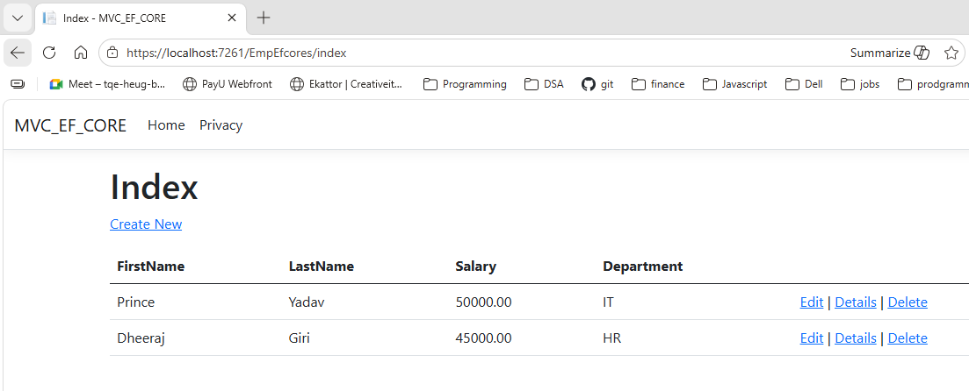

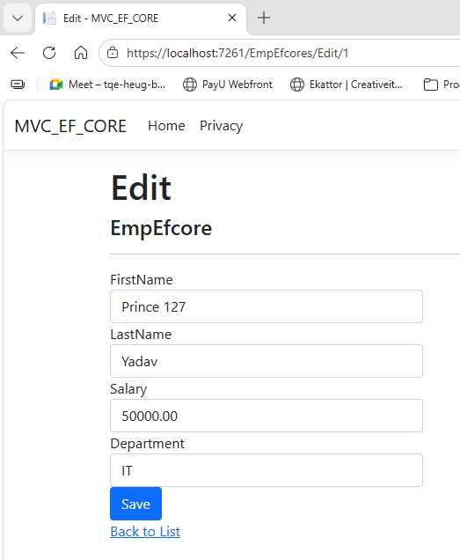

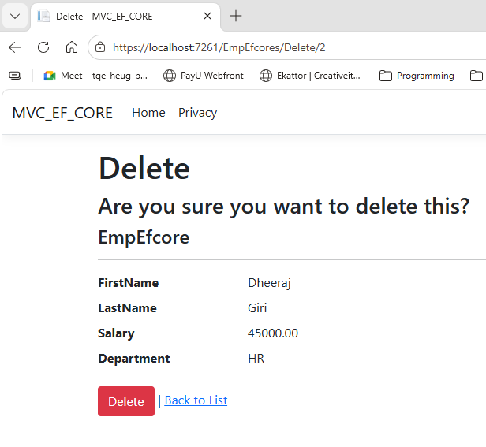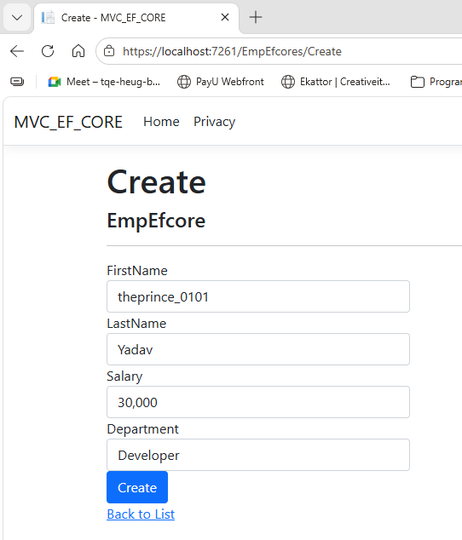

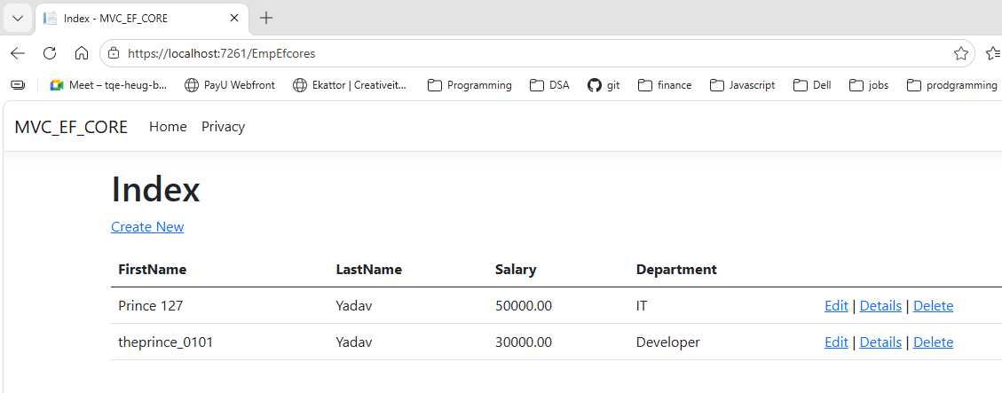

5. Create partial views

Emp.cs
using System.ComponentModel.DataAnnotations;

namespace EmpMvcApp.Models
{
public class Emp
{
public int Id { get; set; }

[Required(ErrorMessage = "Name is required")]
public string Name { get; set; }

[Required(ErrorMessage = "Department is required")]
public string Department { get; set; }

public decimal Salary { get; set; }
}
}

EmpController.cs
using Microsoft.AspNetCore.Mvc;
using EmpMvcApp.Models;
using System.Collections.Generic;
using System.Linq;
namespace EmpMvcApp.Controllers
{
public class EmpController : Controller
{
static List<Emp> empList = new List<Emp>();
// INDEX
public IActionResult Index()
{
return View(empList);
}
// CREATE GET
public IActionResult Create()
{
return View();
}
// CREATE POST
[HttpPost]
public IActionResult Create(Emp emp)
{
if (ModelState.IsValid)
{
emp.Id = empList.Count + 1;
empList.Add(emp);
return RedirectToAction("Index");
}
return View(emp);
}
// EDIT GET
public IActionResult Edit(int id)
{
var emp = empList.FirstOrDefault(e => e.Id == id);
return View(emp);
}
// EDIT POST
[HttpPost]
public IActionResult Edit(Emp emp)
{
var employee = empList.FirstOrDefault(e => e.Id == emp.Id);
if (employee != null)
{
employee.Name = emp.Name;
employee.Department = emp.Department;
employee.Salary = emp.Salary;
}
return RedirectToAction("Index");
}
// DELETE
public IActionResult Delete(int id)
{
var emp = empList.FirstOrDefault(e => e.Id == id);
if (emp != null)
{
empList.Remove(emp);
}
return RedirectToAction("Index");
}
}
}

_EmpFormPartial.cshtml
@model EmpMvcApp.Models.Emp
<div class="form-group">
<label asp-for="Name"></label>
<input asp-for="Name" class="form-control" />
<span asp-validation-for="Name" class="text-danger"></span>
</div>
<br />
<div class="form-group">
<label asp-for="Department"></label>
<input asp-for="Department" class="form-control" />
<span asp-validation-for="Department" class="text-danger"></span>
</div>
<br />
<div class="form-group">
<label asp-for="Salary"></label>
<input asp-for="Salary" class="form-control" />
<span asp-validation-for="Salary" class="text-danger"></span>
</div>

Create.cshtml
@model EmpMvcApp.Models.Emp
<h2>Create Employee</h2>
<form asp-action="Create">
<partial name="_EmpFormPartial" model="Model" />
<br />
<button type="submit" class="btn btn-primary">
Save
</button>
</form>
@section Scripts
{
@{
await Html.RenderPartialAsync("_ValidationScriptsPartial");
}
}

Edit.cshtml
@model EmpMvcApp.Models.Emp
<h2>Edit Employee</h2>
<form asp-action="Edit">
<partial name="_EmpFormPartial" model="Model" />
<input type="hidden" asp-for="Id" />
<br />
<button type="submit" class="btn btn-success">
Update
</button>
</form>

Index.cshtml

@model List<EmpMvcApp.Models.Emp>
<h2>Employee List</h2>
<a asp-controller="Emp"
asp-action="Create"
class="btn btn-success">
Add New Employee
</a>
<table class="table table-bordered mt-3">
<thead>
<tr>
<th>Id</th>
<th>Name</th>
<th>Department</th>
<th>Salary</th>
<th>Action</th>
</tr>
</thead>
<tbody>
@foreach (var item in Model)
{
<tr>
<td>@item.Id</td>
<td>@item.Name</td>
<td>@item.Department</td>
<td>@item.Salary</td>
<td>
<a asp-action="Edit"
asp-route-id="@item.Id"
class="btn btn-warning">
Edit
</a>
<a asp-action="Delete"
asp-route-id="@item.Id"
class="btn btn-danger"
onclick="return confirm('Are you sure you want to delete this employee?')">
Delete
</a>
</td>
</tr>
}
</tbody>
</table>

Output:
