Practical -1
Installing Git on Windows

Step 1: Go to https://www.git-scm.com/. Click on Download [latest version] for Windows.
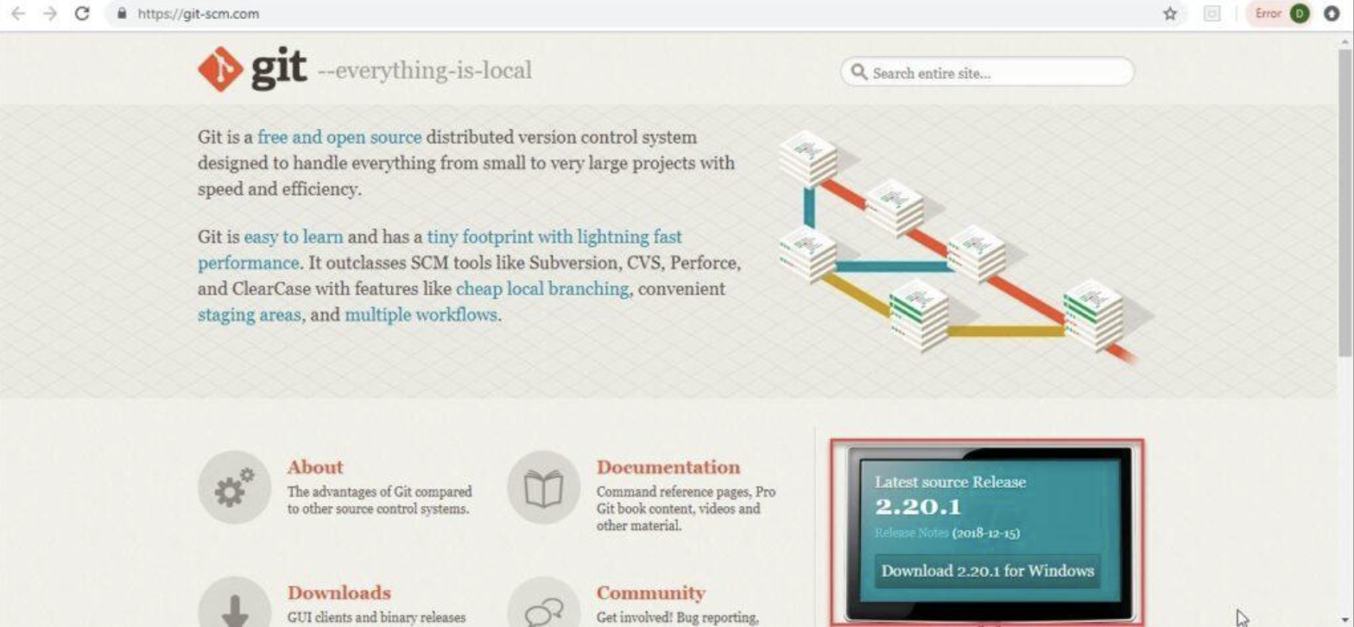

Step 2: You will view the below screen. Download has started and the .exe file is downloading.

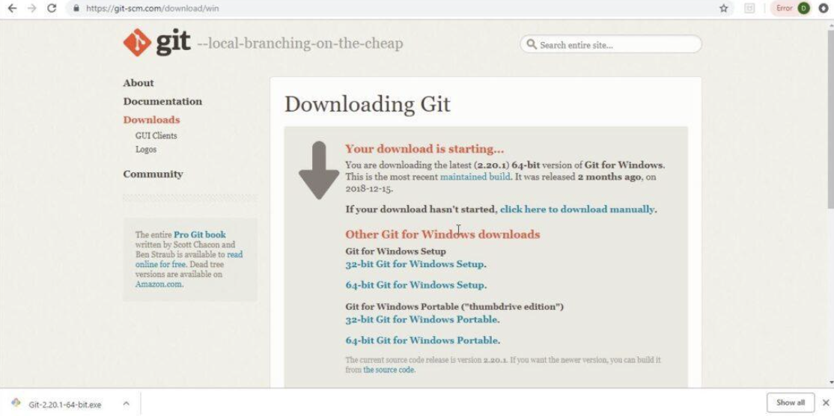

Step 3: Click on Next when this popup window opens.
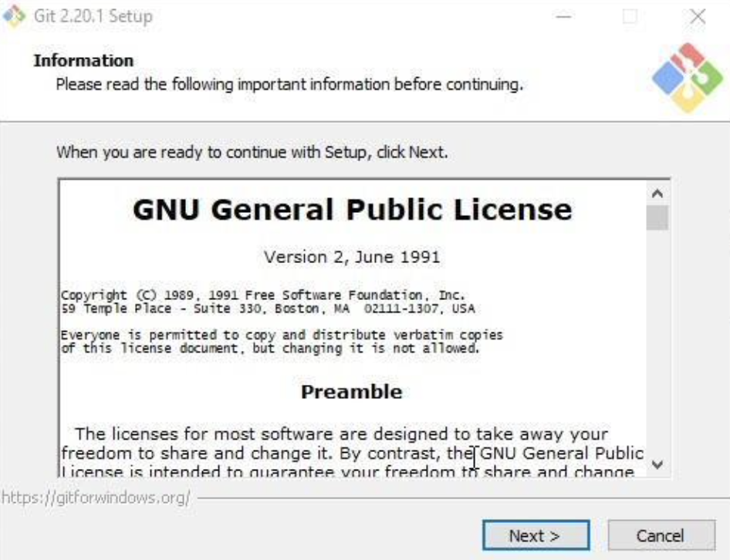

Step 4: Check the below options and click Next.
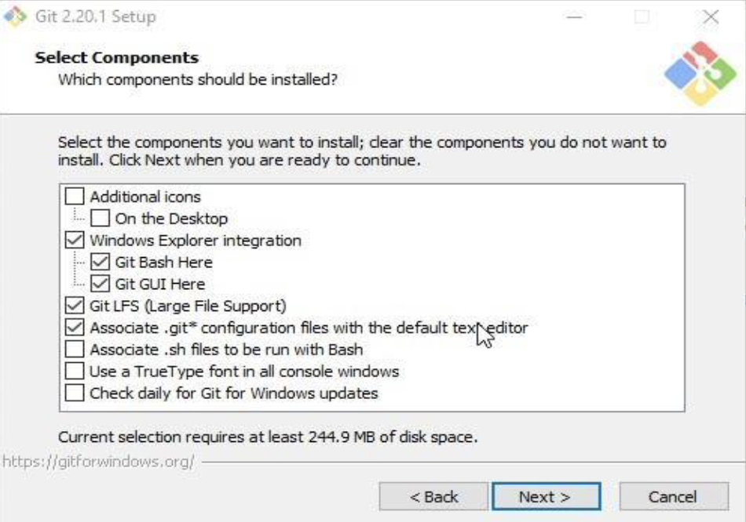

Step 5: The below screen comes. Click Next.
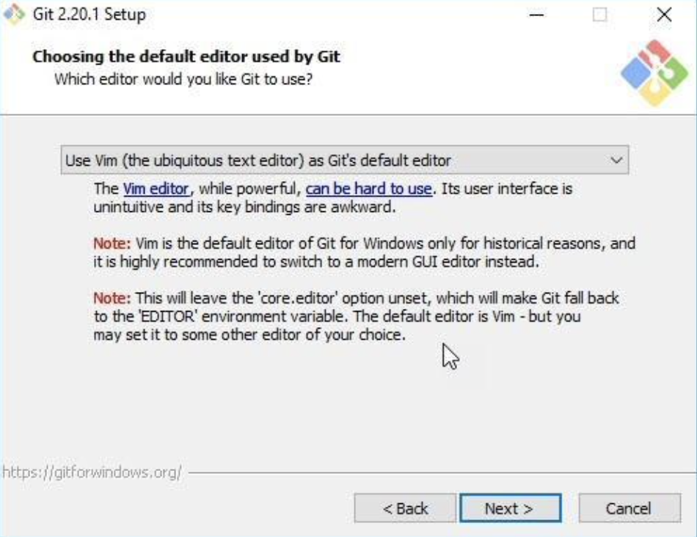
Step 6: Choose the appropriate option and click Next.
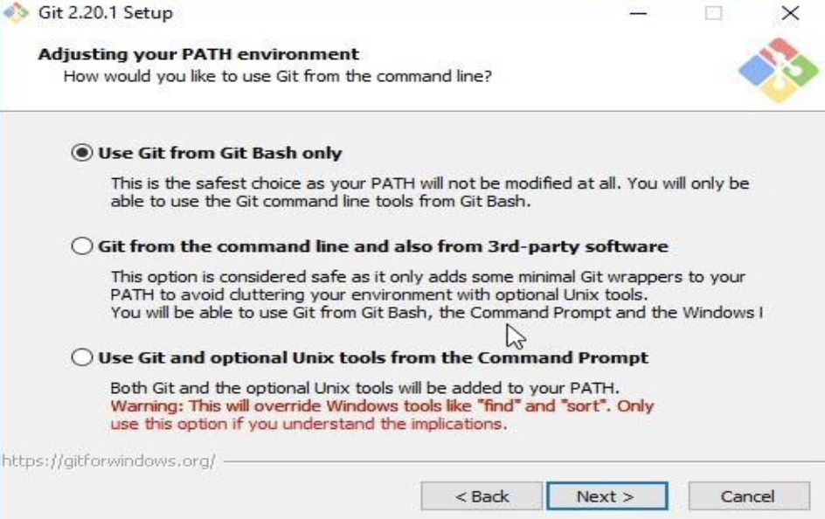

Step 7: Choose the library option and click on Next.
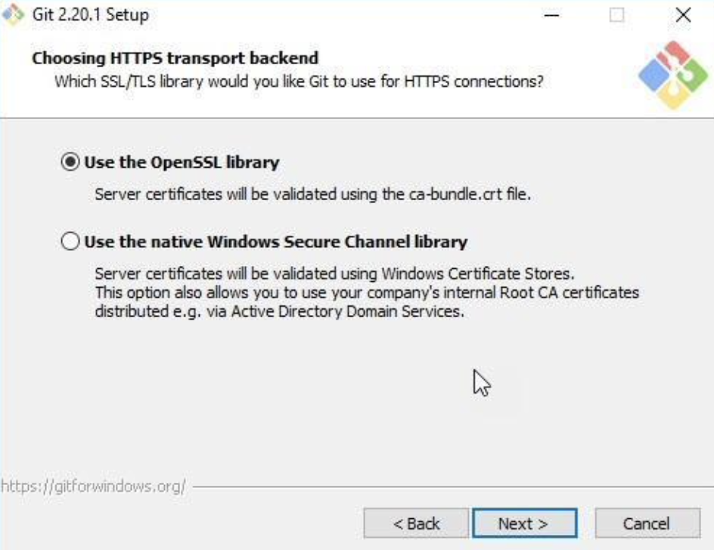

Step 8: Choose the checkout option and click Next.

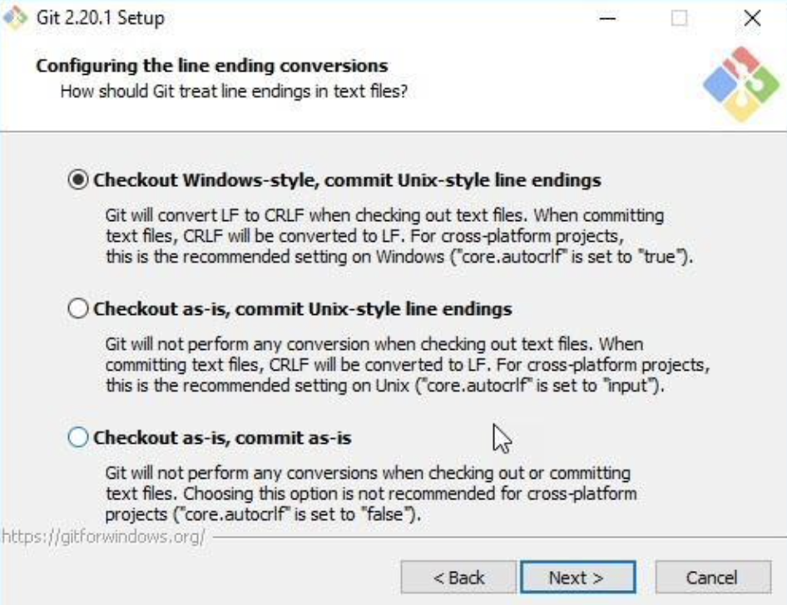
Step 9: Choose the emulator and click Next.

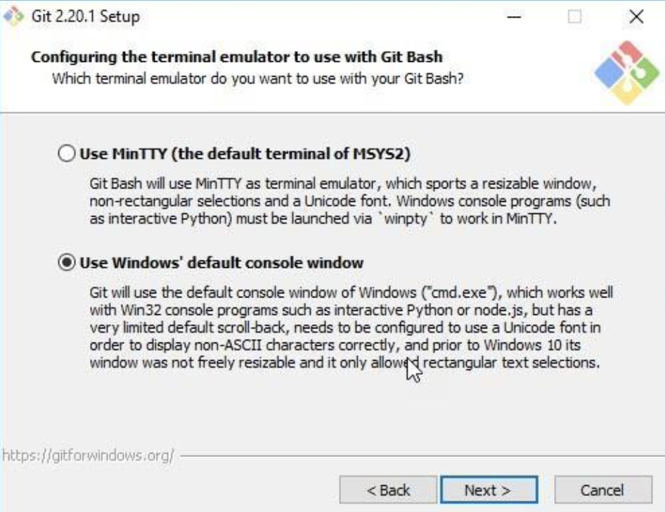

Step 10: Choose configuration options and click on Install.
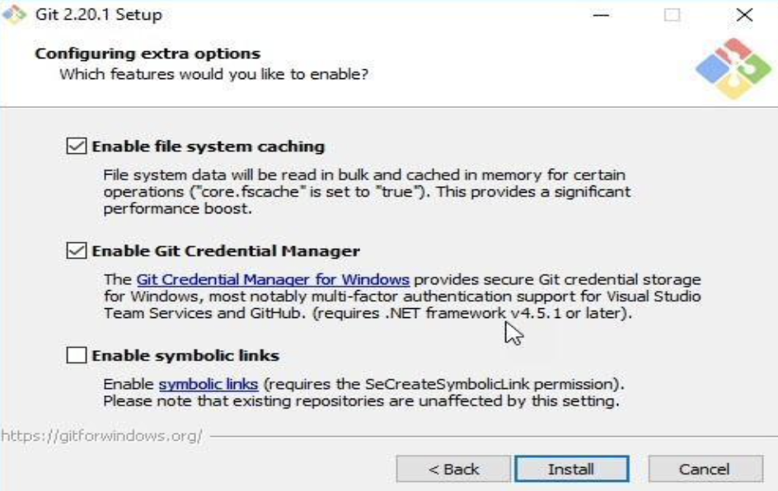

Step 11: Once the installation completes, the Git GUI opens.
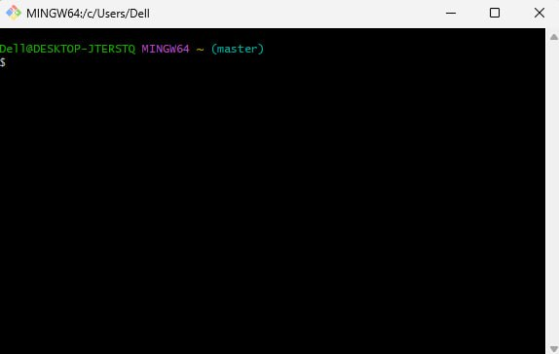
Checks if Git is installed.

git --version
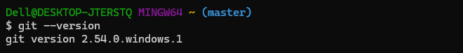
git config --global user.name "Prince Yadav"
git config --global user.email prince@example.com
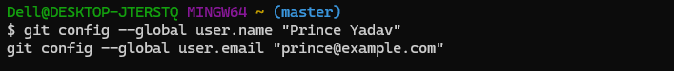
Check Configuration
git config --list
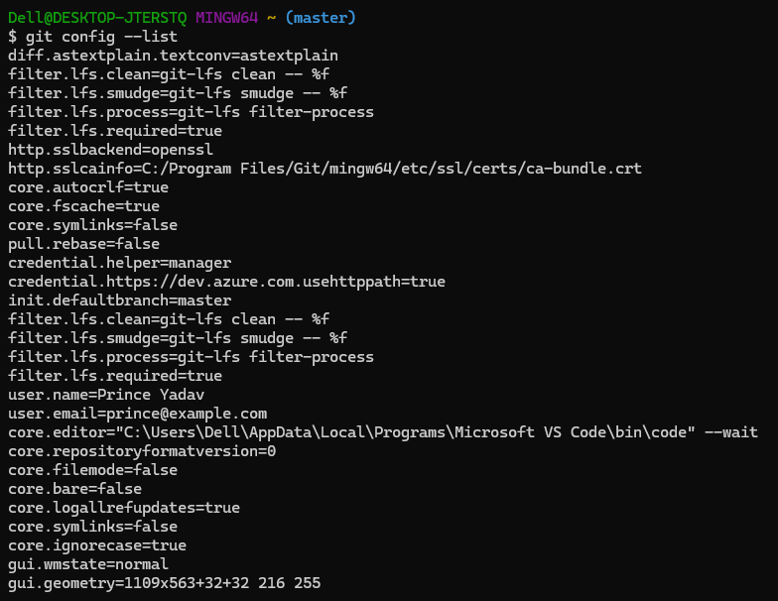
Creating & Cloning Repositories
Create a New Project Folder
mkdir myproject
cd myproject
git init
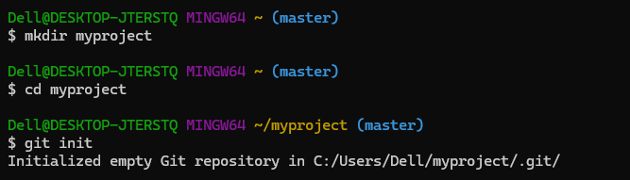
Staging & Committing Changes
git add file.txt
git status
git commit -m "Added first file"
git log --oneline
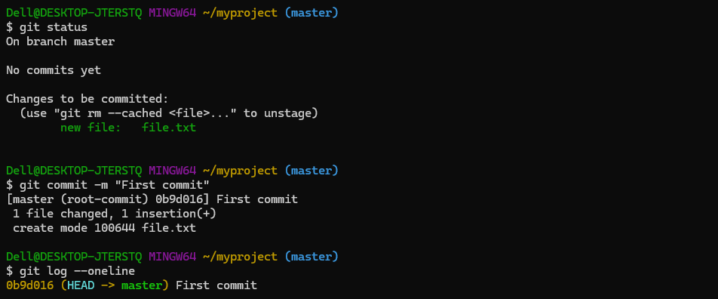
git log
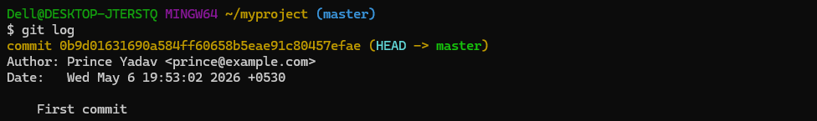
Check File Differences
echo New Line >> file.txt
git diff
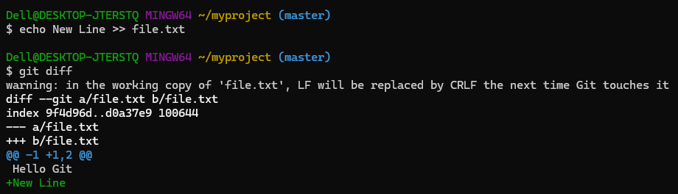
Working with Branches
Create a Branch
git branch feature
git branch
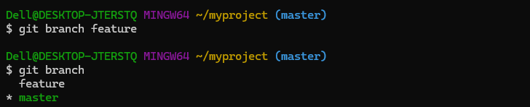
Switch Branch
git checkout feature
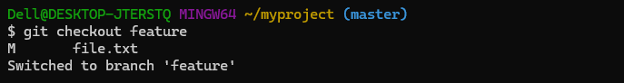
Create + Switch Branch Together
git checkout -b newbranch
Merge Branches
git checkout master
git merge newbranch
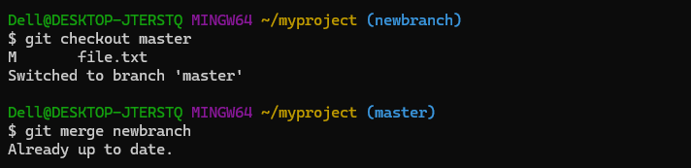
Clone Existing Repository
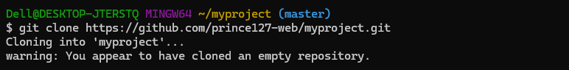
Connect Remote Repository
git remote add origin https://github.com/prince127-web/myproject.git
git remote -v
git push -u origin master
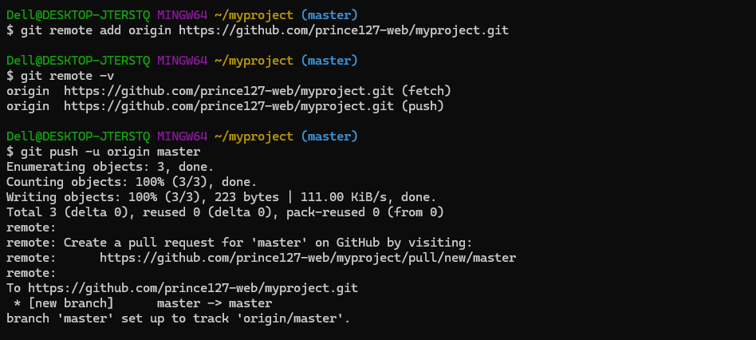
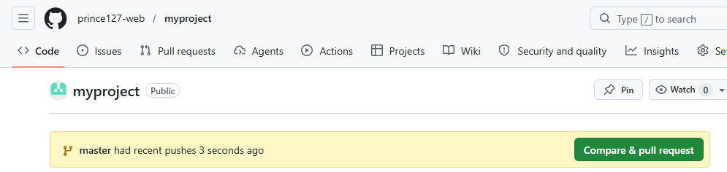

Undo & Fix Mistakes
Discards local changes in a file.
git restore <file_name>
Unstages a file.
git reset <file_name>
Discards all local changes (use carefully).
git reset –hard

Useful Shortcuts
Shows differences before staging.
git diff
Displays details of a commit.
git show
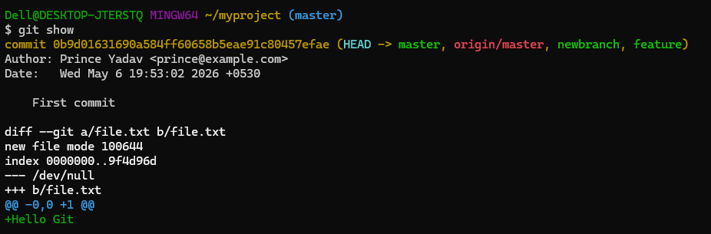

Practical No - 2
Create and Fork Repositories in GitHub – Branch, Merge, Rebase 1.
1. Create a GitHub account and log in.
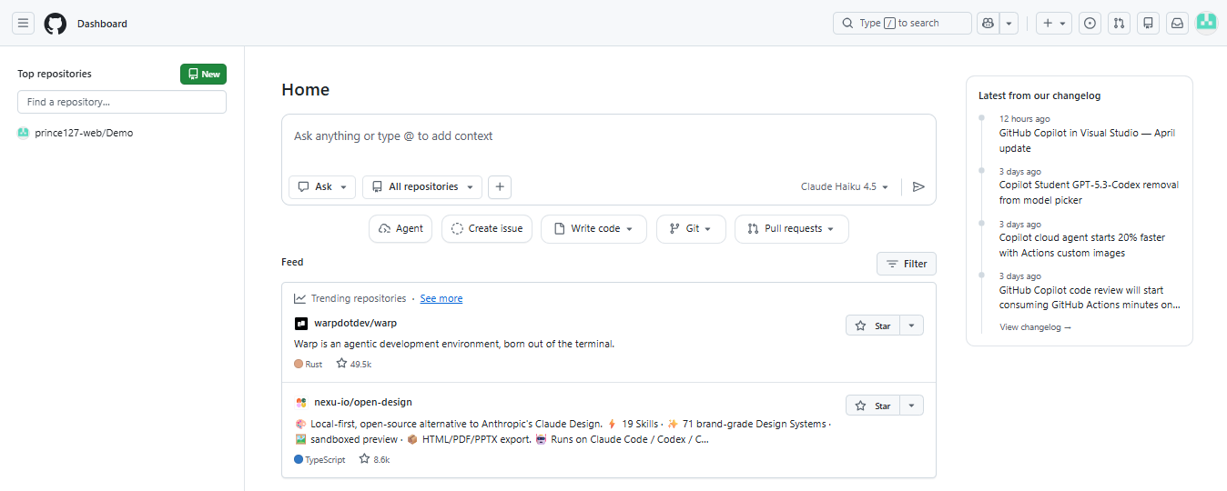

2. Create a repository on GitHub (e.g., prince-git-practical)
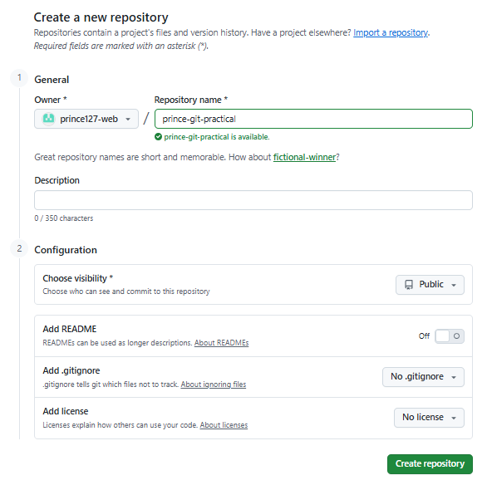

3. Fork any public repository or your own from another account.
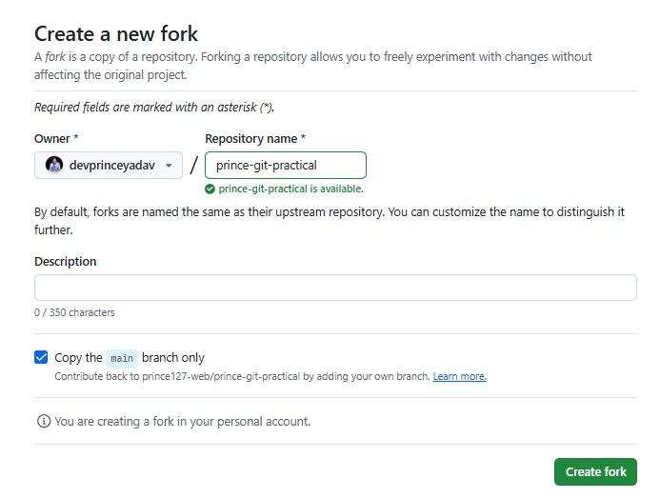
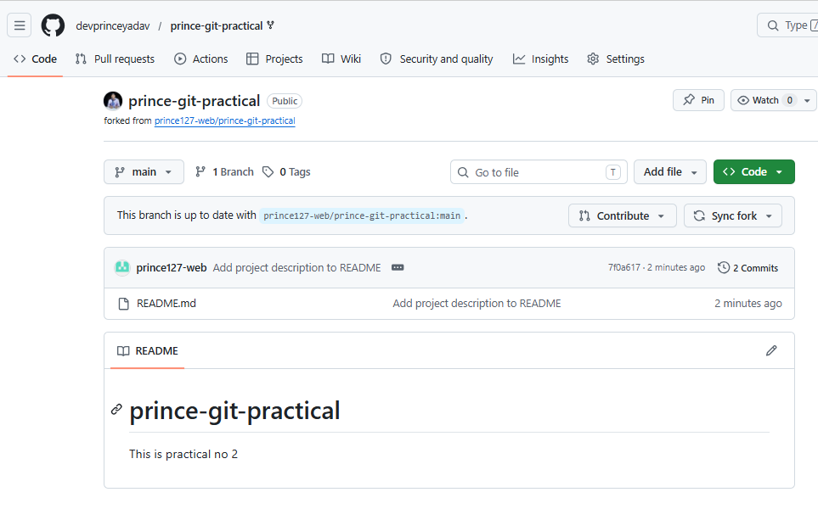

4.Clone the forked repo:
git clone https://github.com/devprinceyadav/prince-git-practical.git
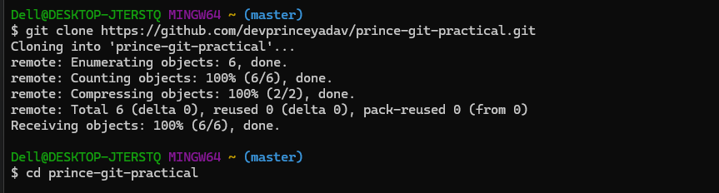
5. Create a branch:
git checkout -b feature
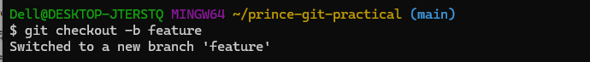
6. Make Changes & Commit
echo "Feature added" >> newfile.txt
git add .
git commit -m "Added new feature"
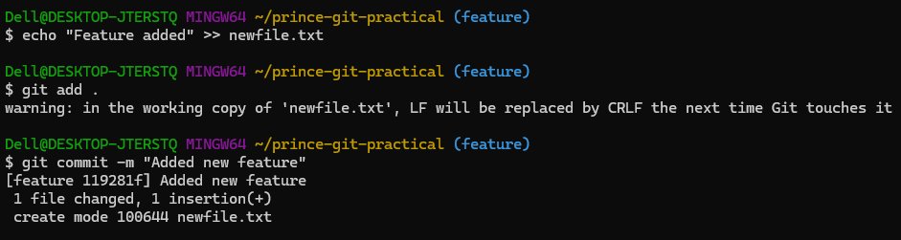
7. Merge branch into main:
git checkout main
git merge feature
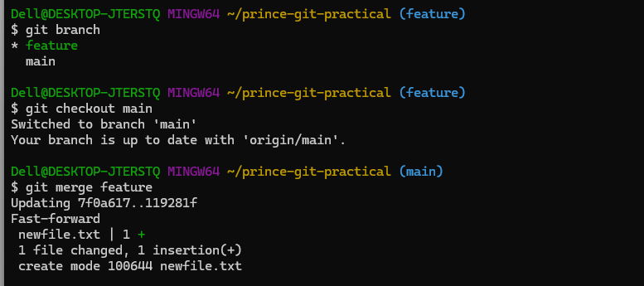
8. Rebase branch (alternative to merge):
git checkout feature
git rebase main
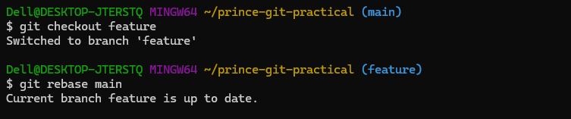
9. Push to GitHub: git push origin feature
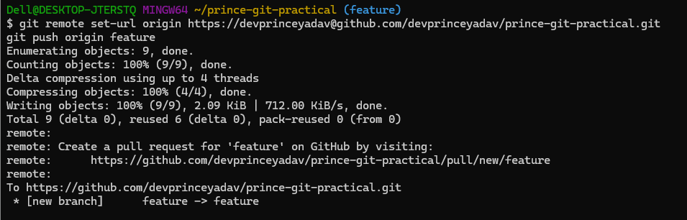

Practical - 3
Using Git for Collaboration
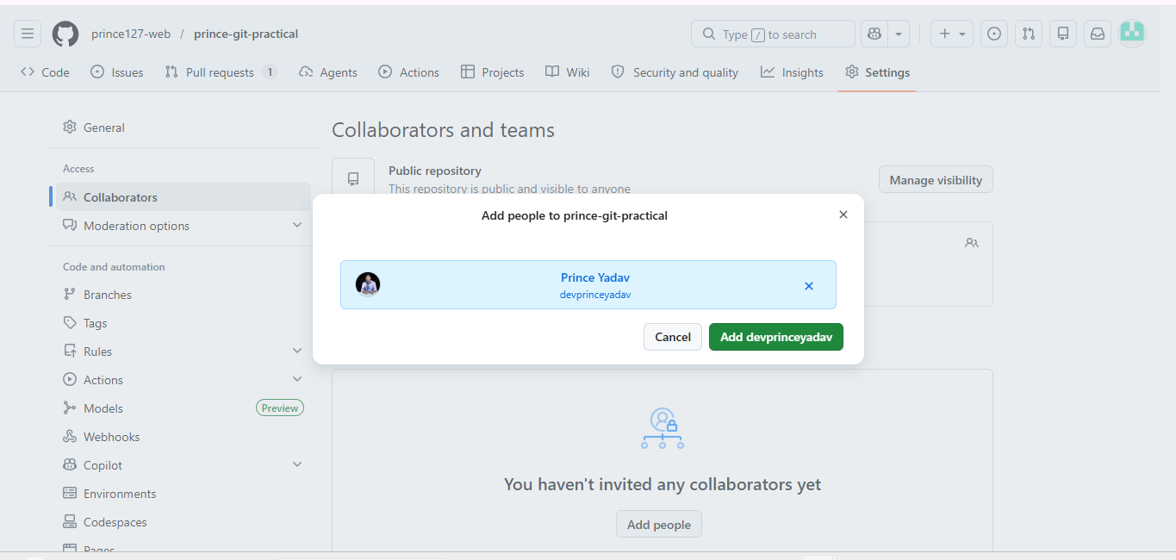
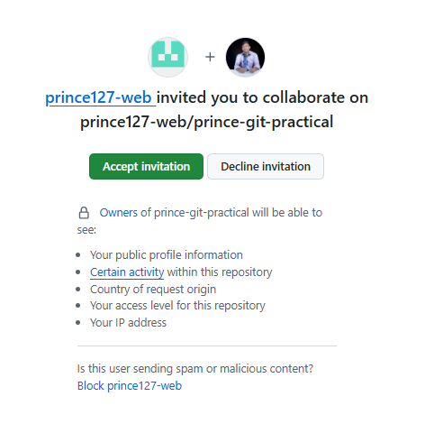
Clones the repo: git clone
git clone https://github.com/prince127-web/prince-git-practical.git
cd prince-git-practical
git checkout -b bug-fix
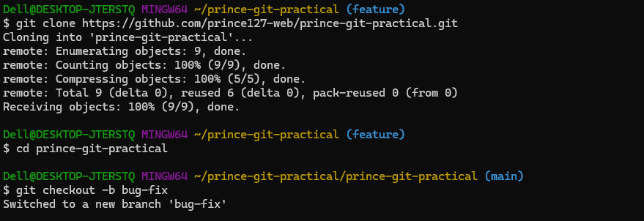
echo "Bug fixed" >> bug.txt
git add .
git commit -m "Fixed a bug"
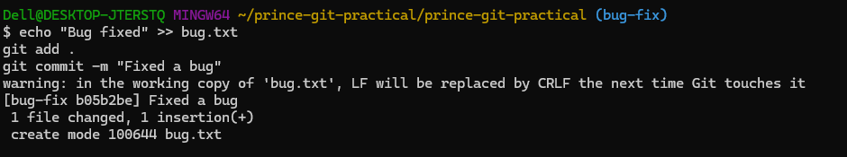
git push origin bug-fix
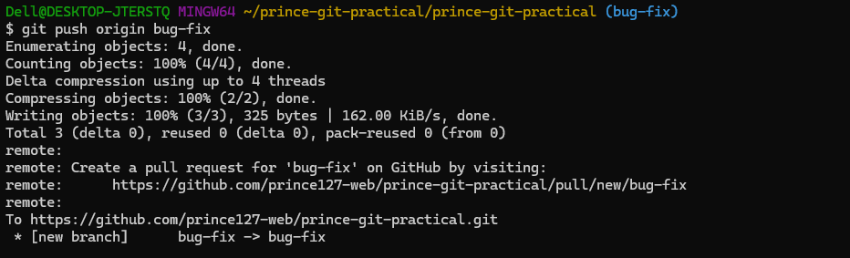
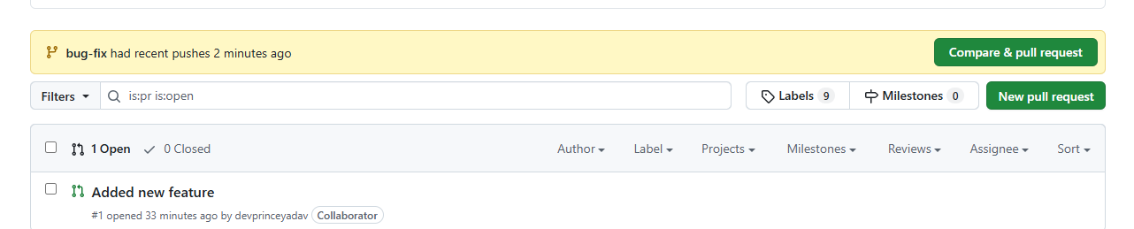

Practical - 4

Collaborating and Cloning Using GitHub
Step 1. Clone a public repository:
git clone https://github.com/prince127-web/Demo.git
cd Demo
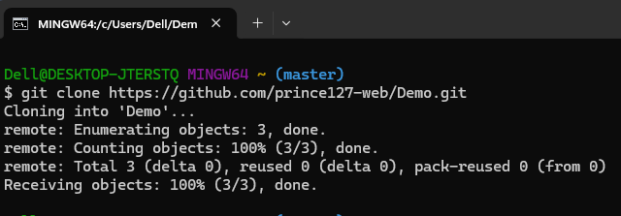
Step 2: Create a New Branch
git checkout -b update-readme
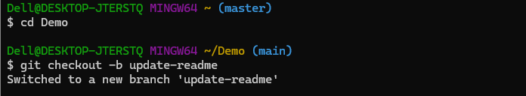
Step 3: Edit and commit changes
echo "Added a line for practical" >> README.md
git add README.md
git commit -m "Updated README for practical"
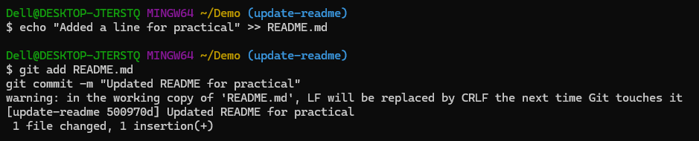

Step 4: Push and Open pull request:
git push origin update-readme
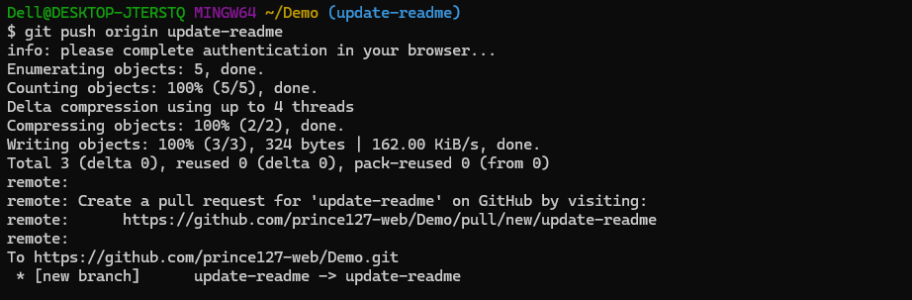
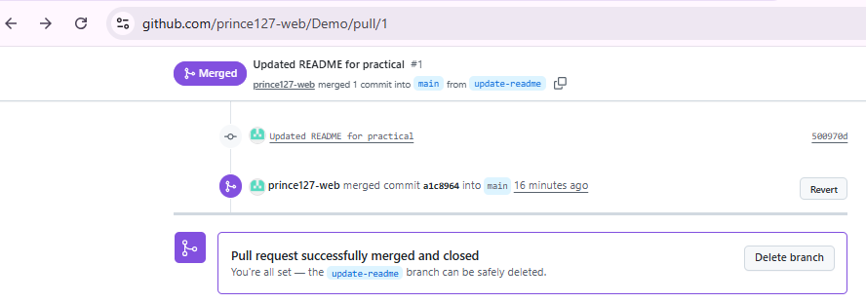

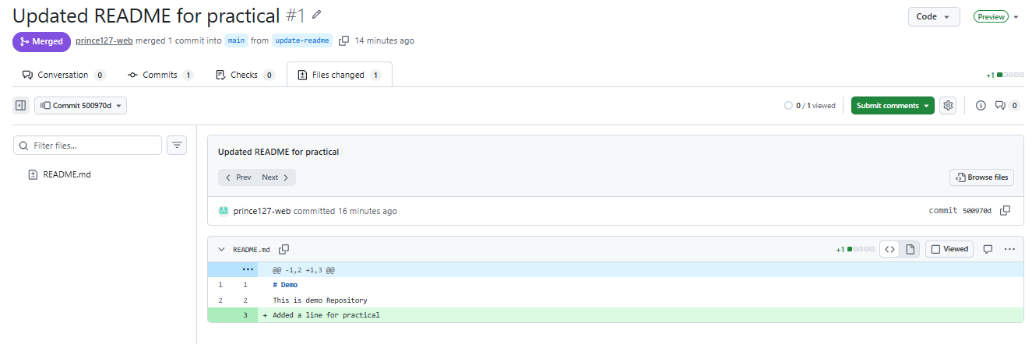

Practical No – 5
Using GitLab Web IDE
GitLab Web IDE
Steps:
1. Sign up at https://gitlab.com
2. Create a project.
3. Click on Web IDE in your repository.

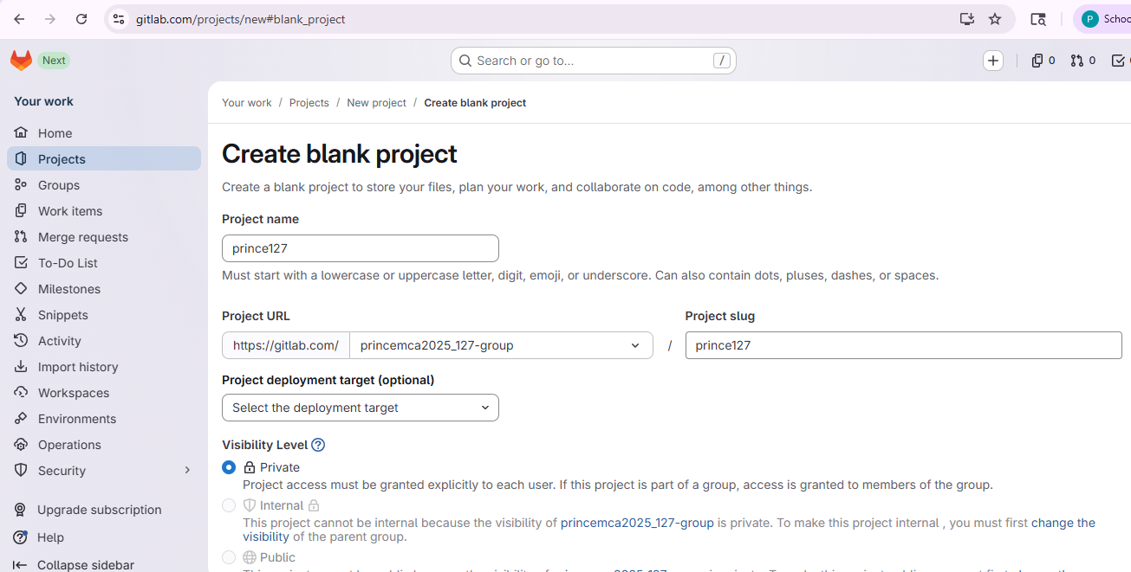
4. Create a file (index.html):
<html>
<body>
<h1>Hello Prince</h1>
<h2>Working on Gitlab</h2>
</body>
</html>
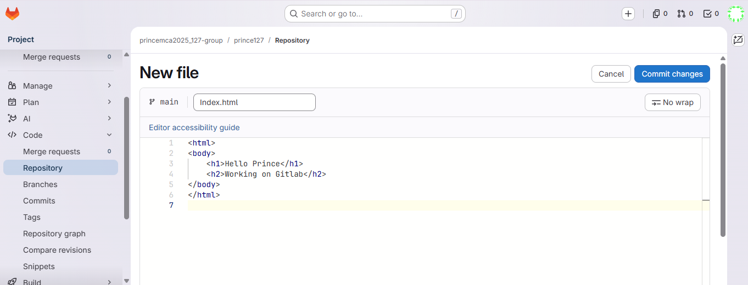

5. Click Commit and push changes
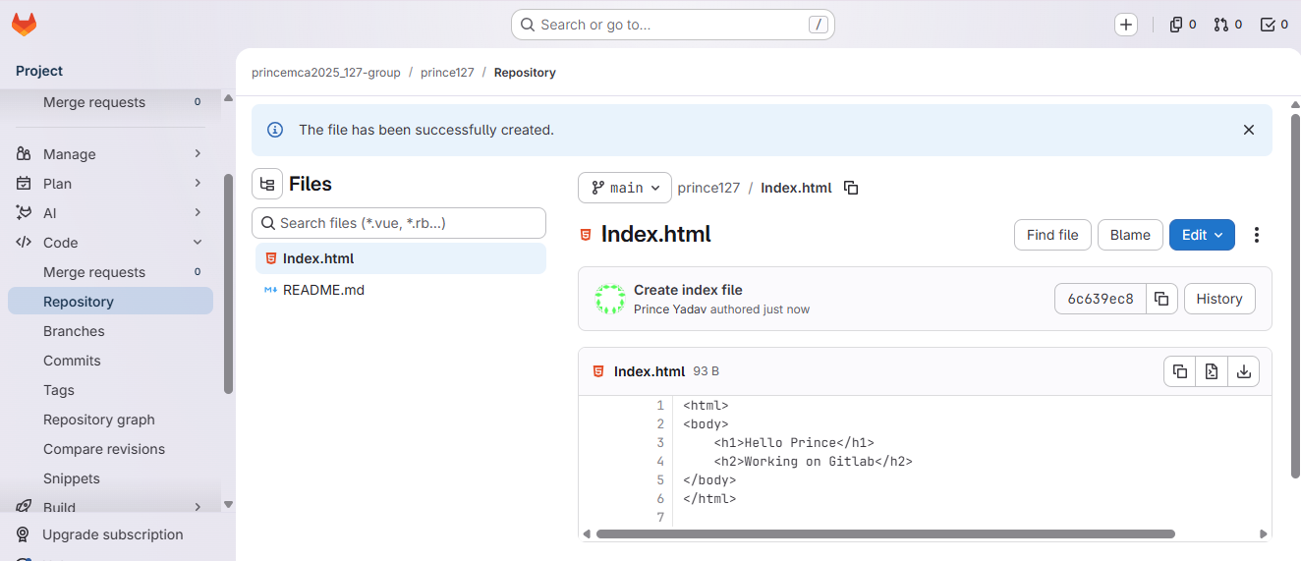

Practical – 6
Performing Merge Requests Using GitLab
Step 1. Create a new branch in Web IDE

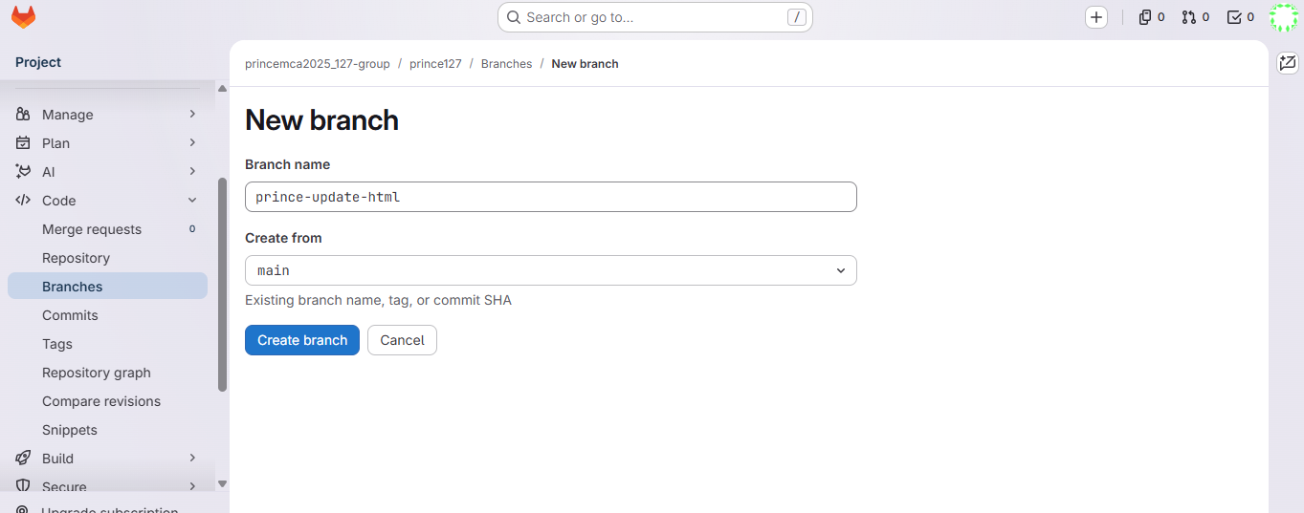
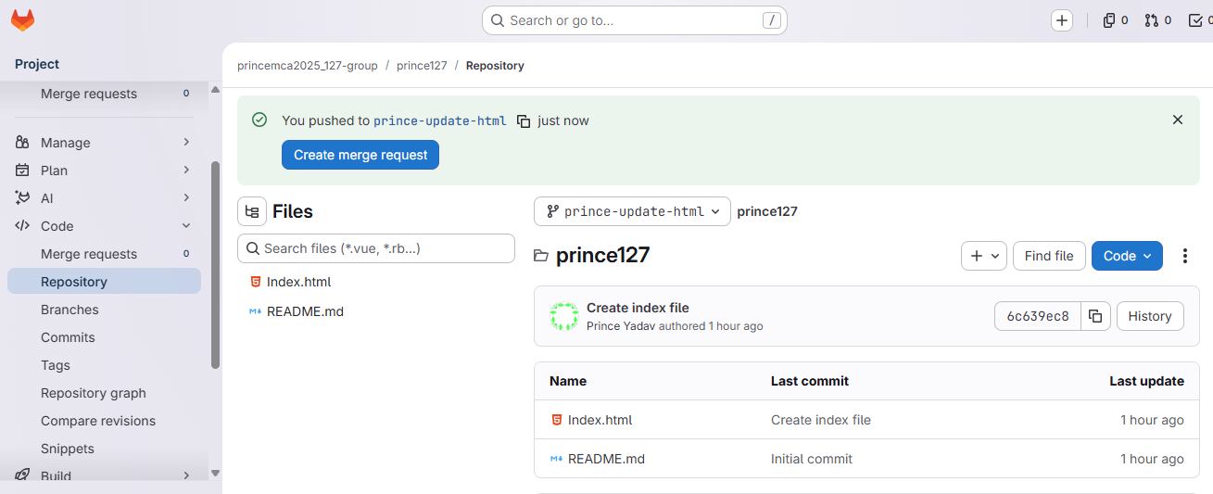

2. Add/edit a file and commit
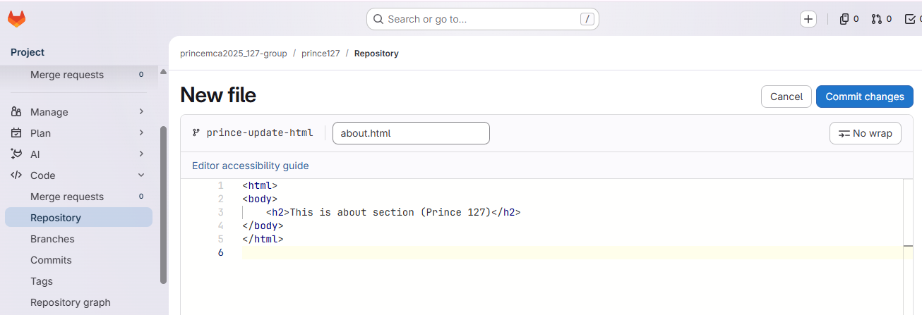

3. Click on Merge Requests > New Merge Request.
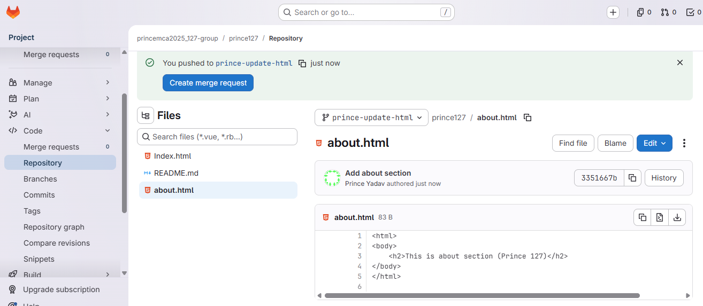

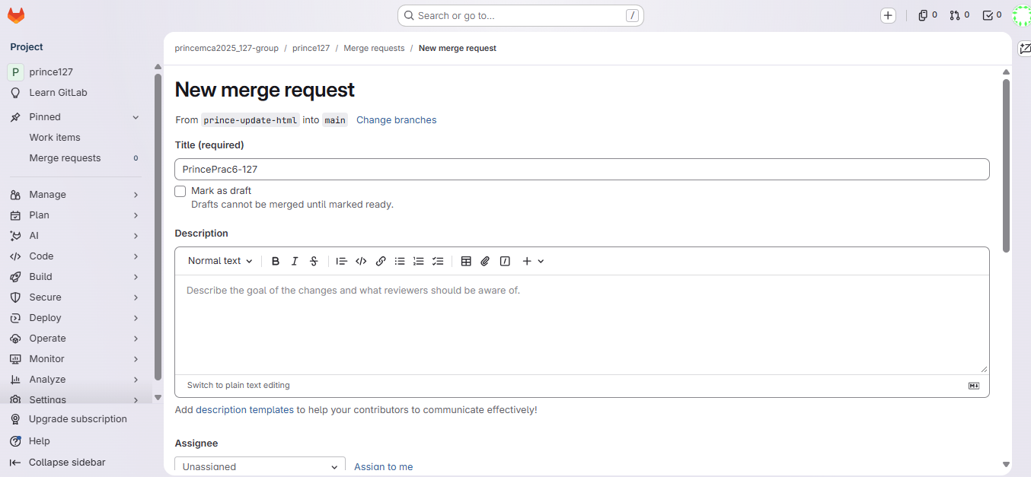

4. Select source and target branches
5. Submit and merge after review
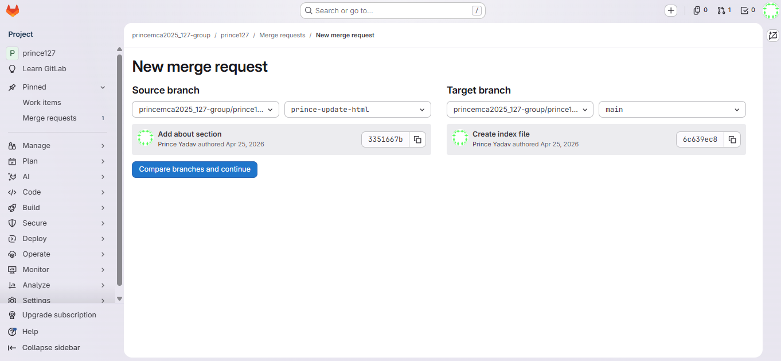

Practical No – 7
Workflow Management in GitLab
Steps1: In your repo, create .gitlab-ci.yml:
stages:
- build
- test
build-job:
stage: build
script:
- echo "Building..."
test-job:
stage: test
script:
- echo "Testing..."

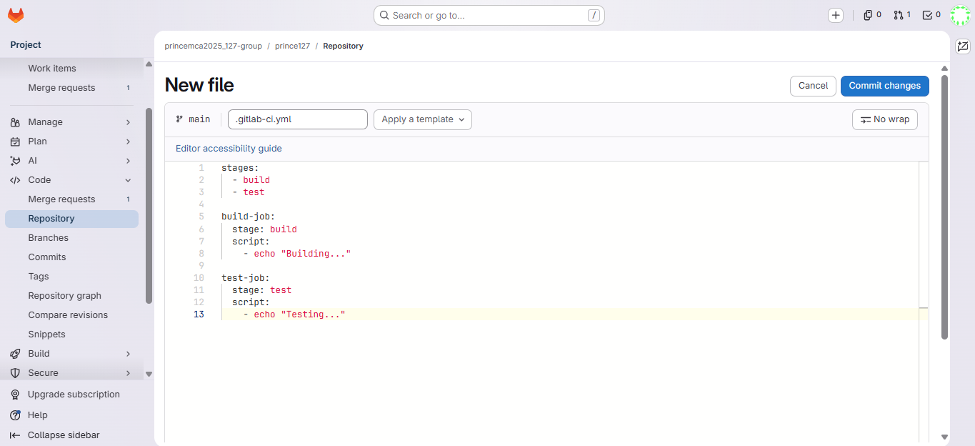

2. Commit and push.
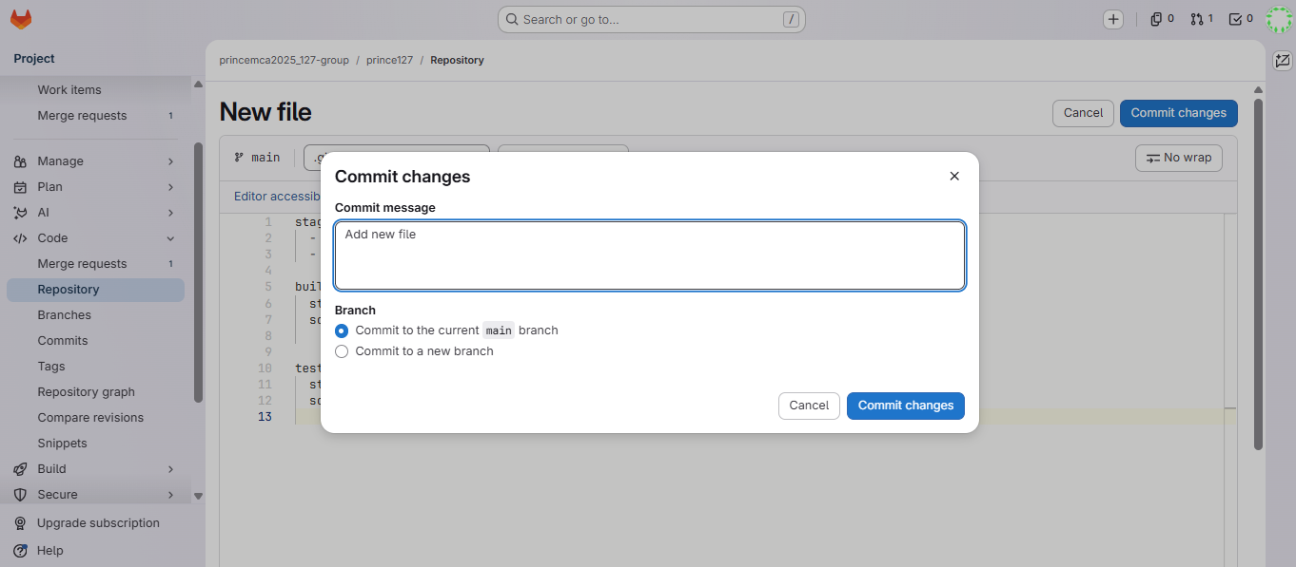

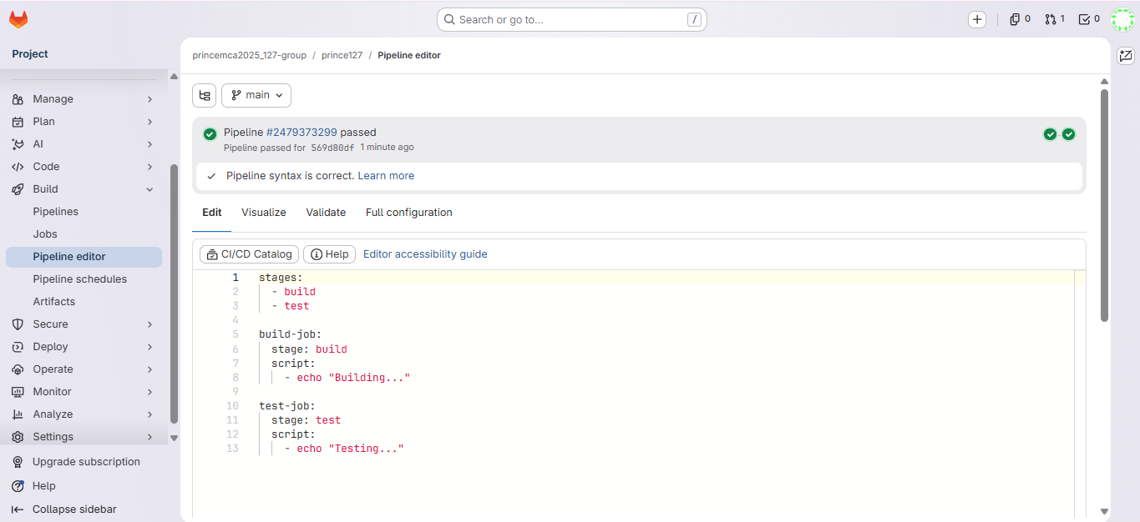

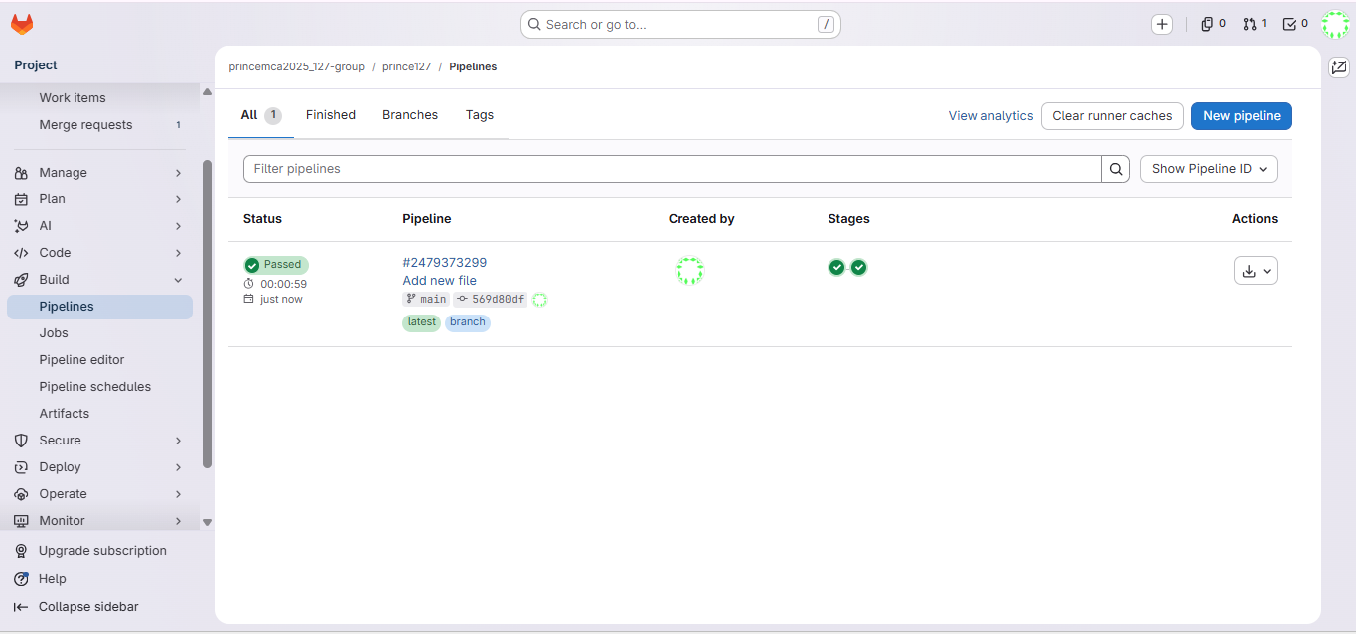

3. Go to CI/CD > Pipelines and view the build/test stages.
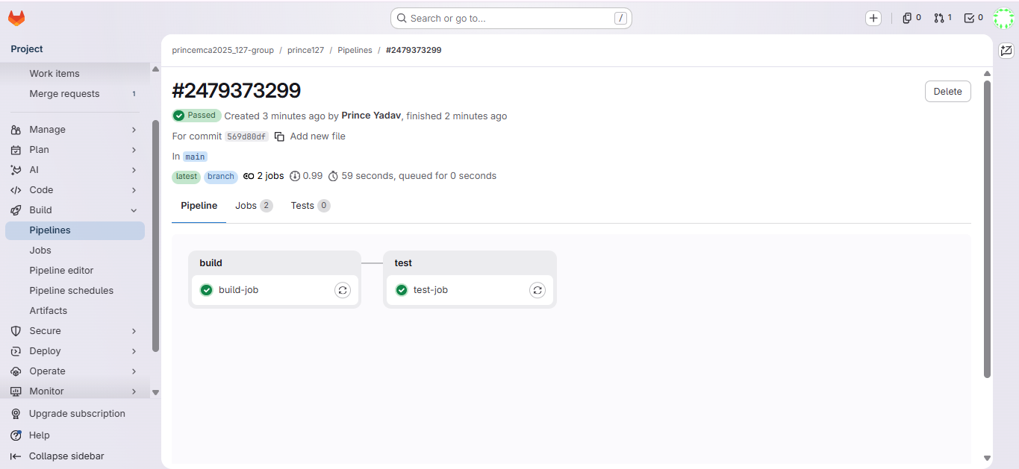
Practical No – 8
Continuous Integration and Development Using Jenkins
Steps:
1. Install Jenkins (visit https://www.jenkins.io)
2. Run Jenkins: http://localhost:8080
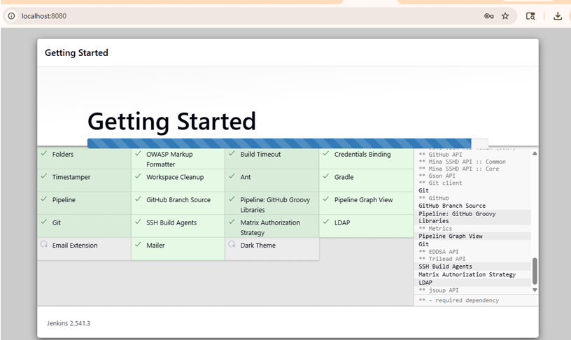
3. Create new Freestyle Project: CI-prince127
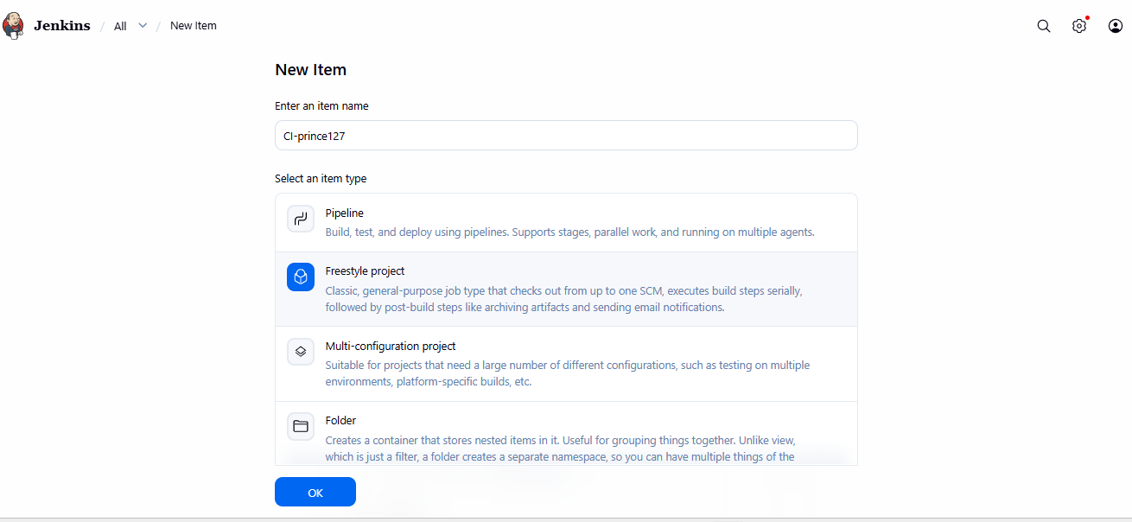

4. Under Source Code Management, choose Git and enter your repo URL.
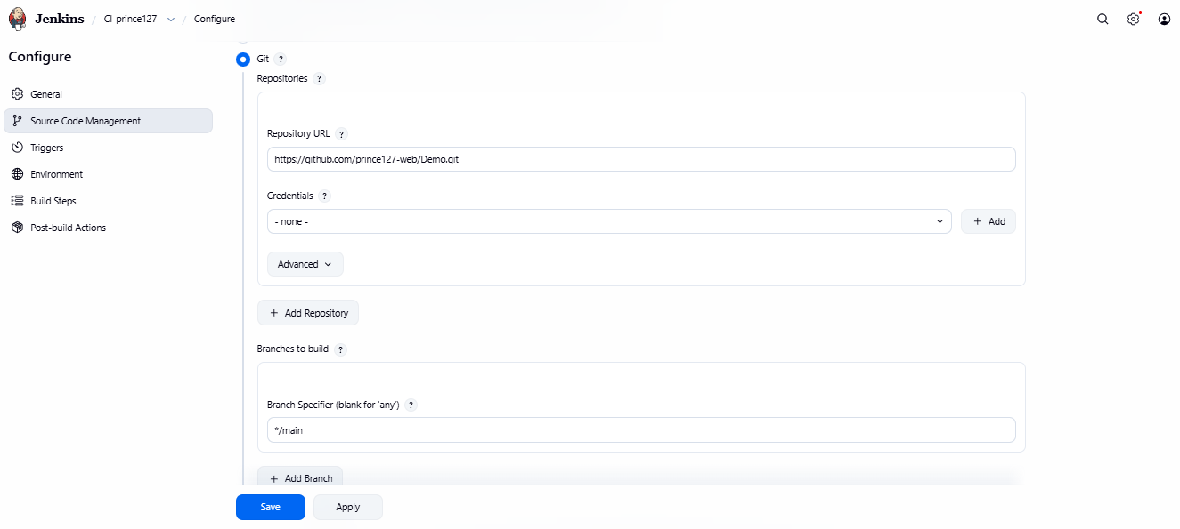

5. Add Build Step > Execute Windows batch command:
echo Building Project...
echo Run tests...
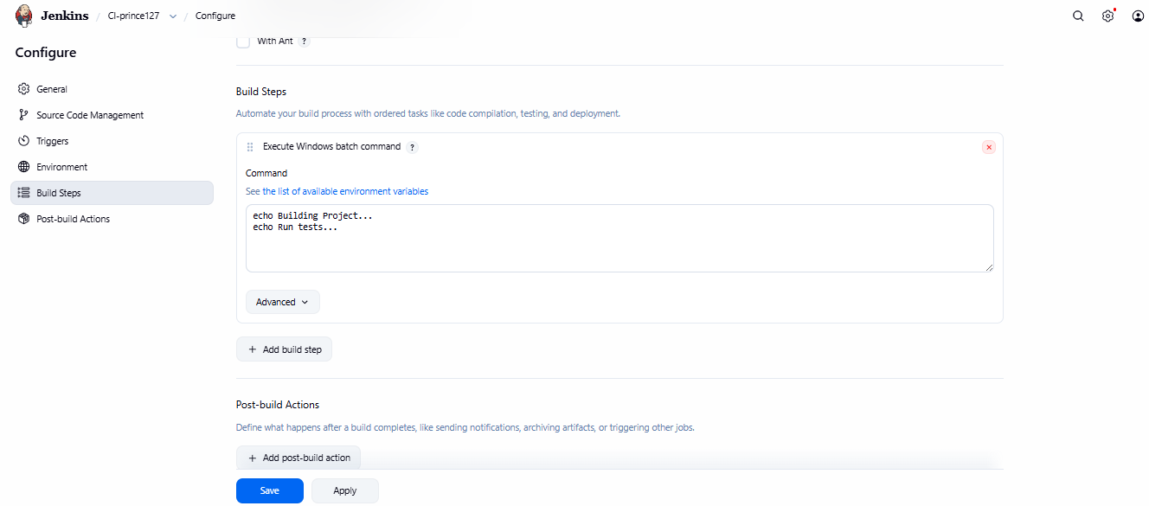

6. Save and click Build Now.
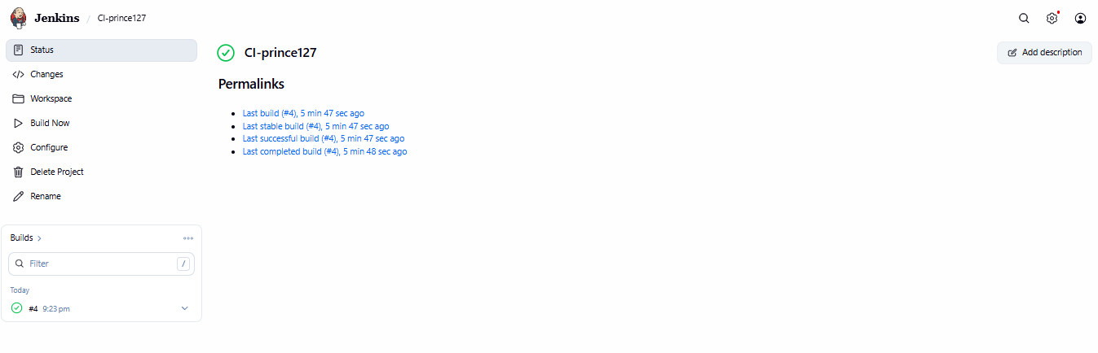
7. Check output in Console Output.
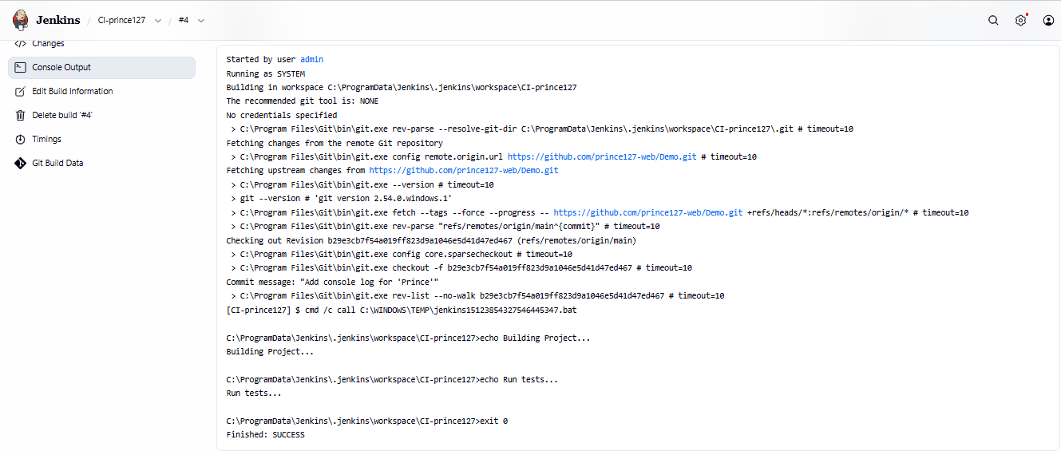

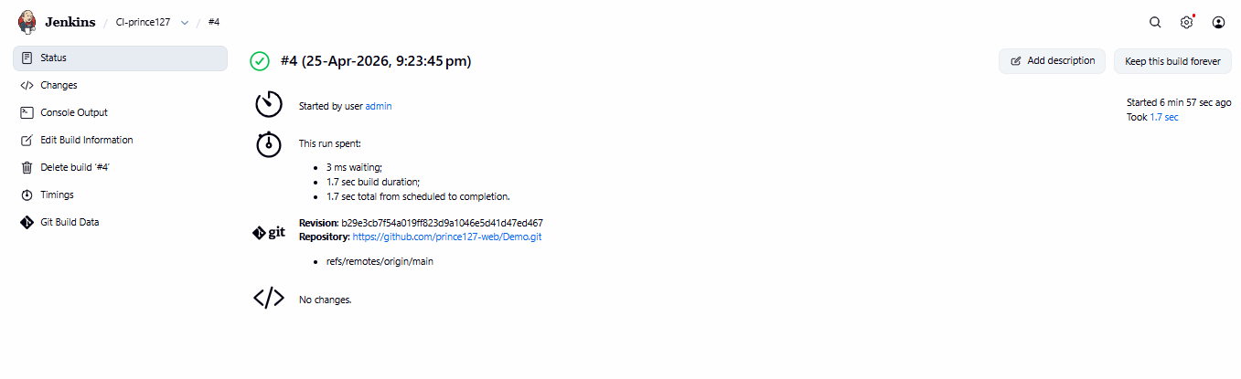

Practical - 9
1. Check Docker Version
docker version
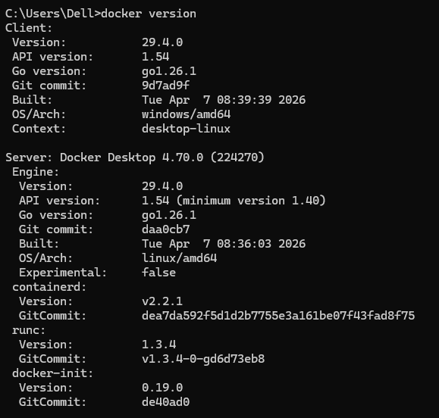
2. Pull Nginx Image
docker pull nginx
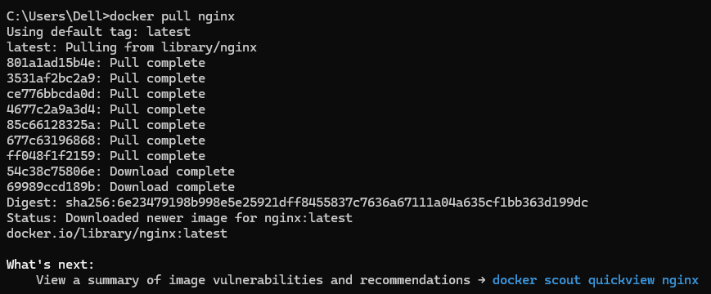

3. List Docker Images
docker images
4. Run Nginx Container
docker run -d -p 8081:80 --name mynginx nginx
5. List Running Containers
docker ps
6. Copy File from Host to Container
docker cp "D:\SIMS\prince127.html" mynginx:/usr/share/nginx/html/index.html
7. Copy File from Container to Host
docker cp mynginx:/usr/share/nginx/html/index.html "D:\SIMS\index.html"
8. Create Docker Volume
docker volume create mydata
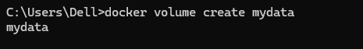
9. List Docker Volumes
docker volume ls
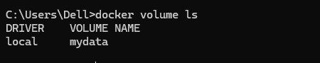
Step 10: Remove Container
docker rm -f mynginx
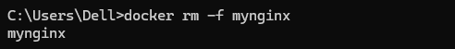
11. Remove Docker Image
docker rmi -f nginx
Output
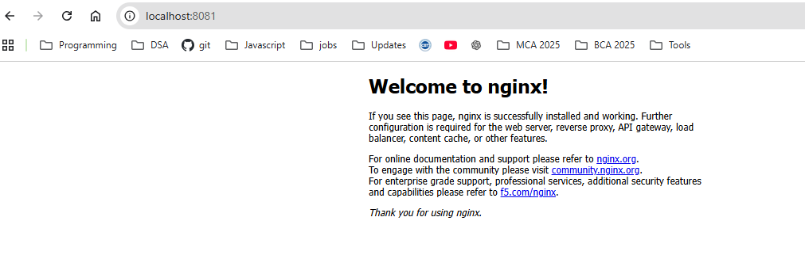
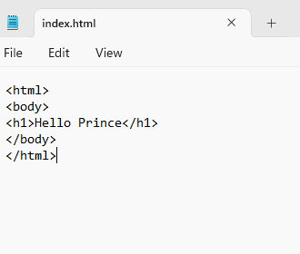
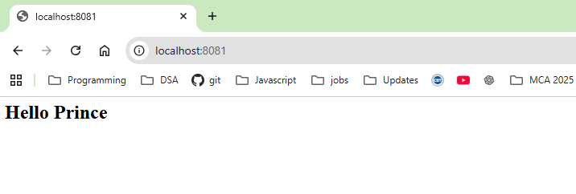

Practical – 10
Aim: Develop a Simple Containerized Application using Docker
Create Files index.html
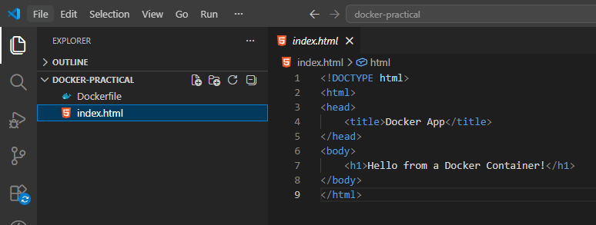
Dockerfile
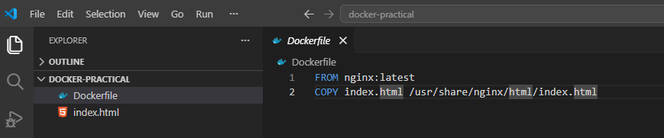
cd Desktop/docker-practical
docker build -t my-docker-webapp .
docker run -d -p 8081:80 --name webapp-container my-docker-webapp
docker ps
http://localhost:8081
docker stop webapp-container
docker rm webapp-container
docker rmi my-docker-webapp
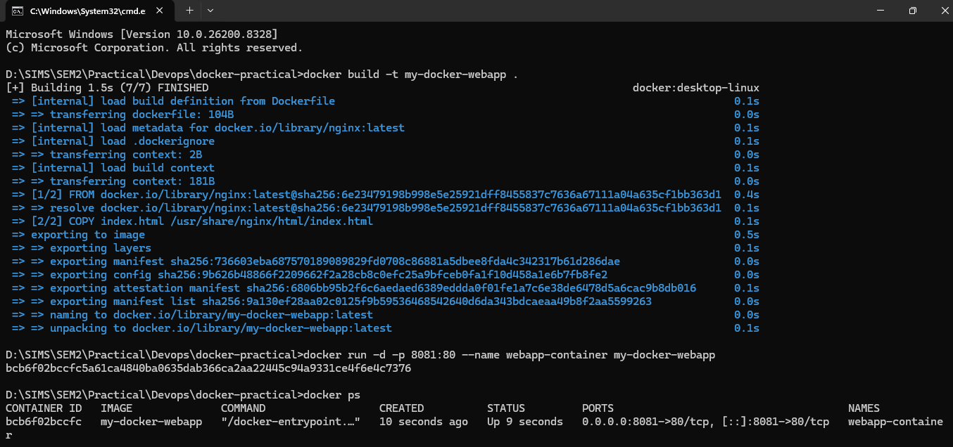
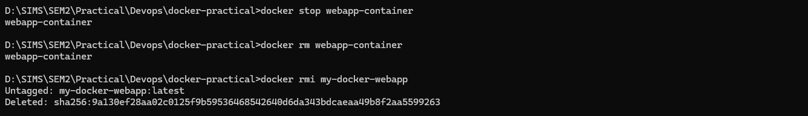
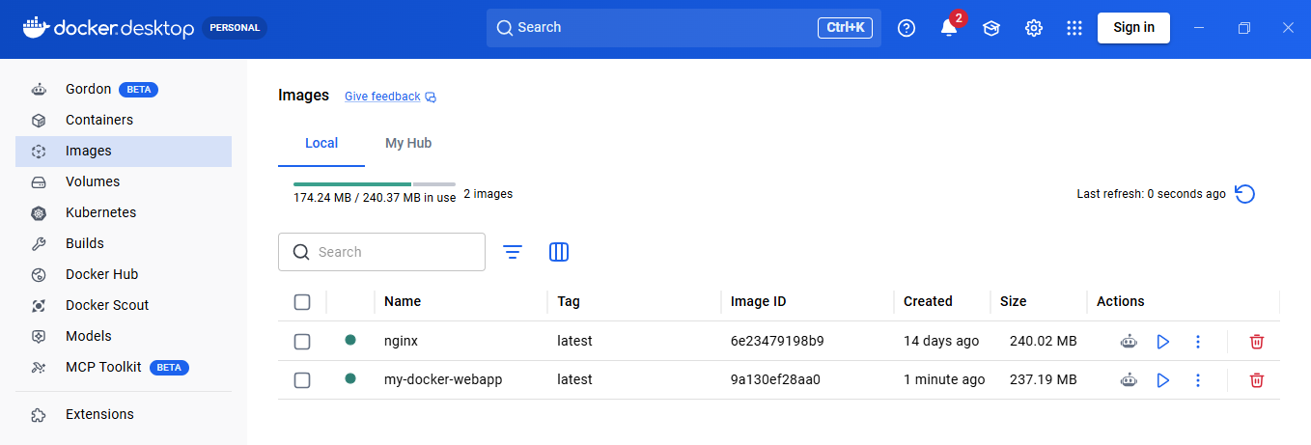
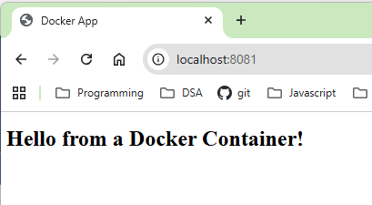

Practical No - 11

Ad-hoc Ansible Commands
Step 1: Update your VM
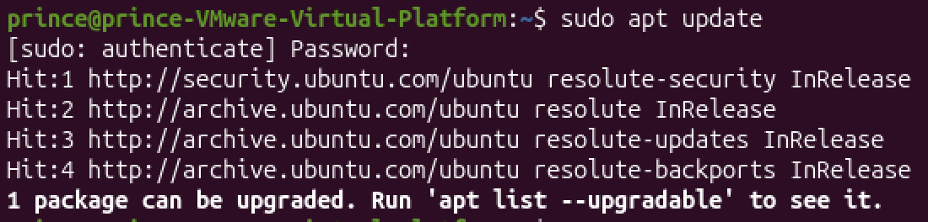
Step 2: Install Ansible
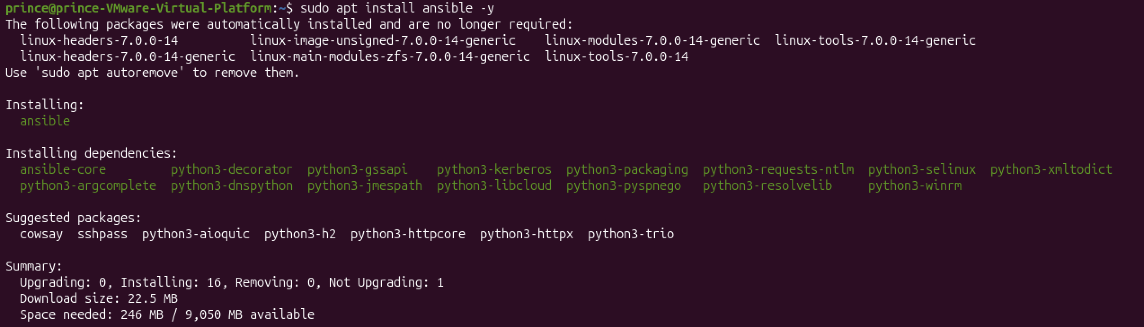

Step 3: Check version
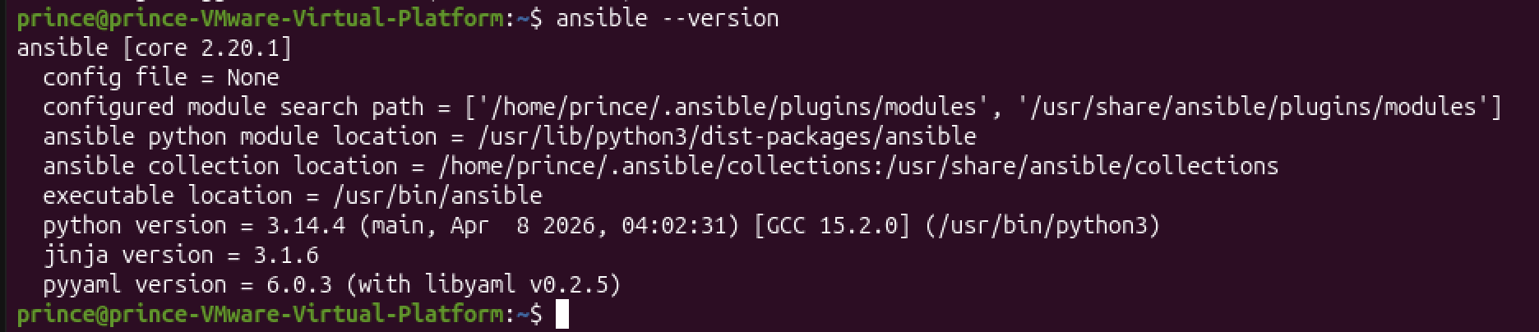
Step 4: Ping the remote host
ansible local -i host.ini -m ping
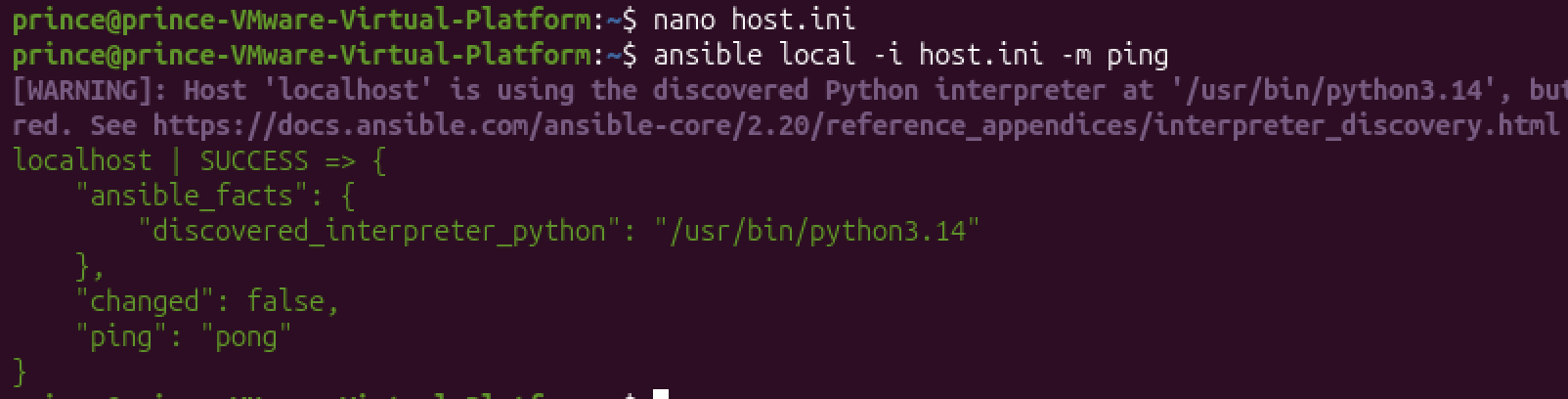

2. Check uptime
ansible local -i host.ini –a "uptime"
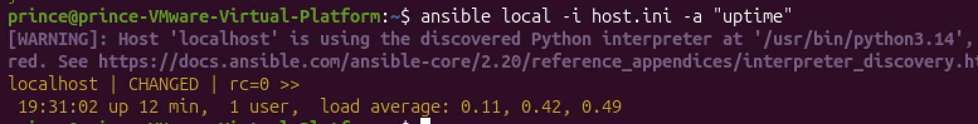
3. Install a package
ansible local -i host.ini -m apt -a "name=nginx state=present update_cache=yes"
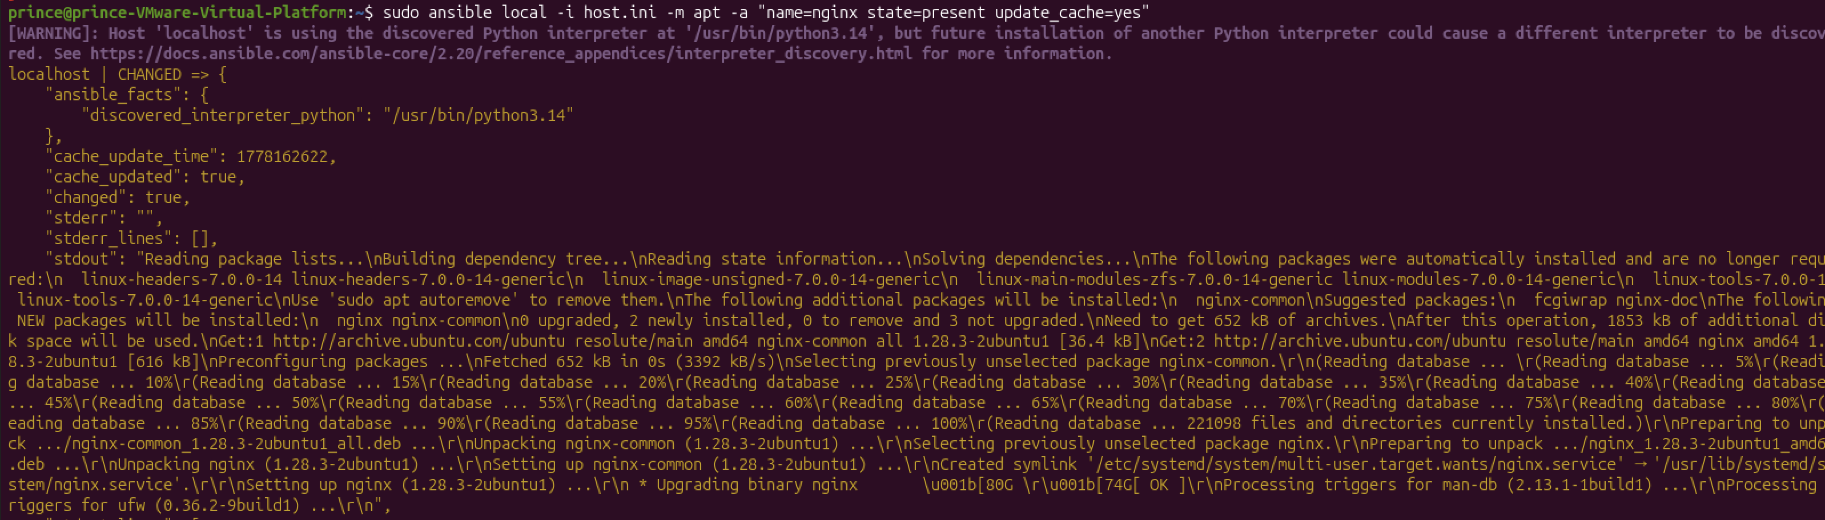
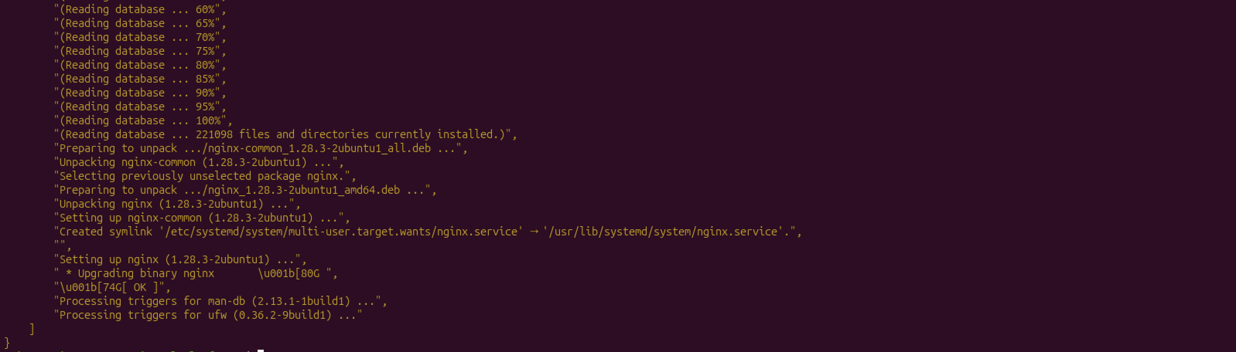

4.Start a service
ansible local -i host.ini -m service –a "name=nginx state=started"
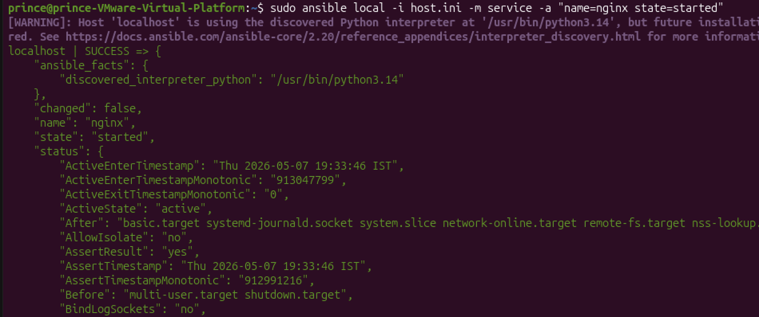
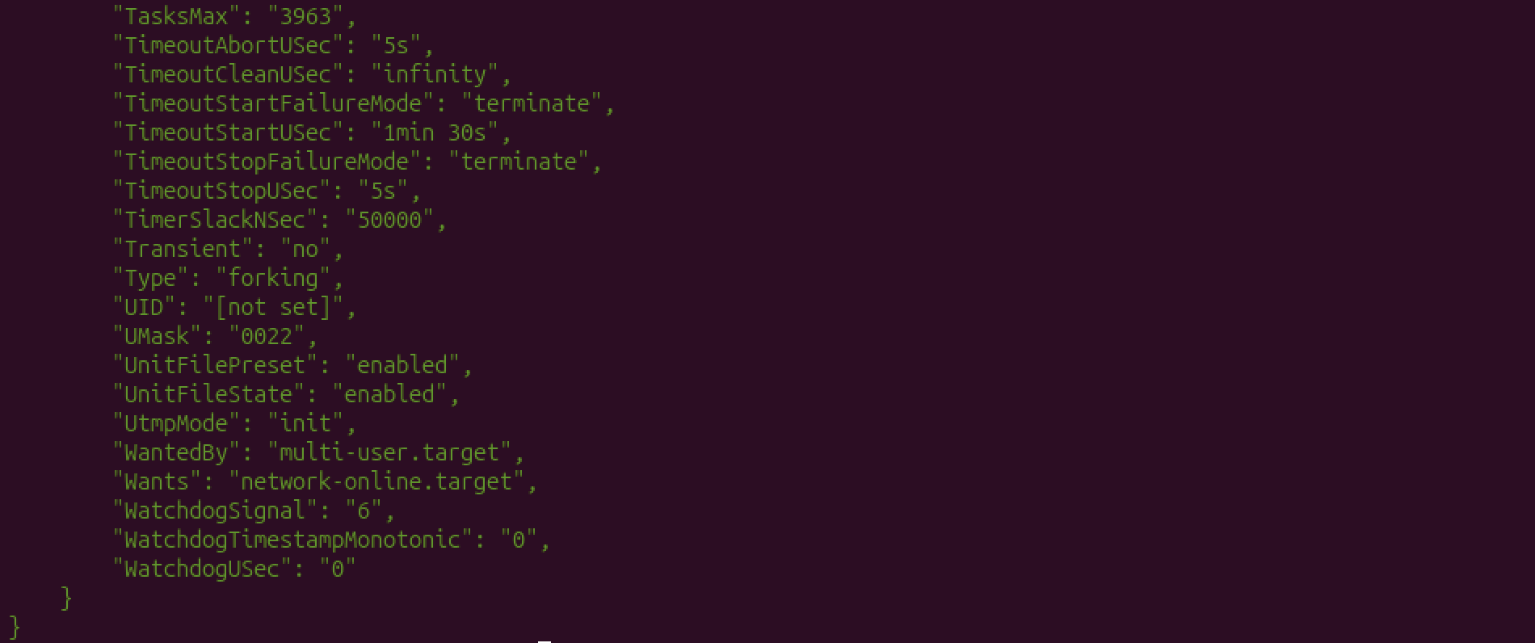

Practical - 12
Using Ansible Playbooks
Install and Start Nginx install_nginx.yml:

- name: Install and start Nginx on web servers
hosts: webservers
become: true

tasks:
- name: Install Nginx
apt:
name: nginx
state: present
update_cache: yes

- name: Start Nginx service
service:
name: nginx
state: started
enabled: true

sudo ansible-playbook -i host.ini install_nginx.yml
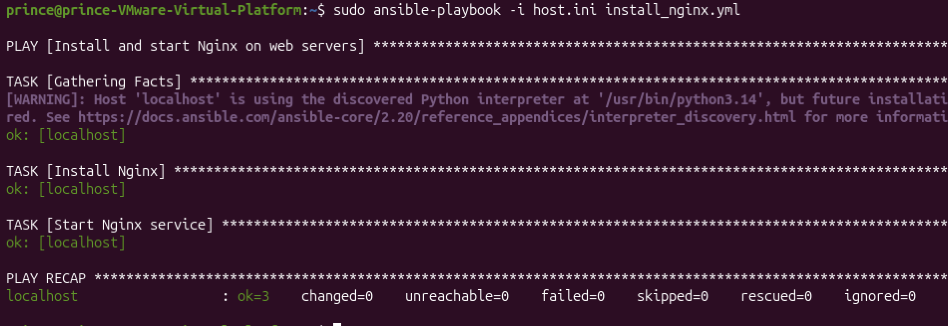
Verify
systemctl status nginx
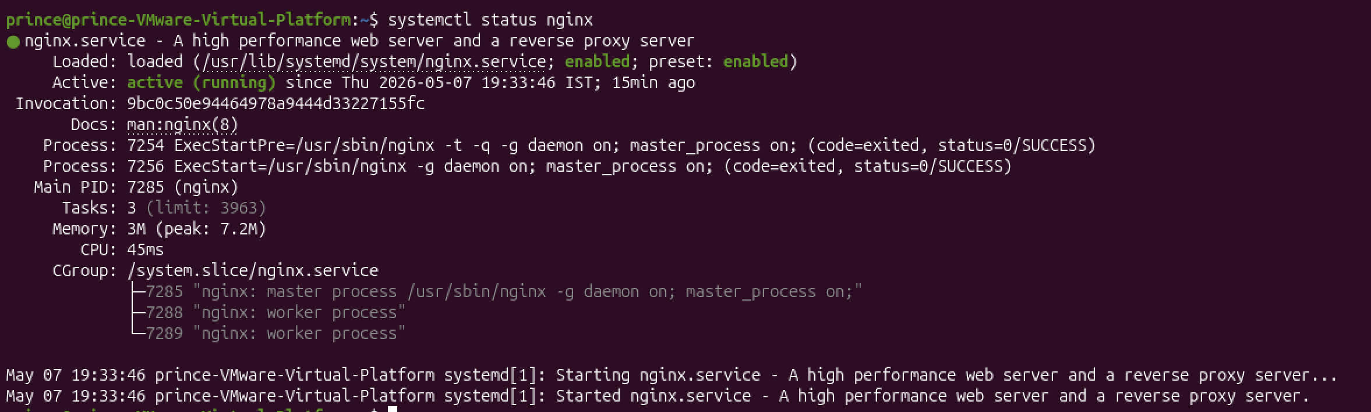
http://localhost
