STERLING INSTITUTE OF MANAGEMENT STUDIES, NERUL

Subject Code: MCAL25 Subject Name: User Interface Lab

INDEX

Sr No. | Name of The Experiment | Date
1. | Introduction to UI life cycle and UI tools | 23/02/26
2. | Project Proposal and Requirement Gathering (Introduction of  Project) | 02/03/26
3. | Logo Designing | 02/03/26
4. | Problem Statement: System Concept Statement | 07/03/26
5. | Design a persona. | 13/03/26
6. | Customer Journey Map | 16/03/26
7. | Entity-Relationship diagram. | 16/03/26
8. | Creation of Scenario- Story Board | 23/03/26
9. | Create Mind Map/ Site map | 23/03/26
10. | Create Wire framing | 13/04/26
11. | Create Prototype | 13/05/26
12 | Usability Evaluation of the Design  Testing of User Interface from Third Party (Test scripts). | 15/05/26

Experiment No - 1
Q. Introduction to UI life cycle and UI tools.
UI Life Cycle:
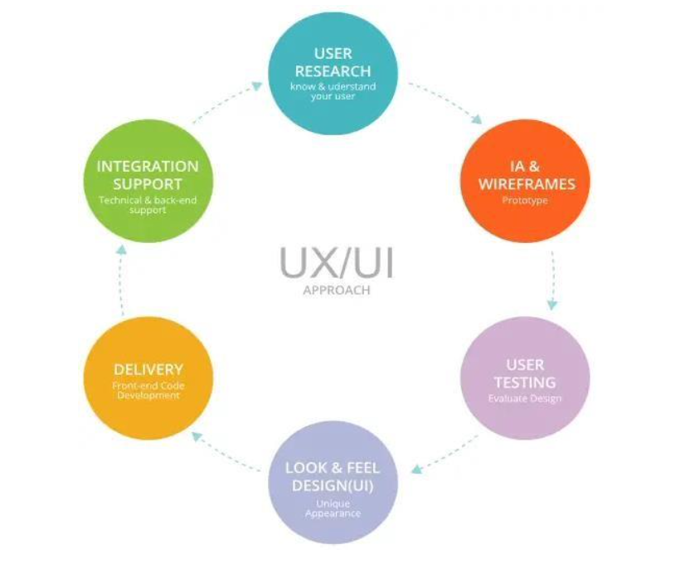
UI Tools:

1. InVision:

InVision is a web-based prototyping tool popular with both UX and UI designers alike.
You can upload static design files and quickly turn them into high-fidelity, interactive
prototypes.

2. Sketch:

The digital design app that every UI pro needs: Sketch. This is a vector-based tool, so you can easily resize anything that you draw without losing sharpness.

3. Figma:
Discover the very first in-browser interface design tool, Figma. With powerful editing
tools and loads of handy features, Figma is a one-stop shop for designing, prototyping
and gathering feedback. UI designers especially can take advantage of constraints
feature, which adapts your designs when the screen size changes. With the
components feature, it’s also extremely easy to reuse elements across your designs.

4. Flinto:
Flinto is an interactive prototyping app for Mac which offers pretty much everything
you need to bring your designs to life. Design micro-interactions and screen
transitions, add video layers simply by dragging video or GIF files straight into your
designs, incorporate UI sound effects and customizable scrolling—the list goes on.

5. Adobe XD:
Adobe XD is a vector-based tool for designing and prototyping user experiences for web,
mobile, and even voice! If you’re already familiar with the Adobe Creative Cloud suite,
you’ll feel right at home in Adobe XD—an extremely versatile tool which offers a whole
host of features for designing, prototyping, sharing, collaborating, and creating a
complete design system. XD natively supports Windows 10 and macOS, and is also
available as a mobile app for both Android and iOS. 3. Figma:
Discover the very first in-browser interface design tool, Figma. With powerful editing
tools and loads of handy features, Figma is a one-stop shop for designing, prototyping
and gathering feedback. UI designers especially can take advantage of constraints
feature, which adapts your designs when the screen size changes. With the
components feature, it’s also extremely easy to reuse elements across your designs.

Experiment No – 2
Q. Project Proposal and Requirement Gathering (Introduction of Project)
Project Name: Medminder (Medicine Reminder App for Elderly)
1. Introduction
Medminder is a healthcare-focused mobile application designed specifically for elderly individuals to help them manage their medication schedules effectively. As people age, remembering to take medicines on time becomes challenging due to memory issues, complex prescriptions, and multiple medications. Missing doses or taking incorrect medication can lead to serious health complications.
Medminder provides a simple, user-friendly, and accessible platform that reminds users to take their medicines on time. The app uses notifications, alarms, and easy-to-read interfaces to ensure that elderly users can use it comfortably without technical difficulty. It also helps caregivers monitor medication schedules, ensuring better health management and improved quality of life.
2. Problem Statement
Many elderly individuals face difficulties in remembering their medication timings, especially when prescribed multiple medicines with different schedules. Traditional methods like written notes or relying on memory are unreliable and often lead to missed or incorrect doses.
This problem becomes more serious for patients with chronic illnesses who require strict adherence to medication schedules. There is a strong need for a simple, digital solution that can remind, track, and manage medicine intake effectively.
Medminder aims to solve this issue by providing an easy-to-use medicine reminder system tailored specifically for elderly users.
3. Project Objectives
The main objectives of the Medminder application are:
- To remind users to take medicines on time through alerts and notifications
- To provide a simple and easy-to-use interface suitable for elderly users
- To allow users to add and manage multiple medications
- To help caregivers monitor medicine intake
- To reduce the chances of missed or incorrect medication
- To improve overall health management and patient safety

4. Scope of the Project
The scope of Medminder focuses on improving medication management for elderly users through a digital platform. The application will provide essential features that help users maintain their medicine schedule effectively.

Scope includes:
- Adding and managing medicine details
- Setting reminders and alarms for medication
- Viewing daily and weekly medicine schedules
- Tracking missed and taken doses
- Notifications for caregivers (optional feature)
The project mainly focuses on basic medication reminder functionality and user-friendly design. It does not include advanced medical diagnosis or direct integration with hospital systems.

Experiment No - 3
Q. Logo Designing
Link: https://www.figma.com/design/CArKrtde6PflkXyc7L34r9/Logo---Prince-127?node-id=0-1&t=upG6gUKF6A9d4o24-0
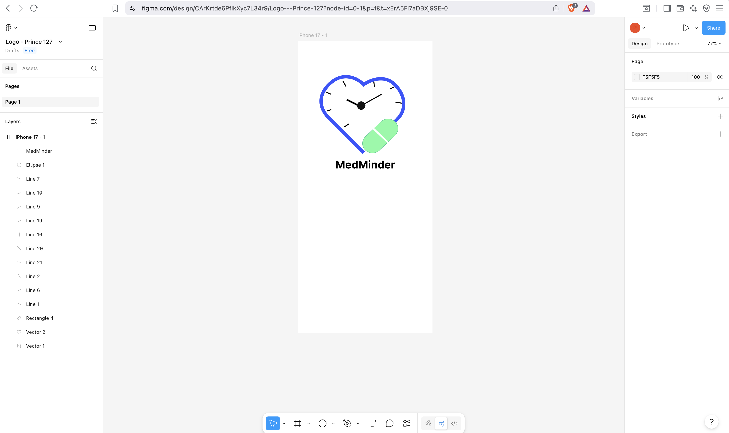

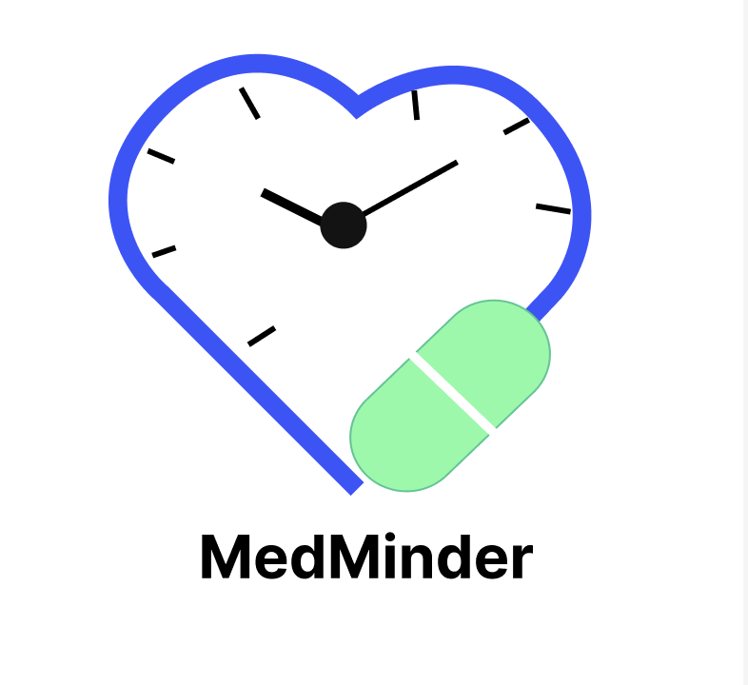

Experiment No – 4
Problem Statement: System Concept Statement
System Name: MedMinder (Medicine Reminder App for Elderly)
Target Users:
- Elderly individuals managing multiple medications
- Family members and caregivers
- Patients with chronic illnesses requiring strict medication schedules
Problem Statement:
Many elderly individuals face difficulty remembering their medication timings, especially when prescribed multiple medicines with different schedules. Traditional methods like written notes or relying on memory are unreliable and often lead to missed or incorrect doses, which can cause serious health complications.
System Solution:
MedMinder is a mobile application designed specifically for elderly individuals to help them manage their medication schedules effectively. The app provides timely notifications, alarms, and an easy-to-read interface so users never miss a dose. Caregivers can also monitor medication schedules and receive alerts when a dose is missed.
Key Features:
- Medicine Management - Add & manage multiple medicine details
- Smart Reminders - Notifications and alarms for each scheduled dose
- Daily and Weekly Schedule - View complete medicine timetable
- Dose Tracking - Track taken and missed doses with history
- Caregiver Access - Share schedule and receive missed-dose alerts
- User-Friendly Interface - Large text and simple navigation for elderly users

Final Concept Statement:
MedMinder is a mobile application designed for elderly individuals who struggle to manage complex medication schedules. The system allows users to add and track multiple medicines, set personalised reminders and alarms, and view their daily and weekly medicine schedule through a simple, large-text interface. Family members and caregivers can monitor medication adherence and receive alerts when a dose is missed. MedMinder aims to reduce the risk of missed or incorrect medication, improve patient safety, and support better health management for elderly users.

Experiment No – 5
Q. Design a user Persona
Link : https://www.figma.com/design/sxdUist0Nkc2dVBOR6ZmPH/Personas?node-id=0-1&t=SghcWrR2W8s9baTr-1

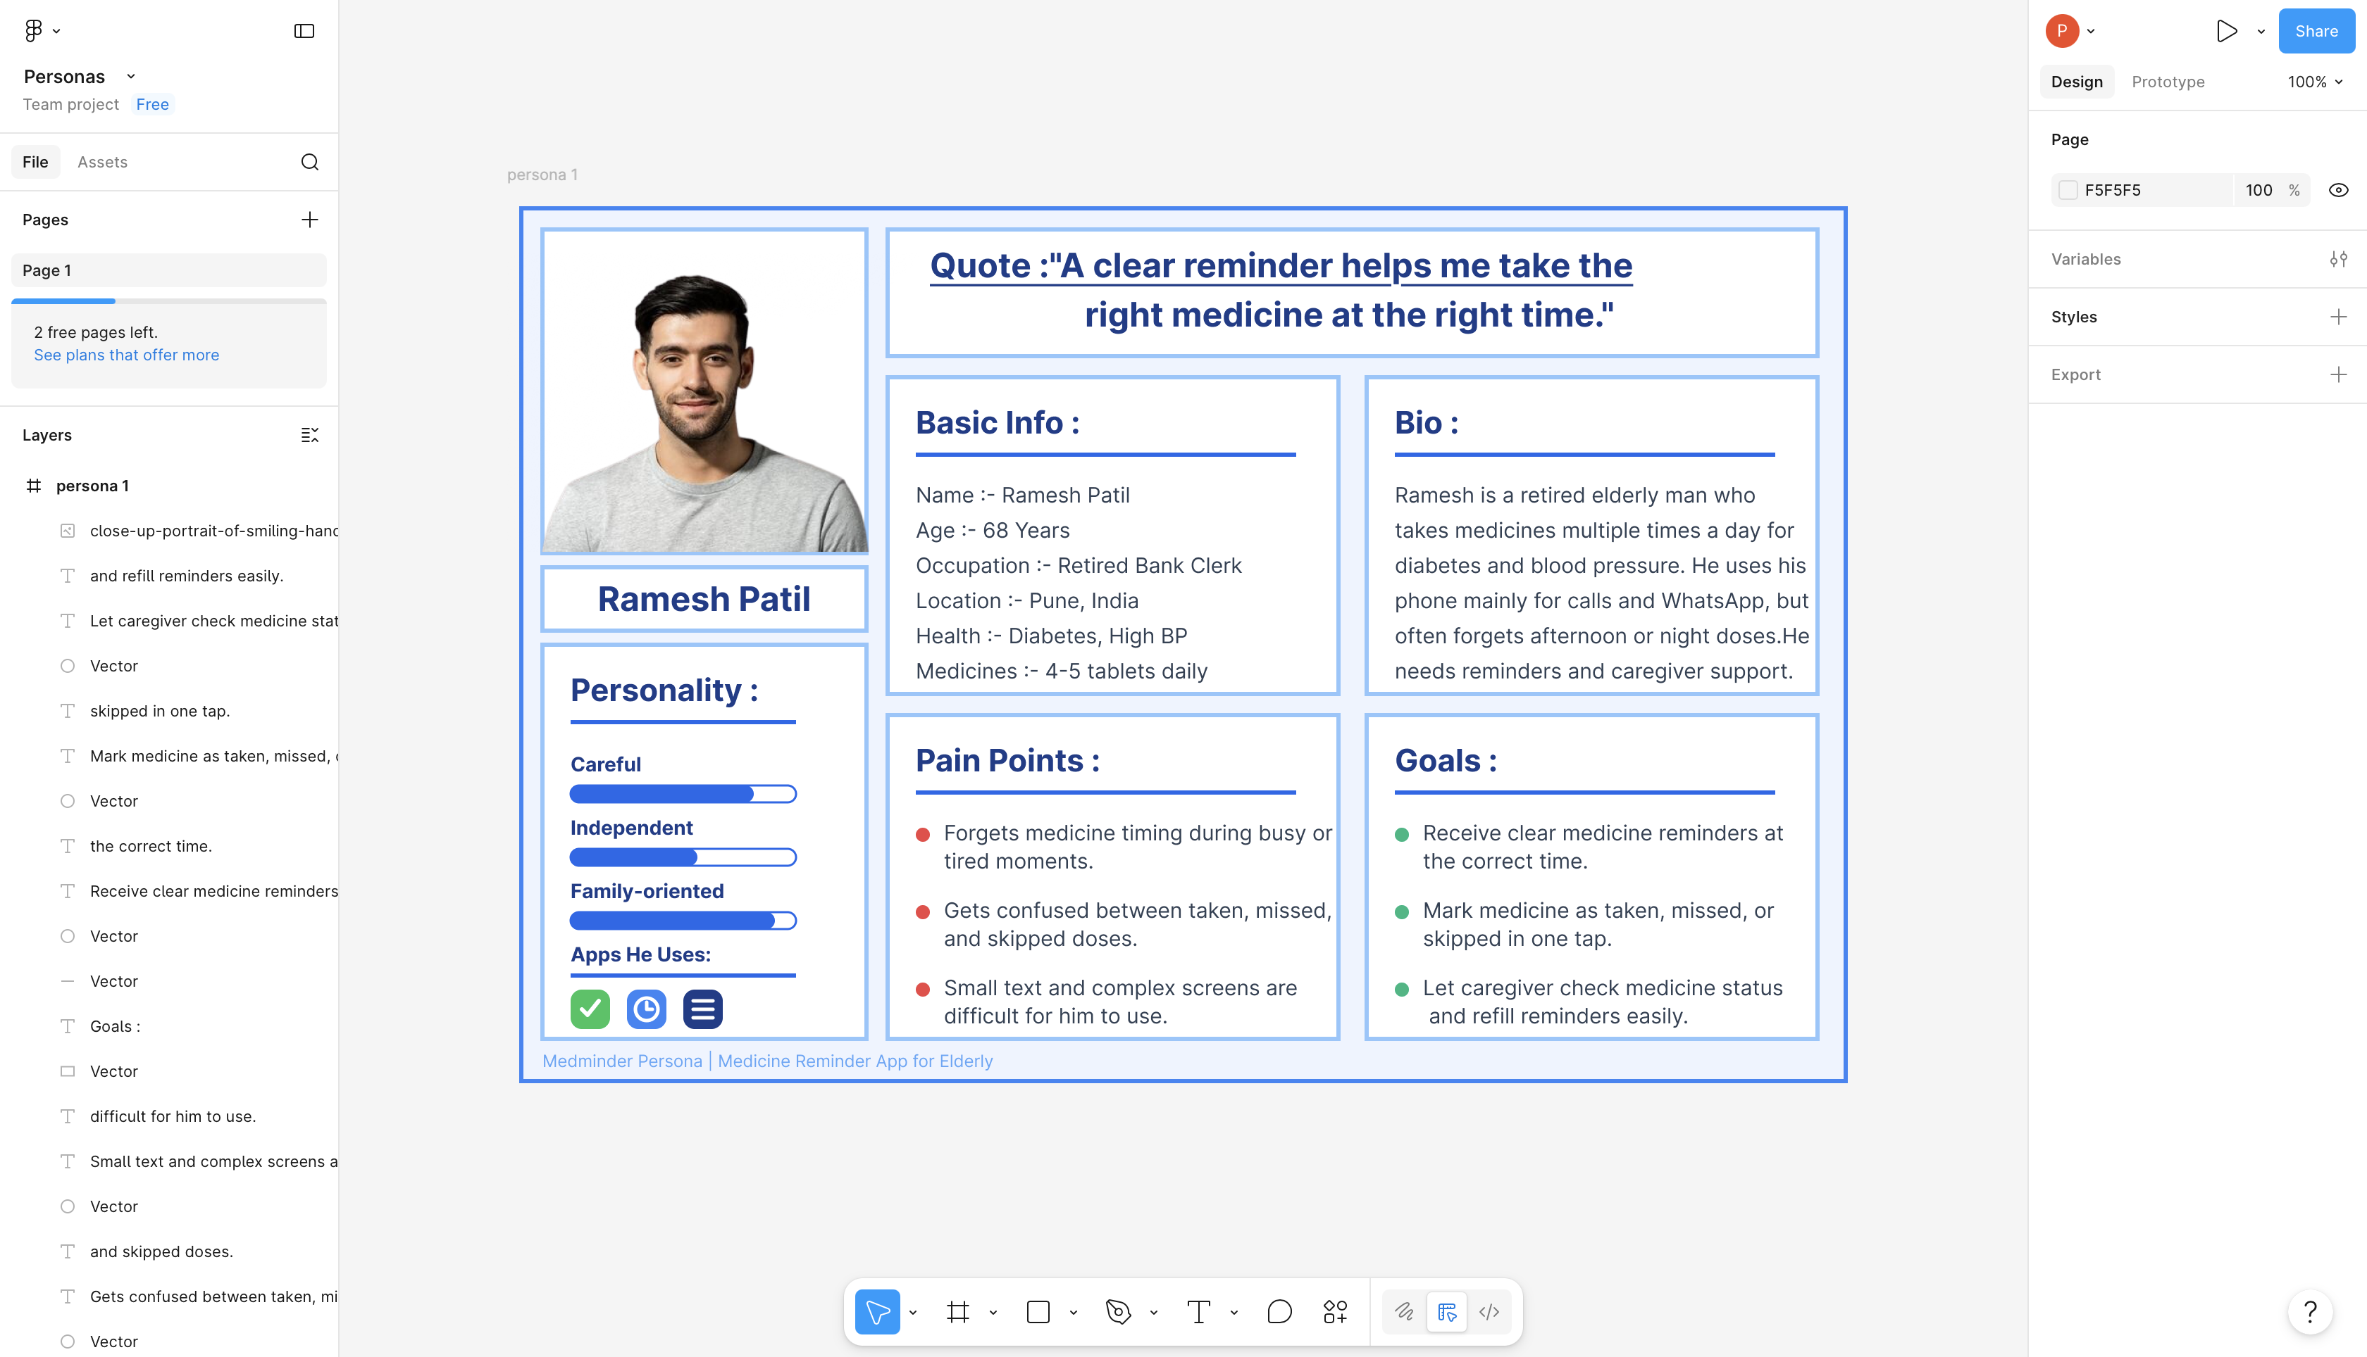

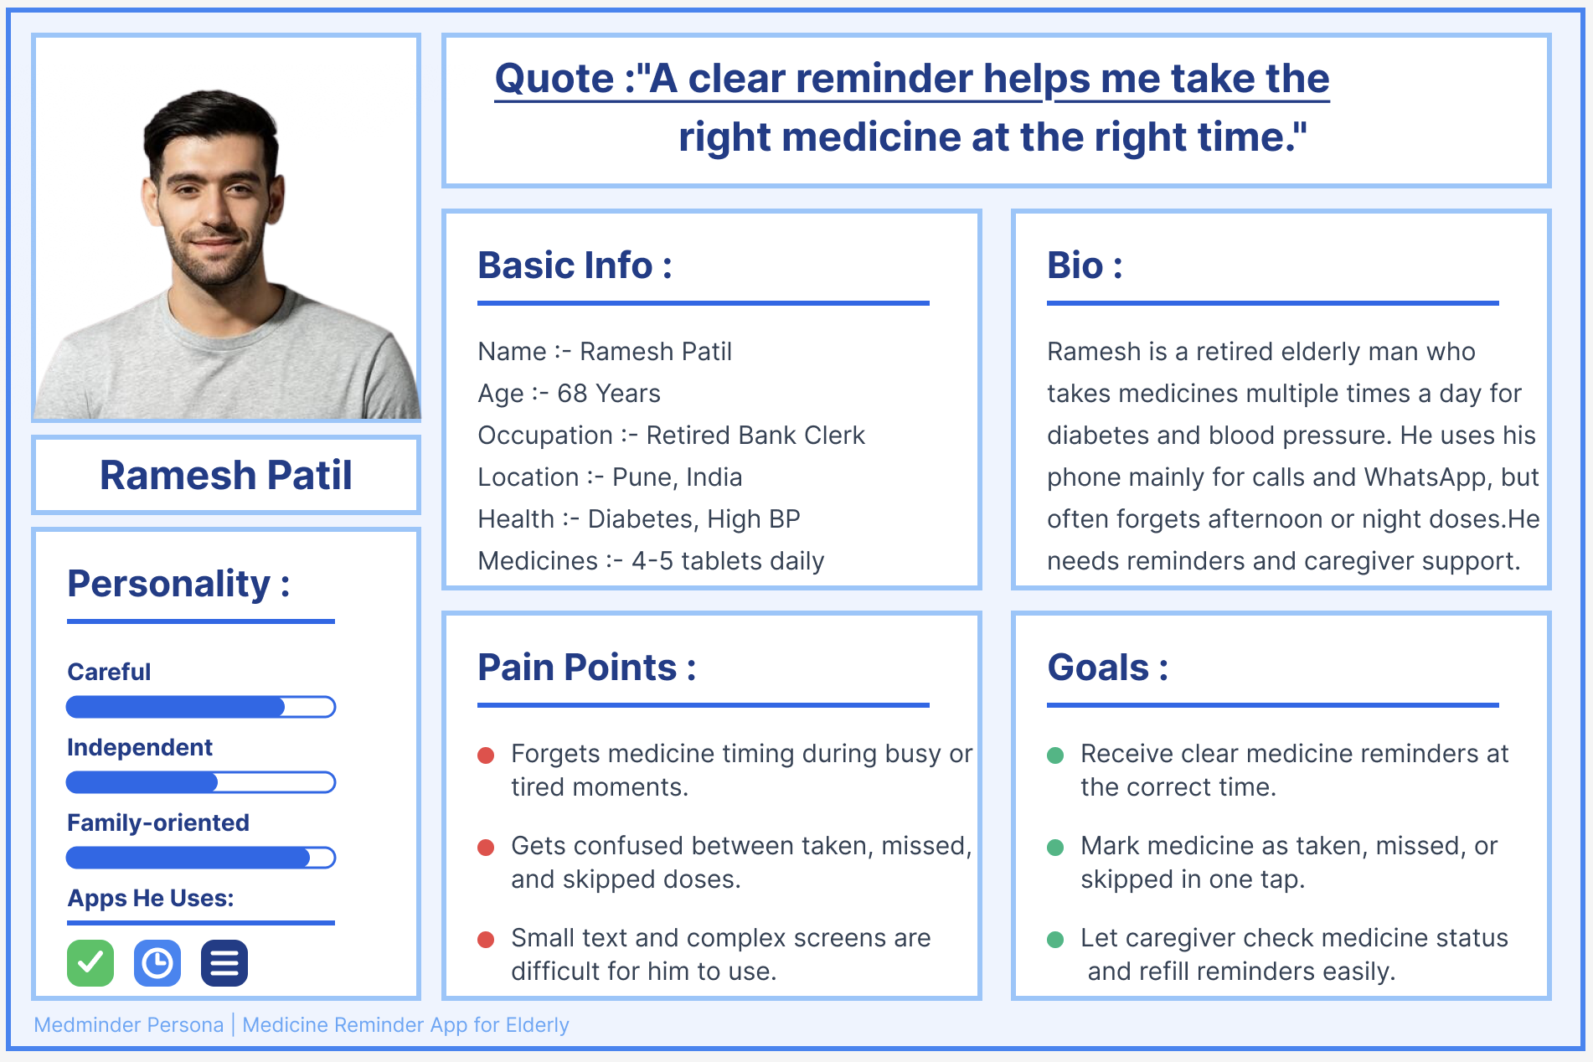

Q. User Requirement Gathering Questions
Section 1: Demographics Questions
(To understand who the user is)
- What is your age?
- What is your gender? Male / Female / Other
- What is your educational background?
- Where do you currently live? (City / Village / Town)
- Do you live alone or with family members?
- Do you have a caregiver or family member who helps you with daily tasks?
Section 2: Questions About Profession
(To understand daily routine and lifestyle)
- Are you currently working or retired?
- What was or is your profession/occupation?
- How many hours per day do you spend on a screen or mobile device?
- Do you use any digital apps or tools in your daily routine?
Section 3: Questions About Physical and Social Environment
(To understand the user's living and health conditions)
- Do you have any chronic health conditions? (e.g. Diabetes, Hypertension, Heart disease)
- How many medicines do you take daily?
- Do you currently use any system (diary, reminder, caregiver) to manage your medicines?
- How often do you visit a doctor or hospital?
- Do you have family members or caregivers nearby who can assist you?
- Have you ever missed a medicine dose? If yes, how often?
Section 4: Questions About Technical Environment
(To understand the user's comfort with technology)
- Do you own a smartphone? If yes, which type? (Android / iPhone)
- How comfortable are you using mobile apps? (Very comfortable / Somewhat / Not at all)
- Do you use WhatsApp, YouTube, or any other mobile apps regularly?
- Have you ever used a health or medicine reminder app before?
- Do you prefer large text and simple buttons on your phone screen?
- Do you have internet access at home?
Section 5: Questions About Goals and Motivations
(To understand what the user wants to achieve)
- What is your main reason for wanting a medicine reminder app?
- What would motivate you to use a medicine tracking app every day?
- How important is it to you to take medicines on time? (Very / Somewhat / Not much)
- Would you like the app to also track your health progress over time?
- Would you like to share your medicine schedule with a family member or caregiver through the app?
Section 6: Questions About Values, Fears and Challenges
(To understand user pain points and concerns)
- What is the biggest challenge you face in remembering to take medicines?
- Are you worried about your personal health data being stored in an app? Why?
- Would you be concerned if the app sent alerts to your family without your permission?
- What frustrates you most about using mobile apps in general?
- Have you ever experienced a health problem due to missing a medicine dose?
Section 7: Questions About Personal Preferences and Traits
(To understand how the user wants to interact with the app)
- Do you prefer reminders as sound alarms, vibrations, or visual pop-ups?
- How often would you like to receive reminders? (Before / At the time / After dose time)
- Would you prefer the app to be in English, Hindi, or another regional language?
- Do you prefer simple one-tap actions in apps, or are you okay with multiple steps?
- Would you like a "Snooze" option for reminders if you are busy?
- Do you prefer light mode or dark mode on your phone screen?
Section 8: Buyer Behavior Questions
(To understand willingness to adopt and use the app)
- Would you be willing to use a free medicine reminder app?
- If the app required a small monthly fee for extra features, would you pay for it?
- Who influenced or would influence your decision to use a health app? (Doctor / Family / Friends)
- Would you recommend this app to other elderly family members or friends?
- What would make you stop using a medicine reminder app?
Section 9: Questions About Competitors and Preferred Tools
(To understand existing solutions and user comparisons)
- Have you used any other medicine reminder or health app before? (e.g. Medisafe, Google Reminders)
- What did you like or dislike about those apps?
- Do you prefer using a physical pill organizer instead of a digital reminder?
- What feature would make MedMinder better than other reminder tools you have tried?
Section 10: Questions Specific to MedMinder (Product/Service)
(To gather direct feedback on the MedMinder app features)
- Which feature of MedMinder do you think would be most helpful to you? (Reminders / Dose tracking / Caregiver alerts / Schedule view)
- How do you want to add a medicine to the app? (By typing name / Scanning prescription / Doctor input)
- Would you use the Medicine History screen to check past doses?
- Would you like an emergency contact button visible on the home screen?
- How would you rate the importance of the Caregiver Access feature? (1 to 5)
- Is there any feature you would like in MedMinder that has not been mentioned?

Experiment No – 6

Q. Design a Customer Journey Map
Link: https://www.figma.com/design/Y92k5zZHoV7mnQgWckURCX/Customer-Journey-map?t=1IAjBNIJG3zO8Zyc-1
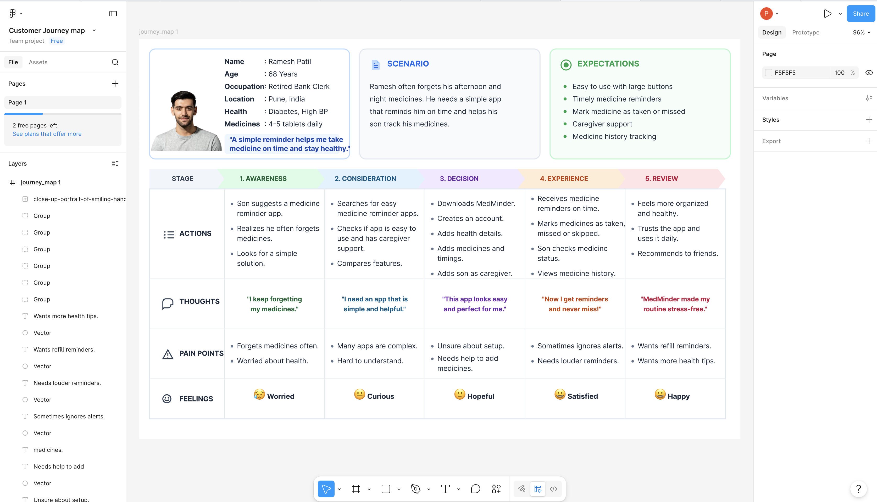

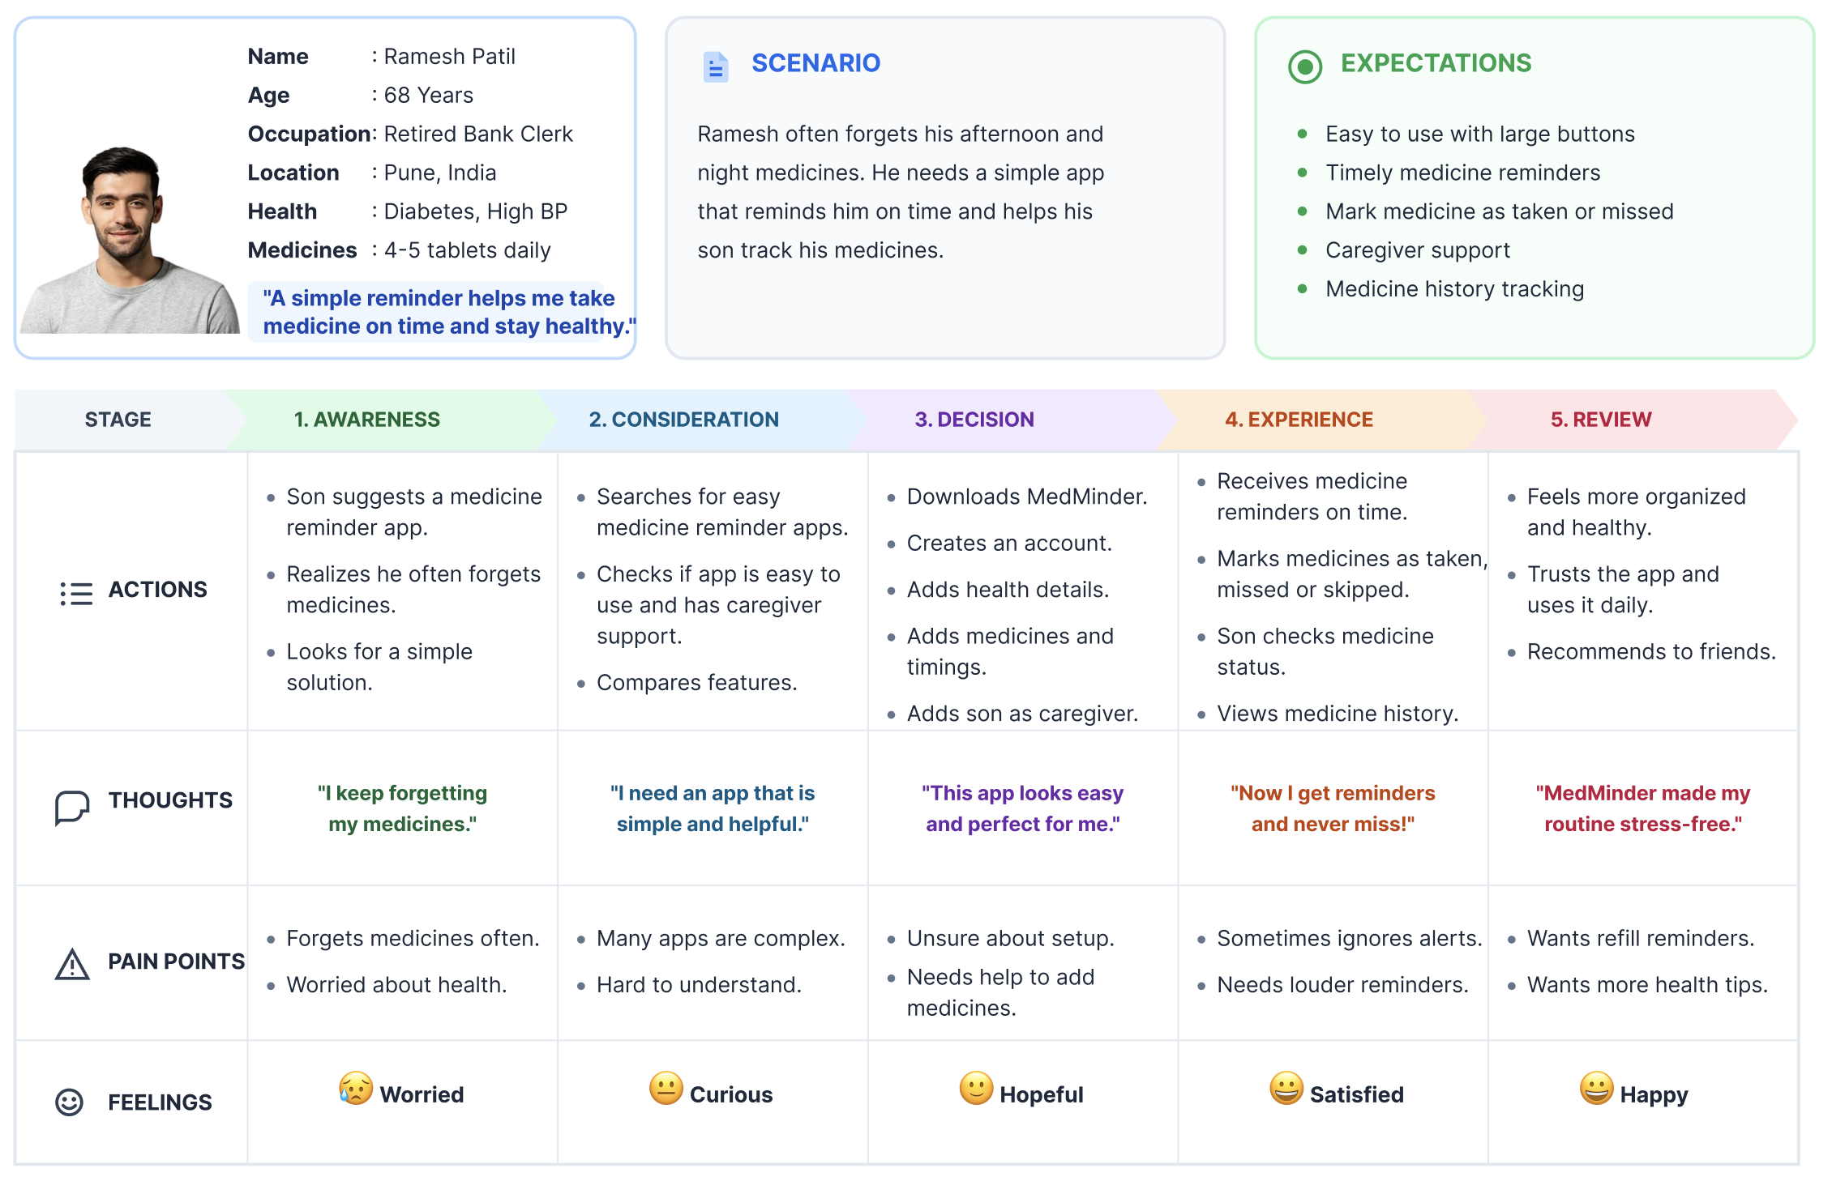

Experiment No – 7
Q. ER (Entity Relationship) Diagram.
MedMinder (Medicine Reminder App for Elderly)

ER Diagram stands for Entity Relationship Diagram, also known as ERD is a diagram
that displays the relationship of entity sets stored in a database. In other words, ER diagrams help to explain the logical structure of databases. ER diagrams are created based on three basic concepts: entities, attributes and relationships.

ER Diagrams contain different symbols that use rectangles to represent entities, ovals
to define attributes and diamond shapes to represent relationships.

ER Model stands for Entity Relationship Model is a high-level conceptual data model
diagram. ER model helps to systematically analyse data requirements to produce a well
designed database. The ER Model represents real-world entities and the relationships
between them. Creating an ER Model in DBMS is considered as a best practice before
implementing your database.

Some E-R model notations are:
1. Entity: entity is thing or object that can be distinguish.
Ex: person is an entity as every person is distinguishable.

2. Attribute: each entity has set of attributes.
Ex: entity person has attributes like name age address gender etc

3. Relationship: relationship is an association among several entities .
example and enquiry relationship is there between customer entity and Railway entity.

Some Notations of E-R model are:
1. Rectangle: It represent entity set.


2. Ellipse: It represent attributes.


3. Diamond: It represents relationship among entity set

4. Line: Line lies between the attribute entity and entity to relationship.
ER Diagram:
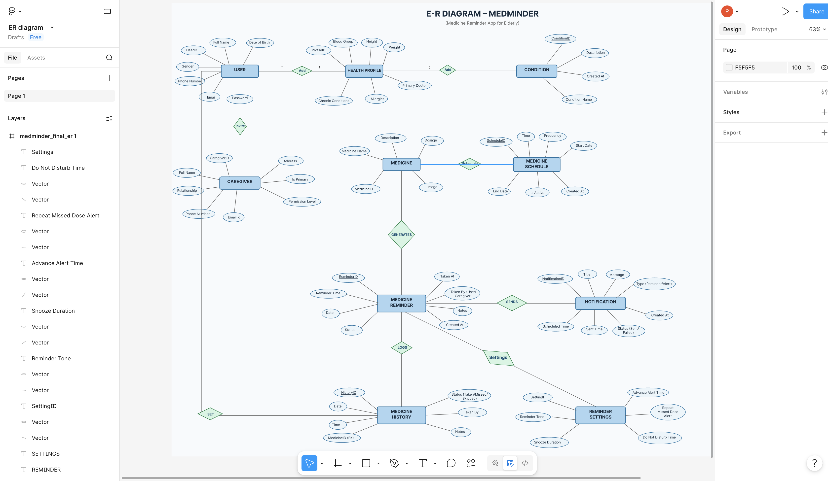
Link - https://www.figma.com/design/l8So6xsj4KePfkqMIo9KsG/ER-diagram?node-id=0-1&t=ZUGwfULk3yTkQHg8-1
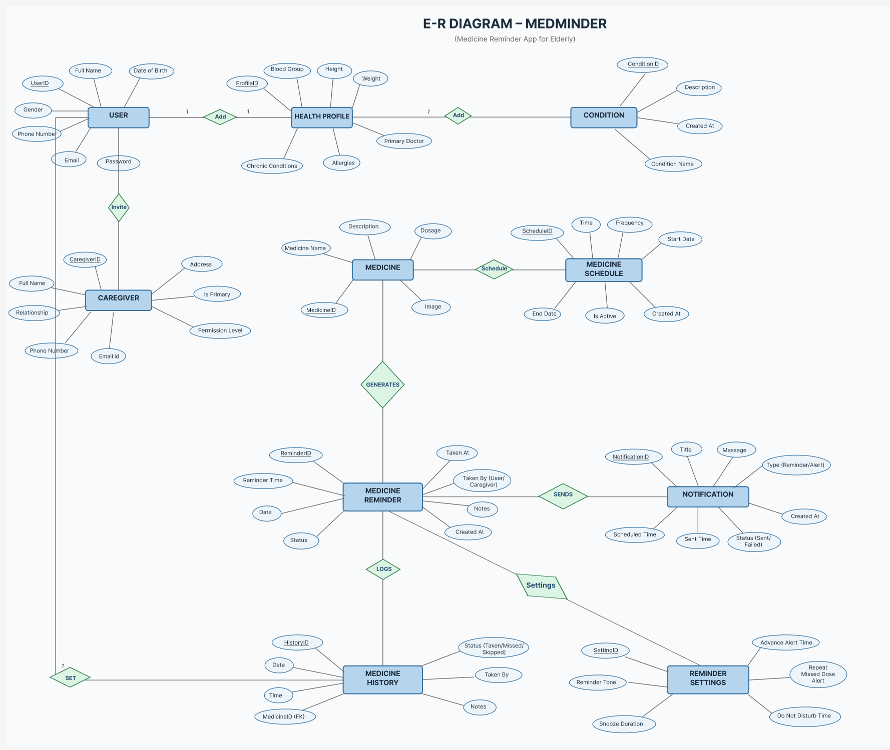

Experiment No – 8
Aim : Creation of scenario – Story Board.
Link: https://www.storyboardthat.com/storyboards/3a195160/medminder-storyboard
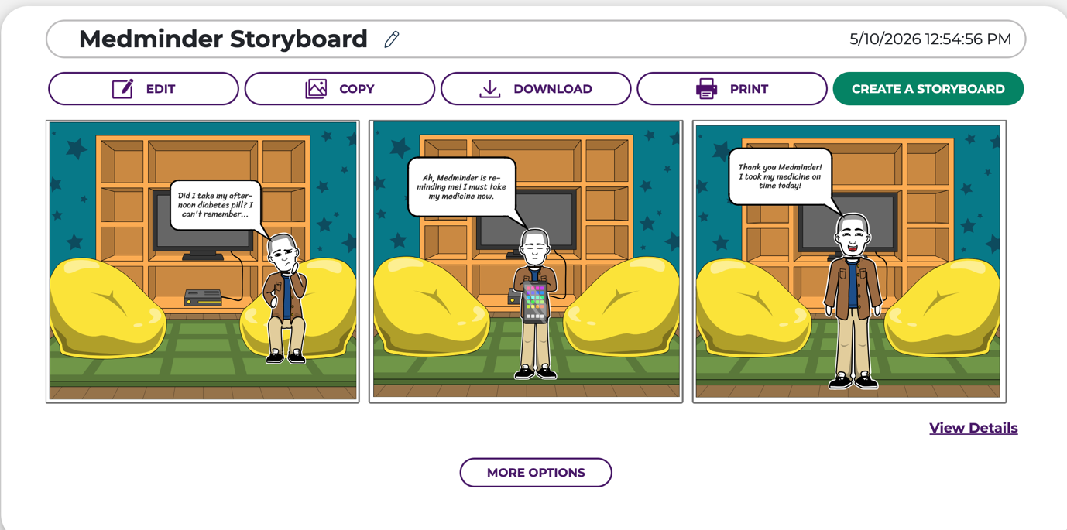
Panel – 1
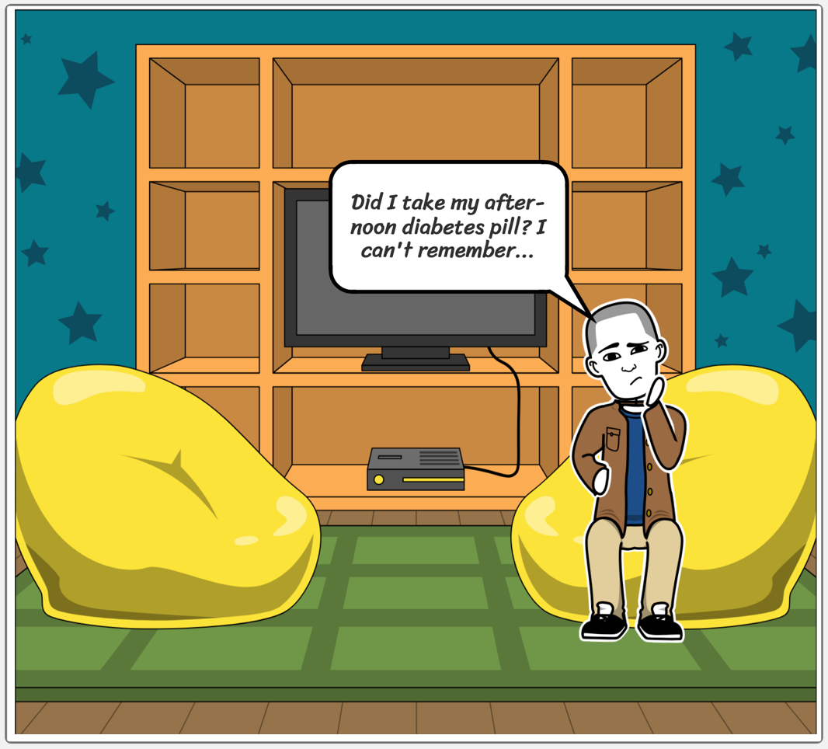
Panel - 2
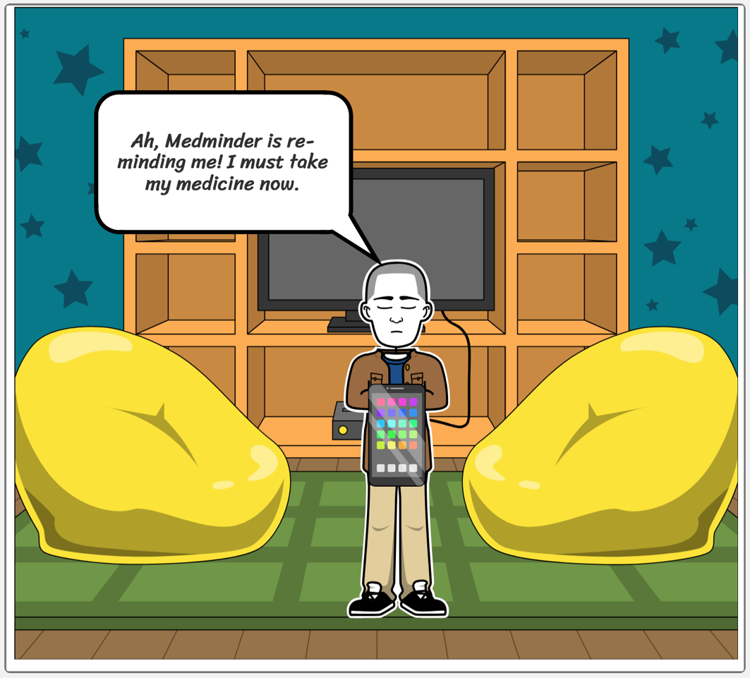
Panel - 3
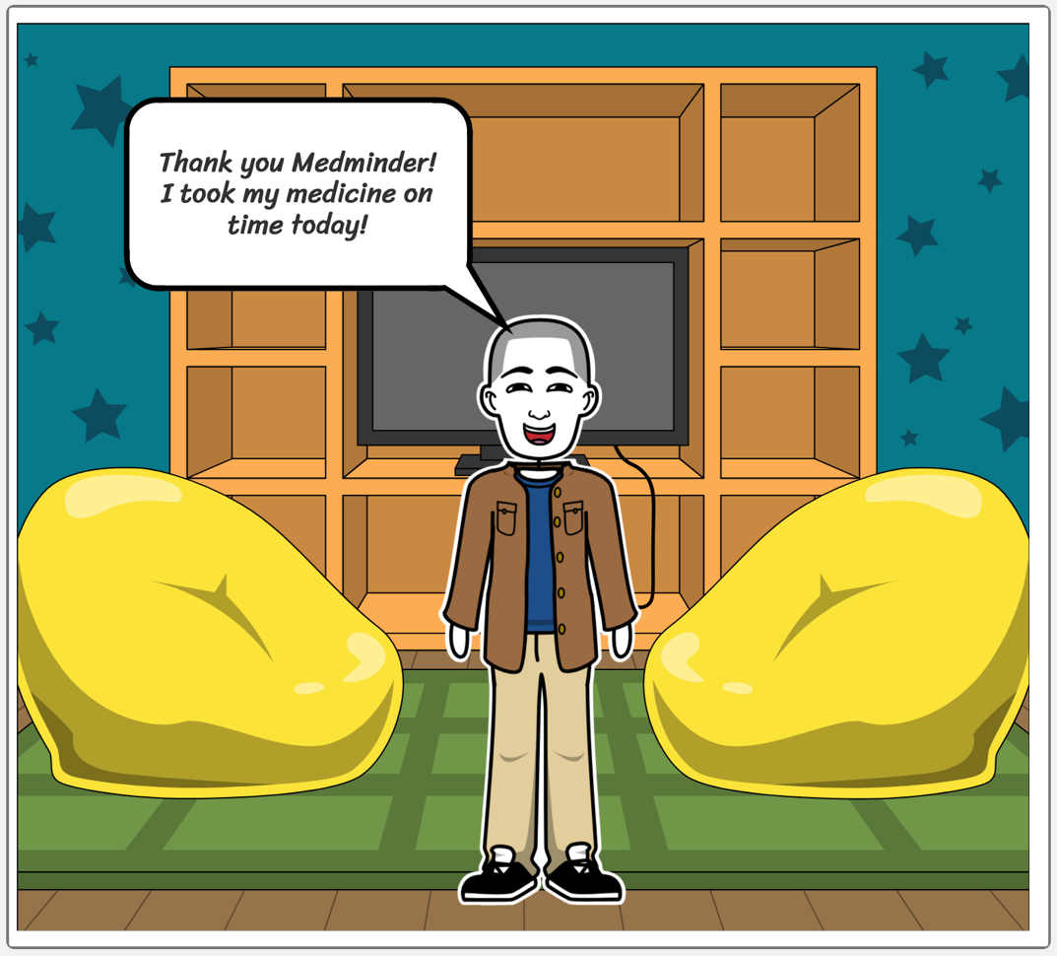
Experiment No – 9
Create Mind Map/Site Map

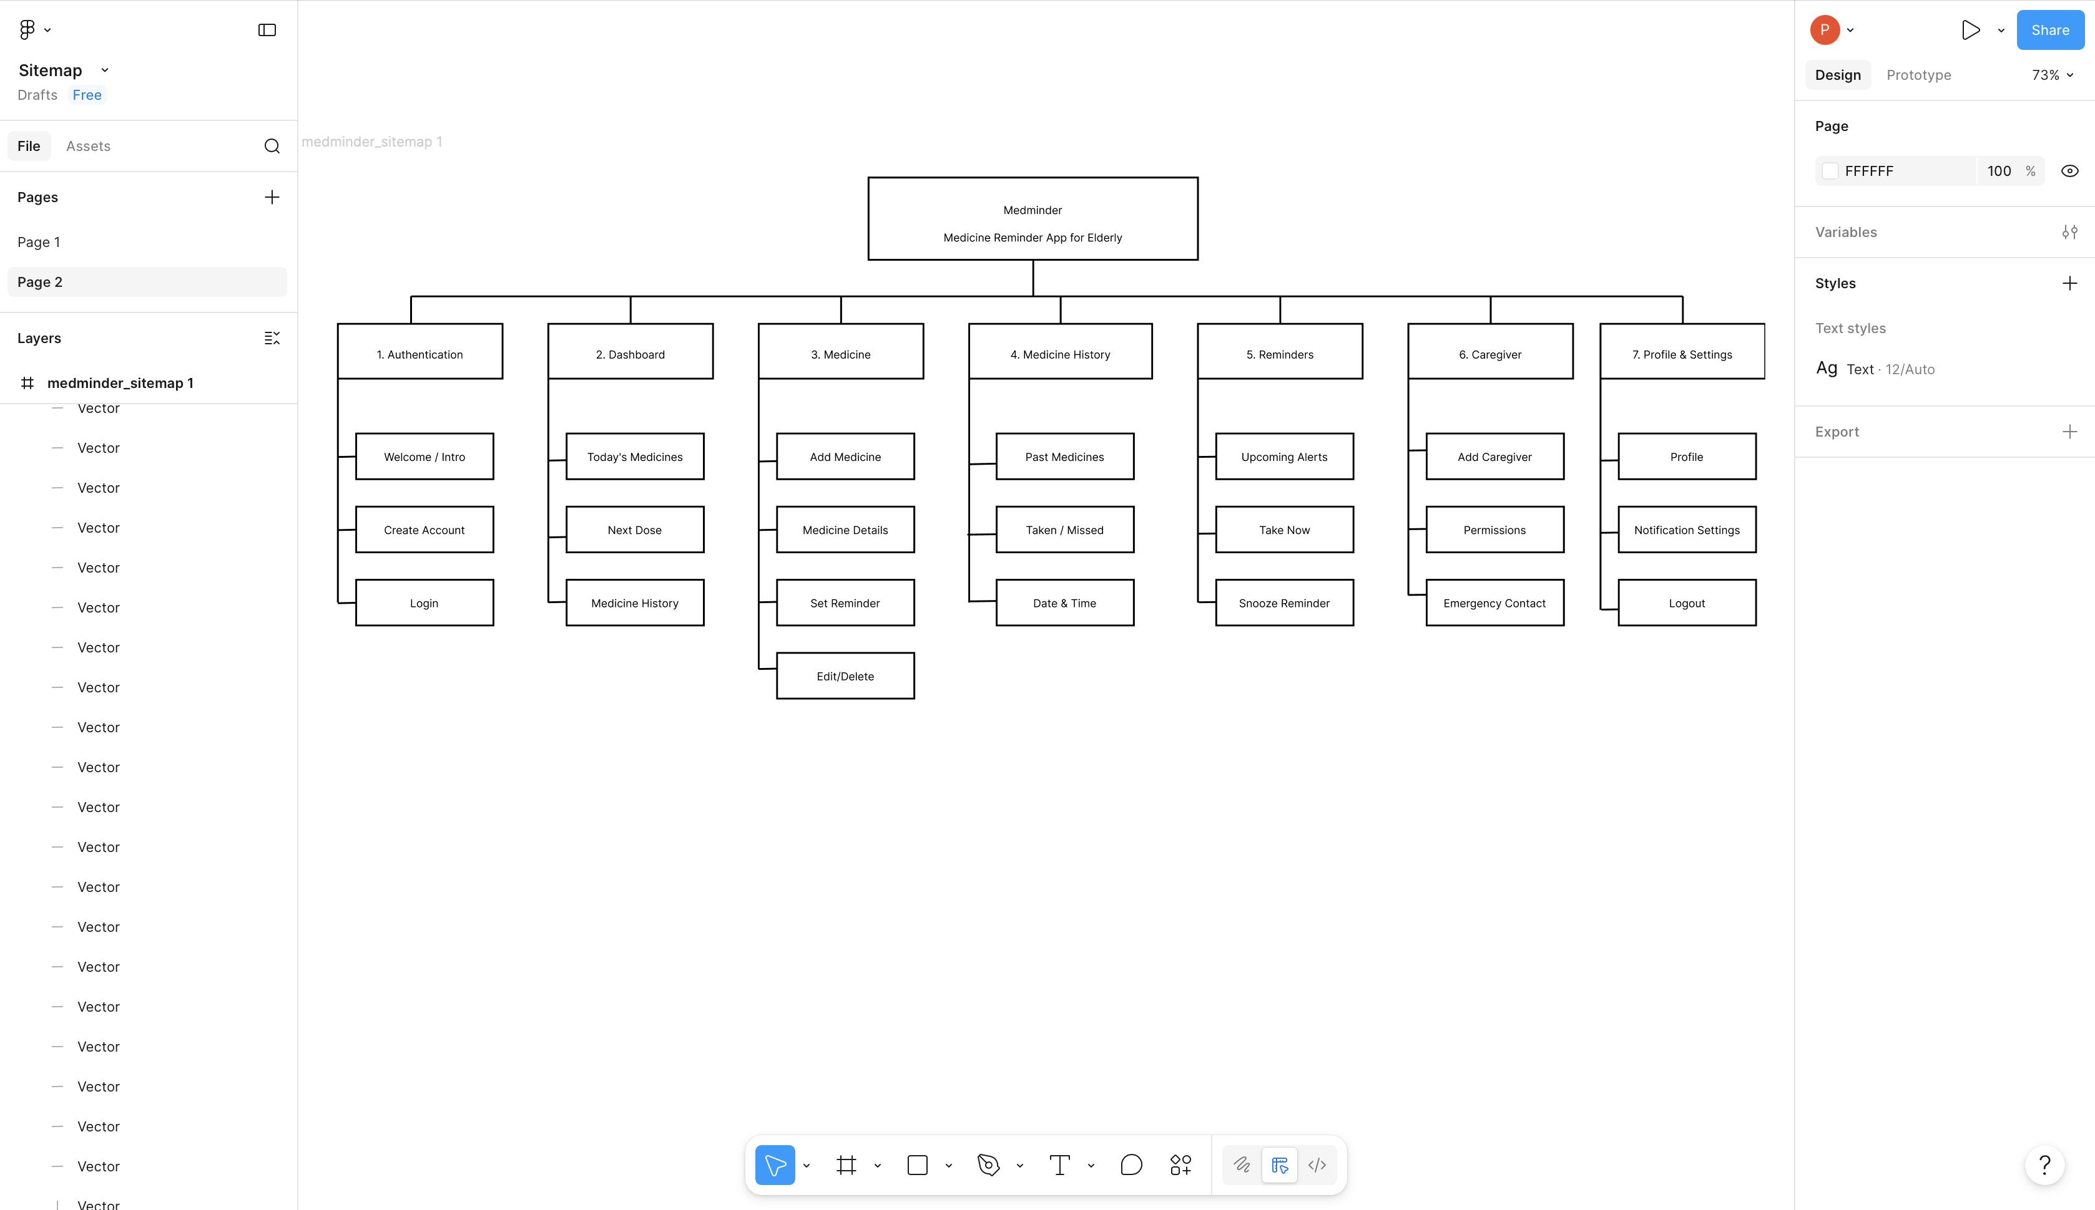

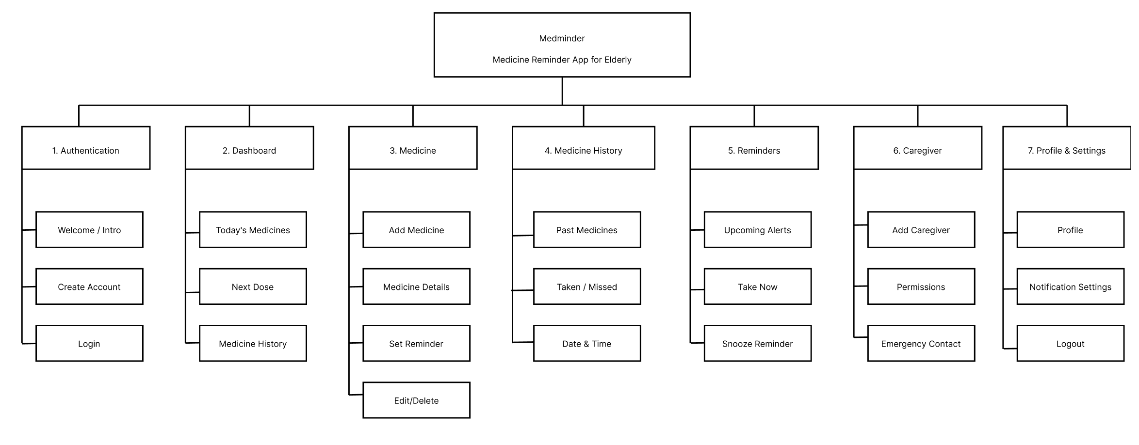

Experiment – 10
Q. Create Wireframe
Link:https://www.figma.com/design/L3cBixZdWLnevAPkMHO6Ou/Wireframe?node-id=0-1&t=qUNilP5GUpH5kd8W-1

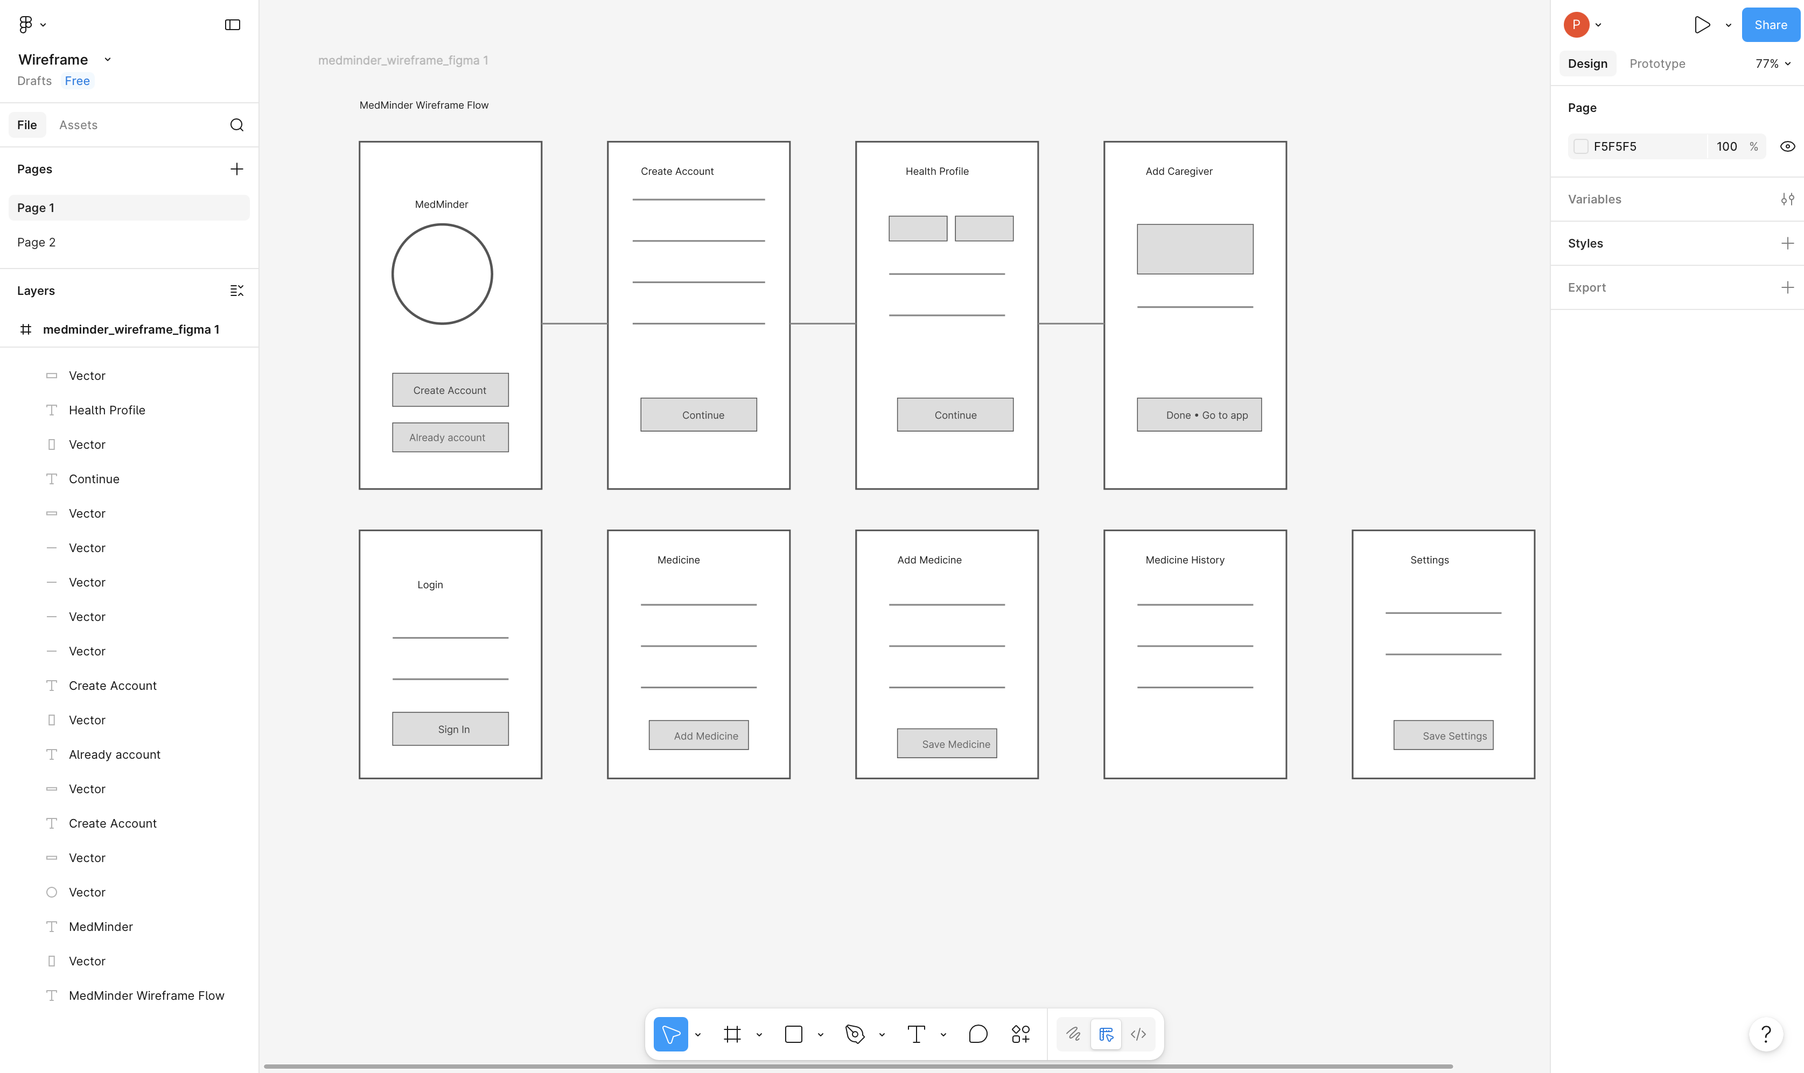
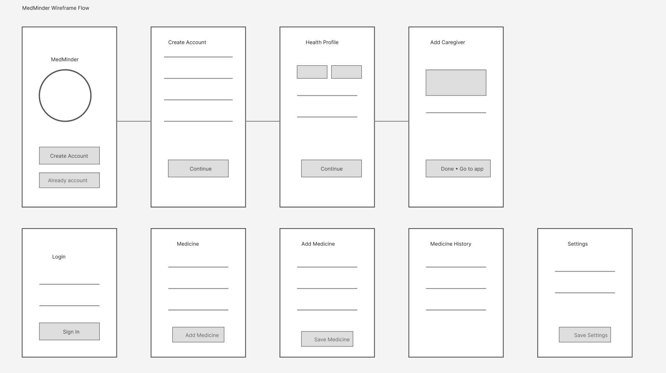

Experiment No – 11
Q. Create Prototype

Link: https://www.figma.com/proto/8scVtgDVbfHf45zB6npVdJ/Prince-127-Complete-Wireframe?node-id=0-1&t=KxUSHGtY1jm62RJH-1

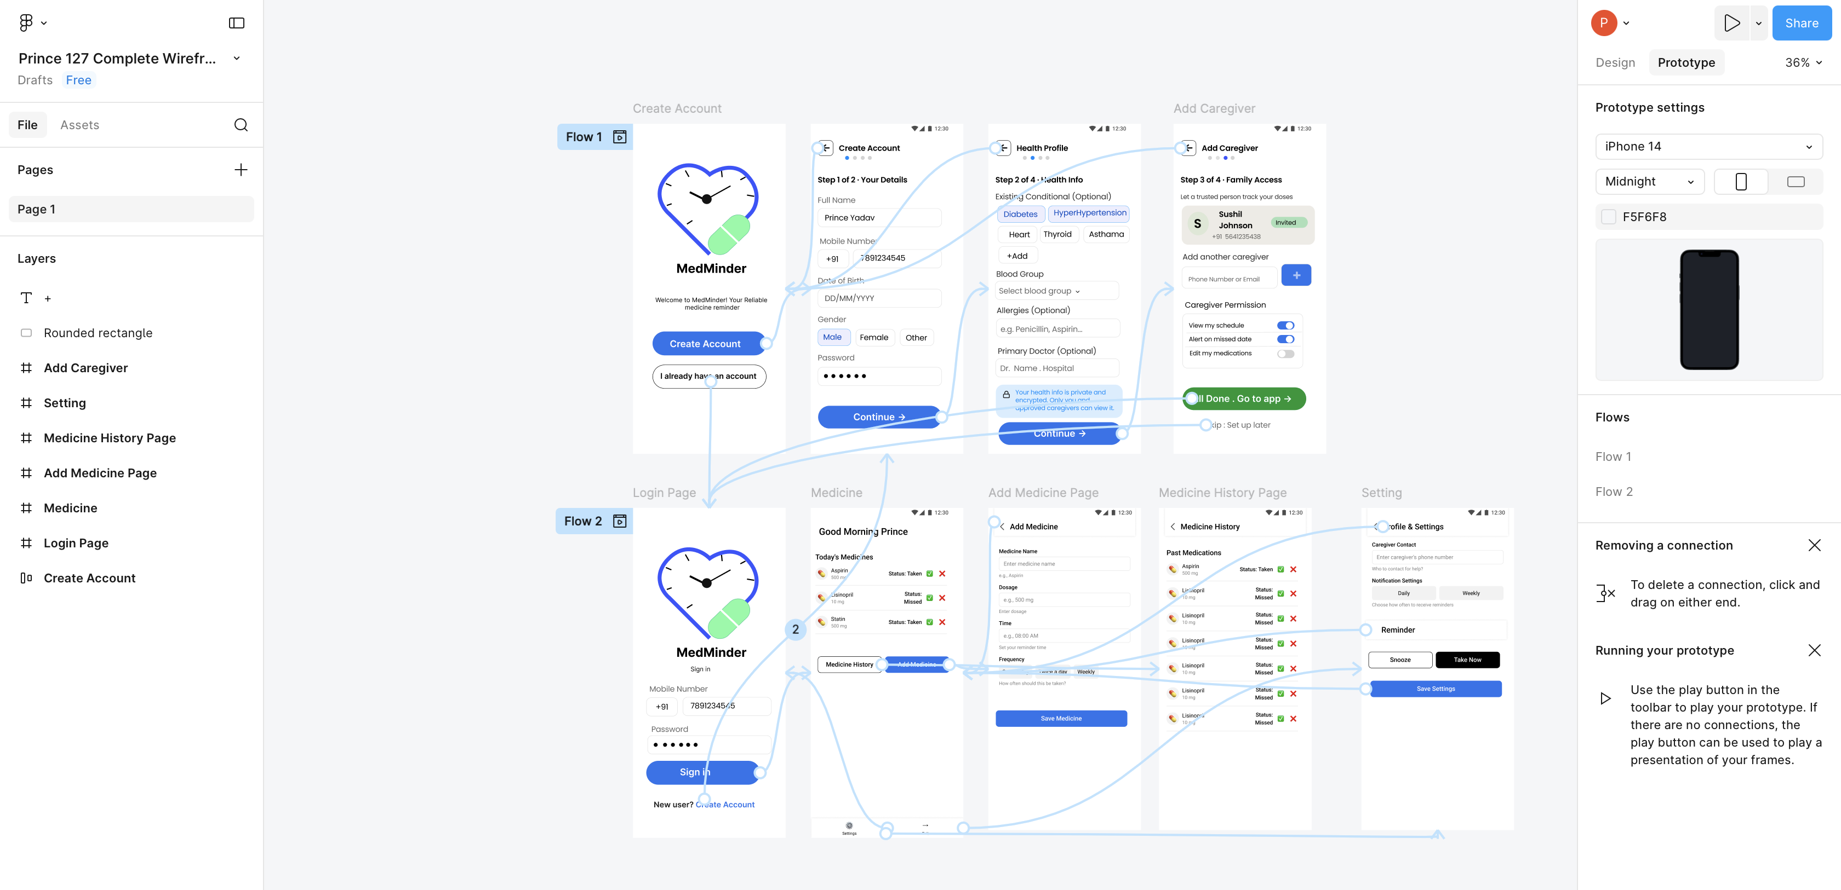

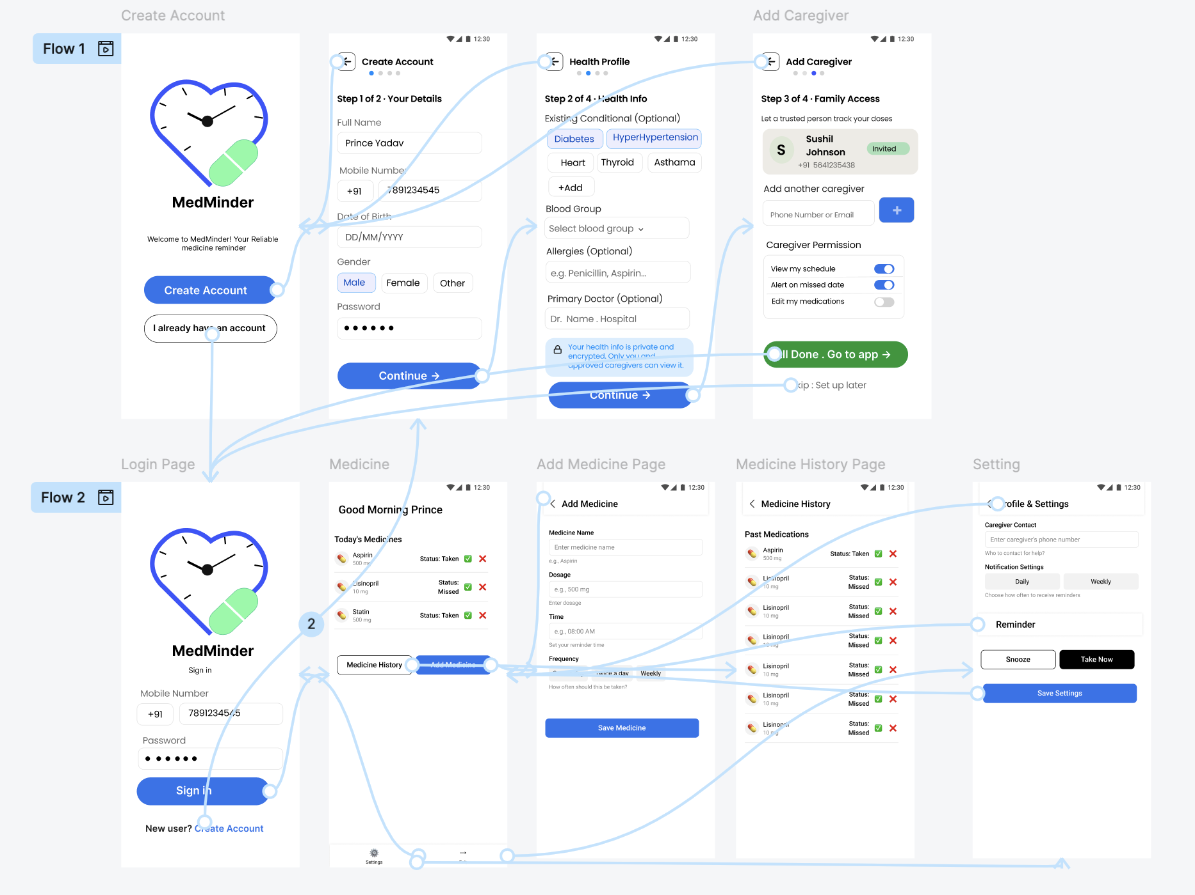

Experiment No – 12
Q. Usability Evaluation of the Design. Testing of User Interface from third party
(Test scripts).
Testing is the process of executing a program to find errors. To make our software perform well it should be error-free. If testing is done successfully, it will remove all the errors from the software.
Types of Testing:
1. Unit Testing:
It focuses on the smallest unit of software design. In this, we test an individual unit or group of interrelated units. It is often done by the programmer by using sample input and observing its corresponding outputs.

2. Integration Testing:
The objective is to take unit-tested components and build a program structure that has been dictated by design. Integration testing is testing in which a group of components is combined to produce output.

3. Regression Testing:
Every time a new module is added leads to changes in the program. This type of testing makes sure that the whole component works properly even after adding components to the complete program.

4. Smoke Testing:
This test is done to make sure that the software under testing is ready or stable for further testing. It is called a smoke test as the testing of an initial pass is done to check if it did not catch the fire or smoke in the initial switch on.

5. Alpha Testing:
This is a type of validation testing. It is a type of acceptance testing which is done before the product is released to customers. It is typically done by QA people.

6. Beta Testing:
The beta test is conducted at one or more customer sites by the end-user of the software. This version is released for a limited number of users for testing in a Realtime environment

7. System Testing:
This software is tested such that it works fine for the different operating systems. It is covered under the black box testing technique. In this, we just focus on the required input and output without focusing on internal working.

8. Stress Testing:
In this, we give unfavorable conditions to the system and check how they perform in those conditions.

9. Performance Testing:
It is designed to test the run-time performance of software within the context of an integrated system.

10. Acceptance Testing:
Acceptance testing is done by the customers to check whether the delivered
products perform the desired tasks or not, as stated in requirements.

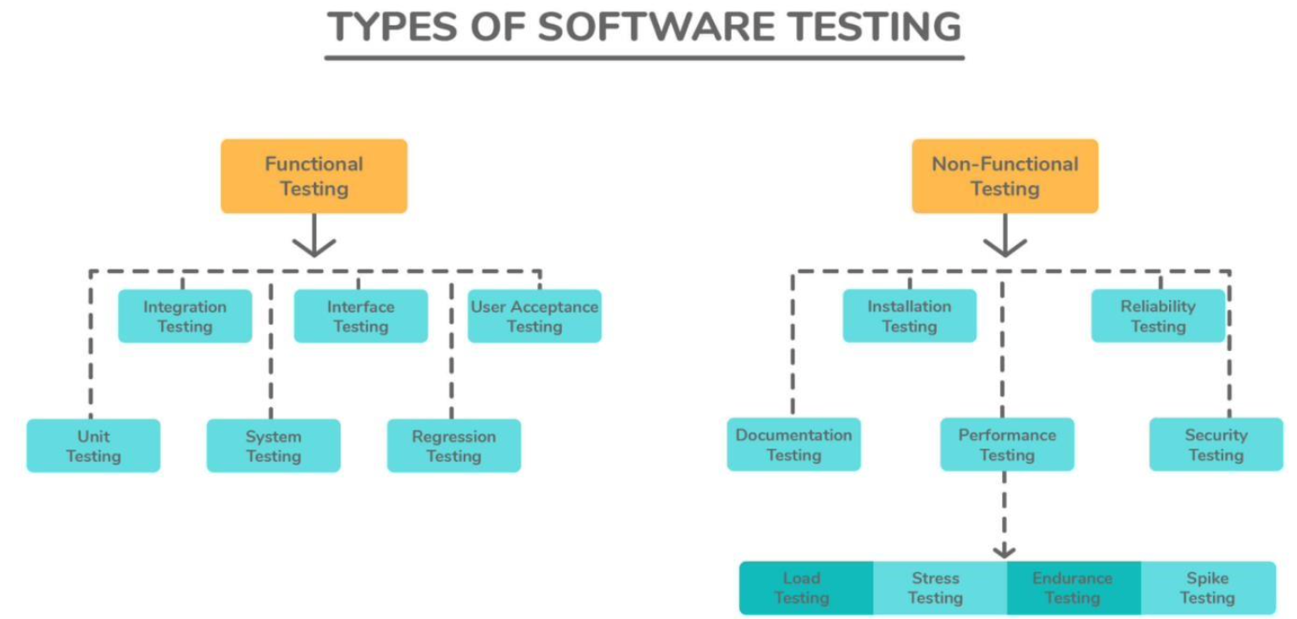
Test Cases -
Sr.no | Action | Input | Expected Output | Actual Output | Test Result | Test Comment
1 | Launch Application | Click on MedMinder App | Login page should display | Login page displayed | Pass | Successful
2 | Create Account | Enter valid details | Account should be created | Account created successfully | Pass | Successful
3 | Invalid Login | Wrong mobile number/password | Login failed message | Login failed message displayed | Pass | Validation working
4 | Valid Login | Correct mobile number/password | Dashboard should display | Dashboard displayed | Pass | Successful
5 | Empty Fields | Leave fields blank | Warning message | Warning displayed | Pass | Successful
6 | Invalid Mobile Number | Enter alphabets in mobile field | Invalid number error | Invalid number shown | Pass | Validation successful
7 | Medicine Add | Enter valid medicine details | Medicine should save | Medicine saved successfully | Pass | Successful
8 | Medicine Name Validation | Enter numeric medicine name | Invalid medicine name | Error displayed | Pass | Successful
9 | Reminder Time | Set reminder time | Reminder should schedule | Reminder scheduled | Pass | Successful
10 | Notification Alert | Wait for reminder time | Reminder notification appears | Notification displayed | Pass | Successful
11 | Medicine History | Open history page | Past medicine records display | History displayed | Pass | Successful
12 | Edit Medicine | Update dosage/time | Updated data should save | Data updated successfully | Pass | Successful
13 | Delete Medicine | Click delete button | Medicine removed | Medicine deleted | Pass | Successful
14 | Caregiver Add | Enter caregiver details | Caregiver added | Caregiver added successfully | Pass | Successful
15 | Invalid Caregiver Email | Wrong email format | Invalid email message | Error displayed | Pass | Validation successful
16 | Reminder Toggle | Disable reminder switch | Reminder disabled | Reminder disabled | Pass | Successful
17 | Settings Save | Update settings | Settings should save | Settings saved | Pass | Successful
18 | Medicine Status | Mark medicine as taken | Status changes to taken | Status updated | Pass | Successful
19 | Menu Navigation | Open side menu | Menu should slide from left | Menu opened successfully | Pass | Successful
20 | Logout | Click logout button | Redirect to login page | Returned to login page | Pass | Successful

