Module - 4
1) Create a web application demonstrating client-side state management using ViewState and Cookies.
WebForm1.aspx
<%@ Page Language="C#" AutoEventWireup="true" CodeBehind="WebForm1.aspx.cs" Inherits="Module4_127.WebForm1" %>
<!DOCTYPE html>
<html xmlns="http://www.w3.org/1999/xhtml">
<head runat="server">
<title>Client-Side State Demo</title>
</head>
<body>
<form id="form1" runat="server">
<h2>Client-Side State Management</h2>
Enter your name:
<asp:TextBox ID="txtName" runat="server"></asp:TextBox>
<br /><br />
<asp:Button ID="btnViewState" runat="server" Text="Save in ViewState" OnClick="btnViewState_Click" />
<asp:Button ID="btnCookie" runat="server" Text="Save in Cookie" OnClick="btnCookie_Click" />
<hr />
<asp:Label ID="lblViewState" runat="server"></asp:Label>
<br />
<asp:Label ID="lblCookie" runat="server"></asp:Label>
</form>
</body>
</html>

WebForm1.aspx.cs
using System;
using System.Web;
namespace Module4_127
{
public partial class WebForm1 : System.Web.UI.Page
{
protected void Page_Load(object sender, EventArgs e)
{
if (ViewState["UserName"] != null)
{
lblViewState.Text = "ViewState Value: " + ViewState["UserName"].ToString();
}
HttpCookie cookie = Request.Cookies["UserNameCookie"];
if (cookie != null)
{
lblCookie.Text = "Cookie Value: " + cookie.Value;
}
}
protected void btnViewState_Click(object sender, EventArgs e)
{
string name = txtName.Text.Trim();
if (name != "")
{
ViewState["UserName"] = name;
lblViewState.Text = "ViewState Value: " + name;
}
}
protected void btnCookie_Click(object sender, EventArgs e)
{
string name = txtName.Text.Trim();
if (name != "")
{
HttpCookie cookie = new HttpCookie("UserNameCookie", name);
cookie.Expires = DateTime.Now.AddDays(1);
Response.Cookies.Add(cookie);
lblCookie.Text = "Cookie Value: " + name;
}
}
}
}
Output:
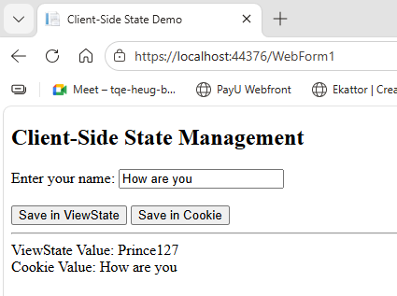

2) Design a session-based login system where users are redirected to a dashboard upon successful login.
Login.aspx
<%@ Page Language="C#" AutoEventWireup="true" CodeBehind="Login.aspx.cs" Inherits="Module4_127.Login" %>
<!DOCTYPE html>
<html xmlns="http://www.w3.org/1999/xhtml">
<head runat="server">
<title>Login</title>
</head>
<body>
<form id="form1" runat="server">
<h2>Login Page</h2>
Username:
<asp:TextBox ID="txtUsername" runat="server"></asp:TextBox>
<br /><br />
Password:
<asp:TextBox ID="txtPassword" runat="server" TextMode="Password"></asp:TextBox>
<br /><br />
<asp:Button ID="btnLogin" runat="server"
Text="Login"
OnClick="btnLogin_Click" />
<br /><br />
<asp:Label ID="lblMessage" runat="server" ForeColor="Red"></asp:Label>
</form>
</body>
</html>

Login.aspx.cs

using System;
using System.Collections.Generic;
namespace Module4_127
{
public partial class Login : System.Web.UI.Page
{
Dictionary<string, string> users = new Dictionary<string, string>()
{
{ "prince127", "prince127" }
};
protected void Page_Load(object sender, EventArgs e)
{
if (Session["Username"] != null)
{
Response.Redirect("Dashboard.aspx");
}
}
protected void btnLogin_Click(object sender, EventArgs e)
{
string username = txtUsername.Text.Trim();
string password = txtPassword.Text.Trim();
if (users.ContainsKey(username) && users[username] == password)
{
Session["Username"] = username;
Response.Redirect("Dashboard.aspx");
}
else
{
lblMessage.Text = "Invalid Username or Password!";
}
}
}
}

Dashboard.aspx
<%@ Page Language="C#" AutoEventWireup="true" CodeBehind="Dashboard.aspx.cs" Inherits="Module4_127.Dashboard" %>
<!DOCTYPE html>
<html xmlns="http://www.w3.org/1999/xhtml">
<head runat="server">
<title>Dashboard</title>
</head>
<body>
<form id="form1" runat="server">
<h2>Dashboard</h2>
Welcome,
<asp:Label ID="lblUser" runat="server"></asp:Label>
<br /><br />
<asp:Button ID="btnLogout" runat="server"
Text="Logout"
OnClick="btnLogout_Click" />
</form>
</body>
</html>

Dashboard.aspx.cs
using System;
namespace Module4_127
{
public partial class Dashboard : System.Web.UI.Page
{
protected void Page_Load(object sender, EventArgs e)
{
if (Session["Username"] == null)
{
Response.Redirect("Login.aspx");
}
else
{
lblUser.Text = Session["Username"].ToString();
}
}
protected void btnLogout_Click(object sender, EventArgs e)
{
Session.Abandon();
Response.Redirect("Login.aspx");
}
}
}

Output
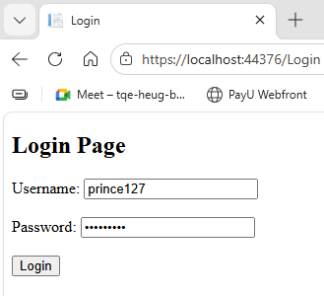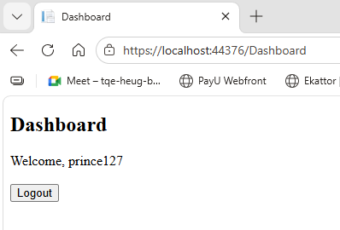

3) Implement an AJAX-enabled web form to fetch user details without reloading the page.
WebForm2.aspx
<%@ Page Language="C#" AutoEventWireup="true" CodeBehind="WebForm2.aspx.cs" Inherits="Module4_127.WebForm2" %>
<!DOCTYPE html>
<html xmlns="http://www.w3.org/1999/xhtml">
<head runat="server">
<title>AJAX User Details</title>
</head>
<body>
<form id="form1" runat="server">
<asp:ScriptManager ID="ScriptManager1" runat="server" />
<asp:UpdatePanel ID="UpdatePanel1" runat="server">
<ContentTemplate>
<h2>Fetch User Details</h2>
Enter User ID:
<asp:TextBox ID="txtUserID" runat="server"></asp:TextBox>
<asp:Button ID="btnFetch" runat="server"
Text="Fetch"
OnClick="btnFetch_Click" />
<br /><br />
<asp:Panel ID="pnlDetails" runat="server" Visible="false">
<asp:Label ID="lblName" runat="server"></asp:Label><br />
<asp:Label ID="lblEmail" runat="server"></asp:Label><br />
<asp:Label ID="lblPhone" runat="server"></asp:Label>
</asp:Panel>
</ContentTemplate>
</asp:UpdatePanel>
</form>
</body>
</html>

WebForm2.aspx.cs
using System;
using System.Collections.Generic;
namespace Module4_127
{
public partial class WebForm2 : System.Web.UI.Page
{
Dictionary<string, (string Name, string Email, string Phone)> users =
new Dictionary<string, (string, string, string)>()
{
{ "1", ("Prince", "prince@gmail.com", "9676543210") },
{ "2", ("Dheeraj", "dheeraj@gmail.com", "9765433456") },
{ "3", ("Vishal", "vishal@gmail.com", "9991234560") }
};
protected void btnFetch_Click(object sender, EventArgs e)
{
string id = txtUserID.Text.Trim();
if (users.ContainsKey(id))
{
var user = users[id];
lblName.Text = "Name: " + user.Name;
lblEmail.Text = "Email: " + user.Email;
lblPhone.Text = "Phone: " + user.Phone;
pnlDetails.Visible = true;
}
else
{
lblName.Text = "User not found";
lblEmail.Text = "";
lblPhone.Text = "";
pnlDetails.Visible = true;
}
}
}
}
Output:
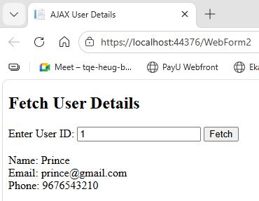

4) Develop a simple to-do list application using AJAX controls and update panels.
WebForm3.aspx
<%@ Page Language="C#" AutoEventWireup="true" CodeBehind="WebForm3.aspx.cs" Inherits="Module4_127.WebForm3" %>
<!DOCTYPE html>
<html xmlns="http://www.w3.org/1999/xhtml">
<head runat="server">
<title>To-Do List</title>
</head>
<body>
<form id="form1" runat="server">
<!-- Required for AJAX -->
<asp:ScriptManager ID="ScriptManager1" runat="server" />
<asp:UpdatePanel ID="UpdatePanel1" runat="server">
<ContentTemplate>
<h2>My To-Do List</h2>
<asp:TextBox ID="txtTask" runat="server"></asp:TextBox>
<asp:Button ID="btnAdd" runat="server"
Text="Add Task"
OnClick="btnAdd_Click" /><br /><br />
<asp:BulletedList ID="lstTasks" runat="server"></asp:BulletedList>
</ContentTemplate>
</asp:UpdatePanel>
</form>
</body>
</html>

WebForm3.aspx.cs
using System;
using System.Collections.Generic;
namespace Module4_127
{
public partial class WebForm3 : System.Web.UI.Page
{
protected void Page_Load(object sender, EventArgs e)
{
if (!IsPostBack)
{
if (Session["Tasks"] == null)
{
Session["Tasks"] = new List<string>();
}
BindTasks();
}
}
protected void btnAdd_Click(object sender, EventArgs e)
{
string task = txtTask.Text.Trim();
if (task != "")
{
List<string> tasks = (List<string>)Session["Tasks"];
tasks.Add(task);
Session["Tasks"] = tasks;
BindTasks();
txtTask.Text = "";
}
}
private void BindTasks()
{
List<string> tasks = (List<string>)Session["Tasks"];
lstTasks.DataSource = tasks;
lstTasks.DataBind();
}
}
}

Output
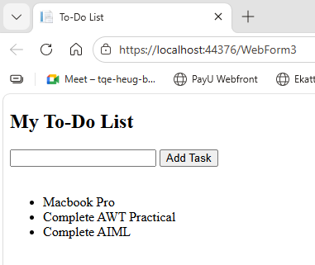

5) Demonstrate the use of the Global.asax file for handling application level events.
Global.asax
using System;
namespace Module4_127
{
public class Global : System.Web.HttpApplication
{
void Application_Start(object sender, EventArgs e)
{
Application["AppStartTime"] = DateTime.Now;
}
void Session_Start(object sender, EventArgs e)
{
Session["VisitCount"] = 0;
}
}
}

WebForm4.aspx
<%@ Page Language="C#" AutoEventWireup="true" CodeBehind="WebForm4.aspx.cs" Inherits="Module4_127.WebForm4" %>
<!DOCTYPE html>
<html xmlns="http://www.w3.org/1999/xhtml">
<head runat="server">
<title>Global.asax Demo</title>
</head>
<body>
<form id="form1" runat="server">
<h2>Global.asax Demo</h2>
<asp:Label ID="lblVisit" runat="server"></asp:Label>
<br />
<asp:Label ID="lblStartTime" runat="server"></asp:Label>
</form>
</body>
</html>

WebForm4.aspx.cs
using System;
namespace Module4_127
{
public partial class WebForm4 : System.Web.UI.Page
{
protected void Page_Load(object sender, EventArgs e)
{
int count = (int)Session["VisitCount"];
count++;
Session["VisitCount"] = count;

lblVisit.Text = "Visits in this session: " + count;

if (Application["AppStartTime"] != null)
{
lblStartTime.Text = "Application started at: "
+ Application["AppStartTime"].ToString();
}
}
}
}

Output

