Practical No - 1
Aim – Implementation of Logic programming using PROLOG DFS for water jug problem.
water_jug(X,Y):- X>4, Y=<3, write('4L jug overflow'), nl, !.
water_jug(X,Y):- X=<4, Y>3, write('3L jug overflow'), nl, !.
water_jug(X,Y):- X>4, Y>3, write('Both jug overflow'), nl, !.
water_jug(X,Y):-
(
X=:=0, Y=:=0,
nl, write('4L:0 & 3L:3 (Action : Fill 3L jug.)'),
YY is 3,
water_jug(X,YY)
);
(
X=:=0, Y=:=3,
nl, write('4L:3 & 3L:0 (Action : Pour water from 3L to 4L jug.)'),
XX is 3, YY is 0,
water_jug(XX,YY)
);
(
X=:=3, Y=:=0,
nl, write('4L:3 & 3L:3 (Action : Fill 3L jug.)'),
YY is 3,
water_jug(X,YY)
);
(
X=:=3, Y=:=3,
nl, write('4L:4 & 3L:2 (Action : Pour water from 3L jug to 4L jug until 4L jug is full.)'),
XX is 4, YY is 2,
water_jug(XX,YY)
);
(
X=:=4, Y=:=2,
nl, write('4L:0 & 3L:2 (Action : Empty 4L jug.)'),
XX is 0,
water_jug(XX,Y)
);
(
X=:=0, Y=:=2,
nl, write('4L:2 & 3L:0 (Action : Pour water from 3L jug to 4L jug.)'),
XX is 2, YY is 0,
water_jug(XX,YY)
);
(
X=:=2, Y=:=0,
nl, write('Goal State Reached...'),
!
).

Output:
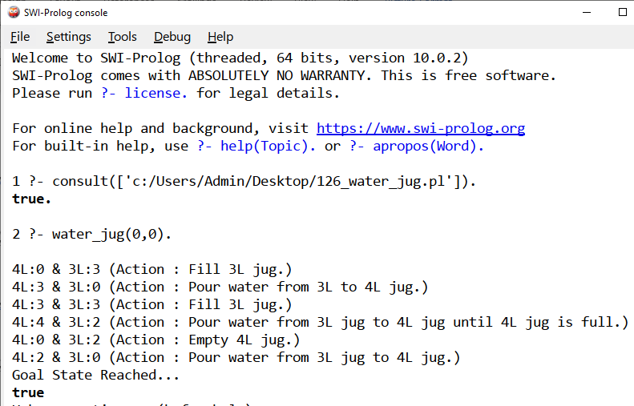
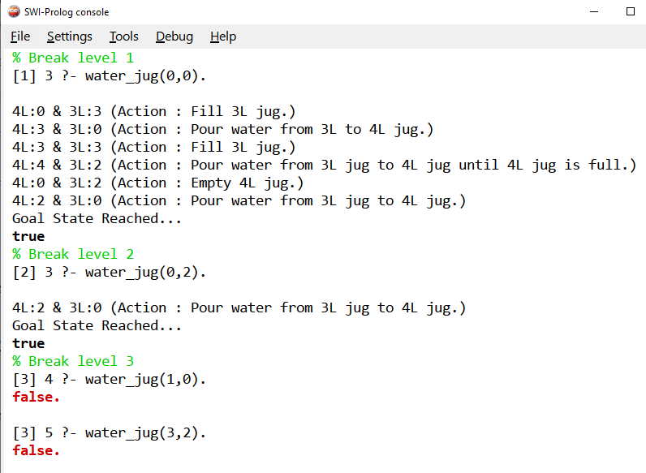

Practical No - 2
Aim – Implementation of Logic programming using PROLOG BFS for tic-tac- toe problem.
% Entry point when compiled
:- initialization(play).
% Initial empty board
board([
' ',' ',' ',
' ',' ',' ',
' ',' ',' '
]).
% Display the board
display_board([A,B,C,D,E,F,G,H,I]) :-
write(A), write(' | '), write(B), write(' | '), write(C), nl,
write('--+---+--'), nl,
write(D), write(' | '), write(E), write(' | '), write(F), nl,
write('--+---+--'), nl,
write(G), write(' | '), write(H), write(' | '), write(I), nl, nl.
% Replace helper
replace([_|T], 1, X, [X|T]).
replace([H|T], I, X, [H|R]) :-
I > 1,
I1 is I - 1,
replace(T, I1, X, R).
% Make a move (only if empty)
move(Board, Pos, Player, NewBoard) :-
nth1(Pos, Board, ' '),
replace(Board, Pos, Player, NewBoard).
% Win conditions
win(Board, Player) :-
member([A,B,C],
[
[1,2,3], [4,5,6], [7,8,9],
[1,4,7], [2,5,8], [3,6,9],
[1,5,9], [3,5,7]
]),
nth1(A, Board, Player),
nth1(B, Board, Player),
nth1(C, Board, Player).
% Draw condition
draw(Board) :-
\+ member(' ', Board).
% Switch player
switch('X', 'O').
switch('O', 'X').
% Start game
play :-
board(B),
display_board(B),
play_turn(B, 'X').
% Alternate turns with validation
play_turn(Board, Player) :-
write(Player),
write(' turn. Enter position (1-9): '),
read(Pos),
(
integer(Pos),
Pos >= 1,
Pos =< 9,
move(Board, Pos, Player, NewBoard)
->
display_board(NewBoard),
(
win(NewBoard, Player)
->
write(Player),
write(' wins!'),
nl,
halt
;
draw(NewBoard)
->
write('Game is a draw!'),
nl,
halt
;
switch(Player, Next),
play_turn(NewBoard, Next)
)
;
write('Invalid move! Try again.'),
nl,
play_turn(Board, Player)
).

Output:
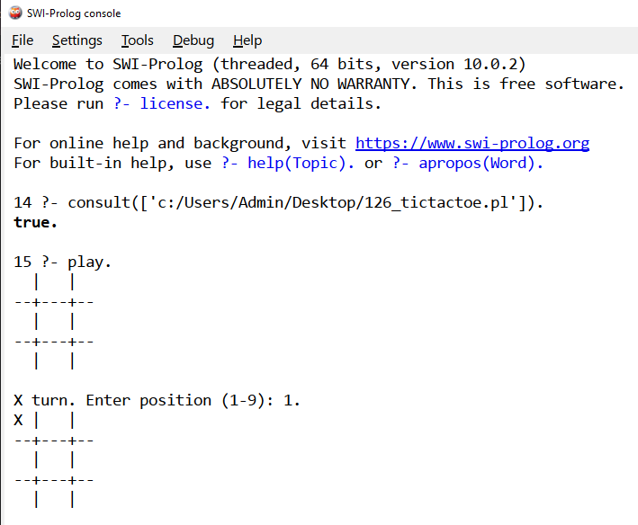
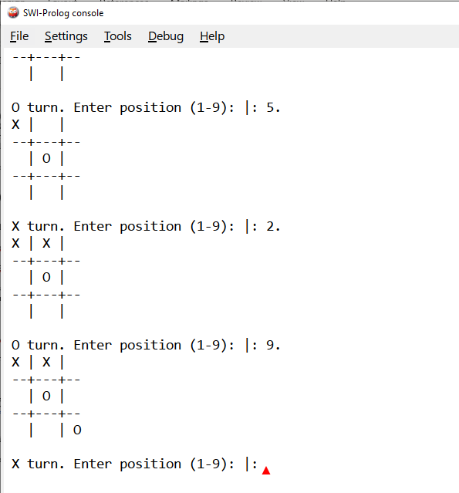
Practical No – 3
Aim – Implementation of Logic programming using PROLOG Hill-climbing to solve 8- Puzzle Problem.
% Simple Prolog Planner for the 8 Puzzle Problem
/* This predicate initialises the problem states. The first argument of solve is the initial state, the
2nd the goal state, and the third the plan that will be produced.*/
test(Plan):-
write('Initial state:'),nl,
Init= [at(tile4,1), at(tile3,2), at(tile8,3), at(empty,4), at(tile2,5), at(tile6,6), at(tile5,7),
at(tile1,8), at(tile7,9)],
write_sol(Init),
Goal= [at(tile1,1), at(tile2,2), at(tile3,3), at(tile4,4), at(empty,5), at(tile5,6), at(tile6,7),
at(tile7,8), at(tile8,9)],
nl,write('Goal state:'),nl,
write(Goal),nl,nl,
solve(Init,Goal,Plan).
solve(State, Goal, Plan):-
solve(State, Goal, [], Plan).
% Determines whether Current and Destination tiles are a valid move.
is_movable(X1,Y1) :- (1 is X1 - Y1) ; (-1 is X1 - Y1) ; (3 is X1 - Y1) ; (-3 is X1 - Y1).
/* This predicate produces the plan. Once the Goal list is a subset of the current State the plan is
complete and it is written to the screen using write_sol */
solve(State, Goal, Plan, Plan):-
is_subset(Goal, State), nl,
write_sol(Plan).
solve(State, Goal, Sofar, Plan):-
act(Action, Preconditions, Delete, Add),
is_subset(Preconditions, State),
\+ member(Action, Sofar),
delete_list(Delete, State, Remainder),
append(Add, Remainder, NewState),
solve(NewState, Goal, [Action|Sofar], Plan).
/* The problem has three operators.
1st arg = name
2nd arg = preconditions
3rd arg = delete list
4th arg = add list. */
% Tile can move to new position only if the destination tile is empty & Manhattan distance = 1
act(move(X,Y,Z),
[at(X,Y), at(empty,Z), is_movable(Y,Z)],
[at(X,Y), at(empty,Z)],
[at(X,Z), at(empty,Y)]).
% Utility predicates.
% Check is first list is a subset of the second
is_subset([H|T], Set):-
member(H, Set),
is_subset(T, Set).
is_subset([], _).
% Remove all elements of 1st list from second to create third.
delete_list([H|T], Curstate, Newstate):-
remove(H, Curstate, Remainder),
delete_list(T, Remainder, Newstate).
delete_list([], Curstate, Curstate).
remove(X, [X|T], T).
remove(X, [H|T], [H|R]):-
remove(X, T, R).
write_sol([]).
write_sol([H|T]):-
write_sol(T),
write(H), nl.
append([H|T], L1, [H|L2]):-
append(T, L1, L2).
append([], L, L).
member(X, [X|_]).
member(X, [_|T]):-
member(X, T).

Output:
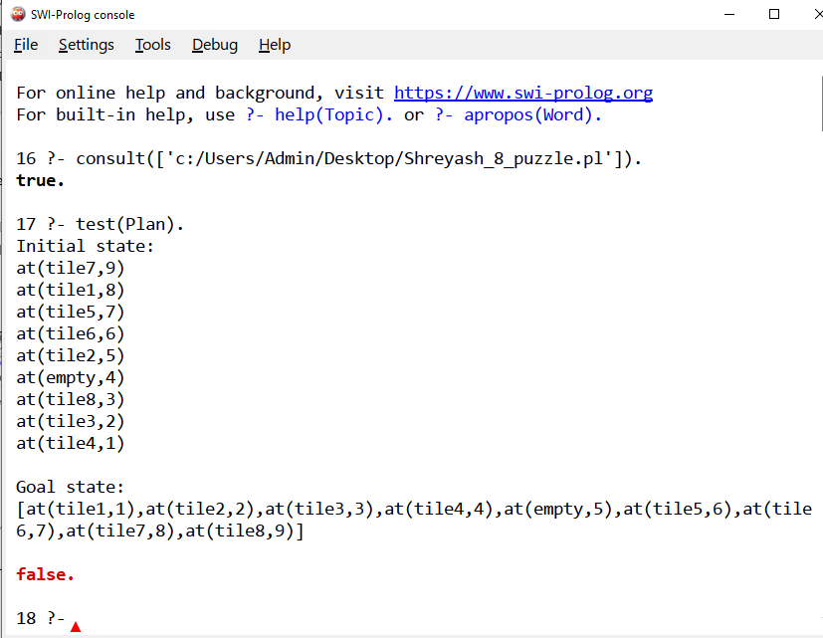

Practical No – 4
Aim –Introduction to Python Programming : Learn the different Libraries- NumPy, Pandas, SciPy , Matplotlib , Scikit Learn
A. Introduction to Python Programming
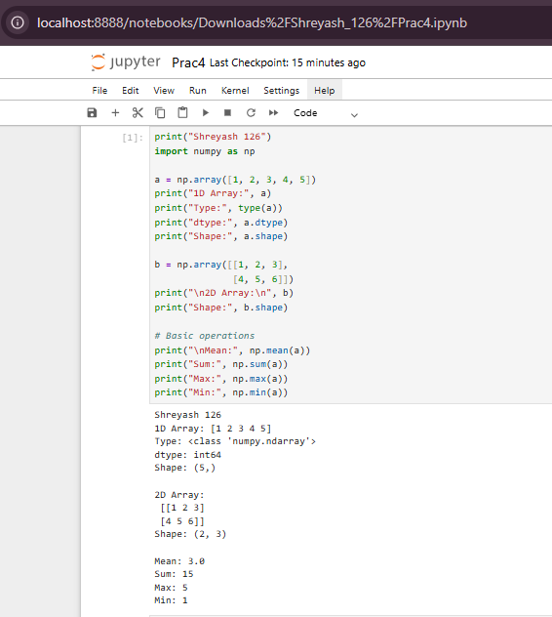

Creating NumPy Array + Checking Type
1. Create Base Arrays.
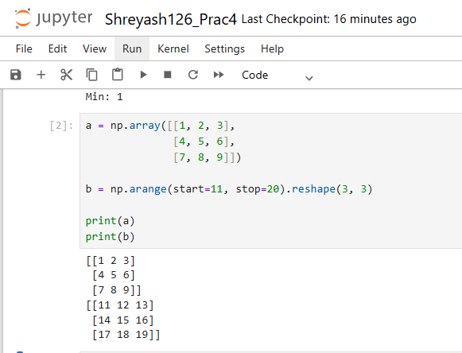
2. NumPy Addition (Element-wise)
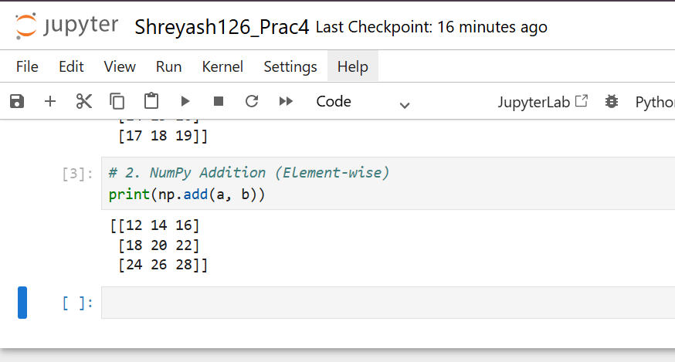
3. NumPy Multiplication (Element-wise)
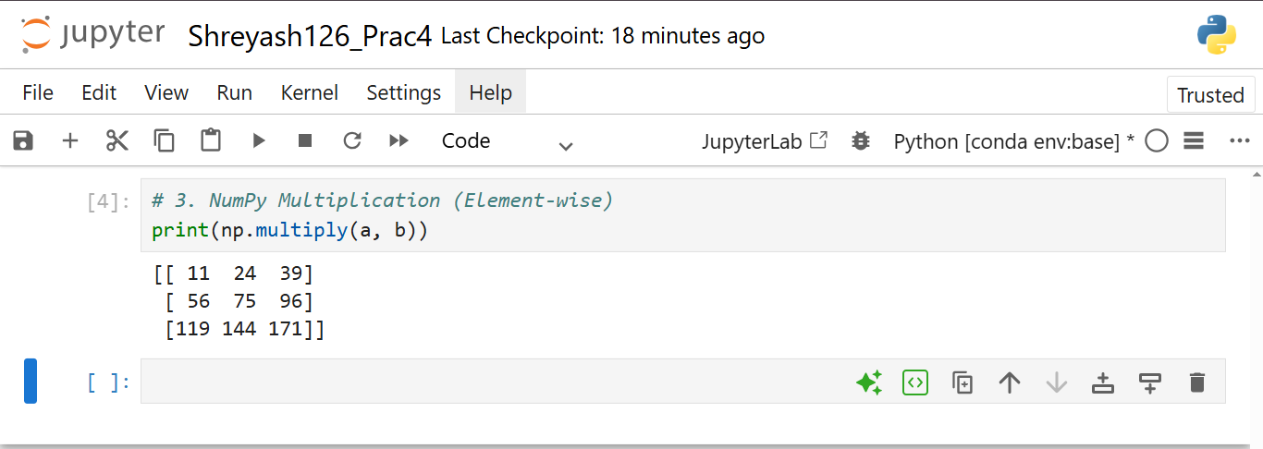

4. Accessing Elements (Indexing)
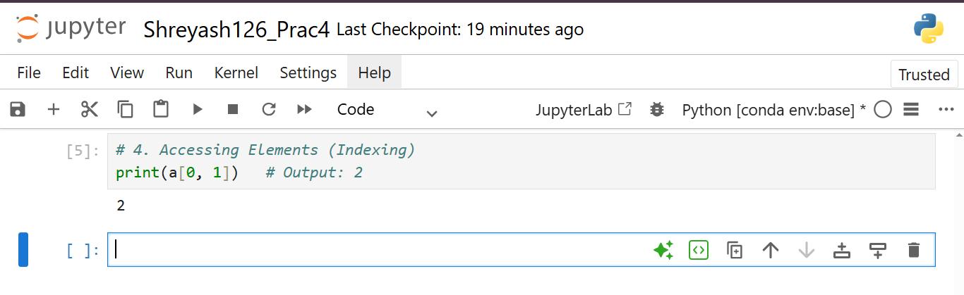
5. Accessing Rows & Columns (Slicing)
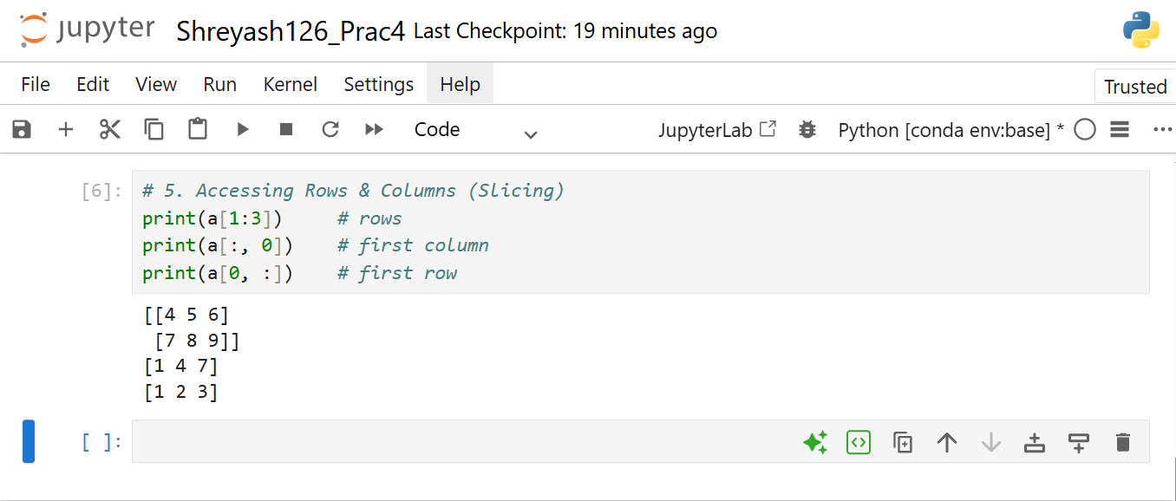
6. Subset of Array (Submatrix)
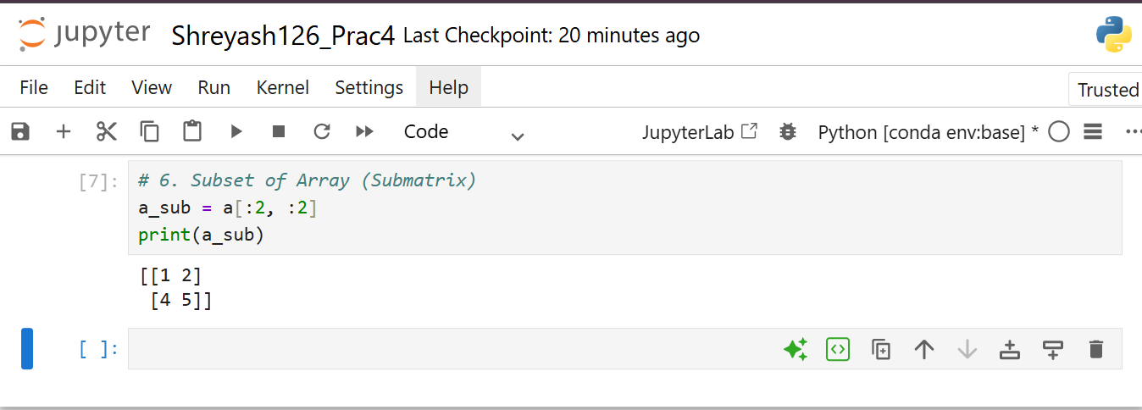
7. Modify Subset (Affects Original Array)
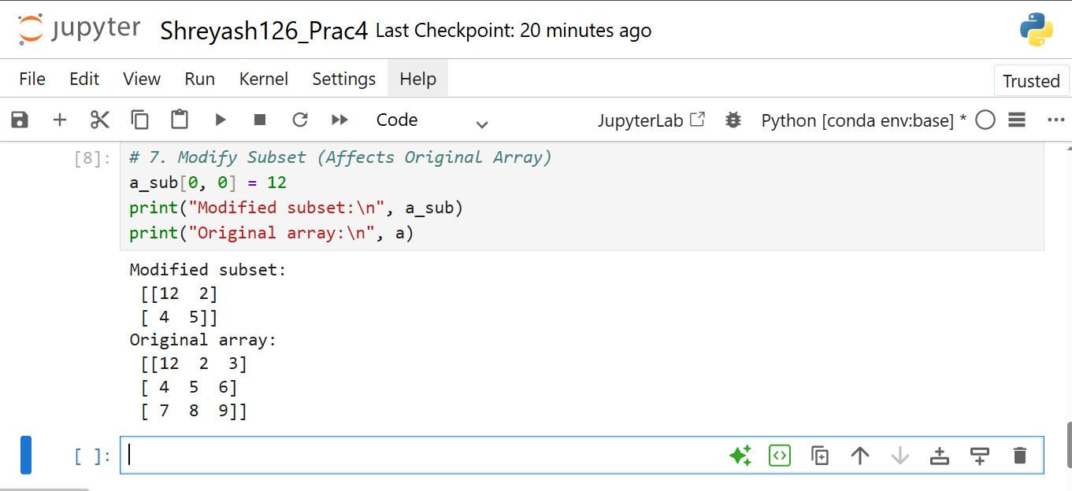
8. Transpose of Array
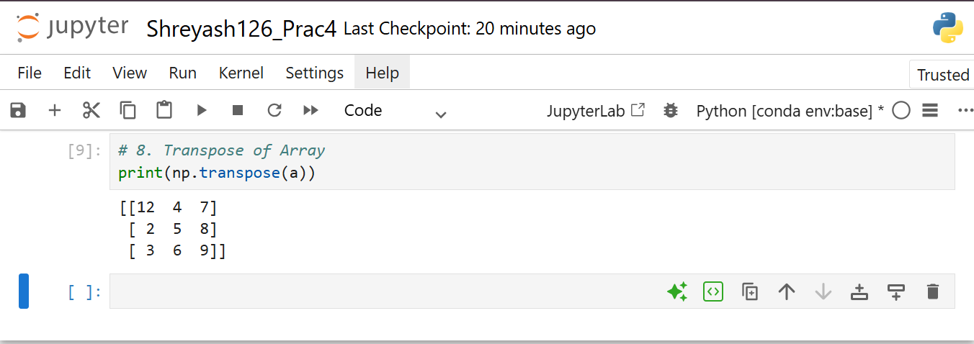
9. Append Row
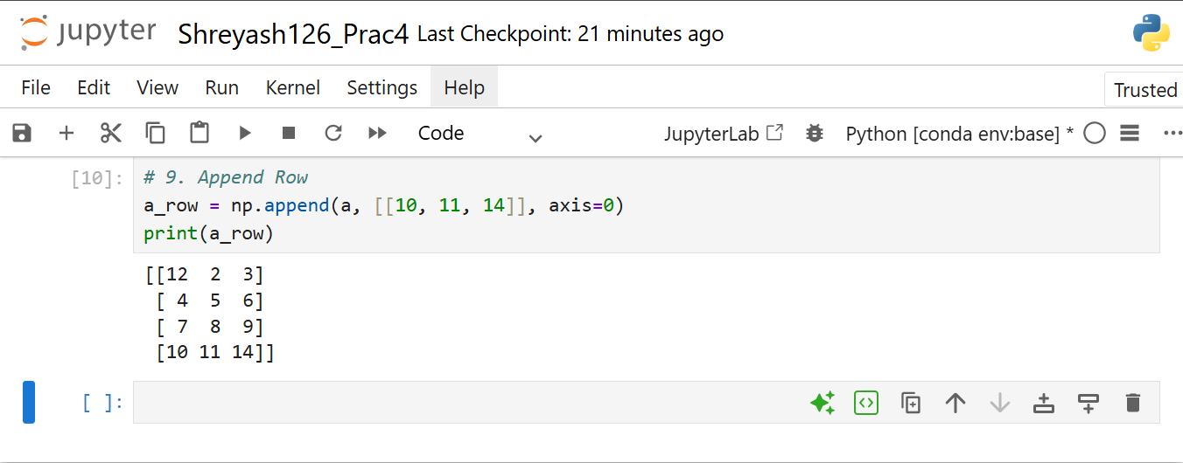
10. Append Column
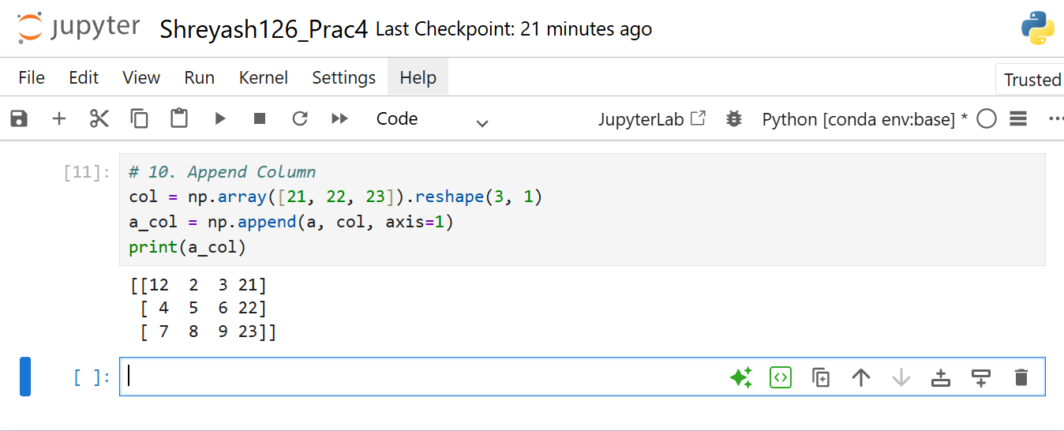

11. Insert Row at Specific Position
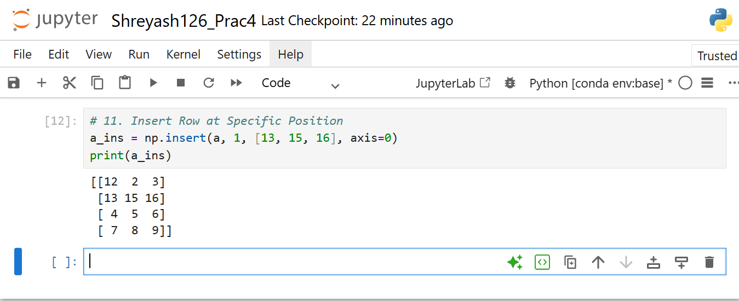
12. Delete Row
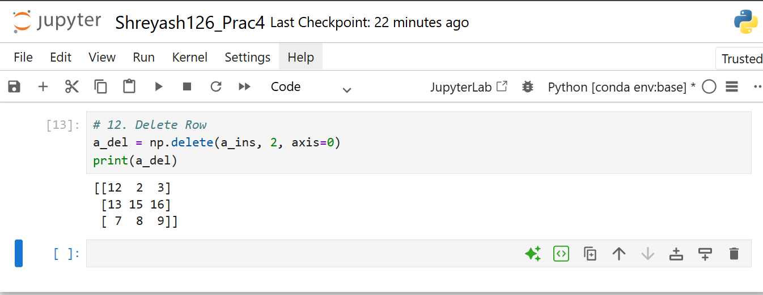
13. Reshape Array
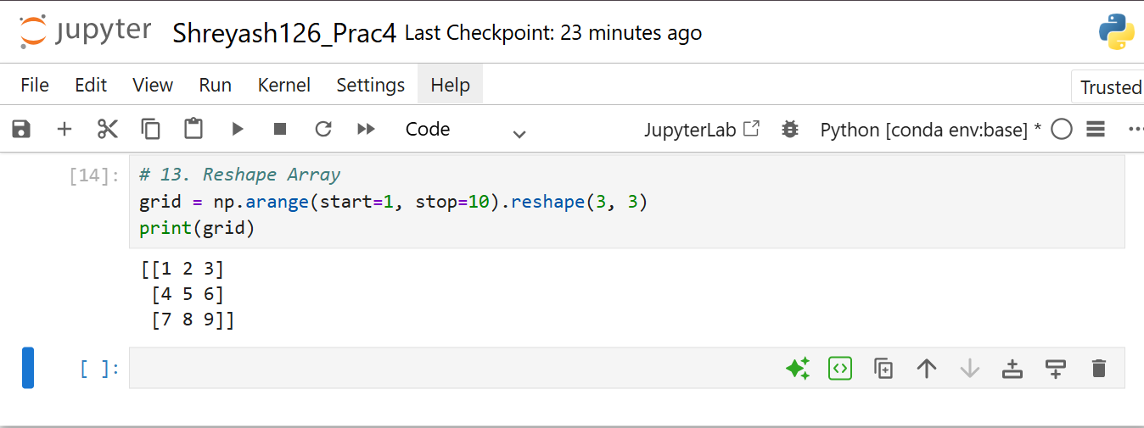

14. Shape of Array
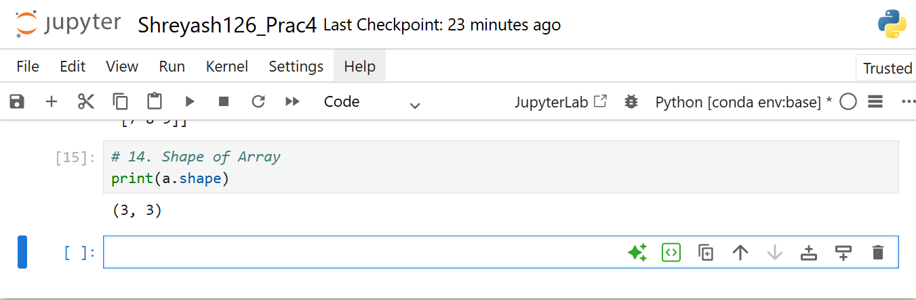
15. Sum of Array (Different Axes)
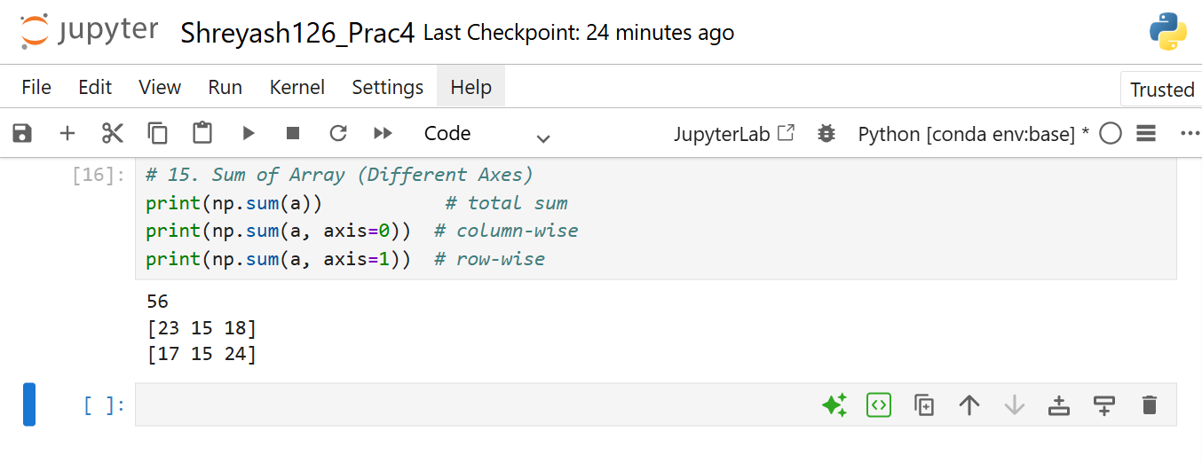
B. Pandas
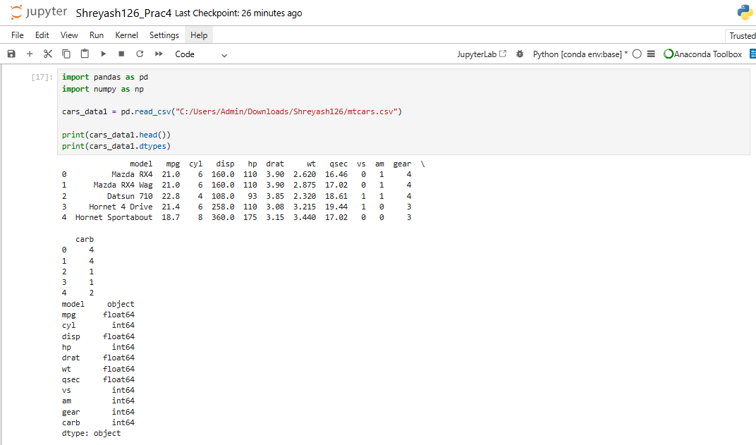
1. Count of Unique Data Types
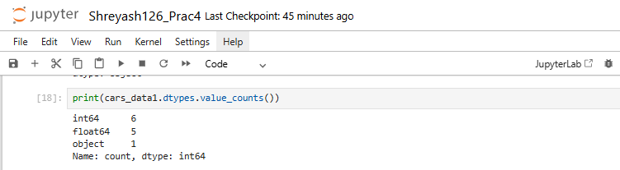

2. Selecting Data Based on Data Types
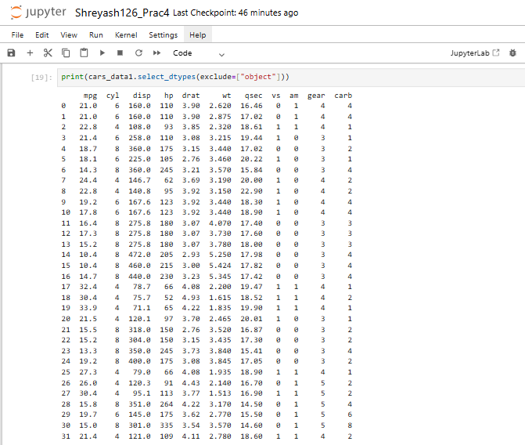

3. Summary of DataFrame
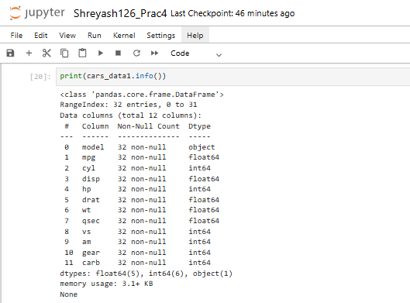
4. Unique Values of a Column (mpg)
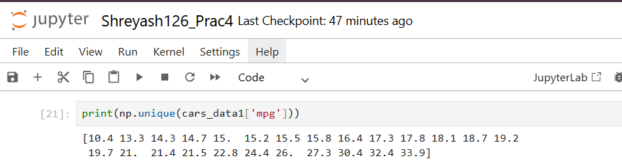
5. Unique Values of HP
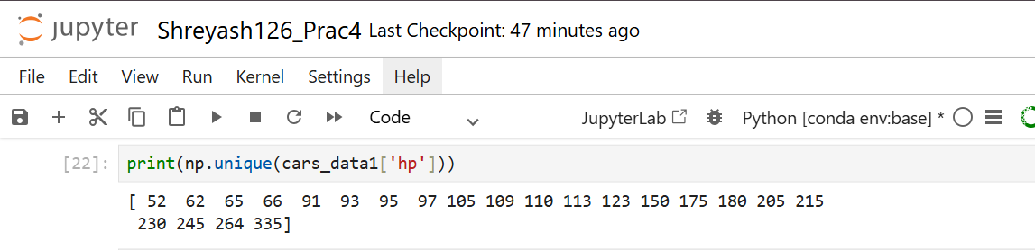

6. Unique Values of gear
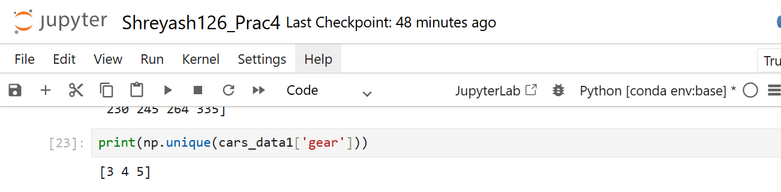
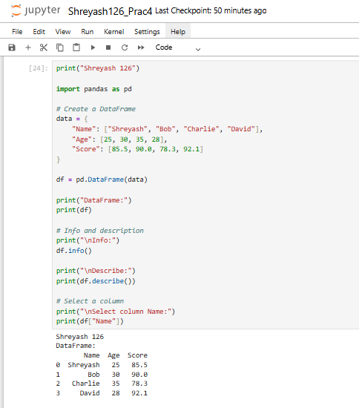
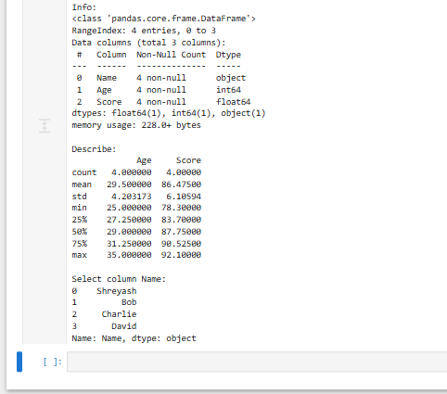
C. Scipy
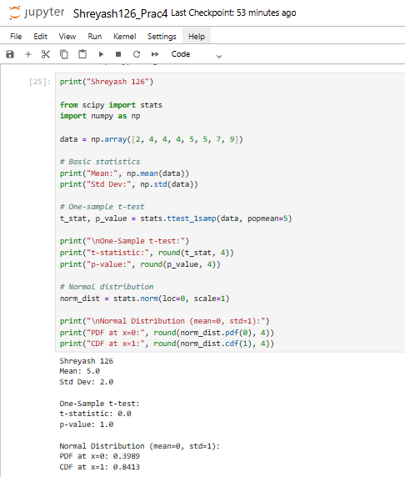

4. Matplotlib
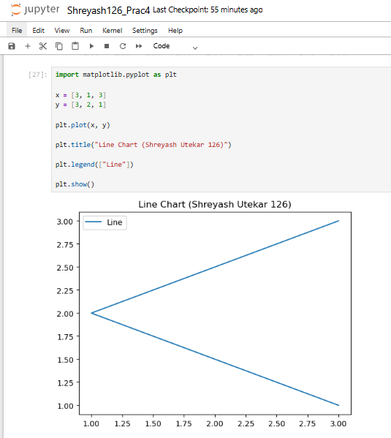
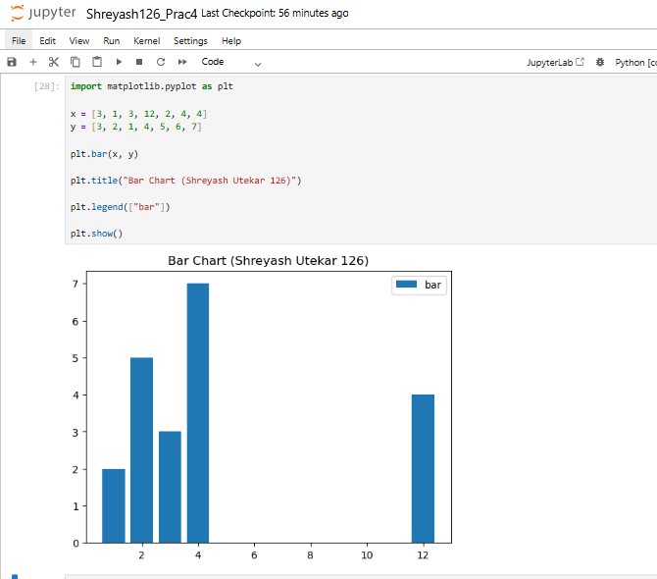

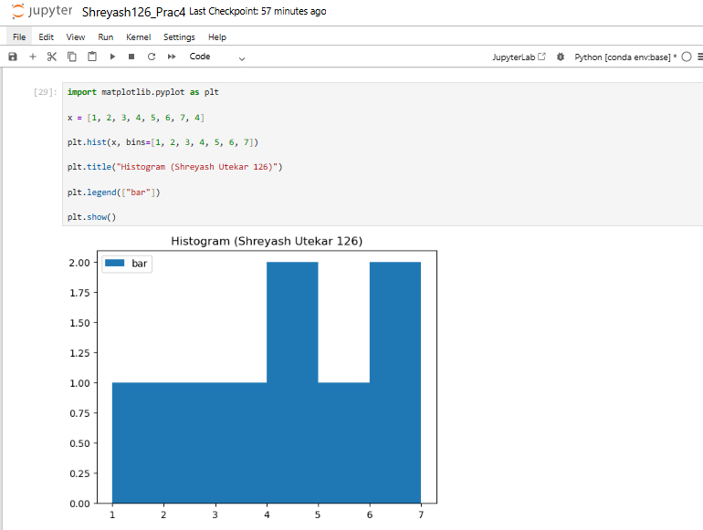

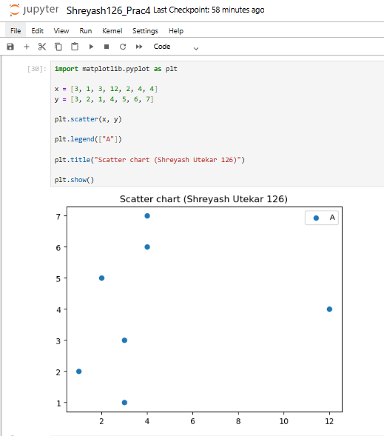

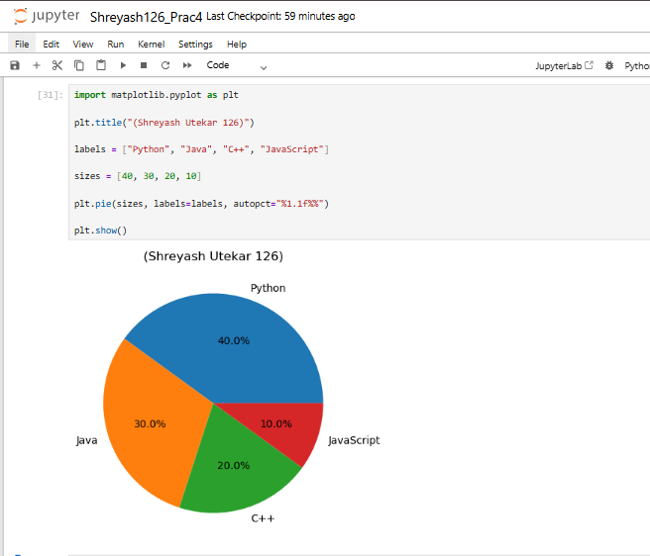

5. Scikit Learn
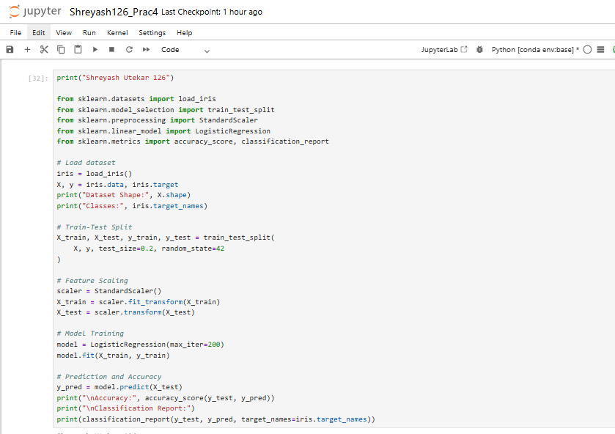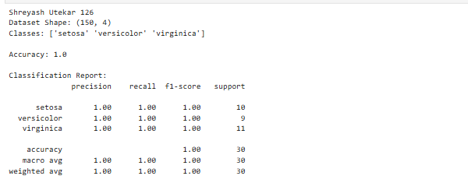
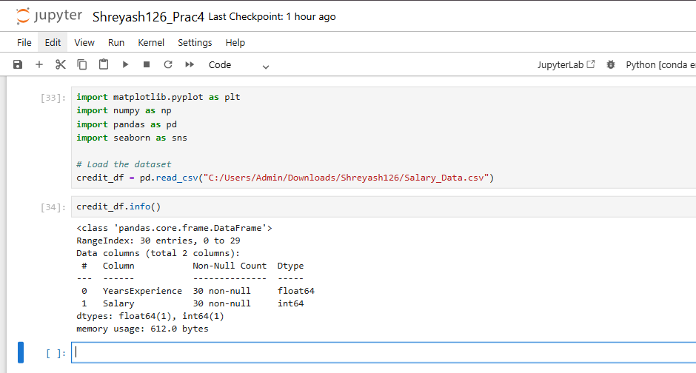

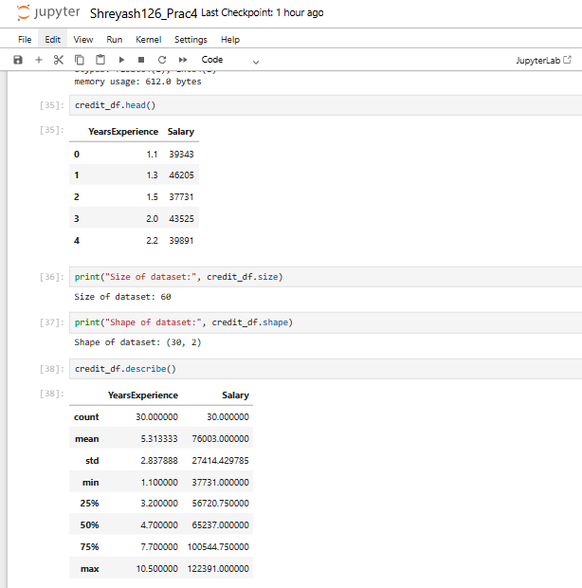
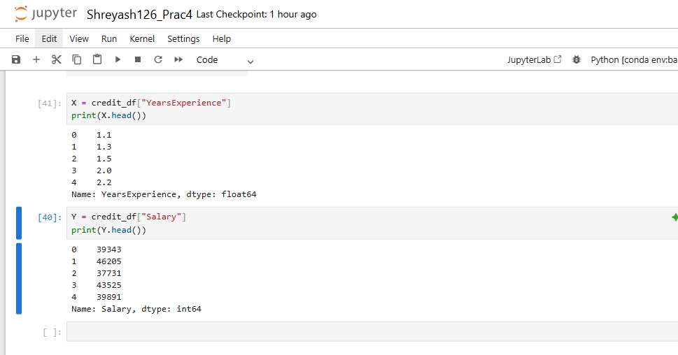
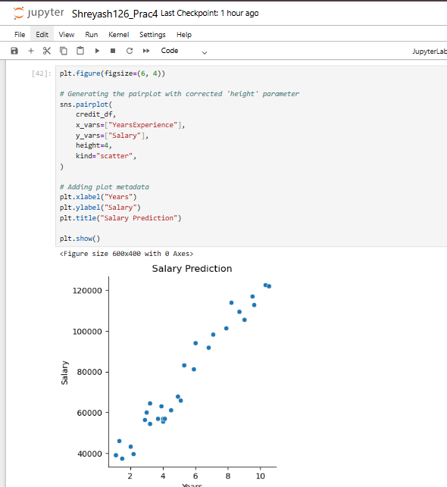

Practical No – 5
Aim - Implement Perceptron algorithm for OR operation
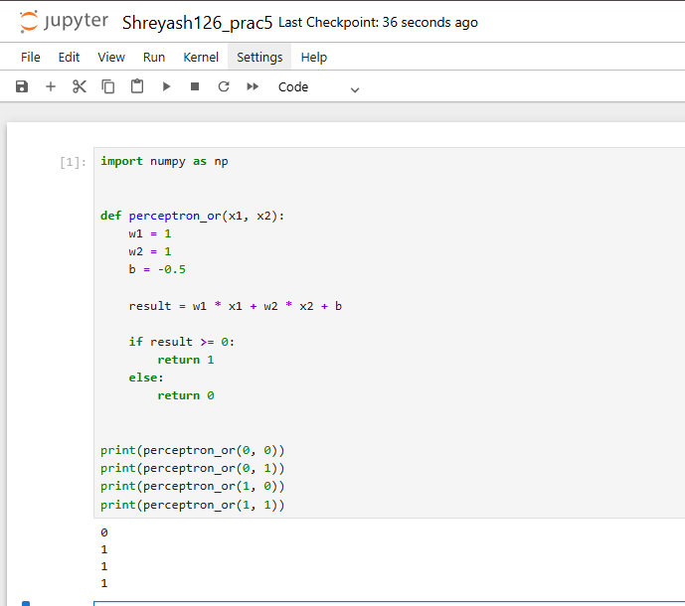

Practical No – 6
Aim - Implement of stochastic gradient descent algorithm (Perceptron).
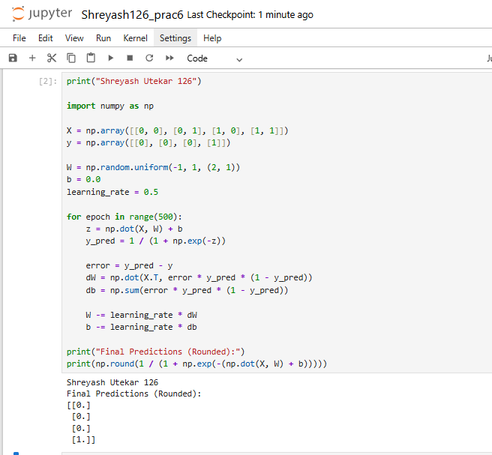

Practical No - 7
Aim: Implement Adaline algorithm for AND operation.
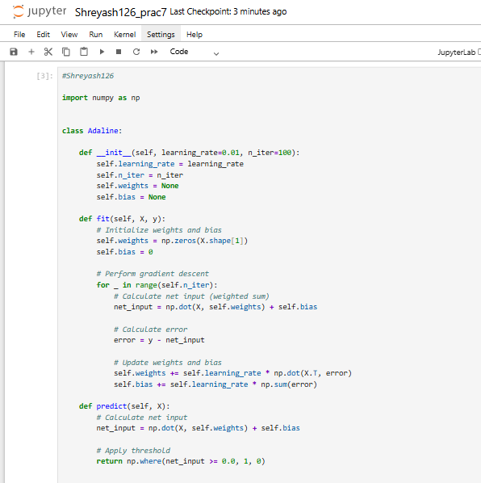
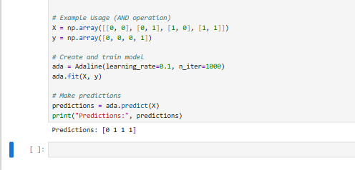
Practical No – 8
Aim - Implementation of Features Extraction and Selection, Normalization, Transformation, Principal Components Analysis.
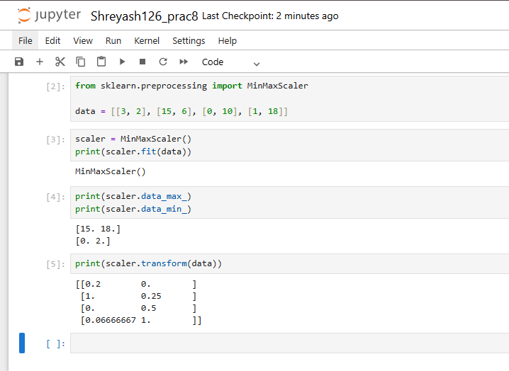
Z-Score Normalization
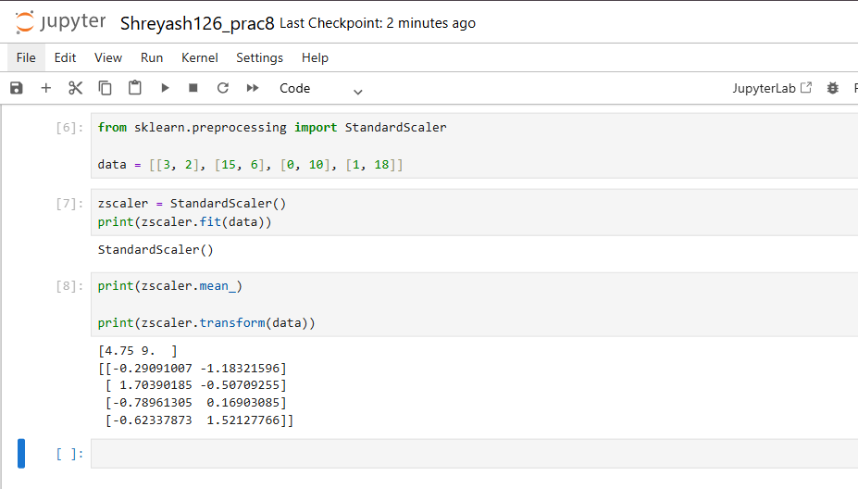
Transform and Normalize
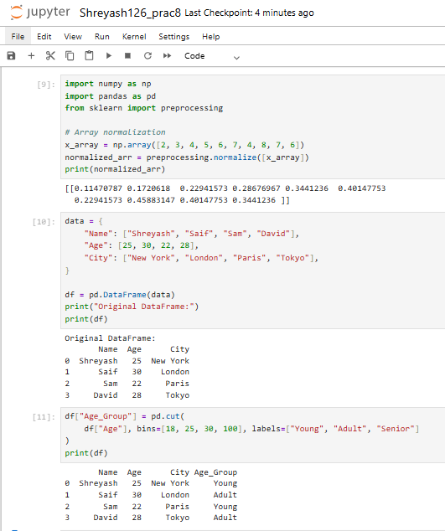
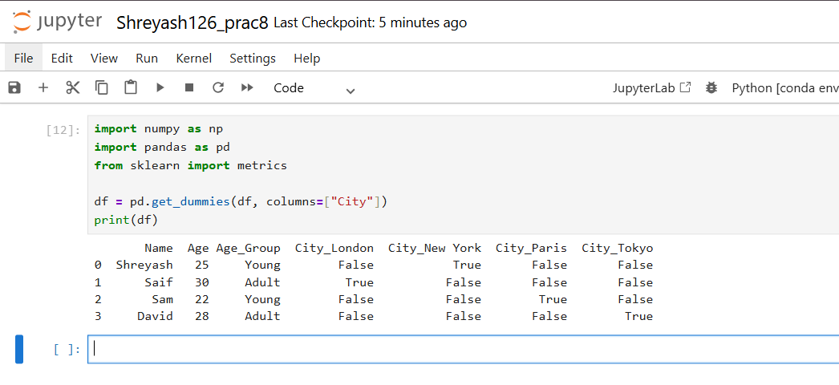
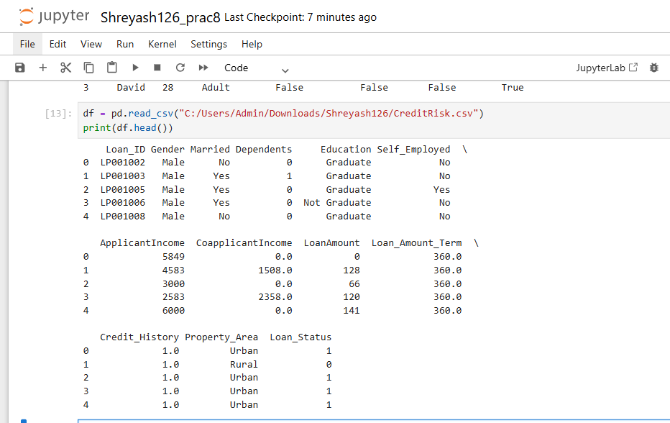
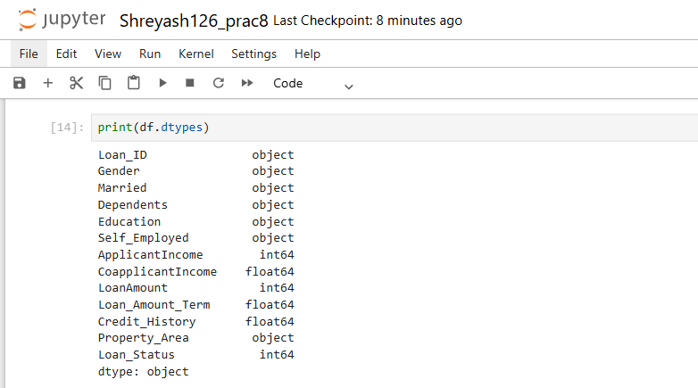
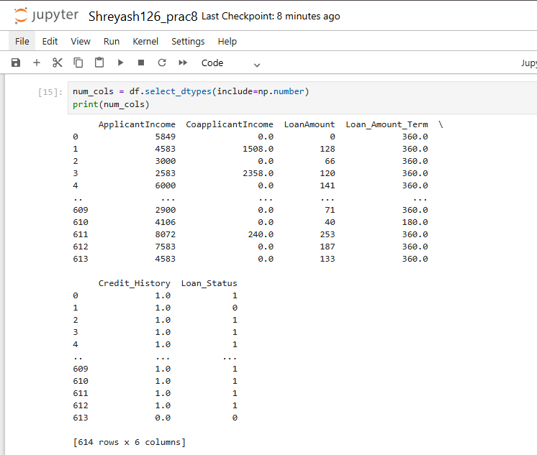
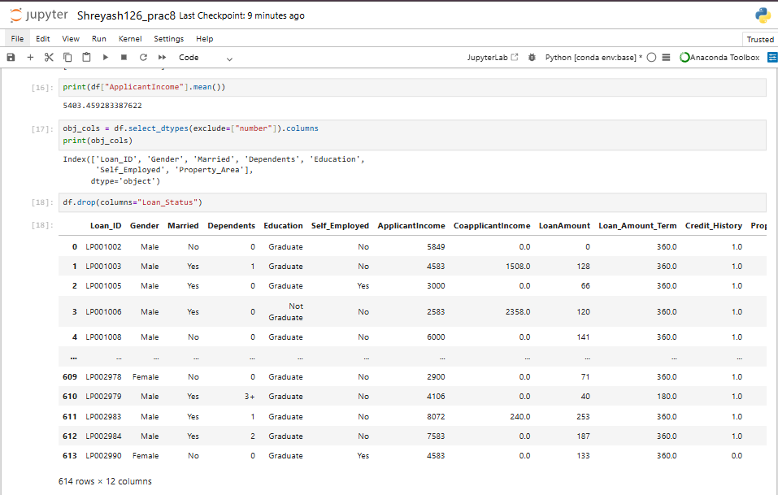
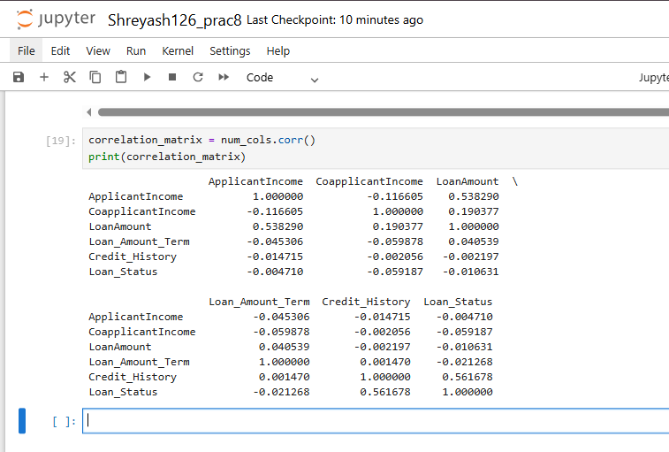
Principal Components Analysis.
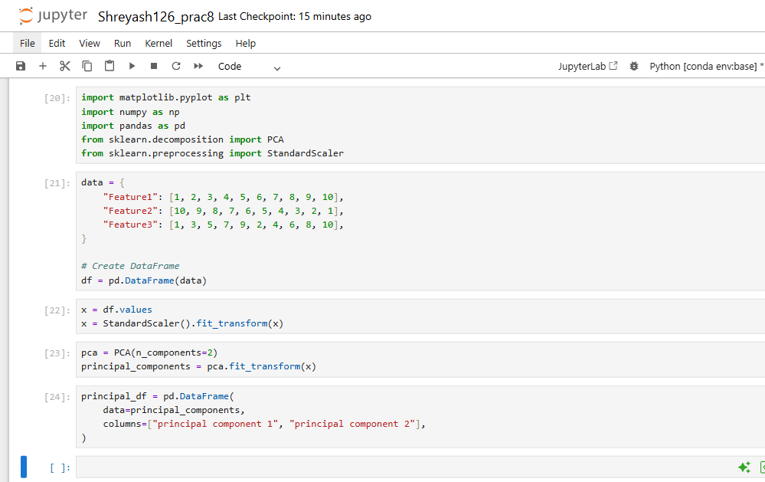
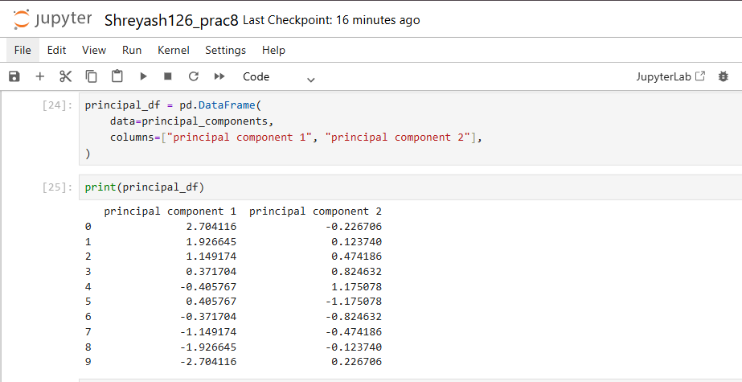
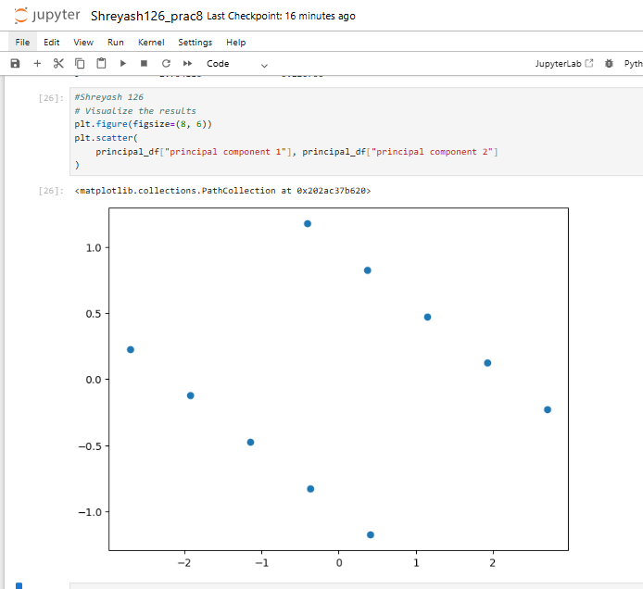
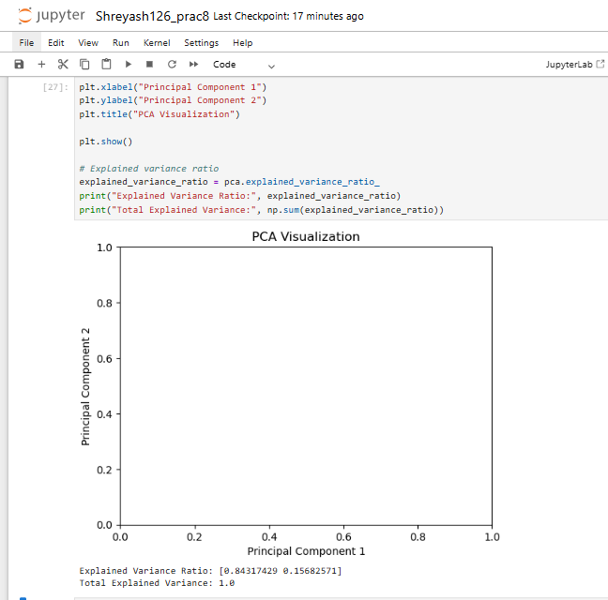

Practical No – 9
Aim - Implementation of Logistic regression
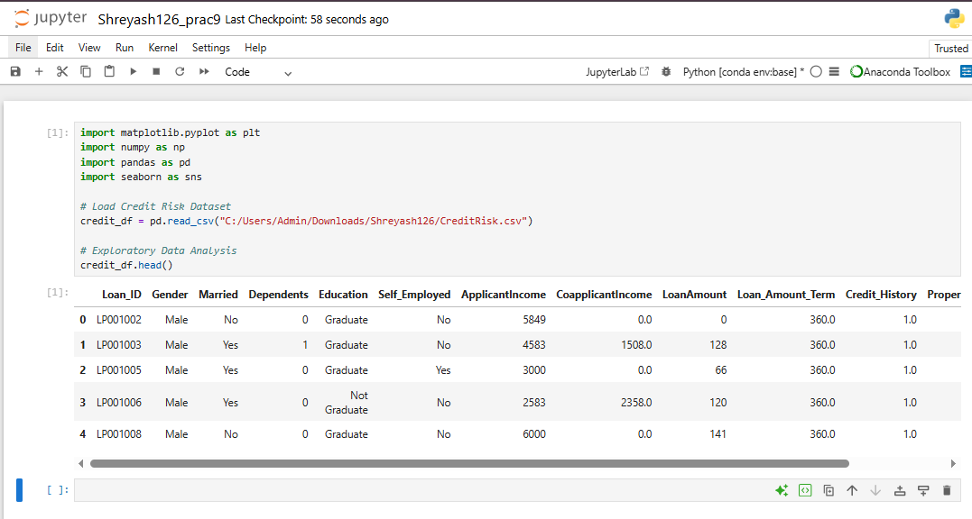
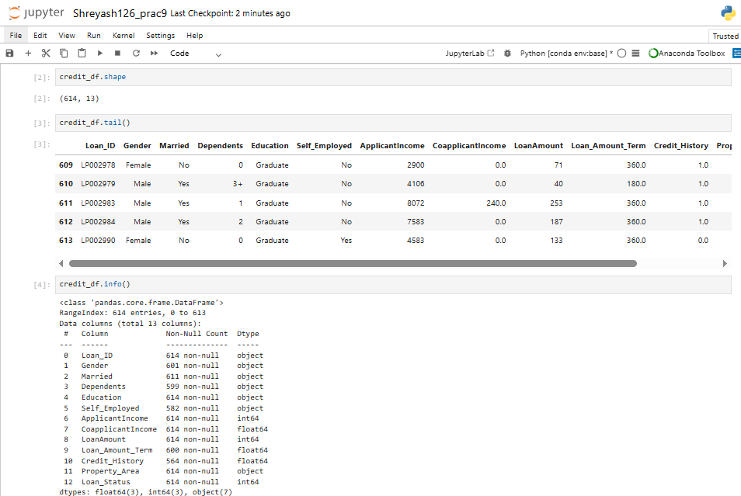

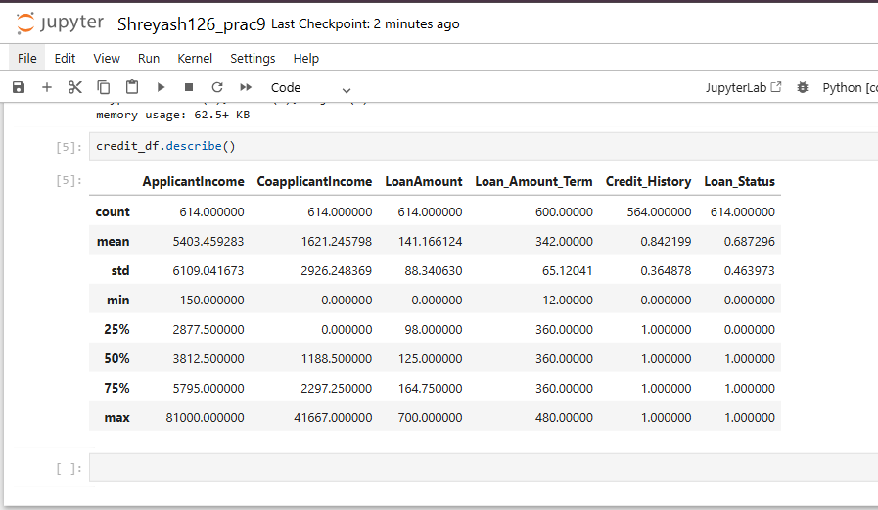
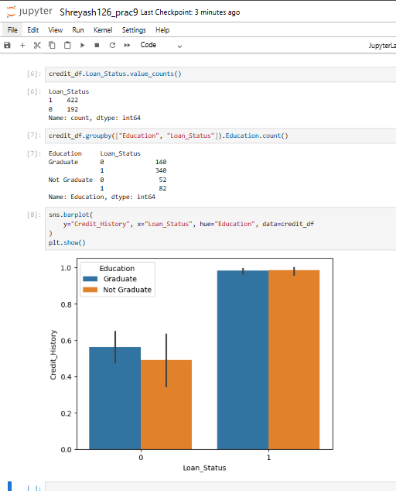
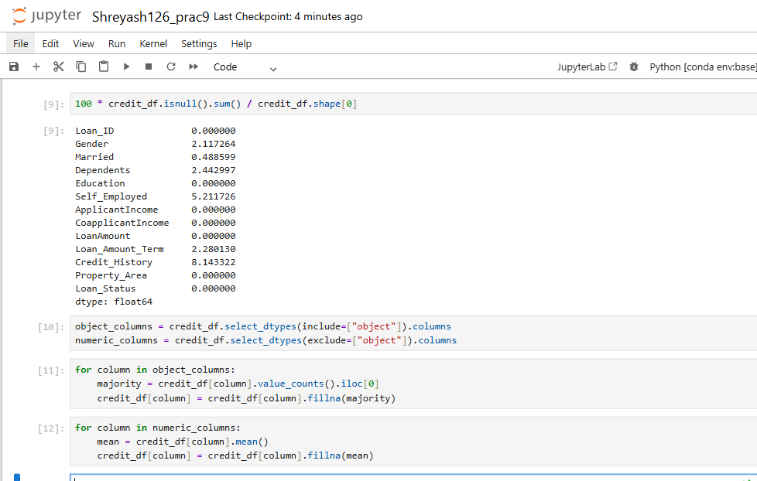
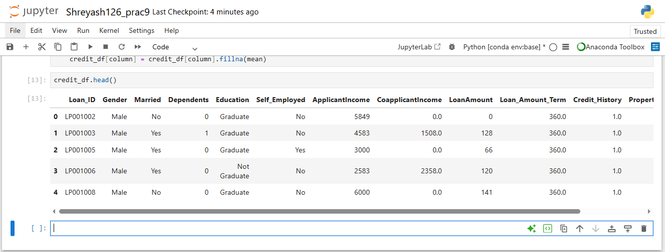
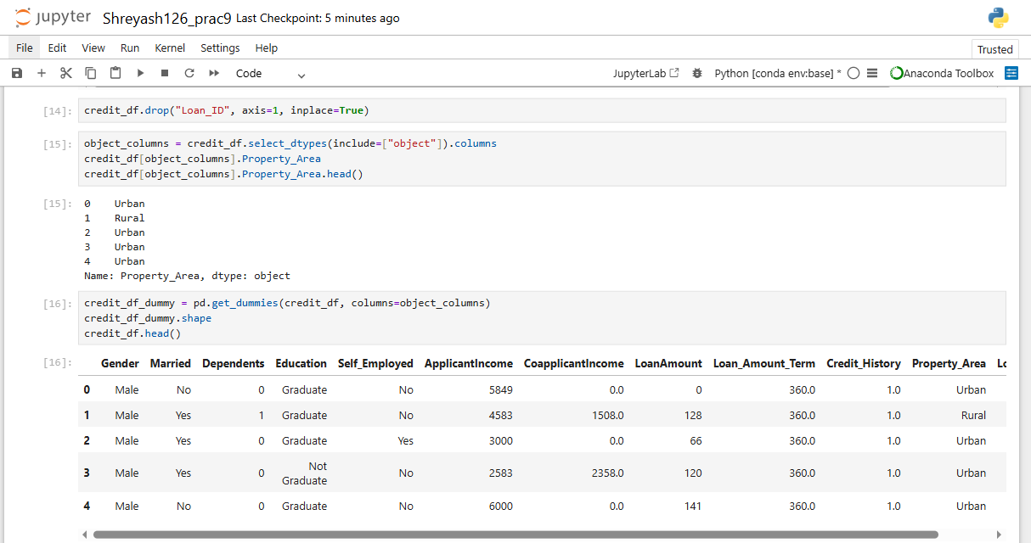
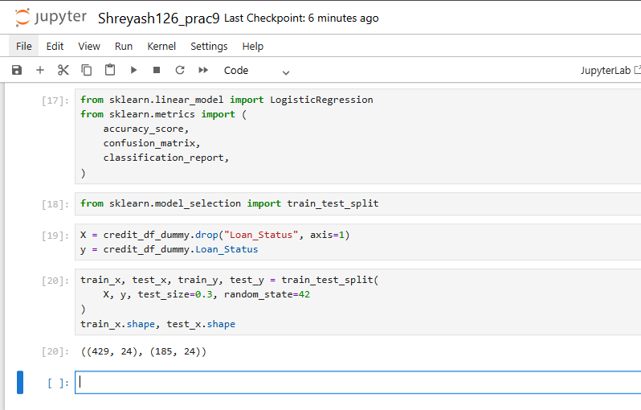
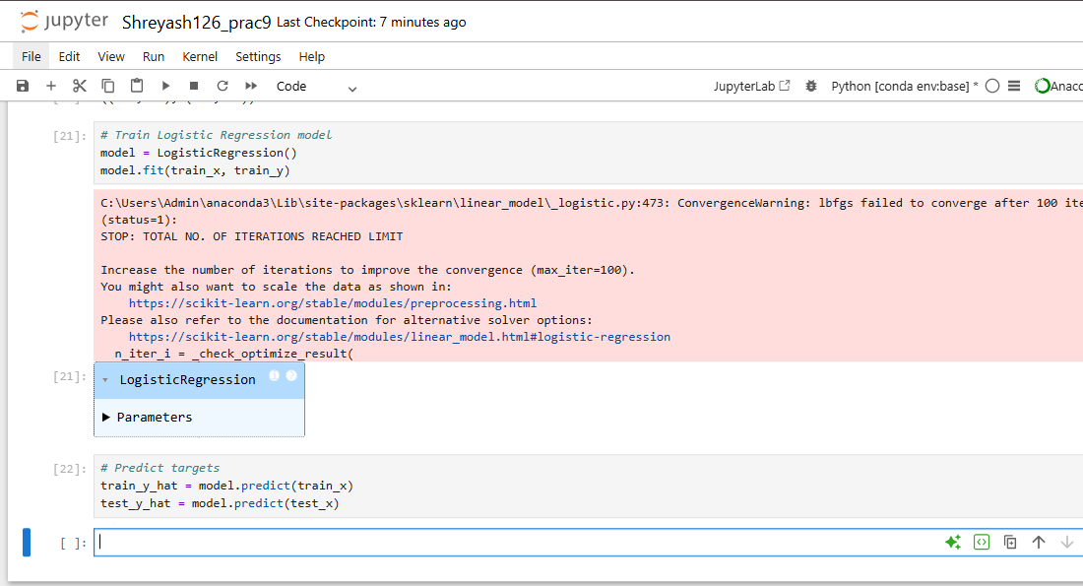
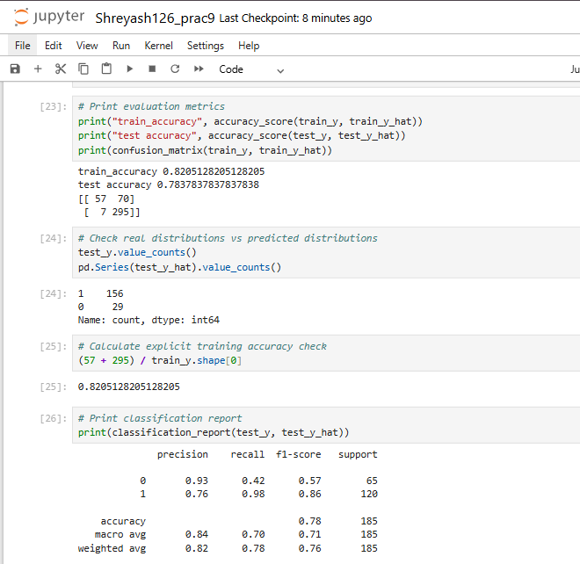
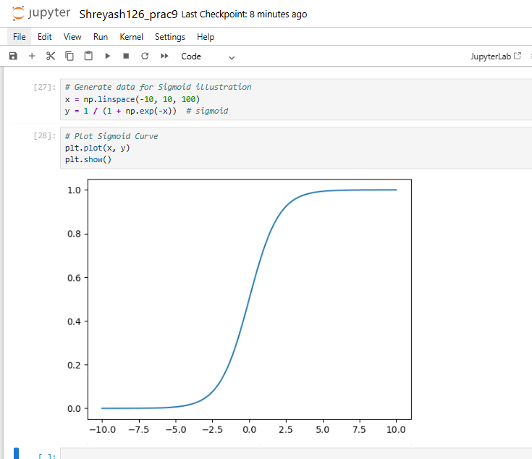
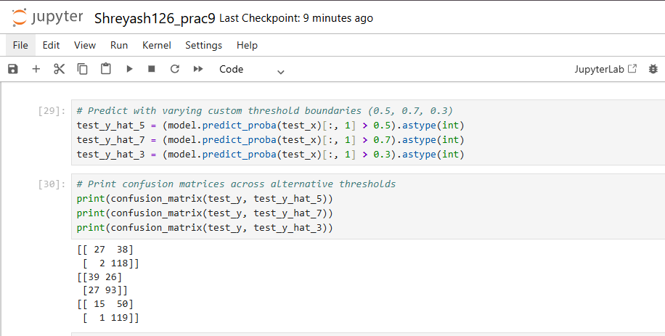
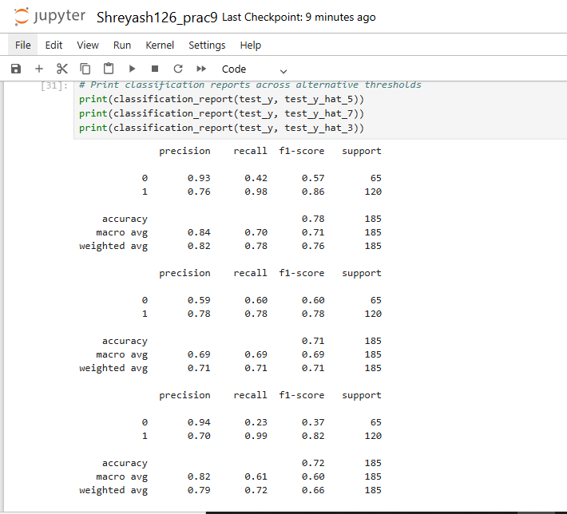

Practical No – 10
Aim - Implementation of Classifying data using Support Vector Machine (SVM).
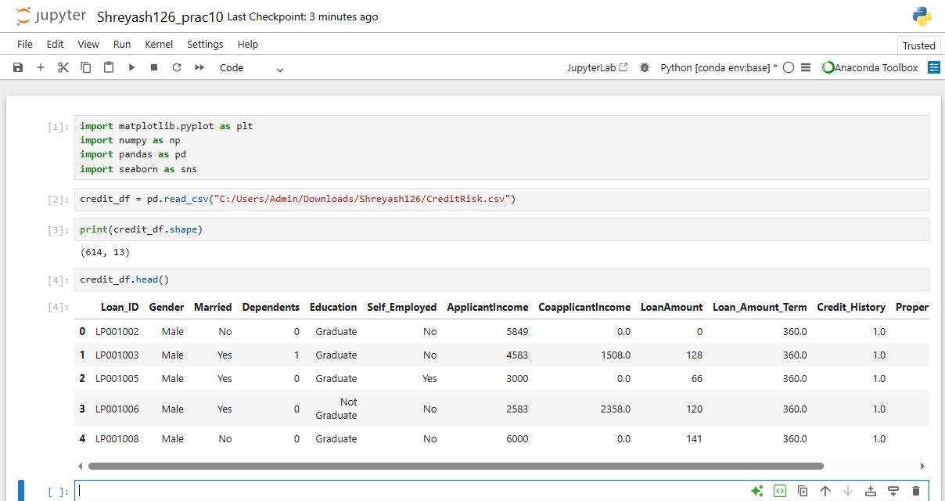
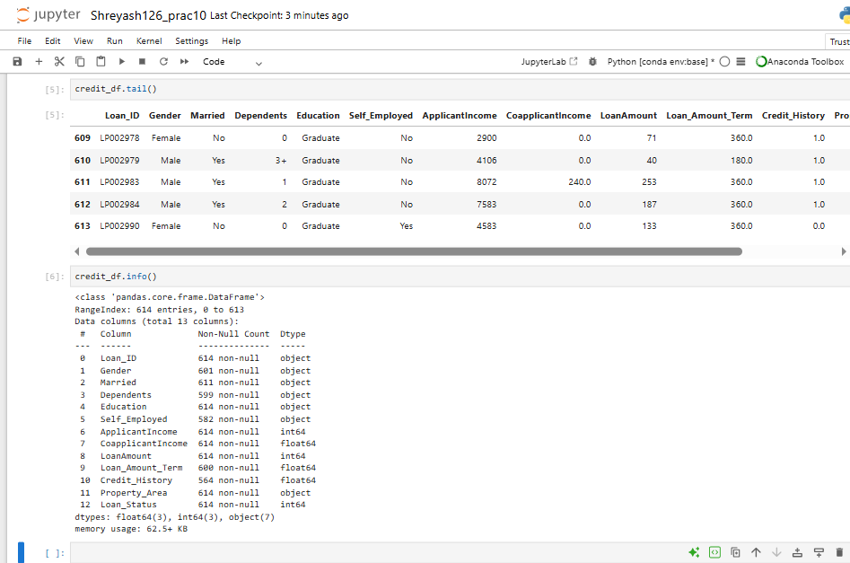

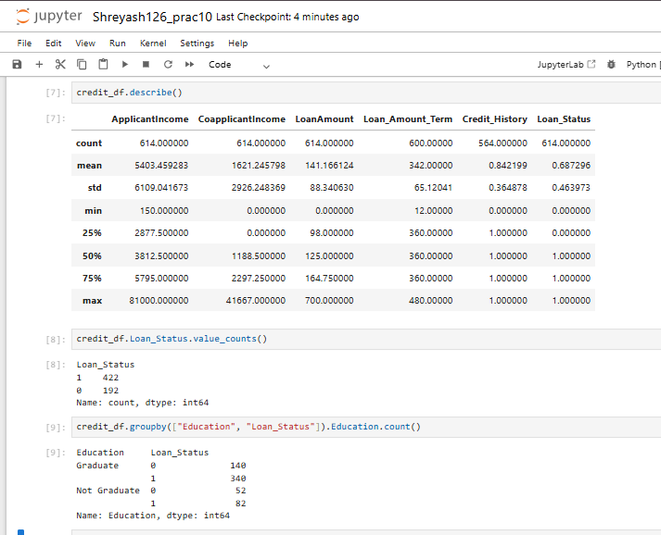
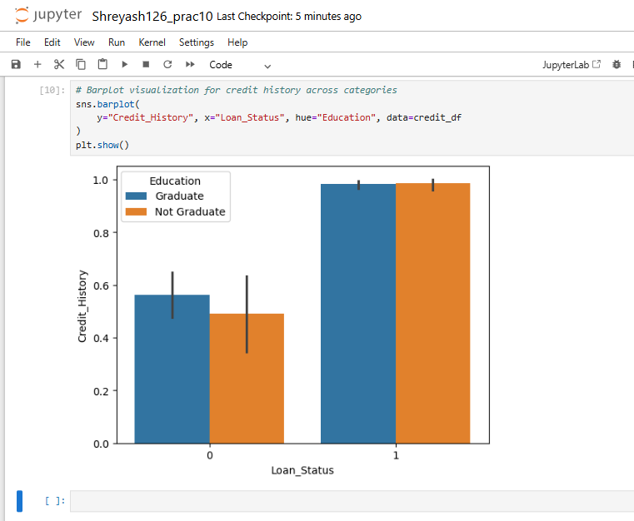
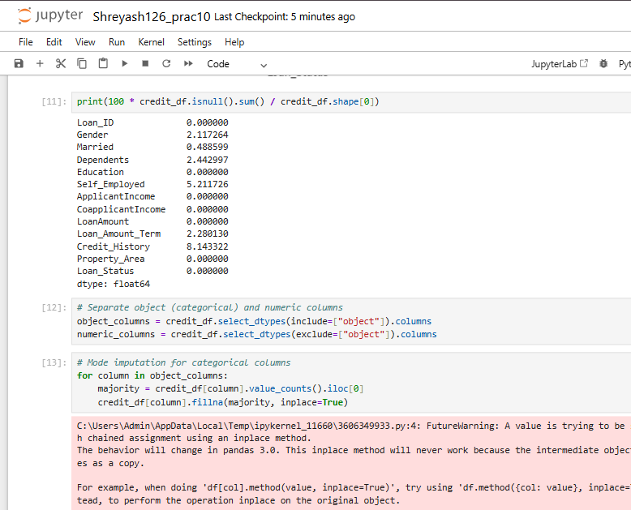

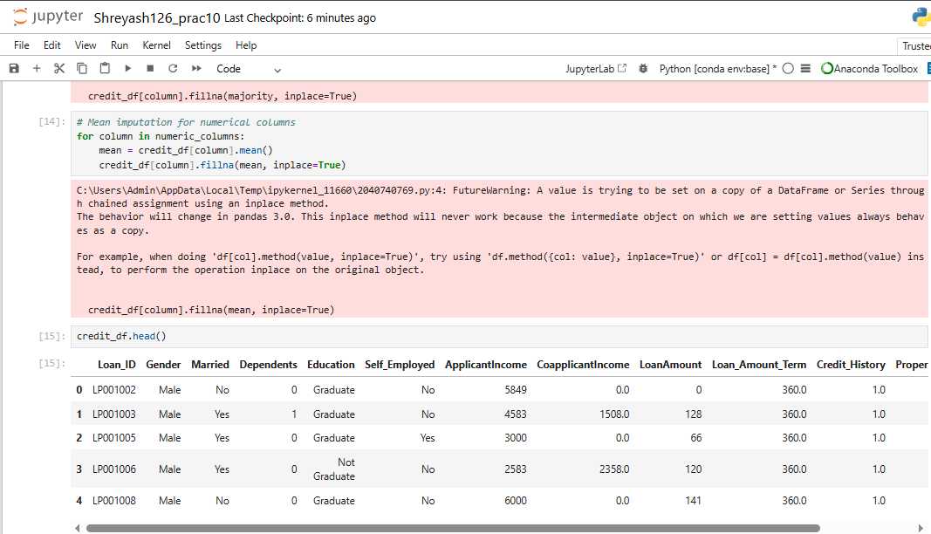
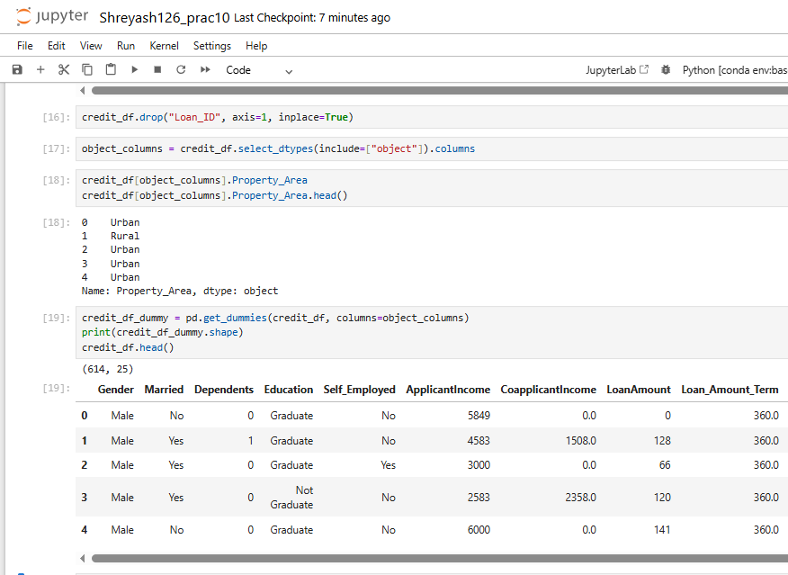
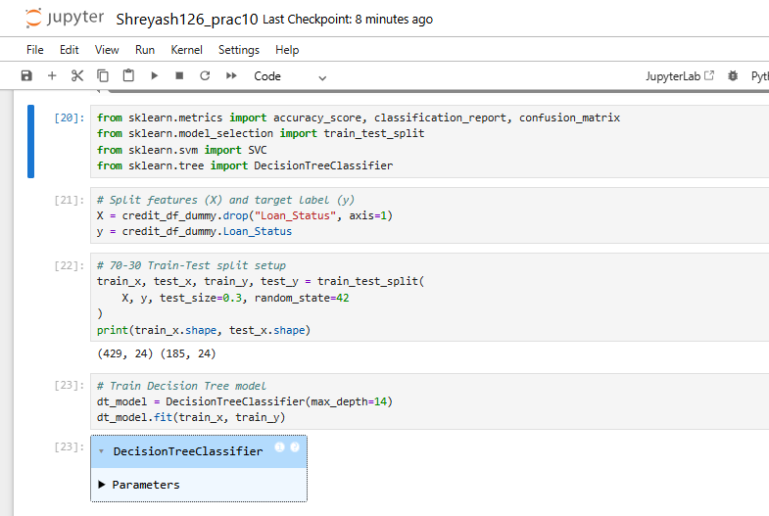
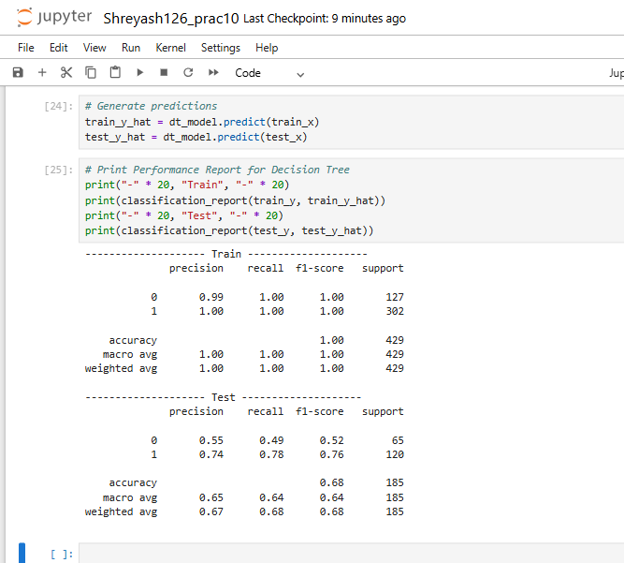

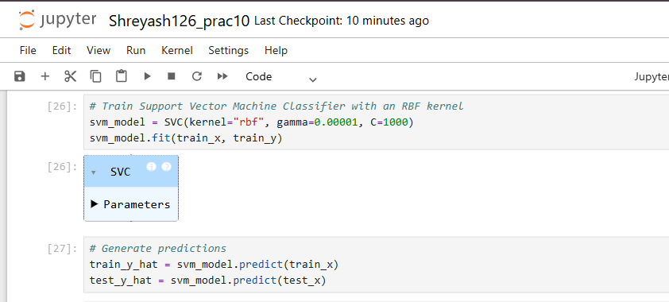
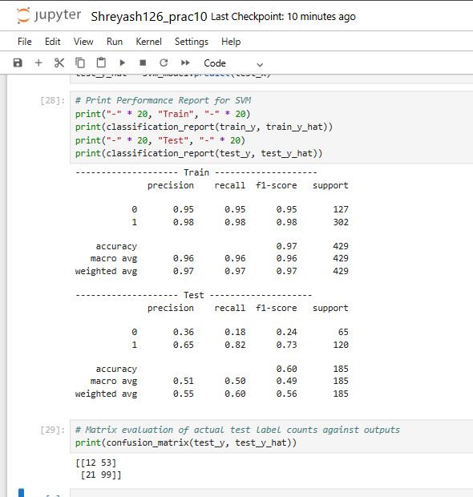

Practical No – 11
Aim - Implement Elbow method for K means Clustering
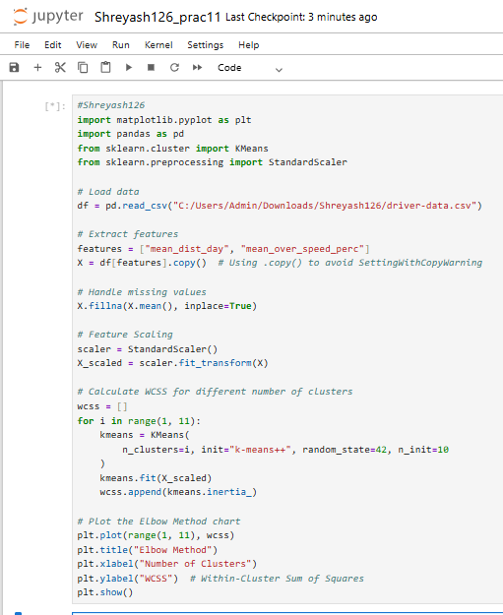
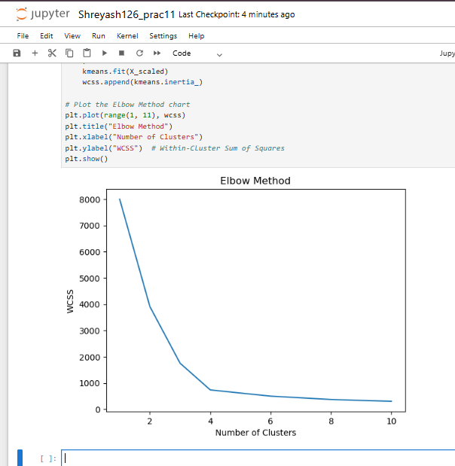

Practical No – 12
Aim : Implementation of Bagging Algorithm: Random Forest
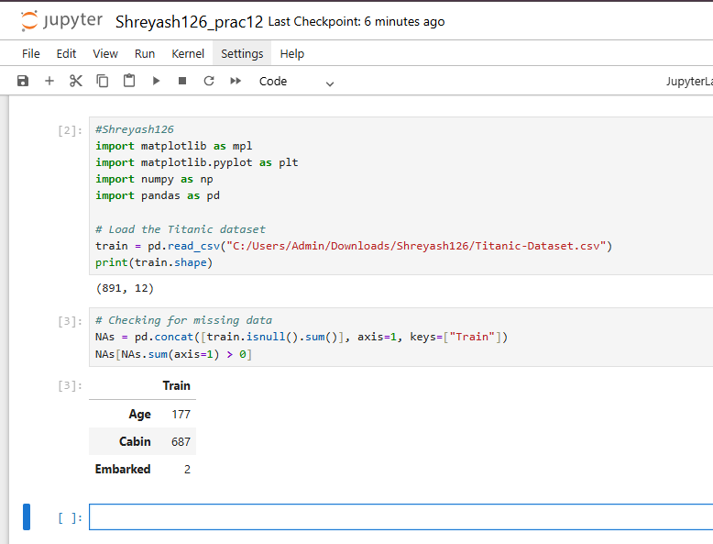
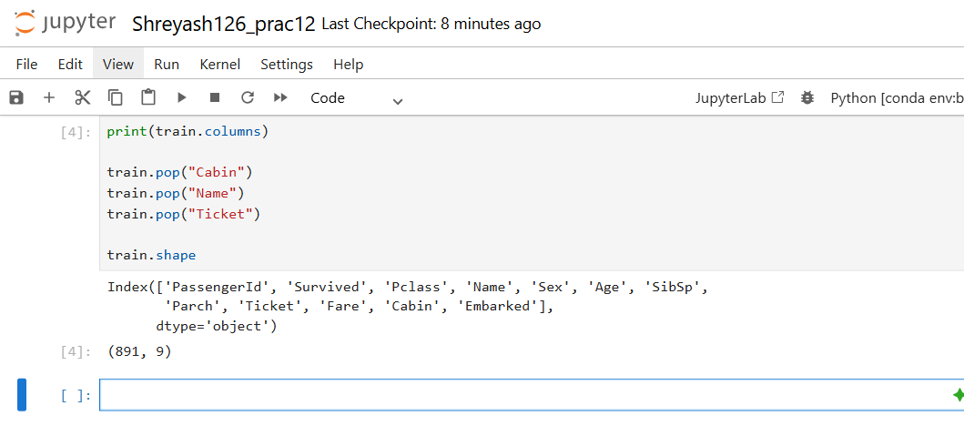

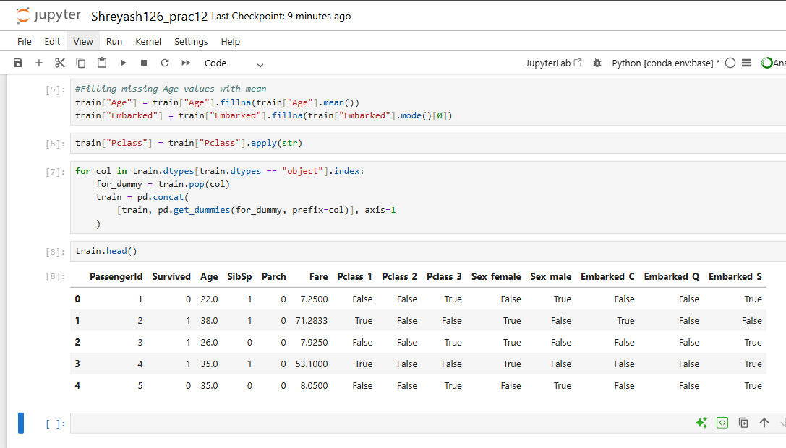
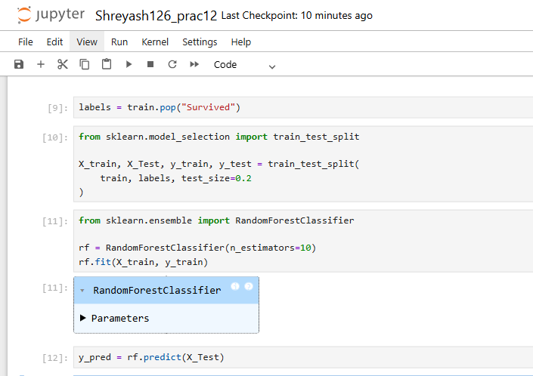
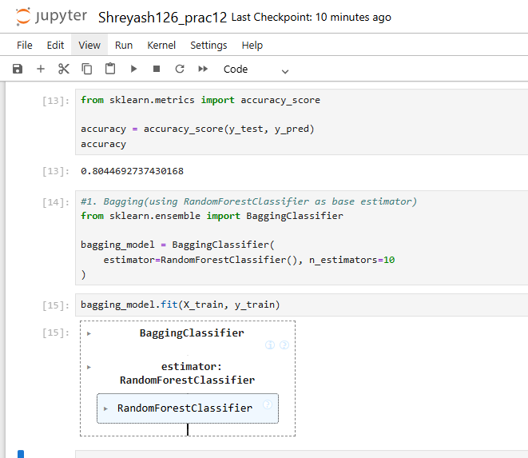
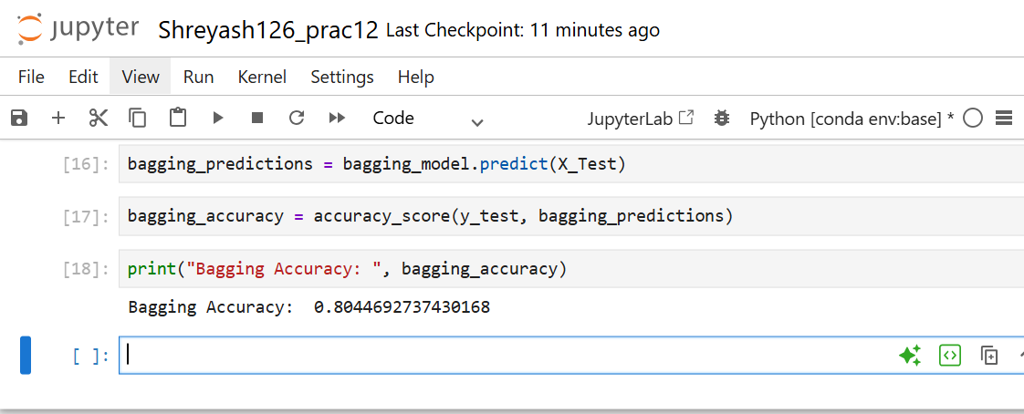

Practical No – 13
Aim - Implementation of Boosting Algorithms: AdaBoost, Stochastic Gradient Boosting, Voting Ensemble.
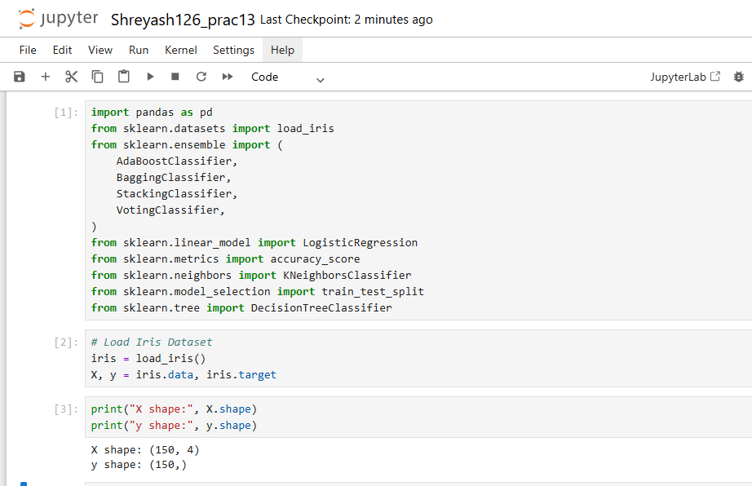
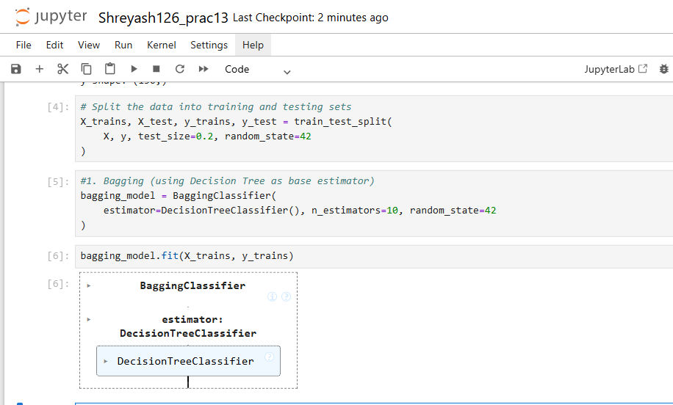
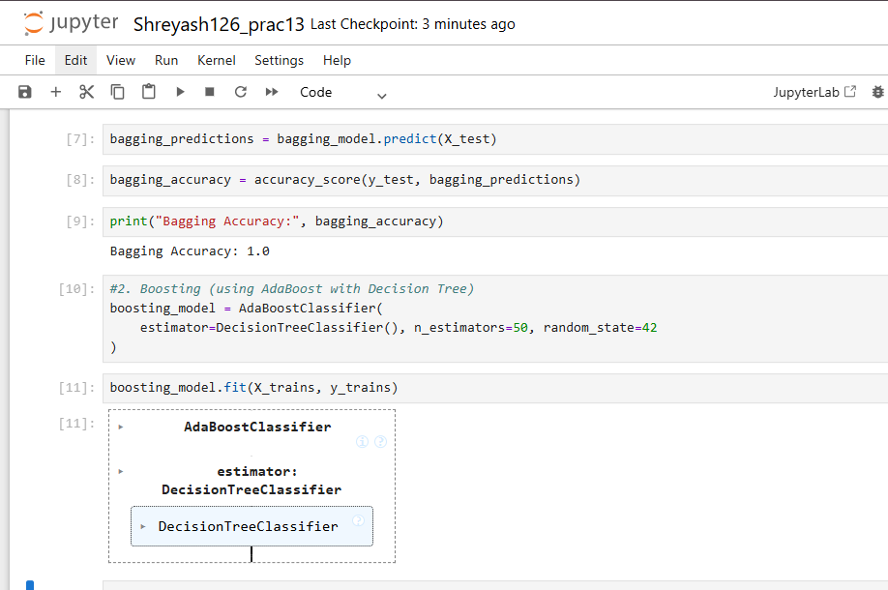
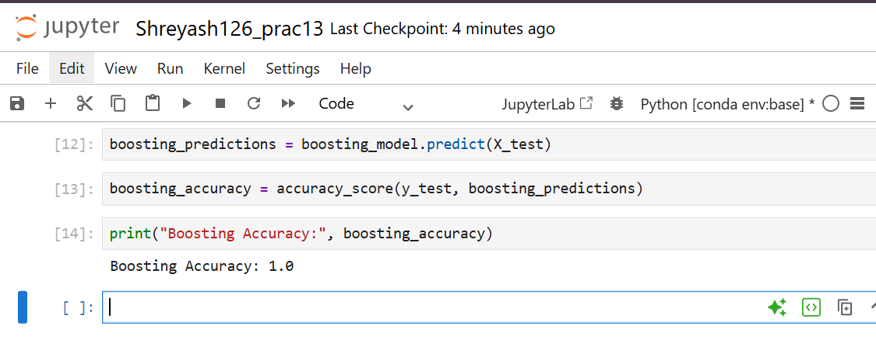
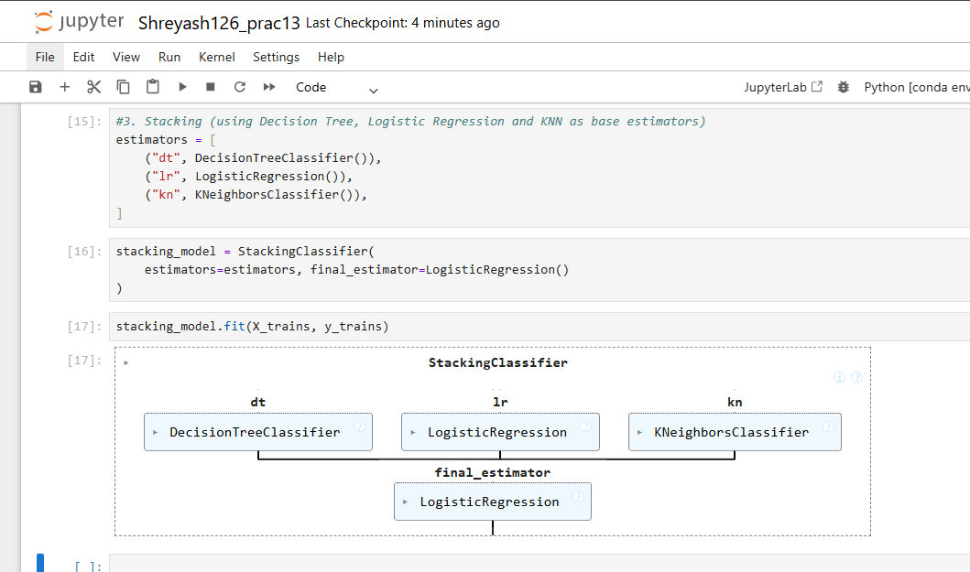
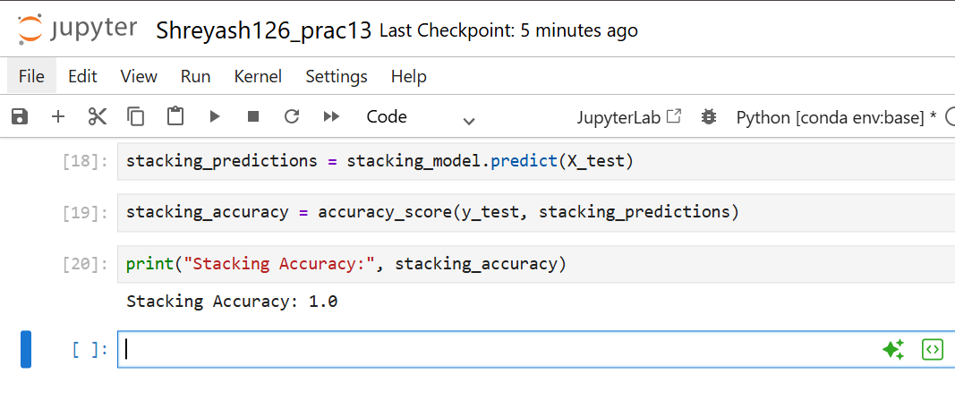

Stochastic Gradient Boosting
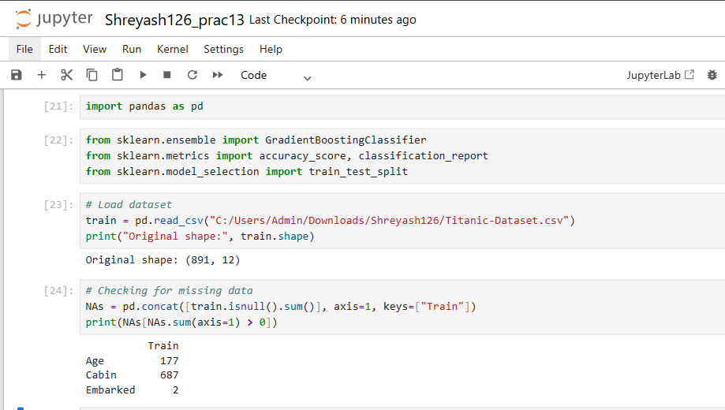
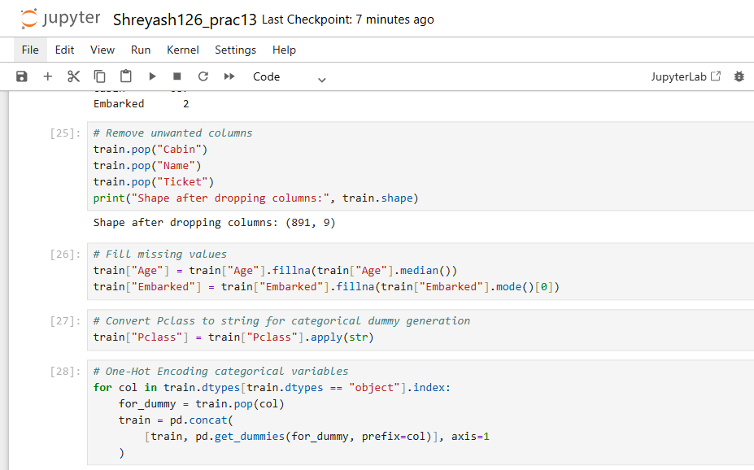
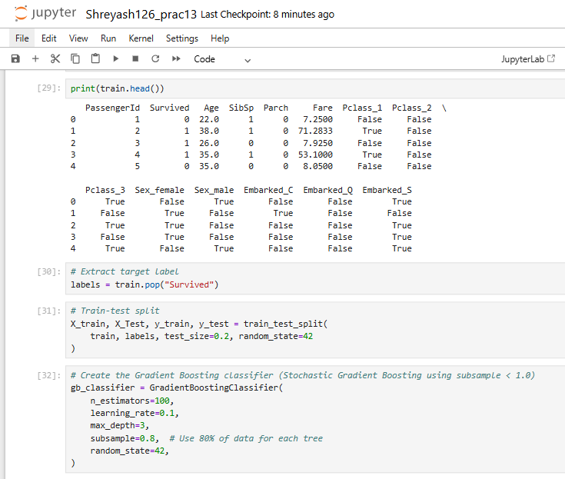
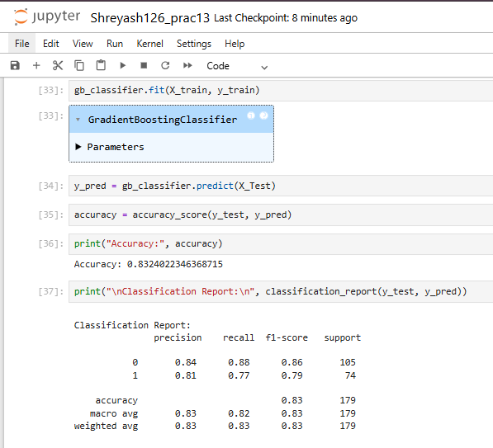
Voting Ensemble
